By: Yente Lens
College promoter: Phaedra Degreef
Company promoter: Kenzo De Ruysscher

Professional Bachelor Electronics-ICT
Major ICT

Bachelor thesis nominated to obtain the degree and diploma of bachelor

Campus De Nayer
Academic year 2025 - 2026
Development of a virtual learning and testing environment with EVE-NG Pro

Foreword
The following thesis describes the detailed explanation of the project that I worked on at Interligo nv from february until june 2026. I want to thank the people at Interligo for the opportunity to do the internship at their company and for their support throughout.

I would like to thank specifically Kenzo De Ruysscher for being my company promoter and his help in guiding me through this project.

Finally I would like to thank Phaedra Degreef for being my College promoter and giving me feedback on the advancement of my project and this thesis.

Summary
In todays world a functional network is more important than ever. That’s why it’s important for companies to know what their applicants and potential future workers are truly capable of. This project seeks to create a simple way of testing an applicants practical knowledge and skills by way of a virtual learning and testing environment.

To accomplish this an Emulated Virtual Environment - Next Generation (EVE-NG) Pro cluster environment was set up to create different labs containing a unique network topology with their own configurations. Each lab fully automated in case of hardware failure or the need to move to a different cluster environment.

The resulting environment made it possible for applicants to demonstrate their knowledge in a safe and risk-free environment. Because of this recruiters can now make a more complete profile of their applicants, as well as allow junior colleagues to get to know real life network topologies.
Table of contents
Foreword 2
Summary 3
List of tables 6
List of figures 7
List of abbreviations and symbols 8
Start-up report 9
1. Introduction 14
2. Problem statement 15
3. Objectives 16
3.1. Automated labs 16
3.2. Documentation of solutions 16
4. Method 17
4.1. Creating the EVE-NG environment 17
4.2. Lab design and creation 17
4.3. Lab automation 17
5. Research 18
5.1. Theoretical background 18
5.1.1. EVE-NG 18
5.1.2. Licenses & prices 18
5.1.2.1. Community Edition 18
5.1.2.2. Professional Edition 18
5.1.2.3. Corporate & Learning Centre 18
5.1.3. Users 20
5.1.4. System requirements 21
5.1.5. Cluster architecture 21
5.1.5.1. Licensing 21
5.1.6. Scalability 22
5.2. Practical implementation 22
5.2.1. Cluster deployment 22
5.2.1.1. Pre-requisites 22
5.2.1.2. Installation 23
5.2.1.3. Joining a Satellite node to the cluster 23
5.2.2. Active Directory integration 24
5.2.3. Images 25
5.2.3.1. QEMU 25
5.2.4. Lab development 26
5.2.4.1. Lab 1 26
5.2.4.2. Lab 2 27
5.2.4.3. Lab 3 28
5.2.5. Lab validation 29
5.2.6. Automation 29
5.2.6.1. API 29
5.2.6.2. Script flow 30
6. Results 33
7. Interpretation of results 34
8. Decision/Discussion 35
Appendixes 37
Appendix A: Master node installation 37
Appendix B: Satellite node installation 40
Appendix C: Configuring internet access 45

List of tables
Table 1 - User Role Comparison 20
Table 2 - Virtual machine requirements 21
Table 3 - Firewall rules between Master and Satellite nodes 22
Table 4 - Naming conventions 25

List of figures
Figure 1 - User Settings 20
Figure 2 - Choice of versions 23
Figure 3 - Add cluster member 23
Figure 4 - Satellite node added succesfully 24
Figure 5 - Active Directory settings 24
Figure 6 - Filesystem naming conventions 25
Figure 7 - Lab 1 26
Figure 8 - Lab 2 27
Figure 9 - Lab 3 28
Figure 10 - API call example 29
Figure 11 - Device data 30
Figure 12 - Script lab topology 31
Figure 13 - Interface connection loop 31
Figure 14 - Connecting interfaces 32
Figure 15 - Node configuration function 32

List of abbreviations and symbols
Abbreviation | Meaning
EVE-NG | Emulated Virtual Environment - Next Generation
VM | Virtual Machine
MTU | Maximum Transmission Unit
NTP | Network Time Protocol
AD | Active Directory
DC | Domain Controller
DN | Distinguished Name
QEMU | Quick Emulator
ACL | Access Control List
OSPF | Open Shortest Path First
VPC | Virtual PC
ASA | Adaptive Security Appliance
PAT | Port Address Translation
UDP | User Datagram Protocol
TCP | Transmission Control Protocol
HSRP | Hot Standby Router Protocol
DMZ | Demilitarized Zone
BGP | Border Gateway Protocol
VRF | Virtual Router Forwarding
RIP | Routing Information Protocol
VPN | Virtual Private Network
LACP | Link Aggregation Control Protocol
API | Application Programming
NIC | Network Interface Card

Start-up report

Gegevens student(en)
Student 1: Yente Lens
Opleiding: E-ICT: Systems, Services & Security
GSM: +32 492 10 75 90
Gegevens bedrijf / instelling
Naam: Interligo nv
Adres: Veldkant 31, Kontich 2550
Tel: 03 451 23 82
Gegevens bedrijfspromoter
Naam: Kenzo De Ruysscher  Functie: Technical & Presales Consultant  Afdeling: Internal IT | Tel/GSM: +32 477 97 35 70  Email: kenzo.deruysscher@interligo.be

Gegevens bachelorproef
Titel bachelorproef
EVE-NG Pro cluster
Omschrijving van het probleem
Als eerste onderdeel zal de stagair een EVE-NG Pro cluster opzetten op de virtuele
omgeving. Dit wordt op een schaalbare manier opgezet met AD integratie etc.
In het tweede onderdeel van de stageopdracht zal de stagair verschillende labo's
voorbereiden en deze automatiseren voor hergebruik.
De invulling van de labo's zal de netwerk kennis van de student testen. Gebaseerd op een
ruw scenario zal hij de nodige devices moeten preconfiguren om problem scenario's te
creëren.
Aansluitend moet de student de oplossing voor elk scenario compleet uitwerken met een
oplossing gids.
Het doel van deze opdracht is om een (leer)omgeving te creëren voor werknemers ter
voorbereiding van certificaties of voor demo's bij klanten.

Doelstellingen van de bachelorproef (kwantitatief en meetbaar)
-Verplichte doelstellingen
-Werkende EVE-NG Pro cluster
- Schaalbaarheid van de cluster. Onderzoek naar de nuttigste manier om de cluster te schalen en de toepassing hiervan
- Integratie van de cluster met AD
- Minstens 3 labo’s voorbereiden die door middel van automatisering herbruikt
kunnen worden
- Maken van een oplossing gids voor elk labo

-Bijkomende niet-verplichte doelstellingen
-Onderzoekscomponent: Cisco Modeling Labs vs EVE-NG Pro cluster
vergelijking van: architectuur, functionaliteit, schaalbaarheid, automatisatie, integraties, beheer, licensing, geschiktheid voor training en demo’s. Gewenste resultaat is een vergelijkingsdocument waarmee technische aanbevelingen kunnen worden gemaakt.
Gewenst resultaat: wat moet er (minimaal) opgeleverd worden?
-Een volledig werkende EVE-NG Pro cluster waarop alle labo’s gesimuleerd kunnen
worden.
- Een leeromgeving die gemakkelijk hebruikt kan worden en voor elke opdracht
voorzien is van een oplossing gids

Wat is de planning (activiteiten van de student + includeer ook planning m.b.t. het schrijven van de scriptie)?
Fase 1 – Analyse & ontwerp (09/02 – 23/02)
- Requirementsanalyse
- Architectuurontwerp
- Scopebepaling
Fase 2 – Voorbereiding virtuele omgeving (24/02 – 02/03)
- Toegang tot Proxmox
- Resource-allocatie
- Netwerktoegang
- Omgevingsvalidatie
Fase 3 – EVE-NG Pro cluster implementatie (03/03 – 23/03)
- Installatie EVE-NG Pro
- Clustering
- AD-integratie
- Multi-user setup
Fase 4 – Stabilisatie & documentatie (24/03 – 06/04)
- Testing
- Optimalisatie
- Technische documentatie
Fase 5 – Labo-ontwikkeling (07/04 – 11/05)
- Scenario’s
- Topologieën
- Device configuraties
- Probleemscenario’s
Fase 6 – Automatisatie (12/05 – 25/05)
- Deployment automatisatie
- Reset-mechanismes
- Templates
Fase 7 – Oplossingsgidsen & documentatie (26/05 – 01/06)
- Oplossingsdocumentatie
- Troubleshooting gidsen
Fase 8 – Integratie, testing & validatie (02/06 – 08/06)
- End-to-end testing
- Validatie
- Optimalisatie
Fase 9 – Bufferperiode / marge (09/06 – 22/06)
2 weken marge voorzien voor:
- Onvoorziene problemen
- Stabilisatie
- Extra optimalisaties
- Aanvullende documentatie
- Feedbackverwerking

Beginnen schrijven scriptie: toevoegen probleemstelling, opstartverslag 16/3 – 22/3
Toevoegen behaalde resultaten, bronnen aan literatuurlijst, lijst met tabellen/figuren 23/3 – 19/5
Besluit/Discussie samenvatting, woord vooraf, interpretatie van de resultaten 19/5 – 24/5
Laatste controle 24/5 – 25/5

Introduction
Interligo is a company that sells network devices and network consultancy. This means that it’s vital for the company to make sure that their consultants have deep layered knowledge and understanding of various networking topics. However it’s very hard to judge what the actual knowledge and skill level of each applicant is like based on a verbal interview. That’s why they need a simple solution to allow all job candidates to show what practical skills they possess.

EVE-NG is a network emulation software that allows network devices like routers, switches and firewalls to be emulated and set up as a topology in a lab environment. It allows us to set up various topologies and see how each device would behave in real life.

With this software we can create different labs which will contain real life network topologies, configured with various purposely made misconfigurations. It is up to the applicant to find the solutions and solve the issues within each topology. The way in which the applicant approaches each task shows the skills and knowledge they have. Allowing the recruiters to more accurately profile each candidate and make more well thought out decisions. Ensuring the future consultants of Interligo are up to the task of representing the company.

Problem statement
The current recruitment process lacks a structured and practical method for assessing applicants’ knowledge and skills. At present, this assessment is mainly based on CVs and face-to-face interviews. This makes it difficult to compare all candidates in a consistent and fair manner.

There is also a need to give junior staff an understanding of real-life network configurations. Using the virtual learning environment, they can familiarise themselves with common network topologies.

Objectives

Automated labs
The primary objective of this project is to create three labs in EVE-NG that are fully automated. The three labs will vary in difficulty, each allowing the applicant to be tested on different skills. All labs can be created from scratch using the automation scripts. These scripts will use the EVE-NG API to create, connect and configure all nodes.

Documentation of solutions
Another objective is to document the intended solution of each lab. These solutions can be used after the lab has been completed to verify if the applicant solved each problem according to the intended solution. Before the applicant starts working a lab he will receive an assignment form that lists everything that needs to work in the lab. The assignment form will also state what he is and isn’t allowed to do in the lab environment.

Method

Creating the EVE-NG environment
The first steps of the project centered around creating the EVE-NG environment. The initial set up consisted of just a single master node and zero satellite nodes. It quickly became apparent that more resources would be needed if more and bigger labs wanted to be used.

The initial setup was used to test the automation solutions. Before any of the current final labs were made a much simpler test lab was created and fully automated to determine how effective this method of automation was. This method consisted of first manually creating the lab on the EVE-NG GUI, then creating a Python script that used the EVE-NG Application Programming Interface to create, start and configure each node. This solution was then chosen to be used for automation of all eventual final labs.

After the succesfull automation test it was time establish the EVE-NG cluster environment. Initially two satellite nodes were created and added to the cluster for additional resources, near the end of the project a third satellite node was also added to the cluster.

Another objective of the project was to integrate the environment with the existing Active Directory of the company. This functionality allows users to authenticate on the environment using their Active Directory credentials.

Lab design and creation
After finalising the EVE-NG environment it was time to design and create the various labs. Initially no concrete designs were given, because of this it was decided to use topologies that had appeared in classes throughout the previous years of education. Only for the third and final lab did the company promoter help design the topology as it was desired to create a large and complex yet realistic lab topology.

Each lab would initially be manually created and configured before creating the automation scripts. All labs also feature an objectives sheet and a correction key. The objectives sheet is given to the applicant and contains information about what they should accomplish within the network, as well as a detailed schema of the lab.

Lab automation
Once all three labs had been fully worked out it was possible to start working on the automation of the labs. This was only possible afterwards as it requires knowledge on where each node is placed within the topology and how they are connected to other nodes.

Each lab has its own Python script and directory full of each nodes’ configuration file. The script authenticates to the EVE-NG server and creates, connects, starts and configures each device. Once the script finishes the lab is ready to be used by the applicant, as the default configuration of each node comes with the purposeful misconfigurations.

Research

Theoretical background

EVE-NG
EVE-NG is a network emulation software that makes it possible to create realistic network topologies. This is achieved through its ability to run software from various well-known vendors. EVE-NG is operated via a web interface, making it easy and intuitive to use. Thanks to the ability to combine multiple servers into a cluster, EVE-NG offers a high scalability. The cluster pools all server capacities, ensuring that all nodes run smoothly. Labs can only be created when software is available. It is up to the user to upload legal software

Licenses & prices
EVE-NG offers three different licences

Community Edition
Community Edition is the free version of EVE-NG, this version is ideal for small projects with simple setups. However, Community Edition does have more limited functionality compared to other versions. In this version, there are two administrator accounts available that can access the EVE-NG server simultaneously

Professional Edition
The Professional Edition is the paid version of EVE-NG, priced at €150. This version includes two administrator accounts as standard and offers almost the full range of EVE-NG’s features. Any features not included in the Professional Edition are available through the user roles that exist alongside the administrator role

Corporate & Learning Centre
Corporate & Learning Centre is a paid version of EVE-NG that includes a Professional licence, as well as other user roles. In addition to the administrator role, there are also Lab User and Lab Editor roles. These are user roles with fewer privileges than the administrator, they allow external users to log in securely to the EVE-NG server to create or edit a practice lab. Table 1 – User Role Comparison shows all permissions per role according to the “EVE-NG Professional Cookbook” (2025, p59-60).

Feature | Administrator Role | Lab-Editor/Teacher Role | Lab-User/Student role
User accounts management | Yes | No | No
User Accounts visibility | Yes | No | No
User edit modal visibility | Yes | No | No
User Folder's management | Yes | No | No
Full EVE root folder tree  access | Yes | No | No
Licencing module access | Yes | No | No
Nodes management module  access | Yes | Yes (only own running nodes) | Yes (only own running nodes)
Lab management module  access | Yes | Yes (only own running nodes) | Yes (only own running nodes)
Shared lab folder  management | Yes | Yes | No
Shared folder access | Yes | Yes | Yes
Shared project | Yes | Yes | No
Rename Folders | Yes | Yes | No
Create labs | Yes | Yes | No
Delete labs | Yes | Yes | No
Edit Custom topology  mapping | Yes | Yes | No
Use only Custom topology  mapping | Yes | Yes | Yes
Lab objects management add  text, drawing on labs | Yes | Yes | No
Export/import labs | Yes | Yes | No
Nodes list management | Yes | Yes | Yes, read-only
Networks management | Yes | Yes | Yes, read-only
Start labs | Yes | Yes | Yes
Stop labs | Yes | Yes | Yes
Search labs | Yes | Yes | Yes
Wipe nodes | Yes | Yes | Yes
Console to all nodes | Yes | Yes | Yes
Export all configs | Yes | Yes | No
Edit lab | Yes | Yes | No
Set nodes startup-cfg to default configset | Yes | Yes | No
Set nodes startup-cfg to none | Yes | Yes | No
Topology refresh | Yes | Yes | Yes
Topology zoom | Yes | Yes | Yes
EVE status | Yes | Yes | Yes
Lab details UUID | Yes | Yes | Yes
See startup configs | Yes | Yes | No
Delete default startup configs | Yes | Yes | No
Create and manage multiconfig sets | Yes | Yes | No
Close labs | Yes | Yes | Yes
Lock labs | Yes | Yes | No
System/Stop all nodes | Yes | No | No
Information tab access | Yes | Yes | Yes
Work with more than one lab | Yes | Yes | Yes
Lab timer function | Yes | Yes | No
Lab background dark mode | Yes | Yes | Yes
Hide node labels | Yes | Yes | Yes
Eve Cluster administration | Yes | No | No
Eve Cluster servers’ assignment per user | Yes | No | No
Table 1 - User Role Comparison

Users
As mentioned earlier, there are different types of users in EVE-NG: the administrator who has full control over the server, the lab editor who can create or edit labs and the lab user who can only work on labs. In addition to user permissions, other settings can be customised for each user. All options are shown in Figure 1 – User Settings
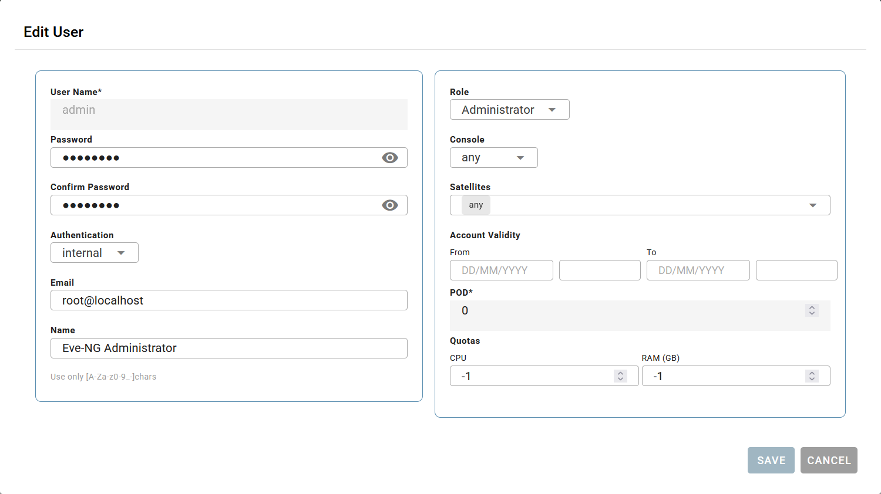
Figure 1 - User Settings

Each user has three authentication methods: Internal, Radius or Active Directory. When “Internal” authentication is used, a password can be set within EVE-NG itself. If “Radius” or “Active Directory” is used, this is not possible as authentication takes place via the respective server.

For each user, the “Role” they will have is determined here. In addition, the user can also be assigned a “Console”; the various options are as follows: Any, Native, HTML5, Desktop. If “Any” is selected, the user can choose which console to use; if one of the other options is specified, the user will only be able to select that option when logging in.

A user can also be assigned to a cluster member using the “Satellites” option. Here, a choice can be made between “Any” or one of the servers that form part of the cluster. If a Lab Editor is assigned a “satellite” server, they can only create or edit labs on the designated server. The same applies to the Lab User, who can only create labs on the assigned satellite servers.

Limits can also be set for each user. The “Account Validity” option allows you to set a limit on how long the account may remain active. Setting the value to “-1” allows for an unlimited duration. In addition, a limit can also be set in terms of server capacity using the “Quotas” option. This means that the user cannot use more capacity than has been allocated; if these limits are exceeded, the user will receive a notification with the message “Failed to start node. Users CPU/Memory quota violation”.

Finally, there is the “Pod” option. This setting is automatically assigned to user accounts and is used to identify the user internally.

System requirements
The recommended system requirements depend on how you want to run EVE-NG. In this project it is ran as a Virtual Machine (VM), the recommended systemrequirements for the EVE VM are specified in Table 2 – Virtual machine requirements (Dzerkals, 2025, p14).

EVE Virtual machine requirements
CPU | 2/24(48) (Number of processors/Cores per socket) Set Expose hardware assisted virtualization to the guest OS to ON (checked) and set Expose IOMMU to the guest OS to ON (checked)
RAM | 64Gb or more
HDD | 800Gb or more
Network | vSwitch/VMnet
Table 2 - Virtual machine requirements

The Professional Cookbook (2025, p12) also specifies that CPU cores are the hardware to prioritise. Without a large amount of CPU cores available the amount of RAM available becomes useless, because the VM CPU cannot hold the labs.

Cluster architecture
In this project a cluster architecture is used. Using a cluster means that we are combining nodes to allow all of their resources to be used as a single pool of resources. In this architecture a single master node is used as well as three satellite nodes.

The master node is responsible for hosting the web-interface and managing the cluster. The satellite nodes are used to provide more resources to the overall pool. All nodes including the master node can run labs. It is up to the user to decide if a lab should be ran on a specified cluster member.

Licensing
To be able to use the cluster functionality, only the master node is required to have a professional licence. Each satellite that joins the cluster does not require a licence. Each satellite can only be joined to one cluster.

Scalability
When creating the environment there are two possibilities in regards to scaling. The first option is to use a single and extremely powerful server. This would mean a simple architecture at a cost of less functionality. The other option is using multiple weaker servers, but combined into a more complex cluster architecture.

For this project the latter solution is preferred, as a greater functionality better aligns with the overall purpose of the project. Without a cluster architecture, it is impossible to loadbalance the various labs over multiple servers. This would mean losing out on the functionality of restricting Lab Editors/Users to their own satellite server on which they can create and work on labs.

Practical implementation

Cluster deployment

Pre-requisites
The EVE-NG Cluster functionality requires several parameters to be configured correctly. The “Proffesional Cookbook” lists the following requirements (Dzerkals, 2025, p218-219).

- Firewall rules between Master and Satellite nodes

Node | Protocol | Port | Direction | Source | Destination
Master | TCP | 22 | Ingress and egress | Master node IP | Satellite nodes IPs
Master | UDP | 60569 | Ingress and egress | Master node IP | Satellite nodes IPs
Satellite | TCP | 22 | Ingress and egress | Satellite node IPs | Master node IP
Satellite | UDP | 60569 | Ingress and egress | Satellite node IPs | Master node IP
Table 3 - Firewall rules between Master and Satellite nodes

- EVE cluster interface Maximum Transmission Unit (MTU) settings

All EVE-NG cluster members must have the same MTU value on their management interfaces, the default value is 1500.

- EVE cluster internal management network

The cluster uses the 172.29.130.0/24 network for internal management, avoid using it in configured networks.

- Network Time Protocol (NTP) synchronization

Satellite nodes must have the same NTP Synchronization as the master server during their installation.

Installation
To create a cluster in EVE-NG a “Master” node and one or more “Satellite” nodes are required. The type of node created is determined at the start of the installation as is seen in Figure 2 – Choice of versions.

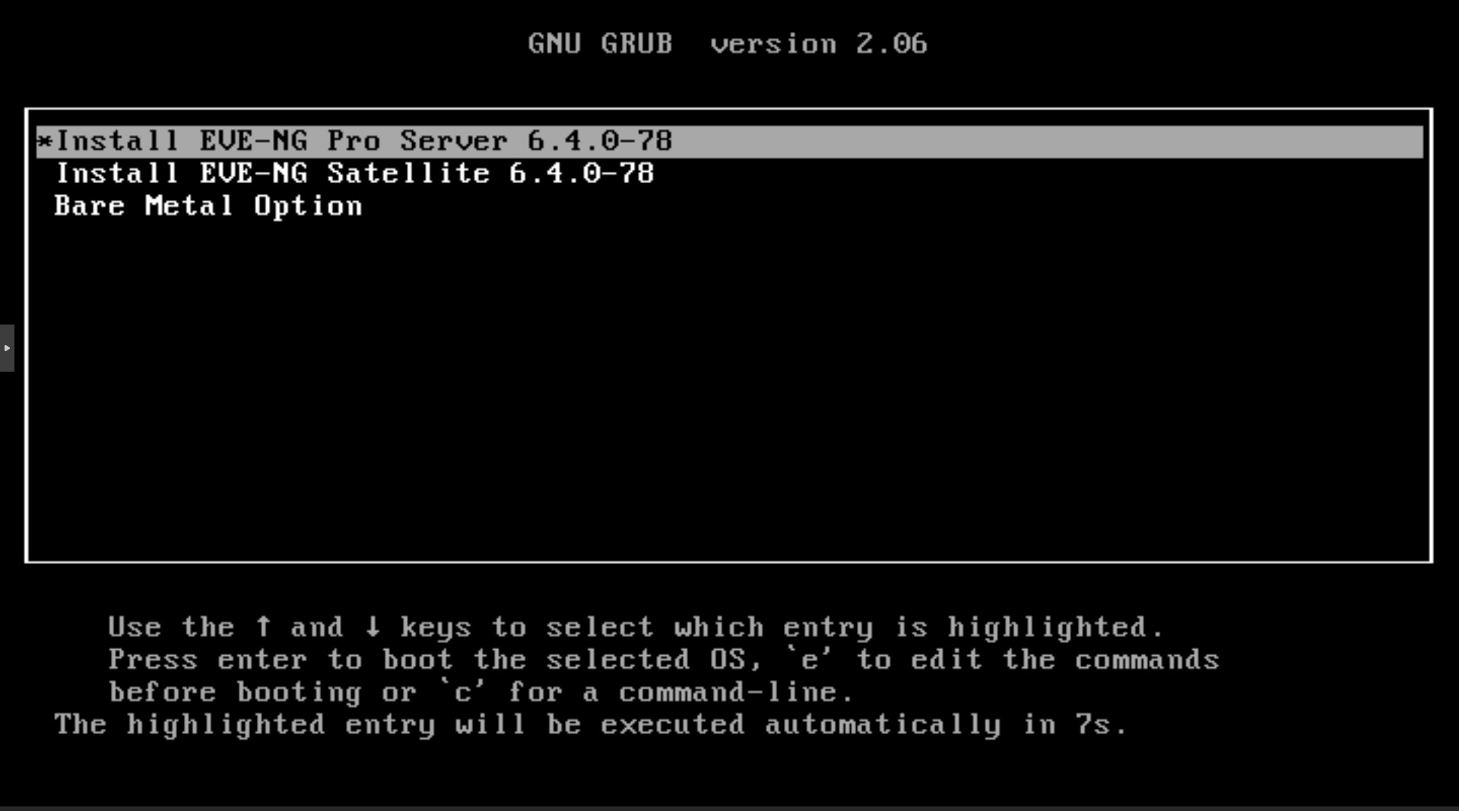
Figure 2 - Choice of versions
The full installation guide for both the Master and Satellite nodes will be documented in the following appendixes: Appendix A – Master node installation, Appendix B – Satellite node installation.

Joining a Satellite node to the cluster
To join a satellite server to the cluster, the user must navigate to System > Cluster settings. On this page a member can be added, as is seen on Figure 3 – Add cluster member.

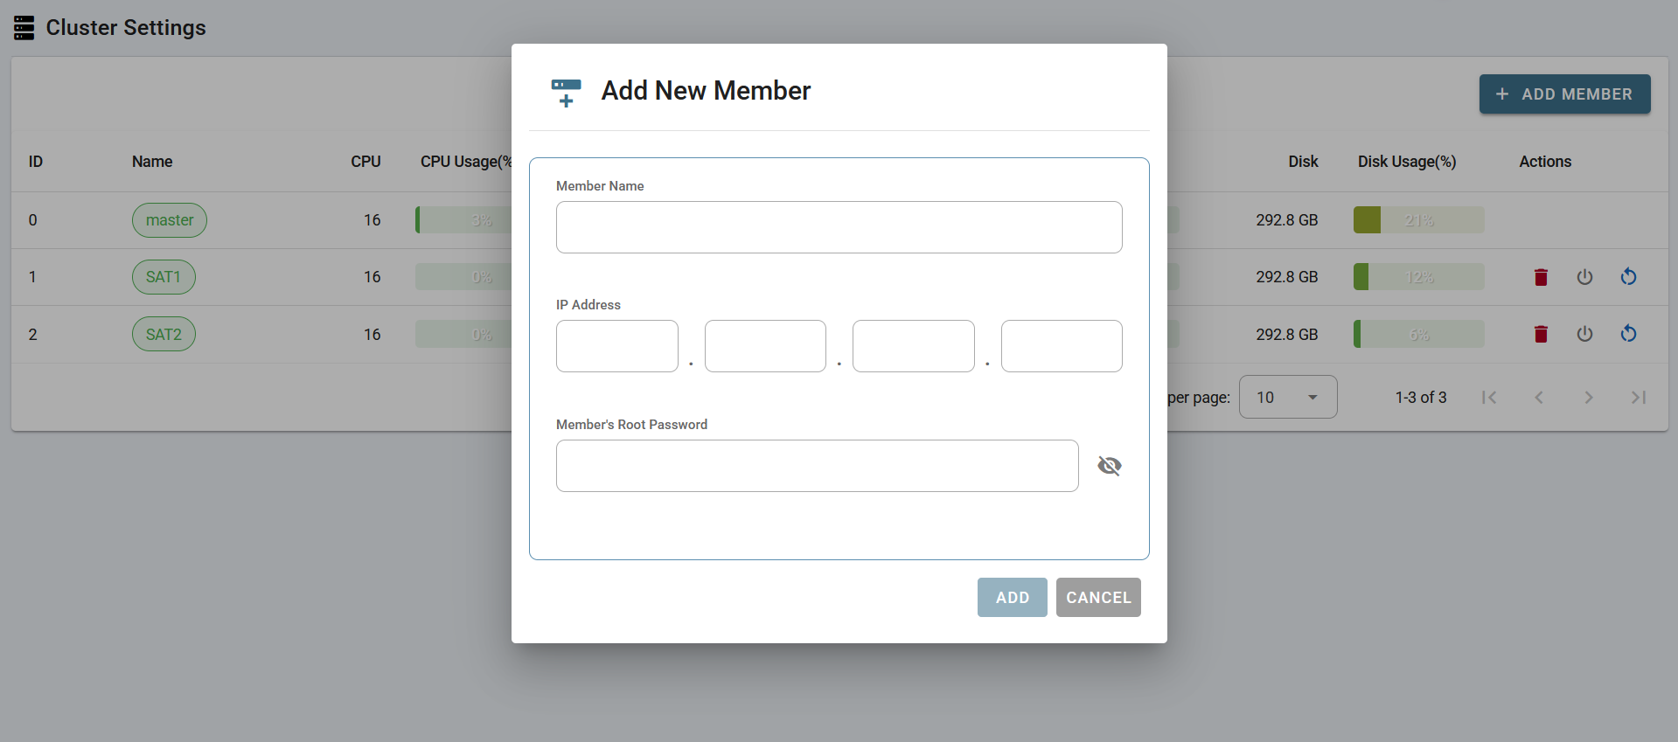
Figure 3 - Add cluster member

The user must provide the Satellite node’s “Member Name”, IPv4 Address and Root password. The “Member Name” is the name which will be used to identify the node within the cluster. If for example “SAT2” is given, the user will see “SAT2” amongst the options when selecting a satellite node to run a lab on.

After filling out the node details the following log can be seen to verify if the node was successfully added. In this case the node “SAT3” was added. The logs and the added node are visible on Figure 4 – Satellite node added succesfully.

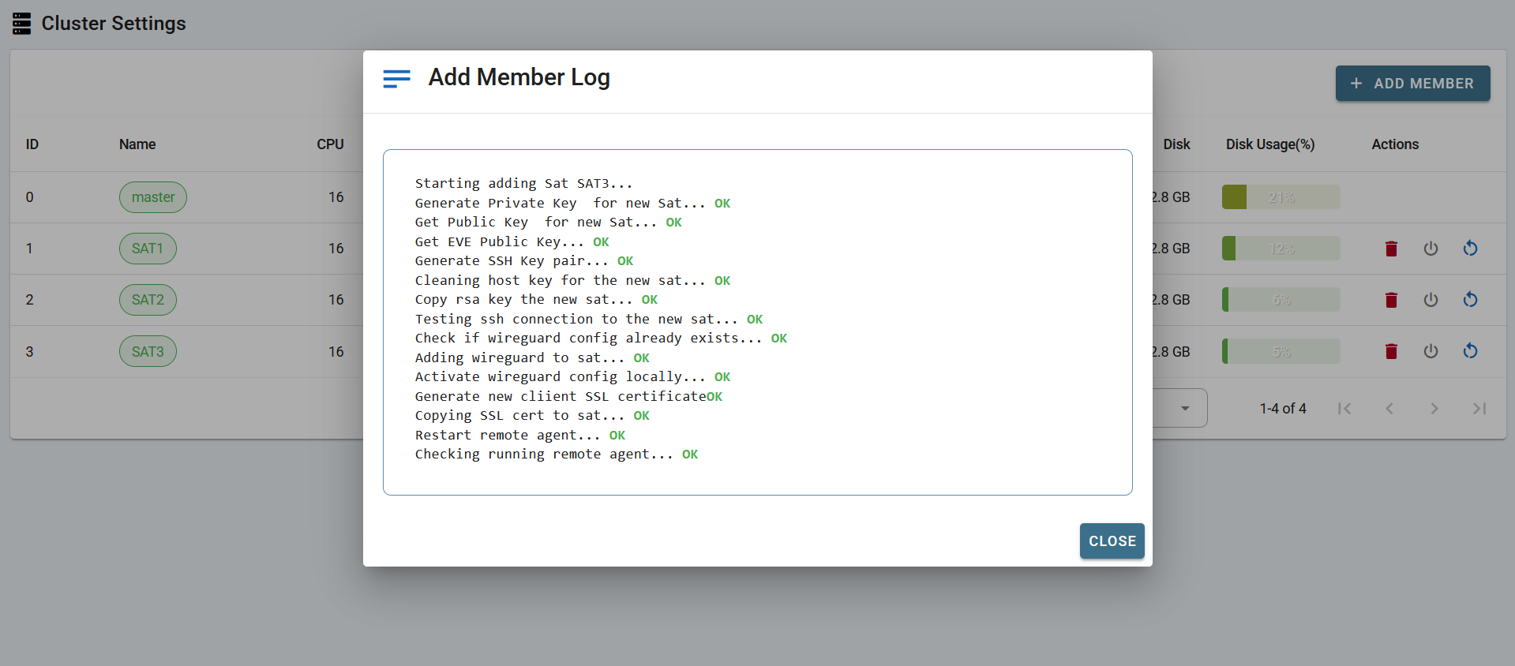
Figure 4 - Satellite node added succesfully
Once a sattelite node has been added to the cluster the full cluster functionality can be used. When creating labs and nodes inside of labs the Satellite nodes can be specified.

Active Directory integration
Active Directory (AD) integration with EVE-NG allows users to authenticate to the EVE server with their AD credentials. In Figure 5 – Active Directory Settings the settings required to link the AD to the EVE server are shown. The administrator must provide the IPv4 address of the primary Domain Controller (DC) of the AD.

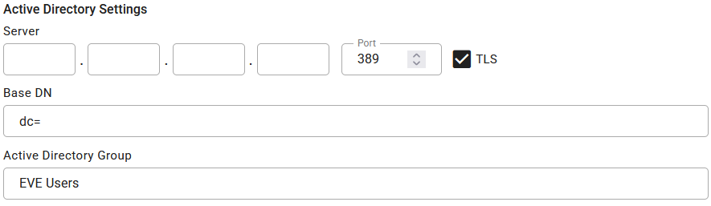
Figure 5 - Active Directory settings

In “Base Distinguished Name” (DN) the domain name can be specified. If the domain is “eve.lab” the DN must be specified as “dc=eve,dc=lab”.

The “Active Directory Group” is a group that must be added in the AD. If a user then wants to be able to authenticate to the EVE server with their AD credentials, they must be part of the “EVE Users” group on the AD. The name of this group can be customised.

To finalise the AD integration the user must have selected the “active directory” option under “Authentication”, this field can be seen in Figure 1 – User Settings.

Images
Software images are required to be able to run devices within a lab. It’s up to the user themselves to acquire these images. EVE-NG provides a list of all supported images on their website.

QEMU
Quick Emulator (QEMU) images follow a naming convention that allows EVE-NG to map VM disks into nodes used in labs. The naming convention is a strict file structure that tells EVE-NG what device the image belongs to and how to boot it.. An example of the naming conventions can be seen in Table 4 – Naming conventions (EVE-NG Ltd, 2025).

QEMU folder name EVE | Vendor | QEMU image .qcow2 name
asav- | ASAv | virtioa
nxosv9k- | NX9K Cisco Nexus | sataa
vios- | L3 vIOS Cisco Router | virtioa
viosl2- | L2 vIOS Cisco SW | virtioa
Table 4 - Naming conventions

QEMU images need to be uploaded to the “/opt/unetlab/addons/qemu/” directory. Within this directory each image gets its own folder to hold the respective disk images. The naming conventions within the filesystem can be seen below in Figure 6 – Filesystem naming conventions.

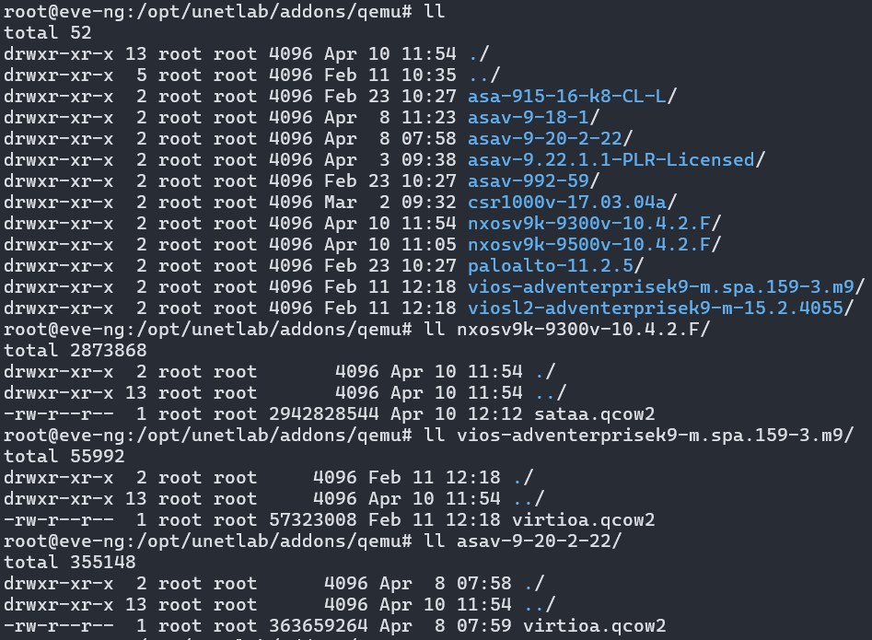
Figure 6 - Filesystem naming conventions

Images can be uploaded to the EVE-NG server using tools like WinSCP and FileZilla. After uploading images it’s important to run the following command: “/opt/unetlab/wrappers/unl_wrapper -a fixpermissions”. The point of this command is to enforce the permission model EVE-NG expects. Without the use of this command an uploaded image will not be usable in labs.

All images should only be uploaded to the master node, as the satellite nodes automatically replicate necessary images by pulling them from the master.

Lab development
During the course of this project three labs have been developed. All three labs focus on different networking topics. The labs also scale in difficulty, the first lab covers basic networking as compared to the third lab which requires a lot more advanced knowledge. Each lab will be listed below with a schema and an explanation as to what the lab covers.

Lab 1
The first lab was designed as a simple network with basic routing and Access Control List (ACL) misconfigurations. The purpose of this is to determine the base of the applicants’ skills. The lab setup can be seen below in Figure 7 – Lab 1.

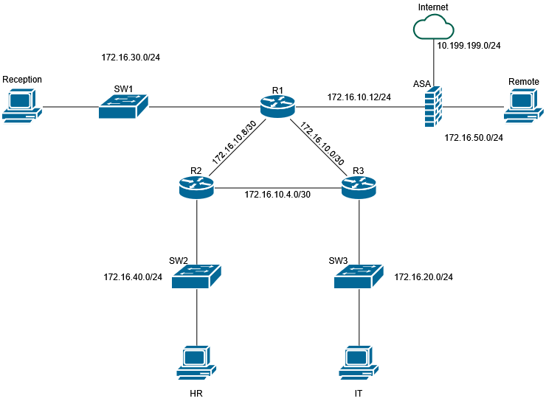
Figure 7 - Lab 1
In this setup the Open Shortest Path First (OSPF) routing protocol is used between the three routers to allow the Virtual PCs (VPC) to communicate with each other. The Adaptive Security Appliance (ASA) firewall allows all internal devices access to the internet using Port Address Translation (PAT).

The ASA firewall also requires ACLs to be configured to allow the remote host to communicate with internal devices. The routers themselves also have ACLs configured to restrict either User Datagram Protocol (UDP) and Transport Control Protocol (TCP) between the HR and reception hosts

PAT has been configured on the ASA firewall to allow the lab nodes access to the internet. The internet access isn’t required for any functionality within EVE-NG but allows the lab to have another objective for the user to complete.

PAT allows all devices on an internal network to share a single public IP address when accessing the internet. The firewall will replace the devices internal IP address with its own public IP and assign a unique port number to the connection. This then allows the ASA to keep track of what traffic belongs to each connection.

The setup guide for allowing internet access within labs will be documented in Appendix C – Configuring internet access.

Lab 2
Lab 2 was designed to be more challenging than the first and features a Collapsed Core model network. The lab focuses more heavily on ACLs, OSPF neighbor adjacency and PAT, as well as Hot Standby Router Protocol (HSRP). The lab topology is visible below in Figure 8 – Lab 2.

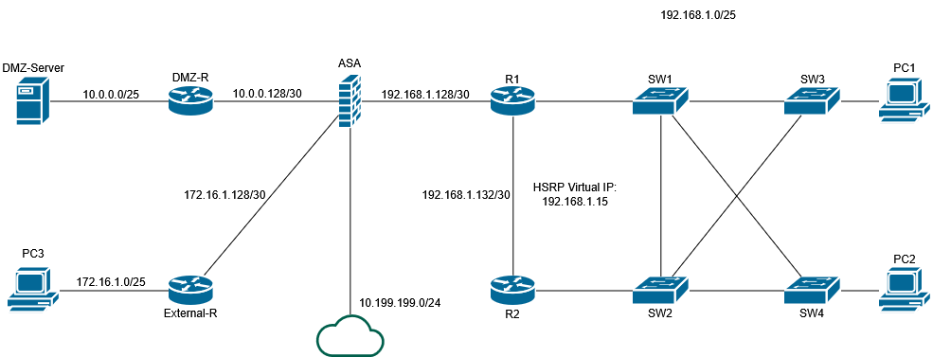
Figure 8 - Lab 2
This lab features 3 networks and uses OSPF to route traffic between them. The ACLs used in this lab have the purpose of blocking specific types of traffic between the networks. The network to the right of the ASA is the “Inside” network, it’s only allowed TCP connectivity with the Demilitarized Zone (DMZ) network. The “External” network on the other hand, is only allowed UDP connectivity with the DMZ network. Traffic from the DMZ network towards the Inside and External network, as well as the internet should be permitted. Traffic between the Inside network and the External network should also be permitted. The objective is to configure these ACLs on the ASA firewall.

The OSPF configuration in this setup features an error which causes specific devices to not form a neighbor adjacency with their neighboring device. It’s up to the applicant to figure out how this should be solved.

HSRP has been configured on R1 and R2 to allow the PCs in the Inside network to use a single virtual IP address as their default gateway. HSRP appoints an “Active” and “Standby” router, the Active device will hold the virtual IP as long as it is up and healthy. If the Active router or its interface were to go down the virtual IP would then switch over to R2, making it the new Active router. R2 will then hold the virtual IP until R1 or its interface comes back up. Which router becomes the initial Active and Standby device is indicated by a priority that is configured on the device’s interface.

The internet access in this setup has been configured using PAT on the ASA firewall just like in Lab 1.

Lab 3
Lab 3 was designed to be the most difficult lab and to also feature multiple different configurations. The base configuration is the same for all setups, the various errors are what makes each setup unique. The lab focuses mainly on Border Gateway Protocol (BGP) and Virtual Router Forwarding (VRF). The lab also features port-channels, OSPF, Routing Information Protocol (RIP), PAT and a site-to-site Virtual Private Network (VPN). The entire topology is visible in Figure - Lab 3.

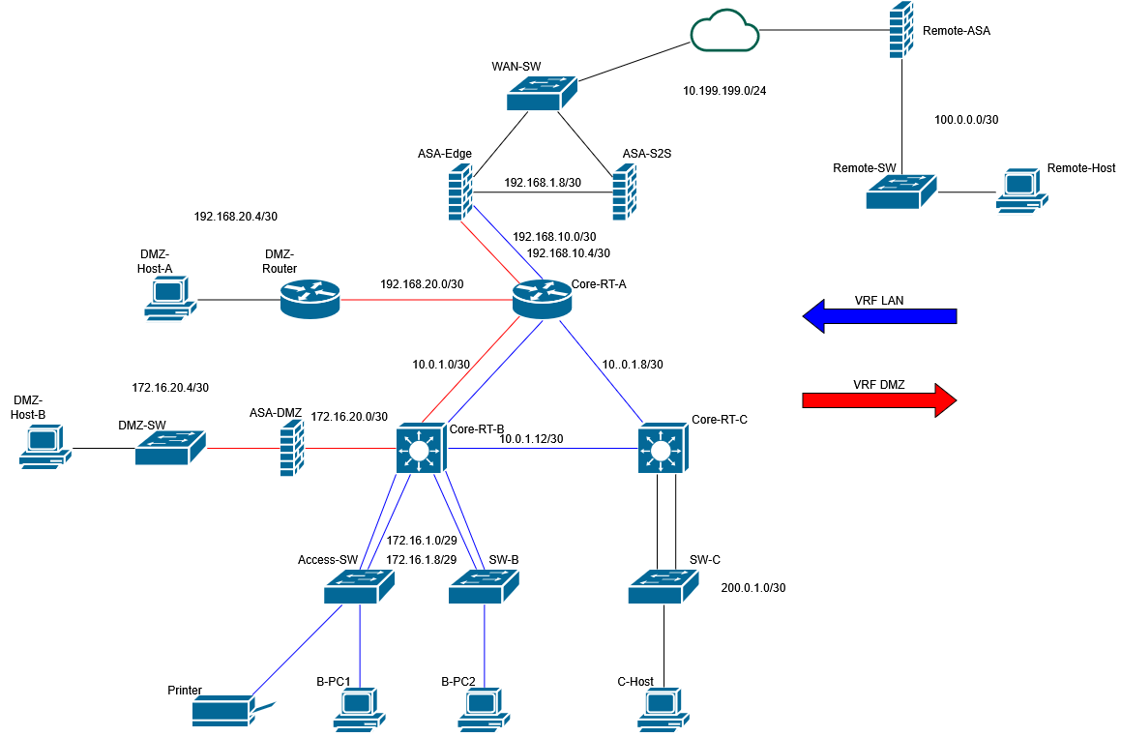
Figure 9 - Lab 3

This topology features a network consisting of four sites. The three core routers use BGP to exchange networking information.

VRFs allow traffic to be separated into a LAN segment and a DMZ segment. Each router maintains multiple separate routing tables, allowing traffic to be isolated while still sharing the same infrastructure. Inter-VRF routing is performed by the ASA-Edge firewall.

Both Core-RT-B and Core-RT-C are Cisco Nexus 9000 series switches which provide layer 2 as well as layer 3 functionality, allowing the configuration of port-channels using Link Aggregation Control Protocol (LACP).

To allow traffic to reach the remote site securely, a site-to-site VPN has been configured between the ASA-S2S and Remote-ASA devices. This setup allows the LAN and DMZ network to communicate with the remote network as if they were on the same private network. All traffic between these networks is encrypted before transmitting.

PAT has been configured in the same way as the other labs to allow internet access for all devices.

Lab validation
The goal in each lab is to allow connectivity between the hosts in various sites, either full connectivity or limited to a specific protocol. If this is achieved then the lab will already be mostly correct. Only specific processes will have to be manually verified, like HSRP, as routing will still work even if there is a misconfiguration present.

Currently the lab environment will be used by applicants while being supervised by a member of the company. This way it will be known if the applicant is solving the lab as intended.

Automation
Another objective of this project was to automate all three labs. This is accomplished by communicating with the EVE-NG Application Programming Interface (API). For this project a Python script was made to fully create and configure each lab. The script covers the following aspects: creating nodes, connecting interfaces, starting and configuring nodes. These scripts are usefull in case a user were to accidentally destroy a lab. Alternatively they can also be used to create the labs on different EVE-NG servers, this would be made possible after only a few changes of variables in the scripts.

API

An API allows software applications to communicate with each other through a set of predefined requests and responses. In this project the Python script sends requests to the EVE-NG API to perform each step of the process. Figure 10 – API call example shows how the script uses an existing session to send a POST request to the EVE-NG API. The response is then stored to be able to store data about the newly created devices.

Figure 10 - API call example

Script flow
The script uses the “Login” function to authenticate as the admin user on the EVE-NG server. It’s important that the user has the required permissions to create and manage labs. After the user authentication the script will start creating each device.

To allow each device to have its own unique name and location within the topology, the data used to make the request needs to be modified per device. In Figure 11 – Device data it is shown how the script differentiates between each device based on the initial given name, to then be able to give the device its own unique data.

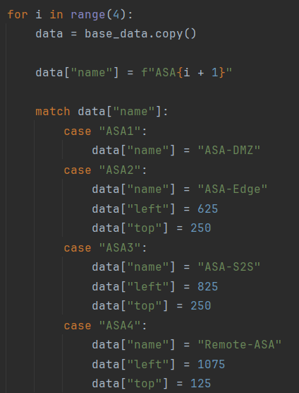
Figure 11 - Device data

After the creation of each device the script can move on to its next stage. The next step is to connect each device on the appropriate interface. To accomplish this the lab topology is defined in the script as a list of tuples. Each tuple contains the individual connection between the two devices, stating the device name and the interface ID to connect. All of these tuples are then stored within a single large list. The list of tuples can be seen below in Figure 12 – Script lab topology.

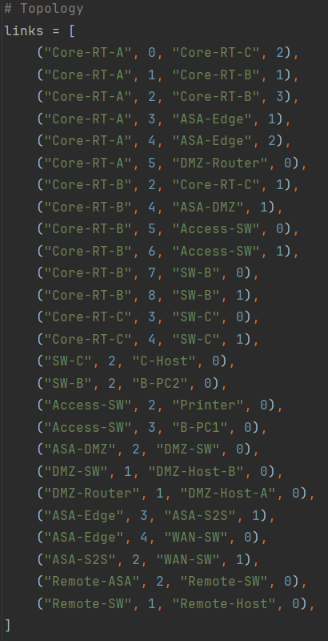
Figure 12 - Script lab topology
The script then uses a loop that goes through each tuple within this list to connect the interfaces.

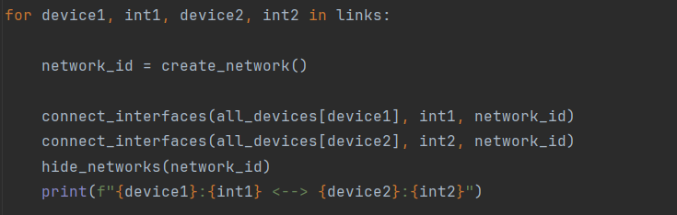
Figure 13 - Interface connection loop
The way the API handles connecting interfaces is as follows. First it will create a network device within the topology, then the two devices that need to be connected will one by one, connect their respective interface to the created network device. As seen above in Figure 13 – Interface connection loop the script will create the network device and return the network device ID. Afterwards it will connect each device to the network device separately. To end the loop it will then make the network device invisible, which causes the link to appear like a normal line within the topology.

In Figure 14 – Connecting interfaces it is seen how the API expects the request to be formatted. Unlike with the creation of a device where a POST request to create data is used, the API in this case expects a PUT request which is used for updating data.

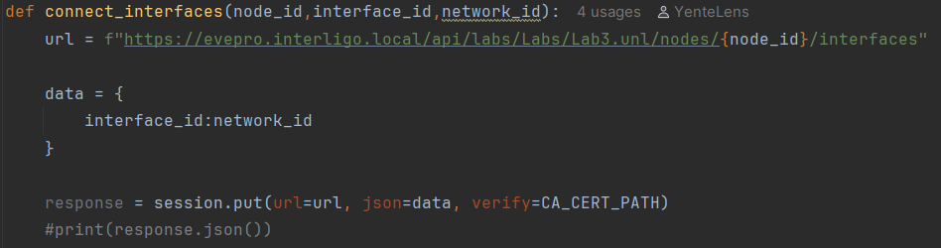
Figure 14 - Connecting interfaces
Once all devices have been connected on the appropriate interfaces the script can move on to its next phase. This consists of starting and configuring each device. After devices have been started there is a required period of sleep as it takes a while for each device to fully boot, the exact duration varies per device.

After letting all devices boot an initialisation function is used to bring each device to its prompt which allows the script to then start configuring the nodes.

Each node requires its own configuration file to make sure everything is configured as intended. Below in Figure 15 – Node configuration function it is shown how the script handles the configuration of each device.

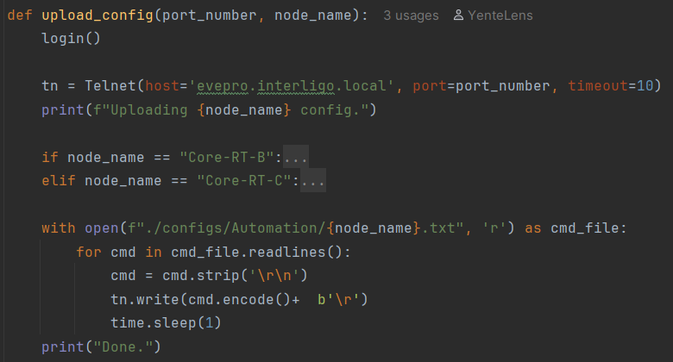
Figure 15 - Node configuration function
Each node in the lab is assigned a telnet port number upon creation, which is required to allow the establishment of a telnet connection to each device. Before configuring the node a function is used to retrieve the nodes port number, it is then passed along into the configuration function.

To fetch the correct configuration file the node name is passed into the function. The script then looks for the correct file in the “configs/Automation/” directory. After opening the correct file the script will loop through each line of the configuration, remove any trailing newline’s and encode the string into bits before sending it over the telnet connection.

The example shown in Figure 15 – Node Configuration function is the one used for lab 3 in which two Nexus switches, Core-RT-B and Core-RT-C, are used. These nodes require credentials to be entered before making configuration possible.

After each node hase been configured the script will finish and the labs will be ready for usage.

Results
Over the course of this internship a fully working EVE-NG Pro cluster was deployed, which has then been integrated with the existing Active Directory. The cluster contains a single master node and three satellite nodes. These nodes together all run three different labs that have been created to test applicants practical knowledge within the field of networking.

The cluster allows up to two users to work on labs at the same time with the smoothest experience possible. Thanks to the combined resources of all nodes, each lab can run concurrently without overloading the cluster.

Lab validation is done manually after the applicants given time has run out. Each lab will feature an objective sheet, which is given to the applicant, and a correction key that is used by the examinator to correct the results.

All labs created have also been fully automated with a Python script, this way the labs can be recreated in case the applicant breaks the lab in any way. It also allows the labs to be created on a different EVE-NG cluster.

During the project it was also concluded that the best way to scale the EVE-NG cluster environment was to do so by prioritising the amount of nodes over individual performance. As the increased number of satellites allows for better load balancing capabilities.

Interpretation of results
The EVE-NG Pro cluster environment allows Interligo to get a better view on what their applicants are actually capable of. By using the labs they can see exactly what skills and knowledge the applicant has. The environment can also be used by junior level colleagues to work in a risk free manner and experience real-life networking topologies without having to worry about breaking existing networks.

These labs can also be used by other people within the company who seek to receive specific networking certificates, as the labs feature various different but equally important networking topics like routing protocols, ACLs, Firewalls, PAT, port-channels, VRF, site-to-site VPN.

Decision/Discussion
The internship has succesfully achieved its objective of deploying an EVE-NG Pro cluster environment which featues AD integration and three fully automated labs. The cluster environment will provide the recruiters a more defined profile of each applicant as they can be tested on various networking topics. It is up to Interligo to decide if they want to continue expanding the environment going forward to allow an even broader range of topics to be covered.
Literature list
Dzerkals, U. D. (2021). EVE-NG Cluster. eve-ng.net. https://www.eve-ng.net/wp-content/uploads/2021/03/EVE_cluster_presentation-4.4-Pro.pdf

Dzerkals, U. D. (2025, December 18). Professional Cookbook. eve-ng.net. https://www.eve-ng.net/index.php/documentation/professional-cookbook/

EVE-NG Ltd. (2025, April 21). Qemu image namings -. https://www.eve-ng.net/index.php/documentation/qemu-image-namings/

Appendixes

Appendix A: Master node installation
After booting the VM you will get to choose which version of EVE-NG to install. The available options are visible in the image below. To install the master node you must select the “EVE-NG Pro Server” option.



Once the version has been selected you can now choose the desired language of the system.

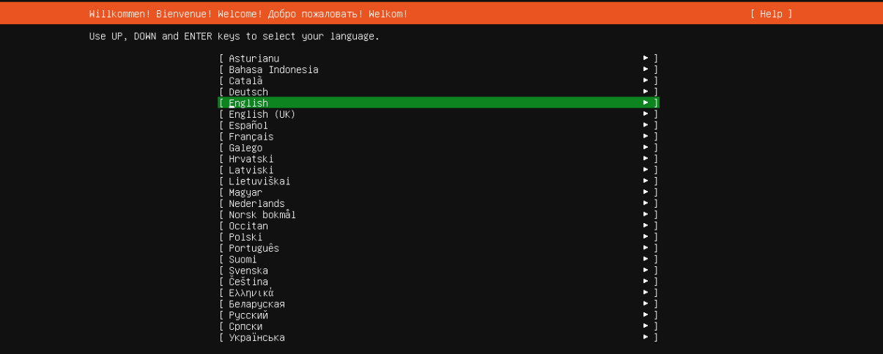

After choosing the language you can now choose the desired keyboard layout.

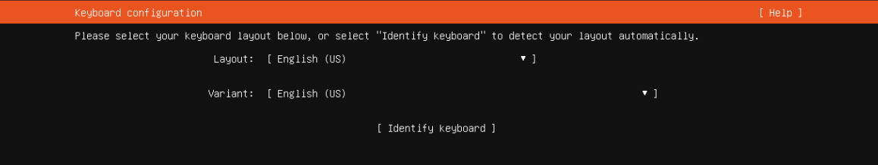

After choosing the keyboar layout the device will start the installation process.

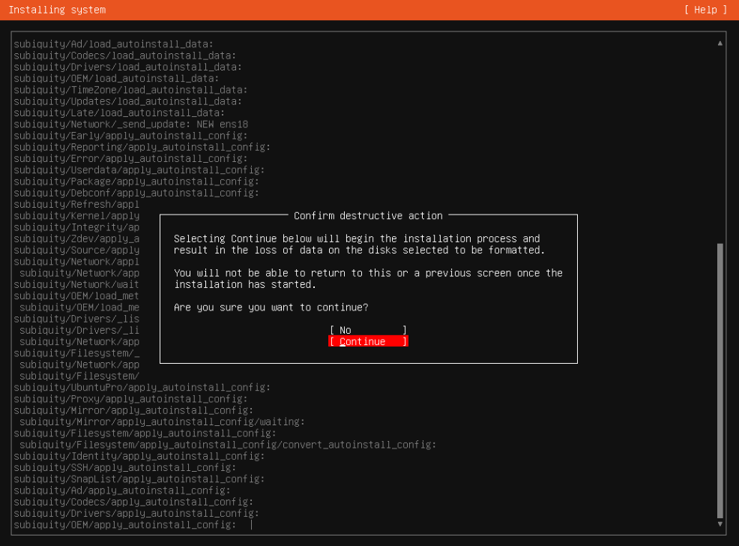

After the installation process has started you will see the following prompt. It’s important to not try to log in when this appears as the installation hasn’t finished yet, this is indicated by the line “Second stage install in progress….”.

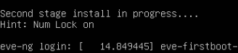

Only when the installation has finished and the device has been rebooted you can log in on the server with the default credentials. The default username is root and the default password is “eve”.

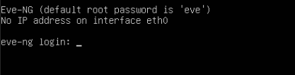

After login you will be prompted to configure the hostname, domain, network settings and new root password. The image below is an example and does not represent the actual device settings.

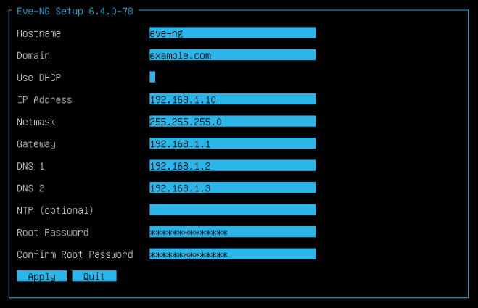

After configuring the device it’s necessary to update and upgrade the packages
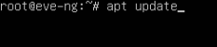
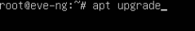

Once packages have been updated and upgraded you can verify the eve-ng installation by running the following command: “dpkg -l eve-ng-pro” (-l = lowercase L). If the output matches what is shown in the image below the installation was succesful.
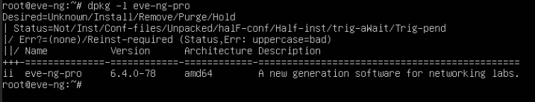

Appendix B: Satellite node installation
The installation of the satellite node is nearly identical to the installation of the master node. To start the satellite node installation select the “EVE-NG Satellite” option in the version selection screen.

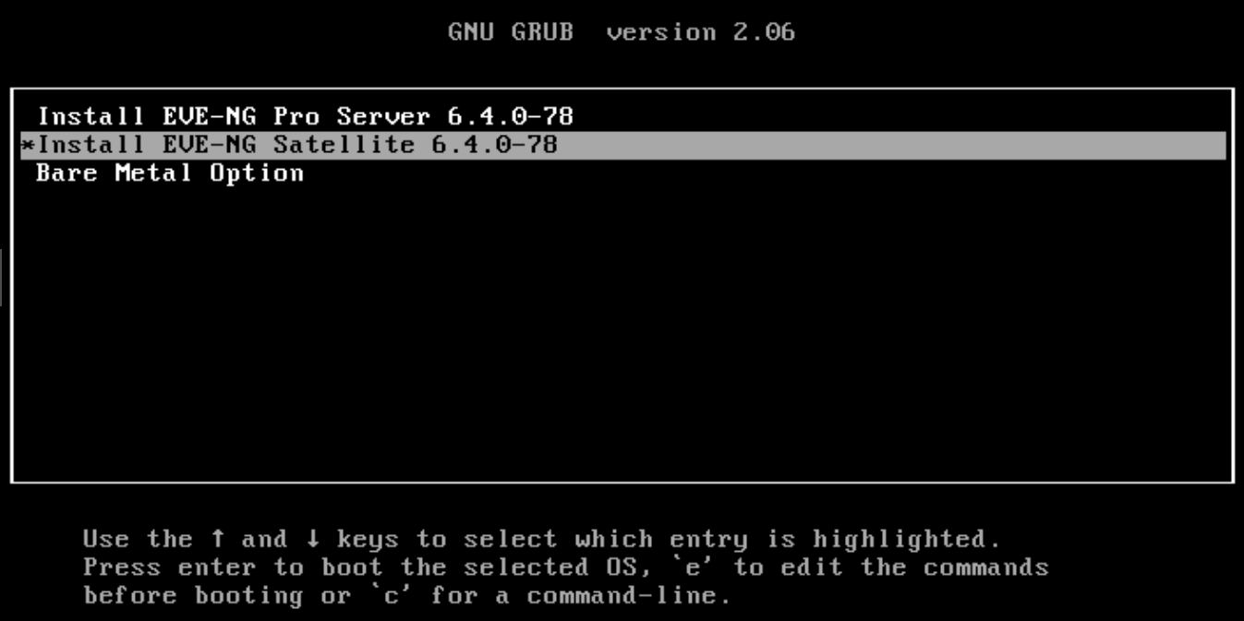

Like before you will now be prompted to select the desired language.

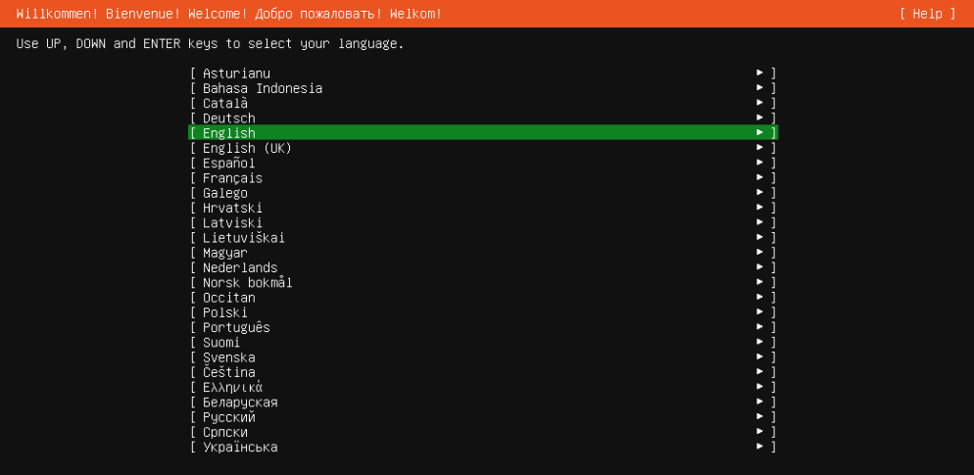

As well as the desired keyboard layout.

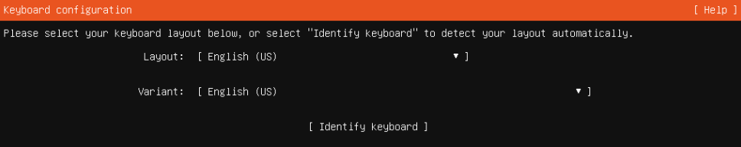
After selection the language and keyboard layout the installation process will be started.

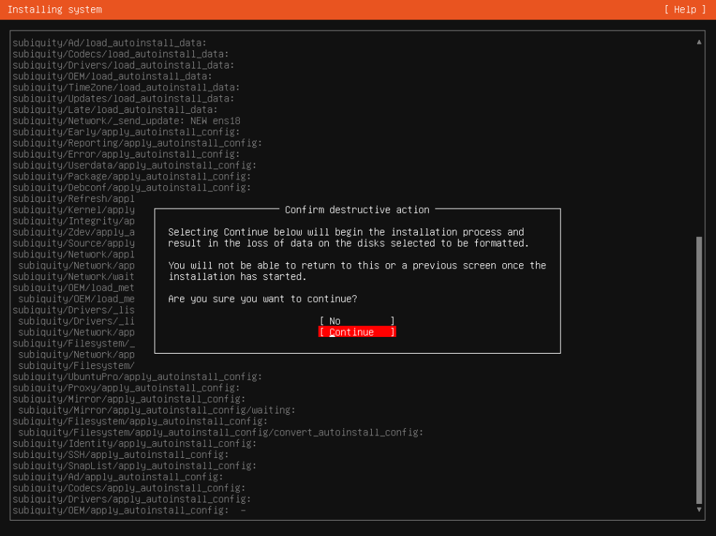

After the first stage installation has finished the device will reboot and show the options in the image below, here you must select “Ubuntu” to continue to the second stage installation.

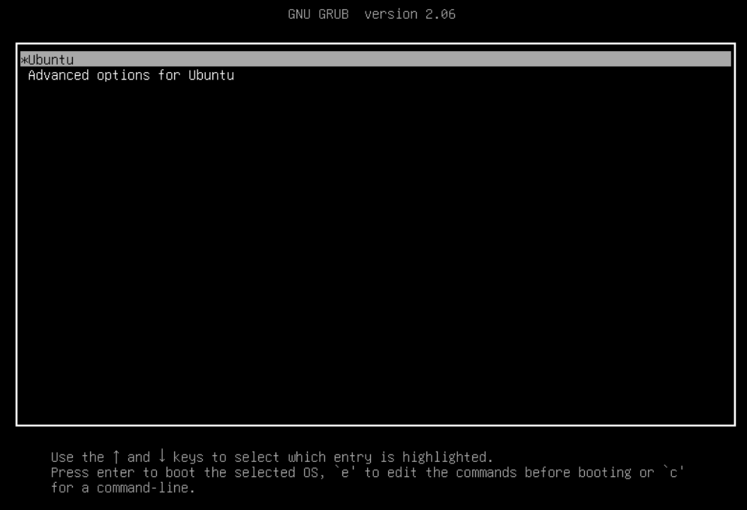

Once again it’s important to not log in when the following prompt appears.



After the second stage installation has finished and the device has rebooted you can log in on the server with the default credentials.

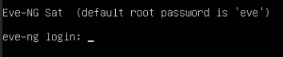

Like with the master node installation, after login you will be prompted to configure the hostname, domain, network settings and new root password.

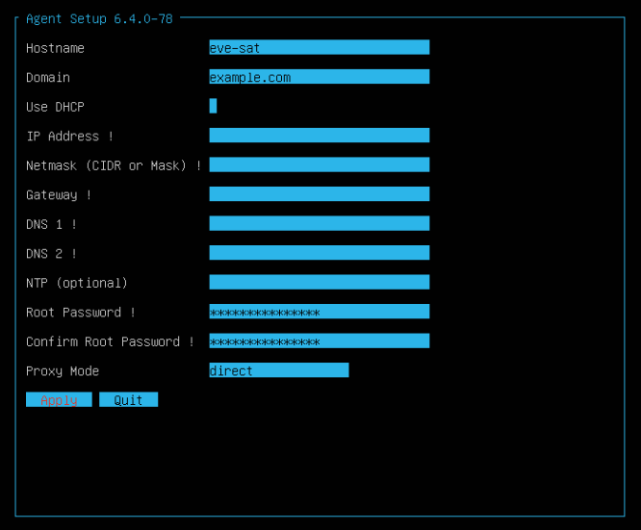

After configuring the device you once again need to update and upgrade the packages.

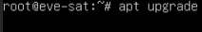

When shown the following screen, you can just leave the selection as default and press <Ok> to continue.

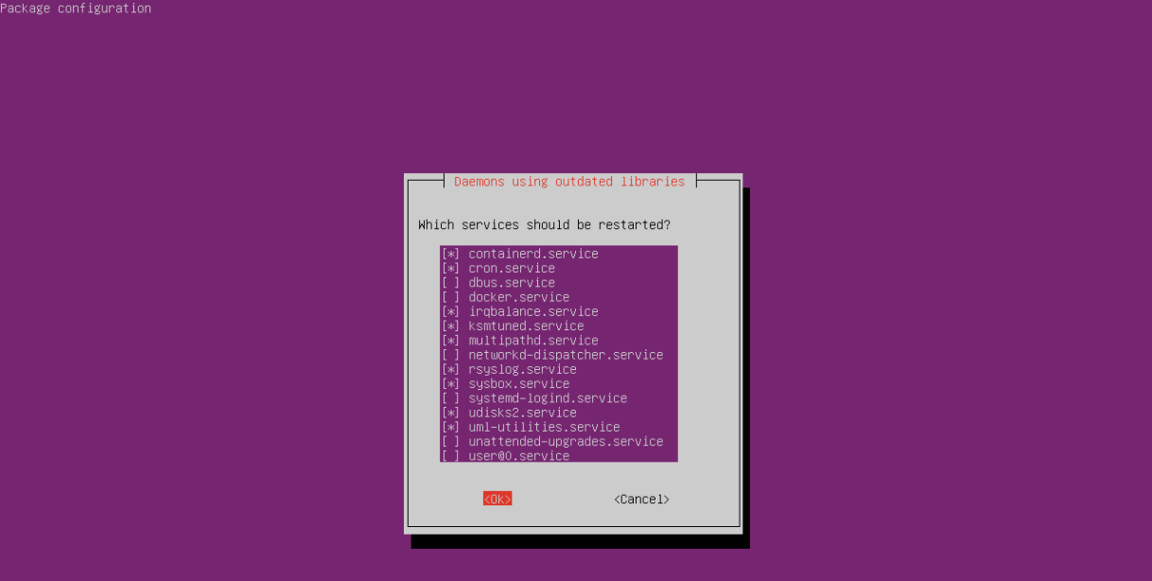

Once the services have restarted you can verify the installation with the following command: “dpkg -l eve-agent”. If the output matches what is shown in the image below, the installation was successful.

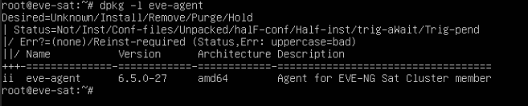

Appendix C: Configuring internet access
To allow nodes within the EVE-NG lab environment access to the internet we must configure the Master node. The first step is to add another Network Interface Card (NIC) to the VM. Once the NIC is added you need to add an IP address to the interface according to the image below

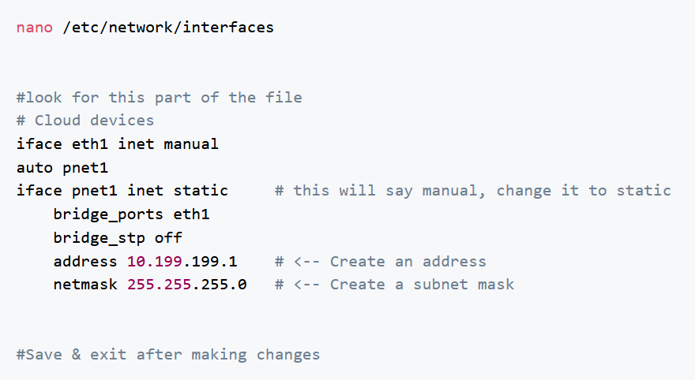

The network you add on this interface should be a network that is not used anywhere else within the virtual environment. After this step has been completed you need to restart the networking service.

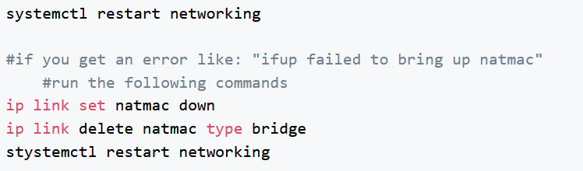

The image above features additional troubleshooting steps in case that restarting the networking service causes an error.

The next step is to enable IPv4 forwarding and applying the changes.

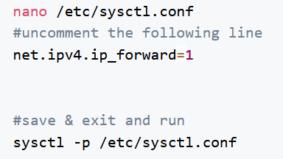

Afterwards we need to configure iptables to use Network Address Translation (NAT) on outbound connections, enter the following line.

Now we must make this change persistent by performing the next few steps.

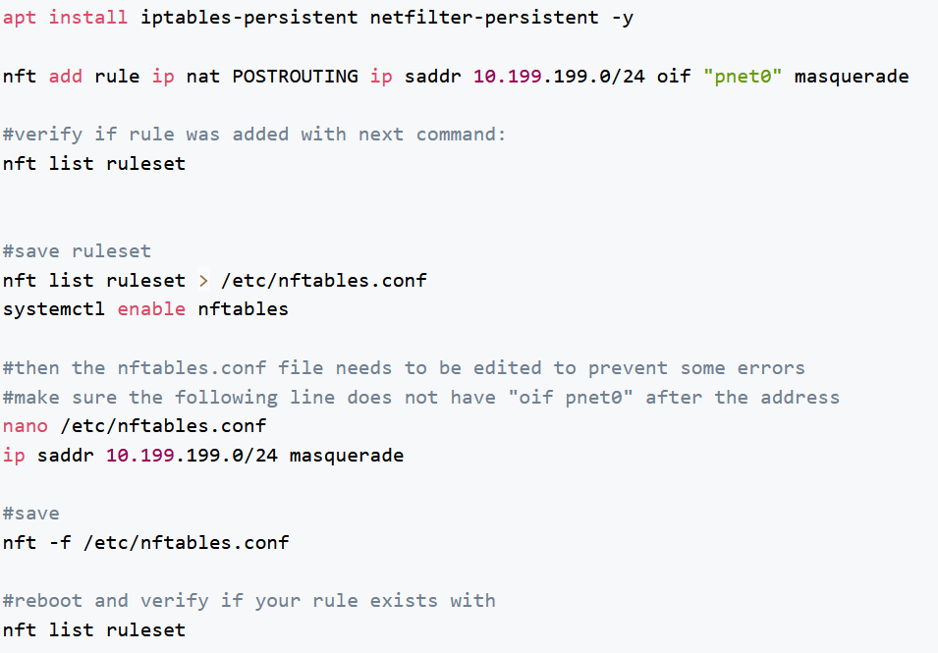

After performing all of these steps it is possible to test the internet connection by connecting a VPC to the cloud1 object within a lab. In case this fails there will be additional troubleshooting steps below.

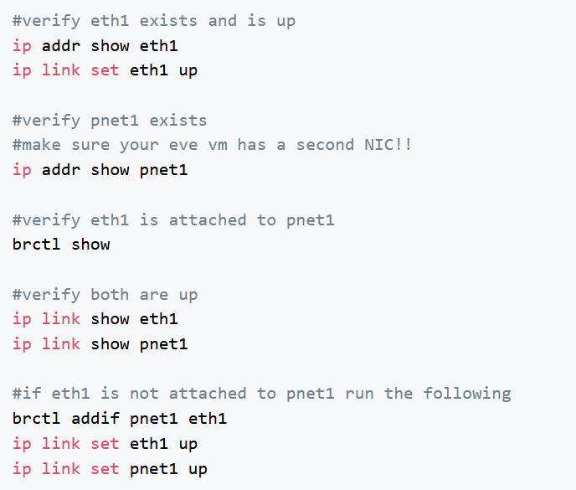

contact
Yente Lens | Student
R0990056@student.thomasmore.be
Tel + 32492107590
Follow us
www.thomasmore.be
fb.com/ThomasMoreBE
#WeAreMore

