By: Yente Lens
College promoter: Phaedra Degreef
Company promoter: Kenzo De Ruysscher

Professional Bachelor Electronics-ICT
Major ICT

Bachelor thesis nominated to obtain the degree and diploma of bachelor

Campus De Nayer
Academic year 2025 - 2026
CLICK HERE TO MODIFY THE SUBTITLE
Development of a virtual learning and testing environment with EVE-NG Pro
Click here to add additional information (optional)

Foreword
"The foreword is in a sense separate from the thesis: it has no relevance to the content of the thesis. You use the foreword to name personal circumstances/experiences that have led to this thesis, you can address a word of thanks to all the persons and organisations that helped in the creation of the thesis. If you want to mention a person or company by name, make sure you have permission to do so (also make sure they know that this thesis will be accessible online). Other things you want to mention but which are not directly related to the topic also belong in the preface." (Bosmans, N., Bryon, E., & Mertens, E., 2021, p 17-18)

Summary
"The summary presents the content of the full text in no more than 200 to 250 words. It is mainly intended for readers who do not want to read the text in its entirety, or who wish to review the text in broad outline. A good summary does not describe the structure of your thesis and is therefore not a list of chapters. However, the summary does clearly present the essence of the paper.
A good summary consists of three parts:
- In an introductory paragraph, you briefly outline the context from which you start. You formulate the precise problem definition and explain what you wanted to achieve with your research. You also explain why the problem statement is relevant.
- Then discuss the method you used and the results. If you did your own research, indicate the principles on which that research was based.
- Finally, you describe the most important information the research has yielded: in a conclusion, you formulate the conclusions you can draw from the information found." (Bosmans, N., Bryon, E., & Mertens, E., 2021, p 18).

Table of contents
Foreword 2
Summary 3
List of tables 5
List of figures 5
List of abbreviations and symbols 6
Start-up report 7
1. Introduction 8
2. Problem statement 8
3. Objectives 9
3.1. Automated labs 9
3.2. Documentation of solutions 9
4. Method 9
4.1. Designmethodology 9
5. Research 9
5.1. Theoretical background 9
5.1.1. EVE-NG 9
5.1.2. Licenses & prices 9
5.1.2.1. Community Edition 9
5.1.2.2. Professional Edition 9
5.1.2.3. Corporate & Learning Centre 9
5.1.3. Users & Active Directory integration 9
5.1.4. Systemrequirements 9
5.1.5. Cluster architecture 9
5.2. Practical implementation 9
5.2.1. Cluster deployment 9
5.2.2. Images 9
5.2.3. Lab development 9
5.2.4. Automation 10
6. Results 10
7. Interpretation of results 10
8. Decision/Discussion 10

List of tables
Table 1 - User Role Comparison 14

List of figures
Figure 1 - User Settings 15

List of abbreviations and symbols

Start-up report

Gegevens student(en)
Student 1: Yente Lens
Opleiding: E-ICT: Systems, Services & Security
GSM: +32 492 10 75 90
Gegevens bedrijf / instelling
Naam: Interligo nv
Adres: Veldkant 31, Kontich 2550
Tel: 03 451 23 82
Gegevens bedrijfspromoter
Naam: Kenzo De Ruysscher  Functie: Technical & Presales Consultant  Afdeling: Internal IT | Tel/GSM: +32 477 97 35 70  Email: kenzo.deruysscher@interligo.be

Gegevens bachelorproef
Titel bachelorproef
EVE-NG Pro cluster
Omschrijving van het probleem
Als eerste onderdeel zal de stagair een EVE-NG Pro cluster opzetten op de virtuele
omgeving. Dit wordt op een schaalbare manier opgezet met AD integratie etc.
In het tweede onderdeel van de stageopdracht zal de stagair verschillende labo's
voorbereiden en deze automatiseren voor hergebruik.
De invulling van de labo's zal de netwerk kennis van de student testen. Gebaseerd op een
ruw scenario zal hij de nodige devices moeten preconfiguren om problem scenario's te
creëren.
Aansluitend moet de student de oplossing voor elk scenario compleet uitwerken met een
oplossing gids.
Het doel van deze opdracht is om een (leer)omgeving te creëren voor werknemers ter
voorbereiding van certificaties of voor demo's bij klanten.

Doelstellingen van de bachelorproef (kwantitatief en meetbaar)
-Verplichte doelstellingen
-Werkende EVE-NG Pro cluster
- Schaalbaarheid van de cluster. Onderzoek naar de nuttigste manier om de cluster te schalen en de toepassing hiervan
- Integratie van de cluster met AD
- Minstens 3 labo’s voorbereiden die door middel van automatisering herbruikt
kunnen worden
- Maken van een oplossing gids voor elk labo

-Bijkomende niet-verplichte doelstellingen
-Onderzoekscomponent: Cisco Modeling Labs vs EVE-NG Pro cluster
vergelijking van: architectuur, functionaliteit, schaalbaarheid, automatisatie, integraties, beheer, licensing, geschiktheid voor training en demo’s. Gewenste resultaat is een vergelijkingsdocument waarmee technische aanbevelingen kunnen worden gemaakt.
Gewenst resultaat: wat moet er (minimaal) opgeleverd worden?
-Een volledig werkende EVE-NG Pro cluster waarop alle labo’s gesimuleerd kunnen
worden.
- Een leeromgeving die gemakkelijk hebruikt kan worden en voor elke opdracht
voorzien is van een oplossing gids

Wat is de planning (activiteiten van de student + includeer ook planning m.b.t. het schrijven van de scriptie)?
Fase 1 – Analyse & ontwerp (09/02 – 23/02)
- Requirementsanalyse
- Architectuurontwerp
- Scopebepaling
Fase 2 – Voorbereiding virtuele omgeving (24/02 – 02/03)
- Toegang tot Proxmox
- Resource-allocatie
- Netwerktoegang
- Omgevingsvalidatie
Fase 3 – EVE-NG Pro cluster implementatie (03/03 – 23/03)
- Installatie EVE-NG Pro
- Clustering
- AD-integratie
- Multi-user setup
Fase 4 – Stabilisatie & documentatie (24/03 – 06/04)
- Testing
- Optimalisatie
- Technische documentatie
Fase 5 – Labo-ontwikkeling (07/04 – 11/05)
- Scenario’s
- Topologieën
- Device configuraties
- Probleemscenario’s
Fase 6 – Automatisatie (12/05 – 25/05)
- Deployment automatisatie
- Reset-mechanismes
- Templates
Fase 7 – Oplossingsgidsen & documentatie (26/05 – 01/06)
- Oplossingsdocumentatie
- Troubleshooting gidsen
Fase 8 – Integratie, testing & validatie (02/06 – 08/06)
- End-to-end testing
- Validatie
- Optimalisatie
Fase 9 – Bufferperiode / marge (09/06 – 22/06)
2 weken marge voorzien voor:
- Onvoorziene problemen
- Stabilisatie
- Extra optimalisaties
- Aanvullende documentatie
- Feedbackverwerking

Beginnen schrijven scriptie: toevoegen probleemstelling, opstartverslag 16/3 – 22/3
Toevoegen behaalde resultaten, bronnen aan literatuurlijst, lijst met tabellen/figuren 23/3 – 19/5
Besluit/Discussie samenvatting, woord vooraf, interpretatie van de resultaten 19/5 – 24/5
Laatste controle 24/5 – 25/5

Introduction
General guidelines on the structure and writing of a thesis can be found in the "Rules & guidelines undergraduate thesis" and the "Style Guide" (see Canvas and/or Internship Portal). To complement the style guide, we also recommend the book "Writing from report to thesis" (Pollefliet, 2018).

Problem statement
The current recruitment process lacks a structured and practical method for assessing applicants’ knowledge and skills. At present, this assessment is mainly based on CVs and face-to-face interviews. This makes it difficult to compare all candidates in a consistent and fair manner.

There is also a need to give junior staff an understanding of real-life network configurations. Using the virtual learning environment, they can familiarise themselves with common network topologies.

Objectives

Automated labs

Documentation of solutions

Method

Designmethodology

Research

Theoretical background

EVE-NG
EVE-NG is a network emulation software that makes it possible to create realistic networktopologies. This is achieved through its ability to run software from various well-known vendors. EVE-NG is operated via a web interface, making it easy and intuitive to use. Thanks to the ability to combine multiple servers into a cluster, EVE-NG offers a high scalability. The cluster pools all server capacities, ensuring that all nodes run smoothly. Labs can only be created when software is available. It is up to the user to upload legal software

Licenses & prices
EVE-NG offers three different licences

Community Edition
Community Edition is the free version of EVE-NG, this version is ideal for small projects with simple setups. However, Community Edition does have more limited functionality compared to other versions. In this version, there are two administrator accounts available that can access the EVE-NG server simultaneously

Professional Edition
The Professional Edition is the paid version of EVE-NG, priced at €150. This version includes two administrator accounts as standard and offers almost the full range of EVE-NG’s features. Any features not included in the Professional Edition are available through the user roles that exist alongside the administrator role

Corporate & Learning Centre
Corporate & Learning Centre is a paid version of EVE-NG that includes a Professional licence, as well as other user roles. In addition to the administrator role, there are also Lab User and Lab Editor roles. These are user roles with fewer privileges than the administrator, they allow external users to log in securely to the EVE-NG server to create or edit a practice lab. Table 1 – User Role Comparison shows all permissions per role according to the “EVE-NG Professional Cookbook” (2025).

Feature | Administrator Role | Lab-Editor/Teacher Role | Lab-User/Student role
User accounts management | Yes | No | No
User Accounts visibility | Yes | No | No
User edit modal visibility | Yes | No | No
User Folder's management | Yes | No | No
Full EVE root folder tree  access | Yes | No | No
Licencing module access | Yes | No | No
Nodes management module  access | Yes | Yes (only own running nodes) | Yes (only own running nodes)
Lab management module  access | Yes | Yes (only own running nodes) | Yes (only own running nodes)
Shared lab folder  management | Yes | Yes | No
Shared folder access | Yes | Yes | Yes
Shared project | Yes | Yes | No
Rename Folders | Yes | Yes | No
Create labs | Yes | Yes | No
Delete labs | Yes | Yes | No
Edit Custom topology  mapping | Yes | Yes | No
Use only Custom topology  mapping | Yes | Yes | Yes
Lab objects management add  text, drawing on labs | Yes | Yes | No
Export/import labs | Yes | Yes | No
Nodes list management | Yes | Yes | Yes, read-only
Networks management | Yes | Yes | Yes, read-only
Start labs | Yes | Yes | Yes
Stop labs | Yes | Yes | Yes
Search labs | Yes | Yes | Yes
Wipe nodes | Yes | Yes | Yes
Console to all nodes | Yes | Yes | Yes
Export all configs | Yes | Yes | No
Edit lab | Yes | Yes | No
Set nodes startup-cfg to default configset | Yes | Yes | No
Set nodes startup-cfg to none | Yes | Yes | No
Topology refresh | Yes | Yes | Yes
Topology zoom | Yes | Yes | Yes
EVE status | Yes | Yes | Yes
Lab details UUID | Yes | Yes | Yes
See startup configs | Yes | Yes | No
Delete default startup configs | Yes | Yes | No
Create and manage multiconfig sets | Yes | Yes | No
Close labs | Yes | Yes | Yes
Lock labs | Yes | Yes | No
System/Stop all nodes | Yes | No | No
Information tab access | Yes | Yes | Yes
Work with more than one lab | Yes | Yes | Yes
Lab timer function | Yes | Yes | No
Lab background dark mode | Yes | Yes | Yes
Hide node labels | Yes | Yes | Yes
Eve Cluster administration | Yes | No | No
Eve Cluster servers’ assignment per user | Yes | No | No
Table 1 - User Role Comparison

Users & Active Directory integration
As mentioned earlier, there are different types of users in EVE-NG: the administrator who has full control over the server, the lab editor who can create or edit labs and the lab user who can only work on labs. In addition to user permissions, other settings can be customised for each user. All options are shown in Figure 1 – User Settings

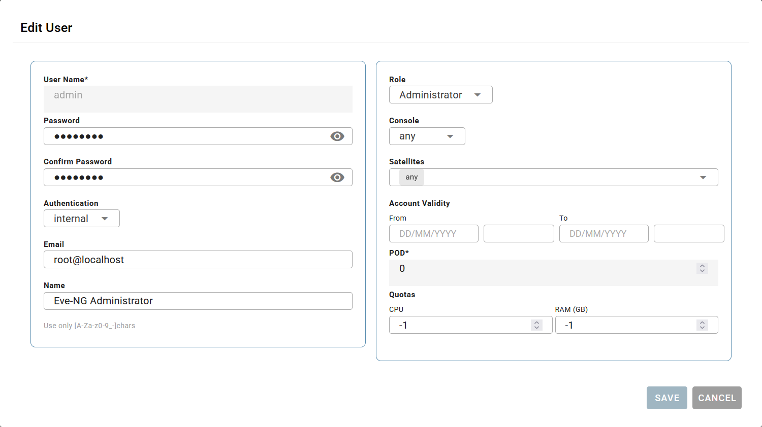
Figure 1 - User Settings
Each user has three authentication methods: Internal, Radius or Active Directory. When “Internal” authentication is used, a password can be set within EVE-NG itself. If “Radius” or “Active Directory” is used, this is not possible as authentication takes place via the respective server.

For each user, the “Role” they will have is determined here. In addition, the user can also be assigned a “Console”; the various options are as follows: Any, Native, HTML5, Desktop. If “Any” is selected, the user can choose which console to use; if one of the other options is specified, the user will only be able to select that option when logging in.

A user can also be assigned to a cluster member using the “Satellites” option. Here, a choice can be made between “Any” or one of the servers that form part of the cluster. If a Lab Editor is assigned a “satellite” server, they can only create or edit labs on the designated server. The same applies to the Lab User, who can only create labs on the assigned satellite servers.

Limits can also be set for each user. The “Account Validity” option allows you to set a limit on how long the account may remain active. Setting the value to “-1” allows for an unlimited duration. In addition, a limit can also be set in terms of server capacity using the “Quotas” option. This means that the user cannot use more capacity than has been allocated; if these limits are exceeded, the user will receive a notification with the message “Failed to start node. Users CPU/Memory quota violation”.

Finally, there is the “Pod” option. This setting is used to identify the user and must therefore be unique; you do not need to set this yourself, but you can if you wish.

Systemrequirements

Cluster architecture

Practical implementation

Cluster deployment

Images

Lab development

Automation

Results

Interpretation of results
Lorem ipsum dolor sit amet, consectetuer adipiscing elit. Maecenas porttitor congue massa. Fusce posuere, magna sed pulvinar ultricies, purus lectus malesuada libero, sit amet commodo magna eros quis urna.
Nunc viverra imperdiet enim. Fusce est. Vivamus a tellus.

Decision/Discussion
Lorem ipsum dolor sit amet, consectetuer adipiscing elit. Maecenas porttitor congue massa. Fusce posuere, magna sed pulvinar ultricies, purus lectus malesuada libero, sit amet commodo magna eros quis urna.
Nunc viverra imperdiet enim. Fusce est. Vivamus a tellus.
Literature list

Bosmans, N., Bryon, E., & Mertens, E. (Eds.). (2021). Thomas More Style Guide. Guidelines for writing papers (4th ed.).

Pollefliet, L. (2018). Writing: from report to final paper: Do's & don'ts (9th rev. dr.). Ghent: Academia Press.

EVE-NG Ltd. (2025, December 18). Professional Cookbook -. https://www.eve-ng.net/index.php/documentation/professional-cookbook/

Annexes

contact
Name | Function
xxx.xxx@thomasmore.be
Tel + 32 xx xx xx xx
Follow us
www.thomasmore.be
fb.com/ThomasMoreBE
#WeAreMore

This is a footnote in style 'Footnote text'.
This is a footnote in style 'Footnote text'.

