**Introduction to Deep Neural Networks (Spring 2021)**

**Homework #4 (50 Pts, Due Date: May 23)**

**Student ID 2016312761**

**Name 여혁수**

**Instruction:** We provide all codes and datasets in Python. Please write your code to complete models(‘models/AlexNet.py’, ‘models/ResNet.py’). Submit two files as follows:

* ‘DNN_HW4_YourName_ STUDENTID.zip’: ./models/*.py and your document
* ‘DNN_HW4_YourName_ STUDENTID.pdf’: Your document converted into pdf.

**TIP 1.** : Please look at PyTorch implementation of the LeNet (models/LeNet_5.py). Please refer the lecture slide ‘W09 Convolutional Neural Networks (CNNs).pdf’ 4 p.

**TIP 2.** : You can use Google Colab for using GPU.

**TIP 3.** : You can check how to use PyTorch.

Kor 1. https://tutorials.pytorch.kr/beginner/blitz/tensor_tutorial.html#sphx-glr-beginner-blitz-tensor-tutorial-py

Kor 2. https://wikidocs.net/book/2788

Eng 1. https://pytorch.org/tutorials/beginner/pytorch_with_examples.html

Eng 2. https://github.com/yunjey/pytorch-tutorial

1. **[30 pts]** Implement CNN models in ‘AlexNet.py’ and ‘ResNet.py.’
2. **[AlexNet]** Implement AlexNet in ‘models/AlexNet.py’. Please refer the lecture slide ‘W09 Convolutional Neural Networks (CNNs).pdf’ 8~25 p.

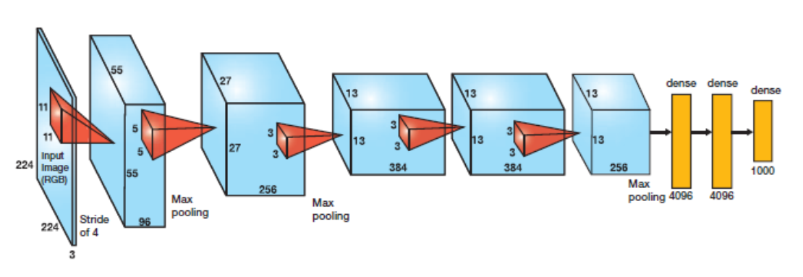

1. **[ResNet]** Implement ResNet-18 in ‘model/ResNet.py’. Please refer the lecture slide ‘W10 Modern ConvNets.pdf’ 23~32 p.

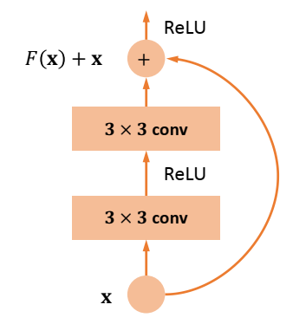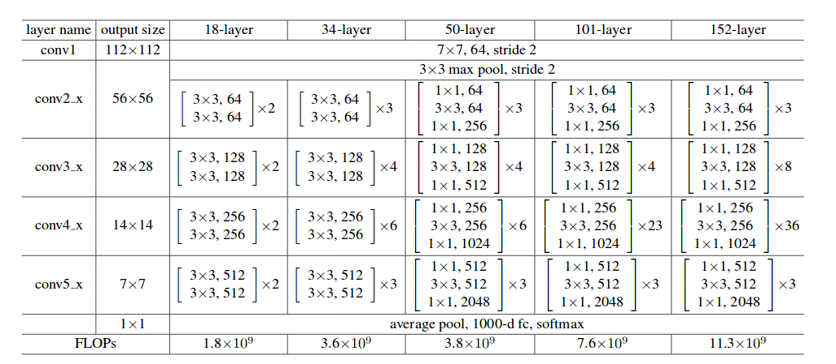

**Answer: Fill your code here. You also have to submit your code to i-campus.**

|  |
| --- |
| **Alexnet)**  import torch  import torch.nn as nn  from torch.utils.data import TensorDataset, DataLoader  import time  import os  import numpy as np  import matplotlib.pyplot as plt  from torchvision.transforms.functional import resize  from tqdm import tqdm  # W09 Convolutional Neural Networks (CNNs).pdf - 10 page  class AlexNet(nn.Module):      def __init__(self, input_channel, output_dim, learning_rate, reg_lambda, device):          super(AlexNet, self).__init__()          self.output_dim = output_dim          self.device = device          self.loss_function = None          self.optimizer = None          # =============================== EDIT HERE ===============================          self.features = nn.Sequential(              nn.Conv2d(input_channel, 96, kernel_size = (11, 11), stride = 4, padding = 0),              nn.ReLU(),              nn.MaxPool2d(kernel_size = 3, stride = 2),                nn.Conv2d(96, 256, kernel_size = (5, 5), stride = 1, padding = 2),              nn.ReLU(),              nn.MaxPool2d(kernel_size = 3, stride = 2),                nn.Conv2d(256, 384, kernel_size = (3, 3), stride = 1, padding = 1),              nn.ReLU(),                nn.Conv2d(384, 384, kernel_size = (3, 3), stride = 1, padding = 1),              nn.ReLU(),              nn.Conv2d(384, 256, kernel_size = (3, 3), stride = 1, padding = 1),              nn.ReLU(),              nn.MaxPool2d(kernel_size = 3, stride = 2),          )            self.classifier = nn.Sequential(              nn.Linear(6*6*256, 4096),              nn.ReLU(inplace = True),              nn.Linear(4096, 4096),              nn.ReLU(inplace = True),              nn.Linear(4096, self.output_dim),          )          self.loss_function = nn.CrossEntropyLoss()          self.optimizer = torch.optim.Adam(self.parameters(), lr=learning_rate, weight_decay=reg_lambda)          # =============================== EDIT HERE ===============================        def forward(self, x):          out = torch.zeros((x.shape[0], self.output_dim))          # =============================== EDIT HERE ===============================          x = self.features(x)          x = x.view(-1, 256 * 6 * 6)          out = self.classifier(x)          # =============================== EDIT HERE ===============================          return out      def predict(self, x):          pred_y = np.zeros((x.shape[0], ))          pred_y = []          x_tenser = torch.tensor(x, dtype=torch.float, device = self.device)          data_loader = DataLoader(x_tenser, batch_size=self.batch_size)          with torch.no_grad():              for batch_data in data_loader:                  batch_x = batch_data                  batch_x = resize(batch_x, (227, 227))                  batch_pred = self.forward(batch_x).argmax(axis=1)                  pred_y.append(batch_pred.cpu().numpy())          pred_y = np.concatenate(pred_y, axis=0)          return pred_y      def train(self, train_x, train_y, valid_x, valid_y, num_epochs, batch_size, test_every=10, print_every=10):          self.train_accuracy = []          self.valid_accuracy = []          best_epoch = -1          best_acc = -1          self.num_epochs = num_epochs          self.test_every = test_every          # transfrom numpy data to torch data and make torch dataset          x_tenser = torch.tensor(train_x, dtype=torch.float, device = self.device)          y_tenser = torch.tensor(train_y, dtype=torch.long, device = self.device)          dataset = TensorDataset(x_tenser, y_tenser)          data_loader = DataLoader(dataset, batch_size=batch_size)          self.batch_size = batch_size          for epoch in range(1, num_epochs+1):              start = time.time()              epoch_loss = 0.0              # model Train              for b, batch_data in enumerate(data_loader):                  batch_x, batch_y = batch_data                  batch_x = resize(batch_x, (227, 227))                  pred_y = self.forward(batch_x)                  if self.loss_function is not None:                      loss = self.loss_function(pred_y, batch_y)                      self.optimizer.zero_grad()                      loss.backward()                      self.optimizer.step()                      epoch_loss += loss              epoch_loss /= len(data_loader)              end = time.time()              lapsed_time = end - start              if epoch % print_every == 0:                  print(f'Epoch {epoch} took {lapsed_time} seconds\n')                  print('[EPOCH %d] Loss = %.5f' % (epoch, epoch_loss))              if epoch % test_every == 0:                  # TRAIN ACCURACY                  pred = self.predict(train_x)                  correct = len(np.where(pred == train_y)[0])                  total = len(train_y)                  train_acc = correct / total                  self.train_accuracy.append(train_acc)                  # VAL ACCURACY                  pred = self.predict(valid_x)                  correct = len(np.where(pred == valid_y)[0])                  total = len(valid_y)                  valid_acc = correct / total                  self.valid_accuracy.append(valid_acc)                  if best_acc < valid_acc:                      best_acc = valid_acc                      best_epoch = epoch                      torch.save(self.state_dict(), './best_model/AlexNet.pt')                  if epoch % print_every == 0:                      print('Train Accuracy = %.3f' % train_acc + ' // ' + 'Valid Accuracy = %.3f' % valid_acc)                      if best_acc < valid_acc:                          print('Best Accuracy updated (%.4f => %.4f)' % (best_acc, valid_acc))          print('Training Finished...!!')          print('Best Valid acc : %.2f at epoch %d' % (best_acc, best_epoch))            return best_acc      def restore(self):          with open(os.path.join('./best_model/AlexNet.pt'), 'rb') as f:              state_dict = torch.load(f)          self.load_state_dict(state_dict)      def plot_accuracy(self):          """              Draw a plot of train/valid accuracy.              X-axis : Epoch              Y-axis : train_accuracy & valid_accuracy              Draw train_acc-epoch, valid_acc-epoch graph in 'one' plot.          """          epochs = list(np.arange(1, self.num_epochs+1, self.test_every))          plt.plot(epochs, self.train_accuracy, label='Train Acc.')          plt.plot(epochs, self.valid_accuracy, label='Valid Acc.')          plt.title('Epoch - Train/Valid Acc.')          plt.xlabel('Epochs')          plt.ylabel('Accuracy')          plt.legend()          plt.show()  **Resnet)**  import torch  import torch.nn as nn  from torch.utils.data import TensorDataset, DataLoader  import time  import os  import numpy as np  import matplotlib.pyplot as plt  from torchvision.transforms.functional import resize  from tqdm import tqdm  # W10 Modern ConvNets.pdf - 23 page  # https://pytorch.org/assets/images/resnet.png  class BasicBlock(nn.Module):      def __init__(self, in_channels, out_channels, stride=1):          super(BasicBlock, self).__init__()          self.conv1 = nn.Conv2d(in_channels, out_channels, kernel_size=(3, 3), stride=stride, padding=1, bias=False)          self.relu = nn.ReLU()          self.conv2 = nn.Conv2d(out_channels, out_channels, kernel_size=(3, 3), stride=1, padding=1, bias=False)          if in_channels == out_channels:              self.downsample = None          else:              self.downsample = nn.Conv2d(in_channels, out_channels, kernel_size=(1, 1), stride=stride, bias=False)      def forward(self, x):          identity = x          out = self.conv1(x)          out = self.relu(out)          out = self.conv2(out)          if self.downsample is not None:              identity = self.downsample(x)          out += identity          out = self.relu(out)          return out  class ResNet(nn.Module):      def __init__(self, input_channel, output_dim, learning_rate, reg_lambda, device):          super(ResNet, self).__init__()          self.output_dim = output_dim          self.device = device          self.loss_function = None          self.optimizer = None          self.CONV1 = nn.Conv2d(in_channels=input_channel, out_channels=64, kernel_size=(7, 7), stride=2, padding=3)          self.POOL1 = nn.MaxPool2d(kernel_size=(3, 3), stride=2, padding=1)          # You can implement ResNet-18 more simply using BasicBlock Module.          # =============================== EDIT HERE ===============================          self.in_planes = 64          self.relu = nn.ReLU()          self.layer1 = self._make_layer(BasicBlock, 64, 2, stride=1)          self.layer2 = self._make_layer(BasicBlock, 128, 2, stride=2)          self.layer3 = self._make_layer(BasicBlock, 256, 2, stride=2)          self.layer4 = self._make_layer(BasicBlock, 512, 2, stride=2)          self.linear = nn.Linear(512, self.output_dim)          self.loss_function = nn.CrossEntropyLoss()          self.optimizer = torch.optim.Adam(self.parameters(), lr=learning_rate, weight_decay=reg_lambda)        def _make_layer(self, block, planes, num_blocks, stride):          strides = [stride] + [1]*(num_blocks-1)          layers = []          for stride in strides:              layers.append(block(self.in_planes, planes, stride))              self.in_planes = planes          return nn.Sequential(*layers)          # =============================== EDIT HERE ===============================      def forward(self, x):          out = torch.zeros((x.shape[0], self.output_dim))          # =============================== EDIT HERE ===============================            out = self.relu(self.POOL1(self.CONV1(x)))          out = self.layer1(out)          out = self.layer2(out)          out = self.layer3(out)          out = self.layer4(out)          out = torch.nn.functional.avg_pool2d(out, 4)          out = out.view(out.size(0), -1)          out = self.linear(out)            # =============================== EDIT HERE ===============================          return out      def predict(self, x):          pred_y = np.zeros((x.shape[0], ))          pred_y = []          x_tenser = torch.tensor(x, dtype=torch.float, device=self.device)          data_loader = DataLoader(x_tenser, batch_size=self.batch_size)          with torch.no_grad():              for batch_data in data_loader:                  batch_x = batch_data                  batch_x = resize(batch_x, (224, 224))                  batch_pred = self.forward(batch_x).argmax(axis=1)                  pred_y.append(batch_pred.cpu().numpy())          pred_y = np.concatenate(pred_y, axis=0)          return pred_y      def train(self, train_x, train_y, valid_x, valid_y, num_epochs, batch_size, test_every=10, print_every=10):          self.train_accuracy = []          self.valid_accuracy = []          best_epoch = -1          best_acc = -1          self.num_epochs = num_epochs          self.test_every = test_every          # transfrom numpy data to torch data and make torch dataset          x_tenser = torch.tensor(train_x, dtype=torch.float, device=self.device)          y_tenser = torch.tensor(train_y, dtype=torch.long, device=self.device)          dataset = TensorDataset(x_tenser, y_tenser)          data_loader = DataLoader(dataset, batch_size=batch_size)          self.batch_size = batch_size          for epoch in range(1, num_epochs+1):              start = time.time()              epoch_loss = 0.0              # model Train              for b, batch_data in enumerate(data_loader):                  batch_x, batch_y = batch_data                  batch_x = resize(batch_x, (224, 224))                  pred_y = self.forward(batch_x)                  loss = self.loss_function(pred_y, batch_y)                  self.optimizer.zero_grad()                  loss.backward()                  self.optimizer.step()                  epoch_loss += loss              epoch_loss /= len(data_loader)              end = time.time()              lapsed_time = end - start              if epoch % print_every == 0:                  print(f'Epoch {epoch} took {lapsed_time} seconds\n')                  print('[EPOCH %d] Loss = %.5f' % (epoch, epoch_loss))              if epoch % test_every == 0:                  # TRAIN ACCURACY                  pred = self.predict(train_x)                  correct = len(np.where(pred == train_y)[0])                  total = len(train_y)                  train_acc = correct / total                  self.train_accuracy.append(train_acc)                  # VAL ACCURACY                  pred = self.predict(valid_x)                  correct = len(np.where(pred == valid_y)[0])                  total = len(valid_y)                  valid_acc = correct / total                  self.valid_accuracy.append(valid_acc)                  if best_acc < valid_acc:                      best_acc = valid_acc                      best_epoch = epoch                      torch.save(self.state_dict(), './best_model/ResNet.pt')                  if epoch % print_every == 0:                      print('Train Accuracy = %.3f' % train_acc + ' // ' + 'Valid Accuracy = %.3f' % valid_acc)                      if best_acc < valid_acc:                          print('Best Accuracy updated (%.4f => %.4f)' % (best_acc, valid_acc))          print('Training Finished...!!')          print('Best Valid acc : %.2f at epoch %d' % (best_acc, best_epoch))            return best_acc      def restore(self):          with open(os.path.join('./best_model/ResNet.pt'), 'rb') as f:              state_dict = torch.load(f)          self.load_state_dict(state_dict)      def plot_accuracy(self):          """              Draw a plot of train/valid accuracy.              X-axis : Epoch              Y-axis : train_accuracy & valid_accuracy              Draw train_acc-epoch, valid_acc-epoch graph in 'one' plot.          """          epochs = list(np.arange(1, self.num_epochs+1, self.print_every))          plt.plot(epochs, self.train_accuracy, label='Train Acc.')          plt.plot(epochs, self.valid_accuracy, label='Valid Acc.')          plt.title('Epoch - Train/Valid Acc.')          plt.xlabel('Epochs')          plt.ylabel('Accuracy')          plt.legend()          plt.show() |

1. **[20 pts]** Experiment results
2. **[Random Search with MNIST]** Adjust the model settings (# of hidden layers, # of hidden nodes, # of epochs, learning rate, etc.) with random search to get the best results over MNIST dataset using ‘main_random_search.py’. Report your best valid accuracy, the model setting, and the search space. Explain how you determined the search space of hyperparameters in a couple of lines.

**[Model Hyperparameters]**

|  |  |  |  |  |  |  |
| --- | --- | --- | --- | --- | --- | --- |
|  | **Search Space** | **# of epochs** | **Learning rate** | **L2 reg. lambda** | **Batch size** | **Best Validation Acc.** |
| **LeNet-5** | num_epochs_list = [30, 40, 50]  learning_rate_list = [0.001, 0.002, 0.005]  reg_lambda_list = [0.0005, 0.001]  batch_size_list = [40, 50, 60]  num_search = 5 | 38 | 0.001 | 0.0005 | 40 | 0.974 |
| **AlexNet** | num_epochs_list = [30, 40, 50]  learning_rate_list = [0.001, 0.002, 0.005]  reg_lambda_list = [0.0005, 0.001]  batch_size_list = [40, 50, 60]  num_search = 5 | 38 | 0.001 | 0.0005 | 40 | 0.984 |
| **ResNet** | num_epochs_list = [30, 40, 50]  learning_rate_list = [0.001, 0.002, 0.005]  reg_lambda_list = [0.0005, 0.001]  batch_size_list = [40, 50, 60]  num_search = 5 | 37 | 0.001 | 0.0005 | 40 | 0.984 |

|  |
| --- |
| At first running time, I defined batch_size parameter to 100. But there is no learning improvement, that is, the accuracy and loss are fixed to about 10%, 2.3 each. So I think the reason of this is dying relu effect caused by big batch_size and backward operation. So I decreased the batch size and instead I also decreased learning rate and reg_lambda. First I started with (learning_rate, reg_lambda) -> (0.1, 0.01), but I continuously decrease to (0.001, 0.0005). I define the number of epoch 30~50, and this is truly proper. |

1. **[CNN with Fashion MNIST]** Choose a model and adjust the model settings (# of hidden layers, # of hidden nodes, # of epochs, learning rate, etc.) to get the best results over FashionMNIST dataset using ‘main_classification.py.’ Report your best test accuracy with your model and fine-tuned hyperparameters. Explain how you determined the model structure or parameters in a couple of lines.

**[Model Hyperparameters]**

|  |  |  |  |  |  |  |  |
| --- | --- | --- | --- | --- | --- | --- | --- |
|  | **Model** | **# of epochs** | **Learning rate** | **L2 reg. lambda** | **Batch size** | **Best Validation Acc.** | **Final Test Acc.** |
| **1st Best** | **Resnet** | 27 | 0.001 | 0.001 | 100 | 0.911 | 0.90 |
| **2nd Best** | **Lenet** | 39 | 0.01 | 0.0005 | 48 | 0.881 | 0.87 |
| **3rd Best** | **Alexnet** | 15 | 0.01 | 0.0005 | 48 | 0.853 | 0.84 |

|  |
| --- |
| I decided all parameters based on question (a), so I keep value of parameters like learning_rate=0.01, reg_lambda=0.0005, batch_size=48. In case of Alexnet, after 15 epochs, accuracy goes 10% suddenly. So learning can’t be continued. However, in case of Lenet, learning progressed stably in same parameter. Lastly, I decreased learning rate and increased batch size to stably learning with Resnet model. I don’t know why learning of model goes bad according to parameters. |