Case Study {X} | QKI binds on opposite sides of two PICALM exons and regulates them in opposite directions
ENCODE has profiled where hundreds of RNA-binding proteins (RBPs) bind RNA by eCLIP, and how splicing changes when each RBP is depleted by shRNA knockdown followed by RNA-seq, in K562 and HepG2 cells.¹ ENCORE and ENCORE2 have since extended the eCLIP collection to 286 RBPs.² RBP-ARK makes this binding data directly accessible: it reprocesses ENCODE3, ENCORE and ENCORE2 eCLIP with a single pipeline (Skipper 2.0.0)³ and serves the reproducible enriched windows and deduplicated alignments through a gene search, per-experiment pages with quality metrics and track hubs, and bulk downloads (BDBag, API and Globus).
Integrating eCLIP binding with knockdown RNA-seq links an RBP's binding sites to the splicing changes it causes. As one example, we used RBP-ARK's gene search to find Skipper-enriched windows across PICALM (phosphatidylinositol-binding clathrin assembly protein), which has been tied to autophagy,⁴ receptor trafficking⁵ and Alzheimer's disease pathways.⁶ Among the RBPs bound to PICALM, the RNA-binding protein Quaking (QKI) stood out as a candidate regulator of two cassette exons, ENSE00000989276.1 (150 nt) and ENSE00001416869.1 (24 nt). QKI eCLIP on RBP-ARK places enriched windows next to both exons, in the ENCORE2 experiment QKI_K562_5007 and the ENCODE3 experiments QKI_K562_ENCSR366YOG and QKI_HepG2_ENCSR570WLM (Supplementary Figure Ab, c).
rMATS⁷ analysis of ENCODE's QKI shRNA knockdown RNA-seq (ENCSR256PLH, K562; ENCSR330YOU, HepG2) and non-targeting controls (ENCSR344XID; ENCSR603TCV) shows that both exons are significantly differentially spliced, in opposite directions. Compared with the non-targeting shRNA, QKI knockdown increases inclusion of the 150-nt exon (ΔPSI +0.22 in K562, +0.47 in HepG2) and decreases inclusion of the 24-nt exon (ΔPSI −0.10 and −0.55; FDR < 10⁻¹⁰ for all four) (Supplementary Figure Ad). This matches QKI's known position-dependent activity,⁸ which the eCLIP data confirm at the two exons and genome-wide. QKI binds just upstream of the 150-nt exon's 3′ splice site and represses it, and binds just downstream of the 24-nt exon's 5′ splice site and promotes its inclusion. Across all exons that change after QKI knockdown in HepG2 (1,514 more included, 913 less included), rbp-maps⁹ splice maps show the same pattern: QKI eCLIP signal is elevated upstream of the 3′ splice site of exons that QKI represses and downstream of the 5′ splice site of exons that QKI promotes (Supplementary Figure Ae).
Together, RBP-ARK's uniformly processed eCLIP and ENCODE's knockdown data take an RBP from a binding site to a functional, position-dependent splicing effect at a disease-relevant gene. The same steps of screen, locus, knockdown and metagene map apply to any RBP profiled by both eCLIP and knockdown. Methods, code and step-by-step notebooks, including a version that runs on free Google Colab, are available at https://github.com/YeoLab/encode-rbp-case-study.

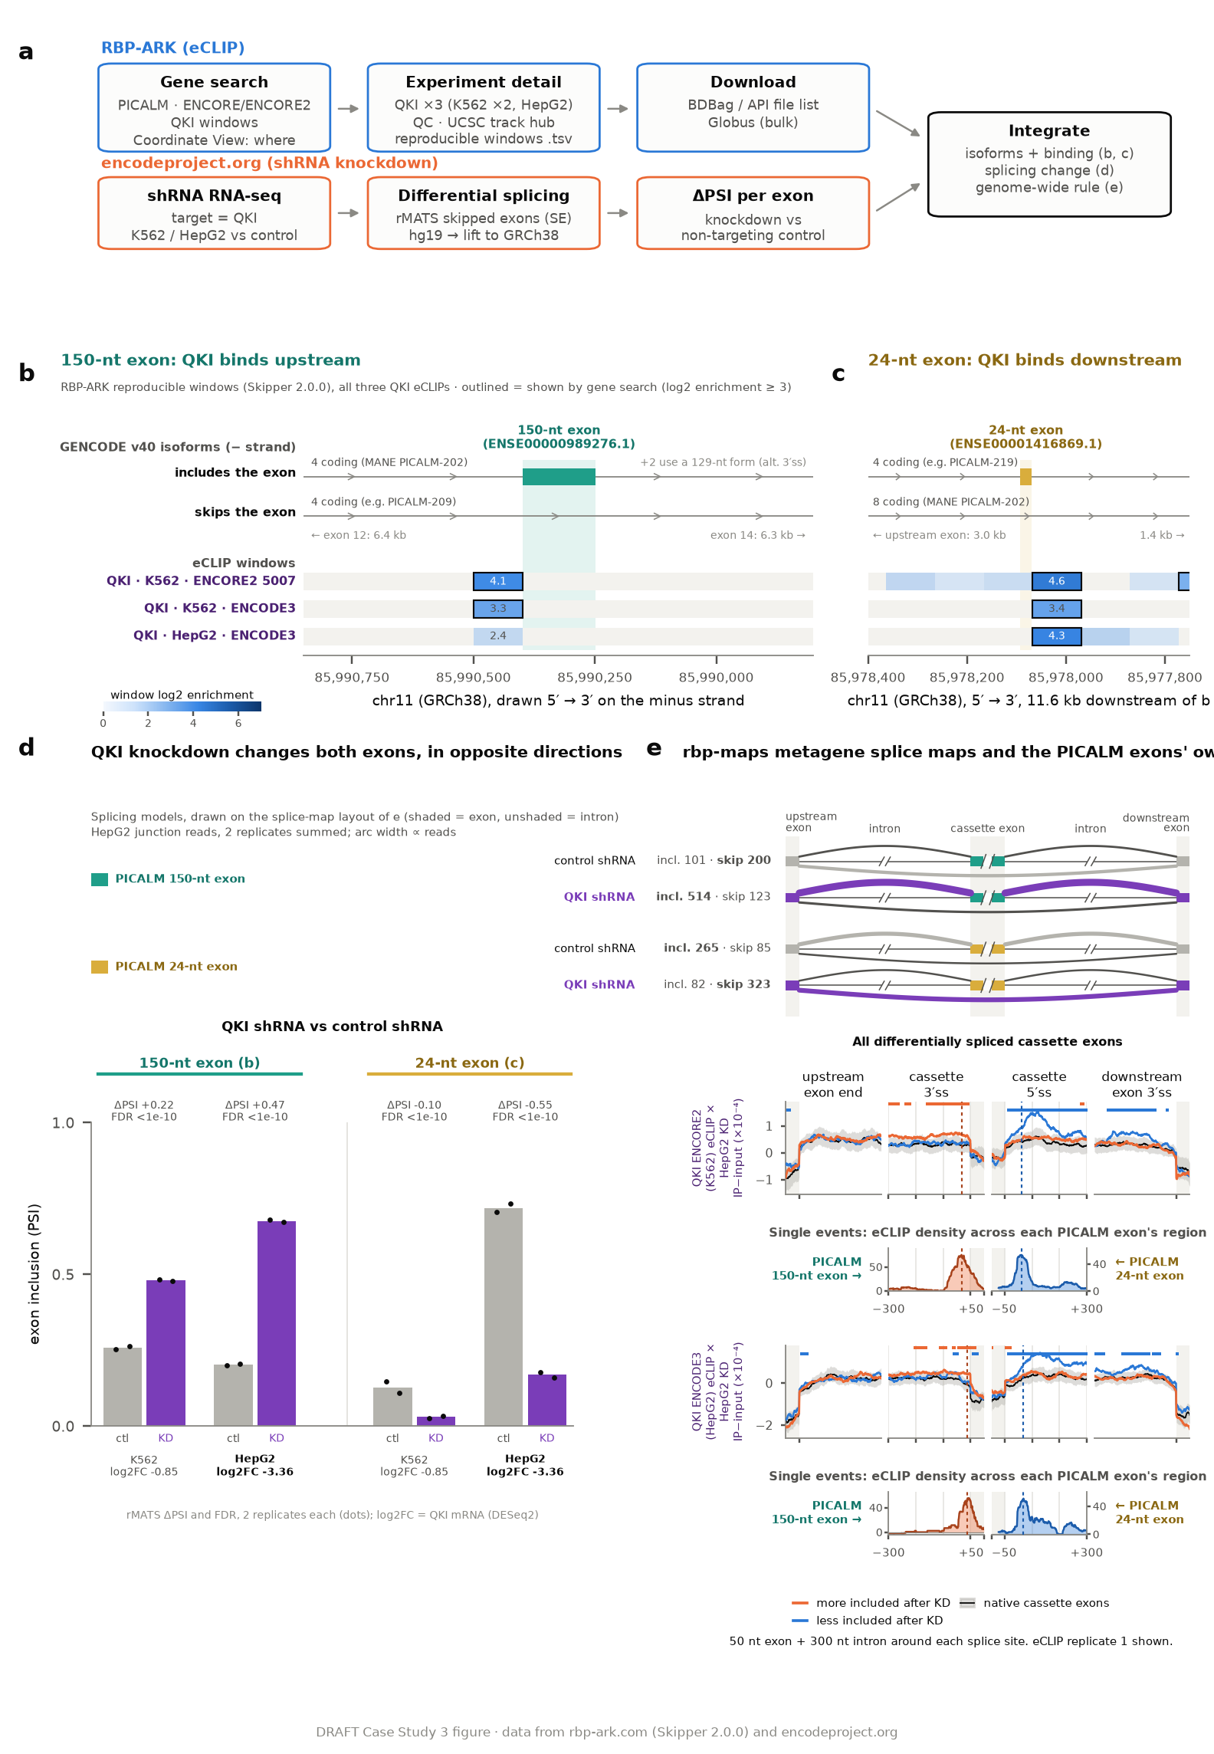
Supplementary Figure A | QKI binds on opposite sides of two PICALM exons and regulates them in opposite directions
Combining RBP-ARK eCLIP with ENCODE shRNA knockdown RNA-seq links QKI binding at two PICALM cassette exons to opposite splicing outcomes, and places both exons within a genome-wide positional rule. (a) Workflow: RBP-ARK eCLIP (gene search, experiment detail, download) and ENCODE QKI knockdown RNA-seq (differential splicing, ΔPSI per exon) are integrated as isoforms and binding (b, c), the splicing change (d) and the genome-wide rule (e). (b) RBP-ARK Coordinate View of the 150-nt exon (ENSE00000989276.1; GRCh38, minus strand, drawn 5′ to 3′) with GENCODE v40 isoforms: four coding transcripts include the exon (including MANE Select PICALM-202), four skip it and two use a 129-nt form. Rows show reproducible enriched windows of the three QKI eCLIP experiments, shaded by mean log2 enrichment; outlined windows reach log2 ≥ 3. The upstream QKI window contains two ACUAAU elements. (c) The same rows at the 24-nt exon (ENSE00001416869.1), 11.6 kb downstream: four coding transcripts include it and eight skip it, including MANE Select. Above d and e, both splicing models are drawn on the splice-map layout of e (shaded, exon; unshaded, intron); the cassette exon is teal for the 150-nt exon (more included after knockdown) and gold for the 24-nt exon (less included), with HepG2 junction reads for control and QKI shRNA (two replicates summed; arc width proportional to reads). (d) PSI per replicate for both exons after QKI versus control shRNA in K562 and HepG2, with rMATS ΔPSI and FDR and QKI knockdown log2 fold change (DESeq2: −0.85 in K562, −3.36 in HepG2). (e) rbp-maps metagene splice maps for the HepG2 QKI knockdown: mean normalized eCLIP signal (IP minus input, ×10⁻⁴) around all cassette exons more included (orange, n = 1,514) or less included (blue, n = 913) after knockdown and around native cassette exons (black, n = 2,267); the gray band is the 0.5–99.5% range of random subsets of native cassette exons the size of each test set, and squares mark positions above the band. Each splice site is shown with 50 nt of exon and 300 nt of intron. Top, ENCORE2 eCLIP from K562 (QKI_K562_5007); bottom, ENCODE3 eCLIP from HepG2 (QKI_HepG2_ENCSR570WLM); eCLIP replicate 1. Below each map, single events: normalized eCLIP density across each PICALM exon's own region. QKI signal peaks 33 nt (ENCORE2) or 11 nt (HepG2) upstream of the 150-nt exon's 3′ splice site and 60 or 68 nt downstream of the 24-nt exon's 5′ splice site.

References
1. Van Nostrand, E. L. et al. A large-scale binding and functional map of human RNA-binding proteins. Nature 583, 711–719 (2020). doi:10.1038/s41586-020-2077-3
2. Her, H.-L. et al. Comprehensive RNA-binding protein analyses and deep learning uncover genetic constraints and disease associations in protein–RNA interfaces. Cell Syst. 17, 101588 (2026). doi:10.1016/j.cels.2026.101588
3. Boyle, E. A. et al. Skipper analysis of eCLIP datasets enables sensitive detection of constrained translation factor binding sites. Cell Genom. 3, 100317 (2023). doi:10.1016/j.xgen.2023.100317
4. Moreau, K. et al. PICALM modulates autophagy activity and tau accumulation. Nat. Commun. 5, 4998 (2014). doi:10.1038/ncomms5998
5. Ishikawa, Y. et al. Role of the clathrin adaptor PICALM in normal hematopoiesis and polycythemia vera pathophysiology. Haematologica 100, 439–451 (2015). doi:10.3324/haematol.2014.119537
6. Ando, K. et al. PICALM and Alzheimer's disease: an update and perspectives. Cells 11, 3994 (2022). doi:10.3390/cells11243994
7. Shen, S. et al. rMATS: robust and flexible detection of differential alternative splicing from replicate RNA-Seq data. Proc. Natl Acad. Sci. USA 111, E5593–E5601 (2014). doi:10.1073/pnas.1419161111
8. Hall, M. P. et al. Quaking and PTB control overlapping splicing regulatory networks during muscle cell differentiation. RNA 19, 627–638 (2013). doi:10.1261/rna.038422.113
9. Yee, B. A. et al. RBP-Maps enables robust generation of splicing regulatory maps. RNA 25, 193–204 (2019). doi:10.1261/rna.069237.118
Reference numbers are local to this case study; renumber into the supplement's sequence when it is placed.

