Q.I IoT Platform Development Project

July – August 2018

Qualcomm Institute, UCSD

Team. E

INDEX

I. Introduce 3

II. System Reference 4

III. System Architecture 4

IV. ER Diagram 5

V. Sequence Diagram / Flowchart 6

1. User Management Procedure 6

1.1. Sign up 6

1.2. Sign in 11

1.3. Sign out 13

1.4. User password change 16

1.5. Forgotten password update 19

1.6. ID cancellation 23

2. Sensor Management Procedure 26

2.1. Sensor registration / association 26

2.2. Sensor deregistraion / dissociation 28

2.3. Sensor list view 31

3. Data Management Procedure 34

3.1. Real-time air quality data transfer 34

3.2. Real-time heart-related data transfer 38

4. Data Monitoring Procedure 41

4.1. Real-time air quality data view 41

4.2. Real-time heart-related data view 45

4.3. Historical air quality data view 48

4.4. Historical heart-related data view 51

# Introduce

Team Member

* Dongsoo Jang (Jade)
  + Keimyung University
  + Team Leader
  + App part
* Yeonjun Kim (John)
  + Dong-Eui University
  + App Part
* Jinwon Cheon
  + Kookmin University
  + Sensor Part
* Hyoeun Kim (Ella)
  + Choseon University
  + Web/Server Part

# System Reference

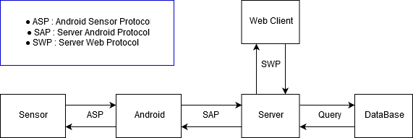

# System Architecture

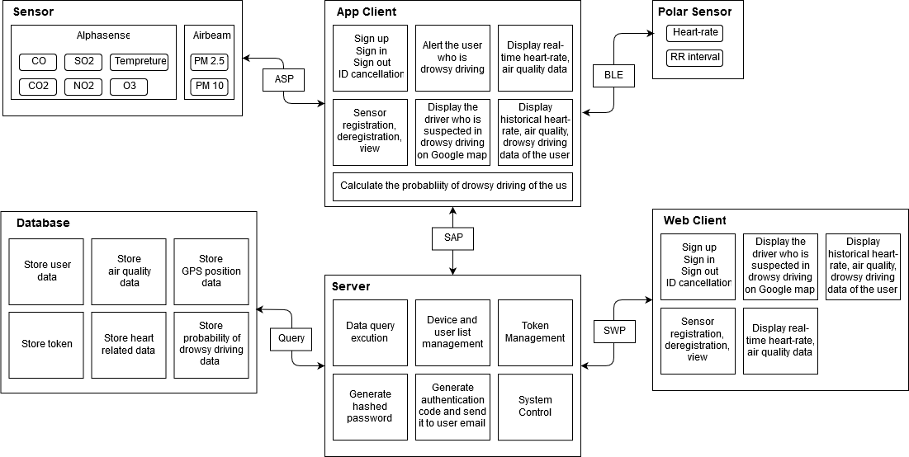

# ER Diagram

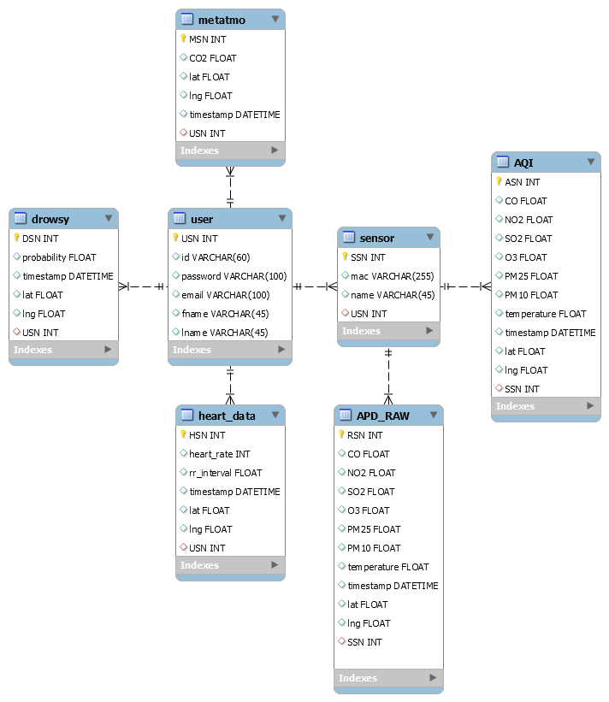

# Sequence Diagram / Flowchart

## User Management Procedure

### Sign up

* Sequence Diagram



* Flowchart
  + Client

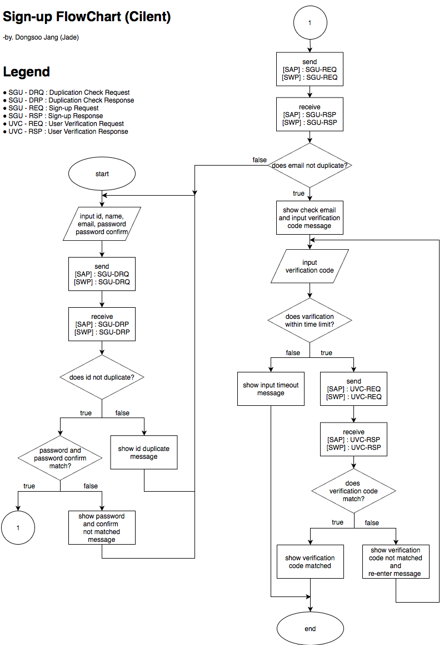

* + Server

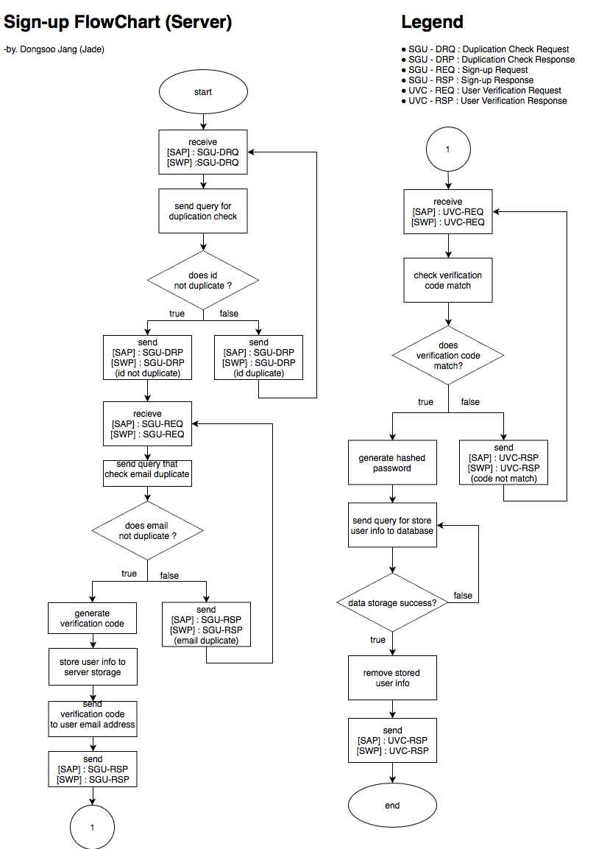

### Sign in

* Sequence Diagram

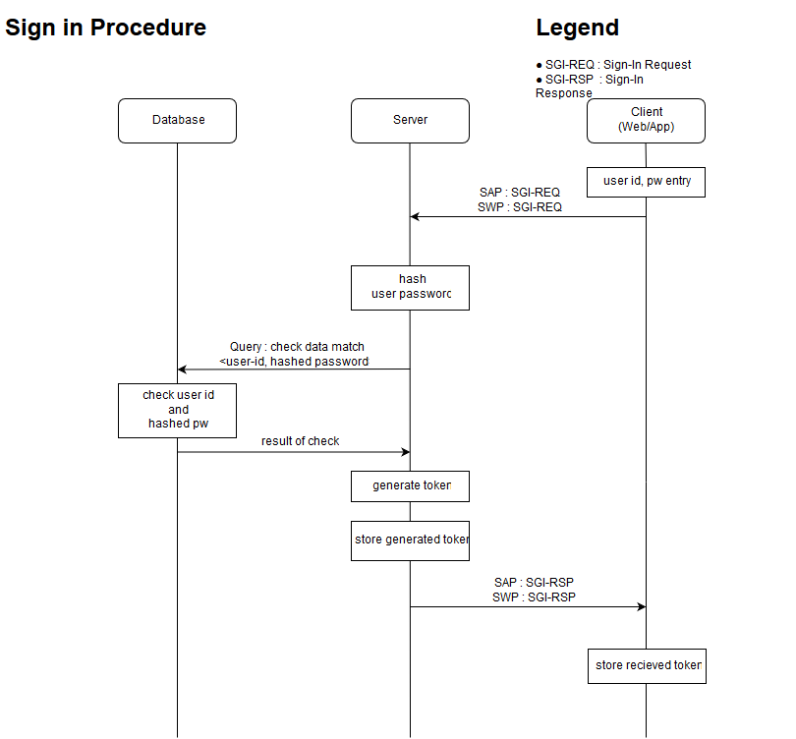

* Flowchart
  + Client

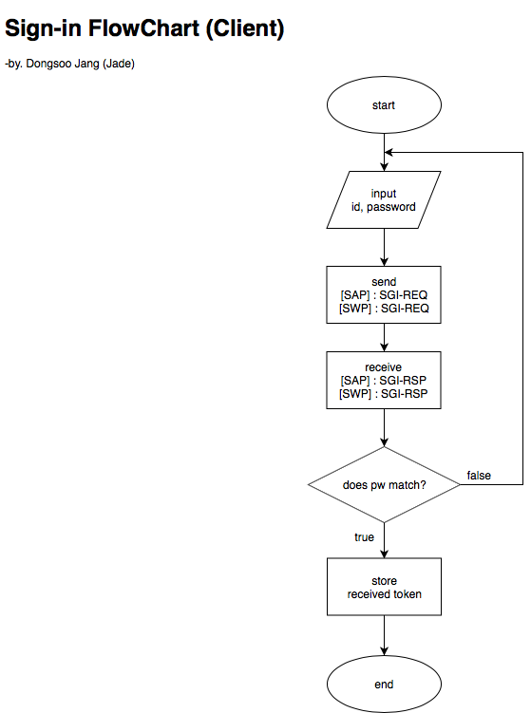

* + Server

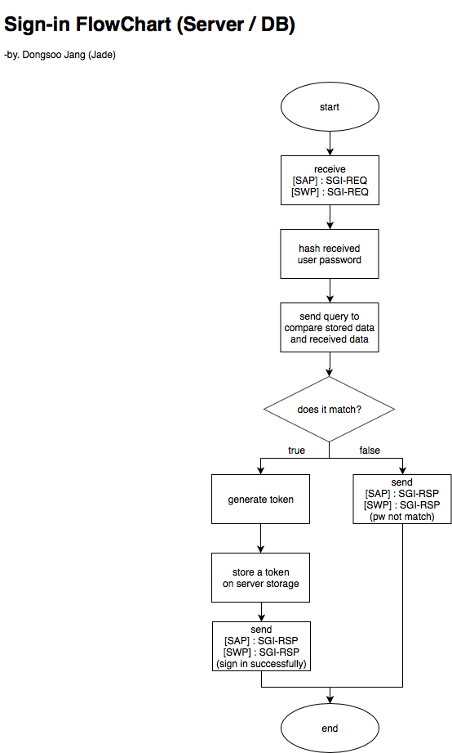

### Sign out

* Sequence Diagram

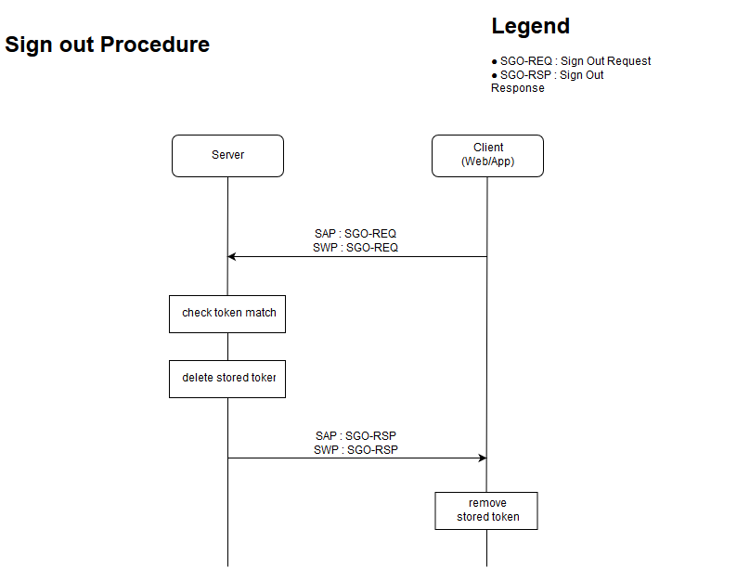

* Flowchart
  + Client

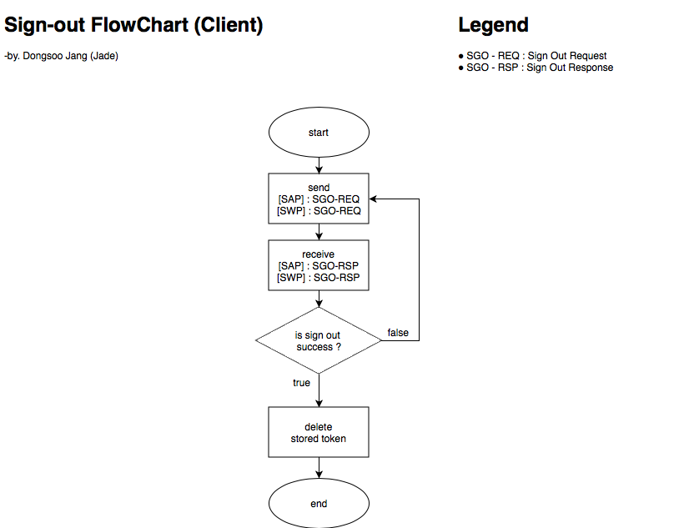

* + Server

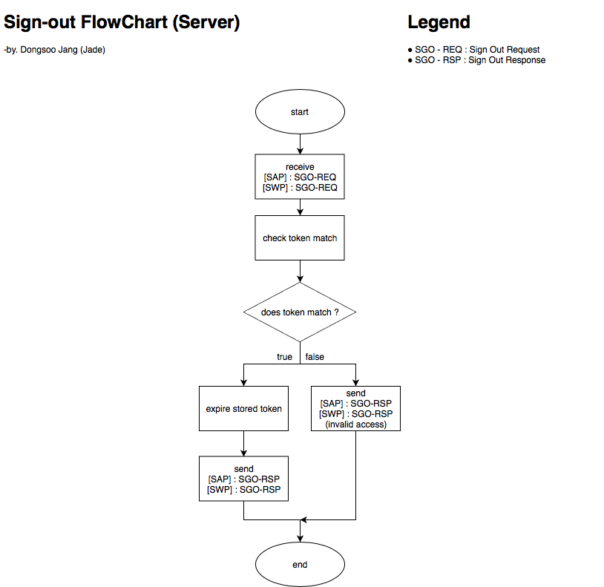

### User password change

* Sequence Diagram

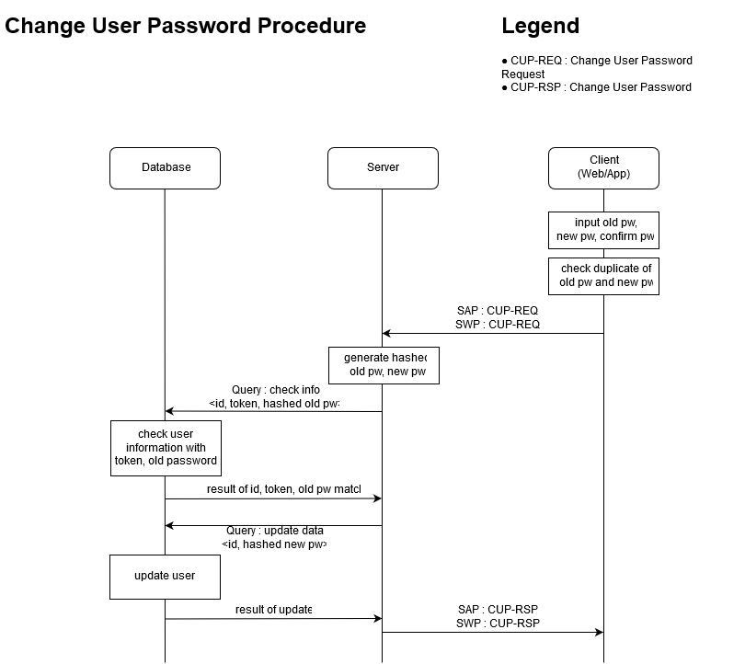

* Flowchart
  + Client

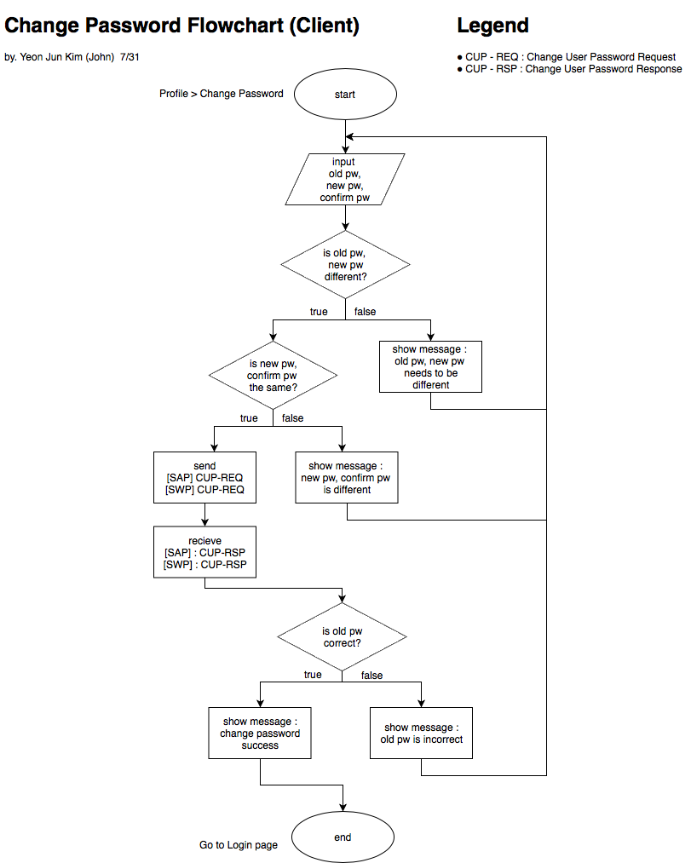

* + Server

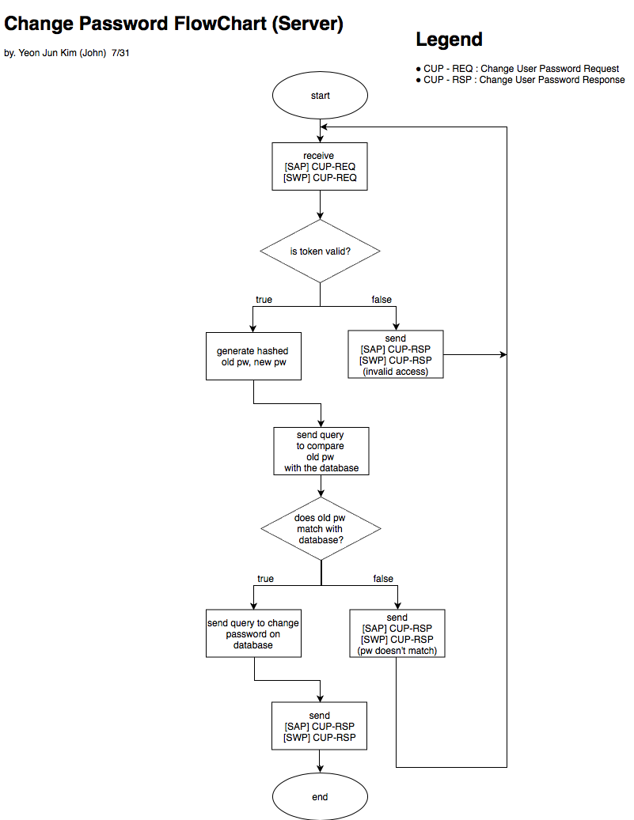

### Forgotten password update

* Sequence Diagram

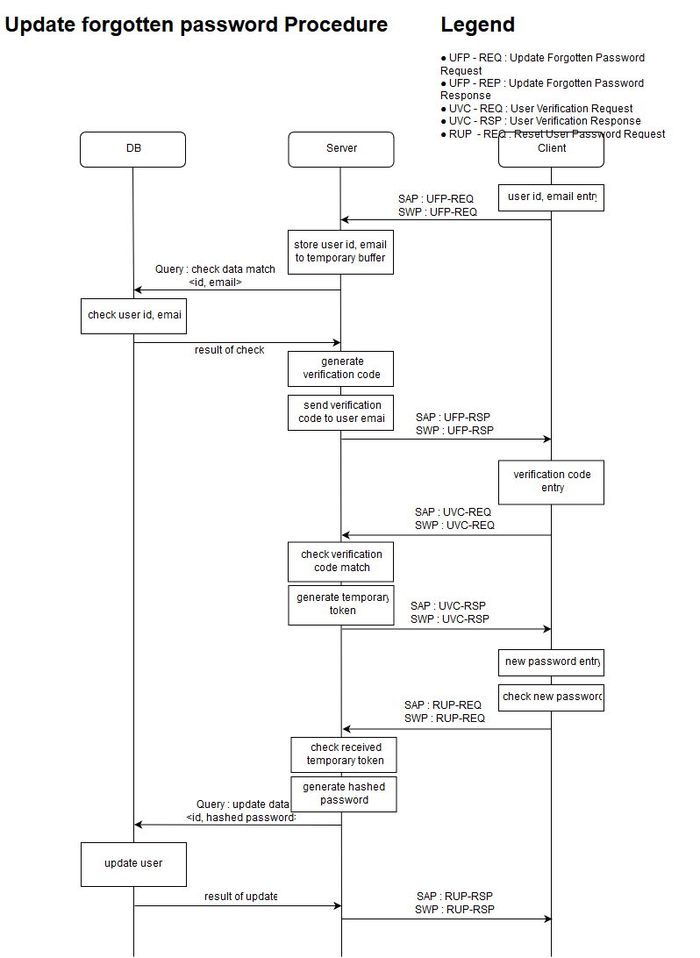

* Flowchart
  + Client

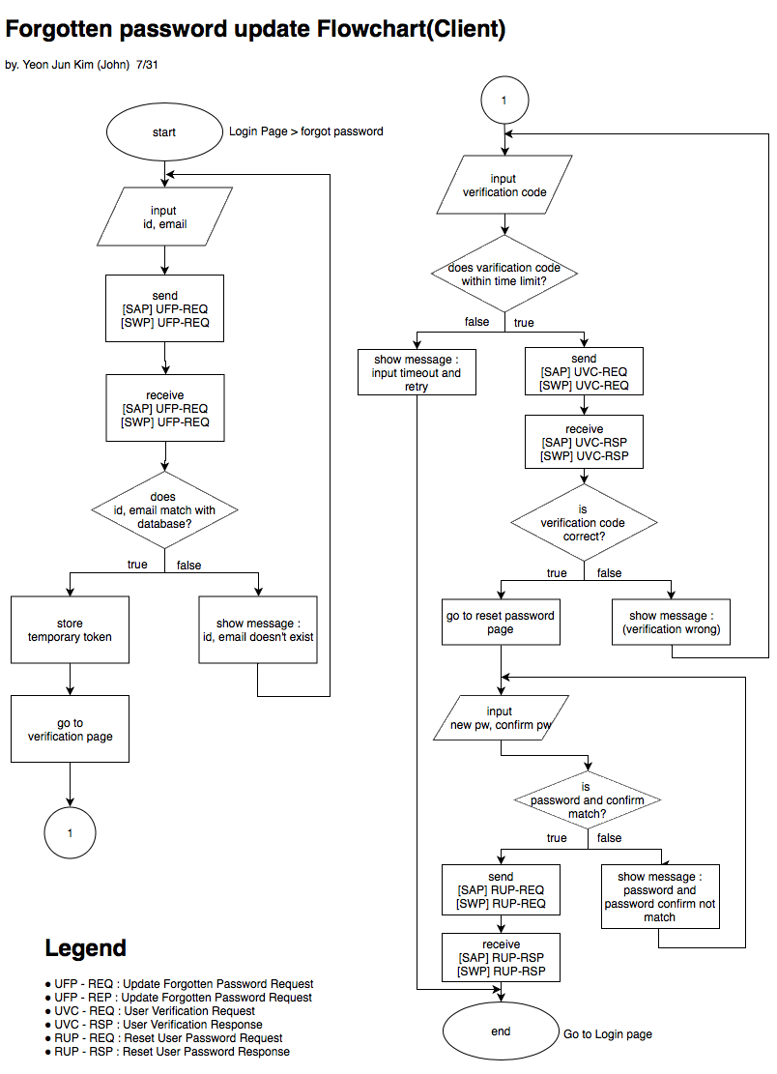

* + Server

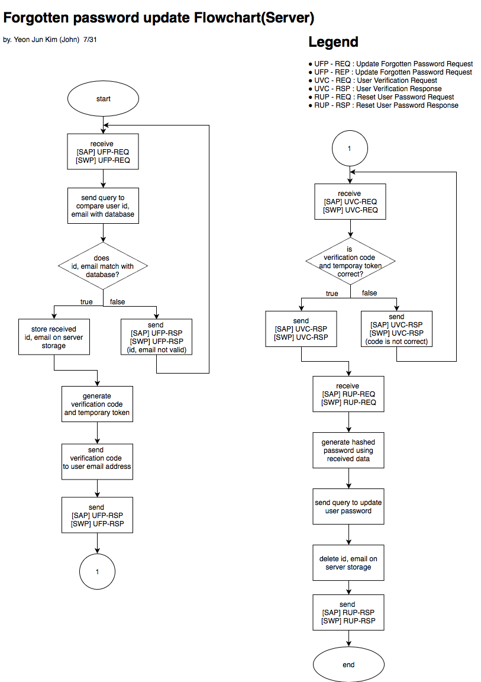

### ID cancellation

* Sequence Diagram

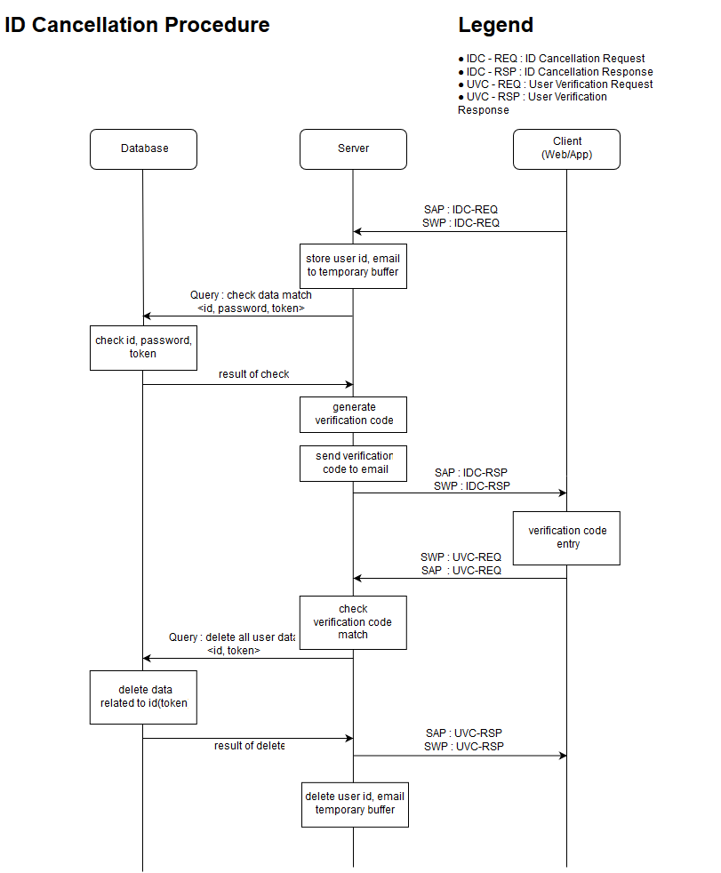

* Flowchart
  + Client

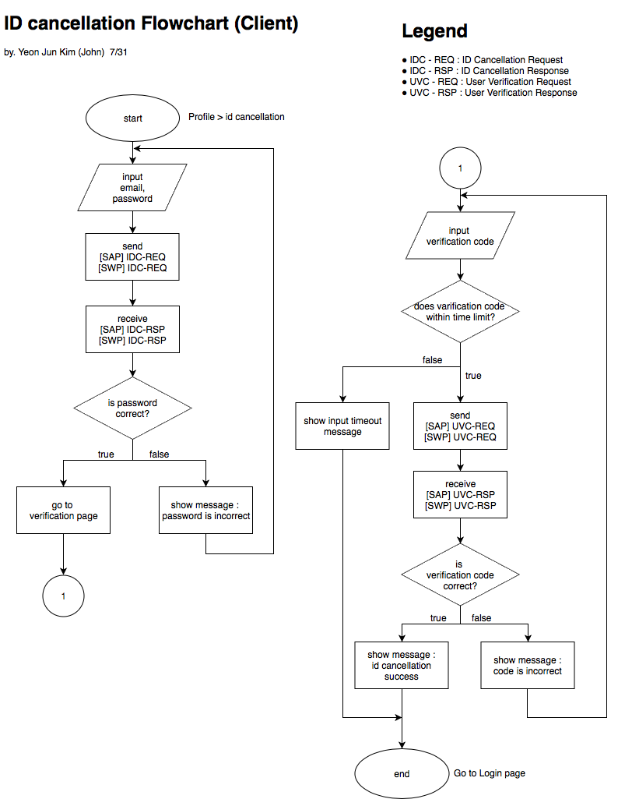

* + Server

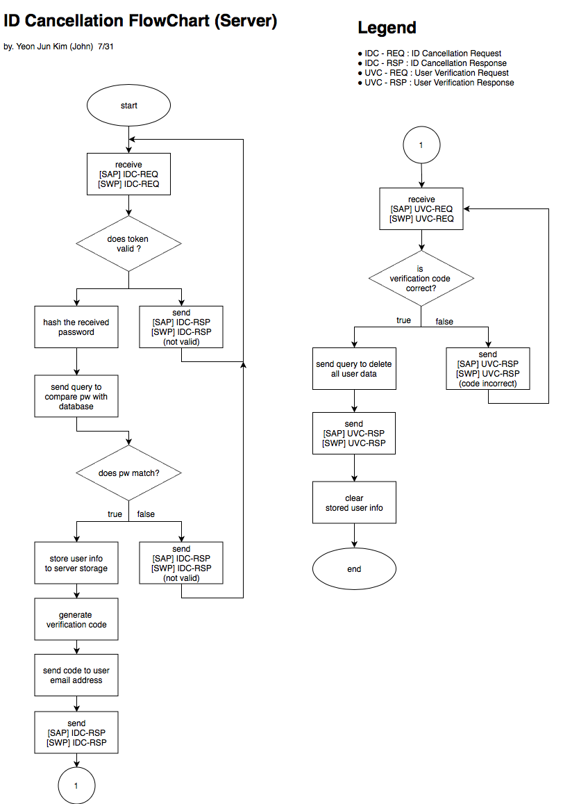

## Sensor Management Procedure

### Sensor registration / association

* Sequence Diagram

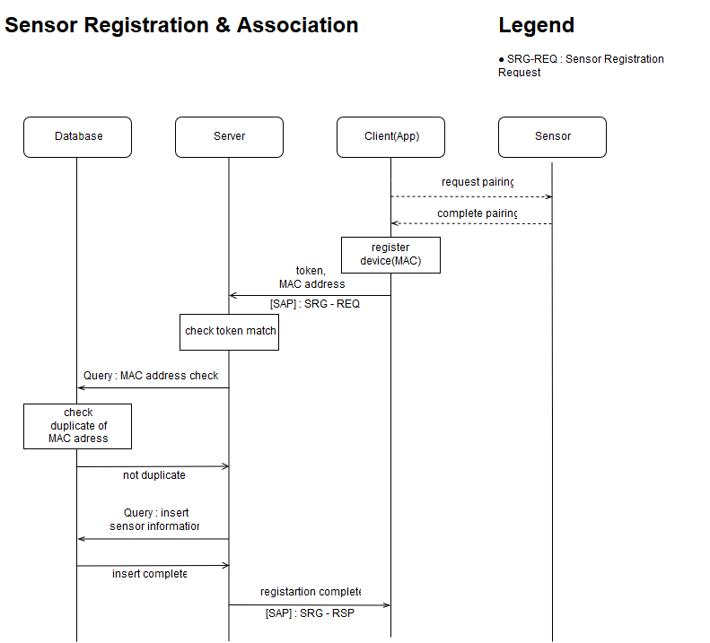

* Flowchart
  + App

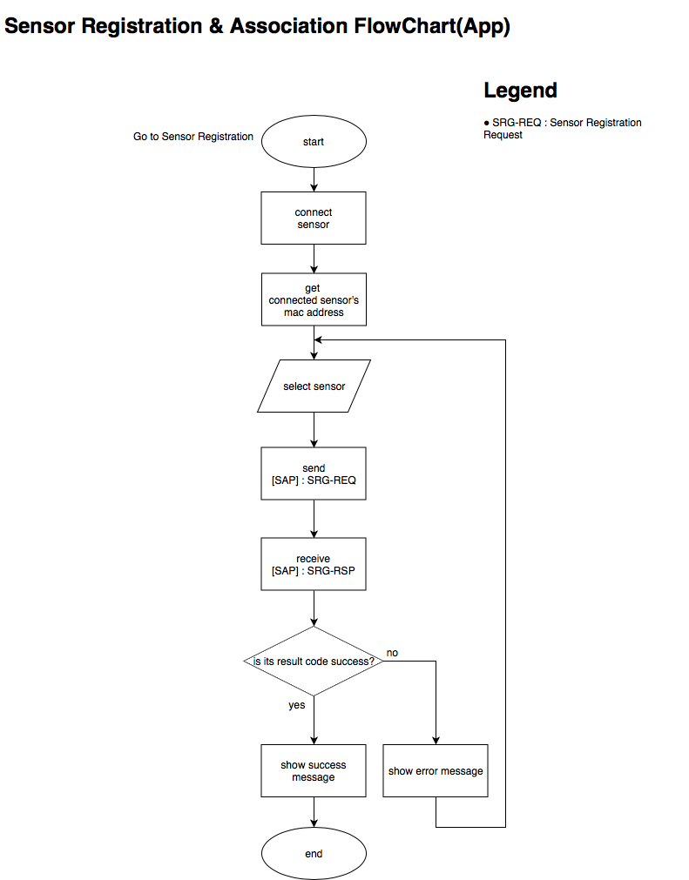

* + Server

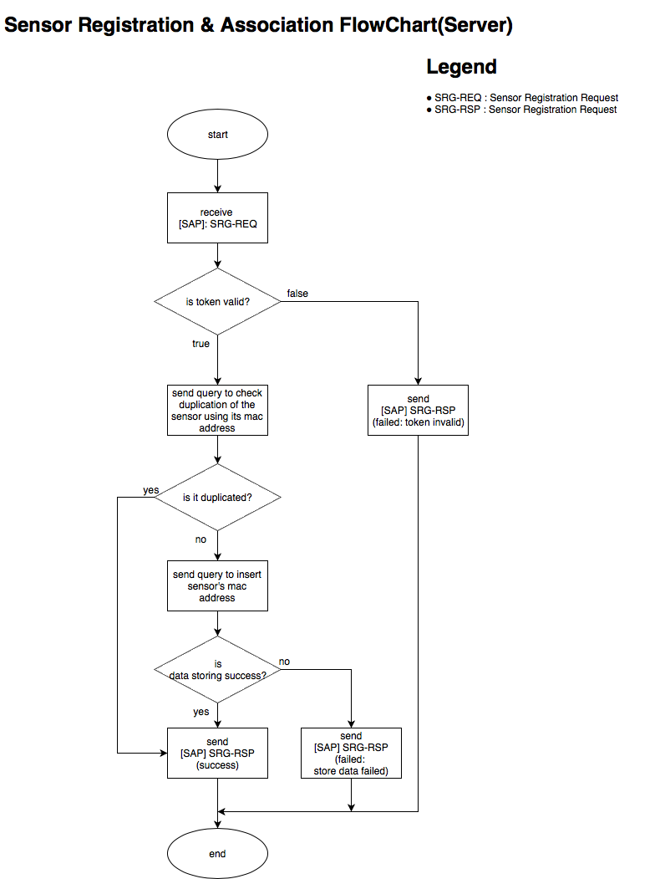

### Sensor deregistraion / dissociation

* Sequence Diagram

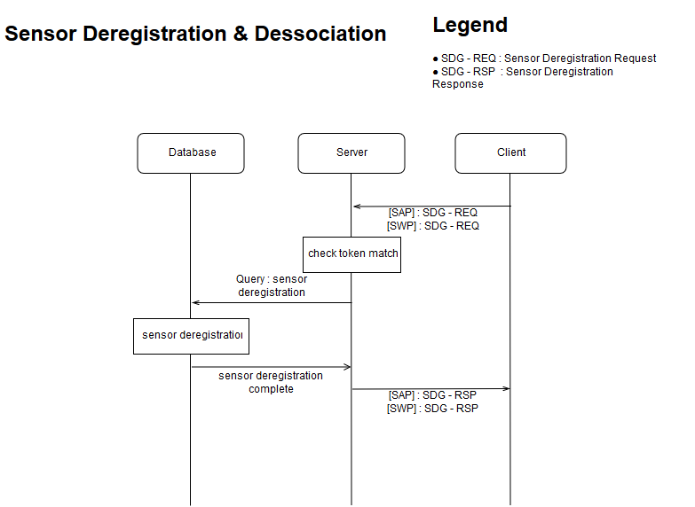

* Flowchart
  + Client

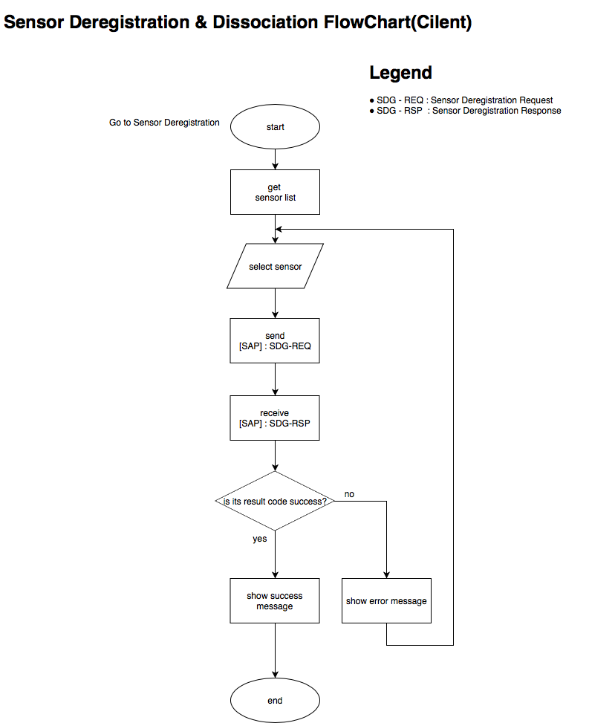

* + Server

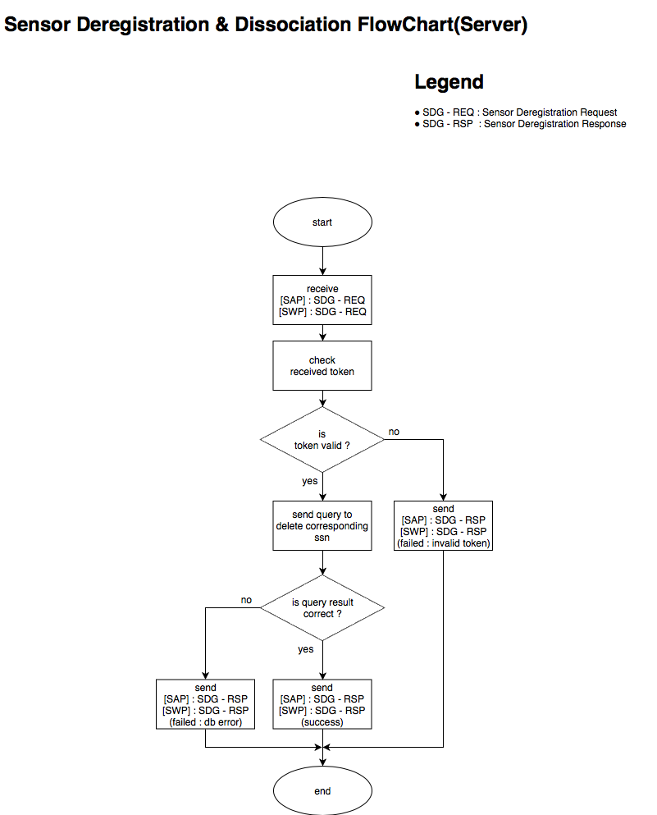

### Sensor list view

* Sequence Diagram

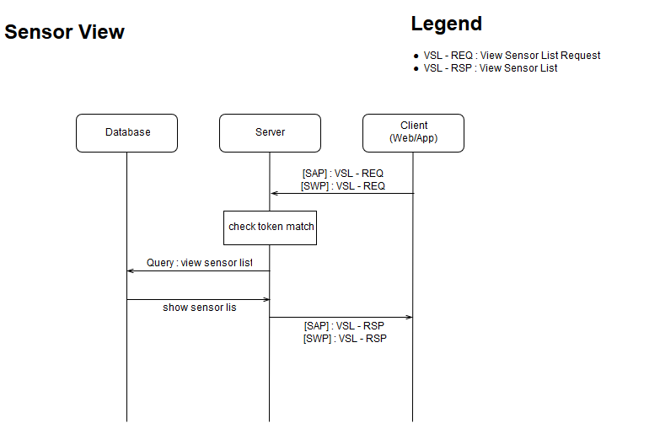

* Flowchart
  + Client

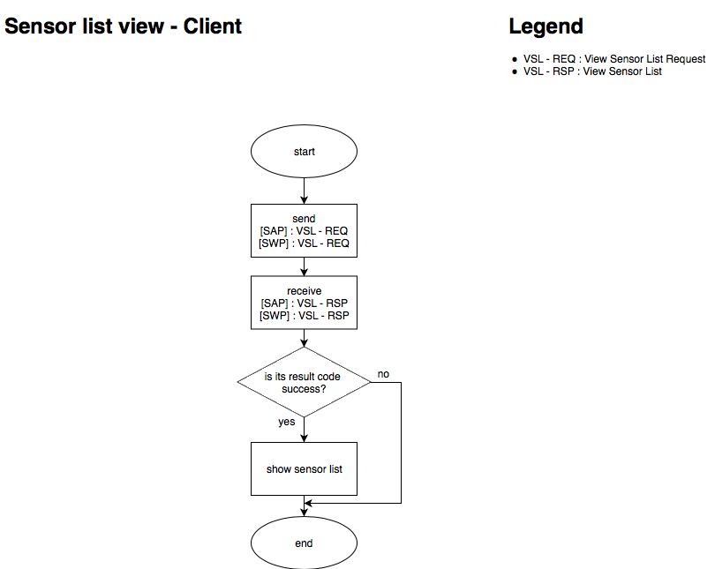

* + Server

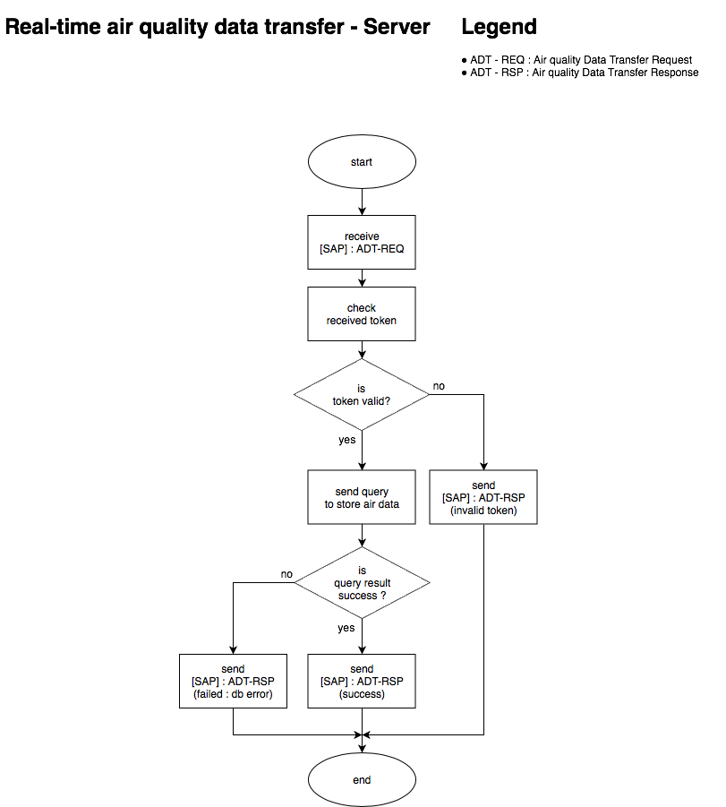

## Data Management Procedure

### Real-time air quality data transfer

* Sequence Diagram

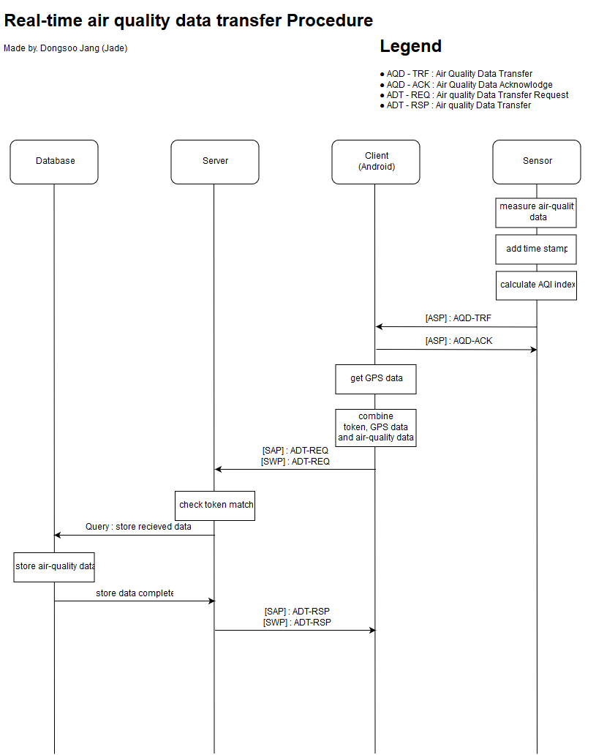

* Flowchart
  + Sensor

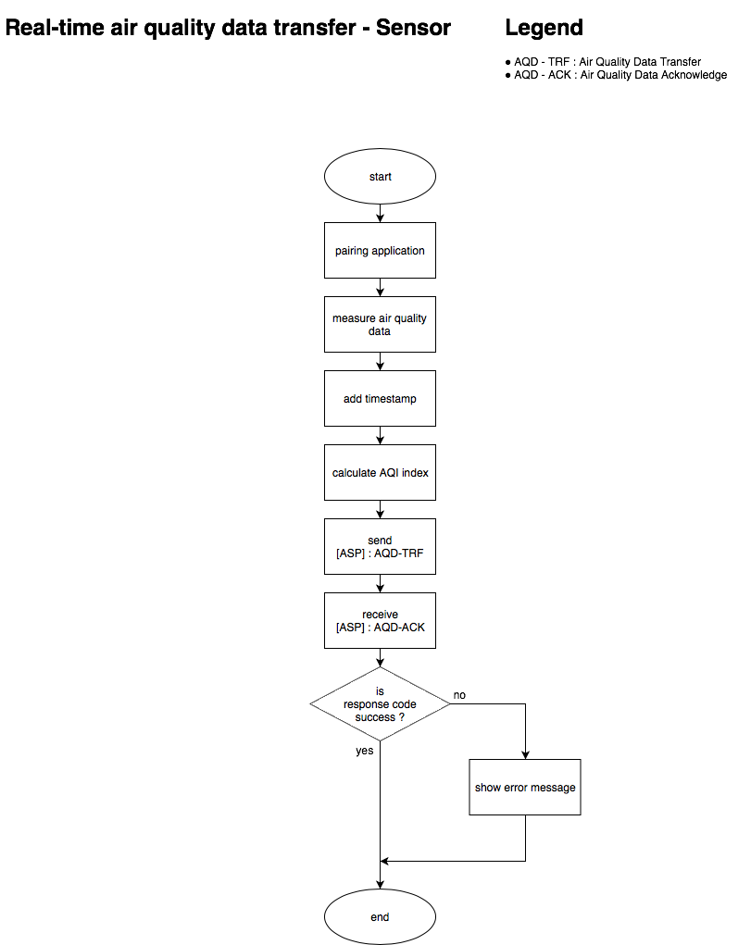

* + App

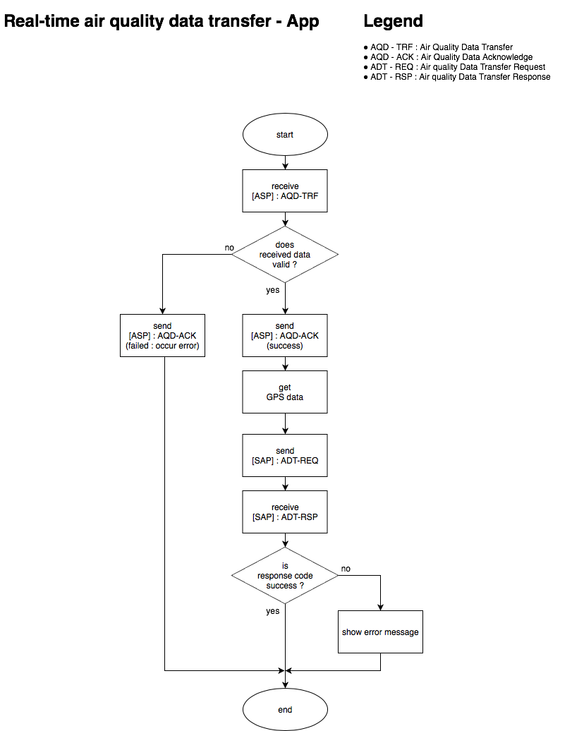

* + Server



### Real-time heart-related data transfer

* Sequence Diagram

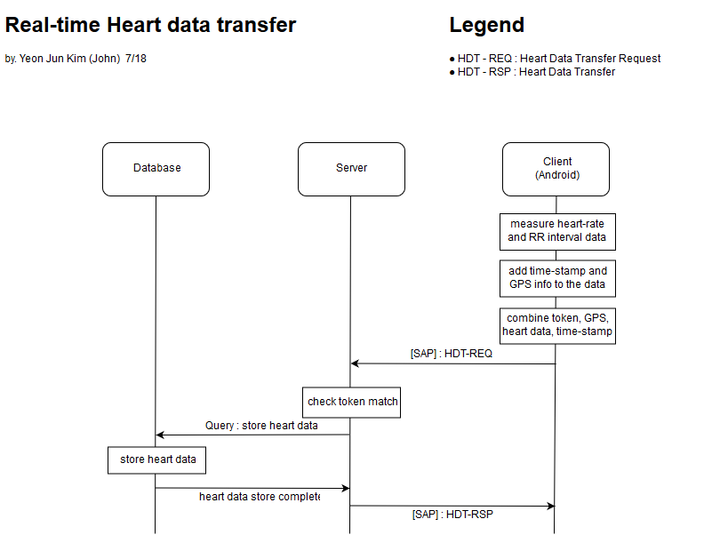

* Flowchart
  + App

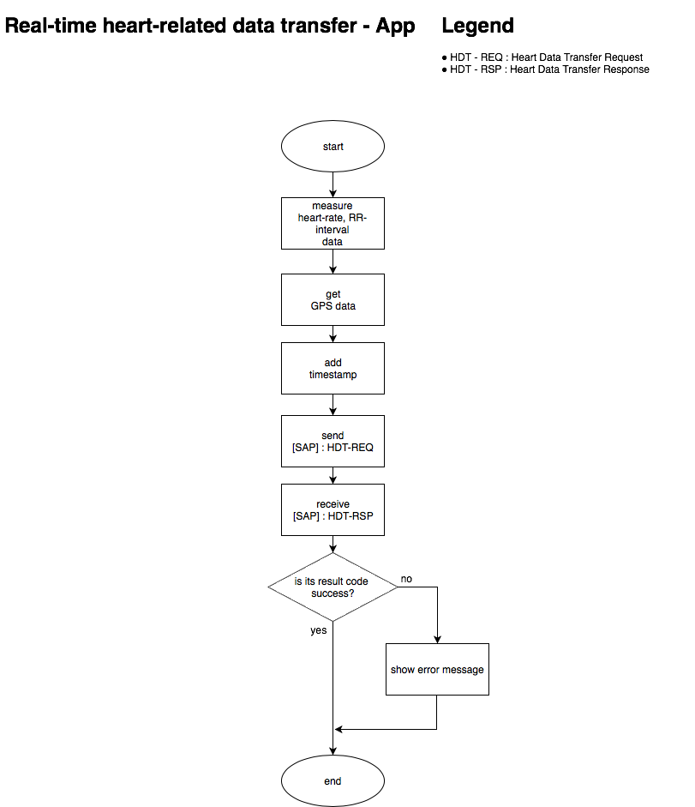

* + Server

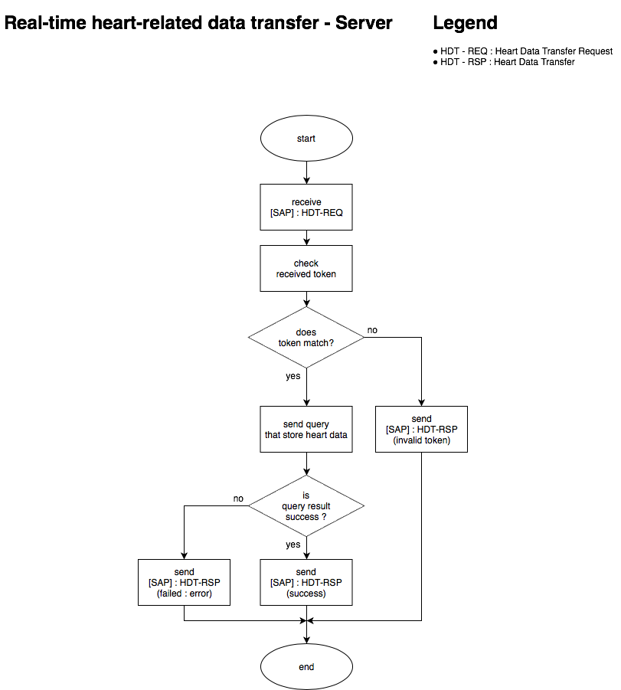

## Data Monitoring Procedure

### Real-time air quality data view

* Sequence Diagram

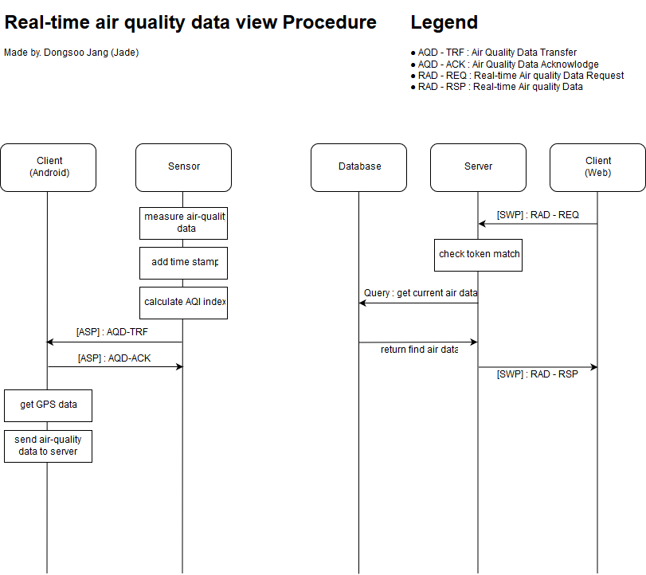

* Flowchart
  + App

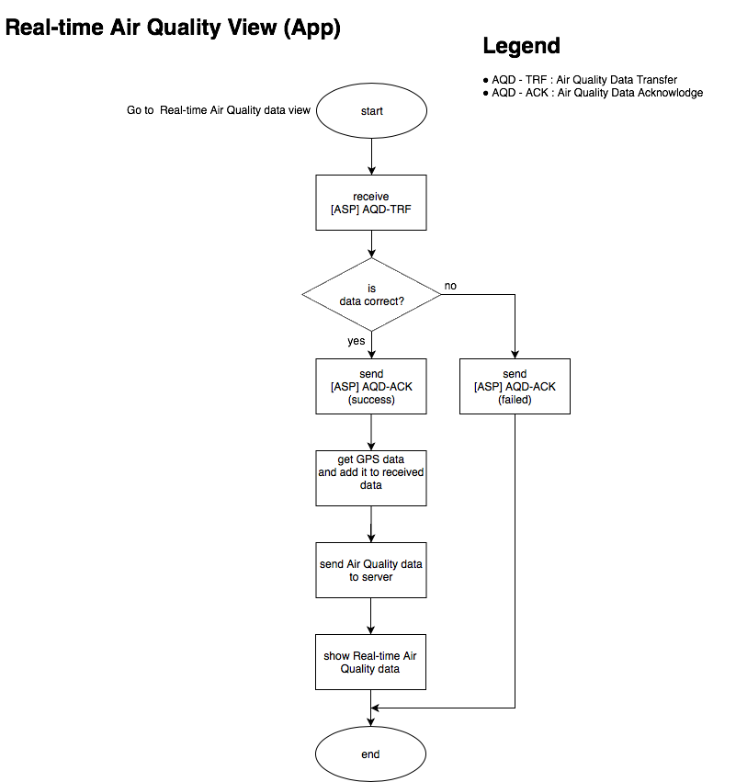

* + Web

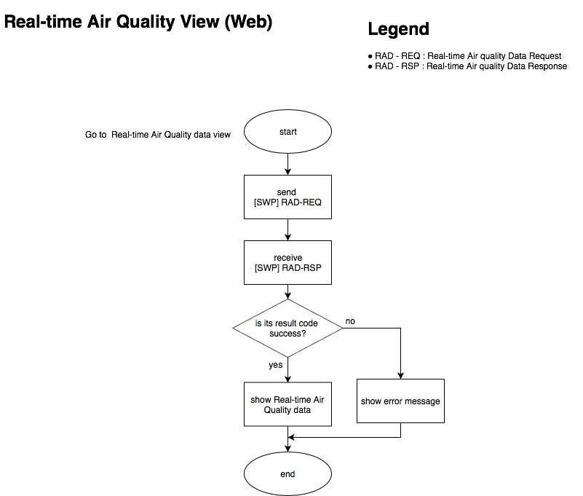

* + Server

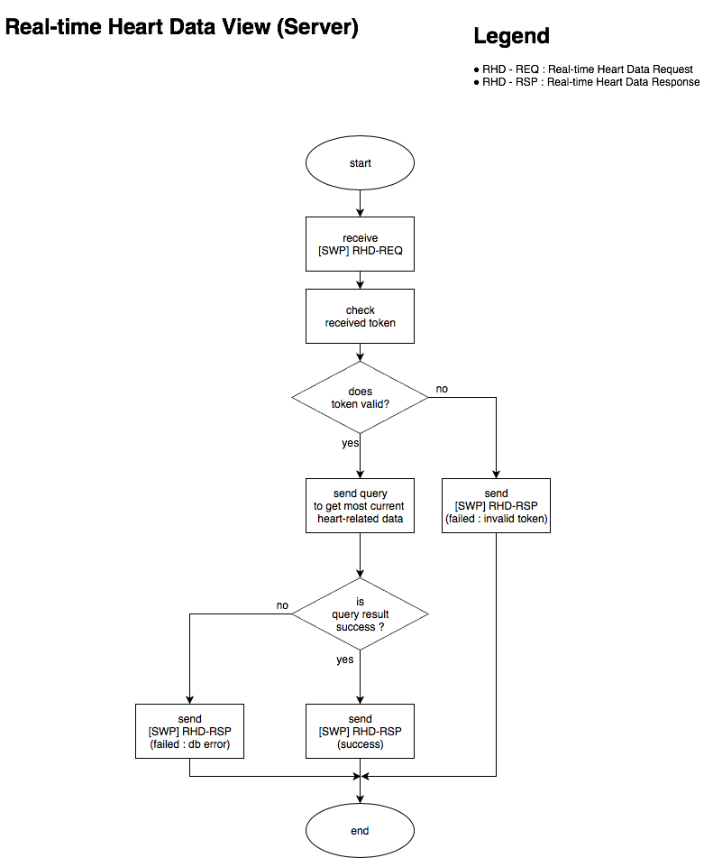

### Real-time heart-related data view

* Sequence Diagram

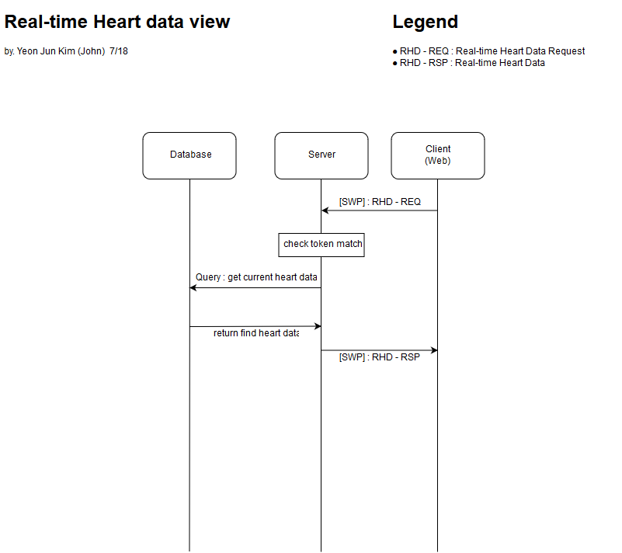

* Flowchart
  + Web

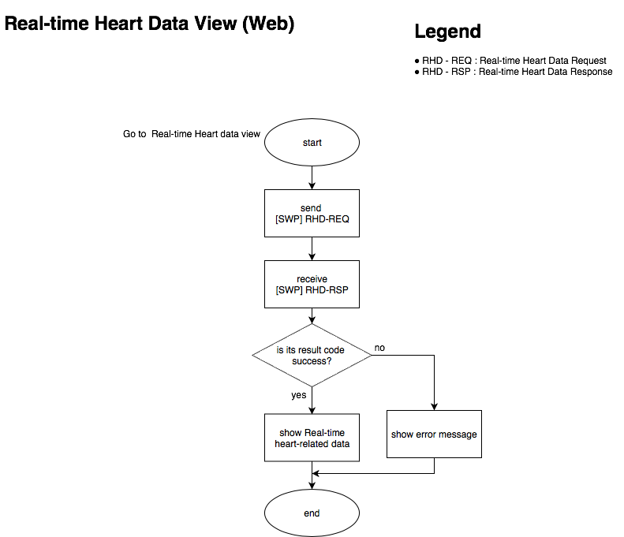

* + Server



### Historical air quality data view

* Sequence Diagram

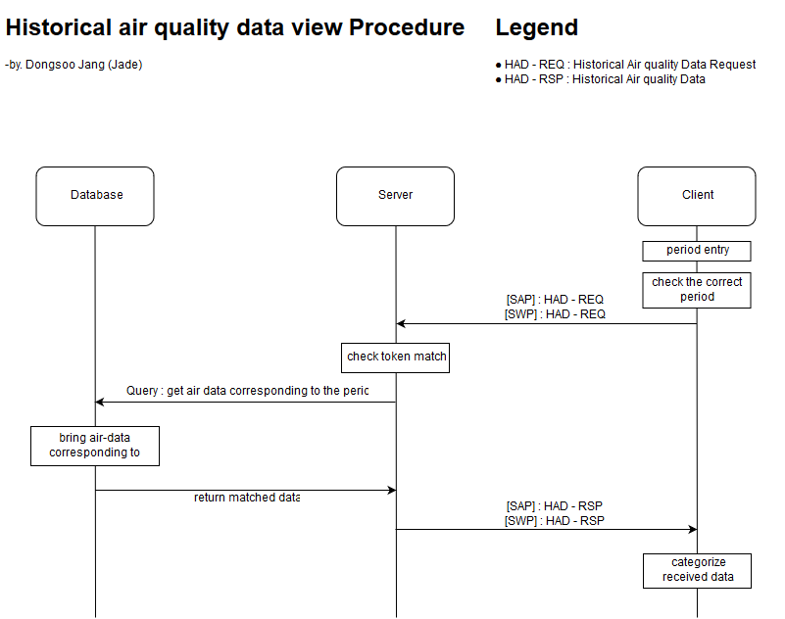

* Flowchart
  + Client

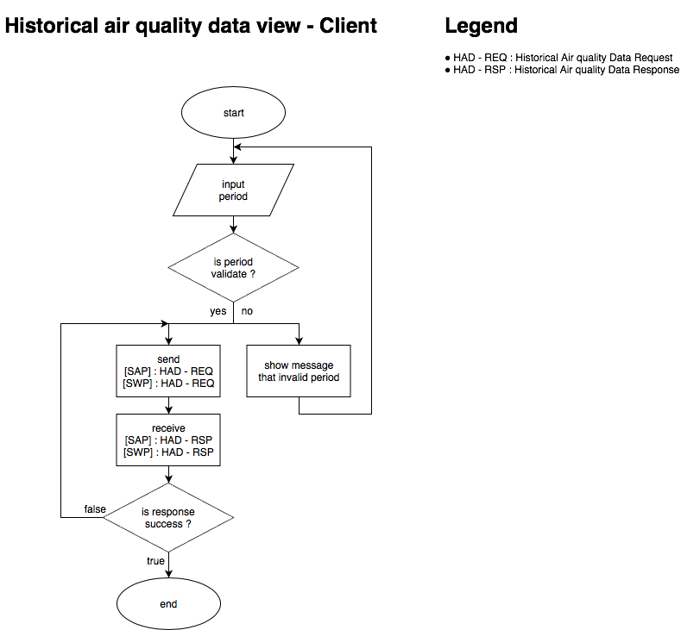

* + Server

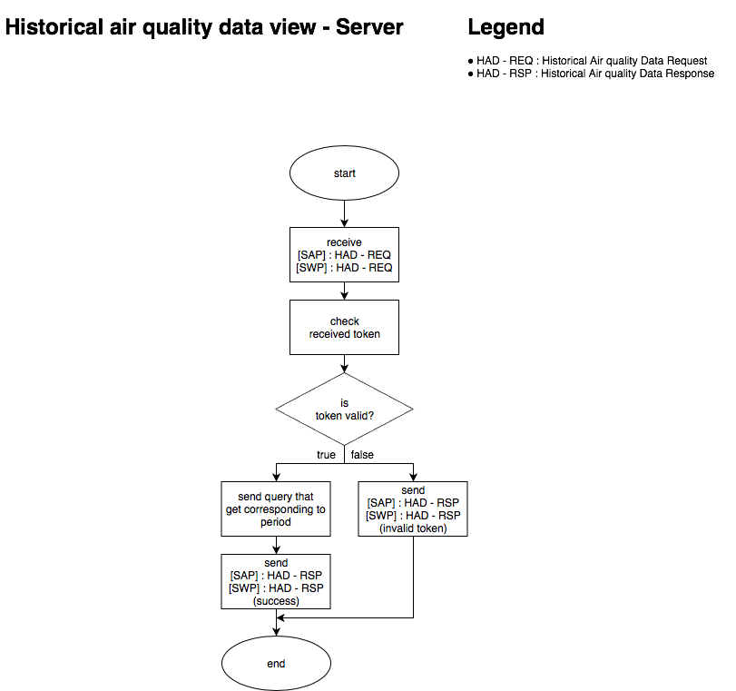

### Historical heart-related data view

* Sequence Diagram

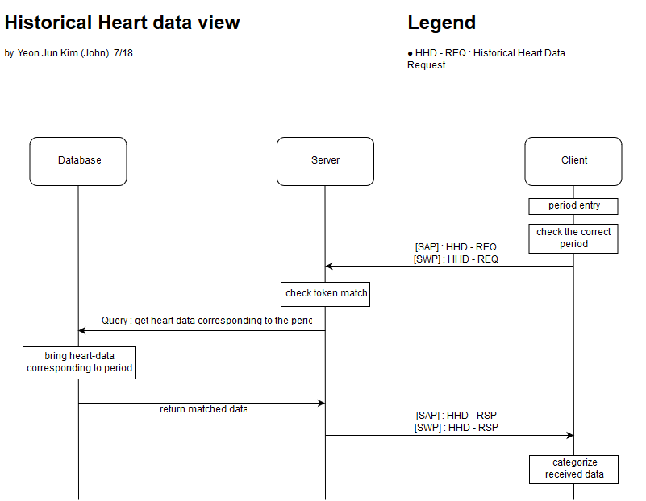

* Flowchart
  + Client

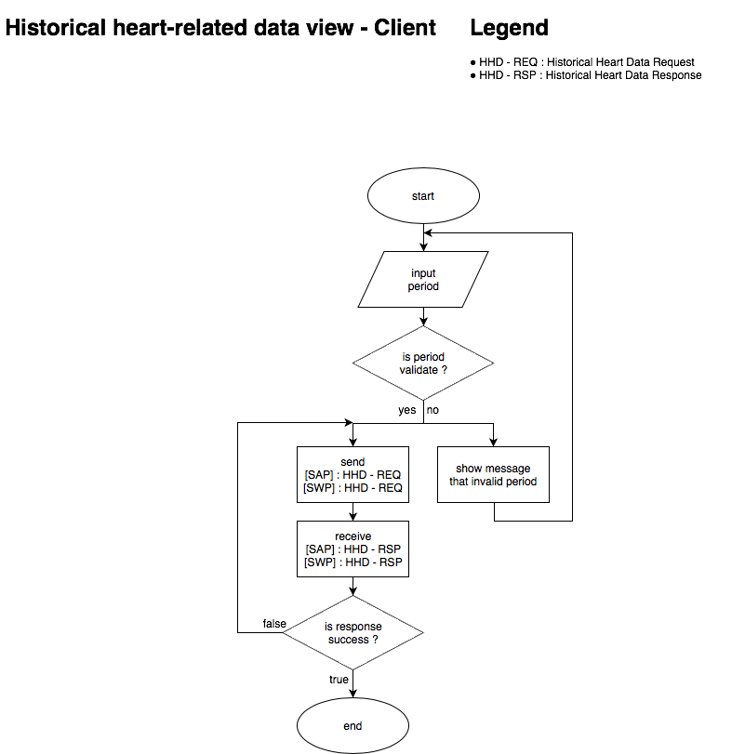

* + Server

