Spirent-pep-logo

User Guide Document

TS management for Landslide

Document Number: XXX-XXXX-XXX

Revision 1.0

01/23/2020

Approvals:

|  |  |  |
| --- | --- | --- |
| Prepared by: Sewoong Eum  Associate Engineer |  | In Seo  Sr. Engineering Manager |
|  |  |  |
| YeongBeen Yun  Associate Engineer |  |  |
|  |  |  |

REVISION HISTORY

|  |  |  |  |
| --- | --- | --- | --- |
| Rev | Date | Req by | Purpose |
| 1.0 | 01/23/19 | Sewoong Eum | First Draft |
| 1.1 | 01/24/19 | Sewoong Eum | Update |
| 1.2 | 01/30/19 | Yeongbeen Yun | Update |

Table of Contents

1. Introduction 3

1.1. Scope 3

1.2. Product Overview 3

2. deployment requirements 4

2.1. Basic environments 3

2.2. Packages 3

2.3. Directory Structure 4

2.4. Modules 5

3. How to run 5

3.1. Setup the Server 5

3.2. Run the Server 6

4. Features 6

4.1. Autentication 6

4.2. Manage User Profile 7

4.3. Manage Common TAS/TS 7

4.4. Reservation 8

5. Enhancements 11

# Introduction

## Scope

The scope of this document is to describe the design of TS management system for the Landslide and to deliver the user guide information.

## Product Overview

The following feature will be included in this project:

* Display all TS list and information(platform, ip address, memory, status…etc)
* Relocate TS by selecting TS, target TAS
* Lock the specific TS to prevent relocation
* Reserve TS for selected period
* Manage common TAS/TS

# deployment requirements

## Basic environments

* Ubuntu 14.0.4.5 LTS
* Python 2.7.6

## Packages

List of the installed packages are as follows:

* bcrypt==3.1.7
* blinker==1.4
* cffi==1.13.2
* Click==7.0
* cryptography==2.8
* enum34==1.1.6
* Flask==1.1.1
* Flask-Bcrypt==0.7.1
* Flask-Mail==0.9.1
* Flask-SQLAlchemy==2.4.1
* ipaddress==1.0.23
* itsdangerous==1.1.0
* Jinja2==2.10.3
* MarkupSafe==1.1.1
* paramiko==2.7.1
* pycparser==2.19
* PyNaCl==1.3.0
* six==1.14.0
* SQLAlchemy==1.3.13
* Werkzeug==0.16.0

## Directory Structure

The basic directory structure is as following:

app  
 templates  
 about.html // HTML template for introducing LandSlide team  
 base.html // HTML base template for other nav bars   
 error_404.html // HTML template for error 404 page  
 login.html // HTML template for login page  
 register.html // HTML template for register page  
 reservePage.html // HTML template for reservation page  
 tslistview.html // HTML template for the main page   
 tslistview.js // JS function for tslistview.html  
 static  
 scripts  
 jquery.datetimepicker.full.js // Time and date picker class for reservation page  
 jquery.js // Base module to use time picker  
 timetable.js // Timetable to display reserved TS list  
 styles  
 about.css // CSS for about template  
 base.css // CSS for nav bar base template  
 demo.css // CSS for timetable in reserve page  
 error_404.css // CSS for the error 404 page  
 jquery.datetimepicker.min.css // CSS for date and time picker in reserve page  
 timetablejs.css // CSS for timetable in reserve page  
 tslistview.css // CSS for the main page.  
 gear.jpg  
 teamlunch1.jpg  
 __init__.py // Main function for the server  
 reserveTS.py // Reservation function  
 sendMail.py // Send mail when TS forcibly taken during reservation   
 tsDB.py // Manage database  
 tsmodify.py // Relocates test servers to other TAS  
__init__.py // Initialize file for the flask structure  
config.py // Configuration of port and other options for the flask  
run.py // Function to run the server  
requirements.txt // Pacakge list for virtualenv environment

## Modules

|  |  |
| --- | --- |
| **Module Name** | **Description** |
| flask | Flask server |
| render_template | Renders the html template to server |
| url_for | Call specific route function when server asks for it |
| redirect | Redicrect to specific URL |
| request | - |
| session | Manage data by session |
| flash | - |
| SQLAlchemy | Database for flask server |
| Bcrypt | Encrypt user password |
| requests | Get the data from API server when server asks for it |
| base64 | Encode the string data s a 64bit-os |
| datetime | Get the current time date |
| paramiko | Connect TS by using SSH |
| time | Get current time and calculate reserve period and start time etc. |
| os | Get the base path of the os |
| flask_mail | Not used. |
| multiprocessing | Create new process to move TS |
| threading | Timer in server runs on other thread |
| smtplib | Send e-mail when TS reservation is interfered by other person |
| subprocess | Not used. |

# How to run

## Setup the server

TS Management is located at 10.140.92.100 at the directory(/home/spcoast/TSmanagement/).

1. Place the TSmangement file to the server you want to install.
2. Install virtualenv by command: *$pip install virtualenv*
3. To create new virtualenv, we need to delete previous virtualenv by command: *$rmvirtualenv venv*
4. Create new virtualenv by command: *$virtualenv venv*
5. Activate virtualenv by command: *$source venv/bin/activate*
6. Copy “requirements.txt” into /venv/bin
7. Download your packages by command: *$pip install -r requirements.txt*
8. Deactivate virtualenv by command: *$deactivate*

Great! Now your server is prepared to run!

## Run the server

1. You have to run the server in virtualenv by command: $source venv/bin/activate
2. If you want to run the server on the background, input the command: *$nohub python run.py &*  
   If you are not running the server on the background, input the command: *$python run.py*

# Features

## Authentication

### Description

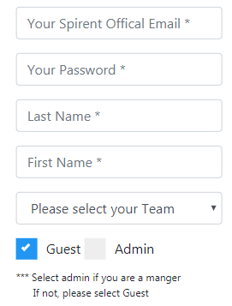When you register to system, your information (Spirent Email, Password, Name, Team, Guest/Admin) is saved to database. Currently, *SQLAlchemy* is used for the databse and password is encrypted by *bcrypt* module in *flask_bcrypt.*

### User Guide

1. Register to TS Management in order to use all the features.
2. When you register, you have to write Spirent official email for your ID.
3. Select which team are you belong to.
4. Select “Admin” if you are the manager of your team.   
   If not, select “Guest”

## Manage User Profile

### Description

To use the system, you have to add your TAS and TS to the system. Similar to your user information, when you add your TAS and TS, both information is saved to dabase. When you add TAS, database stores TAS address, your name and your team. When you add TS, TS address, located TS address, your name, dedicated TAS and basic information is added to its database. After adding TAS and TS list from the user Profile, you will see your TAS and TS list on your user file.

### User Guide

1. Press User Profile from the top-right navigation.
2. Press “Add”, type your TAS Address below and press “Confirm” which is located at the bottom side. If you have multiple TAS, please repeat this behavior.
3. Press User Profile once more to fill in the seond block.
4. Type TS list which you want to add. You can and only one TS by leaving the last box blank.
5. Type TAS Address to dedicate your TS. Your TS will be returned to specific TAS after the reservation
6. Press User Profile again. You will see your added TAS and TS list.
7. Since TS list is called by the API, you cannot remove the registered TS. Instead, you can remove your TAS by following   
   the procedure number 2 but change the action to “Remove”.

## Manage Common TAS/TS

### Description

Here you manage common TAS and common TS. Only Admin can control this feature and this is the reason why manager has to register account as “admin”. By using this feature, you can freely add and remove common TAS/TS. By removing Common TAS/TS, It won’t delete the address from the database. Instead, the deleted common TAS/TS change back to private TAS/TS. If you want to delete your TAS permanently, please use delet it on “User Profile”.

### User Guide

1. Please follow the description written on top. This tab is to modify common TAS/TS into TS management system. Only admin can add or remove the common system.
2. If you want to add common system, choose action “Add” . Select type and type address(es) of the s ystem you would like to add.
3. If you want to remove common system and change it back to private system, choose action “Remove”. Select type and type address(es) of the system you would like to remove.

## Reservation

### Description

* Sorted linked list is used for reservation function.
* Node in sorted linked list has following items:
* Data : Key value for sorting. It stores how much time left until the node is executed.
* TSaddress : Stores TS address to reallocate.
* TASToMove : Stores TAS address to reallocate
* StartingFlg : Represents whether the node is for starting reservation or finishing.
* ReservePeriod : Stores reserved period.
* reservingPerson : Stores the reserved user name.
* next : Point the next node
* In Node, Data and ReservePeriod stores integer value that remaining minutes from the current time to the target time divided by 5 and rounded up. For example:
* If 15 minutes left to the target time, Data and ReservePeriod store 3
* If 12 minutes left to the target time, Data and ReservePeriod store 3
* A timer is running on server and timer executes every 1 minute.
* Every 5 minutes, ‘Data’ in node decrease 1.
* 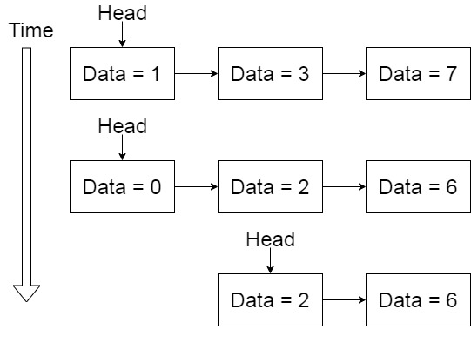If the ‘Data’ becomes 0, TS address, ‘TSaddress’ in the node reallocates to TAS address, ‘TASToMove’ in the node, and remove the node.

<HI>

* When reserve, two nodes are inserted to the linked list and the nodes have different values

1. Start Node – This node is for start reservation

* Data : Stores how much time left until the reservation start from now
* TASToMove : Stores TAS address of reserved user.
* StartingFlg : Stores ‘True’

1. Finish Node – This node is for finish reservation

* Data : Stores how much time left until the reservation finish from now
* TASToMove : Stores TAS address of original TS user.
* StartingFlg : Stores ‘False’
* When reserve, check whether the trying reservation is interferes other reservation.
* The information in sorted linked list is display on timetable in reservation page.
* User can check and cancel reservation in reservation page.
* If someone who has account for TS management takes the reserved TS while middle of reserve period, the server sends the notification e-mail to him.

### User Guide

In ‘Reservation’ page, you can see 4 components:

1. Displays TS list in this section. The tabs are divided by team.
2. Displays the reserve status of the TS. The types of status are:

* Available : Reservation for this TS is not existing.
* On going : The TS is reserved by someone and it is middle of reserved period.
* Display date : The TS is reserved by someone. The displaying date is the start time of the fastest reservation

1. The reservations for 12 hours from current hour is display in this section.
2. 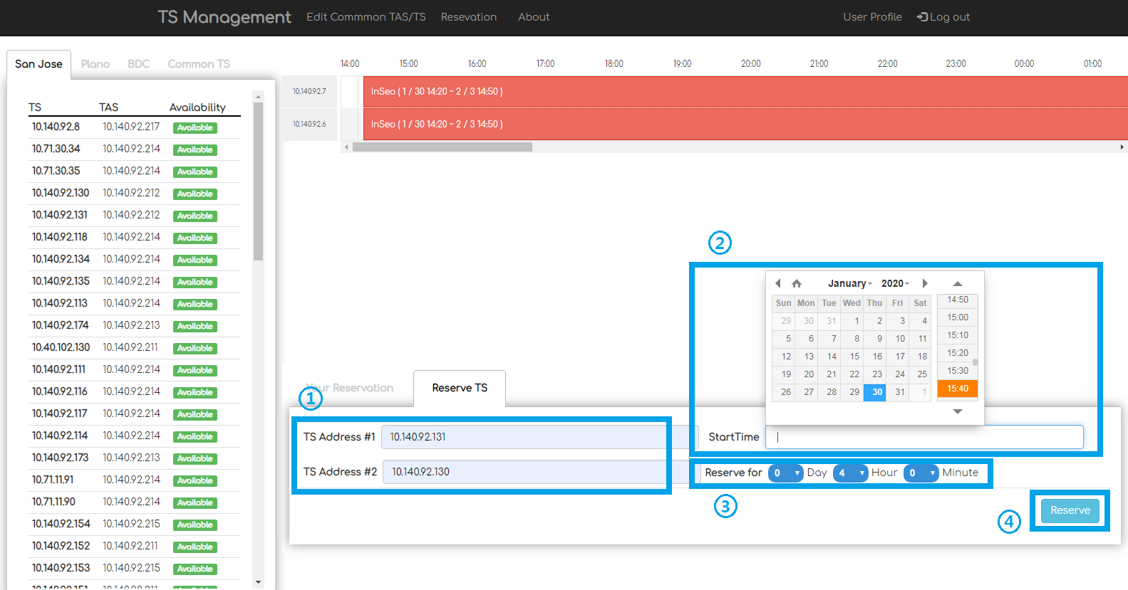List of reservations for current user is display in this section.

To reserve TS, follow the steps:

1. Enter the TS address to reserve. You can enter 1 or 2 addresses.
2. Select date and time from date-time picker. The picker will display if you click ‘Start Time’ textbox.
3. Set reservation period. You can set to 10 days, 23 hours, 55 minutes.
4. Press the ‘Reserve’ button

# Enhancement

1. Support One-Login system.
2. We should lock our system so that others can’t grab your system if you don’t want to
3. We should able to select date on the time table.
4. Support forget password template. (No way to find lost password currently)
5. Reduce the time it takes for TS to move to another TAS.
6. Time table should be sorted by TS addresses
7. TAS/TS list on user profile should be paired.
8. On the main page, TS should be paired.