## TEST 실행 시 아래 에러 나는 경우 FAILURE: Build failed with an exception.

* What went wrong:

Execution failed for task ':test'.

> No tests found for given includes: [jpabook.jpashop.MemberRepositoryTest](filter.includeTestsMatching)

* Try:

Run with --stacktrace option to get the stack trace. Run with --info or --debug option to get more log output. Run with --scan to get full insights.

* Get more help at https://help.gradle.org

* 아래 방법으로 해결 가능

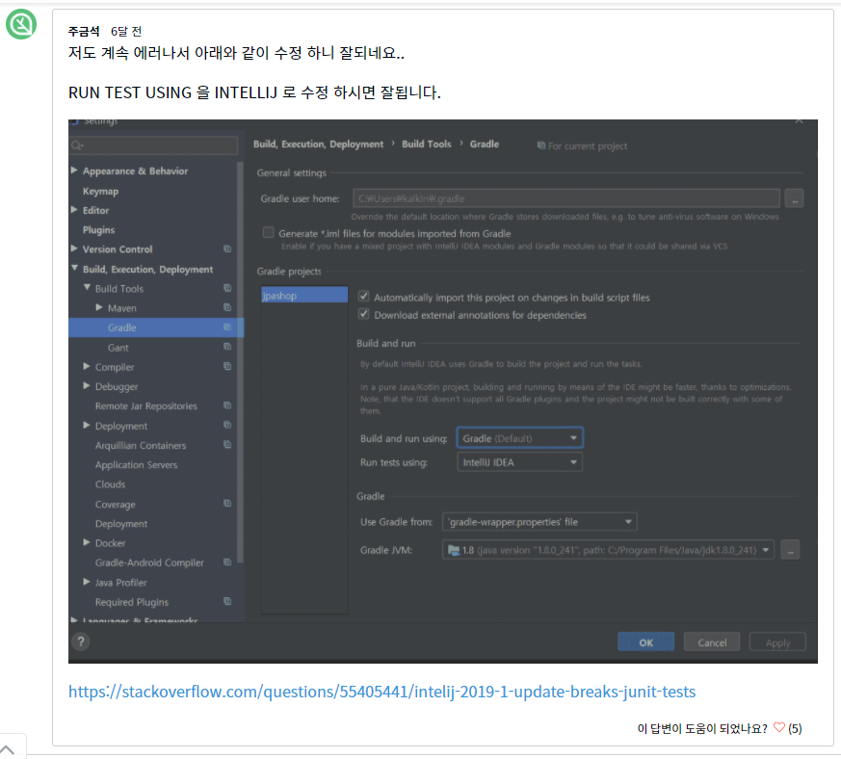

https://www.inflearn.com/questions/15495