This file is a guide on how to run figma prototype with interactive interactions and seeing how the flow of the User Interface (UI) should be.

On the top left side of the screen, you would be able to see the different pages which indicates the different roles for IT Administrator, Manager and Staff.

Below will be a screenshot of how the pages look like in Fig.1.

*Fig.1. Different Pages*

To set up for the interactive prototype flow and see the flow of the prototype as shown in Fig.2, follow the following steps:  
Step1: Navigate to the right panel as shown in Fig.3.

Step2: Select Prototype tab from the right panel as shown in Fig.4.

*Fig.2. Prototype flow*

*Fig.3. Right Panel*

*Fig.4. Selecting of prototype tab*

To run our team’s prototype, it is designed according to the screen size of a MacBook Pro 14 inch. Under the device dropdown, look for MacBook Pro 14 inch and select it as shown in Fig.5.

*Fig.5. Device list*

To run the prototype, you can click on the play button located at the top right of the navigation bar as shown in Fig.6.

*Fig.6. top right of navigation bar*

After clicking on the ‘play’ button, you should see something like Fig.7, to enter full screen Click on the top right corner which is indicated in Fig.7.

*Fig.7. Prototype presentation mode*

If you are not sure how the flow of the prototype flow, you can always click on the black area beside the device. Look out for a blue indicator on where to click. Or you can always use the arrow feature located at the bottom of the device as shown in Fig.8.

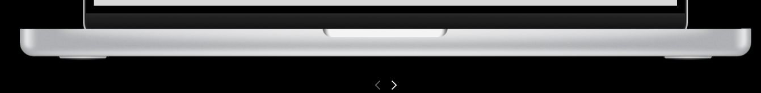

*Fig.8. Arrow indicator*

To start from a certain frame, you can click on that particular frame as shown in Fig.9 and click on the ‘play’ button and the flow would be starting from the frame that you have selected.

*Fig.9. Selection of frame*