CS2006 Python – Group Project 1: Classes and iterators in Python Report
Group 15

160012035, 160021429

Functionality

- All Basic Requirements Implemented – (twistedint.py)

- Additional Requirements

  - Easy:
    - First Easy Extension – Completed (easyextension.py)
    - Second Easy Extension – Completed (easyextension.py)
    - Third Easy Extension (Twisted Integers) - Completed (twistewdintegers.py)

  - Medium:
    - First Medium Extension (Iterating Twisted Integers) – Completed (midextension.py)
    - Second Medium Extension – Completed (midextension.py)
    - Third Medium Extension (Iterating Twisted Integers) – Completed (midextension.py)

  - Hard:
    - Matrices – Completed (Matrices.py)
    - Doctesting – Completed – Visible in all files apart from test files and Matrices and newTwist

  - Additional:
    - Made a new class (newTwist.py) that allows the user to create and reuse functions of adding and multiplying together newTwists (which are the same format as twistedIntegers)

<How to use the Makefile>

1. Documentation tests: make doctest
2. Unit tests: a) basic requirements: make unittestBasic
b) newTwist.py: make unittestNewTwist
c) Matrices.py: make unittestMatrix
3. Delete: make clean

Design and Implementation

Basic Requirements: To implement the twisted int, we simply made the class called TwistedInt, and overrode the init, add, mul, str, eq, ne and repr methods. The init, add, and mul methods checks if the arguments satisfy the condition, and raise the error if a given argument is invalid. The init method checks if the n value is greater than 0, and if the value of the twisted int is less than the n value. The add and mul method checks if the two operands use the same n value.

Easy Extension 1 & 2: In the easyextension.py file, we implemented 7 functions: findMul1, checkReverse, checkReverseAdd, checkReverseMultiply, checkReverseAddAndAdd, checkReverseMultiplyAndMult, and checkReverseNested. The findMul1 function finds all elements in the Zn, where x * x = <1:n>, and put all results in the list. The checkReverse function takes 2 arguments, n and commandNum. We used if else statement in the checkReverse function to check the value of the commandNum, and call the corresponding function. The checkReverseAdd function checks if any elements in the Zn satisfies the condition “x+y == y+x”. Similarly, the checkReverseMultiply function checks if any twisted int in the Zn satisfies the condition “x*y == y*x”. The checkReverseAddAndAdd function checks if any twisted int in the Zn satisfies the condition “(x+y)+z == x+(y+z)”, and the checkReverseMultiplyAndMult checks if any twisted int in the Zn condition “(x*y)*z == x*(y*z)”. Basically, I used multiple for loops, which starts from 0 to n-1, to test all twisted int objects in the given set.

Easy Extension 3 (Twisted Integers): For the third easy extension, we made the file that is called twistedintegers.py. In that file, we made the new class called TwistedIntegers which will represent Zn with respect to the operations “a + b = (val_a + val_b) mod n”, and “a * b = (val_a + val_b + val_a * val_b) mod n”, where “a = <val_a:n>” and “b = <val_b:n>”. The TwistedIntegers class has 7 methods: init, str, repr, Size, IntegerList, addTwoTwistedInt, and mulTwoTwistedInt. The init method sets the n value of the TwistedIntegers, and append all TwistedInt objects in the list, and store it as an attribute. The str method and repr method returns the list of TwistedInt objects, which will be used for the print function. The addTwoTwistedInt and mulTwoTwistedInt methods takes two arguments, which are the index of the operands. So, if the user call the addTwoTwistedInt with 2 arguments 3 and 4, it will calculate the operation “TwistedInt<2:n> + TwistedInt<3:n>” and return the result of the operation. The Size method returns the size of the TwistedIntegers, which would be n.

Medium Extensions: We implemented every required thing for the medium extension in the “midextension.py” file. We made the IteratorOfTwistedIntegers class for the first medium extension, and made the modArithmetic(n, f), addModArithmetic(n), and multModArithmetic(n) for the second and third medium extension. The IteratorOfTwistedIntegers is the class of iterator for the TwistedIntegers type object, which iterates the list of TwistedInt type objects. The iter and next method supports the iterating. The next method will check if the list has more elements, and raise the “StopIteration” when the list has no more element in it. Otherwise, the next method will return the next element.

The addModArithmetic function and the multModArithmetic calls the modArithmetic function, which uses the IteratorOfTwistedIntegers to find every element ‘e’ in the TwistedIntegers which satisfies the given condition: “e + a == a” or “e * a == a” for all ‘a’s in the Zn. In the addModArithmetic function, the modArithmetic function takes the “lambda m, i: m + i” as a parameter to check if the condition “e+a == a” is true. Similarly, in the multModArithmetic function takes the “lambda m, I : m * i” to check if the condition “e * a == a” is true.

Matrices: The way the Matrices class works is by, on creation, asking the user to immediately fill the matrix. The user inputs the values and the matrix fills itself with twisted ints. In both addition and multiplication it creates an empty set of lists in the correct size which are then filled and then turned into a matrix type. When adding matrices together it first checks that they are the right size and are both actually matrices, if two matrices with twisted ints with different values of n are added, as it does twisted int addition it will be caught in the twisted int class. Multiplication works by checking the sizes are correct to multiply, and checking the types are correct to multiply, either another matrix or a twisted int.

New Twist: This is a very complex class. It basically works by using mutually recursive functions (inspired by haskell logic) to create the expression. When creating the function it will recursively call between prompting the user to add a letter and add a symbol. By using recursion like this an invalid input can just recall the same function its in so that it will only accept a valid input. The user will then use q to evaluate the expression which returns the calculated value and saves the function to that instance. Brackets work correctly in this by having a recursive call as the value inside the recursive call, this allows the user to use as many nested brackets as they want. It can also reuse previously defined functions by reading over the saved input in a similar way to getting the users input

Current Problems
The only thing that we could not get working was being able to multiply a twisted int by a matrix, it works the other way around though.

Problems Encountered
One of the hardest parts of this practical was understanding what it was actually asking. For several of the extensions especially it would be quite unclear.
Medium extension.

It was quite tough to understand things that the specification asked us to do in the second and third medium extensions.
Implementing them was not too hard, just using the iterator that I made in the first medium extension with for loops.
After we implemented both second and third medium extensions, we thought that it would be better to make another function, which does the iterating thing for them. That is the reason why we made the modArithmetic function in the midextension.py file.

Moreover, the concept of the documentation testing was really weird to us. Understanding what the doc test is and how to use it was
a tough thing.
Figuring out how to do proper matrix multiplication was quite tricky, other than that getting it to return a matrix type object was quite tricky. This was because on creation of a matrix it requires a fair amount of user IO to create and that is not easily done. The solution was to, in the constructor, allow it to take if given a premade matrix.
NewTwist had several problems associated with it, the main one being brackets. To allow for brackets to be evaluated correctly a recursive call inside a recursive call had to be implemented.
Testing however might have been the most difficult part, the testing for the majority was fairly simple, reading in the outputted print was tricky but doable, the problem was with all the IO. After a long time, mock.patch, was used to mock the user input, with the side_effect returning the next thing in the list every time user input is asked for.

Provenance
All the code was written by us.

Working Demonstration
For these two type python3 into terminal before following instructions shown below
Matrices:
Creating Matrices
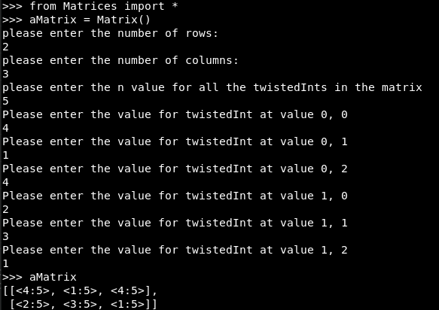
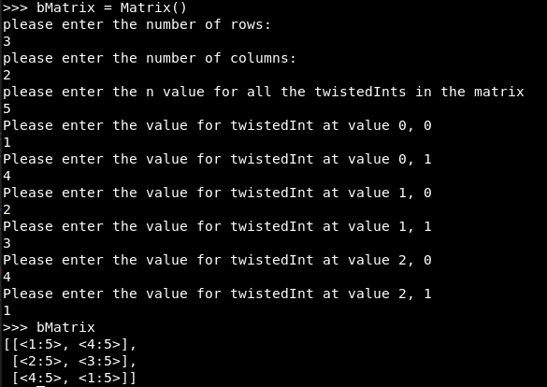

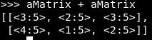
Adding Matrices

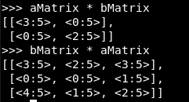
Multiplying Matrices by matrix

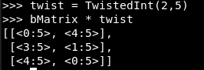
Multiplying Matrix by twisted int

NewTwist
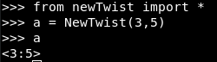
Creating New Twist:

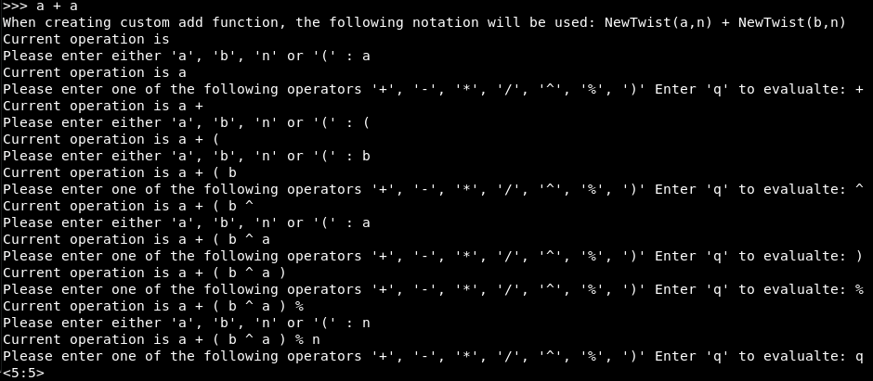
Creating add function:
Reusing Add function:
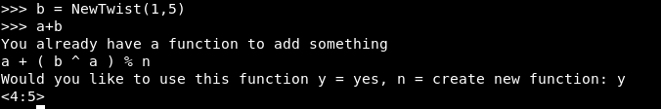
This works exactly the same for multiplication where it can save a separate function.

Below are the screen shots for the doc tests.

