Yerassyl Ibrayev SE-2425
REPORT
Web Technologies Assignment #6
Task 1. Selectors & CSS
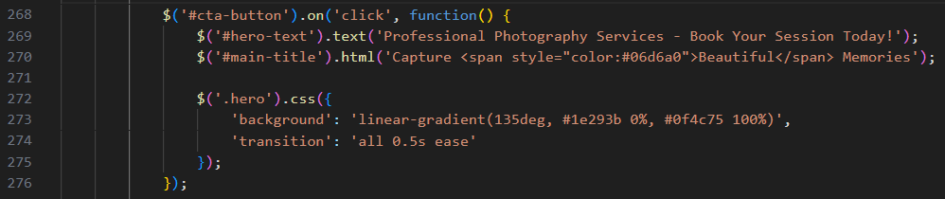
Task 2. Visibility Methods
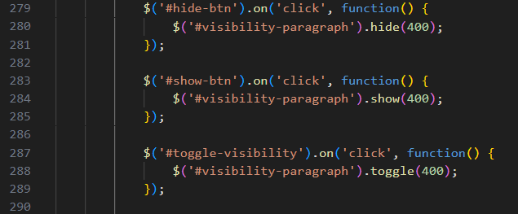
Task 3. Fade Methods
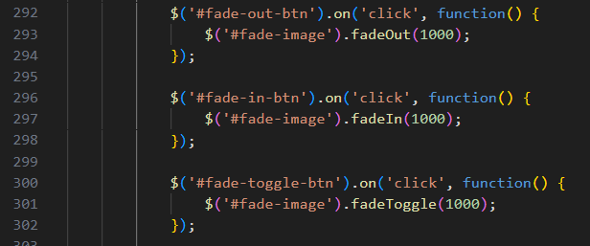

Task 4. Slide Methods
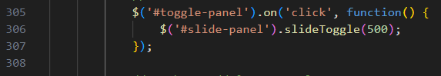
Task 5. Add & Remove Elements
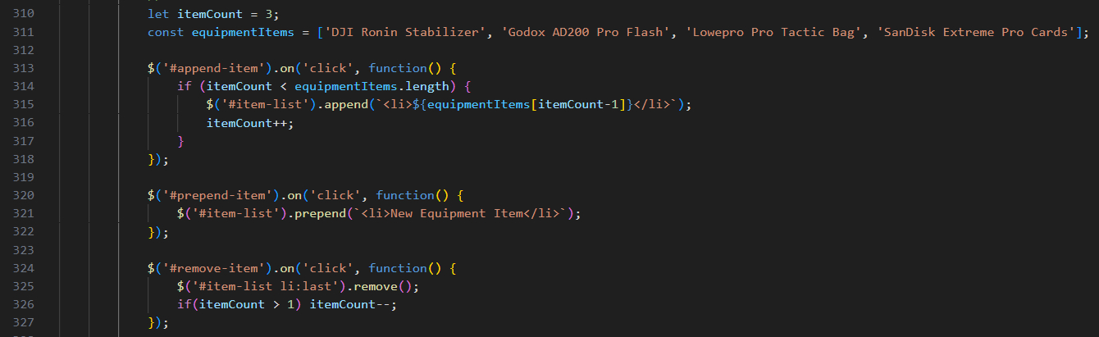
Task 6. Modifying Attributes
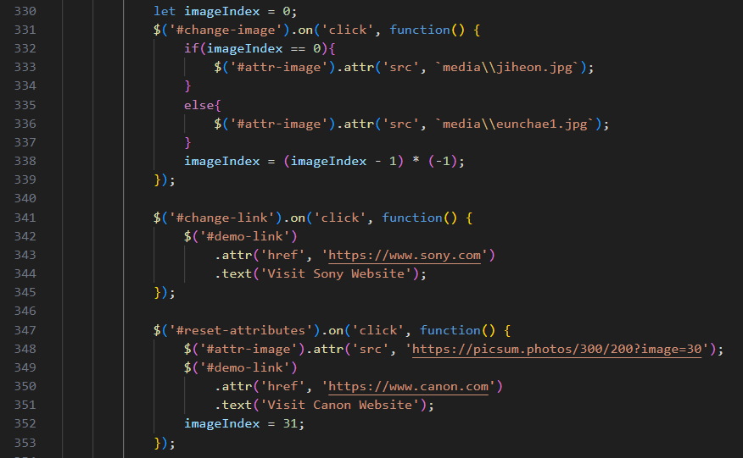

Task 7. Form Interaction
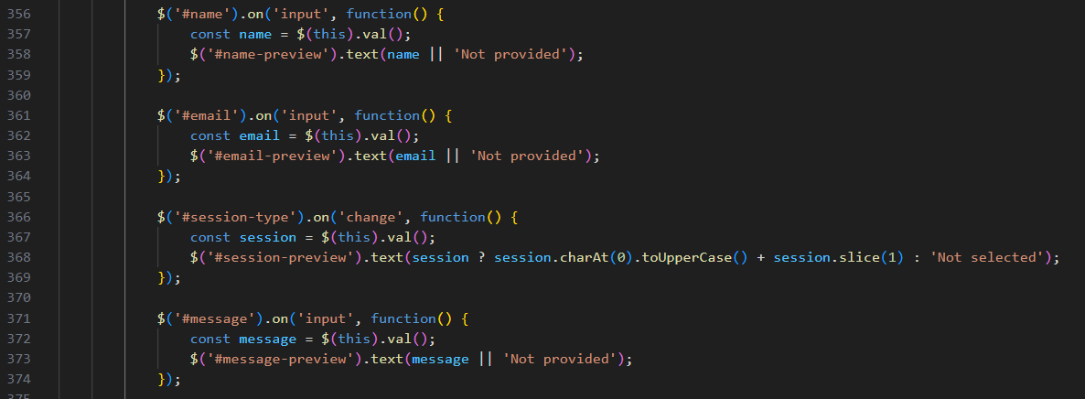
Part 4. Animations
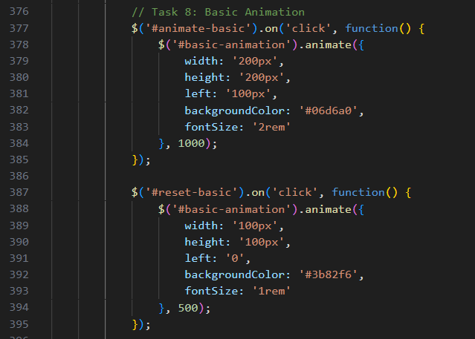
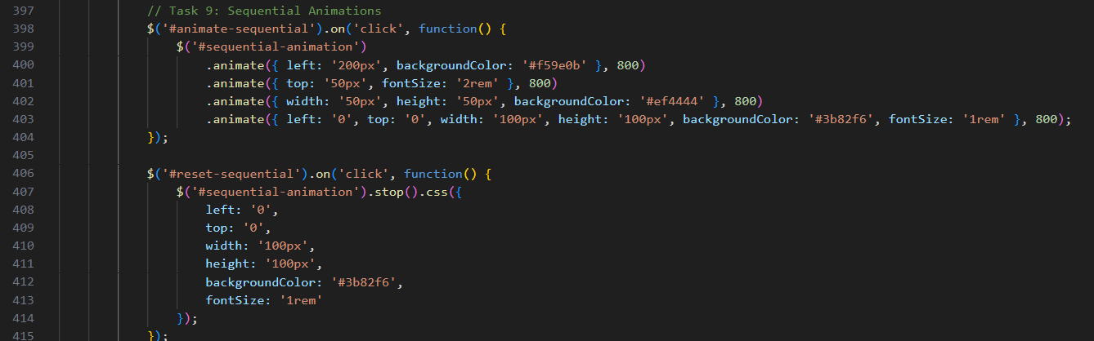
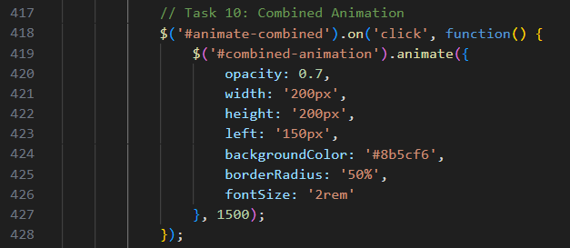
Task 11. Interactive jQuery Project
