Yerassyl Ibrayev SE-2425
REPORT
Web Technologies Assignment #8

- Project Structure & Pages
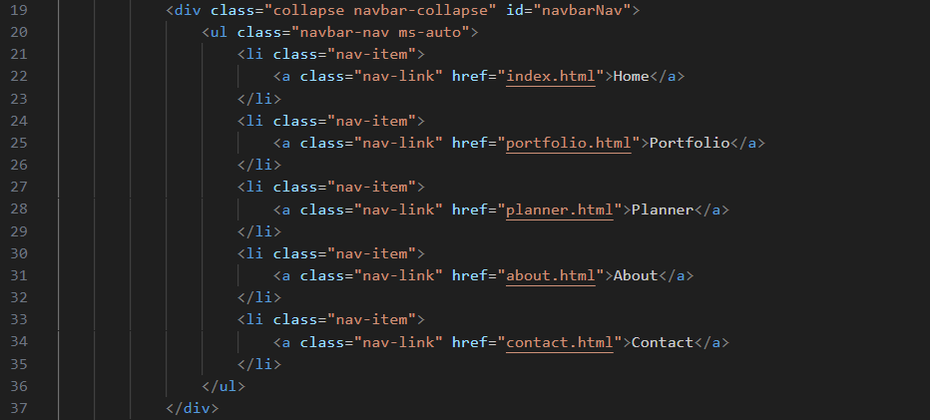
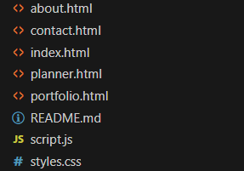

- Design Consistency
Every web-page links same css, jquery, bootstrap

- Responsive Layout
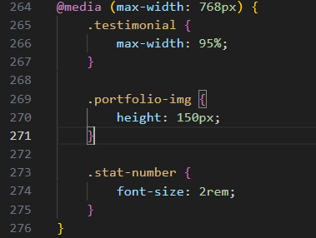

- Bootstrap Grid Usage
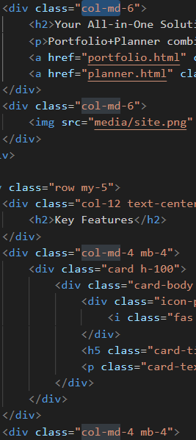
- JavaScript Functionality
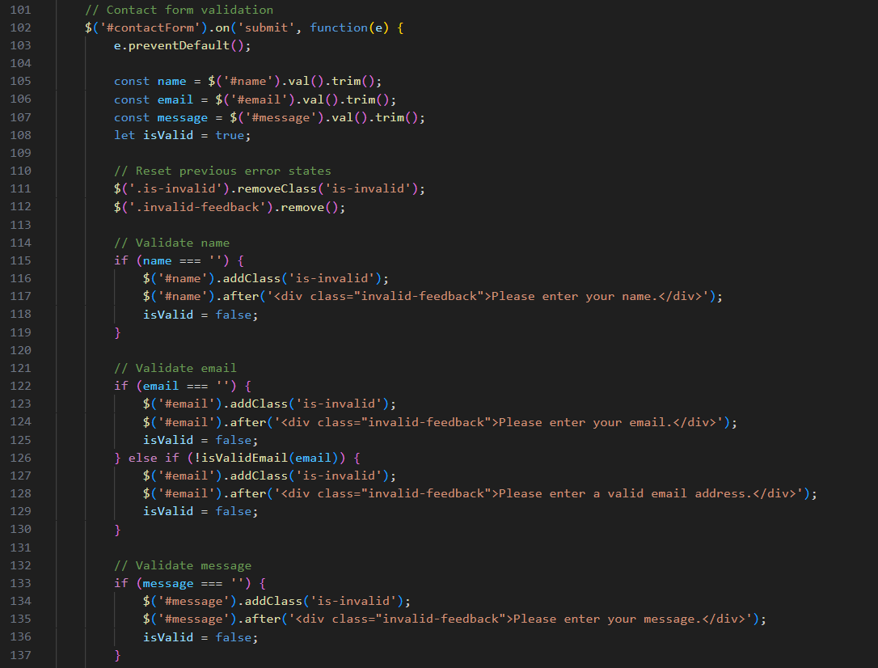

- jQuery Effects/Animations
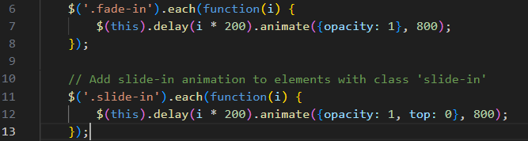

- Interactive Component

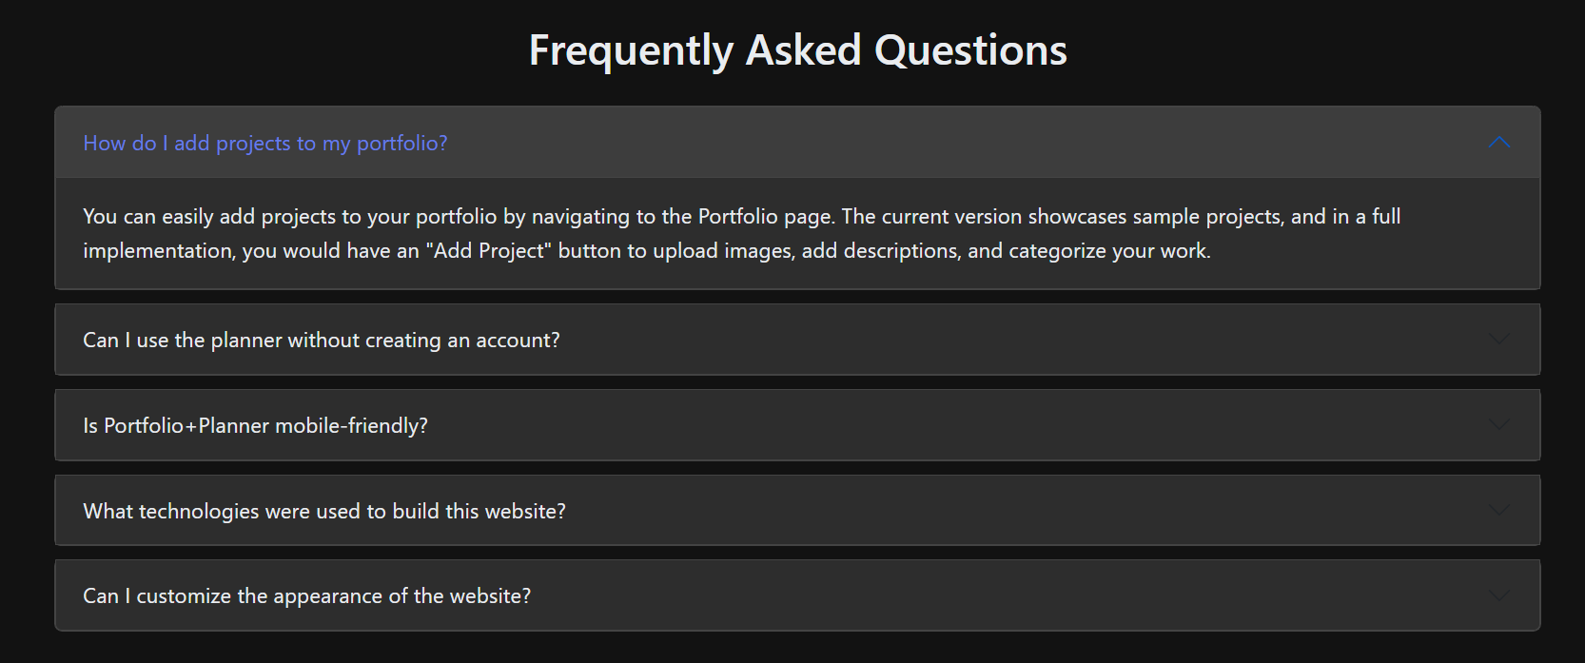

- Code Quality & Semantics
