1. **List the ordno and dollars of all orders.**

SELECT ordnum, totalUSD

FROM orders;

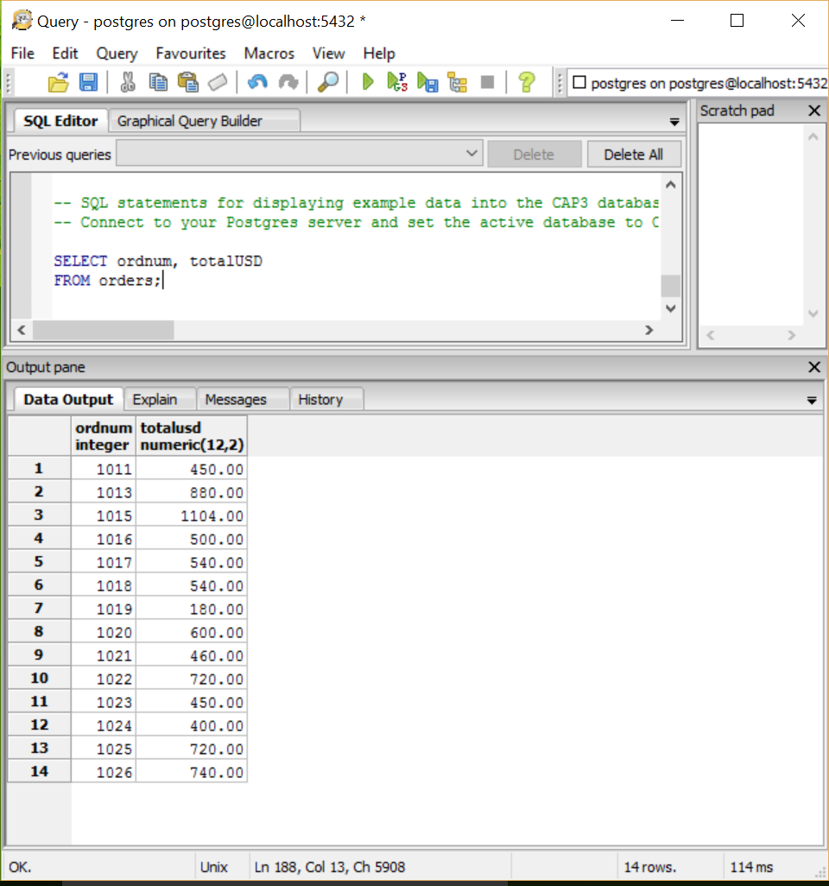

1. **List the name and city of agents named Smith**.

SELECT name, city

FROM agents

WHERE name = 'Smith';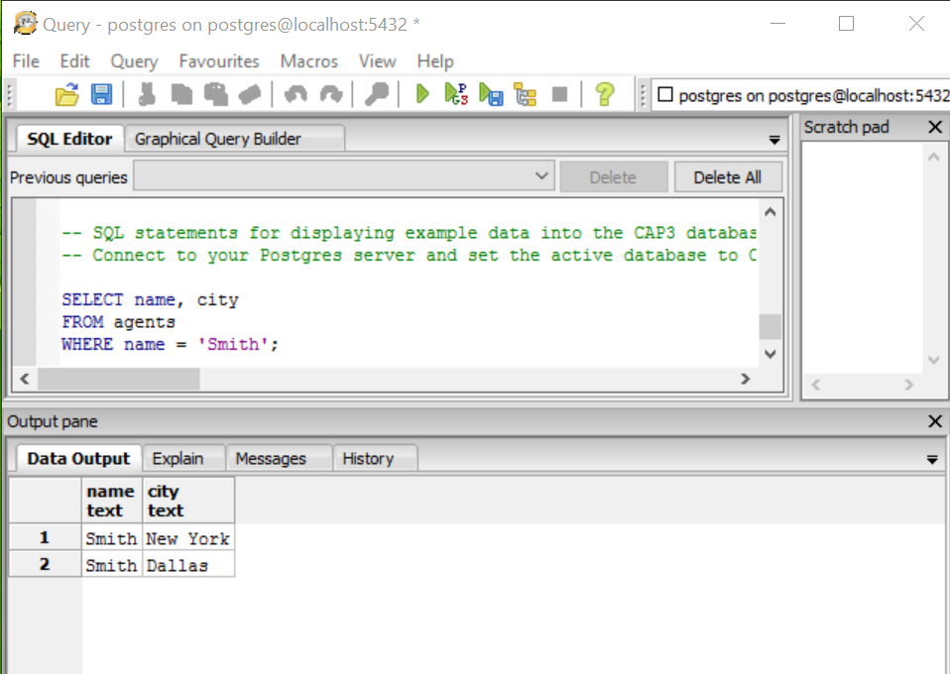

1. **List the pid, name, and priceUSD of products with quantity more than 208,000.**

SELECT pid, name, priceUSD

FROM products

WHERE quantity > 208000;

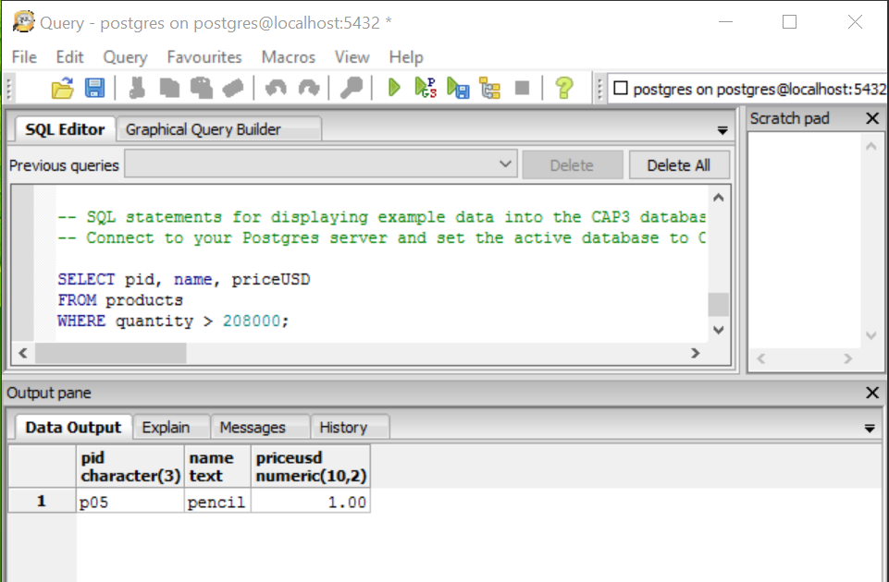

1. **List the names and cities of customers in Dallas.**

SELECT name, city

FROM customers

WHERE city = 'Dallas';

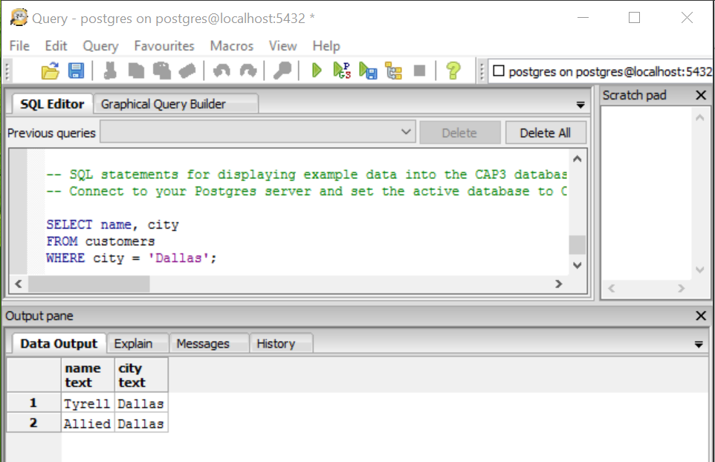

1. **List the names of agents not in New York and not in Tokyo.**

(SELECT name, city

FROM agents)

EXCEPT

(SELECT name, city

FROM agents

WHERE city = 'New York' OR city = 'Tokyo');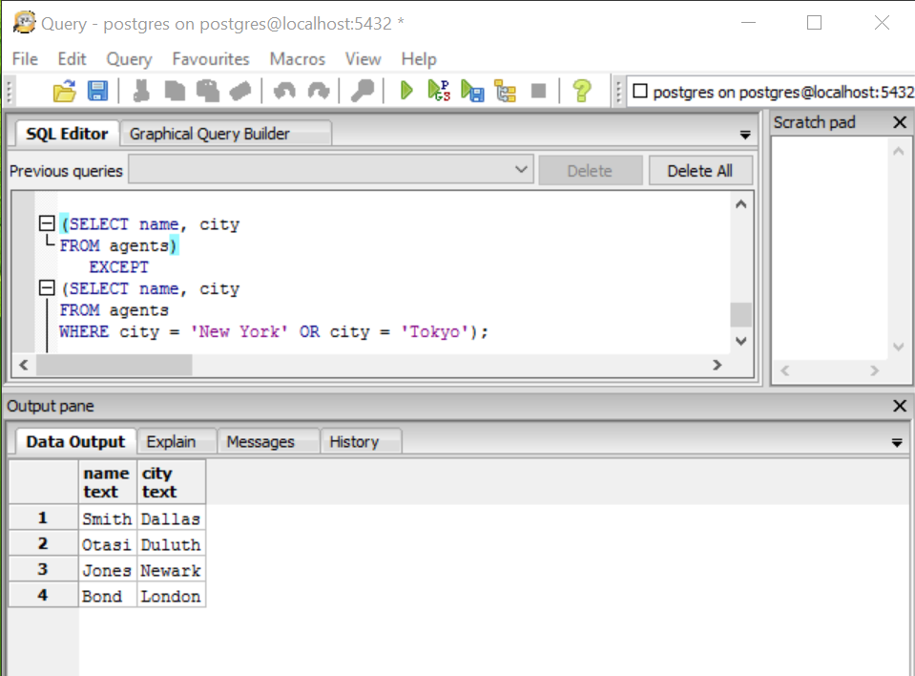

1. **List all data for products not in Dallas or Duluth that cost US$1 or more.**

(SELECT pid, name, city, quantity, priceUSD

FROM products)

EXCEPT

(SELECT pid, name, city, quantity, priceUSD

FROM products

WHERE city = 'Dallas' OR city = 'Duluth');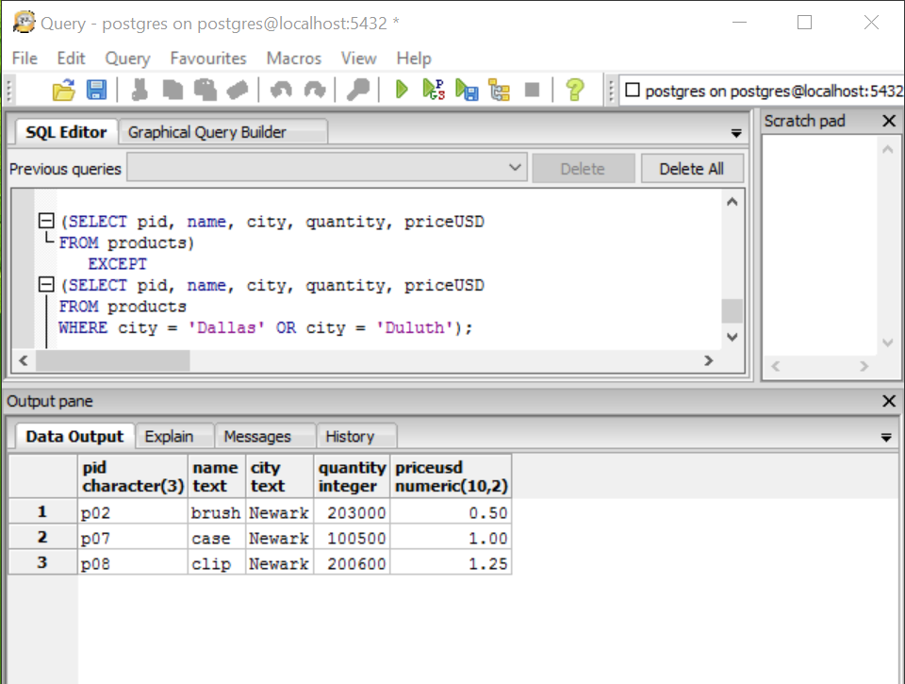

1. **List all data for orders in January or March.**

SELECT *

FROM orders

WHERE mon = 'jan' OR mon = 'mar';

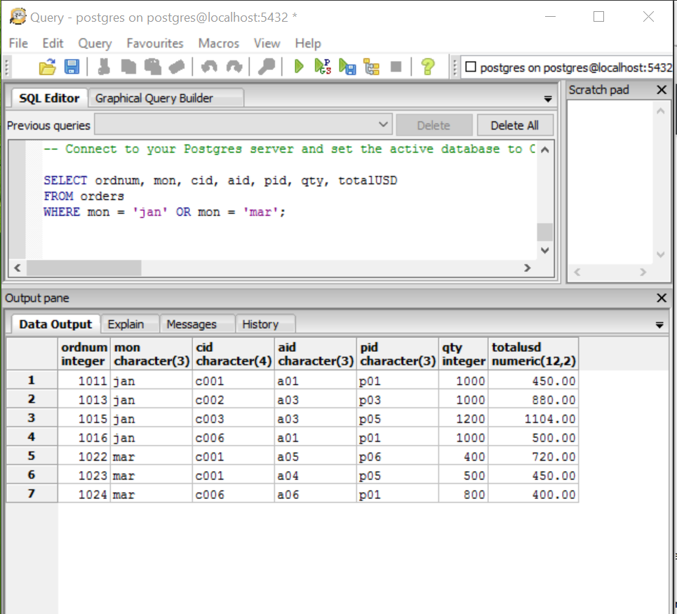

1. **List all data for orders in February less than us$500.**

SELECT *

FROM orders

WHERE mon = 'feb' AND totalUSD < 500;

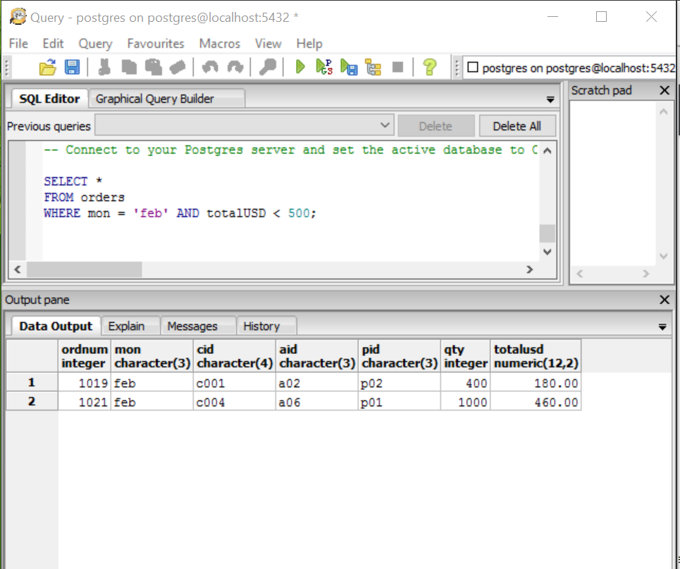

1. **List all orders from the customer whose cid is C005.**

SELECT *

FROM orders

WHERE cid = 'c005';

