**Laboratory work 3**

**We continue to work with the database from the previous laboratory works.**

**Take a full-page screenshot that covers the code and results of each task.**

**Tasks**:

1. Select all the data of passengers whose last name is same as first name 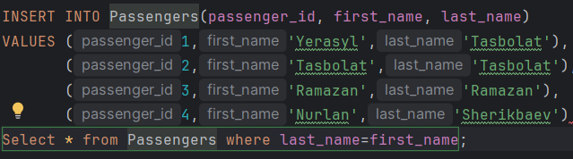
2. Select the last name of all passangers without duplicates. 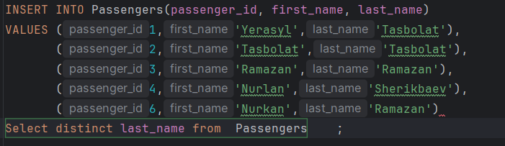
3. Find all male passengers born between 1990 and 2000.(10%) 
4. Find price of tickets sold for each month in sorted way.(10%) Изображение выглядит как текст, снимок экрана, Шрифт

   Автоматически созданное описание
5. Create a query that shows all flights flying to ‘China’.(10%) 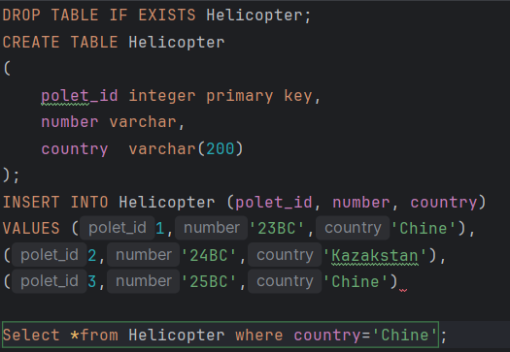
6. Find all airline names based in Kazakhstan.(10%) 
7. Reduce the cost of booking price by 10% created before ’12-12-2010’ .(10%) 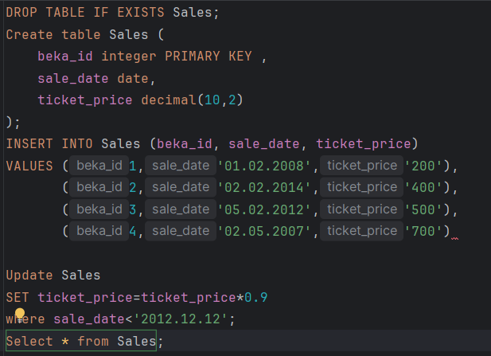
8. Find top3 overweighted baggage with more than 25kg.(10%) 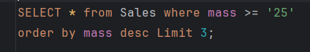
9. Find the youngest passengers’ full name.(10%) Изображение выглядит как текст, Шрифт, снимок экрана, Графика

   Автоматически созданное описание
10. Find the cheapest booking price in each booking platform.(10%) Изображение выглядит как текст, снимок экрана, Шрифт, линия

    Автоматически созданное описание