$ssh -i your-key.pem ec2-user@<your-ec2-public-ip>
install docker

$sudo dnf update -y
$sudo dnf install docker -y
$sudo systemctl enable docker
$sudo systemctl start docker
$sudo usermod -aG docker ec2-user
Test Docker –
$docker version

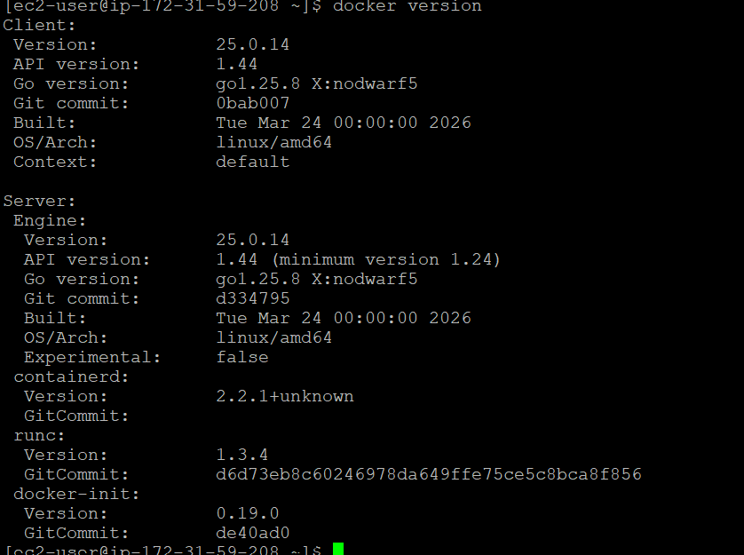

$docker images
$docker run hello-world
$docker ps
$docker ps -a --- exited containers
$docker ps -aq ---- exited container ids
docker ps -q --- container id
$docker ps $(docker ps -aq) ---to remove
$docker image -q ----- gives image ids
$docker rmi $(docker rmi -q)

For Pull images from docker hub : for public image no need of log in
$docker images
$docker pull stacksimplify/retail-store-sample-ui:1.0.0

Run Docker image
Copy the Docker image name from Docker Hub or GitHub Packages.
HOST_PORT: The port number on your host machine where you want to receive traffic (e.g., 8888).
CONTAINER_PORT: The port number within the container that's listening for connections (e.g., 8080).
To run image as a container :
$docker run --name <CONTAINER-NAME> -p <HOST_PORT>:<CONTAINER_PORT> -d <IMAGE_NAME>:<TAG>
# Example using Docker Hub image:
docker run --name myapp1 -p 8888:8080 -d stacksimplify/retail-store-sample-ui:1.0.0
# Or using GitHub Packages image:
docker run --name myapp1 -p 8888:80 -d ghcr.io/stacksimplify/retail-store-sample-ui:1.0.0
-d --- detach mode
No to access application :
http://EC2-Instance-Public-IP:8888/
Flow:
Browser EC2 public IP : 8888 docker host port : 8888 Container port : 8080
Docker Commands
$docker exec -it <CONTAINER-NAME> /bin/sh ---- Connect to the container's terminal
$docker exec -it myapp1 /bin/sh
-it serves different ------ -i → Interactive (Keep STDIN open)
Keeps the standard input (STDIN) open even if you’re not actively typing.
Allows you to send input to the container.
Without -i, you wouldn’t be able to type commands inside the shell.
-t → Allocate TTY (Terminal)
Allocates a pseudo-terminal (TTY).
Gives you a proper terminal interface (like a real Linux shell).

# Inside the container, you can run the following commands:
## Basic OS Info
uname -a --- Kernel version and system details
cat /etc/os-release --- Check base OS details
whoami --- See current user (usually 'root')

## File System + App Structure
pwd -----Current directory (usually /)
ls --- List files
ls -l /app -----Check where app.jar is located (if /app is used)

## Java Runtime
java -version ----- Verify Java is installed and check version

## Test Application (from inside container - Container port 8080)
$curl http://localhost:8080 ----- Send a request to the app running inside

## Exit container shell
exit ---- Exit from /bin/sh back to host shell
$docker exec -it myapp1 ls ----- List files/folders in the container's root directory

# Test if the application is running inside the container
$docker exec -it myapp1 curl http://localhost:8080 --- ----- Sends a request to the app on port 8080 (internal container port)

How to stop and start container and test
$docker stop myapp1 -----Stop a running container
docker ps ----- Verify the container has stopped
curl http://<EC2-Instance-Public-IP>:8888 ----- Test if the application is down
$docker start myapp1 ----start container

$docker rm myapp1 --- remove container
$docker rm -f myapp1 --- stop and remove container
$docker rmi <image id > --- remove image with id mentioned
$docker rmi <image name >
Note: Docker Hub vs. GitHub Packages: If you encounter Docker Hub pull rate limits, consider using GitHub Packages (ghcr.io) as an alternative.

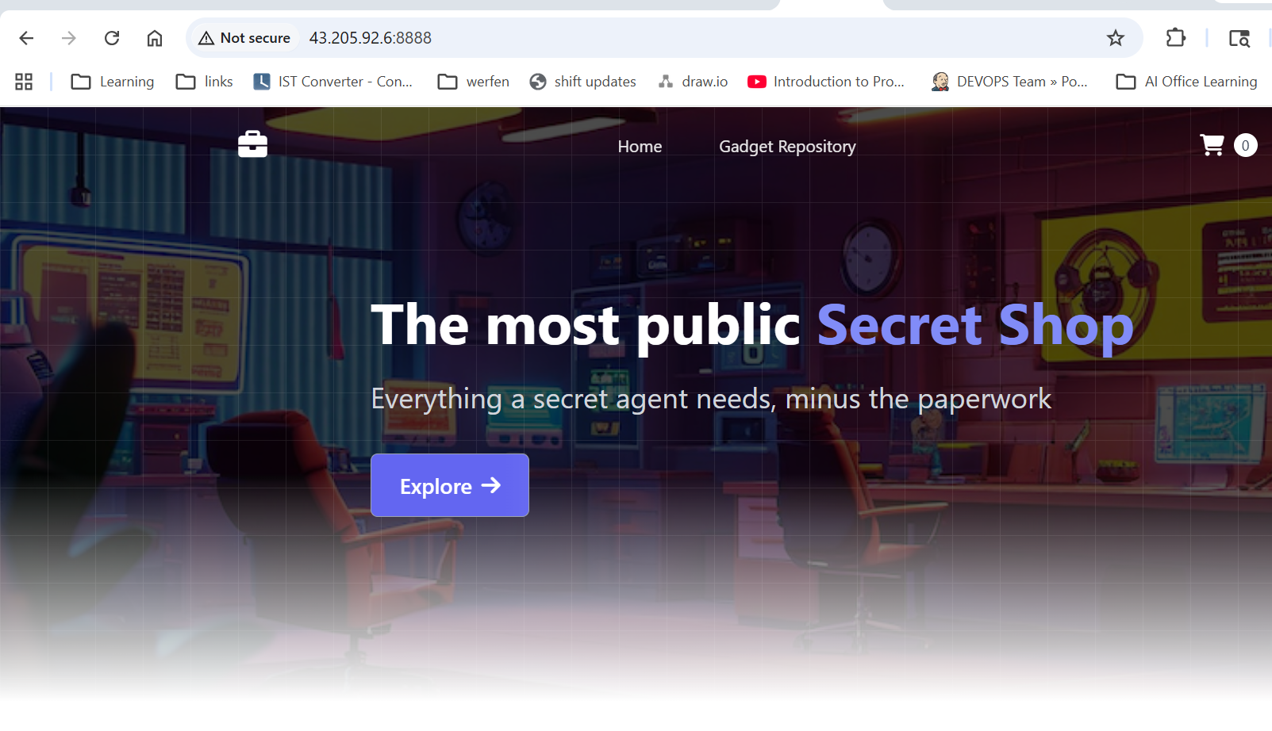

Section : 02-03 Build docker image and Push to docker hub

Svc -UI , Dockerfile
First do docker login
# Create a Folder
mkdir demo-docker-build
cd demo-docker-build
# Download the Application Source
wget https://github.com/aws-containers/retail-store-sample-app/archive/refs/tags/v1.2.4.zip
# Unzip Application Source
unzip v1.2.4.zip
# Make change to file home.html
cd /home/ec2-user/demo-docker-build/retail-store-sample-app-1.2.4/src/ui/src/main/resources/templates
We are making a change for UI stating V2 at line
# List to Verify if we are at that file
ls home.html
ls -lrt

# Changes we are doing
## Before
The most public <span class="text-primary-400">Secret Shop</span>
## After
The most public <span class="text-primary-400">Secret Shop - V2 Version</span>
# Command to Make That Change via Terminal
sed -i 's/Secret Shop<\/span>/Secret Shop - V2 Version<\/span>/' home.html
-i stands for in-place editing.
# Verify It Worked:
grep 'Secret Shop' home.html

Will do some changes in home.html --- added name pooja Yerawar
Now build docker file to test changes
# Change to the directory containing your Dockerfile
cd /home/ec2-user/demo-docker-build/retail-store-sample-app-1.2.4/src/ui

# Verify Dockerfile before starting the build
ls -lrt Dockerfile
cat Dockerfile
# Build the Docker image
docker build -t <IMAGE_NAME>:<TAG> .
# Example:
docker build -t retail-store-sample-ui:2.0.0 .
docker images

# Run the Docker container and verify
docker run --name <CONTAINER-NAME> -p <HOST_PORT>:<CONTAINER_PORT> -d <IMAGE_NAME>:<TAG>
# Example:
docker run --name myapp1-v2 -p 8889:8080 -d retail-store-sample-ui:2.0.0

# Access the application in your browser
http://<EC2-Instance-Public-IP>:8889
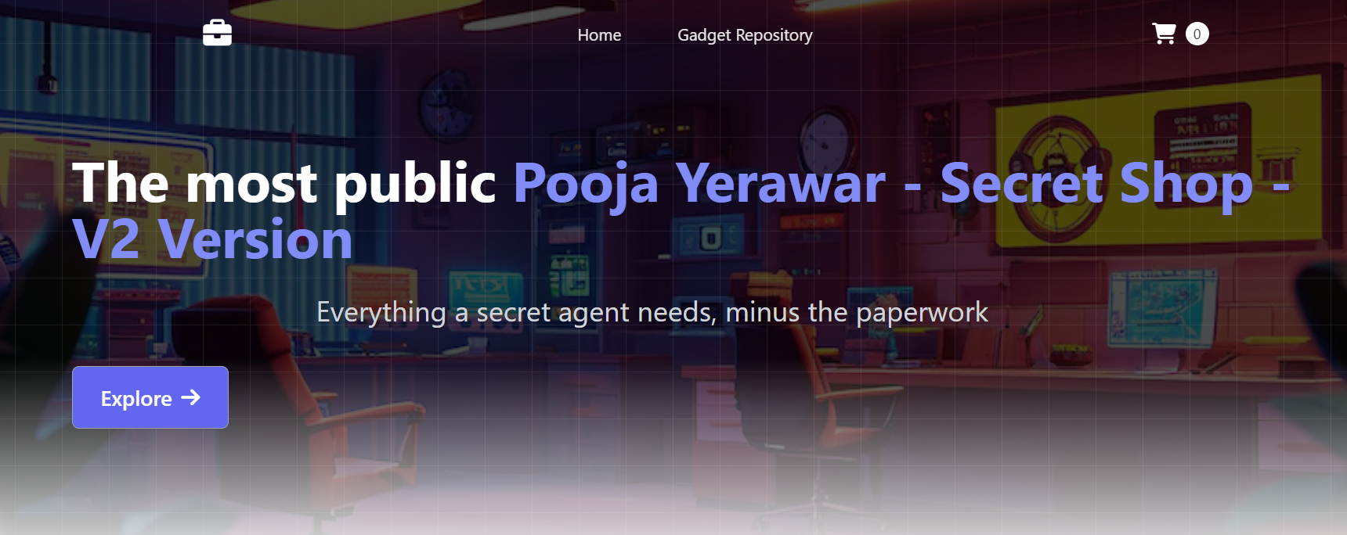
#Also run
$docker run --name myapp1 -p 8888:8080 -d stacksimplify/retail-store-sample-ui:1.0.0
To compare old image UI
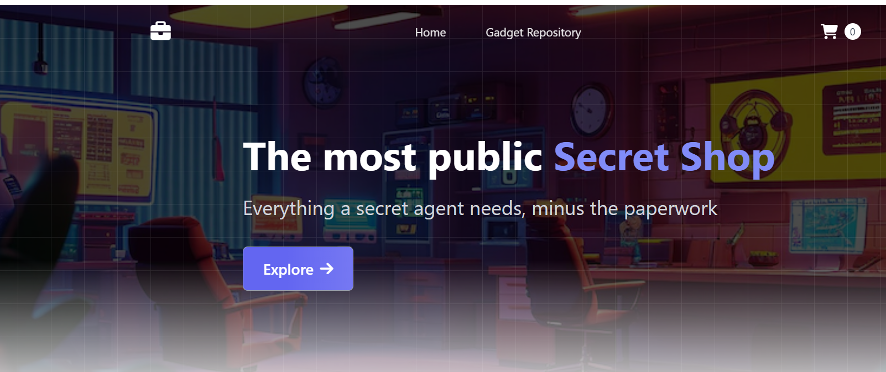
## RUN Container: 1.0.0 version on Host port 8888 (TO COMPARE WITH 2.0.0)
# Example using Docker Hub image:
$docker run --name myapp1 -p 8888:8080 -d stacksimplify/retail-store-sample-ui:1.0.0
# Or using GitHub Packages image:
$docker run --name myapp1 -p 8888:80 -d ghcr.io/stacksimplify/retail-store-sample-ui:1.0.0
Tag and push image to your docker hub :

# Tag the Docker image
docker tag retail-store-sample-ui:2.0.0 YOUR_DOCKER_USERNAME/mynginx-custom:2.0.0
$docker tag retail-store-sample-ui:2.0.0 username/retail-store-sample-ui:2.0.0
# Push the Docker image to Docker Hub
docker push username/retail-store-sample-ui:2.0.0

Section5: Section3: Docker files
.dockerignore
Specify files which don’t want in final build
$docker builder prune –all --- cleans any previous cache
$cd retail-store-sample-app-1.2.4/src/ui
$build docker image
$docker build -t retail-ui:9.0.0 .
$docker run -d --name retail-ui -p 8080:8080 retail-ui:9.0.0
$docker ps
http://<EC2-Instance-Public-Ip>:8080/actuator/health
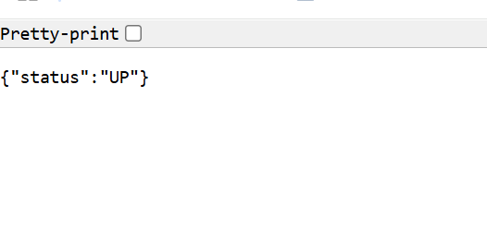
http://<EC2-Instance-Public-Ip>:8080/topology
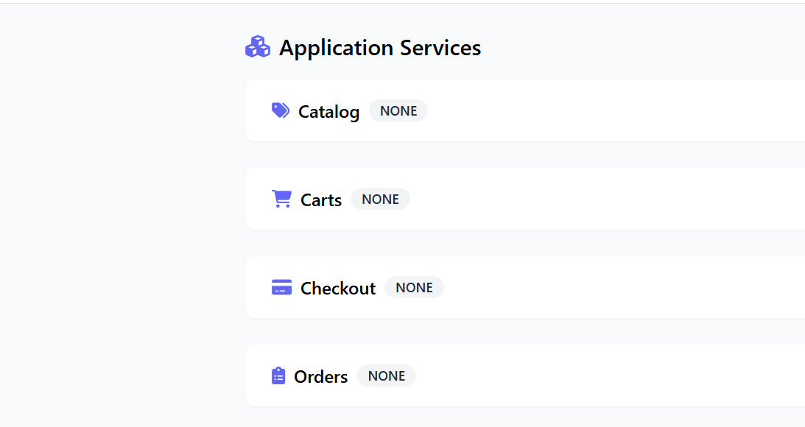
#Analyze the image – as we used multi-stage docker builds we have not copied src and mvn to our final docker image
# Connect to Docker Container
docker exec -it retail-ui sh
# Inside the container
which mvn ---- should return "sh: which: command not found"
ls /src ----- should say "No such file or directory"
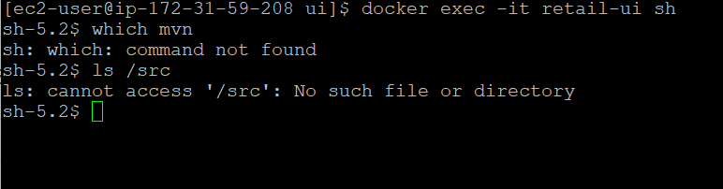
Stop and Clean up all images and container
Docker Layer Caching (Build Optimization)
Docker builds images in layers, and each instruction (RUN, COPY, ENV, etc.) becomes a separate layer.
Docker skips redundant steps by reusing cached layers
If you want to rebuild from scratch and ignore cache: (if we see uncertain issues, sometime caching also cause some issues)
docker build --no-cache -t retail-ui:10.0.0 .
Remove All Build Cache**
docker builder prune
Remove ALL Build Cache (including unused images and layers)
docker builder prune --all
docker builder prune --all -f ---- -f to confirm without prompt, This will clear all cache layers, including those from old builds or untagged images.
Clean Everything Unused (Stopped containers, volumes, networks, cache, images)**
docker system prune
$docker system prune -–volumes -----To clean everything including volumes
$docker system prune -a --volumes -f ----- Full Clean-Up (DISASTER OPTION) , -f for full cleanup with no prompt

