Section8 : Section6 (1-4)
Terraform Tools
For Windows :

Install Terraform CLI
- Download Terraform
- Unzip the package
- Create new folder terraform-bins
- Copy the terraform.exe to a terraform-bins
- Set PATH in windows
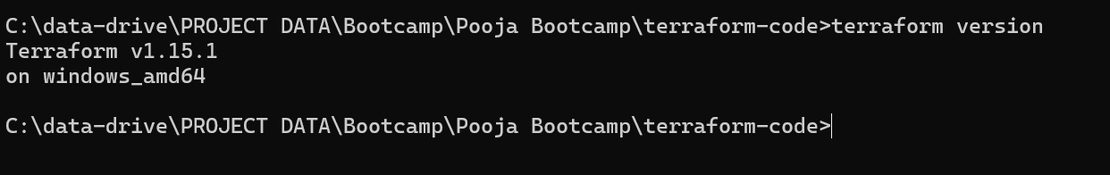
VS code with hashicorp extension so that will get autocomplete functionality
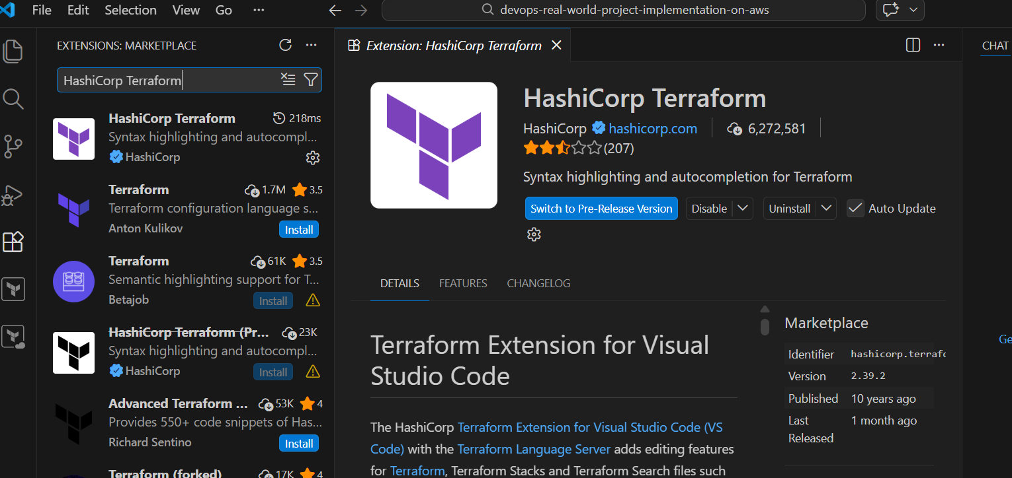
Install AWS CLI
For Amazon EC2 Linux machine:
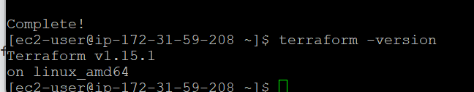
Configure AWS CLI
For code reference: registry.terraform.io
# Terraform Block
terraform {
required_version = ">= 1.0.0" ---terraform version for CLI
required_providers {
aws = {
source = "hashicorp/aws"
version = "~> 6.0" -----cloud platform plugin version
}
random = {
source = "hashicorp/random" ----s3 bucket as it’s a global service
version = "~> 3.0" -------- ~> is only allow 3.x not 4.x etc
}
}
}

# Provider Block
provider "aws" {
region = "us-east-1" ----cloud platform details
}

Resource Block:
# Resouruce Block: Random String
resource "random_string" "suffix" { ---- As s3 bucket is global resource and name might already in use so we need to make it unique so we will use random string resource block

length = 6
special = false
upper = false
}

# Resource Block: AWS S3 Bucket
resource "aws_s3_bucket" "demo_bucket" { -------“resourcetype” “local name”
bucket = "devopsdemo-${random_string.suffix.result}"

tags = {
Name = "DevOps Demo Bucket"
Environment = "Dev"
# Owner = "Kalyan Reddy"
# Organization = "StackSimplify"
}
}
Local name is used to take reference and you can call in any other resource block
Output Block
# Output Block
output "s3_bucket_name" {
value = aws_s3_bucket.demo_bucket.bucket
}

output "s3_bucket_id" {
value = aws_s3_bucket.demo_bucket.id
}

output "s3_bucket_arn" {
value = aws_s3_bucket.demo_bucket.arn
description = "S3 Bucket ARN"
}

It is used to print values after the successful terraform apply
This is very helpful when you want to see important information quickly like id, arn, etc
random refers to a Terraform provider called the Terraform Random Provider.
It is used to generate random values such as:
- Strings
- Numbers
- Passwords
- IDs

$terraform init ---download required plugins for provider and initialize terraform as mentioned in c1-version.tf --- download terraform plugin in .terraform folder
This will create .terraform.lock.hcl file --- this ensure consistency because if someone else in your team runs the same on they will get same version on production avoiding surprises
This also contain hashes which are cryptography checksum hich terraform provides and uses to verify the provider hasn’t tampered with.
This is for security and reliability.
Every time check in this file with your terraform code.
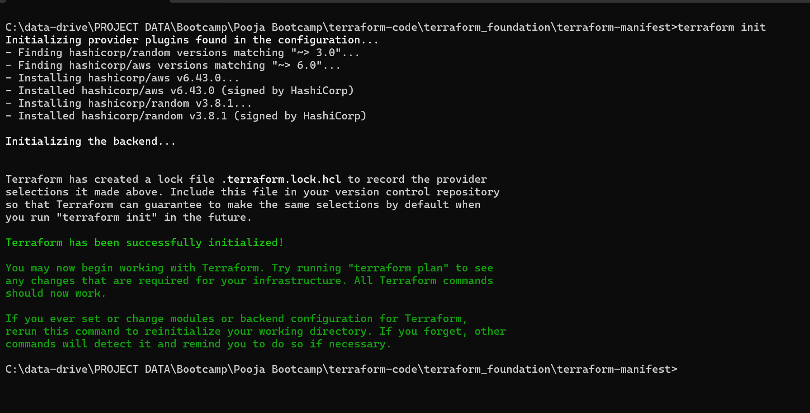
$terraform validate --- this will validate your terraform code is syntactically correct and internally consistent also validate the references are correct
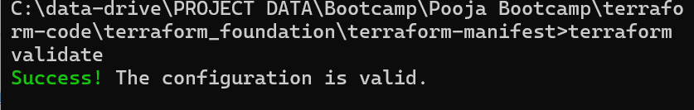
Now we change and give wrong reference it will throw an error as below
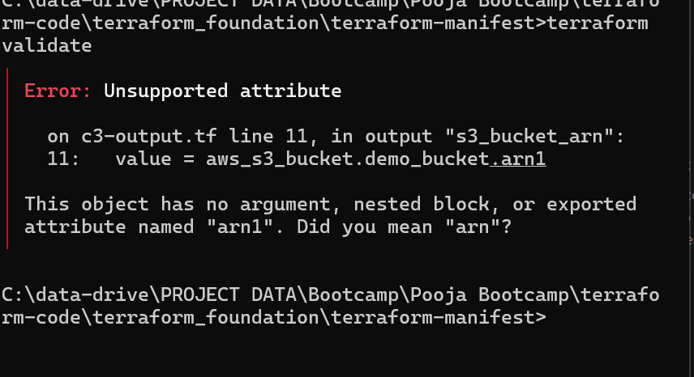
$terraform plan ---dryrun or preview what your code will do , shows impact
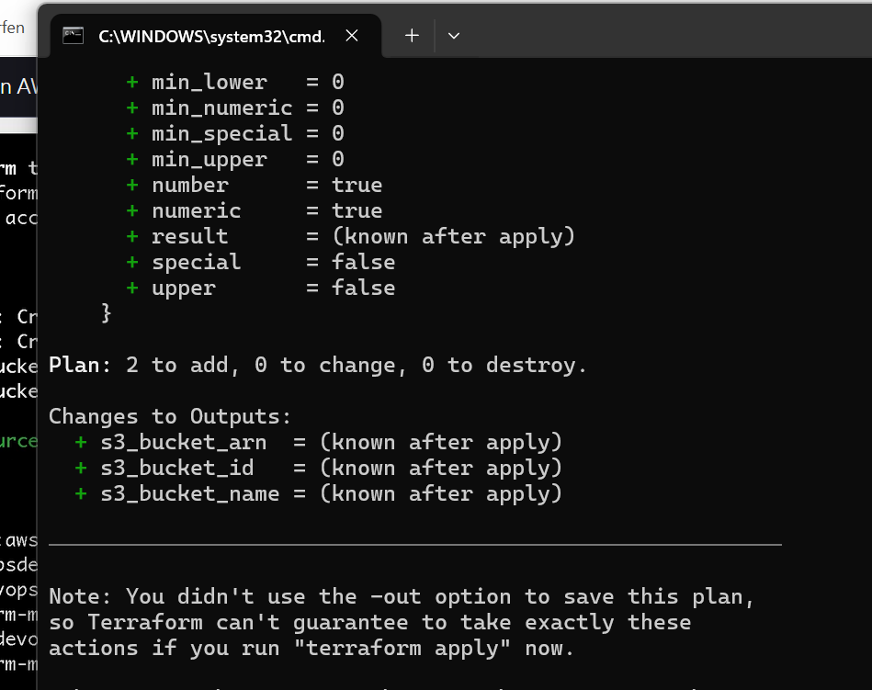
$terraform apply
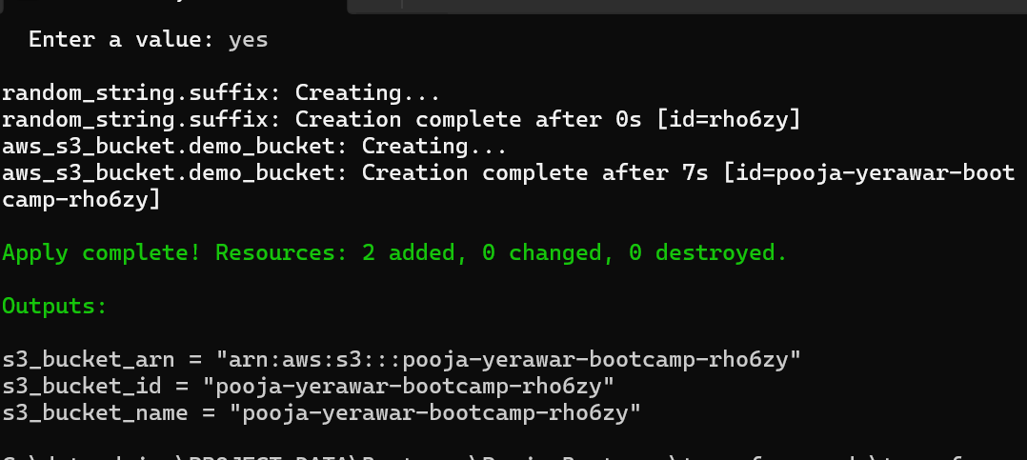
$terraform output
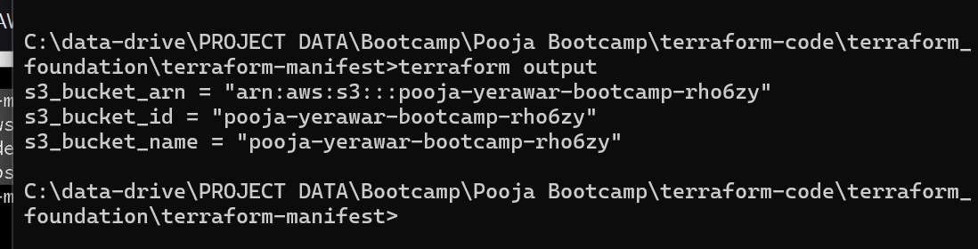
Now if you change and run terraform plan and then apply it will do in-place , it will not run everything , only the changes will apply
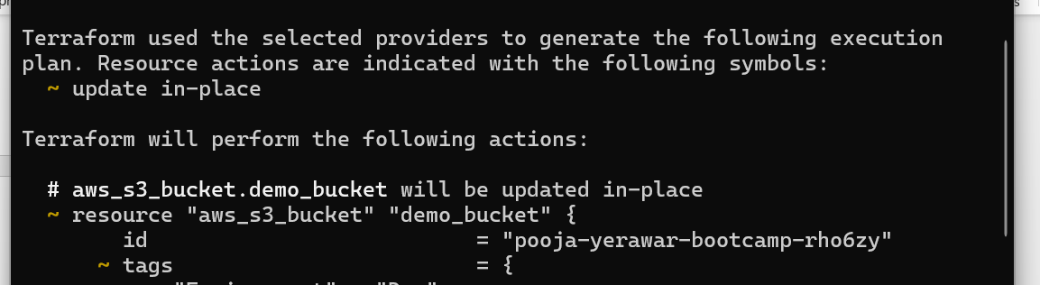
Can use -auto-approve --- but not recommanded
$terraform destroy ---to remove or clean up resources created by terraform apply
Or $terraform apply -destroy
This will generate destroy plan and prompt for confirmation to destroy resource
$terraform plan -out=s3planv1 ----this will useful when you want to give same code to apply in any other environment if you run terraform apply it run the same plan and apply it and create same resource
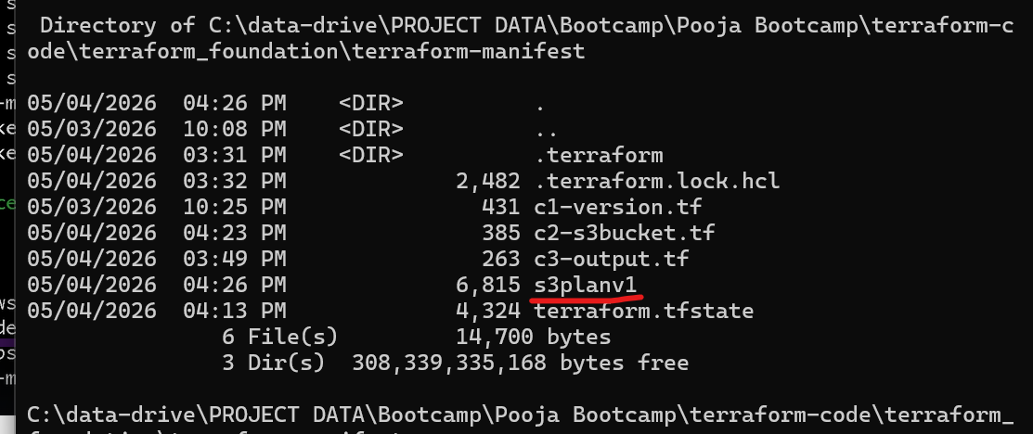
$terraform apply s3planv1
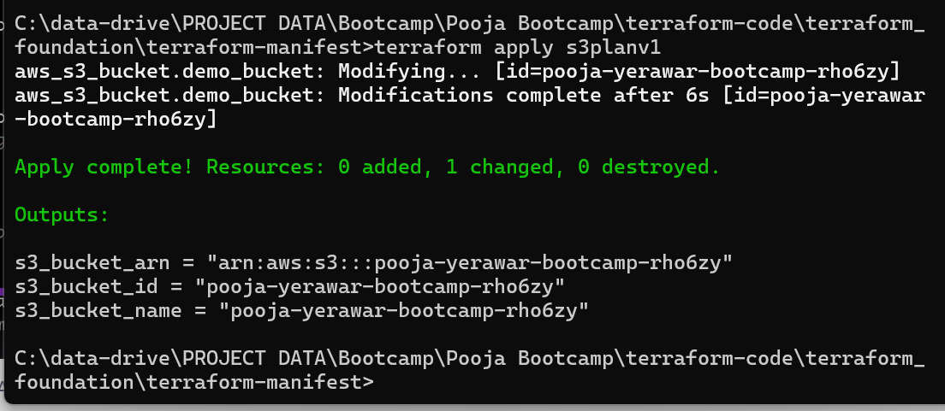
To review plan file which is in binalry is
$terraform show s3planv1
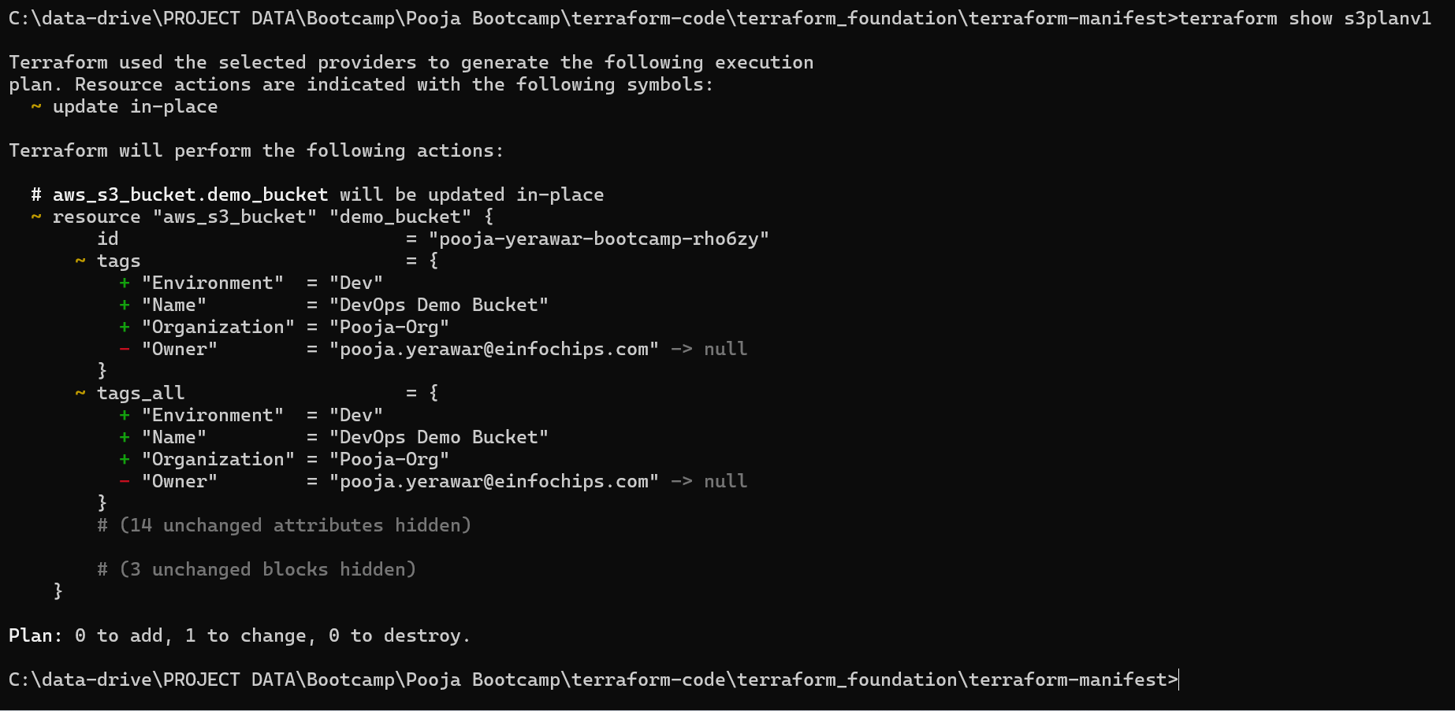
Can convert in json file for prod or policy check
$terraform show -json > s3planv1
Destroy our resources
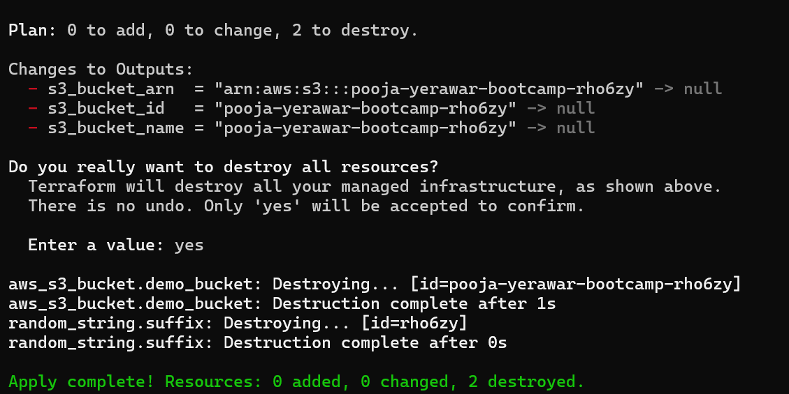
Section06:03 : terraform advanced
Terraform variables:
Its used to make your terraform code dynamic.
This makes the code reusable across different environments. Also make it flexible , environment agnostic.
- c1-versions.tf
- c2-variables.tf
- c3-datasources-and-locals.tf
# Datasources
data "aws_availability_zones" "available" {
state = "available"
If you will not define region it will take from versions.tf file where we have defined provider block
}

# Locals Block
locals {
azs = slice(data.aws_availability_zones.available.names, 0, 3)
----list public_subnets = [for k, az in local.azs : cidrsubnet(var.vpc_cidr, var.subnet_newbits, k)]
private_subnets = [for k, az in local.azs : cidrsubnet(var.vpc_cidr, var.subnet_newbits, k + 10)]
block is similar to function-scoped variables in other programming languages. Local values assign names to expressions, letting you use the name multiple times within a module instead of repeating the expression.
Newbits – number of bits to add in subnets , is the number of additional bits with which to extend the prefix.
}

To test terraform functions use:
$terraform console
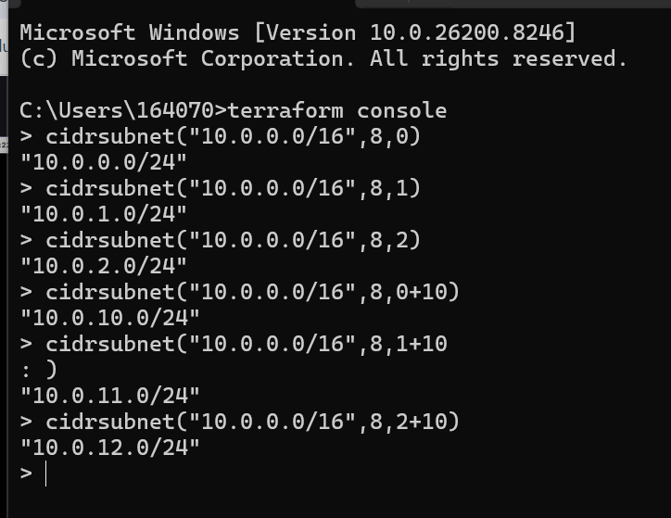
- c4-vpc.tf
# Resource-1: VPC
resource "aws_vpc" "main" {
cidr_block = var.vpc_cidr
enable_dns_hostnames = true ----allow services to talk to each other
enable_dns_support = true
tags = merge(var.tags, { Name = "${var.environment_name}-vpc" }) ---merge into single value
lifecycle { ----meta-argument,control how terraform creates infrastructure
prevent_destroy = false ----rejects operation to destroy
}
}

# Resource-2: Internet Gateway
resource "aws_internet_gateway" "igw" {
vpc_id = aws_vpc.main.id
tags = merge(var.tags, { Name = "${var.environment_name}-igw" })
}

# Resource-3: Public Subnets
resource "aws_subnet" "public" {
for_each = { for idx, az in local.azs : az => local.public_subnets[idx] } ---for each is meta-argument , here az is key and local.public_subnets is value
vpc_id = aws_vpc.main.id
cidr_block = each.value
availability_zone = each.key
map_public_ip_on_launch = true

map derived for above for each is as below :
{ key=value and to access we use each.key and each.value
Ap-south-1a =10.0.0.0/24
Ap-south-1b =10.0.1.0/24
Ap-south-1c =10.0.2.0/24
}

tags = merge(var.tags, {
Name = "${var.environment_name}-public-${each.key}"
})
}

# Resource-4: Private Subnets
resource "aws_subnet" "private" {
for_each = { for idx, az in local.azs : az => local.private_subnets[idx] }
vpc_id = aws_vpc.main.id
cidr_block = each.value
availability_zone = each.key
tags = merge(var.tags, {
Name = "${var.environment_name}-private-${each.key}"
})
}

# Resource-5: Elastic IP for NAT Gateway
resource "aws_eip" "nat" {
tags = merge(var.tags, { Name = "${var.environment_name}-nat-eip" })
}

# Resource-6: NAT Gateway
resource "aws_nat_gateway" "nat" {
allocation_id = aws_eip.nat.id
subnet_id = values(aws_subnet.public)[0].id ---extract only values from map
tags = merge(var.tags, { Name = "${var.environment_name}-nat" })
depends_on = [aws_internet_gateway.igw] ---meta-argument
}

# Resource-7: Public Route Table
resource "aws_route_table" "public_rt" {
vpc_id = aws_vpc.main.id
route {
cidr_block = "0.0.0.0/0"
gateway_id = aws_internet_gateway.igw.id
}
tags = merge(var.tags, { Name = "${var.environment_name}-public-rt" })
}

# Resource-8: Public Route Table Associate to Public Subnet
resource "aws_route_table_association" "public_rt_assoc" {
for_each = aws_subnet.public
subnet_id = each.value.id
route_table_id = aws_route_table.public_rt.id
}

# Resource-9: Private Route Table
resource "aws_route_table" "private_rt" {
vpc_id = aws_vpc.main.id
route {
cidr_block = "0.0.0.0/0"
nat_gateway_id = aws_nat_gateway.nat.id
}
tags = merge(var.tags, { Name = "${var.environment_name}-private-rt" })
}

# Resource-10: Private Route Table Association to Private Subnet
resource "aws_route_table_association" "private_rt_assoc" {
for_each = aws_subnet.private
subnet_id = each.value.id
route_table_id = aws_route_table.private_rt.id
}

- c5-outputs.tf
output "vpc_id" {
value = aws_vpc.main.id
description = "The ID of the created VPC"
}

output "public_subnet_ids" {
value = [for s in aws_subnet.public : s.id]
description = "List of public subnet IDs"
}

output "private_subnet_ids" {
value = [for s in aws_subnet.private : s.id]
description = "List of private subnet IDs"
}

output "public_subnet_map" {
value = { for az, subnet in aws_subnet.public : az => subnet.id }
description = "Map of AZ to Public Subnet ID"
}

Create and verify all above resources
$terraform plan
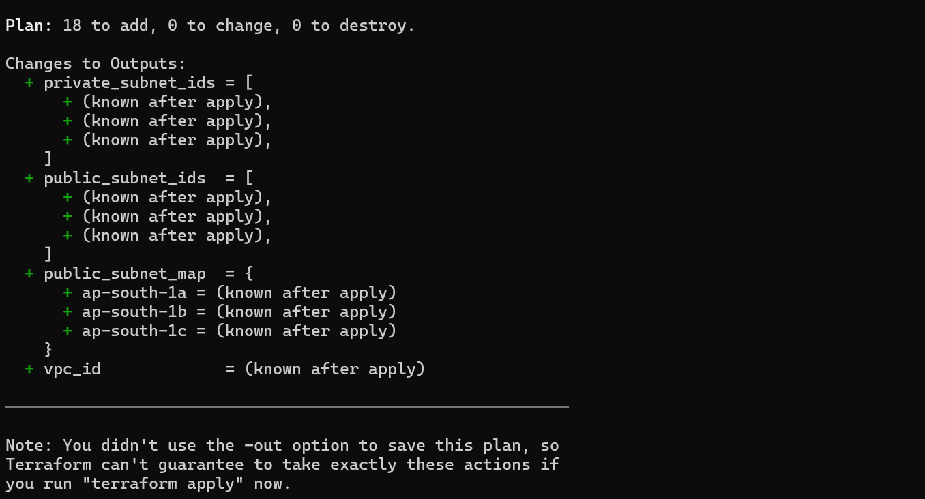
$terraform apply
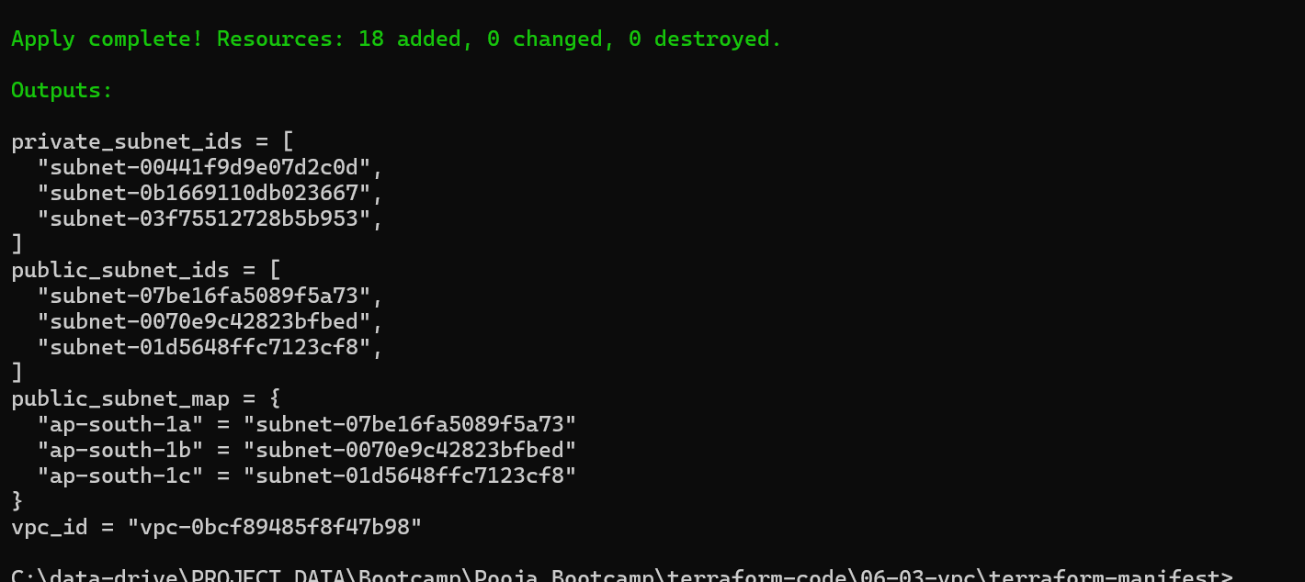
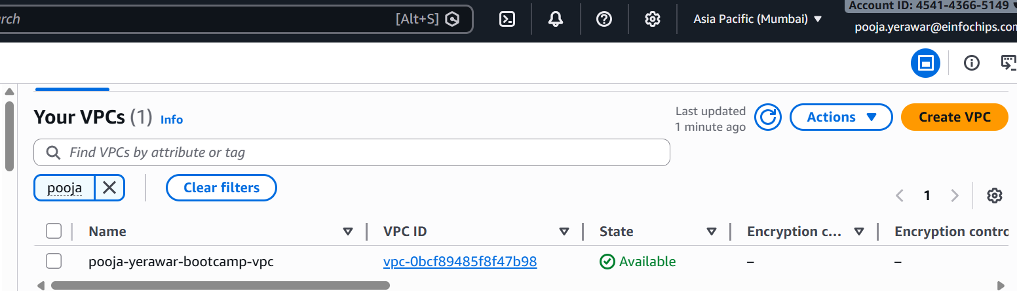

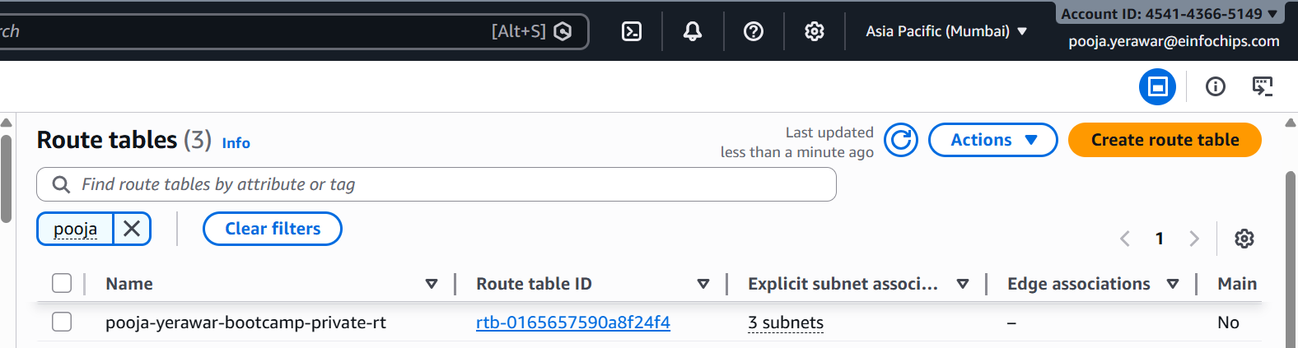
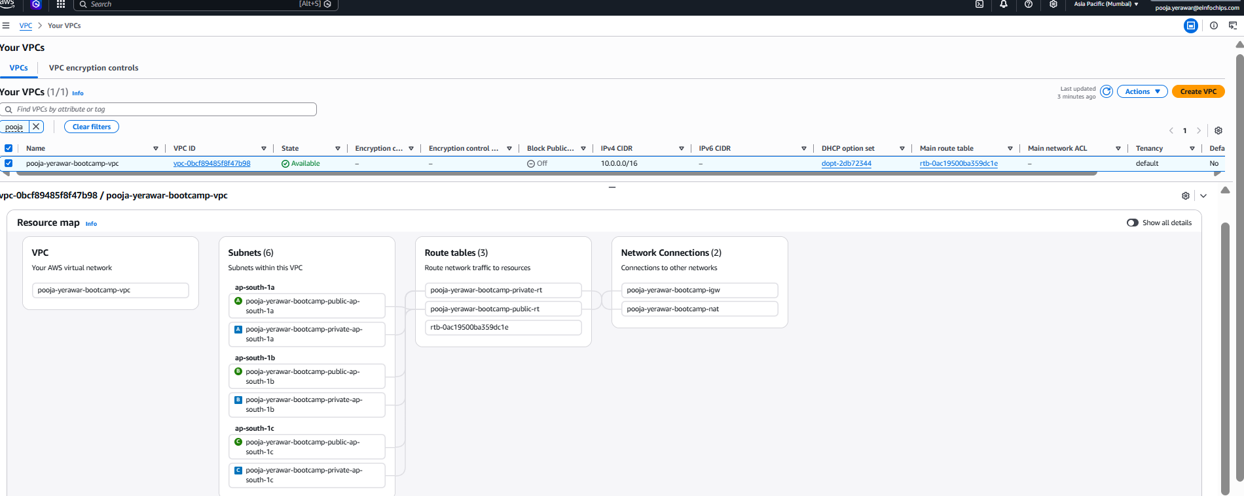

State file concepts :
Terraform doesn’t create resources blindly it will keep track of all resources its creating.
Two types of state files :
- Local state file
terraform.tfstate ---act as a single source of truth for terraform
backbone of terraform , it holds the mapping between your code and real-world infrastructure
- Remote state file
This is called as remote state backend , where we will not store our file locally specially for prod environments.
Here we use amazon s3. It also provide state locking.

What is Terraform drift -- someone change from console and another person did changes from terraform and apply the console changes will be removed
$terraform show ----this will show all resources in tfstate file in human readable format as tfstate file is in terraform language format will not show any future changes
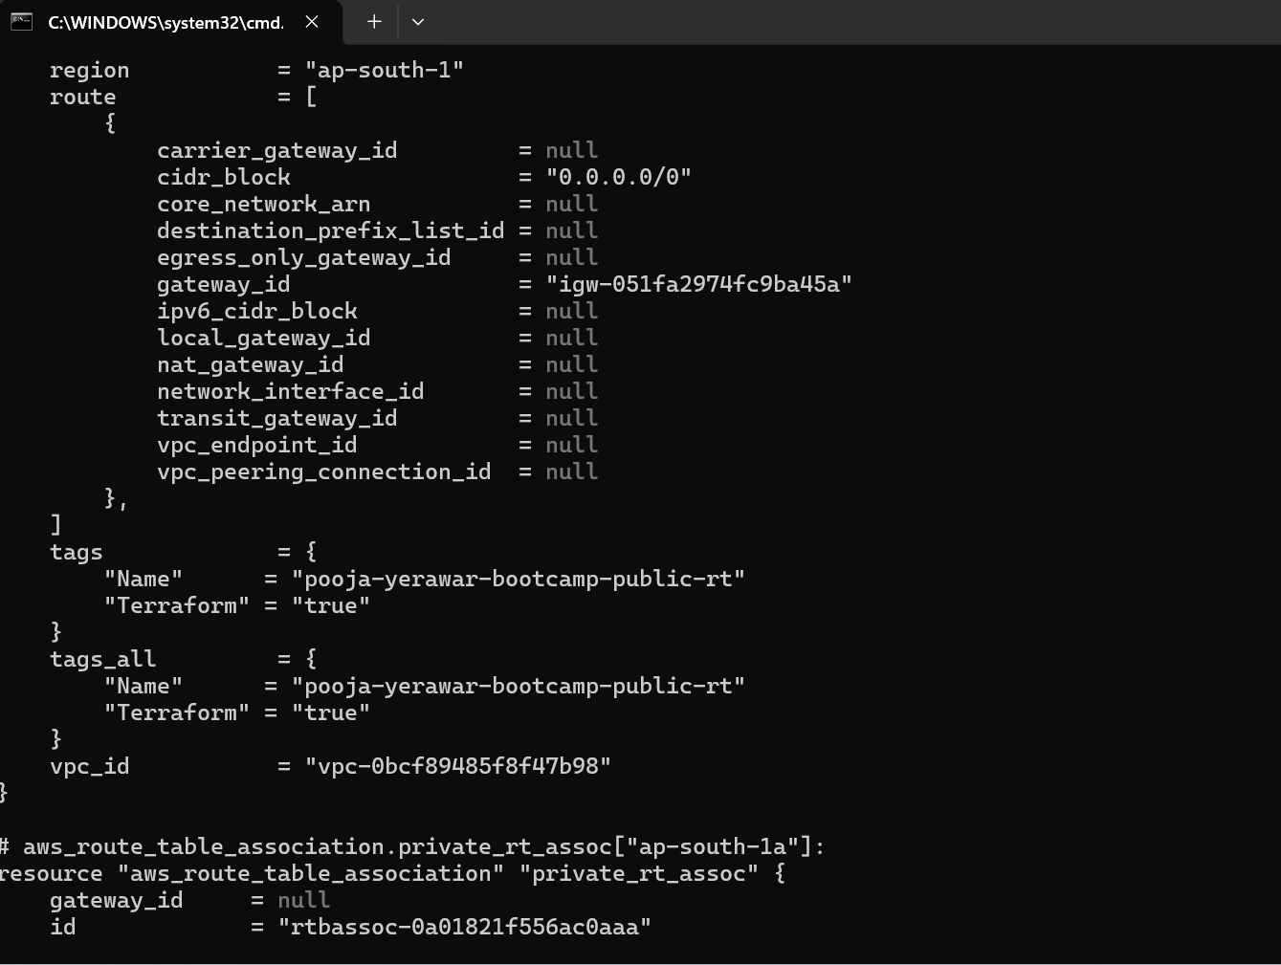
$terraform state list --- will show all the resources managed by terraform
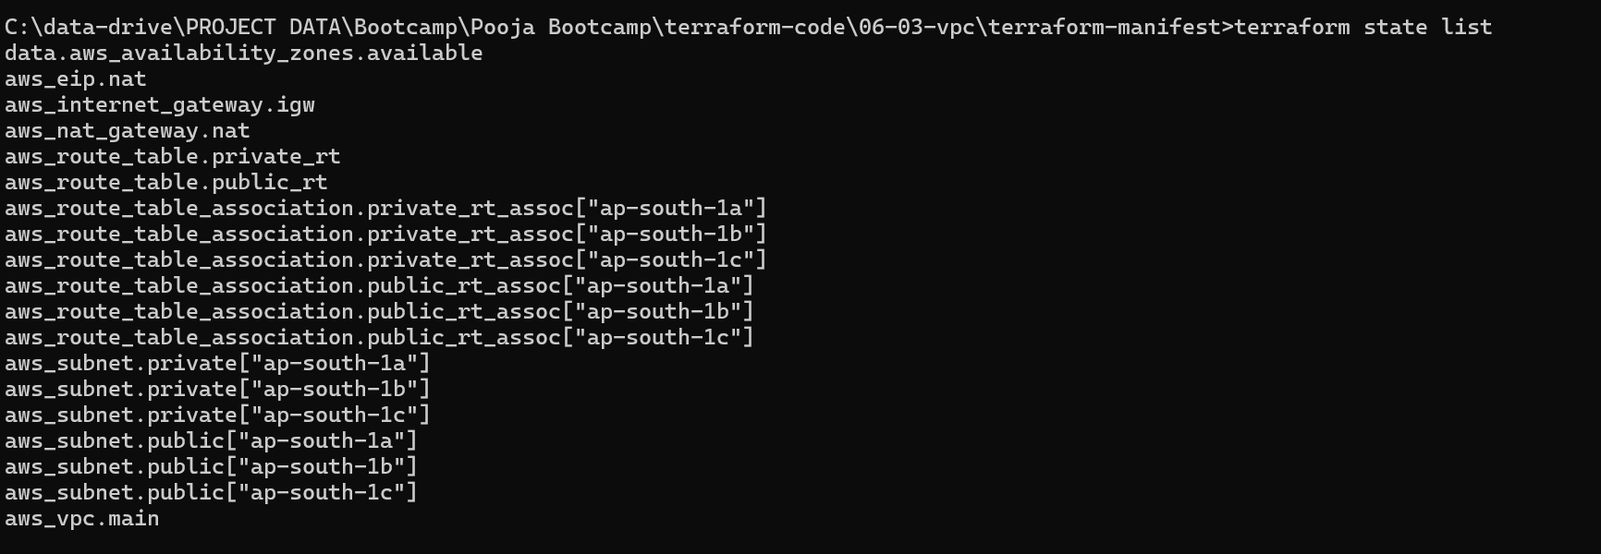

Variable precedence:
High to low
- -var and -var-file as cli argument
- *.auto.tfvars
- Terraform.tfvars – auto loads if present in working directory
- Environment variable
- Default values from variables.tf

