Curriculum Vitae

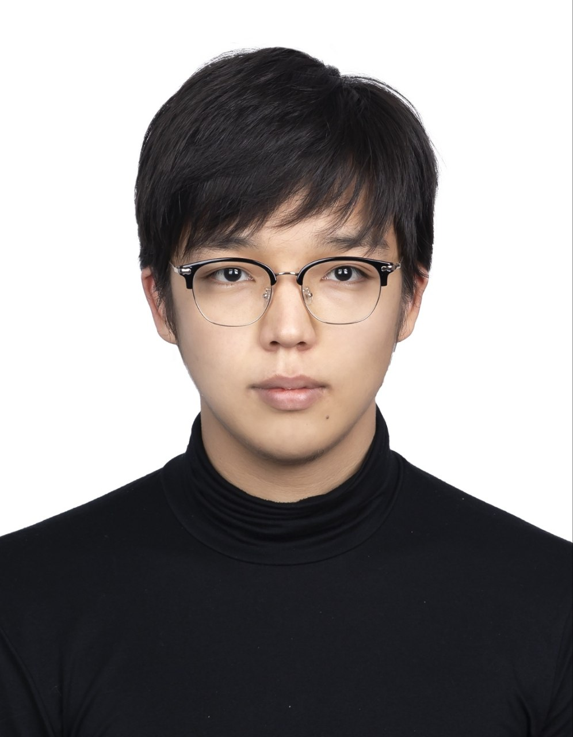
Personal Information
Name: Yerdos Narzhigitov
Phone름: 010-2182-4867
Email: yerdosnarzhigit@gmail.com
Location: 춘천시, 강원특별자치도 (Chuncheon, Gangwon Province)
Languages: Korean (TOPIK 6), English (TOEIC 870), Russian, Uzbek, Kazakh
GitHub / Portfolio: github.com/YerdosNar

Objective
A fourth-year Computer Science and Engineering student at Kangwon National University seeking a systems programming, networking, or security internship. Focused on low-level system internals, networking, applied cryptography, and secure infrastructure automation.

Education
Kangwon National University — B.Sc. in Computer Science and Engineering
Chuncheon, South Korea
Expected Graduation: January 2027
GPA: 3.3 / 4.5

Technical Skills
Languages: C11, Bash, Java, Python, Assembly (studying)
Tools & Technologies: Git, GDB, AddressSanitizer (ASAN), Docker, Caddy, UFW, Sodium
Systems & Networking: Linux Administration (Arch, Void), TCP/IP, NAT Traversal, TCP BBR, POSIX Threads (pthread)
Human Languages: Korean (TOPIK 6), English (TOEIC 870), Russian (Native), Kazakh, Uzbek

Engineering Projects

1. OpenP2P: E2EE Messenger/File-transfer & Proxy (SOCKS) (C11, Makefile)
- Peer-to-peer communication tool featuring NAT hole-punching for direct connections.
- End-to-end encryption and forward secrecy using sodium (X25519, XChaCha20-Poly1305).
- Authenticated handshake protocol to resist Man-in-the-Middle (MITM) attacks.
- pthreads to handle concurrent operations.
- Validated memory safety using AddressSanitizer (ASAN) and GDB.
2. Secure Proxy Deployment Pipeline (3X-UI) (Bash)
- Bash script (>1K LOC) to fully automate the installation of 3X-UI panel.
- Network stack optimization by modifying sysctl configuration file to enable TCP BBR congestion control, and expand TCP buffers, increasing VPN throughput to maximum.
- UFW for firewall, Caddy for reverse proxy and HTTPS/SSL certificate management.
3. Low-Level PNG Image Processor (C11, Makefile)
- Custom PNG parser from scratch capable of reading, decompressing (via zlib), and validating IHDR, IDAT, IEND chunks, alongside custom hidden chunks manipulation.
- Detects injected hidden data and can inject hidden data chunks (steganography).
- 3x3 convolution kernels to apply image processing filters (Sobel, Gaussian, Laplacian) via direct memory manipulation of pixel matrix.
4. MNIST Digit Recognition Neural Network (C11)
- Feedforward operation, the backpropagation algorithm, and ReLU activation function through manual memory management in C with no libraries.
- Graphical 28x28 canvas (using SDL2) allows users to draw digits and test the neural network.
5. Campfire website – 모닥불 (Team project) (Python, SQLite3)
- Collaborated in a 4-person agile team utilizing Git version control to build a real-time anonymous community backend.
- Engineered the core topic creation endpoints and implemented a similarity mapping algorithm to track and cluster trending discussions.
- No heavy ORMs to write a highly optimized Raw SQL queries for maximum DB retrieval performance.
6. UDP with ACK Simulation (C11, Bash)
- Simple Stop-and-Wait flow control over UDP with ACK packets.
- Simulates network instability, including packet loss, delays, and retransmission strategies.

Additional Info
- Consistent Development Discipline: Maintained a continuous 6-month daily coding streak (minimum 3 hours/day), with over 50% of the codebase written in C and Bash.
- Contributions to open source projects:
- Blitz (Obfuscation protocol: Hysteria2 Panel): Fixed the installation Bash script and implemented process logging to streamline debugging for broken/interrupted deployments.
- MAT364 (Security Course Repository of Suleyman Demirel University): Corrected the Bash script for Markdown-to-PDF conversion and fixed calculation logic for encryption algorithm.
- Linux familiriaty: Daily drive 2 linux distributions: Arch Linux and Void Linux. Arch Linux uses Hyprland as Desktop environment and systemd as init system. Void Linux uses KDE as Desktop Environment, and uses runit as init.

