vboxuser@111:~$ echo "Собаки" > "Домашние животные"
vboxuser@111:~$ echo "Кошки" >> "Домашние животные"
vboxuser@111:~$ echo "Хомяки" >> "Домашние животные"
vboxuser@111:~$ echo "Лошади" > "Вьючные животные"
vboxuser@111:~$ echo "Верблюды" >> "Вьючные животные"
vboxuser@111:~$ echo "Ослы" >> "Вьючные животные"
vboxuser@111:~$ cat "Домашние животные" "Вьючные животные" > "Общие животные"
vboxuser@111:~$ mv "Общие животные" "Друзья человека"
vboxuser@111:~$ mkdir homework
vboxuser@111:~$ mv "Друзья человека" homework/
vboxuser@111:~$ sudo apt-get install mysql-server
[sudo] password for vboxuser:
Reading package lists... Done
Building dependency tree... Done
Reading state information... Done
The following additional packages will be installed:
libaio1 libcgi-fast-perl libcgi-pm-perl libevent-core-2.1-7
libevent-pthreads-2.1-7 libfcgi-bin libfcgi-perl libfcgi0ldbl
libhtml-template-perl libmecab2 libprotobuf-lite23 mecab-ipadic
mecab-ipadic-utf8 mecab-utils mysql-client-8.0 mysql-client-core-8.0
mysql-common mysql-server-8.0 mysql-server-core-8.0
Suggested packages:
libipc-sharedcache-perl mailx tinyca
The following NEW packages will be installed:
libaio1 libcgi-fast-perl libcgi-pm-perl libevent-core-2.1-7
libevent-pthreads-2.1-7 libfcgi-bin libfcgi-perl libfcgi0ldbl
libhtml-template-perl libmecab2 libprotobuf-lite23 mecab-ipadic
mecab-ipadic-utf8 mecab-utils mysql-client-8.0 mysql-client-core-8.0
mysql-common mysql-server mysql-server-8.0 mysql-server-core-8.0
0 upgraded, 20 newly installed, 0 to remove and 243 not upgraded.
Need to get 29.3 MB of archives.
After this operation, 242 MB of additional disk space will be used.
Do you want to continue? [Y/n] y
Get:1 http://ru.archive.ubuntu.com/ubuntu jammy/main amd64 mysql-common all 5.8+1.0.8 [7,212 B]
Get:2 http://ru.archive.ubuntu.com/ubuntu jammy-updates/main amd64 mysql-client-core-8.0 amd64 8.0.33-0ubuntu0.22.04.2 [2,802 kB]
Get:3 http://ru.archive.ubuntu.com/ubuntu jammy-updates/main amd64 mysql-client-8.0 amd64 8.0.33-0ubuntu0.22.04.2 [22.7 kB]
Get:4 http://ru.archive.ubuntu.com/ubuntu jammy/main amd64 libaio1 amd64 0.3.112-13build1 [7,176 B]
Get:5 http://ru.archive.ubuntu.com/ubuntu jammy/main amd64 libevent-core-2.1-7 amd64 2.1.12-stable-1build3 [93.9 kB]
Get:6 http://ru.archive.ubuntu.com/ubuntu jammy/main amd64 libevent-pthreads-2.1-7 amd64 2.1.12-stable-1build3 [7,642 B]
Get:7 http://ru.archive.ubuntu.com/ubuntu jammy/main amd64 libmecab2 amd64 0.996-14build9 [199 kB]
Get:8 http://ru.archive.ubuntu.com/ubuntu jammy-updates/main amd64 libprotobuf-lite23 amd64 3.12.4-1ubuntu7.22.04.1 [209 kB]
Get:9 http://ru.archive.ubuntu.com/ubuntu jammy-updates/main amd64 mysql-server-core-8.0 amd64 8.0.33-0ubuntu0.22.04.2 [17.5 MB]
Get:10 http://ru.archive.ubuntu.com/ubuntu jammy-updates/main amd64 mysql-server-8.0 amd64 8.0.33-0ubuntu0.22.04.2 [1,431 kB]
Get:11 http://ru.archive.ubuntu.com/ubuntu jammy/main amd64 libcgi-pm-perl all 4.54-1 [188 kB]
Get:12 http://ru.archive.ubuntu.com/ubuntu jammy/main amd64 libfcgi0ldbl amd64 2.4.2-2build2 [28.0 kB]
Get:13 http://ru.archive.ubuntu.com/ubuntu jammy/main amd64 libfcgi-perl amd64 0.82+ds-1build1 [22.8 kB]
Get:14 http://ru.archive.ubuntu.com/ubuntu jammy/main amd64 libcgi-fast-perl all 1:2.15-1 [10.5 kB]
Get:15 http://ru.archive.ubuntu.com/ubuntu jammy/main amd64 libfcgi-bin amd64 2.4.2-2build2 [11.2 kB]
Get:16 http://ru.archive.ubuntu.com/ubuntu jammy/main amd64 libhtml-template-perl all 2.97-1.1 [59.1 kB]
Get:17 http://ru.archive.ubuntu.com/ubuntu jammy/main amd64 mecab-utils amd64 0.996-14build9 [4,850 B]
Get:18 http://ru.archive.ubuntu.com/ubuntu jammy/main amd64 mecab-ipadic all 2.7.0-20070801+main-3 [6,718 kB]
Get:19 http://ru.archive.ubuntu.com/ubuntu jammy/main amd64 mecab-ipadic-utf8 all 2.7.0-20070801+main-3 [4,384 B]
Get:20 http://ru.archive.ubuntu.com/ubuntu jammy-updates/main amd64 mysql-server all 8.0.33-0ubuntu0.22.04.2 [9,462 B]
Fetched 29.3 MB in 56s (525 kB/s)
Preconfiguring packages ...
Selecting previously unselected package mysql-common.
(Reading database ... 203639 files and directories currently installed.)
Preparing to unpack .../0-mysql-common_5.8+1.0.8_all.deb ...
Unpacking mysql-common (5.8+1.0.8) ...
Selecting previously unselected package mysql-client-core-8.0.
Preparing to unpack .../1-mysql-client-core-8.0_8.0.33-0ubuntu0.22.04.2_amd64.deb ...
Unpacking mysql-client-core-8.0 (8.0.33-0ubuntu0.22.04.2) ...
Selecting previously unselected package mysql-client-8.0.
Preparing to unpack .../2-mysql-client-8.0_8.0.33-0ubuntu0.22.04.2_amd64.deb ...
Unpacking mysql-client-8.0 (8.0.33-0ubuntu0.22.04.2) ...
Selecting previously unselected package libaio1:amd64.
Preparing to unpack .../3-libaio1_0.3.112-13build1_amd64.deb ...
Unpacking libaio1:amd64 (0.3.112-13build1) ...
Selecting previously unselected package libevent-core-2.1-7:amd64.
Preparing to unpack .../4-libevent-core-2.1-7_2.1.12-stable-1build3_amd64.deb ...
Unpacking libevent-core-2.1-7:amd64 (2.1.12-stable-1build3) ...
Selecting previously unselected package libevent-pthreads-2.1-7:amd64.
Preparing to unpack .../5-libevent-pthreads-2.1-7_2.1.12-stable-1build3_amd64.deb ...
Unpacking libevent-pthreads-2.1-7:amd64 (2.1.12-stable-1build3) ...
Selecting previously unselected package libmecab2:amd64.
Preparing to unpack .../6-libmecab2_0.996-14build9_amd64.deb ...
Unpacking libmecab2:amd64 (0.996-14build9) ...
Selecting previously unselected package libprotobuf-lite23:amd64.
Preparing to unpack .../7-libprotobuf-lite23_3.12.4-1ubuntu7.22.04.1_amd64.deb ...
Unpacking libprotobuf-lite23:amd64 (3.12.4-1ubuntu7.22.04.1) ...
Selecting previously unselected package mysql-server-core-8.0.
Preparing to unpack .../8-mysql-server-core-8.0_8.0.33-0ubuntu0.22.04.2_amd64.deb ...
Unpacking mysql-server-core-8.0 (8.0.33-0ubuntu0.22.04.2) ...
Setting up mysql-common (5.8+1.0.8) ...
update-alternatives: using /etc/mysql/my.cnf.fallback to provide /etc/mysql/my.cnf (my.cnf) in auto mode
Selecting previously unselected package mysql-server-8.0.
(Reading database ... 203863 files and directories currently installed.)
Preparing to unpack .../00-mysql-server-8.0_8.0.33-0ubuntu0.22.04.2_amd64.deb ...
Unpacking mysql-server-8.0 (8.0.33-0ubuntu0.22.04.2) ...
Selecting previously unselected package libcgi-pm-perl.
Preparing to unpack .../01-libcgi-pm-perl_4.54-1_all.deb ...
Unpacking libcgi-pm-perl (4.54-1) ...
Selecting previously unselected package libfcgi0ldbl:amd64.
Preparing to unpack .../02-libfcgi0ldbl_2.4.2-2build2_amd64.deb ...
Unpacking libfcgi0ldbl:amd64 (2.4.2-2build2) ...
Selecting previously unselected package libfcgi-perl:amd64.
Preparing to unpack .../03-libfcgi-perl_0.82+ds-1build1_amd64.deb ...
Unpacking libfcgi-perl:amd64 (0.82+ds-1build1) ...
Selecting previously unselected package libcgi-fast-perl.
Preparing to unpack .../04-libcgi-fast-perl_1%3a2.15-1_all.deb ...
Unpacking libcgi-fast-perl (1:2.15-1) ...
Selecting previously unselected package libfcgi-bin.
Preparing to unpack .../05-libfcgi-bin_2.4.2-2build2_amd64.deb ...
Unpacking libfcgi-bin (2.4.2-2build2) ...
Selecting previously unselected package libhtml-template-perl.
Preparing to unpack .../06-libhtml-template-perl_2.97-1.1_all.deb ...
Unpacking libhtml-template-perl (2.97-1.1) ...
Selecting previously unselected package mecab-utils.
Preparing to unpack .../07-mecab-utils_0.996-14build9_amd64.deb ...
Unpacking mecab-utils (0.996-14build9) ...
Selecting previously unselected package mecab-ipadic.
Preparing to unpack .../08-mecab-ipadic_2.7.0-20070801+main-3_all.deb ...
Unpacking mecab-ipadic (2.7.0-20070801+main-3) ...
Selecting previously unselected package mecab-ipadic-utf8.
Preparing to unpack .../09-mecab-ipadic-utf8_2.7.0-20070801+main-3_all.deb ...
Unpacking mecab-ipadic-utf8 (2.7.0-20070801+main-3) ...
Selecting previously unselected package mysql-server.
Preparing to unpack .../10-mysql-server_8.0.33-0ubuntu0.22.04.2_all.deb ...
Unpacking mysql-server (8.0.33-0ubuntu0.22.04.2) ...
Setting up libmecab2:amd64 (0.996-14build9) ...
Setting up mysql-client-core-8.0 (8.0.33-0ubuntu0.22.04.2) ...
Setting up libfcgi0ldbl:amd64 (2.4.2-2build2) ...
Setting up libcgi-pm-perl (4.54-1) ...
Setting up libfcgi-bin (2.4.2-2build2) ...
Setting up libhtml-template-perl (2.97-1.1) ...
Setting up libprotobuf-lite23:amd64 (3.12.4-1ubuntu7.22.04.1) ...
Setting up mecab-utils (0.996-14build9) ...
Setting up libevent-core-2.1-7:amd64 (2.1.12-stable-1build3) ...
Setting up mysql-client-8.0 (8.0.33-0ubuntu0.22.04.2) ...
Setting up libfcgi-perl:amd64 (0.82+ds-1build1) ...
Setting up libaio1:amd64 (0.3.112-13build1) ...
Setting up libevent-pthreads-2.1-7:amd64 (2.1.12-stable-1build3) ...
Setting up mecab-ipadic (2.7.0-20070801+main-3) ...
Compiling IPA dictionary for Mecab. This takes long time...
reading /usr/share/mecab/dic/ipadic/unk.def ... 40
emitting double-array: 100% |###########################################|
/usr/share/mecab/dic/ipadic/model.def is not found. skipped.
reading /usr/share/mecab/dic/ipadic/Postp.csv ... 146
reading /usr/share/mecab/dic/ipadic/Noun.place.csv ... 72999
reading /usr/share/mecab/dic/ipadic/Noun.adverbal.csv ... 795
reading /usr/share/mecab/dic/ipadic/Noun.others.csv ... 151
reading /usr/share/mecab/dic/ipadic/Noun.number.csv ... 42
reading /usr/share/mecab/dic/ipadic/Interjection.csv ... 252
reading /usr/share/mecab/dic/ipadic/Adverb.csv ... 3032
reading /usr/share/mecab/dic/ipadic/Noun.demonst.csv ... 120
reading /usr/share/mecab/dic/ipadic/Noun.proper.csv ... 27328
reading /usr/share/mecab/dic/ipadic/Others.csv ... 2
reading /usr/share/mecab/dic/ipadic/Noun.nai.csv ... 42
reading /usr/share/mecab/dic/ipadic/Suffix.csv ... 1393
reading /usr/share/mecab/dic/ipadic/Adj.csv ... 27210
reading /usr/share/mecab/dic/ipadic/Adnominal.csv ... 135
reading /usr/share/mecab/dic/ipadic/Noun.verbal.csv ... 12146
reading /usr/share/mecab/dic/ipadic/Filler.csv ... 19
reading /usr/share/mecab/dic/ipadic/Postp-col.csv ... 91
reading /usr/share/mecab/dic/ipadic/Symbol.csv ... 208
reading /usr/share/mecab/dic/ipadic/Conjunction.csv ... 171
reading /usr/share/mecab/dic/ipadic/Noun.adjv.csv ... 3328
reading /usr/share/mecab/dic/ipadic/Noun.org.csv ... 16668
reading /usr/share/mecab/dic/ipadic/Auxil.csv ... 199
reading /usr/share/mecab/dic/ipadic/Noun.csv ... 60477
reading /usr/share/mecab/dic/ipadic/Verb.csv ... 130750
reading /usr/share/mecab/dic/ipadic/Noun.name.csv ... 34202
reading /usr/share/mecab/dic/ipadic/Prefix.csv ... 221
emitting double-array: 100% |###########################################|
reading /usr/share/mecab/dic/ipadic/matrix.def ... 1316x1316
emitting matrix : 100% |###########################################|

done!
update-alternatives: using /var/lib/mecab/dic/ipadic to provide /var/lib/mecab/dic/debian (mecab-dictionary) in auto mode
Setting up libcgi-fast-perl (1:2.15-1) ...
Setting up mysql-server-core-8.0 (8.0.33-0ubuntu0.22.04.2) ...
Setting up mecab-ipadic-utf8 (2.7.0-20070801+main-3) ...
Compiling IPA dictionary for Mecab. This takes long time...
reading /usr/share/mecab/dic/ipadic/unk.def ... 40
emitting double-array: 100% |###########################################|
/usr/share/mecab/dic/ipadic/model.def is not found. skipped.
reading /usr/share/mecab/dic/ipadic/Postp.csv ... 146
reading /usr/share/mecab/dic/ipadic/Noun.place.csv ... 72999
reading /usr/share/mecab/dic/ipadic/Noun.adverbal.csv ... 795
reading /usr/share/mecab/dic/ipadic/Noun.others.csv ... 151
reading /usr/share/mecab/dic/ipadic/Noun.number.csv ... 42
reading /usr/share/mecab/dic/ipadic/Interjection.csv ... 252
reading /usr/share/mecab/dic/ipadic/Adverb.csv ... 3032
reading /usr/share/mecab/dic/ipadic/Noun.demonst.csv ... 120
reading /usr/share/mecab/dic/ipadic/Noun.proper.csv ... 27328
reading /usr/share/mecab/dic/ipadic/Others.csv ... 2
reading /usr/share/mecab/dic/ipadic/Noun.nai.csv ... 42
reading /usr/share/mecab/dic/ipadic/Suffix.csv ... 1393
reading /usr/share/mecab/dic/ipadic/Adj.csv ... 27210
reading /usr/share/mecab/dic/ipadic/Adnominal.csv ... 135
reading /usr/share/mecab/dic/ipadic/Noun.verbal.csv ... 12146
reading /usr/share/mecab/dic/ipadic/Filler.csv ... 19
reading /usr/share/mecab/dic/ipadic/Postp-col.csv ... 91
reading /usr/share/mecab/dic/ipadic/Symbol.csv ... 208
reading /usr/share/mecab/dic/ipadic/Conjunction.csv ... 171
reading /usr/share/mecab/dic/ipadic/Noun.adjv.csv ... 3328
reading /usr/share/mecab/dic/ipadic/Noun.org.csv ... 16668
reading /usr/share/mecab/dic/ipadic/Auxil.csv ... 199
reading /usr/share/mecab/dic/ipadic/Noun.csv ... 60477
reading /usr/share/mecab/dic/ipadic/Verb.csv ... 130750
reading /usr/share/mecab/dic/ipadic/Noun.name.csv ... 34202
reading /usr/share/mecab/dic/ipadic/Prefix.csv ... 221
emitting double-array: 100% |###########################################|
reading /usr/share/mecab/dic/ipadic/matrix.def ... 1316x1316
emitting matrix : 100% |###########################################|

done!
update-alternatives: using /var/lib/mecab/dic/ipadic-utf8 to provide /var/lib/mecab/dic/debian (mecab-dictionary) in auto mode
Setting up mysql-server-8.0 (8.0.33-0ubuntu0.22.04.2) ...
update-alternatives: using /etc/mysql/mysql.cnf to provide /etc/mysql/my.cnf (my.cnf) in auto mode
Renaming removed key_buffer and myisam-recover options (if present)
mysqld will log errors to /var/log/mysql/error.log
mysqld is running as pid 3801
Created symlink /etc/systemd/system/multi-user.target.wants/mysql.service → /lib/systemd/system/mysql.service.
Setting up mysql-server (8.0.33-0ubuntu0.22.04.2) ...
Processing triggers for man-db (2.10.2-1) ...
Processing triggers for libc-bin (2.35-0ubuntu3.1) …
vboxuser@111:~/homework$ sudo dpkg -i mysql-server_8.0.33-2_all.deb
(Reading database ... 204030 files and directories currently installed.)
Preparing to unpack mysql-server_8.0.33-2_all.deb ...
Unpacking mysql-server (8.0.33-2) over (8.0.33-0ubuntu0.22.04.2) ...
Setting up mysql-server (8.0.33-2) …
vboxuser@111:~$ sudo dpkg -r mysql-server_8.0.33-2_all
Reading package lists... Done
Building dependency tree... Done
Reading state information... Done
The following packages were automatically installed and are no longer required:
libaio1 libcgi-fast-perl libcgi-pm-perl libevent-core-2.1-7
libevent-pthreads-2.1-7 libfcgi-bin libfcgi-perl libfcgi0ldbl
libhtml-template-perl libmecab2 libprotobuf-lite23 mecab-ipadic
mecab-ipadic-utf8 mecab-utils mysql-client-8.0 mysql-client-core-8.0
mysql-common mysql-server-8.0 mysql-server-core-8.0
Use 'sudo apt autoremove' to remove them.
The following packages will be REMOVED:
mysql-server
0 upgraded, 0 newly installed, 1 to remove and 243 not upgraded.
After this operation, 41.0 kB disk space will be freed.
Do you want to continue? [Y/n] y
(Reading database ... 204032 files and directories currently installed.)
Removing mysql-server (8.0.33-2) …
vboxuser@111:~$ history
1 echo "Собаки" > "Домашние животные"
2 echo "Кошки" >> "Домашние животные"
3 echo "Хомяки" >> "Домашние животные"
4 echo "Лошади" > "Вьючные животные"
5 echo "Верблюды" >> "Вьючные животные"
6 echo "Ослы" >> "Вьючные животные"
7 cat "Домашние животные" "Вьючные животные" > "Общие животные"
8 mv "Общие животные" "Друзья человека"
9 mkdir homework
10 mv "Друзья человека" homework/
11 sudo apt-get install mysql-server
12 visudo
13 sudo visudo
14 visudo
15 sudo visudo
16 apt-get install mysql-server
17 apt update
18 su
19 restart
20 reboot
21 sudo apt-get install mysql-server
22 cd /download
23 cd /downloads
24 cd downloads
25 cd homework
26 sudo dpkg -i package.deb
27 sudo dpkg -i .deb
28 [200~sudo dpkg -i package.deb
29 sudo dpkg -i package.deb
30 sudo apt install -f
31 sudo dpkg -r package
32 sudo apt update
33 sudo apt-get install --download-only nombre-del-paquete
34 sudo dpkg -i *
35 wget https://download.teamviewer.com/download/linux/teamviewer_amd64.deb
36 sudo dpkg -i mysql-server_8.0.33-2_all.deb
37 sudo dpkg -r package
38 sudo dpkg -r sudo dpkg -r package
39 sudo dpkg -r mysql-server_8.0.33-2_all
40 sudo dpkg -i mysql-server_8.0.33-2_all.deb
41 sudo dpkg -r mysql-server_8.0.33-2_all
42 sudo dpkg -r mysql-server_8.0.33-2_all.deb
43 cd
44 sudo dpkg -r mysql-server_8.0.33-2_all.deb
45 sudo dpkg -r mysql-server_8.0.33-2_all
46 dpkg -l | grep mysql-server
47 sudo apt remove mysql-server
48 dpkg -l | grep mysql-server
49 history

Домашнее животное | Вьючное животное
Собака  Коршка  Хомяк | Лошадь  Верблюд  Осел

vboxuser@111:~$ sudo mysql
[sudo] password for vboxuser:
Welcome to the MySQL monitor. Commands end with ; or \g.
Your MySQL connection id is 13
Server version: 8.0.33-0ubuntu0.22.04.2 (Ubuntu)

Copyright (c) 2000, 2023, Oracle and/or its affiliates.

Oracle is a registered trademark of Oracle Corporation and/or its
affiliates. Other names may be trademarks of their respective
owners.

Type 'help;' or '\h' for help. Type '\c' to clear the current input statement.

mysql> CREATE DATABASE Друзья_человека;
Query OK, 1 row affected (0.04 sec)

mysql> USE Друзья_человека;
Database changed

mysql> CREATE TABLE Домашние_животные (
-> id INT PRIMARY KEY AUTO_INCREMENT);
Query OK, 0 rows affected (0.12 sec)

mysql> CREATE TABLE Вьючные_животные (
-> id INT PRIMARY KEY AUTO_INCREMENT);
Query OK, 0 rows affected (0.11 sec)

mysql> INSERT INTO Собака (id, parent_id, name, command, birth_date) VALUES
(1, NULL, 'Rex', 'sit down, jump', '2018-05-01'),
(2, NULL , 'Abrek', 'run', '2017-01-05'),
(3, NULL, 'Jack', 'fetch, lie', '2019-02-01');
Query OK, 3 rows affected (0.81 sec)
Records: 3 Duplicates: 0 Warnings: 0

mysql> CREATE TABLE Кошка (
-> id INT PRIMARY KEY AUTO_INCREMENT,
-> parent_id INT,
-> name VARCHAR(255),
-> command VARCHAR(255),
-> birth_date DATE,
-> FOREIGN KEY (parent_id) REFERENCES Домашние_животные(id)
-> );
Query OK, 0 rows affected (0.17 sec)

mysql> CREATE TABLE Кошка (
id INT PRIMARY KEY AUTO_INCREMENT,
parent_id INT,
name VARCHAR(255),
command VARCHAR(255),
birth_date DATE,
FOREIGN KEY (parent_id) REFERENCES Домашние_животные(id)
);
Query OK, 0 rows affected (0.11 sec)

mysql> INSERT INTO Кошка (id, parent_id, name, command, birth_date) VALUES
-> (1, NULL, 'Lili', 'jump, lie', '2022-02-01'),
-> (2, NULL , 'Susy', 'run', '2023-02-05'),
-> (3, NULL, 'Betty', 'run', '2019-12-01');
Query OK, 3 rows affected (0.08 sec)
Records: 3 Duplicates: 0 Warnings: 0

mysql> CREATE TABLE Хомяк (
-> id INT PRIMARY KEY AUTO_INCREMENT,
-> parent_id INT,
-> name VARCHAR(255),
-> command VARCHAR(255),
-> birth_date DATE,
-> FOREIGN KEY (parent_id) REFERENCES Домашние_животные(id)
-> );
Query OK, 0 rows affected (4.13 sec)

mysql> INSERT INTO Хомяк (id, parent_id, name, command, birth_date) VALUES
-> (1, NULL, 'Fil', 'lie', '2020-02-01'),
-> (2, NULL , 'Joe', 'run', '2023-01-01');
Query OK, 2 rows affected (0.82 sec)
Records: 2 Duplicates: 0 Warnings: 0

mysql> CREATE TABLE Лошадь (
-> id INT PRIMARY KEY AUTO_INCREMENT,
-> parent_id INT,
-> name VARCHAR(255),
-> command VARCHAR(255),
-> birth_date DATE,
-> FOREIGN KEY (parent_id) REFERENCES Вьючные_животные(id)
-> );
Query OK, 0 rows affected (0.23 sec)

mysql> CREATE TABLE Верблюд (
-> id INT PRIMARY KEY AUTO_INCREMENT,
-> parent_id INT,
-> name VARCHAR(255),
-> command VARCHAR(255),
-> birth_date DATE,
-> FOREIGN KEY (parent_id) REFERENCES Вьючные_животные(id)
-> );
Query OK, 0 rows affected (0.78 sec)

mysql> CREATE TABLE Осел (
-> id INT PRIMARY KEY AUTO_INCREMENT,
-> parent_id INT,
-> name VARCHAR(255),
-> command VARCHAR(255),
-> birth_date DATE,
-> FOREIGN KEY (parent_id) REFERENCES Вьючные_животные(id)
-> );
Query OK, 0 rows affected (0.34 sec)

mysql> INSERT INTO Лошадь (id, parent_id, name, command, birth_date) VALUES
-> (1, NULL, 'Rob', 'sit down', '2021-01-01'),
-> (2, NULL, 'Abba', 'run', '2022-11-01');
Query OK, 2 rows affected (0.06 sec)
Records: 2 Duplicates: 0 Warnings: 0

mysql> INSERT INTO Верблюд (id, parent_id, name, command, birth_date) VALUES
-> (1, NULL, 'Camel', 'sit down', '2018-03-01'),
-> (2, NULL, 'Anna', 'run', '2020-11-01');
Query OK, 2 rows affected (0.12 sec)
Records: 2 Duplicates: 0 Warnings: 0

mysql> INSERT INTO Осел (id, parent_id, name, command, birth_date) VALUES
-> (1, NULL, 'Hose', 'jump', '2019-05-01'),
-> (2, NULL, 'Richi', 'run', '2020-10-10');
Query OK, 2 rows affected (0.16 sec)
Records: 2 Duplicates: 0 Warnings: 0

mysql> SELECT*FROM Верблюд;
+----+-----------+-------+----------+------------+
| id | parent_id | name | command | birth_date |
+----+-----------+-------+----------+------------+
| 1 | NULL | Camel | sit down | 2018-03-01 |
| 2 | NULL | Anna | run | 2020-11-01 |
+----+-----------+-------+----------+------------+
2 rows in set (0.00 sec)

mysql> DELETE FROM Верблюд;
Query OK, 2 rows affected (0.09 sec)

mysql> SELECT*FROM Верблюд;
Empty set (0.00 sec)

mysql> CREATE TABLE Лошадь_и_осел AS
-> SELECT * FROM Лошадь
-> UNION
-> SELECT * FROM Осел;
Query OK, 4 rows affected (2.55 sec)
Records: 4 Duplicates: 0 Warnings: 0

mysql> SELECT * FROM Лошадь_и_осел;
+----+-----------+-------+----------+------------+
| id | parent_id | name | command | birth_date |
+----+-----------+-------+----------+------------+
| 1 | NULL | Rob | sit down | 2021-01-01 |
| 2 | NULL | Abba | run | 2022-11-01 |
| 1 | NULL | Hose | jump | 2019-05-01 |
| 2 | NULL | Richi | run | 2020-10-10 |
+----+-----------+-------+----------+------------+
4 rows in set (0.00 sec)

CREATE TABLE Лошадь_и_осел AS
SELECT * FROM Лошадь
UNION
SELECT * FROM Осел;
mysql> CREATE TABLE Молодые_животные AS SELECT*FROM Лошадь_и_осел WHERE birth_date BETWEEN DATE_SUB(CURDATE(), INTERVAL 3 YEAR) AND DATE_SUB(CURDATE(), INTERVAL 1 YEAR);
Query OK, 2 rows affected (0.46 sec)
Records: 2 Duplicates: 0 Warnings: 0
mysql> CREATE TABLE Общая_таблица AS
-> SELECT * FROM Молодые_животные””
-> UNION
-> SELECT * FROM Лошадь_и_осел
-> UNION
-> SELECT * FROM Кошка
-> UNION
-> SELECT * FROM Собака
-> UNION
-> SELECT * FROM Хомяк;
Query OK, 12 rows affected (0.64 sec)
Records: 12 Duplicates: 0 Warnings: 0

vboxuser@111:~$ nano animal_registry.py

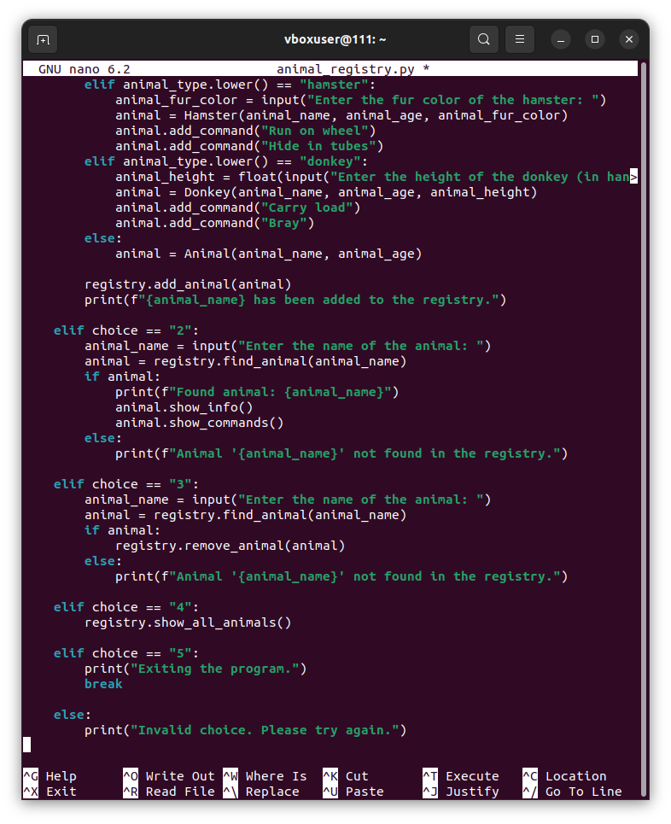
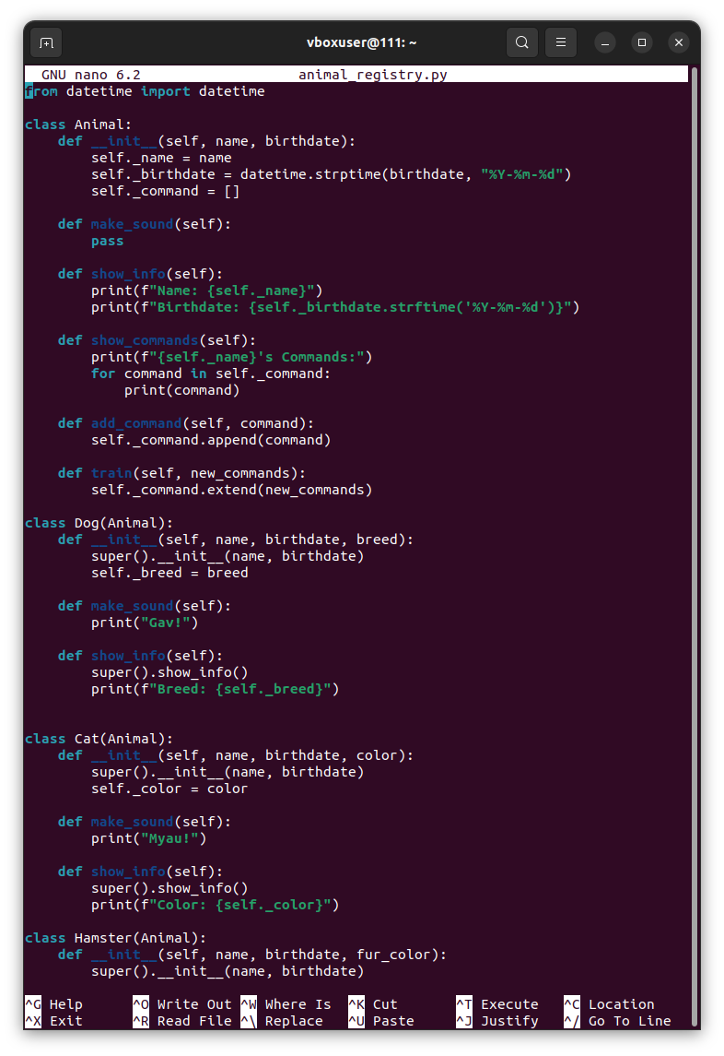
Ниже представлен полный код программы
from datetime import datetime

class Animal:
def __init__(self, name, birthdate):
self._name = name
self._birthdate = datetime.strptime(birthdate, "%Y-%m-%d")
self._command = []

def make_sound(self):
pass

def show_info(self):
print(f"Name: {self._name}")
print(f"Birthdate: {self._birthdate.strftime('%Y-%m-%d')}")

def show_commands(self):
print(f"{self._name}'s Commands:")
for command in self._command:
print(command)

def add_command(self, command):
self._command.append(command)

def train(self, new_commands):
self._command.extend(new_commands)

class Dog(Animal):
def __init__(self, name, birthdate, breed):
super().__init__(name, birthdate)
self._breed = breed

def make_sound(self):
print("Gav!")

def show_info(self):
super().show_info()
print(f"Breed: {self._breed}")

class Cat(Animal):
def __init__(self, name, birthdate, color):
super().__init__(name, birthdate)
self._color = color

def make_sound(self):
print("Myau!")

def show_info(self):
super().show_info()
print(f"Color: {self._color}")

class Hamster(Animal):
def __init__(self, name, birthdate, fur_color):
super().__init__(name, birthdate)
self._fur_color = fur_color

def make_sound(self):
print("Peek!")

def show_info(self):
super().show_info()
print(f"Fur Color: {self._fur_color}")

class Horse(Animal):
def __init__(self, name, birthdate, color):
super().__init__(name, birthdate)
self._color = color

def make_sound(self):
print("Igo-go!")

def show_info(self):
super().show_info()
print(f"Color: {self._color}")

class Donkey(Animal):
def __init__(self, name, birthdate, height):
super().__init__(name, birthdate)
self._height = height

def make_sound(self):
print("Ia-ia!")

def show_info(self):
super().show_info()
print(f"Height: {self._height} hands")

class AnimalRegistry:
def __init__(self):
self._animals = []
self._counter = counter()

def add_animal(self, animal):
self._animals.append(animal)
self._counter.add()

def remove_animal(self, animal):
if animal in self._animals:
self._animals.remove(animal)
print(f"Removed {animal._name} from the registry.")
else:
print("Animal not found in the registry.")

def show_all_animals(self):
if self._animals:
print("Animal Registry:")
for animal in self._animals:
animal.show_info()
print()
else:
print("No animals in the registry.")

def find_animal(self, name):
for animal in self._animals:
if animal._name.lower() == name.lower():
return animal
return None

class counter:
def __init__(self):
self._value = 0

def add(self):
self._value += 1

def __enter__(self):
return self

def __exit__(self, exc_type, exc_val, exc_tb):
if exc_type is None and self._value > 0:
raise Exception("Work with an object of type 'Counter' was not in t>

registry = AnimalRegistry()
try:
with counter() as counter:
while True:
print("---- Animal Registry Menu ----")
print("1. Add a new animal")
print("2. Find an animal")
print("3. Remove an animal")
print("4. Show all animals")
print("5. Exit")
choice = input("Enter your choice: ")
if choice == "1":
animal_name = input("Enter the name of the animal: ")
animal_birthdate = input("Enter the birthdate of the animal (YYYY-MM-DD): ")
animal_type = input("Enter the type of the animal (dog, cat, hamster, horse, donkey): ")
if animal_type.lower() == "dog":
animal_breed = input("Enter the breed of the dog: ")
animal = Dog(animal_name, animal_birthdate, animal_breed)
animal.add_command("Sit")
animal.add_command("Stay")
elif animal_type.lower() == "cat":
animal_color = input("Enter the color of the cat: ")
animal = Cat(animal_name, animal_birthdate, animal_color)
animal.add_command("Meow")
animal.add_command("Purr")
elif animal_type.lower() == "horse":
animal_color = input("Enter the color of the horse: ")
animal = Horse(animal_name, animal_birthdate, animal_color)
animal.add_command("Gallop")
animal.add_command("Trot")
elif animal_type.lower() == "hamster":
animal_fur_color = input("Enter the fur color of the hamster: ")
animal = Hamster(animal_name, animal_birthdate, animal_fur_color)
animal.add_command("Run on wheel")
animal.add_command("Hide in tubes")
elif animal_type.lower() == "donkey":
animal_height = float(input("Enter the height of the donkey (in hands): "))
animal = Donkey(animal_name, animal_birthdate, animal_height)
animal.add_command("Carry load")
animal.add_command("Bray")
else:
animal = Animal(animal_name, animal_birthdate)

registry.add_animal(animal)
print(f"{animal_name} has been added to the registry.")

elif choice == "2":
animal_name = input("Enter the name of the animal: ")
animal = registry.find_animal(animal_name)
if animal:
print(f"Found animal: {animal_name}")
animal.show_info()
animal.show_commands()
else:
print(f"Animal '{animal_name}' not found in the registry.")
elif choice == "3":
animal_name = input("Enter the name of the animal: ")
animal = registry.find_animal(animal_name)
if animal:
registry.remove_animal(animal)
else:
print(f"Animal '{animal_name}' not found in the registry.")

elif choice == "4":
registry.show_all_animals()

elif choice == "5":
print("Exiting the program.")
break

else:
print("Invalid choice. Please try again.")
except Exception as e:
print(f"An error occurred: {e}")

ЗАПУСК ПРОГРАММЫ
vboxuser@111:~$ python3 animal_registry.py
---- Animal Registry Menu ----
1. Add a new animal
2. Find an animal
3. Remove an animal
4. Show all animals
5. Exit
Enter your choice: 1
Enter the name of the animal: Pony
Enter the birthdate of the animal (YYYY-MM-DD): 2020-10-20
Enter the type of the animal (dog, cat, hamster, horse, donkey): horse
Enter the color of the horse: black
Pony has been added to the registry.
---- Animal Registry Menu ----
1. Add a new animal
2. Find an animal
3. Remove an animal
4. Show all animals
5. Exit
Enter your choice: 1
Enter the name of the animal: Mika
Enter the birthdate of the animal (YYYY-MM-DD): 2022-01-01
Enter the type of the animal (dog, cat, hamster, horse, donkey): cat
Enter the color of the cat: pink
Mika has been added to the registry.
---- Animal Registry Menu ----
1. Add a new animal
2. Find an animal
3. Remove an animal
4. Show all animals
5. Exit
Enter your choice: 4
Animal Registry:
Name: Pony
Birthdate: 2020-10-20
Color: black

Name: Mika
Birthdate: 2022-01-01
Color: pink

---- Animal Registry Menu ----
1. Add a new animal
2. Find an animal
3. Remove an animal
4. Show all animals
5. Exit
Enter your choice: 2
Enter the name of the animal: Mika
Found animal: Mika
Name: Mika
Birthdate: 2022-01-01
Color: pink
Mika's Commands:
Meow
Purr
---- Animal Registry Menu ----
1. Add a new animal
2. Find an animal
3. Remove an animal
4. Show all animals
5. Exit
Enter your choice: 1
Enter the name of the animal: Rex
Enter the birthdate of the animal (YYYY-MM-DD): 2020-12-12
Enter the type of the animal (dog, cat, hamster, horse, donkey): dog
Enter the breed of the dog: akita
Rex has been added to the registry.
---- Animal Registry Menu ----
1. Add a new animal
2. Find an animal
3. Remove an animal
4. Show all animals
5. Exit
Enter your choice: 4
Animal Registry:
Name: Pony
Birthdate: 2020-10-20
Color: black

Name: Mika
Birthdate: 2022-01-01
Color: pink

Name: Rex
Birthdate: 2020-12-12
Breed: akita

---- Animal Registry Menu ----
1. Add a new animal
2. Find an animal
3. Remove an animal
4. Show all animals
5. Exit
Enter your choice: 3
Enter the name of the animal: Pony
Removed Pony from the registry.
---- Animal Registry Menu ----
1. Add a new animal
2. Find an animal
3. Remove an animal
4. Show all animals
5. Exit
Enter your choice: 4
Animal Registry:
Name: Mika
Birthdate: 2022-01-01
Color: pink

Name: Rex
Birthdate: 2020-12-12
Breed: akita

---- Animal Registry Menu ----
1. Add a new animal
2. Find an animal
3. Remove an animal
4. Show all animals
5. Exit
Enter your choice: 5
Exiting the program.

