1. Find all customers who had a package on that truck at the time of the crash

SELECT TRANSPORT.TRANSPORT_ID, CUSTOMER.CUST_ID, PACKAGE.PACKAGE_TYPE

FROM TRANSPORT

INNER JOIN PACKAGE ON TRANSPORT.TRANSPORT_ID = PACKAGE.TRANSPORT_ID

INNER JOIN CUSTOMER ON CUSTOMER.CUST_ID = PACKAGE.CUST_ID

WHERE PACKAGE.TRANSPORT_ID = 1721

GROUP BY TRANSPORT.TRANSPORT_ID, CUSTOMER.CUST_ID, PACKAGE.PACKAGE_TYPE

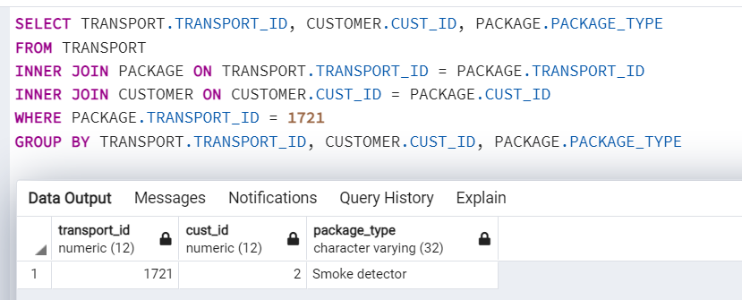

1. Find the customer who has shipped the most packages in the past year

SELECT CUSTOMER.CUST_ID, CUSTOMER.FNAME, CUSTOMER.LNAME, COUNT(PACKAGE.PACKAGE_ID) AS NUMBER_OF_PACKAGES

FROM CUSTOMER

INNER JOIN PACKAGE ON PACKAGE.CUST_ID = CUSTOMER.CUST_ID

WHERE PACKAGE.ARRIVAL_DATE > '2021-01-01'

GROUP BY CUSTOMER.CUST_ID

ORDER BY NUMBER_OF_PACKAGES DESC

LIMIT 1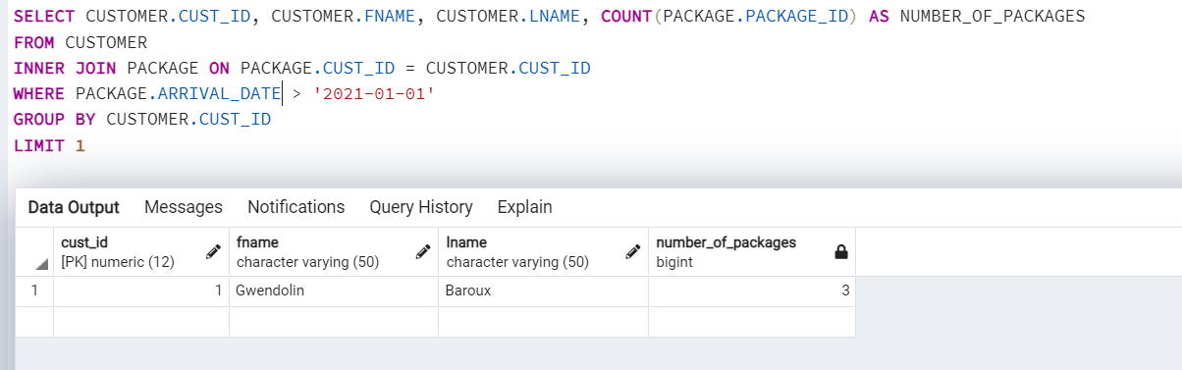

1. Find the customer who has spent the most money on shipping in the past year.

SELECT CUSTOMER.CUST_ID, SUM(PACKAGE.PRICE) AS TOTAL_PRICE

FROM CUSTOMER

INNER JOIN PACKAGE ON CUSTOMER.CUST_ID = PACKAGE.CUST_ID

WHERE PACKAGE.ARRIVAL_DATE > '2021-01-01'

GROUP BY CUSTOMER.CUST_ID

ORDER BY TOTAL_PRICE DESC

LIMIT 1

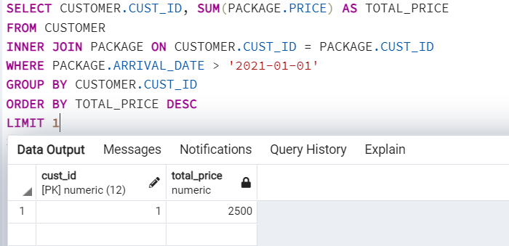

1. Find the street with the most customers

SELECT CUSTOMER.STREET, COUNT(CUSTOMER.CUST_ID) AS NUMBER_OF_CUSTOMERS

FROM CUSTOMER

GROUP BY CUSTOMER.STREET

ORDER BY NUMBER_OF_CUSTOMERS DESC

LIMIT 1

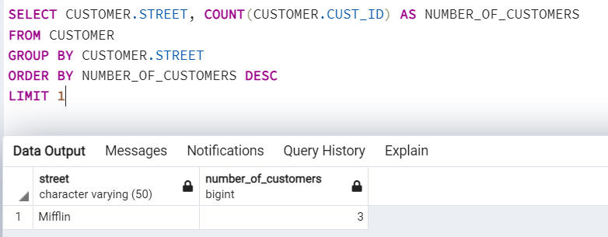

1. Find those packages that were not delivered within the promised time

SELECT PACKAGE.PACKAGE_ID, TRANSPORT.DATE_OF_ARRIVAL AS ARRIVED_DATE, PACKAGE.ARRIVAL_DATE AS HAD_TO_ARRIVED

FROM PACKAGE

INNER JOIN TRANSPORT ON TRANSPORT.TRANSPORT_ID = PACKAGE.TRANSPORT_ID

WHERE PACKAGE.ARRIVAL_DATE < TRANSPORT.DATE_OF_ARRIVAL

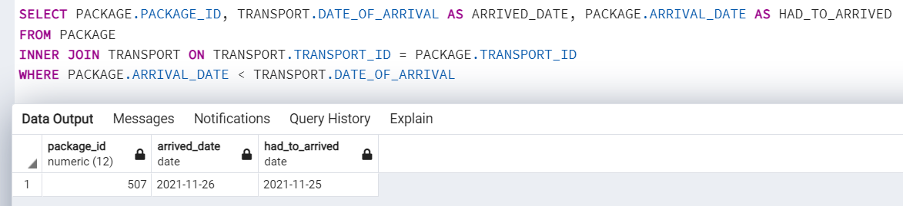

1. A simple bill: customer, address, and amount owed

SELECT CUSTOMER.CUST_ID, CUSTOMER.CITY, CUSTOMER.STREET, CUSTOMER.HOME, BILL.AMOUNT_OWED

FROM CUSTOMER

INNER JOIN BILL ON CUSTOMER.CUST_ID = BILL.CUST_ID

WHERE BILL.AMOUNT_OWED > 0

GROUP BY CUSTOMER.CUST_ID, BILL.AMOUNT_OWED

ORDER BY BILL.AMOUNT_OWED

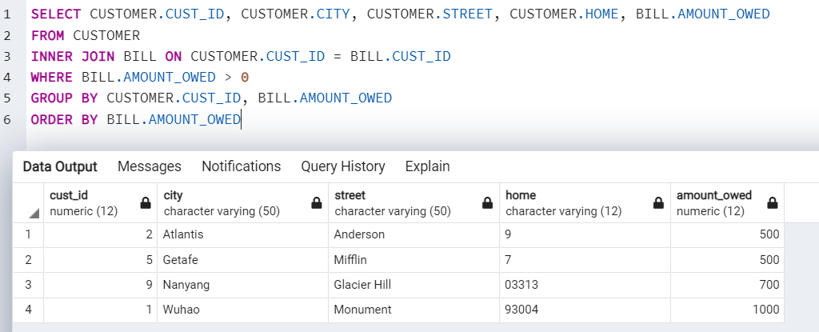

1. A bill listing charges by type of service.

SELECT BILL.BILL_ID, PACKAGE.PACKAGE_ID, PACKAGE.PACKAGE_TYPE, PACKAGE.PRICE

FROM PACKAGE

INNER JOIN CUSTOMER ON CUSTOMER.CUST_ID = PACKAGE.CUST_ID

INNER JOIN BILL ON BILL.CUST_ID = CUSTOMER.CUST_ID

GROUP BY BILL.BILL_ID, PACKAGE.PACKAGE_ID

ORDER BY BILL.BILL_ID

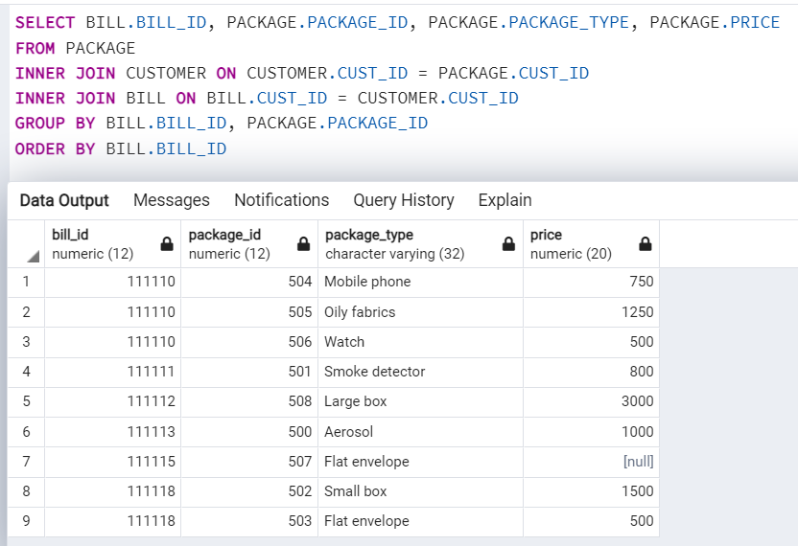

1. An itemize billing listing each individual shipment and the charges for it

SELECT PACKAGE.PACKAGE_ID, PACKAGE.PRICE

FROM PACKAGE

INNER JOIN CUSTOMER ON CUSTOMER.CUST_ID = PACKAGE.CUST_ID

GROUP BY PACKAGE_ID

ORDER BY PACKAGE_ID

