**Raspberry PI4 B (4 GB)**

**(Плата принятия решении и обработки данных )**

**Price: $167**

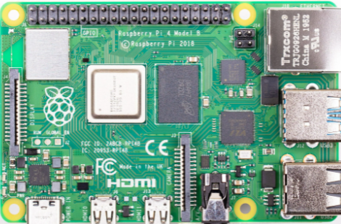

Picture 1 - Raspberry PI4 B (4 GB)

* 1.5GHz 64-bit quad-core ARM Cortex-A72 CPU (ARM v8, BCM2837)
* 1GB, 2GB, or 4GB RAM (LPDDR4)
* On-board wireless LAN (dual-band 802.11 b/g/n/ac)
* On-board Bluetooth 5.0, low-energy (BLE)
* 2x USB 3.0 ports
* 2x USB 2.0 ports
* Gigabit Ethernet
* Power-over-Ethernet (this will require a PoE HAT)
* 40-pin GPIO header
* 2× micro-HDMI ports (up to 4Kp60 supported)
* H.265 (4Kp60 decode)
* H.264 (1080p60 decode, 1080p30 encode)
* OpenGL ES, 3.0 graphics
* DSI display port
* CSI camera port
* Combined 3.5mm analog audio and composite video jack
* Micro-SD card slot
* USB-C power
* Link: <https://ampermarket.kz/raspberry/pi-4-model-b-4gb/>

**Adafruit Ultimate GPS Breakout - 66 channel w/10 Hz updates - Version 3**

**(Модуль позиционирования GPS)**

**Price: $29.95**

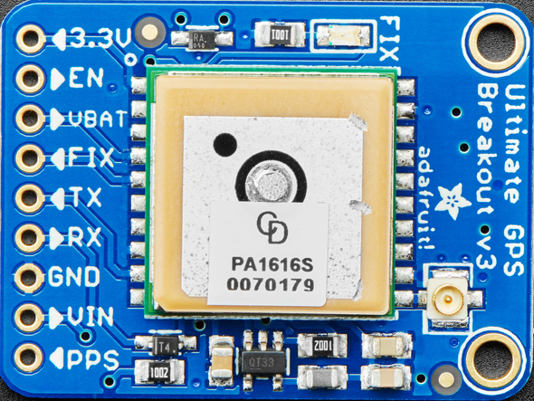

Picture 2 - Adafruit Ultimate GPS Breakout

* Satellites: 22 tracking, 66 searching
* Patch Antenna Size: 15mm x 15mm x 4mm
* Update rate: 1 to 10 Hz
* Position Accuracy: < 3 meters (all GPS technology has about 3m accuracy)
* Velocity Accuracy: 0.1 meters/s
* Warm/cold start: 34 seconds
* Acquisition sensitivity: -145 dBm
* Tracking sensitivity: -165 dBm
* Maximum Velocity: 515m/s
* Vin range: 3.0-5.5VDC
* MTK3339 Operating current: 25mA tracking, 20 mA current draw during navigation
* Output: NMEA 0183, 9600 baud default, 3V logic level out, 5V-safe input
* DGPS/WAAS/EGNOS supported
* FCC E911 compliance and AGPS support (Offline mode : EPO valid up to 14 days )
* Up to 210 PRN channels
* Jammer detection and reduction
* Multi-path detection and compensation
* -165 dBm sensitivity, 10 Hz updates, 66 channels
* 5V friendly design and only 20mA current draw
* Breadboard friendly + two mounting holes
* RTC battery-compatible
* Built-in datalogging
* PPS output on fix
* Internal patch antenna + u.FL connector for external active antenna
* Fix status LED
* Link: <https://www.adafruit.com/product/746?gclid=EAIaIQobChMI4eLCn5CN4QIVSL7ACh0UUADREAYYASABEgLOs_D_BwE>

**Raspberry Pi 3G-4G/LTE Base Shield V2**

**(Модуль сотовой связи 4G/LTE)**

**Price: $39.00**

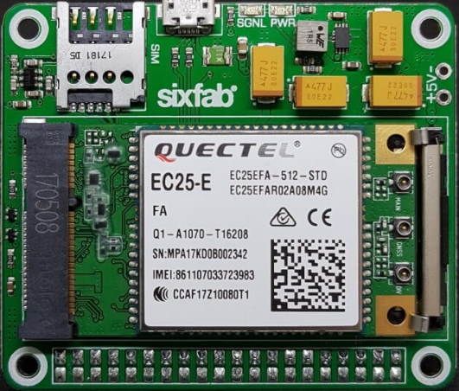

Picture 3 - Raspberry Pi 3G-4G/LTE Base Shield V2

* Fully compatible with Raspberry Pi models that have the 40-pin GPIO header (4, 3, 2, B+, A+, Zero)
* Easy-to-use, simple setup, plug-and-play
* Clip-in Mini PCIe socket compatible with worldwide LTE, UMTS/HSPA+ and GSM/GPRS/EDGE coverage with regional or global modules which work with different frequencies&carriers
* With the 4G/LTE Module(e.g Quectel EC25) you can reach 150Mbps downlink and 50Mbps uplink data rates. And the 3G Module( e.g Quectel UC20) delivers the maximum data rate of 14.4Mbps downlink and 5.76Mbps uplink.
* Micro SIM Card socket can easily reachable on the upside of the shield.
* Can be used standalone with PC/Laptop over micro USB, without stacking with Raspberry Pi.
* The shield can be powered from an external 5V source by exposed power pins, directly from Raspberry Pi 5V GPIO headers or over micro USB. A specially designed 90-degree right angle micro USB cable is included to package as a gift by default.
* Efficient and low quiescent current regulator circuit can hold up to 3.6A
* Optional Send/Receive commands over Raspberry Pi UART port is available
* Taking the module into the Airplane Mode, resetting module or RI and DTR functions can be done over GPIO pins.
* The modules(EC25&UC20) have built-in GNSS(GPS/GLONASS) receiver for your location-based applications.
* Working temperature range: -40°C ~ 80°C
* Link: <https://sixfab.com/product/raspberry-pi-3g-4glte-base-shield-v2/>
* Link2: <https://corpshadow.biz/raspberry-pi/raspberry-pi-3g-4g-lte-base-shield-v2-long-header>

**L3GD20H Triple-Axis Gyro Breakout Board - L3GD20/L3G4200 Upgrade - L3GD20H**

**(Модуль гироскопического датчика)**

**Price: $14.95**

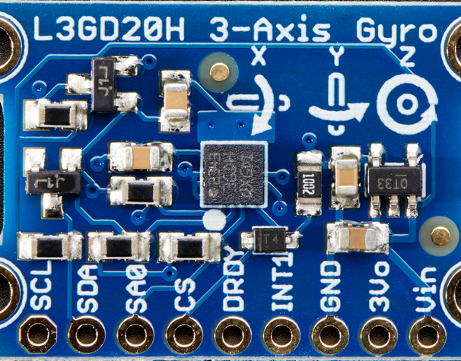

Picture 4 - L3GD20H Triple-Axis Gyro Breakout Board - L3GD20/L3G4200 Upgrade - L3GD20H

* Length:30.65mm
* Width:19.11mm
* Height:3mm
* Weight:2.02g
* Link: <https://www.adafruit.com/product/1032>

**CQRobot Ocean: Contact Water/Liquid Level Sensor**

**(Модуль датчика уровня воды)**

**Price: $16.99**

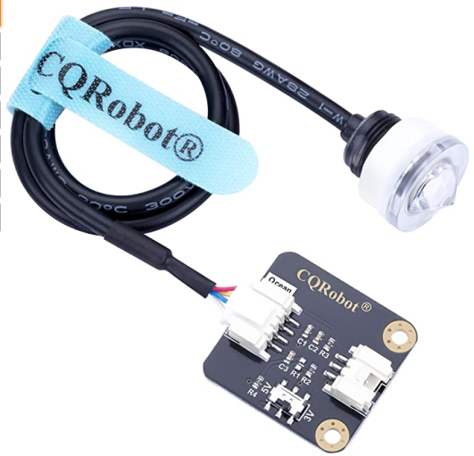

Picture 5 - CQRobot Ocean: Contact Water/Liquid Level Sensor

Sensor Specifications:

* Type: Photoelectric Level Switch
* Power Supply Voltage: DC 5V
* Output Current: 12 (mA)
* Working Temperature: -25 Degree Celsius to +105 Degree Celsius
* Low Level Output: Less Than 0.1V
* High Level Output: 3.3V or 5V (Dial Switch Control)
* Liquid Level Detection Accuracy: Plus/Minus 0.5mm
* Material: PC
* Measuring Range: NO Limit
* Life: 50,000 Hours
* Scope of Application: Water Level Control and Protection of Electrical Products
* Probe Line Length: 50cm
* Dimension: 35mm * 36mm
* Mounting hole size: 3.0mm
* Ocean interface Cable Specifications
* Cable Specifications: 22AWG
* Material: Silicone
* Length: 21cm
* Withstand Voltage: Less Than 50V
* Withstand Current: Less Than 1000MA
* Line Sequence: Black-Negative Power Supply, Red-Positive Power Supply, Green-Signal.
* Link: <https://www.amazon.com/CQRobot-Consumption-Resistance-Temperature-Properties/dp/B07ZMGW3QJ>