|  |
| --- |
|  |
| Kindergarten “БАҚ” |
| **Software Requirements Document** |

|  |
| --- |
| 27.2.2016 |

**Software Requirements Document for Kindergarten “BAK”**

**Author: Team 8**

**Zhansaya Assylbek, Yernar Gappar, Assylbek Rahman, Dana Yergalieva**

|  |  |  |  |
| --- | --- | --- | --- |
| **Version** | **Date** | **Author** | **Change** |
| 0.1 | 24.02.16 | Team 8 | Initial Document |
|  |  |  |  |
|  |  |  |  |
|  |  |  |  |
|  |  |  |  |

**1 Introduction**

* 1. **Purpose**

The purpose of this document is to provide detailed requirements information about the Kindergarten “БАҚ”.

* 1. **Scope**

This document will describe the use cases and features of the Kindergarten “БАҚ”.

**1.6 Definitions, acronyms, abbreviations**

|  |  |
| --- | --- |
| **Term** | **Description** |
| Admin | Administrate all the content and users of the web site, can do everything |
| Authority | Is a permission for some type of users |
| Group | Collective of babies |
| Parent | User who can see, download all the staff that was allowed by administrator. |
| Username | Describes accepted practices and behavior in naming and operating a user  account on system |
|  |  |
|  |  |
|  |  |

**1.4 References**

Wikipedia: <http://wikipedia.org>

**1.5 Overview**

[OMIT]

1. **Overall Description**

Kindergarten is a child's first experience with formal education. Since this primary year provides a foundation for success in the grades that follow, it is very important that a child is in a good kindergarten. This website helps parents keep an eye on their kids` digital activity.

* 1. **Product Perspective**

This site is made on advanced JAVA technology, HTML, PHP, CSS, Jscript. Our target audience kids` parents.

* + 1. **Concept of Operations**
    2. **Major User Interfaces**

See Appendix___

Example Screenshot and description

See Appendix___

* + 1. **Hardware Interfaces**

This software requires no more than standard personal computer peripherals.

* + 1. **Software Interfaces**

// example: CGI-URL or function signatures etc (OMIT for now).

* + 1. **Communication Interfaces**

// example: modem etc (OMIT for now)

**2.1.6 Memory Constraints**

// RAM, and other storage constraints (OMIT for now)

**2.1.7 Operations**

// special operations (if any) (OMIT for now)

**2.1.8 Site Adaptation Requirements**

//ex: Japanese language etc (OMIT for now)

* 1. **Product functions**

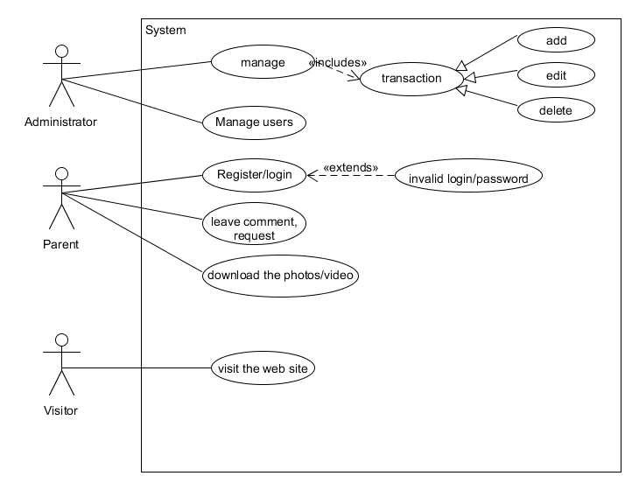

**Use Cases:**

**Parent**:

* Register;
* Login/logout;
* Leave comment/request;
* Download the photos, videos;

**Administrator:**

* Manage users;
* Manage staff;
* Add/edit/delete photo,video
  + 1. **Example Use Case**

**Leaving comments**

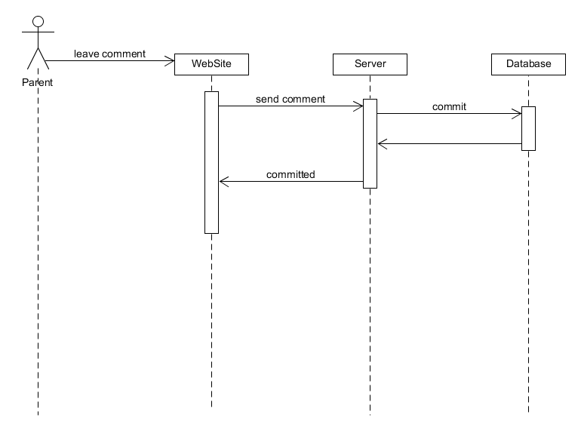

1. **Name of the use-case**

Leaving comments

1. **Brief description of the use-case – include the goal**

To write requirements and ask questions users use comment field.

1. **Actors**

Parents, teachers, admin, visitors

1. **Main flow**

By leaving comment users can get information, or answer for their question. When user writes comment this information receives by server; server will send it to database, then comment will be saved in database. If user`s comment is approved, then server redirects to the main page notification. If it`s not approved, server sends error signal.

1. **Alternate flow**

No alternative flows.

1. **Pre-conditions(if any)**

Every user can edit or delete his/her comment.

1. **Post-conditions (if any)**

No post-conditions

**Getting photos/videos**

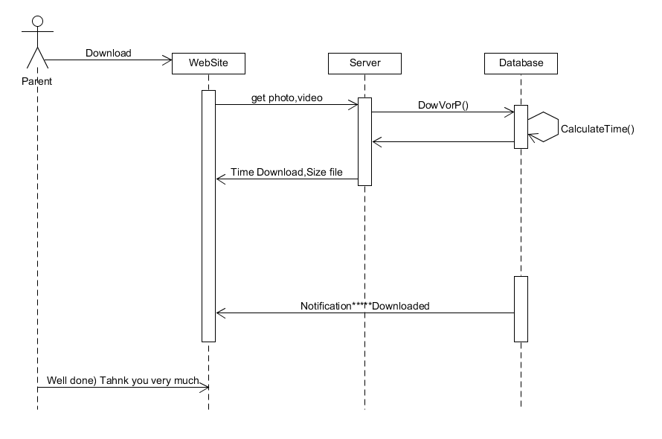

1. **Name of the use-case**

Getting photos/videos

1. **Brief description of the use-case – include the goal**

To save the photos and videos user will download it.

1. **Actors**

Parent

1. **Main flow**

Every parent wants to save their kids` photos and videos on their cellphones and notebooks. When user clicks “download the photo/video”, this information will be received by server; server will send it to database, then database calculates the time and sends size of file, time to download to the main page by server. When file is successfully downloaded database sends notification or signal. If not database sends error message.

1. **Alternate flows**

User can just watch it online.

1. **Preconditions(if any)**

No preconditions

**g) postconditions(if any)**

no postconditions

**Adding photo**

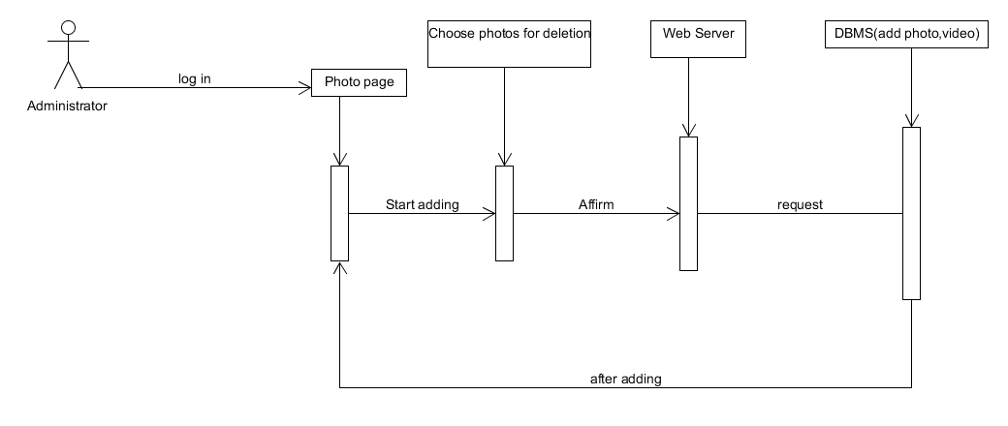

1. **Name of the use-case**

Adding photo

1. **Brief description of the use-case – include the goal**

In order to share kids` photos with parents admin must add it.

1. **Actors**

Administrator

1. **Main flow**

When admin wants to add photo he/she enters to profile photo, then click “add photo” and select the photos to download. This information will be received by server. Web server sends it to database, and it will be saved in database. If it`s approved, server will redirect admin to profile photo with the message “the photo has successfully added”. If error occurred then error message will be displayed.