Project Library Service

Group:EN3_D04(ID 1304005,130104002,130104016)

Kindergarten ”BAKKINDER”

Team 8
SDU 2016

Lab-3 : Screenshots Analysis
N4 “Message Distribution Service”
Team N8
Problems:
1. Based on Step-1, there isn`t identified the list of actors, use-cases of each actor;
2. Menus, buttons, entry fields, action mechanisms aren`t described;
3. Based on Step-3, there isn`t shown transitions in the screen flow graph showing what choices/events cause the transition;
Benefits:
1. Screenshots and screenflow diagrams are very useful to interact the system with actors(client).
2. Analysis helps to identify the actors and the use-cases (or services needed by the actors).

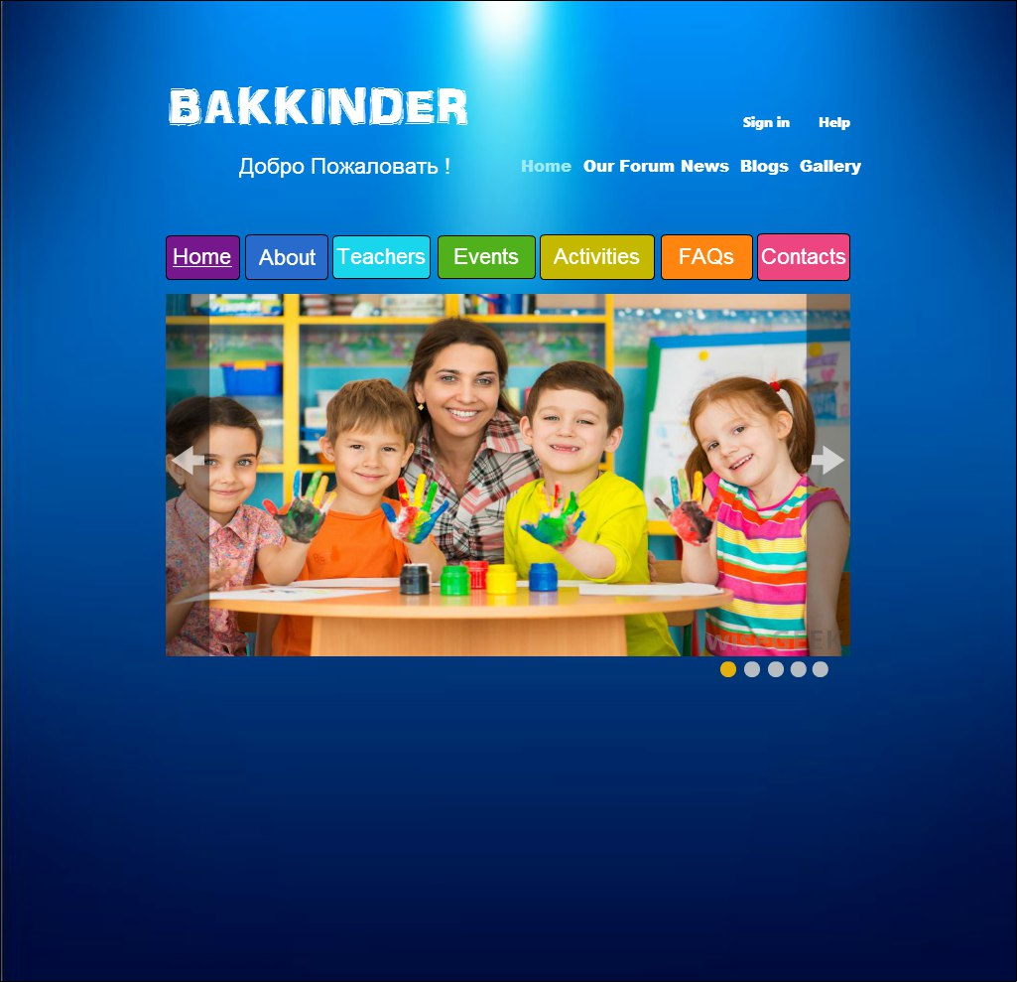

Home page

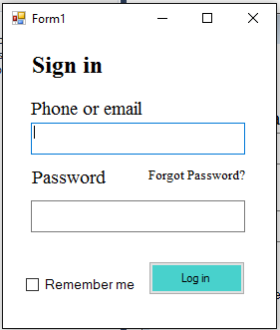

1.Parents can enter your personal cabinet and see a calendar or events, and also to leave a review of the kindergarten
2.And pay for the month(Maybe)



1.Parents can look at the event

2.The administrator can add events

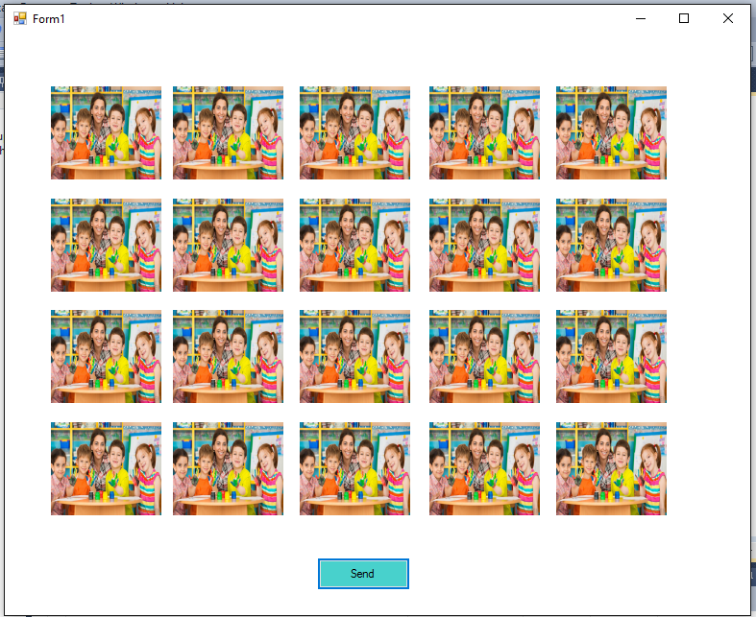

1. The admin can send parents pictures

