**Proposal Number:**  **PR12-25-003** **Hall: C**

**Title:** Final-State Interactions Studies in Deuterium at Very High Missing Momenta

**Contact person:** Carlos Yero (yero@cua.edu)

**Beam time request:**

Days requested for approval: 23 days

Tune up included in beam time request:

**Beam characteristics:**

Energy: 10.55 GeV

Current: 80 mA

Polarization: n/a

**Targets:**

Nuclei: LD2/LH2/C12

Rastering: 3 x 3 mm

Polarized: No

**Spectrometers:**

HMS Yes (proton arm)

SHMS Yes (electron arm)

Other (NPS, CPS, new): None

**Special requirements/requests:**

**Technical Comments:**

**Question/Comment 1:** 80 uA could be challenging for accelerator, not possible if Hall A is running high current.  
  
 **Answer 1:** The beam current limitation would be mainly a scheduling issue between the   
 experimental halls. The actual limit is determined by a combined beam dump power limit

from both Hall A/C and a limit on the total power that the machine can handle.

The combined beam dump limit is around 1100kW and the machine limit for this run period is 900 kW.   
  
The combined power output for Halls A and C is given by:   
( Beam Energy_A x current_A +   Beam Energy_C x current_C ) = power [kW].   
where the beam energy is in units of [GeV] and current in [micro-Amps]  
  
So, for example, if we ran Hall C at (5-pass) with beam energy ~10.7 GeV and 70 uA, and Hall A was running say at (1-pass) 2.200 GeV and 70 uA, the combined power   
output of both halls would be: total_power = 10.7 * 70 + 2.2 * 70 = 903 kW  
  
**Question/Comment 2:**Spectrometer Angles and momentum settings are within the design ranges. However extra SHMS optics may be required for these relatively high momentum settings.

**Answer 2:** The highest SHMS momentum to-date has been ran by the x>1 / EMC experiment   
 (XEM) group during their run-period on Fall 2022 - Spring 2023 with a maximum SHMS

central momentum of 9.5 GeV. They have taken the corresponding optics runs.

**Question/Comment 3:**While the coincidence trigger rates may be low, the hodoscope rate (e.g. S1X) could be high for the SHMS at these smaller angles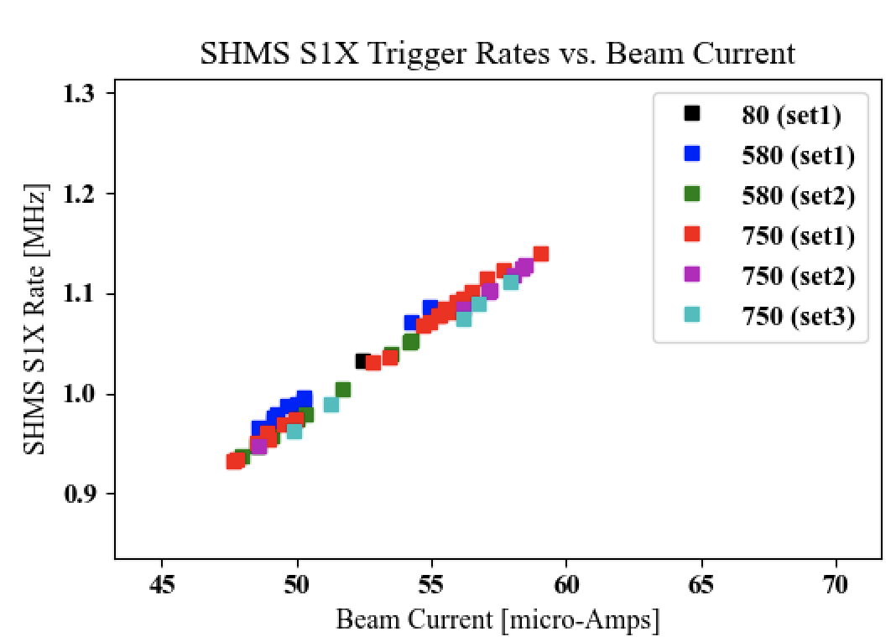.   
  
**Answer 3:**   
The SHMS hodoscope rates on the first plane are indeed expected to be on the order of ~1-2 MHz. This is based on the trigger rates observed from our 2018 deuteron experiment, as seen in the attached plots below.

FIG 1. Shows the SHMS S1X plane rates go up to ~1.1 MHz for beam currents ~60 uA,  
We can make an extrapolation, based on the slope:

$Δy/Δx$ = (1.15 - 0.91) / (60-47) = 0.01846 MHz / uA  
  
from which we can expect that for a maximum current of 80 uA, one expects a maximum  
S1X rate of ~ 0.01846 MHz / uA x 80 uA = 1.48 MHz. This increase in rates is   
**NOT** expected to be an issue during the experiment, given the upgrades of Hall C trigger interface to make it capable of handling higher rates via the TI “buffered mode”, which we did not have during the 2018 deuteron commissioning experiment  
  
**Question/Comment 4:**Will a slightly higher beam energy, 10.68 or 10.78 GeV, impact the results?

(for reference)

SHMS: angles: 12.82, 13.14, 13.65 deg, momentum: 7.552, 8.151, 8.551 GeV/c

HMS: angles: 41.57, 44.17, 49.27, 54.85 deg, momentum 2.468, 2.891, 3.069, 3.516 GeV/c   
  
**Answer 4:**   
After running our code to calculate the central kinematics for a beam energy of 10.78 GeV, and central missing momenta Pm = 800 MeV/c, we have the following updated kinematics   
  
SHMS: angles: 12.51, 12.81, 13.29 deg, momentum: 7.78, 8.38, 8.78 GeV/c

HMS: angles: 41.71, 49.41, 54.98 deg, momentum 2.468, 2.891, 3.516 GeV/c

The kinematics change is very small, and well within the acceptance of the Hall C spectrometers. For example, the largest change in the SHMS momentum corresponds  
to a momentum fraction (8.780 - 8.551)/ 8.551 = 0.0267 (2.67 %) which is well within the SHMS momentum acceptance (-10, 22) % . For the HMS side, the momentum itself  
did not change at all. The change in spectrometer angles was found to be less than 1 deg  
In all cases. **No change is expected with a slightly higher beam energy.**