**2.2. «Изображение номера этажа»**

# Дано:

Исходная таблица истинности:

|  |  |  |  |  |  |  |
| --- | --- | --- | --- | --- | --- | --- |
| S4 | S3 | S2 | S1 | C2 | C1 | C0 |
| 0 | 0 | 0 | 0 | 0 | 0 | 0 |
| 0 | 0 | 0 | 1 | 0 | 0 | 1 |
| 0 | 0 | 1 | 0 | 0 | 1 | 0 |
| 0 | 0 | 1 | 1 | 0 | 0 | 1 |
| 0 | 1 | 0 | 0 | 0 | 1 | 1 |
| 0 | 1 | 0 | 1 | 0 | 0 | 1 |
| 0 | 1 | 1 | 0 | 0 | 1 | 1 |
| 0 | 1 | 1 | 1 | 0 | 0 | 1 |
| 1 | 0 | 0 | 0 | 1 | 0 | 0 |
| 1 | 0 | 0 | 10 | 0 | 0 | 1 |
| 1 | 0 | 1 | 0 | 1 | 0 | 0 |
| 1 | 0 | 1 | 1 | 0 | 0 | 1 |
| 1 | 1 | 0 | 0 | 0 | 1 | 1 |
| 1 | 1 | 0 | 1 | 0 | 0 | 1 |
| 1 | 1 | 1 | 0 | 0 | 1 | 1 |
| 1 | 1 | 1 | 1 | 0 | 0 | 1 |

Тип нормальной формы оптимизированной функции: МДНФ, МКНФ

Базис реализации: базис Пирса (ИЛИ-НЕ)

# Решение:

Карты Карно:

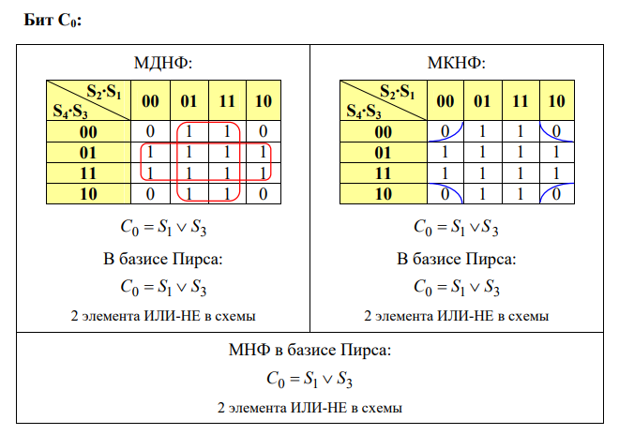

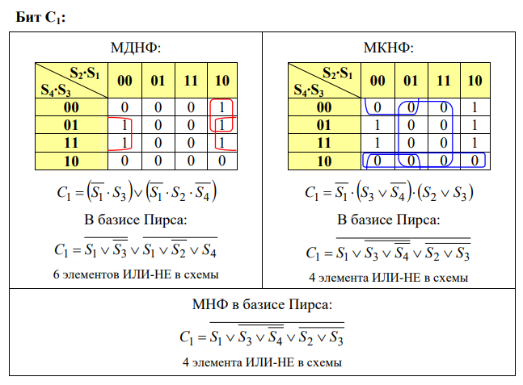

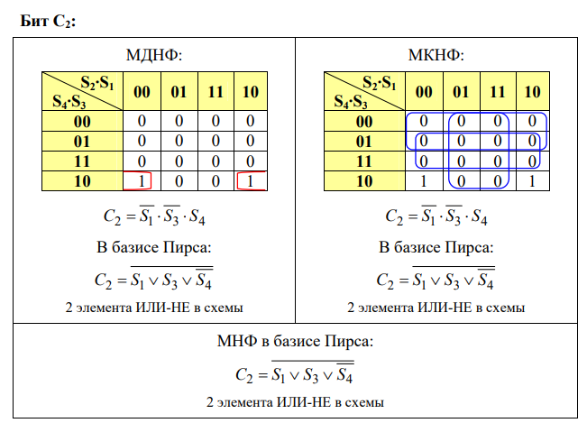

Схема логической функции:

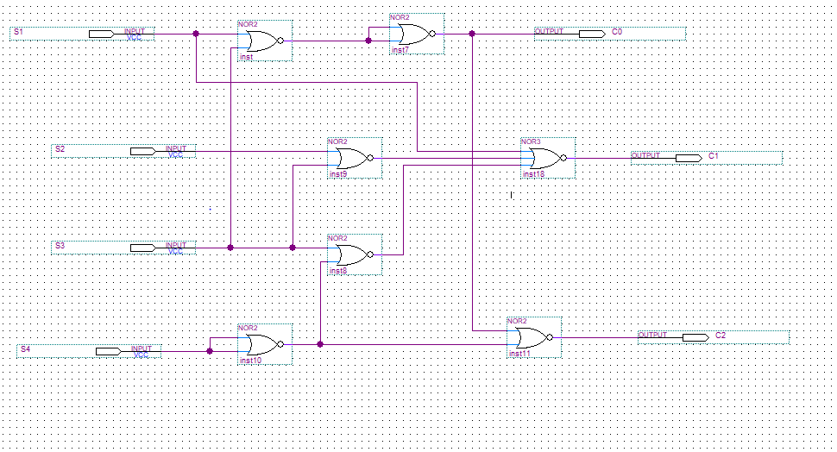

Simulation Report:

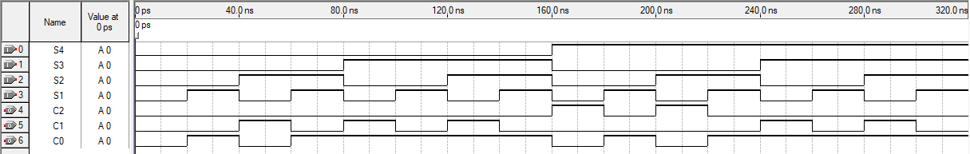

|  |  |  |  |  |  |  |  |
| --- | --- | --- | --- | --- | --- | --- | --- |
| t, ns | Аргументы функции | | | | Значение функции | | |
| S4 | S3 | S2 | S1 | C2 | C1 | C0 |
| 10 | 0 | 0 | 0 | 0 | 0 | 0 | 0 |
| 30 | 0 | 0 | 0 | 1 | 0 | 0 | 1 |
| 50 | 0 | 0 | 1 | 0 | 0 | 1 | 0 |
| 70 | 0 | 0 | 1 | 1 | 0 | 0 | 1 |
| 90 | 0 | 1 | 0 | 0 | 0 | 1 | 1 |
| 110 | 0 | 1 | 0 | 1 | 0 | 0 | 1 |
| 130 | 0 | 1 | 1 | 0 | 0 | 1 | 1 |
| 150 | 0 | 1 | 1 | 1 | 0 | 0 | 1 |
| 170 | 1 | 0 | 0 | 0 | 1 | 0 | 0 |
| 190 | 1 | 0 | 0 | 10 | 0 | 0 | 1 |
| 210 | 1 | 0 | 1 | 0 | 1 | 0 | 0 |
| 230 | 1 | 0 | 1 | 1 | 0 | 0 | 1 |
| 250 | 1 | 1 | 0 | 0 | 0 | 1 | 1 |
| 270 | 1 | 1 | 0 | 1 | 0 | 0 | 1 |
| 290 | 1 | 1 | 1 | 0 | 0 | 1 | 1 |
| 310 | 1 | 1 | 1 | 1 | 0 | 0 | 1 |

Схема сопряжения модуля устройства:

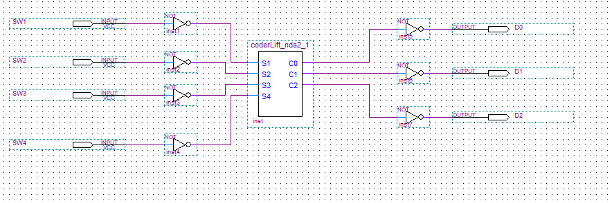

Результат работы:

