**2.2. «Изображение номера этажа»**

# Дано:

Таблица соятояний для дешифратора:

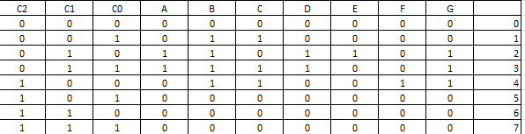

Для шифратора берем с лабораторной работы 2-1.

Тип нормальной формы оптимизированной функции: МДНФ, МКНФ

Базис реализации: базис Шеффера (И-НЕ)

# Решение:

МДНФ:

A: !С2*С1

B: !(!C2*C1)+(!C2*C0)+(C2*!C1*!C0)

C: (!C2*!C0)+(C2*!C1*!C0)

D: !С2*С1

E: !C2*C1*!C0

F: C2*!C1*!C0

G: (!C2*C1)+(C2*!C1*!C0)

МКНФ:

A: !С2*С1

B: (!C2+!C1)*(!C2+!C0)*(C0+C1+C2)

C: (!C2+!C1)*(!C2+!C0)*(C2+C0)

D: !С2*С1

E: !C2*C1*!C0

F: C2*!C1*!C0

G: (!C2+!C1)*(C2+C1)*(!C2+!C0)

Лучше всего подходить МДНФ

Карты Карно (для МДНФ):

A: !С2*С1

|  |  |  |  |  |
| --- | --- | --- | --- | --- |
|  | 00 | 01 | 11 | 10 |
| 0 | 0 | 0 | 1 | 1 |
| 1 | 0 | 0 | 0 | 0 |

B: !(!C2*C1)+(!C2*C0)+(C2*!C1*!C0)

|  |  |  |  |  |
| --- | --- | --- | --- | --- |
|  | 00 | 01 | 11 | 10 |
| 0 | 0 | 1 | 1 | 1 |
| 1 | 1 | 0 | 0 | 0 |

C: (!C2*!C0)+(C2*!C1*!C0)

|  |  |  |  |  |
| --- | --- | --- | --- | --- |
|  | 00 | 01 | 11 | 10 |
| 0 | 0 | 1 | 1 | 0 |
| 1 | 1 | 0 | 0 | 0 |

D: !С2*С1

|  |  |  |  |  |
| --- | --- | --- | --- | --- |
|  | 00 | 01 | 11 | 10 |
| 0 | 0 | 0 | 1 | 1 |
| 1 | 0 | 0 | 0 | 0 |

E: !C2*C1*!C0



|  |  |  |  |  |
| --- | --- | --- | --- | --- |
|  | 00 | 01 | 11 | 10 |
| 0 | 0 | 0 | 0 | 1 |
| 1 | 0 | 0 | 0 | 0 |

F: C2*!C1*!C0

|  |  |  |  |  |
| --- | --- | --- | --- | --- |
|  | 00 | 01 | 11 | 10 |
| 0 | 0 | 0 | 0 | 0 |
| 1 | 1 | 0 | 0 | 0 |

G: (!C2*C1)+(C2*!C1*!C0)

|  |  |  |  |  |
| --- | --- | --- | --- | --- |
|  | 00 | 01 | 11 | 10 |
| 0 | 0 | 0 | 1 | 1 |
| 1 | 1 | 0 | 0 | 0 |

В базисе Шеффера:



|  |  |
| --- | --- |
| A | !(!С2*С1) |
| B | !(!(!С2*С1)*!(!С2*С0)*!(С2*!С1*!С0)) |
| C | !(!(!С2!С0)*!(С2*!С1*!С0)) |
| D | !(!С2*С1) |
| E | !(!С2*С1*!С0) |
| F | !(С2*!С1*!С0) |
| G | !(!(!С2*С!)*!(С2*!С1*!С)) |

Схема логической функции:

Шифратор:

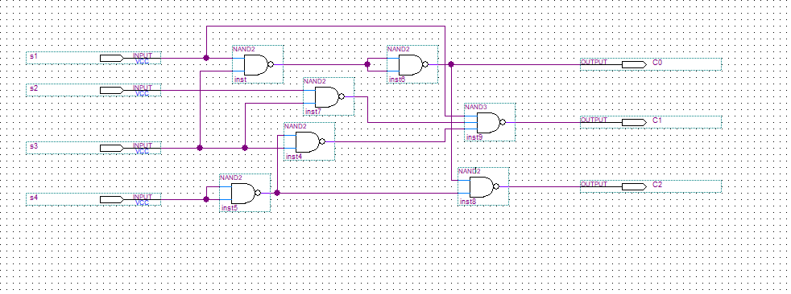

Дешифратор:

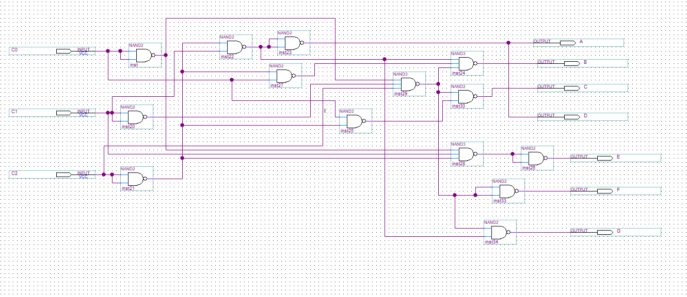

Simulation Report:

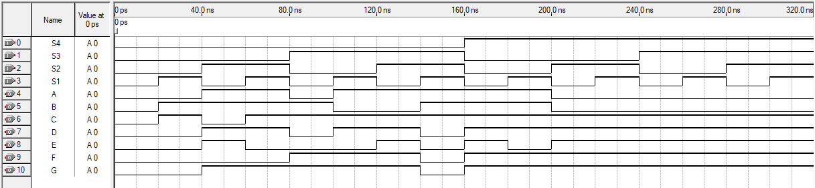

|  |  |  |  |  |  |  |  |  |  |  |  |
| --- | --- | --- | --- | --- | --- | --- | --- | --- | --- | --- | --- |
| t, ns | Аргументы функции | | | | Значение функции | | | | | | |
| S4 | S3 | S2 | S1 | A | B | C | D | E | F | G |
| 10 | 0 | 0 | 0 | 0 | 0 | 0 | 0 | 0 | 0 | 0 | 0 |
| 30 | 0 | 0 | 0 | 1 | 0 | 1 | 1 | 0 | 0 | 0 | 0 |
| 50 | 0 | 0 | 1 | 0 | 1 | 1 | 0 | 1 | 1 | 0 | 1 |
| 70 | 0 | 0 | 1 | 1 | 1 | 1 | 1 | 1 | 0 | 0 | 1 |
| 90 | 0 | 1 | 0 | 0 | 0 | 1 | 1 | 0 | 0 | 1 | 1 |
| 110 | 0 | 1 | 0 | 1 | 1 | 0 | 1 | 1 | 0 | 1 | 1 |
| 130 | 0 | 1 | 1 | 0 | 1 | 0 | 1 | 1 | 1 | 1 | 1 |
| 150 | 0 | 1 | 1 | 1 | 1 | 1 | 1 | 0 | 0 | 0 | 0 |
| 170 | 1 | 0 | 0 | 0 | 1 | 1 | 1 | 1 | 1 | 1 | 1 |
| 190 | 1 | 0 | 0 | 1 | 1 | 1 | 1 | 1 | 0 | 1 | 1 |
| 210 | 1 | 0 | 1 | 0 | 0 | 0 | 1 | 1 | 1 | 1 | 1 |
| 230 | 1 | 0 | 1 | 1 | 0 | 0 | 1 | 1 | 1 | 1 | 1 |
| 250 | 1 | 1 | 0 | 0 | 0 | 0 | 1 | 1 | 1 | 1 | 1 |
| 270 | 1 | 1 | 0 | 1 | 0 | 0 | 1 | 1 | 1 | 1 | 1 |
| 290 | 1 | 1 | 1 | 0 | 0 | 0 | 1 | 1 | 1 | 1 | 1 |
| 310 | 1 | 1 | 1 | 1 | 0 | 0 | 1 | 1 | 1 | 1 | 1 |

Схема сопряжения модуля устройства:

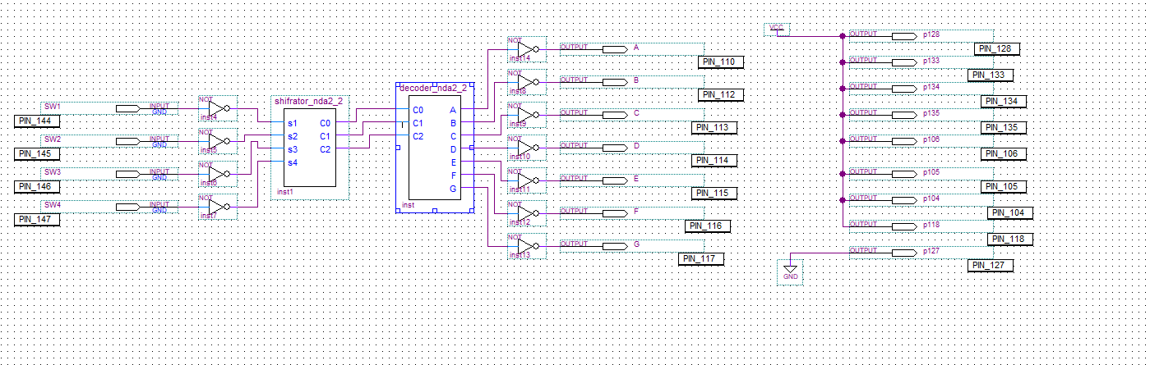

Результат работы:

