# Task3_1

## Четверть сумматор

|  |  |  |
| --- | --- | --- |
| **a** | **b** | **S** |
| 0 | 0 | 0 |
| 0 | 1 | 1 |
| 1 | 0 | 1 |
| 1 | 1 | 0 |

Базис реализации: базис Шеффера (И-НЕ)

#### Решение:

МДНФ: $S= \overline{\overline{a*\overline{a*b}}*\overline{b*\overline{a*b}}}$

### Схема модуля:

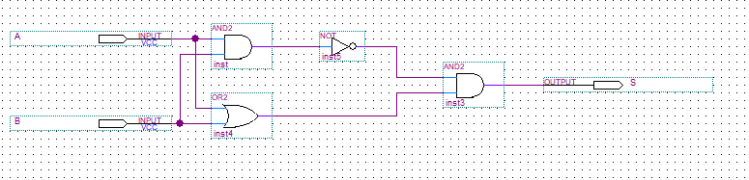

### Simulation Report:

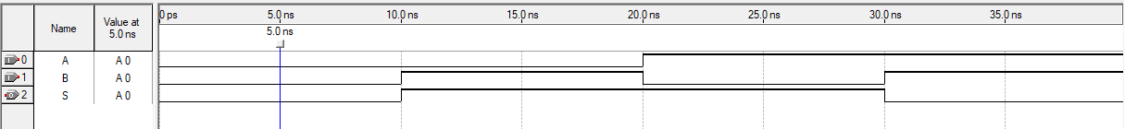

|  |  |  |  |
| --- | --- | --- | --- |
| **t** | **a** | **b** | **S** |
| 5 | 0 | 0 | 0 |
| 15 | 0 | 1 | 1 |
| 25 | 1 | 0 | 1 |
| 35 | 1 | 1 | 0 |

## Полусумматор

|  |  |  |  |
| --- | --- | --- | --- |
| **a** | **b** | **S** | **P** |
| 0 | 0 | 0 | 0 |
| 0 | 1 | 1 | 0 |
| 1 | 0 | 1 | 0 |
| 1 | 1 | 0 | 1 |

Базис реализации: базис Буля (И, ИЛИ, НЕ)

#### Решение:

### Схема модуля:

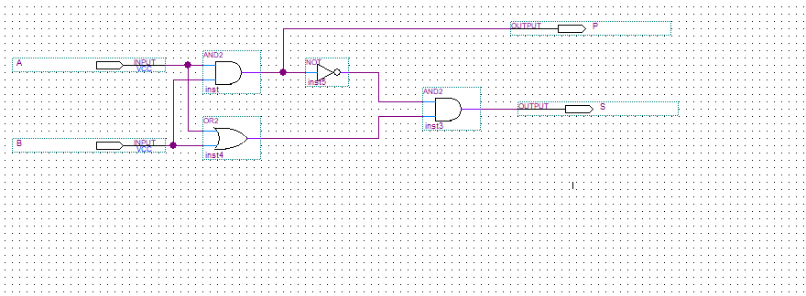

### Simulation Report:

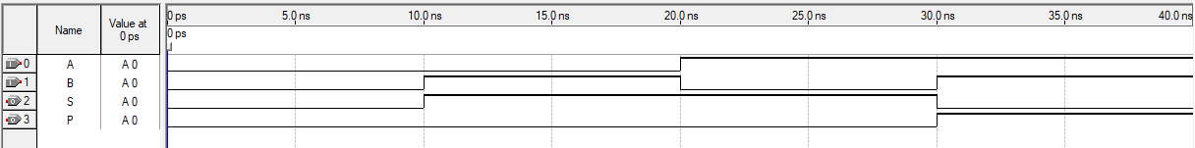

|  |  |  |  |  |
| --- | --- | --- | --- | --- |
| **t** | **a** | **b** | **S** | **P** |
| 5 | 0 | 0 | 0 | 0 |
| 15 | 0 | 1 | 1 | 0 |
| 25 | 1 | 0 | 1 | 0 |
| 35 | 1 | 1 | 0 | 1 |

## Полный одноразрядный двоичный сумматор

|  |  |  |  |  |
| --- | --- | --- | --- | --- |
| **a** | **b** | **pin** | **S** | **P** |
| 0 | 0 | 0 | 0 | 0 |
| 0 | 0 | 1 | 1 | 0 |
| 0 | 1 | 0 | 1 | 0 |
| 0 | 1 | 1 | 0 | 1 |
| 1 | 0 | 0 | 1 | 0 |
| 1 | 0 | 1 | 0 | 1 |
| 1 | 1 | 0 | 0 | 1 |
| 1 | 1 | 1 | 1 | 1 |

Базис реализации: базис Буля (И, ИЛИ, НЕ)

#### Решение:

### Схема модуля:

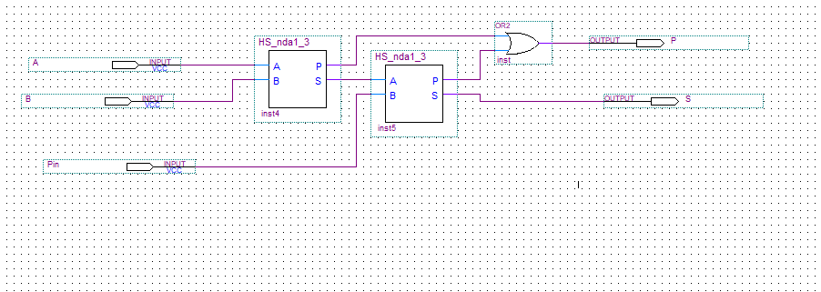

### Simulation Report:

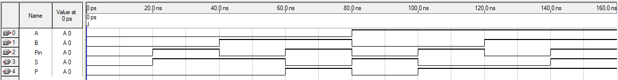

|  |  |  |  |  |  |
| --- | --- | --- | --- | --- | --- |
| **t** | **a** | **b** | **pin** | **S** | **P** |
| 10 | 0 | 0 | 0 | 0 | 0 |
| 30 | 0 | 0 | 1 | 1 | 0 |
| 50 | 0 | 1 | 0 | 1 | 0 |
| 70 | 0 | 1 | 1 | 0 | 1 |
| 90 | 1 | 0 | 0 | 1 | 0 |
| 110 | 1 | 0 | 1 | 0 | 1 |
| 130 | 1 | 1 | 0 | 0 | 1 |
| 150 | 1 | 1 | 1 | 1 | 1 |

## Арифметико-логическое устройство

|  |  |  |  |  |  |  |
| --- | --- | --- | --- | --- | --- | --- |
| B2 | B1 | B0 | S3 | S2 | S1 | S0 |
| 0 | 0 | 0 | 0 | 1 | 1 | 1 |
| 0 | 0 | 1 | 1 | 0 | 0 | 0 |
| 0 | 1 | 0 | 1 | 0 | 0 | 1 |
| 0 | 1 | 1 | 1 | 0 | 1 | 0 |
| 1 | 0 | 0 | 1 | 0 | 1 | 1 |
| 1 | 0 | 1 | 1 | 1 | 0 | 0 |
| 1 | 1 | 0 | 1 | 1 | 0 | 1 |
| 1 | 1 | 1 | 1 | 1 | 1 | 0 |

Базис реализации: базис Буля (И, ИЛИ, НЕ)

#### Решение:

### Схема модуля:

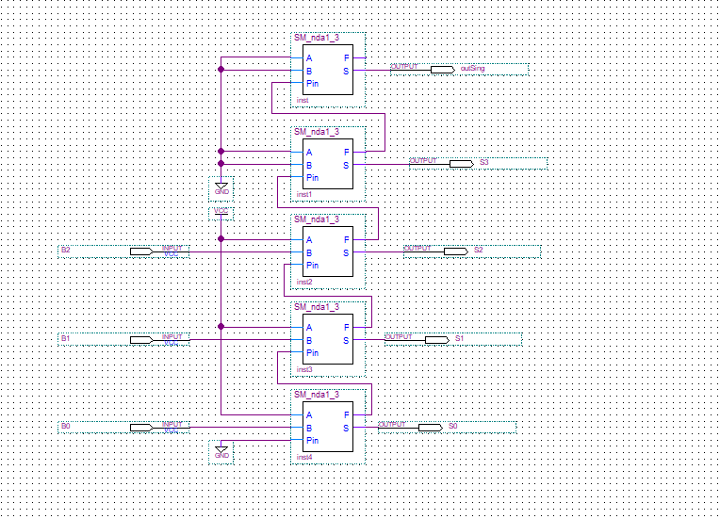

### Simulation Report:

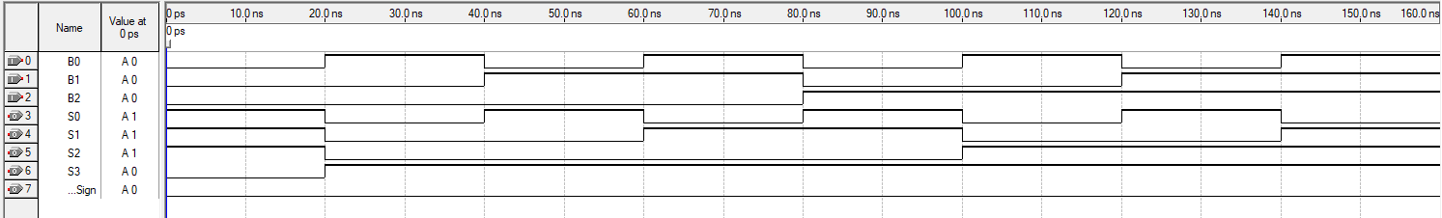

|  |  |  |  |  |  |  |  |
| --- | --- | --- | --- | --- | --- | --- | --- |
| t | B2 | B1 | B0 | S3 | S2 | S1 | S0 |
| 10 | 0 | 0 | 0 | 0 | 1 | 1 | 1 |
| 30 | 0 | 0 | 1 | 1 | 0 | 0 | 0 |
| 50 | 0 | 1 | 0 | 1 | 0 | 0 | 1 |
| 70 | 0 | 1 | 1 | 1 | 0 | 1 | 0 |
| 90 | 1 | 0 | 0 | 1 | 0 | 1 | 1 |
| 110 | 1 | 0 | 1 | 1 | 1 | 0 | 0 |
| 130 | 1 | 1 | 0 | 1 | 1 | 0 | 1 |
| 150 | 1 | 1 | 1 | 1 | 1 | 1 | 0 |

#### **Дано**:

|  |  |  |  |  |  |  |  |
| --- | --- | --- | --- | --- | --- | --- | --- |
| inSign | B2 | B1 | B0 | S3 | S2 | S1 | S0 |
| 0 | 0 | 0 | 0 | 0 | 1 | 1 | 1 |
| 0 | 0 | 0 | 1 | 1 | 0 | 0 | 0 |
| 0 | 0 | 1 | 0 | 1 | 0 | 0 | 1 |
| 0 | 0 | 1 | 1 | 1 | 0 | 1 | 0 |
| 0 | 1 | 0 | 0 | 1 | 0 | 1 | 1 |
| 0 | 1 | 0 | 1 | 1 | 1 | 0 | 0 |
| 0 | 1 | 1 | 0 | 1 | 1 | 0 | 1 |
| 0 | 1 | 1 | 1 | 1 | 1 | 1 | 0 |
| 1 | 0 | 0 | 0 | 0 | 1 | 1 | 1 |
| 1 | 0 | 0 | 1 | 0 | 1 | 1 | 0 |
| 1 | 0 | 1 | 0 | 0 | 1 | 0 | 1 |
| 1 | 0 | 1 | 1 | 0 | 1 | 0 | 0 |
| 1 | 1 | 0 | 0 | 0 | 0 | 1 | 1 |
| 1 | 1 | 0 | 1 | 0 | 0 | 1 | 0 |
| 1 | 1 | 1 | 0 | 0 | 0 | 0 | 1 |
| 1 | 1 | 1 | 1 | 0 | 0 | 0 | 0 |

#### Решение:

### Схема модуля:

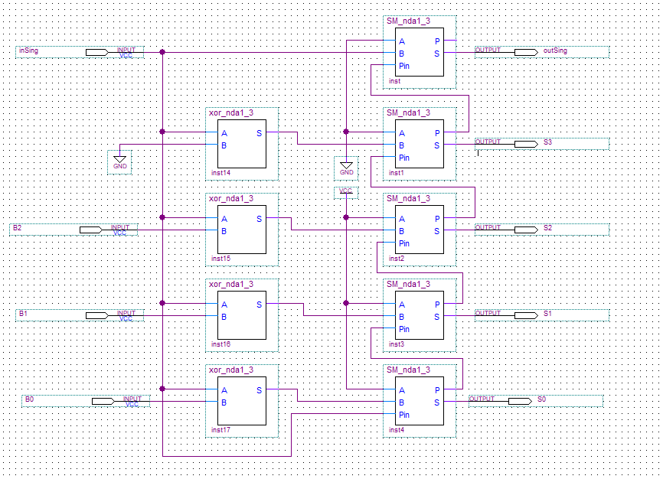

### Simulation Report:

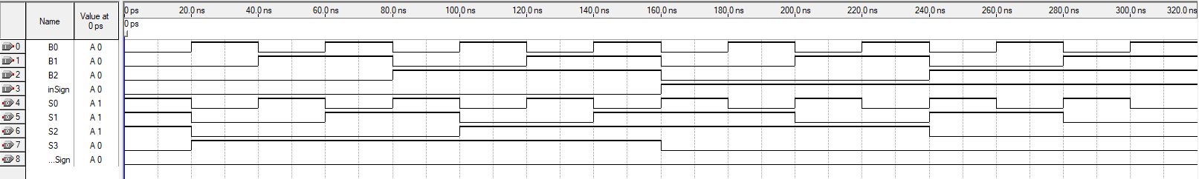

|  |  |  |  |  |  |  |  |  |
| --- | --- | --- | --- | --- | --- | --- | --- | --- |
| t | inSign | B2 | B1 | B0 | S3 | S2 | S1 | S0 |
| 10 | 0 | 0 | 0 | 0 | 0 | 1 | 1 | 1 |
| 30 | 0 | 0 | 0 | 1 | 1 | 0 | 0 | 0 |
| 50 | 0 | 0 | 1 | 0 | 1 | 0 | 0 | 1 |
| 70 | 0 | 0 | 1 | 1 | 1 | 0 | 1 | 0 |
| 90 | 0 | 1 | 0 | 0 | 1 | 0 | 1 | 1 |
| 110 | 0 | 1 | 0 | 1 | 1 | 1 | 0 | 0 |
| 130 | 0 | 1 | 1 | 0 | 1 | 1 | 0 | 1 |
| 150 | 0 | 1 | 1 | 1 | 1 | 1 | 1 | 0 |
| 170 | 1 | 0 | 0 | 0 | 0 | 1 | 1 | 1 |
| 190 | 1 | 0 | 0 | 1 | 0 | 1 | 1 | 0 |
| 210 | 1 | 0 | 1 | 0 | 0 | 1 | 0 | 1 |
| 230 | 1 | 0 | 1 | 1 | 0 | 1 | 0 | 0 |
| 250 | 1 | 1 | 0 | 0 | 0 | 0 | 1 | 1 |
| 270 | 1 | 1 | 0 | 1 | 0 | 0 | 1 | 0 |
| 290 | 1 | 1 | 1 | 0 | 0 | 0 | 0 | 1 |
| 310 | 1 | 1 | 1 | 1 | 0 | 0 | 0 | 0 |

## дешифратор

|  |  |  |  |  |  |  |  |  |  |  |  |  |
| --- | --- | --- | --- | --- | --- | --- | --- | --- | --- | --- | --- | --- |
| Dec | Hex | S3 | S2 | S1 | S0 | A | B | C | D | E | F | G |
| 0 | 0 | 0 | 0 | 0 | 0 | 1 | 1 | 1 | 1 | 1 | 1 | 0 |
| 1 | 1 | 0 | 0 | 0 | 1 | 0 | 1 | 1 | 0 | 0 | 0 | 0 |
| 2 | 2 | 0 | 0 | 1 | 0 | 1 | 1 | 0 | 1 | 1 | 0 | 1 |
| 3 | 3 | 0 | 0 | 1 | 1 | 1 | 1 | 1 | 1 | 0 | 0 | 1 |
| 4 | 4 | 0 | 1 | 0 | 0 | 0 | 1 | 1 | 0 | 0 | 1 | 1 |
| 5 | 5 | 0 | 1 | 0 | 1 | 1 | 0 | 1 | 1 | 0 | 1 | 1 |
| 6 | 6 | 0 | 1 | 1 | 0 | 1 | 0 | 1 | 1 | 1 | 1 | 1 |
| 7 | 7 | 0 | 1 | 1 | 1 | 1 | 1 | 1 | 0 | 0 | 0 | 0 |
| 8 | 8 | 1 | 0 | 0 | 0 | 1 | 1 | 1 | 1 | 1 | 1 | 1 |
| 9 | 9 | 1 | 0 | 0 | 1 | 1 | 1 | 1 | 1 | 0 | 1 | 1 |
| 10 | A | 1 | 0 | 1 | 0 | 1 | 1 | 1 | 0 | 1 | 1 | 1 |
| 11 | B | 1 | 0 | 1 | 1 | 0 | 0 | 1 | 1 | 1 | 1 | 1 |
| 12 | C | 1 | 1 | 0 | 0 | 1 | 0 | 0 | 1 | 1 | 1 | 0 |
| 13 | D | 1 | 1 | 0 | 1 | 0 | 1 | 1 | 1 | 1 | 0 | 1 |
| 14 | E | 1 | 1 | 1 | 0 | 1 | 0 | 0 | 1 | 1 | 1 | 1 |
| 15 | F | 1 | 1 | 1 | 1 | 1 | 0 | 0 | 0 | 1 | 1 | 1 |

Базис реализации: базис Шеффера (И-НЕ)

#### Решение:

|  |  |
| --- | --- |
|  | МДНФ (и-не) |
| A | $$\overline{\overline{(S3*!S0)}*\overline{\left(S2*S1\right)}*\overline{\left(!S2*!S0\right)}*\overline{\left(!S3*S1\right)}*\overline{\left(S3*!S2*!S1\right)}*\overline{(!S3*S2*S0)}}$$ |
| B | $$\overline{\overline{(!S3*!S2)}*\overline{(!S2*!S1)}*\overline{(!S2*!S0)}*\overline{(!S3*!S1*!S0)}*\overline{ (S3*!S1*S0)}*\overline{(!S3*S1*S0)}}$$ |
| C | $$\overline{\overline{(S3*!S2)}*\overline{(!S3*!S1)}*\overline{(!S3*S2)}*\overline{(!S3*S0)}*\overline{(!S1*S0)}}$$ |
| D | $$\overline{(\overline{S3*!S1)}*\overline{(!S3*!S2*!S0)}*\overline{(S3*!S2*S0)}*\overline{(S2*S1*!S0)}*\overline{(S2*!S1*S0)}*\overline{(!S3*!S2*S1)}}$$ |
| E | $$\overline{\overline{(S3*S2)}*\overline{(S3*S1)}*\overline{(!S2*!S0)}*\overline{(S1*!S0)}}$$ |
| F | $$\overline{(\overline{S3*!S2)}*(\overline{S3*S1})*\overline{(S2*!S0)}*\overline{(!S1*!S0)}*\overline{(!S3*S2*!S1)}}$$ |
| G | $$\overline{\overline{(S3*!S2)}*\overline{(S3*S0)}*\overline{(!S2*S1)}*\overline{(S1*!S0)}*\overline{(!S3*S2*!S1)}}$$ |

### Схема модуля:

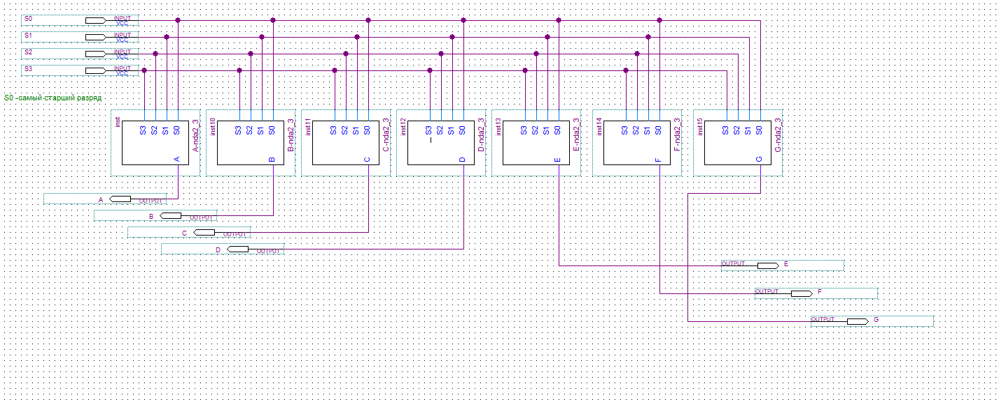

### Simulation Report:

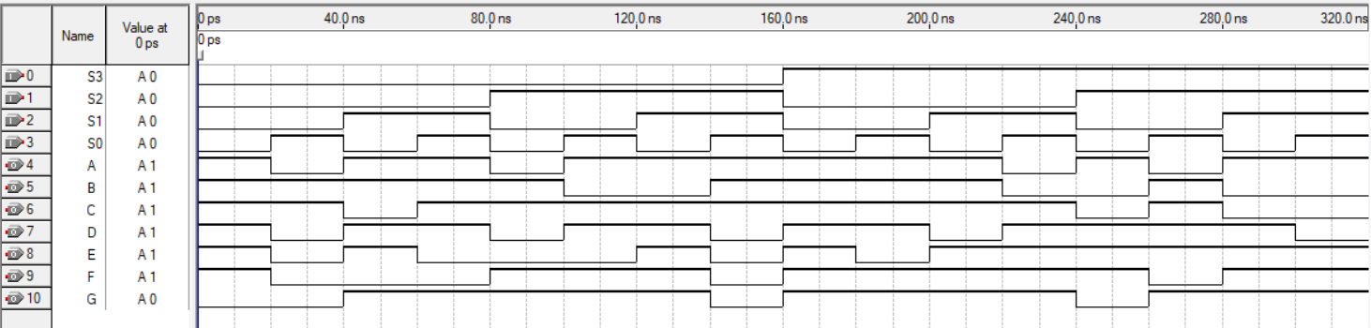

|  |  |  |  |  |  |  |  |  |  |  |  |
| --- | --- | --- | --- | --- | --- | --- | --- | --- | --- | --- | --- |
| t | S3 | S2 | S1 | S0 | A | B | C | D | E | F | G |
| 10 | 0 | 0 | 0 | 0 | 1 | 1 | 1 | 1 | 1 | 1 | 0 |
| 30 | 0 | 0 | 0 | 1 | 0 | 1 | 1 | 0 | 0 | 0 | 0 |
| 50 | 0 | 0 | 1 | 0 | 1 | 1 | 0 | 1 | 1 | 0 | 1 |
| 70 | 0 | 0 | 1 | 1 | 1 | 1 | 1 | 1 | 0 | 0 | 1 |
| 90 | 0 | 1 | 0 | 0 | 0 | 1 | 1 | 0 | 0 | 1 | 1 |
| 110 | 0 | 1 | 0 | 1 | 1 | 0 | 1 | 1 | 0 | 1 | 1 |
| 130 | 0 | 1 | 1 | 0 | 1 | 0 | 1 | 1 | 1 | 1 | 1 |
| 150 | 0 | 1 | 1 | 1 | 1 | 1 | 1 | 0 | 0 | 0 | 0 |
| 170 | 1 | 0 | 0 | 0 | 1 | 1 | 1 | 1 | 1 | 1 | 1 |
| 190 | 1 | 0 | 0 | 1 | 1 | 1 | 1 | 1 | 0 | 1 | 1 |
| 210 | 1 | 0 | 1 | 0 | 1 | 1 | 1 | 0 | 1 | 1 | 1 |
| 230 | 1 | 0 | 1 | 1 | 0 | 0 | 1 | 1 | 1 | 1 | 1 |
| 250 | 1 | 1 | 0 | 0 | 1 | 0 | 0 | 1 | 1 | 1 | 0 |
| 270 | 1 | 1 | 0 | 1 | 0 | 1 | 1 | 1 | 1 | 0 | 1 |
| 290 | 1 | 1 | 1 | 0 | 1 | 0 | 0 | 1 | 1 | 1 | 1 |
| 310 | 1 | 1 | 1 | 1 | 1 | 0 | 0 | 0 | 1 | 1 | 1 |

## ALU_Stend

### Схема модуля:

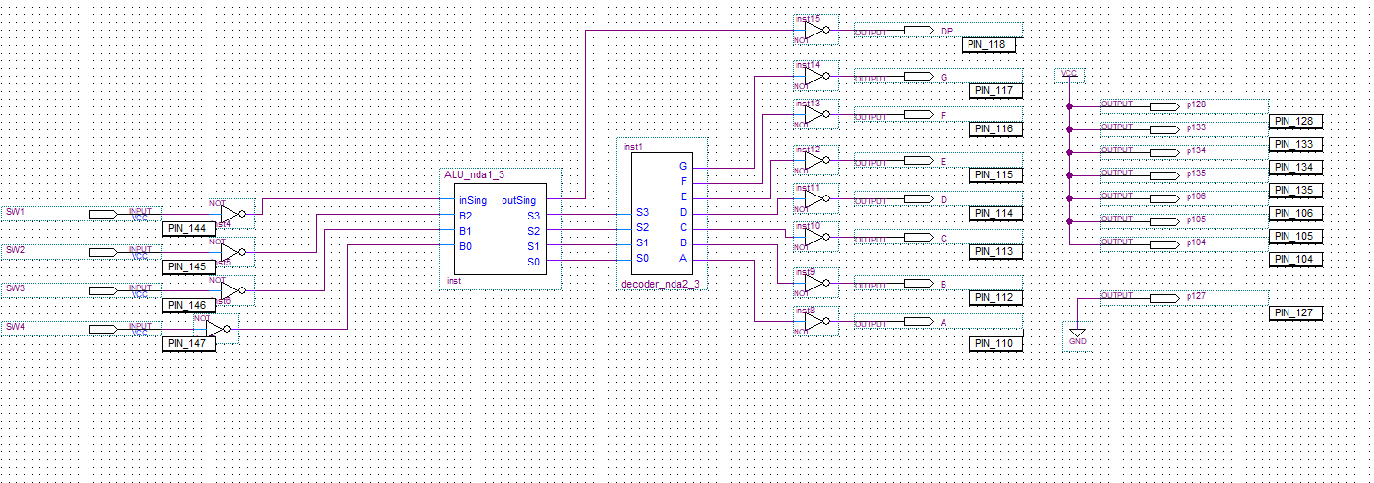

**Заключение:**

Построено арифметико-логическое устройство, способное складывать и вычитать двоичные положительные числа. Первым операндом, подаваемым на вход арифметического устройства, является константа +710, а значащие биты второго операнда определяться кнопками SW1 – SW3 лабораторного стенда. Кнопка SW4 используется чтобы задать вид операции. В случае отпущенной кнопки SW4 арифметическое устройство производит сложение операндов, а при нажатой – вычитание второго операнда из первого.

Максимальное время задержки комбинационной схемы составило 12.399 нс. Таким образом, максимальная частота составляет порядка 40 МГц.

**Результат работы:**

