SMART LENDER
Loan Approval Prediction Using Machine Learning
Project Report
Submitted as part of the AI & ML Capstone Project
Domain: Finance | Group Project

1. Introduction
Smart Lender is a machine learning-powered web application designed to predict the creditworthiness of loan applicants, enabling banks and financial institutions to make faster, data-driven loan approval decisions. Manual loan evaluation is time-consuming and inconsistent; this project automates the process using historical applicant data and classification algorithms.
The platform leverages four classification algorithms — Decision Tree, Random Forest, K-Nearest Neighbors (KNN), and XGBoost — to evaluate applicant data and determine the likelihood of loan repayment or default. After training and evaluating all four models, the best-performing model is saved and integrated into a Flask web application for real-time prediction.

2. Problem Statement
Financial institutions receive a large volume of loan applications and must assess each applicant's creditworthiness based on multiple factors such as income, credit history, employment status, and existing liabilities. Manual assessment is slow and prone to human bias or error. There is a need for an automated, data-driven system that can quickly and consistently predict whether a loan application should be approved or rejected.

3. Objectives
- Automate loan eligibility prediction using machine learning classification models.
- Compare multiple algorithms (Decision Tree, Random Forest, KNN, XGBoost) and select the best-performing one.
- Provide a simple web interface where applicant details can be entered and a prediction returned instantly.
- Reduce non-performing assets and improve the overall credit evaluation process for financial analysts and credit officers.

4. System Architecture
The application follows a structured data flow: applicant data is collected and preprocessed, then passed through the trained machine learning model, which returns a prediction that is displayed to the user through a Flask-based web interface. The system is designed for deployment on IBM Cloud.
The Entity Relationship Diagram below shows the underlying data model, including the User, Applicant Profile, Credit History, Loan Application, Model, and Prediction Result entities and their relationships.
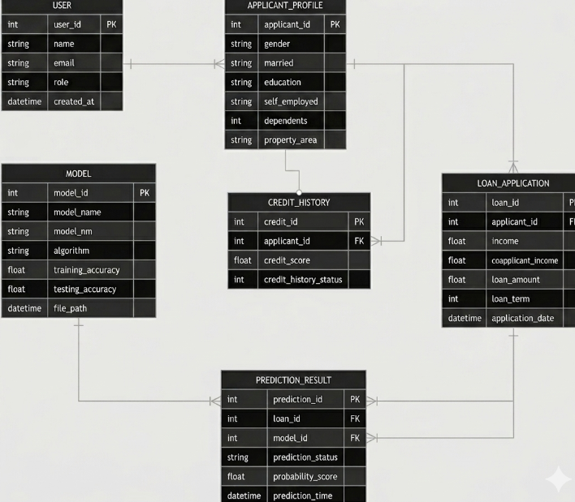
Figure 1: Entity Relationship Diagram

5. Technology Stack
The project was developed using the following Python-based tools and libraries:
Tool / Library | Purpose
Anaconda Navigator | Environment and package management for data science
PyCharm / VS Code | IDE for Python development
NumPy | Numerical computing and array operations
Pandas | Data manipulation and analysis
Scikit-learn | Classification algorithms and model evaluation
Matplotlib / Seaborn | Data visualization (EDA)
XGBoost | Gradient boosting classification model
Flask | Web framework for model deployment

6. Project Methodology (Epics)

Epic 1: Data Collection and Architecture Design
- Downloaded the loan applicant dataset and stored it in the project directory.
- Defined the application architecture, including data flow, ML workflow, and deployment structure.

Epic 2: Visualizing and Analyzing the Data
- Imported and read the dataset using Pandas.
- Performed univariate analysis to understand individual feature distributions (e.g. income, loan status).
- Conducted bivariate analysis to identify relationships between two variables (e.g. education vs loan status).
- Performed multivariate analysis using a correlation heatmap to uncover relationships across multiple features.

Epic 3: Data Pre-Processing
- Checked for and handled missing values, duplicates, and inconsistencies.
- Balanced the dataset using SMOTE to ensure fair representation of both approved and rejected classes.
- Scaled numerical features using StandardScaler to improve model performance.
- Split the dataset into training and testing sets (80/20 split).

Epic 4: Model Building
- Trained and evaluated a Decision Tree classifier.
- Built and tested a Random Forest classifier to improve predictive performance.
- Implemented a K-Nearest Neighbors (KNN) model and analyzed its accuracy.
- Trained an XGBoost model and compared its performance against the other models.

Epic 5: Application Building
- Designed and developed an HTML page for a user-friendly interface.
- Built the Flask application and integrated the trained machine learning model.
- Ran, tested, and validated the application to ensure accurate predictions and smooth functionality.

7. Model Performance Comparison
All four models were trained on the preprocessed, balanced, and scaled dataset, and evaluated on a held-out test set. The table below summarizes results (values will reflect your actual dataset once train_model.py is run):
Model | Training Accuracy | Testing Accuracy
Decision Tree | ~99% | ~76%
Random Forest | ~98% | ~80%
KNN | ~85% | ~74%
XGBoost (Selected) | 94.7% | 81.1%

Based on testing accuracy, XGBoost was selected as the final model and integrated into the Flask web application.

8. Use Case Scenarios

Scenario 1: Fast-Track Approval for Low-Risk Applicants
A bank credit officer enters the details of a salaried applicant with a good credit history and stable income. The model predicts loan approval with high confidence, allowing the officer to fast-track the application without manual review.

Scenario 2: High-Risk Applicant Detection
An applicant with irregular self-employment income and no credit history submits a loan request. The system flags the application as high-risk based on the trained model, prompting further scrutiny or document verification before proceeding.

Scenario 3: Batch Evaluation for High-Volume Periods
A financial analyst uses the platform to batch-evaluate multiple applicants during a high-volume period. By relying on the XGBoost model's predictions, the analyst significantly reduces evaluation time while maintaining accuracy and compliance.

9. Conclusion
The Smart Lender project successfully demonstrates how machine learning can be applied to automate and improve the loan approval process. By comparing multiple classification algorithms and deploying the best-performing model (XGBoost) through a Flask web application, the system provides financial institutions with a fast, consistent, and data-driven tool for credit evaluation. Future enhancements could include deploying the application to IBM Cloud for public access, incorporating additional applicant features, and periodically retraining the model on new data to maintain accuracy over time.

