# Common Questions about Reports

## When do I submit my report?

The report is due the next class date that your demo is due.

For example:

* For MWF people, if you must demo by Wednesday at 5pm, you must submit your report by Friday at 5pm.
* For TR people, if you must demo by Thursday at 5pm, you must submit your report by Tuesday at 5pm.

## What if I demo on time but submit my report late?

If you demo on time but you submit your report late, **this will count as a tardy**.  It is highly suggested that you submit your report very soon after your demo so you don't forget.

## What if there is something wrong with my report? How will I know and can I fix it?

If you turn in your report ON TIME and it looks like you put in a minimal amount of effort (aka not just a few sentences), you will be allowed to fix your report with no penalty.

The TAs will read through your report and give you feedback on how to improve your report.  All you need to do to avoid penalties is to resubmit that report within **1 week** of us giving you feedback with the suggested fixes.

**If your initial report submission does not show you put in a minimal amount of effort, it will be deemed insufficient and will count as a tardy**.   The TA gets to make this determination.

## What is required to be in a report?

In every report, you must have 3 sections:

* Introduction
* Design
* Conclusion

For the **Analog Filter Module**, the **Power Supply Module**, and the **Pre-Amp Module**, you must include in your design section:

* Schematic
* Bill of Materials
* LTSpice Images.
  + Note: LTSpice images can be difficult to read, so make them big and use colors that contrast black.
* Either screenshots of the DAD and/or pictures of an oscilloscope
  + Collect and include as many visuals in your reports as possible. More is better.

For the **Ohmmeter Part 1 Module**, the **Ohmmeter Part 2 Module**, the **Function Generator Module**, the **RTC Module**, and the **Stepper Motor Module**, you must include in your design section:

* Schematic
* Hardware Block Diagram
* Software Flow Chart
* Either screenshots of the DAD and/or pictures of an oscilloscope (if applicable)
* Bill of Materials

**Note:** Do NOT include your code in the report. That should be submitted separately.

For the **PCB Module** you must submit your board on the Design Website ([www.seniordesign.ece.ufl.edu](http://www.seniordesign.ece.ufl.edu)) with 9999 as the selected quantity. You must include in your design section:

* Sample schematic (the schematic you got from lab)
* Altium schematic drawing
* PCB layout drawing in 1:1 format

**Note:** The PCB module will most likely be less detailed than the other reports because in general, it does not involve many major design decisions.

## My LTspice graphs aren’t clear. The lines barely show. How do I fix that?

1. Open the control panel (tools menu bar)  
2. To thicken the schematic lines, Select the Drafting Options tab and check "Draft Thick Lines"  
3. To thicken simulation lines, Select the Waveforms tab and check "Plot data with thick lines"

## What is the difference between a Schematic and a Block Diagram?

A **schematic** (see Figure 1) **shows connections in a circuit** in a way that is clear and standardized. It is a way of communicating to other engineers exactly what components are involved in a circuit as well as how they are connected. A good schematic will show component names and values, and provide labels for sections or components to help communicate the intended purpose. Note how connections on wires (or "nets") are shown using dots and *non-connections* are shown without a dot.

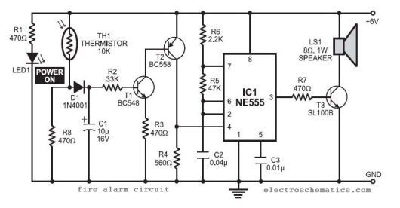

Figure : Schematic

A **block diagram** (see Figure 2) **shows a higher level (or organizational layout) of functional units** in a circuit (or a device, machine, or collection of these). It is meant to show data flow or organization between separate units of function. A block diagram gives you an *overview* of the interconnected nature of circuit assemblies or components. **A block diagram should not include any circuitry!**

Here are some links to help you understand the difference

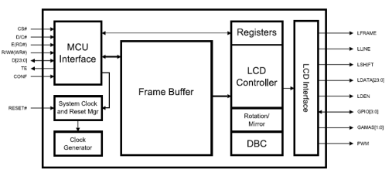

Figure : Hardware Block Diagram

* [WIKI article on block diagrams](https://en.wikipedia.org/wiki/Block_diagram)
* [Really good forum question about schematics vs block diagrams](https://electronics.stackexchange.com/questions/105136/whats-a-schematic-compared-to-other-diagrams)

## How should I format a Bill of Materials?

There is a template on Canvas that will help you make a bill of materials. It is called: Design 1 BOM Template.xlsx

## What should I write about in my Introduction?

The introduction should be one to two paragraphs and include background information on the module’s hardware and explain the goal(s) of the design.

## What should I write about in my Design Section?

* The design section should include a detailed description of the module’s design and how it is implemented.
* It should be at least 4 paragraphs but it usually takes more than 4 paragraphs to convey all the necessary information.
* You need to **convey what you did, why you did it, and how you did it**
* The reader should be able to read your report and understand your design to the point that the reader could implement it if he/she wanted to.
* For the **software architecture:**
  + Include a software flow chart
  + Give a detailed description of the that flow chart in words
  + Tell the reader about the states, how to do the transition, what do they represent.
  + Tell the reader about any interesting functions:
    - What were they?
    - Why did you have to write them?
    - What was tricky about it.
  + What internal hardware from the micro controller did you use?
    - Why did you choose to use it?
    - Did it make anything easier.?
  + What are the inputs and outputs?
  + Etc
* For the **hardware architecture:**
  + Include a schematic and/or a block diagram
  + Tell the reader what parts you used.
    - Why did you use those parts?
    - What do they contribute to the success of the design?
  + Was there anything interesting (bypass caps, signal filters, so on) you had to do to get your design to work correctly?
  + Etc
* If you ran into problems during the design and/or construction (and I'm sure you did), tell the reader about it.
  + What were the problems?
  + How did you find them?
  + How did you fix them?

## What should I write about in my Conclusion?

The conclusion should compare the experimental results to the theoretical results and explain any discrepancies and why they occurred. This section should also list any difficulties encountered during implementation of the design and describe the design’s success or explain how/why it failed.