

​​Web Technologies

Final Project

Football Team

**Students**: Nurzhan Moldash, Dariga Tasbolatova, Symbat Maidanova, Yersoltan Sadriden

**Group**: Team 2

**Tutor**: Aldiyar Salkenov

Nur-Sultan, 2021

**Overview**

**About your team** – Our team consist of 4 members

**Members and their roles ы]я**

**Yersoltan Sadriden**. student id: 203049, email: 203049@astanait.edu.kz, role: JS front-end, express.js

**Nurzhan Moldash**. student id: 203027, email: 203027@astanait.edu.kz, role: JS front-end, express.js

**Dariga Tasbolatova.** student id: 203017, email: 203017@astanait.edu.kz, role: About Team html/css

**Symbat Maidanova.** student id: 203046, email: 203046@astanait.edu.kz, role: Home Page html/css

**Communication strategy**

We used a verbal communication strategy. We organized meetings using Microsoft teams. Also, we have a chat, where we can discuss some little problems and other stuff. During the brainstorm, we have additional meetings where we can describe our problems and find the solution to the problems we have.

**Motivation**

Due to some limitations in organizing large events such as collection of football fans and voters during the game itself, this group project has been managed. Our project is aimed to calculate in distance the result of goals made by each playing team. This provides easy and healthy access to vote for each fan from any place.

**High-level project scope**

This is absolutely a brand-new website, but some parts were spied on from other websites

**Target audience/market**

A website designed for all categories of people who are interested in football and not only. You do not need any special knowledge or skills to use this site.

**Project goals and team interests**

**Project goals**

● Create a good looking and functionally well-managed website for football goals

● Make website user friendly and easy to use

● Become confident with Github

● Improve teamwork skills

● Creating fully responsive server with express node js

**Team interests**

● Reinforce our front-end knowledge

● Understand the work with JavaScript

● To use express.js in practice

# **Phases**

● Phase 1 – Creating “Homepage” and “About Team” using HTML and CSS;

● Phase 2 – Using JavaScript for calculating goal scores, input and output datas;

● Phase 3 - Build a server using express.js;

● Phase 4 – Write documentation and create presentation;

● Phase 5 –Preparing to defence;

**Content structure**

**Site map**

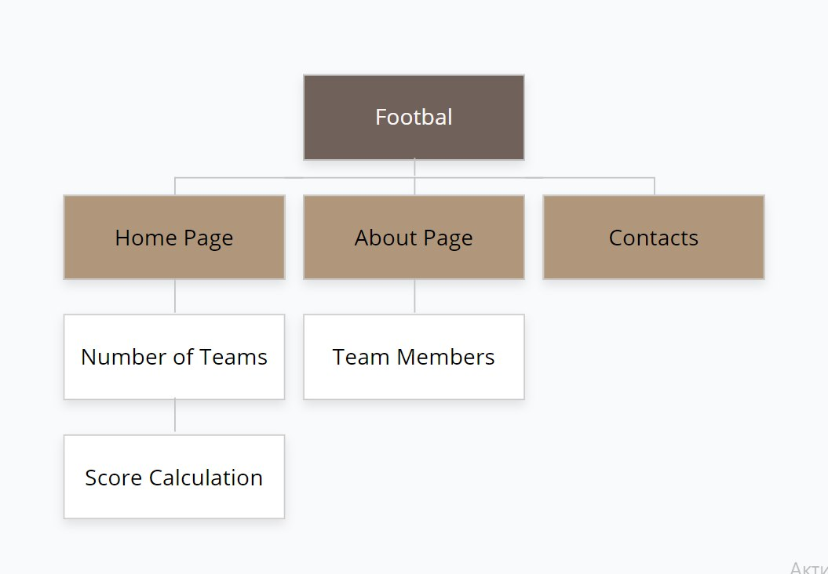

**Content types:**

● Index.html has event type content as it displays the winner team.

● About.html is people type content as it shows the group members with their photo and name.

**Design**

● Our site created in cartoon style and colors were chosen through a special color palette: basic colors such as white, black, gray; and individual color such as #ffe8d6, #ffd67, #2A6039, #22B24B.

● In CSS we add animation and transition using hover

● Instead of our photo we used t-shirts with own numbers

● For background image we used football field

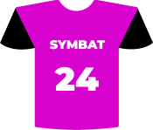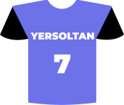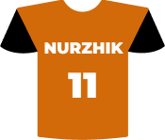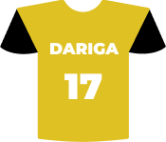

**image1.** T-Shirts

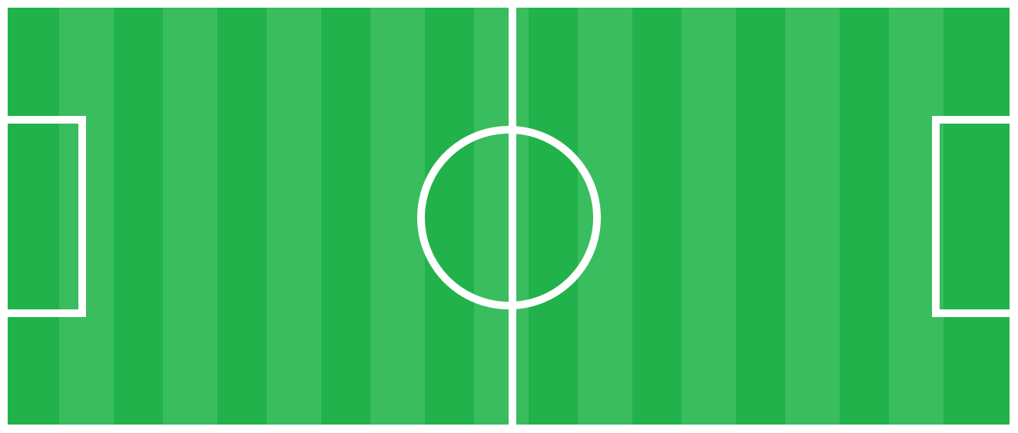

**image2.** Football field.

**Functionality**

We have two pages: Home page and About team. Each of the pages has its functionality: for instance, Home page contain 4 inputs: 1) Players of team 1, 2) Players of team 2, 3) How many goals scored the team 1, 4) How many goals scored the team 2 and has a button that displays the winner and a score list. The score list shows the number of goals scored in the game; while About team displays information about us and shows our team image.

**Hosting**

Hosting on GitHub by steps:

1. Create app.js file

2. Create package.json using ‘npm init’ command (in gitBash)

3. Install the express node ‘node i express’

4. Develop an express commands to support server work

5. Run the routing using gitBash ‘nodemon app.js’

**Accessibility**

Our site has good accessibility. All the content is beautiful. Basic functions are easy to find and use, no problem with colors and how they relate. But due to our inexperience, our site is not yet accessible to the visually impaired. But in the future this flaw will be corrected, and in the future it is possible to create a color blindness mode.

**Deadlines**

● Phase 1 –November 14, 19:00

● Phase 2 –November 16, 20:00d

● Phase 3 –November 18, 20:00

● Phase 4 – November 20, 21:00

● Phase 5 –November 21, 22:00

# **Summary**

In conclusion, we want to say that this project was very interesting for us. We have gained tremendous experience that will be very useful in the future. Our knowledge of front-end (html/css, JavaScript) and back-end (express.js) has improved a lot. There were moments when it was difficult for us, because of our inexperience, we made a lot of mistakes, we initially failed much. But in the end, we were able to overcome these difficulties and create our website. Our skills in JavaScript have also greatly advanced which is quite difficult to use. In general, we have only positive emotions from this project and are very grateful for such an experience.