

Web Technologies

MidTerm Group Project

University Library Website

Students: Nurbek Abeuov, Yersoltan Sadriden, Dilnaz Zhaxylykova

Group: TS-2004

Tutor: Aldiyar Salkenov

Nur-Sultan, 2021

# **Overview**

**Team Responsibilities:**

* Dilnaz – navbar, footer, carousel, documentation.
* Nurbek – books, Body div with best books available, Body div with at least 6 books available with the name, picture, and description, Body div with subscription databases
* Yersoltan – borrow a book, Body div with a Mailchimp form to reserve a book, carousel.

**Communication strategy:**

* Verbal (face to face, telegram chats)
* Visual (plan drawing)
* Brainstorm.

**Motivation**:

The project is necessary to make it easier to navigate the university's research library. Nowadays, we don't have to waste our time and energy to come to the library, just go to the website, find what we need, reserve, and pick up the book, which is actually much easier. Therefore, a website for the library is essential.

**High-level project scope:**

A website built from the ground up using Bootstrap components.

**Target audience/market**:

The project mainly targets the university, the university library, employees, and students.

# **Project goals and team interests**

**Project goals:**

* Write a full-featured website easy to use for users
* Attract more people to get the necessary and additional knowledge, materials through digitalization.
* Reduce the consumption of paper and wood through e-books.
* Attract more applicants by having a digital library full of different books.

**Team interests:**

* Understand HTML tags and CSS by building a library website
* Get used to Bootstrap, Grid
* Improve teamwork skills
* Improve adaptability skills in unfamiliar environments by working with people from different groups
* Establish a solid understanding of website design principles

# **Phases**

* Phase 1 – Basic library website with HTML and CSS (currently)
* Phase 2 – Create an extensive database for the website (what should we add in the future)
* Phase 3 – Add a refresh/load animation via JS
* Phase 4 – Add a chat with a bot on the site itself to get answers to frequently asked questions

# **Content structure**

**Site map**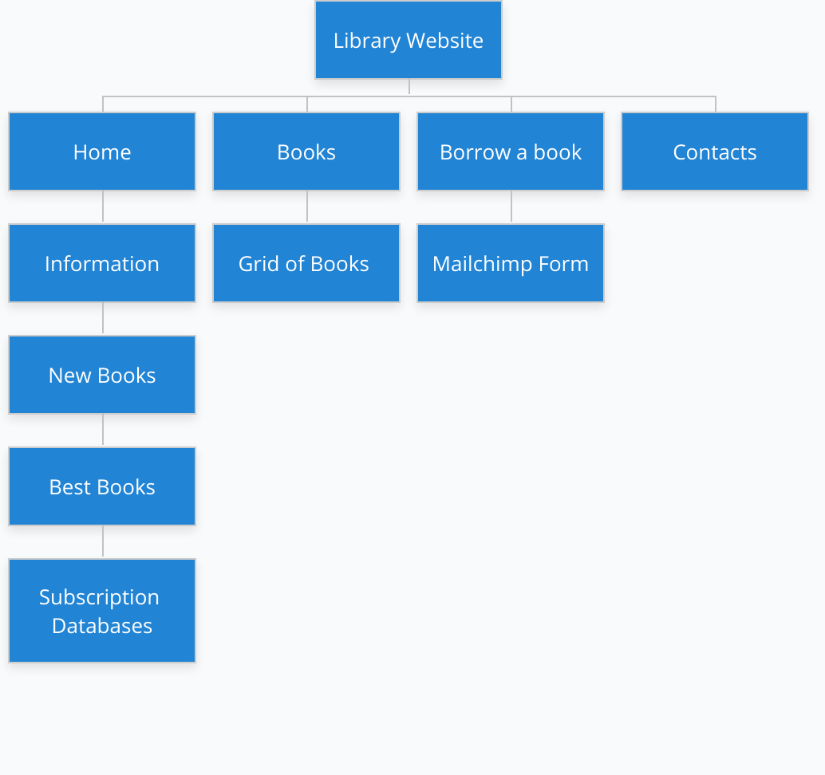

**Content types:**

* Portal
* Educational
* Visual
* Content Assets
* Calls to Action (contact us, reserve)
* Landing Pages

**Design:**

* Reference Links
* Images
* Carousel
* Text content
* Grid
* Padding
* Spacing
* Color
* Typography rules
* Background
* Animation of Carousel
* Logotype
* Fonts

**Functionality:**

Our website has fields to fill out to reserve your book. This requires you to fill in several fields, i.e:

* Reserve Name.
* Student Id.
* Date and time
* Phone number
* Email

After the user fills out the data, the information is sent to us in the mail and then we can work with the book reserve, or link the librarian mail with Mailchimp, so that the librarian receives the data directly.

**Hosting**

Hosting via GitHub.

**Accessibility:**

1. Color

The colors on this site are chosen so that all the lettering and other elements can be easily distinguished. All of the colors used are not harsh, but still catch the user's attention. This will not interfere with the colorblind user's ability to navigate our site.

1. Header

Headings help guide the user and improve user understanding.

1. Responsive form

Each field has text next to it, so that the user understands what to fill in.

1. Text to Images

Each picture is accompanied by text so that you can understand what the picture is about.

What could have been done to improve the public accessibility of the site?

It would be possible to add a voice assistant, which would help blind people understand what the site provides

**Deadlines:**

Plan – 8.10.2021

Homepage – 11.10.2021 23:59

Books – 11.10.2021 23:59

Borrow a book – 11.10.2021 23:59

Documentation – 11.10.2021 23:59

# **Summary**

In conclusion, we succeeded in making the website. There were a few difficulties, namely the flexibility of the site on different devices, working with MailChimp, setting up pictures for the carousel and adding text to the carousel. Despite the difficulties, we still achieved our goal and definitely improved our skills in group work, HTML and CSS, got better working with Bootstrap and Grid. Also, we had a great experience in creating a website for an existing university portal.