OPEN ENDED ASSIGNMENT

ON

## DIGITAL IMAGE PROCESSING

**Title: Digital image processing applications in Bio medical field**

**Our Aim: To detect Kidney Stone using Digital Image Processing**

### Student Names:

3249: PURVA SHROTRIYA

3256:SWARANGI THAKURDESAI

3265: SHRADDHA YERULE

3271: AISHWARYA BABAR

UNDER THE GUIDANCE OF

# Prof. Sandhya Potdar

###### 

**DEPARTMENT OF**

**ELECTRONICS AND TELECOMMUNICATION ENGINEERING**

**MKSSS’s**

**Cummins College of Engineering for Women, Pune**

**(An Autonomous Institute Affiliated to Savitribai Phule Pune University)**

INDEX

| **Sr.No** | **Contents Page No.** |
| --- | --- |
| 1 | ABSTRACT |
| 2 | INTRODUCTION |
| 3 | METHODOLOGY |
| 4 | BLOCK DIAGRAM |
| 5 | ALGORITHM AND CODE |
| 6 | RESULTS |
| 7 | CONCLUSION |

**ABSTRACT**

The Kidney stones are a hard collection of salt and minerals, often calcium and uric acid that form in the kidneys. The majority of persons with kidney stones do not recognize them at first, and their organs gradually deteriorate. For surgical procedures, it is critical to determine the exact and precise location of a kidney stone. Speckle noise is present in most ultrasound images, which cannot be removed by humans. The paper consists of problems of kidney stones in the human body and detection mechanisms by using Image processing techniques. The Techniques like preprocessing, segmentation and Morphological Analysis. The Results of techniques are evaluated based on the output parameters and analyzed to conclude the methods working efficiently.

**INTRODUCTION**

The kidney is a vital organ in the human body. Kidney stones have been a widespread problem in recent years and if not detected at an early stage then it may cause complications and sometimes surgery is also needed to remove the stone. Kidney stones are solid pieces of material that form as a result of minerals in the urine. They are caused by a combination of genetic and environmental factors.Blood tests, urine tests, and scans are utilized to diagnose this kidney stone. Image processing is a very effective way to properly detect the stone. Imaging is the most important component in the medical field. CT scans, Ultrasound scans, and Doppler scans all have different scanning methods . Nowadays, the automated technique is being employed in the medical industry to analyze diseases. Many frequent issues may arise due to the diagnosis by automation, such as the use of inaccurate results, inadequate algorithms, etc. Generally, the process of medical diagnosis is very complex and hazy. Additionally, several mathematical approaches were previously utilized to identify kidney stones using ultrasound images. Among all the approaches for detecting kidney stones, image processing has the most advantages since it analyzes the stone with great precision.

**METHODOLOGY**

The proposed method for detecting kidney stones is divided into several phases such as:

Image collection

Image preprocessing

Image enhancement

Image adjustment

Photo segmentation

Morphological analysis

**BLOCK DIAGRAM**

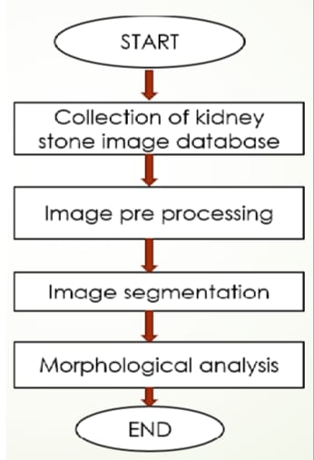

**ALGORITHM AND CODE:**

**ALGORITHM:**

1. Start

2. Get the image file.

3. Extract and read the input image.

4. Display the original image

5. Pre-process the image.

6. Convert the image from RGB to Grayscale.

7. Get the pixel information.

8. Set a threshold level of pixel intensities to be greater than 20. So the values greater than 20 are 1 (white) and less than or equal to 20 are 0 (black).

9. Fill the holes in the image.

10. Perform Area Opening Operation on Binary image.

11. Multiply this mask 3 times with the original image for R,G,B channel respectively.And then convert it to an integer which is of 8 bit.

12. Contrast stretching using the function imadjust

13. Convert RGB image to Grayscale image.

14. Apply a 5*5 median filter on the image.

15. After getting the pixel information, we decide to set a very high threshold value for thresholding.

16. Calculate the size of the image.

17. Define x and y coordinates, also define the x and y coordinates of all other points in filter matrix (rectangular in shape)

18. Multiply this mask with the image.

19. Again perform area opening in order to filter out very small objects in the vicinity.

20. Apply labeling.

21. If the number of such pixels in the processed image is greater than or equal to 1 , then the stone is present; otherwise, it is not.

22. Stop.

**CODE**

clc

clear all

close all

warning off

[filename,pathname]=uigetfile('WithoutStone.jpg');

filename=strcat(pathname,filename);

a=imread(filename);

imshow(a);

b=rgb2gray(a);

figure;

imshow(b);

impixelinfo;

c=b>20;

figure;

imshow(c);

d=imfill(c,'holes');

figure;

imshow(d);

e=bwareaopen(d,1000);

figure;

imshow(e);

PreprocessedImage=uint8(double(a).*repmat(e,[1 1 3]));

figure;

imshow(PreprocessedImage);

PreprocessedImage=imadjust(PreprocessedImage,[0.3 0.7],[])+50;

figure;

imshow(PreprocessedImage);

uo=rgb2gray(PreprocessedImage);

figure;

imshow(uo);

mo=medfilt2(uo,[5 5]);

figure;

imshow(mo);

po=mo>250;

figure;

imshow(po);

[r c m]=size(po);

x1=r/2;

y1=c/3;

row=[x1 x1+200 x1+200 x1];

col=[y1 y1 y1+40 y1+40];

BW=roipoly(po,row,col);

figure;

imshow(BW);

k=po.*double(BW);

figure;

imshow(k);

M=bwareaopen(k,4);

[ya number]=bwlabel(M);

if(number>=1)

disp('Stone is Detected');else

disp('No Stone is detected');

End

**RESULTS**

**WITH STONE**

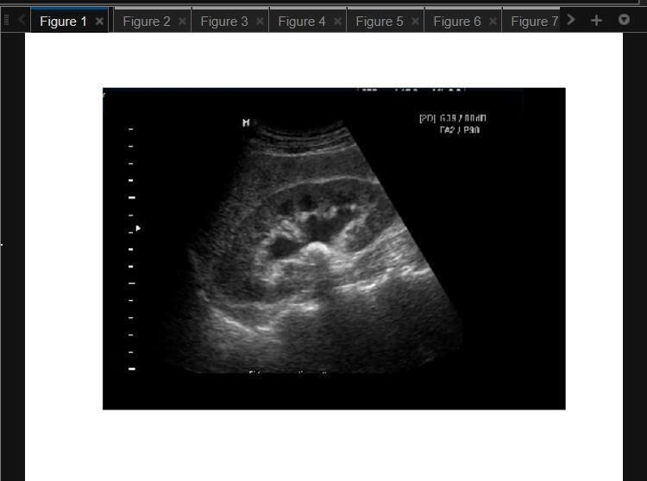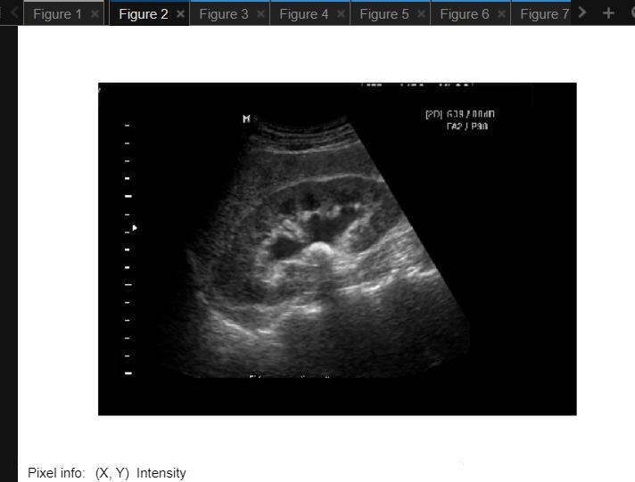

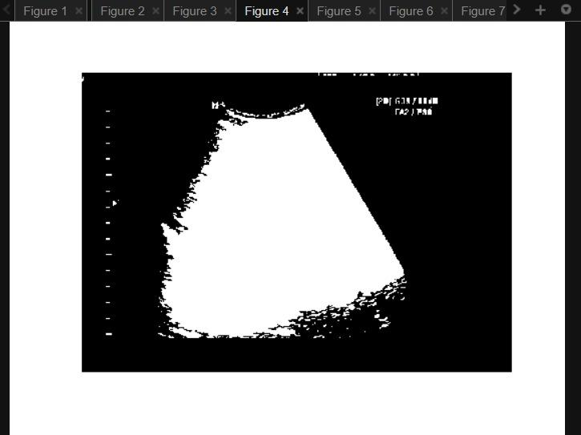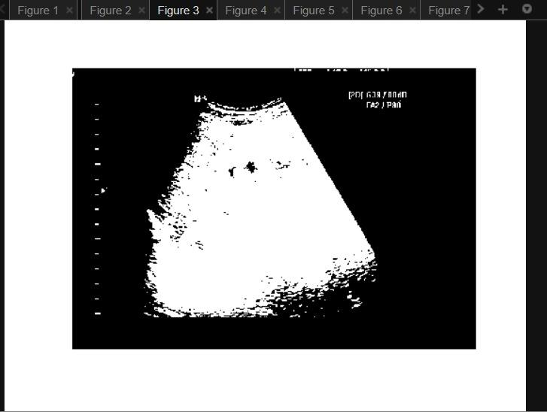

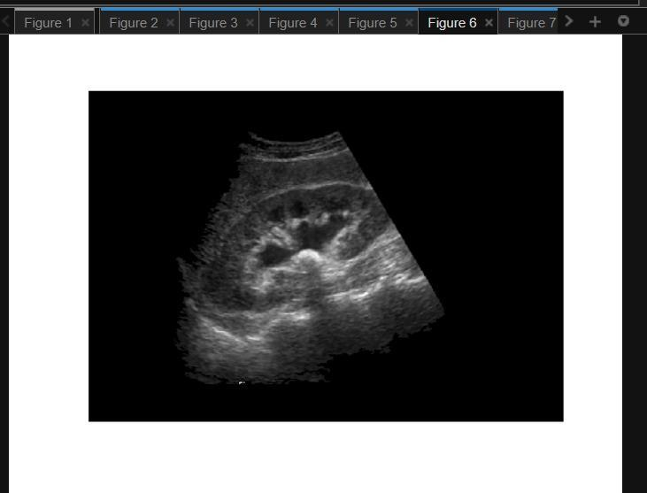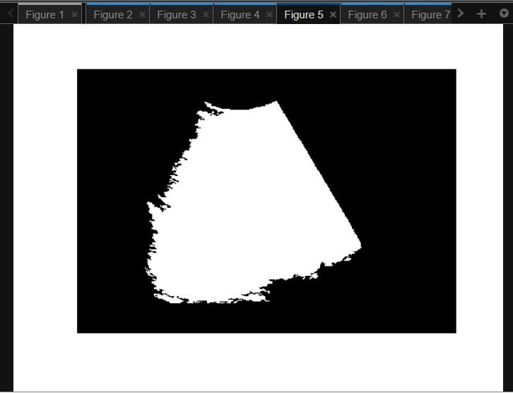

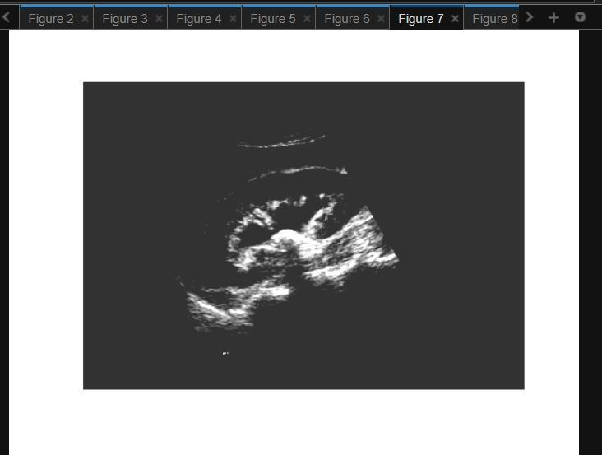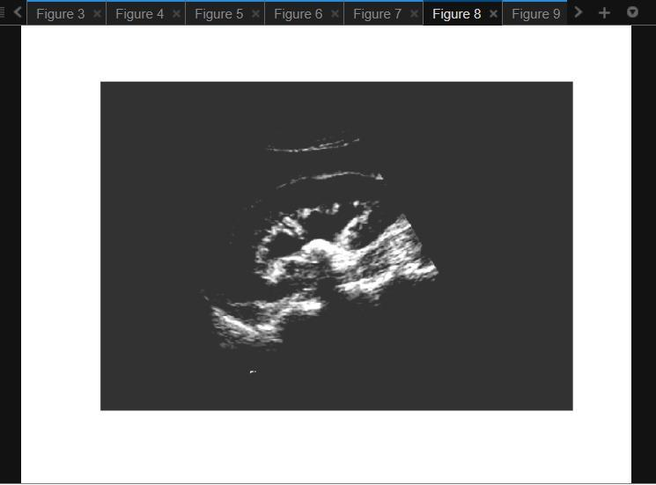

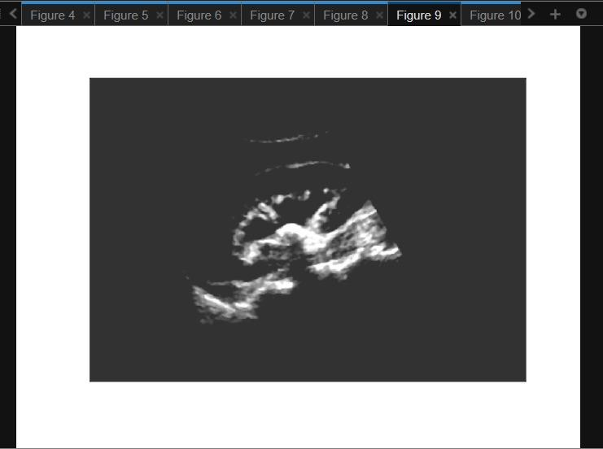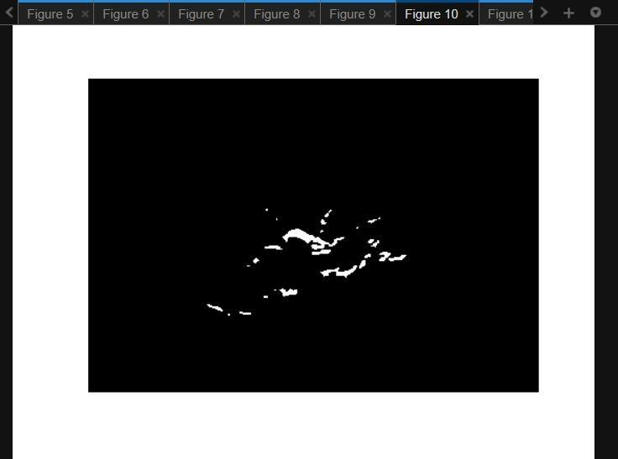

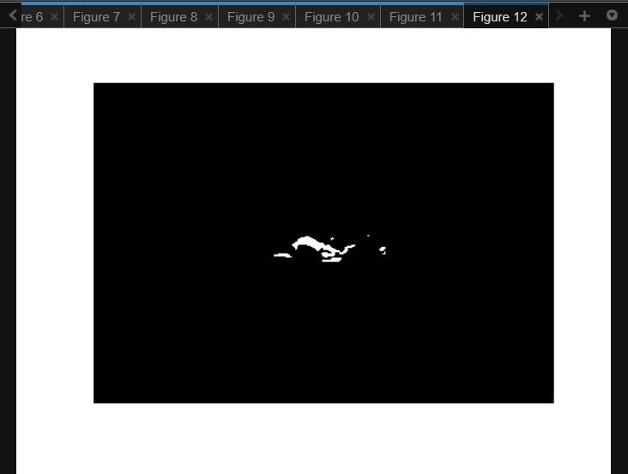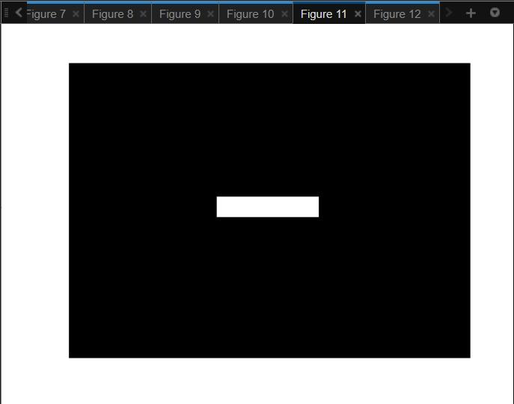

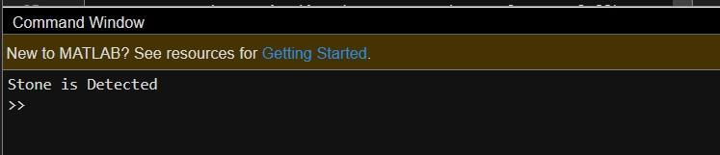

**Without Stone** 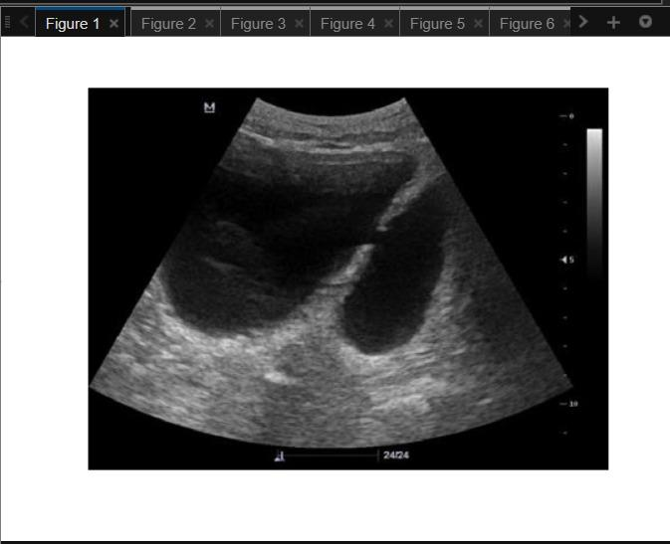

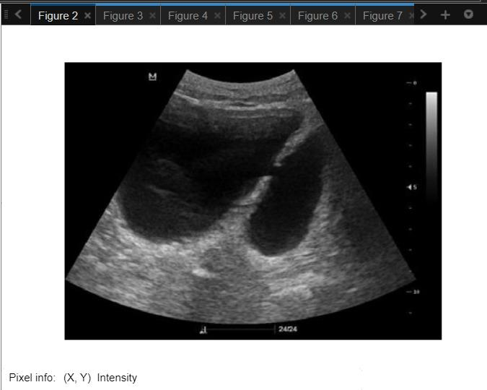

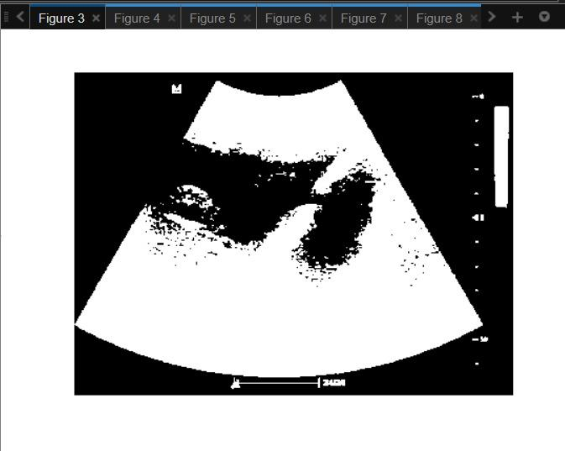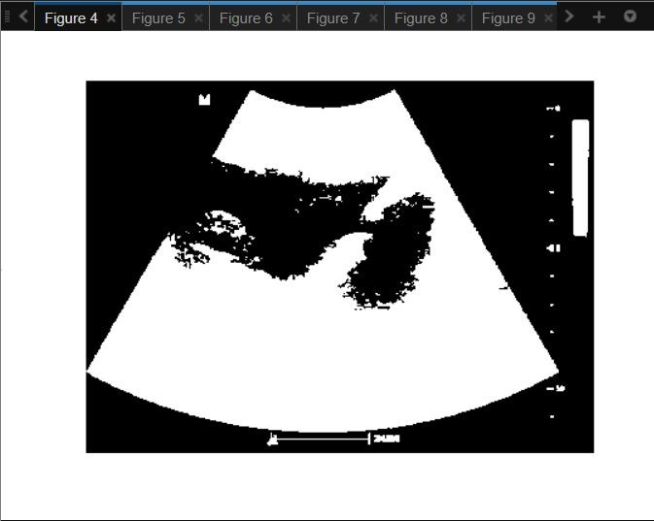

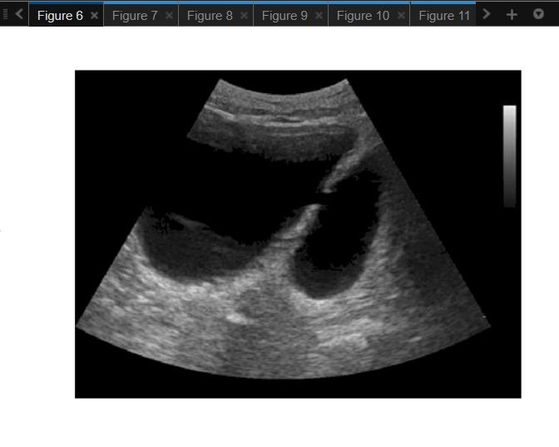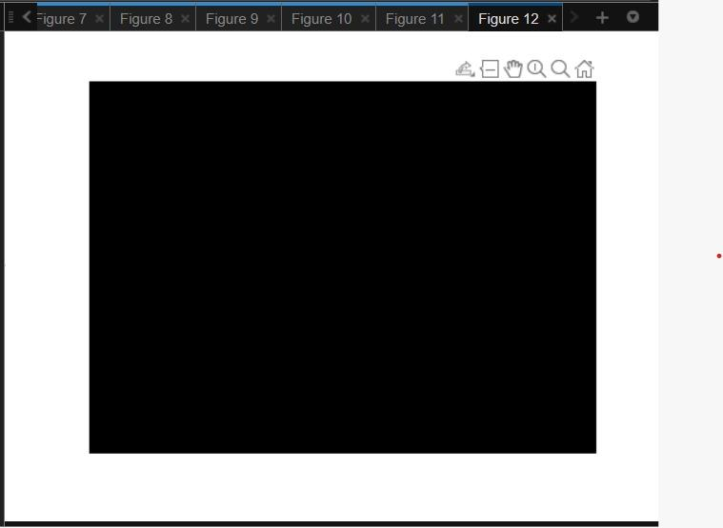

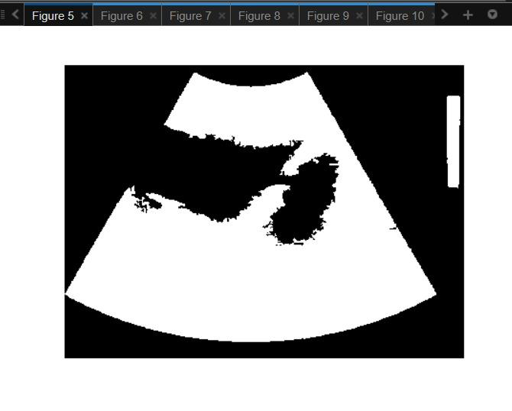

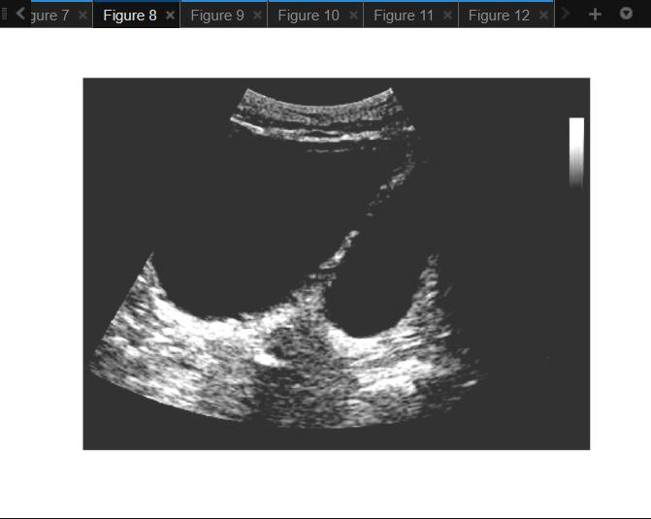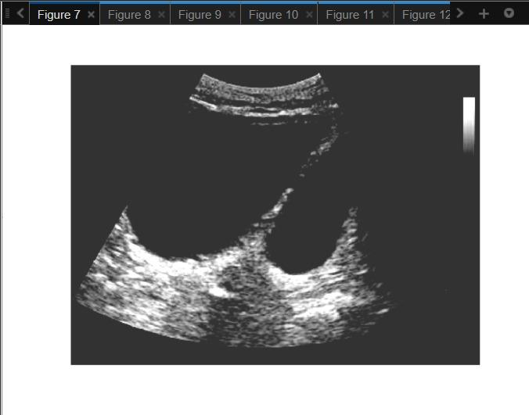

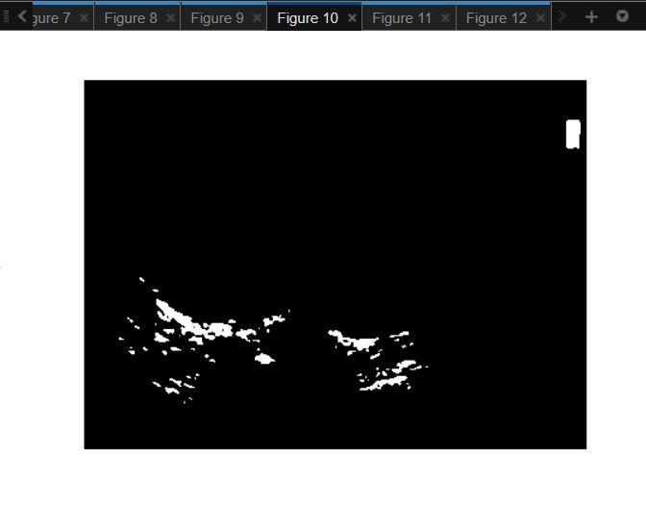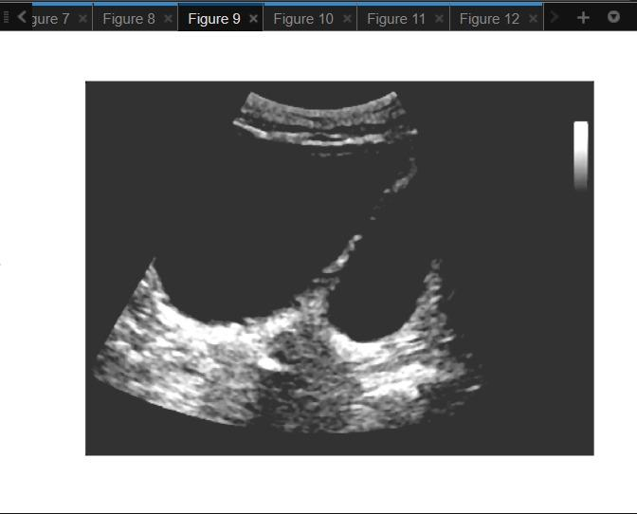



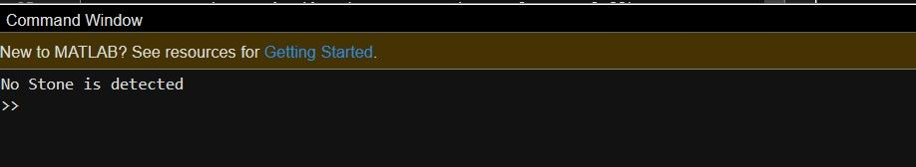

**CONCLUSION**

Pre-processing on the input image are the basic and key functions of our proposed scheme for spotting the presence of kidney stones. The image enhancement and image segmentation approach was used to measure the precise coordinates of the stone and the overall appearance of the stones created from the picture.

Doctors could intelligently diagnose kidney stones following the surgery by using a composite of all three methods. The accuracy of the proposed method is 96.82%, which is acceptable compared to baseline algorithms but we can extend the work by proposing artificial neural network-based methodology to achieve more accuracy.