LABORATORY 1A

Raw Security Logs to
Rule-Based Detection
MITRE ATT&CK Mapping & SOC Dashboard

Environment | Windows PowerShell, Docker Compose, dashboard on localhost:8000
Detection data | security.log and output/findings.json
Report date | 25 October 2026

Practical lab report

1. Executive Summary
This lab demonstrated a simple security monitoring workflow: raw security events were written to a log, a rule-based detector evaluated the events, candidate detections were mapped to MITRE ATT&CK techniques, and the results were exposed through a SOC-style dashboard and a JSON findings file. The initial baseline produced two findings: T1110 (Brute Force) for three failed-password events from 172.18.0.5, and T1046 (Network Service Discovery) for a network-scan log event from 172.18.0.7. Four controlled tests changed the input logs and showed that detection outcomes depend on the configured rules. During the simulator observation, the findings file reported 16 findings while synthetic events were being appended. The original six-line log was restored and all Compose services were stopped at the end.

2. Environment and Verification
The lab was run from the repository folder labs/lab1a-mitre-soc on Windows using PowerShell and Docker Compose. The dashboard was available at http://localhost:8000. The detector reported a five-second scan interval, a failed-password threshold of three, and MITRE knowledge status Loaded with two techniques.
Component | Observed state | Purpose
lab1a-dashboard | Running during test; port 8000 published | SOC dashboard
mitre-log-detector | Running during test | Scans logs and creates findings
lab1a-log-simulator | Running during Activity D | Appends synthetic events
Verification evidence: `docker compose ps` showed all three containers as running before the simulator observation. After cleanup, `docker compose ps` returned no running containers. The simulator log stated that it started with a 10-second interval and repeatedly appended one or three synthetic events.

3. Initial Baseline Findings
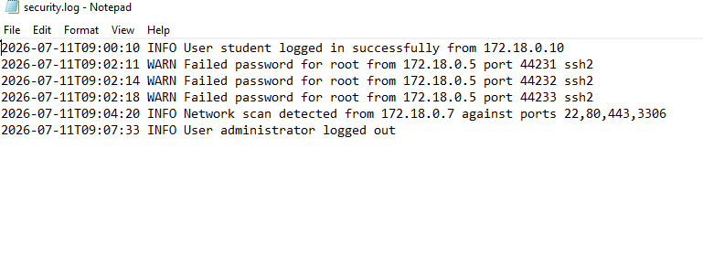
Figure 1. Original security.log showing the six baseline events.
Technique | Finding / evidence | Source IP | Severity | Tactic
T1110 — Brute Force | 3 failed-password events from the same IP | 172.18.0.5 | High | Credential Access
T1046 — Network Service Discovery | Log contains “Network scan detected” | 172.18.0.7 | Medium | Discovery

4. Evidence-to-Detection-to-MITRE Mapping
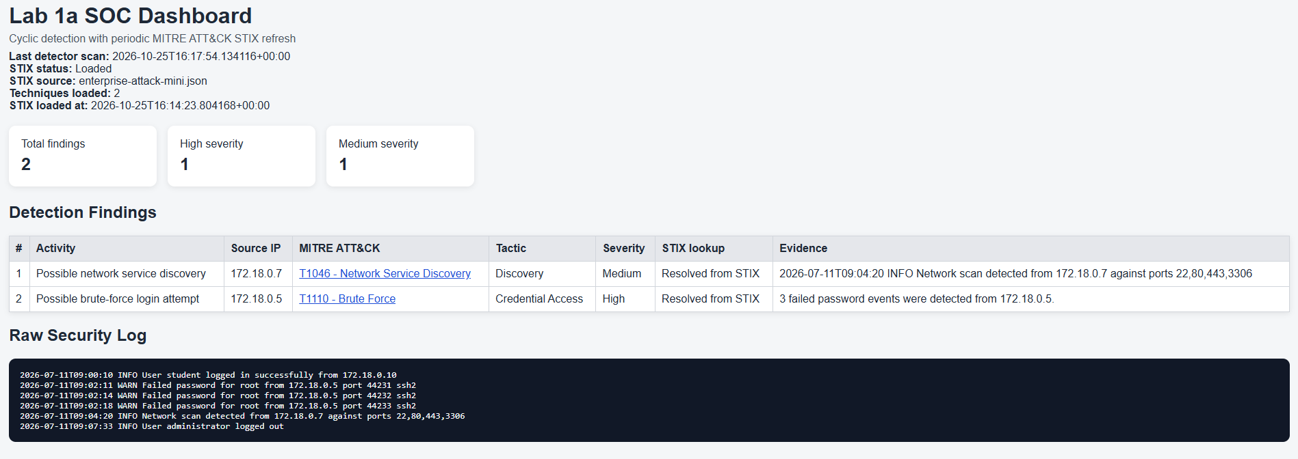
Figure 2. SOC dashboard showing the two initial findings and their MITRE ATT&CK mappings.
The mapping below describes what the lab's configured rules detected. MITRE ATT&CK labels are candidate behavioral mappings, not proof that an adversary performed the behavior.
Evidence | Detection rule | Technique | Tactic | Uncertainty / limitation
3 failed password events from 172.18.0.5 | At least 3 failed-password events from one source IP | T1110 — Brute Force | Credential Access | May reflect user error or a test; does not prove a successful login or compromise.
“Network scan detected” from 172.18.0.7 against ports 22, 80, 443, 3306 | Log contains the phrase “network scan detected” | T1046 — Network Service Discovery | Discovery | Rule relies on a log phrase; does not independently verify a real scan, intent, or ownership of the IP.

5. Controlled Experiments (C1–C4)
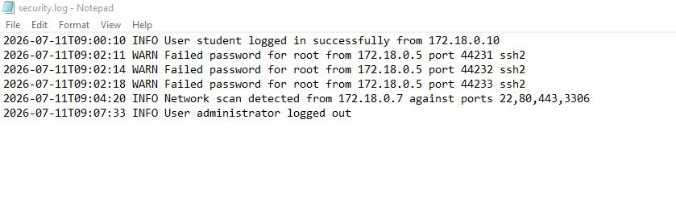
Figure 3. Additional capture of the baseline security log (same baseline state).
Note: The uploaded second log screenshot shows the same six baseline events as Figure 1; it is included as supplementary evidence.
Test | Change to the log | Observed result
C1 — Below threshold | Removed one of the three failed-password records from 172.18.0.5, leaving two. | finding_count = 1; T1110 disappeared and T1046 remained.
C2 — Split source IPs | Used three failed-password events from 172.18.0.5, 172.18.0.6, and 172.18.0.8. | finding_count = 1; no T1110 was generated because no IP reached the threshold of three.
C3 — New repeated failures | Added three failed-password events from 192.0.2.55. | finding_count = 2; new High-severity T1110 finding for 192.0.2.55; T1046 remained.
C4 — New scan event | Added a “Network scan detected” event from 192.0.2.77. | finding_count = 3; new Medium-severity T1046 finding for 192.0.2.77.

6. Activity D — Simulator Observation
The simulator, detector, and dashboard containers were all running. The simulator reported a 10-second interval and repeatedly appended synthetic events to /data/security.log. The findings output reported finding_count = 16 at 2026-10-25T17:15:05Z. The displayed findings included T1046 events from simulator addresses such as 172.18.0.31, 172.18.0.32, and 172.18.0.33, and T1110 findings for 172.18.0.21 (9 failed attempts), 172.18.0.22 (12), and 172.18.0.23 (3). The manually added C3 finding from 192.0.2.55 was also present. The simulator logs confirmed continuous event generation. The count is a snapshot of findings at that time and should not be interpreted as 16 unique attackers or 16 confirmed incidents.

7. SOC Narrative (100–150 words)
During the lab, the rule-based detector identified two initial patterns in the security log: repeated failed-password events from 172.18.0.5 and a network-scan message from 172.18.0.7. These were mapped to MITRE ATT&CK T1110 (Brute Force) and T1046 (Network Service Discovery), respectively. Controlled tests showed that the brute-force rule required at least three failures from the same source IP: removing one event or distributing attempts across separate IPs prevented a T1110 finding. Adding three failures from 192.0.2.55 generated a new High-severity finding, while a scan message from 192.0.2.77 generated another Medium-severity T1046 finding. During simulator activity, synthetic events caused the findings count to reach 16. These detections are leads for analyst review, not proof of compromise, malicious intent, or attacker identity. A SOC analyst should validate source context, event authenticity, and related activity.

8. Cleanup and Final State
- Stopped the Compose environment with `docker compose --profile simulation down`.
- Restored the original log with `Copy-Item .\logs\security.log.bak .\logs\security.log -Force`.
- Verified that `docker compose ps` returned no running containers.
- Confirmed that security.log returned to the original six baseline lines.

9. Conclusion
The lab demonstrated the relationship between raw log evidence, simple detection rules, MITRE ATT&CK technique mapping, and SOC-style presentation. The experiments illustrated both the value and limitations of threshold- and phrase-based rules. Reliable incident assessment would require additional context, corroborating telemetry, and analyst validation.

Evidence note: This report is based on the command output and findings shared during the lab. Add your own dashboard screenshot and/or terminal screenshot to the submitted copy if your instructor requires visual evidence; no screenshot was provided in the material used to prepare this report.

