FACULTY OF CYBERSECURITY

Kengesbayev Y.
Asylbekov N.
Temirgali Q.

Real-time Credit Card Fraud Prevention

DIPLOMA PROJECT

Major 6806303 - Network Security

Almaty 2026
INTERNATIONAL INFORMATION TECHNOLOGY UNIVERSITY
DEPARTMENT OF NETWORK SECURITY

Approved Head of Department,
________________________
________________Full name
«__»_______________20___
DIPLOMA PAPER

Real-time Credit Card Fraud Prevention
Major - Network Security
Done by: | Kengesbayev Y. __________  «__» _________20___ (signature)
Asylbekov N. __________
«__» _________20___ (signature)
Temirgali Q. __________
«__» _________20___ (signature)
Research advisor: | Nyrlybaev T. __________  «__» _________20___ (signature)
Reviewer: | __________  «__» _________20___ (signature)

Almaty 2026
INTERNATIONAL INFORMATION TECHNOLOGY UNIVERSITY
FACULTY OF COMPUTER TECHNOLOGY AND CYBERSECURITY
DEPARTMENT OF CYBERSECURITY
Major 6806303 - Network Security
Diploma Work or Project Assignment
Students
Kengesbayev Y., Asylbekov N., Temirgali Q. SIS2213

Diploma work (project) topic
Real-time Credit Card Fraud Prevention

Approved by IITU order № ____ dated «__» _______20___
Diploma work (project) submission date «__» _______20___
Diploma work (project) initial data
______________________________________________________________________________________________________________________________________________________________________________________________________

Details of computaticas and explanations (list of issues due to be addressed)
______________________________________________________________________________________________________________________________________________________________________________________________________
CD containing the digital version of diploma paper and attachments
______________________________________________________________________________________________________________________________________________________________________________________________________

Diploma paper writing schedule

Kengesbayev Y. Y. Asylbekov N. B. Temirgali Q.B.

Title: Real-time Credit Card Fraud Prevention

№ | Assignment | Submission date
1. | Creation of the graduation paper writing schedule | October 30
2. | Collection, study, processing, analyzing, and generalizing data | November-December
3. | Drafting and submission to the Research advisor  (Introduction, Chapter 1,Chapter 2, Chapter 3, Chapter 4,  Conclusion) | January- February
4. | Revision of the graduation paper with due consideration of the advisor’s comments | March – April
5. | Submission of the completed diploma paper to the research advisor | May 31
6. | Pre-defense | February
7. | Submission of the completed graduation paper to the research advisor | May 31
8. | Compilation of the graduation paper presentation for the State Commission | May 30
9. | Submission to the reviewer for approval | May 30
10. | Graduation paper presentation to State Commission | June 3

Student: Kengesbaeyev Y. Y.
(signature)
Student: Asylbekov N.B.
(signature)
Student: Temirgali Q.B.
(signature)

Research advisor: Nyrlybaev T.
(signature)
Date «___» ______2026

АННОТАЦИЯ АҢДАТПА

Бұл дипломдық жұмыс төлем жүйелеріндегі кибералаяқтықты нақты уақыт режимінде анықтауға арналған зияткерлік жүйені әзірлеуге бағытталған. Қаржы саласының цифрлануы және электрондық төлем қызметтерінің кеңінен қолданылуы алаяқтық операциялардың санының өсуіне әкеліп отыр, бұл төлем жүйелерінің киберқауіпсіздігін қамтамасыз ету мәселесінің өзектілігін арттырады. Жұмыста қаржы секторындағы кибералаяқтықтың негізгі түрлері мен қауіп-қатерлері талданған.

Зерттеудің мақсаты — ансамбльдік машиналық оқыту әдістеріне негізделген және қабылданатын шешімдердің түсіндірмелілігін қамтамасыз ететін алаяқтықты анықтау жүйесін әзірлеу. Зерттеу барысында пәндік саланы талдау, машиналық оқыту әдістері, деректерді өңдеу және эксперименттік бағалау әдістері қолданылды. Практикалық бөлімде транзакциялық деректер негізінде алаяқтық операцияларды анықтайтын модель жүзеге асырылып, оның тиімділігі бағаланды.

Дипломдық жұмыстың нәтижелері төлем операцияларының қауіпсіздігін арттыруға, қаржылық шығындарды азайтуға және пайдаланушылардың электрондық төлем жүйелеріне деген сенімін нығайтуға мүмкіндік береді.

Түйін сөздер: киберқауіпсіздік, кибералаяқтық, төлем жүйелері, машиналық оқыту, ансамбльдік модельдер, түсіндірілетін жасанды интеллект.

АННОТАЦИЯ

Данная дипломная работа посвящена разработке интеллектуальной системы обнаружения кибермошенничества в платёжных системах в режиме реального времени. Активное развитие цифровых финансовых технологий и широкое использование электронных платёжных сервисов приводят к увеличению количества мошеннических операций, что обусловливает актуальность обеспечения кибербезопасности платёжных систем. В работе проведён анализ основных видов кибермошенничества и угроз в финансовом секторе.

Целью исследования является разработка системы обнаружения мошеннических транзакций на основе ансамблевых методов машинного обучения с обеспечением интерпретируемости принимаемых решений. В ходе выполнения работы использовались методы анализа предметной области, машинного обучения, обработки данных и экспериментальной оценки. В практической части реализована модель выявления мошеннических операций на основе транзакционных данных и проведена оценка её эффективности.

Результаты дипломной работы могут быть использованы для повышения уровня безопасности платёжных операций, снижения финансовых потерь и повышения доверия пользователей к электронным платёжным системам.

Ключевые слова: кибербезопасность, кибермошенничество, платёжные системы, машинное обучение, ансамблевые модели, объяснимый искусственный интеллект.

ABSTRACT

Payment card fraud ranks today among the most acute security concerns in the digital banking sector. What this paper presents is a real-time system for identifying suspicious transactions — responsive enough to act before authorization is finalized, yet calibrated finely enough to avoid disrupting genuine customer activity. The opening section investigates how fraud is carried out in modern payment networks and explains why conventional detection methods continue to lose effectiveness.

Two design objectives guided this project. One was dependable fraud identification. The other was generating decisions that an analyst could read and act on without needing a background in machine learning. Reaching a functional system involved a sequence of stages: analysis of the threat environment, choice of models, preparation of the data, building of the ensemble, and finally evaluation against a real credit card transaction dataset.

If implemented within a working banking environment, this system would shorten response times for security teams, lower the institution's financial exposure, and strengthen the customer's confidence that their account is under proper supervision.

Keywords: cybersecurity, credit card fraud, payment systems, machine learning, ensemble models, explainable artificial intelligence.

CONTENTS
 | Introduction | 10
1 | Chapter 1. Analytical Aspects and Justification of Research Relevance | 11
1.1 | Relevance of Cybersecurity in Payment Systems | 11
1.2 | Evolution and Automation of Cyber Fraud in the Financial Sector | 13
1.3 | Classification of Fraud Types in Payment Systems | 13
1.4 | Fraud as a Form of Cyber Attack in Payment Infrastructure | 14
1.5 | Limitations of Traditional Fraud Detection Methods | 15

INTRODUCTION
Across most economies, digital payment methods have steadily displaced cash. A trip to the supermarket, a flight reservation, a transfer between friends — today, the average user handles all of this from a mobile device, generally without considering the underlying systems that enable it. There is a downside to that convenience. Infrastructure designed for ease of use is also infrastructure that attracts adversaries. Year after year, fraud volumes within electronic payment networks have climbed, and every successive generation of techniques pushes detection a little further out of reach.
Concrete data published by ENISA confirms this trend. Within the financial sector, recorded cyber incident totals have grown each year since 2019, with no exceptions. From one yearly report to the next, the dominant categories remain largely unchanged — unauthorized transactions, phishing attempts, and account takeovers consistently lead the rankings. In the vast majority of these cases, the funds are gone by the time the account holder becomes aware of the breach.
The rationale for the project is relatively clear-cut. Fraud detection tools in use today generally fall into two categories. The first relies on hard-coded conditions that fraudsters figured out how to work around long ago. The second category uses machine learning models so opaque internally that even their developers have difficulty explaining specific blocking decisions. This project sets out to construct something that escapes both shortcomings — a system operating in real time, managing the awkward statistics of rare fraud events, and reporting not just its decisions but the logic behind them.

To achieve the stated objective, the following tasks are addressed in this study:
- To conduct an analytical review of the main types of fraud in payment systems.
- To analyze the limitations of traditional fraud detection methods.
- To design the architecture of a real-time fraudulent transaction detection system.
- To implement machine learning models, including both supervised and unsupervised methods.
- To develop an ensemble-based fraud detection mechanism.
- To apply Explainable Artificial Intelligence (Explainable AI) techniques to interpret model decisions.
- To evaluate the effectiveness of the model using classification performance metrics.
- To analyze the obtained results and develop recommendations for improving fraud detection systems.

The object of the research is the process of ensuring cybersecurity in payment systems during the processing of financial transactions.
The subject of the research is machine learning methods and algorithms applied to the detection of fraudulent operations in payment systems.
The study employs methods of domain analysis, machine learning techniques, transactional data processing, experimental modeling, and comparative evaluation of algorithm performance.

Scientific Novelty of the Research
What distinguishes this work from much of the existing literature is the specific pairing it pursues. Ensemble learning takes care of the accuracy requirement. SHAP provides explainability. Most studies in this space focus on one of the two and treat the other as secondary. In this project, neither was treated as secondary — both were considered mandatory.
Earlier payment fraud research has generally presented accuracy and interpretability as goals in tension: gains in one come at the expense of the other. The position taken here is different. The architecture was structured from the earliest design phase to satisfy both criteria simultaneously, and experimental results confirm that this remains achievable even when fraud represents less than one percent of the dataset.

Practical Significance of the Study
In practical terms, the system is not just an academic construct. It was assembled with deployment as its end goal — a modular layout, low latency throughout, and output formatted for direct integration into an existing security operations workflow.
Banks and payment processors looking to modernize their fraud monitoring can adopt this pipeline without dismantling what is currently in place. The architecture has been designed to coexist with existing infrastructure rather than replace it outright.

Structure of the Thesis
After this introduction, the thesis continues across three chapters, followed by a conclusion and a reference list. The first chapter surveys the fraud problem and builds the case for taking a machine learning approach. The second presents the architecture and walks through the reasoning behind each design choice. Implementation details and the experimental results obtained in testing are the subject of the third chapter.
Chapter 1 concentrates on the threat landscape — the principal fraud categories, how they have evolved through time, and the reasons that older detection tools have stopped keeping pace. Chapter 2 introduces the architecture, going through the reasoning behind each algorithm choice and explaining how the ensemble and explainability layers interact. Chapter 3 traces the implementation step by step and assesses the resulting system using standard classification metrics.
The second chapter presents the design of the fraud detection system architecture.
The third chapter describes the model implementation, experimental evaluation, and analysis of the obtained results.

Figure 0.1 provides a six-year view of financial-sector incident data. Each successive year on the chart sits above the one preceding it. That single observation says a great deal about the gap between what current detection tools deliver and what the operational environment is demanding from them.
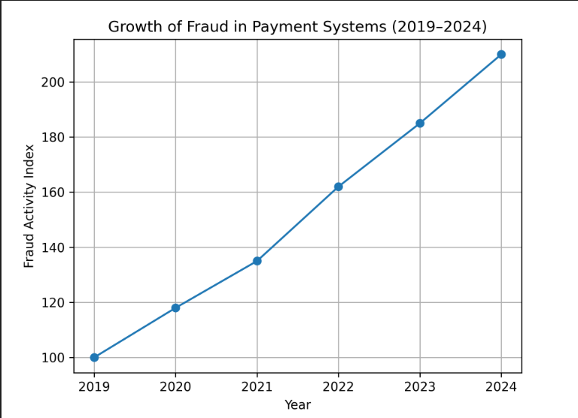

Fraud today looks nothing like a single person at a keyboard processing one transaction after another. It runs at scale, it is automated, and it is deliberately tuned to resemble ordinary consumer behavior. Thousands of stolen card numbers can be cycled through within a few minutes. Amounts get adjusted upward or downward, merchant categories get swapped, every parameter is positioned just under whatever thresholds the bank has chosen. The traditional model — flag anything over a thousand dollars from a foreign country — was not designed for this environment and is not going to cope with it.
The machine learning models introduced to take over from rule-based systems bring their own complications. Accuracy is frequently quite strong, but transparency is largely missing. An analyst trying to determine whether to block a payment gets a probability value and not much beyond that. A regulator asking how a particular decision was reached gets even less. What is required is therefore something that performs both functions simultaneously — catches fraud reliably and supplies its own explanation. Constructing exactly such a system is the goal of this project.
The system described in this thesis ties those pieces together. The ensemble handles the classification side. The SHAP layer handles the explanation side, turning every prediction into a readable breakdown of which features pushed the model one way or the other.
To achieve this goal, the following tasks must be addressed:
- to analyze modern threats and types of financial cyber fraud in payment systems;
- to study existing methods and approaches to detecting fraudulent transactions;
- to justify the selection of ensemble machine learning methods for fraud detection;
- to design the architecture of an intelligent cyber fraud detection system;
- to implement a model for detecting fraudulent transactions;
- to conduct an experimental evaluation of the developed system’s effectiveness;
- to analyze the obtained results and formulate conclusions.
The work draws on a combination of systematic literature review, information system design methodology, applied machine learning, empirical experimentation on real transactional data, and quantitative analysis of model performance outcomes.
:
As tools and technologies, The implementation was carried out in Python, relying on standard data science and machine learning libraries together with SHAP for the explainability component.
Practical significance of this work is straightforward: the developed system can be integrated into real payment security workflows and used to catch fraud faster, reduce losses, and give customers more confidence that their money is protected.
The overall structure consists of three chapters, then a conclusion, then a list of references. an introduction, three chapters, a conclusion, and a list of references. Chapter 1 provides an analytical overview of the fraud landscape and justifies the research approach. Chapter 2 covers the design of the intelligent fraud detection system. Chapter 3 describes the implementation and experimental evaluation. The conclusion summarizes the key findings.

Chapter 1. Analytical Aspects and Justification of Research Relevance

1.1 Relevance and Analysis of Cyber Fraud Threats in Payment Systems
Fraud has accompanied payment systems for as long as such systems have been around. What digitalization changed was the scale and the speed at which it operates. Today, a single transaction passes through a lengthy chain of components — the customer's device, the payment gateway, a processing center, and the issuing bank — and any one of those links can be turned into an attack entry point. Securing one component provides no assurances about the others, and this is part of why end-to-end protection of payment infrastructure is such a hard engineering problem.
What makes defending the current environment hard is not, in the first place, the volume of attacks. It is the speed at which the attacks change shape. Combinations of social engineering, stolen credentials, and automation that did not exist ten years ago have become standard fraudster equipment. Card-Not-Present fraud counts among the fastest-growing categories: the card data on its own is sufficient — the physical card is never required, and the entire verification layer built around physical-card presence is effectively bypassed from the start.
Going through the incident data reveals a recurring pattern: fraud rarely begins with a technical exploit. It begins with deception. The typical entry points are phishing emails, counterfeit banking pages, and SMS scams. Credentials and card details obtained this way are subsequently used to authorize unauthorized transactions, often within a short time window. As more banking activity continues to migrate to online channels, the pool of potential victims keeps expanding.
The difficulty in pushing back on this comes down to one factor: the automation underlying the entire operation. Fraudster tooling can quietly probe a bank's detection logic, calibrate transaction amounts to drop below alert thresholds, and switch tactics within seconds whenever something stops working — none of which requires human involvement. A rule that catches fraud today may be obsolete by tomorrow. This is the fundamental shortcoming of any threshold-based system: the rules remain static while the adversary keeps changing.
Stack these factors together and the argument against rules-only detection becomes hard to refute. The transaction volume is too high, the adversary is too sophisticated, and the rate of change is too quick. What follows is that detection logic has to be derived from data rather than written by hand — logic that flags an anomaly the first time it shows up rather than waiting for the tenth occurrence.

1.2 Evolution and Automation of Cyber Fraud in the Financial Sector
Over the past two decades, fraud has changed shape considerably. Two decades ago, carrying out a fraudulent transaction generally required either having the physical card or going to the trouble of deceiving the victim in person. The current situation is markedly different: stolen card numbers are sold in bulk on underground markets, and automated tools can run through hundreds of accounts within an hour. Financial crime has shifted in character from opportunistic to industrial, while the methods used to counter it have not always kept up.
From the attacker's perspective, the available tooling is genuinely impressive. Botnets run credential stuffing operations across thousands of accounts in parallel. Stolen cards get quietly verified with small test transactions before any serious fraud is attempted. Adaptive algorithms tune their behavior in response to which payments are being declined. From the system's perspective, all of this produces fraudulent activity that is essentially indistinguishable from regular customer spending. This is the precise reason that signature-based detection continues to fall short.
Across every fraud category, social engineering remains the most common starting point. Phishing, smishing, and vishing all share a key characteristic: none of them needs anyone to break into a system. The user voluntarily hands over the credentials after being misled. Since all of this happens outside the payment infrastructure itself, the initial compromise stays invisible to transaction monitoring. By the moment anything appears on the bank's side, fraudulent transactions are already moving. That delay is the reason that fast, accurate detection at the transaction level matters so much.
Considering where the trajectory is going — more automation, more scale, more sophistication — detection systems will need to be built on foundations quite unlike those most banks currently rely on. A new generation of systems needs to learn from data, track changes as fraud patterns drift over time, and flag anomalies that no human analyst would ever have thought to encode as a rule.
The increase in the number of incidents and the transition to automated attacks in the financial sector are illustrated in Figure 1.1.

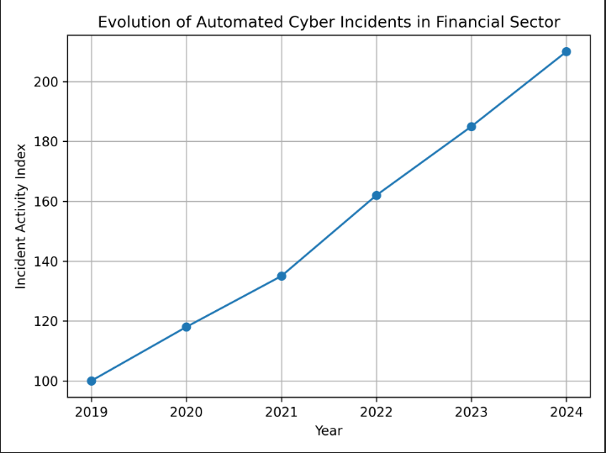
Рисунок 1.1 — Эволюция и автоматизация киберинцидентов в финансовом секторе (2019–2024)
Источник: составлено автором на основе ENISA Threat Landscape: Finance Sector

1.3 Classification of Cyber Threats and Fraud in Payment Systems
A natural question presents itself before any detection system can be designed: detect what, exactly? Fraud in payment systems is not one uniform thing. It is a collection of attack types, each with its own mechanism and its own frequency of occurrence. Mapping those categories out is a useful starting point before deciding where defensive resources should be directed.
One of the most common types of fraud is Card-Not-Present Fraud, in which transactions are carried out without the physical presence of a bank card. This type of attack is widely used in online payments and is characterized by high scalability. A significant share is also represented by Account Takeover, where attackers gain control of a victim's bank account by obtaining their login credentials — typically through phishing or malware.
A separate category includes attacks based on phishing, smishing, and vishing — all designed to trick users into handing over payment credentials or personal data. Despite being relatively simple in concept, these attacks remain effective and account for a large share of incidents in the financial sector. Merchant Fraud involves dishonest merchants conducting fake transactions or abusing the refund process. While less common, it can cause substantial losses and is often harder to detect.
Figure 1.2 illustrates the actual distribution of these categories using ENISA data. Card-Not-Present fraud holds a substantially larger share than any other category, which is one of the reasons this project focuses on transaction-level classification rather than on something positioned further upstream in the payment flow.
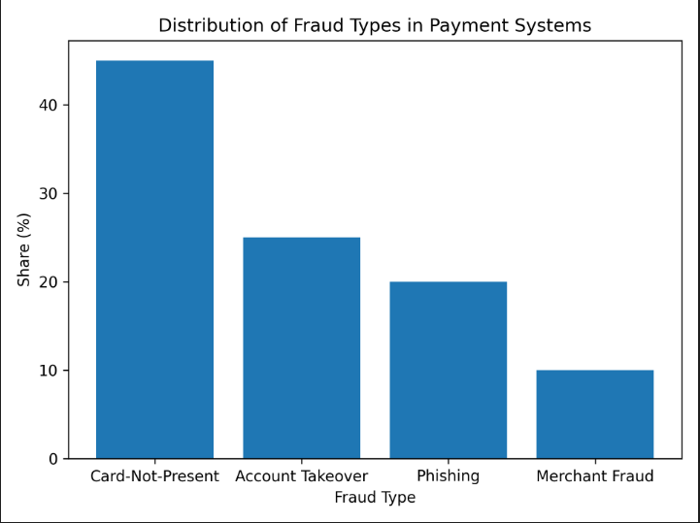
Figure 1.2 — Distribution of the Main Types of Fraud in Payment Systems
Source: compiled by the author based on ENISA Threat Landscape: Finance Sector (January 2023 – June 2024)

1.4 Fraud as a Form of Cyberattack in Payment Systems
Worth stating explicitly: payment fraud is at its root a cybersecurity issue, not merely an economic one. The mechanisms behind it — stolen credentials, malware, account takeover — are the same attack vectors that appear in any other security analysis. Trace most fraud cases back to their origin and what shows up is a security failure somewhere in the chain. A confidentiality breach. An authentication step that was sidestepped. Frequently both at the same time.
In most payment security chains, the user is the weakest point. Social engineering works precisely by stepping around technical controls entirely — the target is psychology, not software. Once an attacker is in possession of valid credentials or card data, every transaction they then perform appears legitimate from the system's point of view. This is precisely why transaction-level detection — examining behavior rather than authentication alone — matters so much.
In many campaigns, technical methods are layered on top of the social engineering. Malware captures card data as it is being typed in. Transaction details get altered before they ever reach the payment processor. In some scenarios, alerts are suppressed long enough to delay any response. Following an account takeover, the attacker generally mimics the victim's normal spending habits — amounts within the usual range, familiar merchants, ordinary times of day — specifically chosen to slip past rule-based checks.
Considering all this, treating payment fraud as a multi-vector cyber threat — rather than as a single category of event — is probably the more accurate framing. Figure 1.3 maps out the main attack vectors involved, again based on ENISA threat reporting.
Keywords: cybersecurity, cyber fraud, payment systems, machine learning, ensemble models, explainable artificial intelligence.

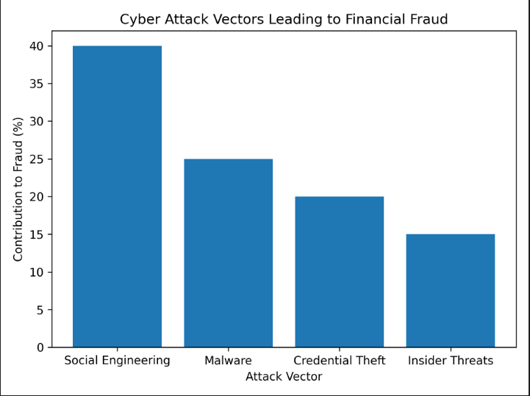

Figure 1.3 — Main Cyberattack Vectors Leading to Financial Fraud
Source: compiled by the author based on analytical reports of ENISA Threat Landscape.

1.5 Limitations of Traditional Fraud Detection Methods
Conventional fraud detection operates through rule sets — hand-written conditions that fire an alert whenever a transaction fits a suspicious profile. Anything above a thousand dollars from a foreign IP gets flagged. Payments at three in the morning get blocked. That kind of thing. The approach worked reasonably well when fraud was simple and transaction volumes were modest. Today, neither of those conditions applies anymore.
The fundamental problem with rules is that they cannot adapt. Once a fraudster works out which thresholds trigger alerts, the response is straightforward: keep transactions just under them. The rule itself remains in place regardless, blocking legitimate customers and failing to stop the actual fraud, until an analyst eventually notices the gap and updates the logic. That cycle takes days, sometimes weeks. Fraud continues uninterrupted in the meantime. The same inflexibility responsible for these blind spots also produces a flood of false positives, since real users do not behave in neat patterns either.
False positives are not, in fact, the worst limitation. The worst limitation is that rule-based detection can only identify fraud resembling fraud that has already been documented somewhere. Anything genuinely new passes through undetected until an analyst eventually writes a matching rule. When the adversary is actively probing defenses and shifting tactics the moment something stops working, this is not a problem that can be patched around. It is intrinsic to the approach itself.
Machine learning gets around these limitations by deriving its logic from data rather than from rules. With a large enough pool of historical transactions, an ML model can extract patterns no analyst would ever have written down by hand — subtle interactions between transaction time, amount, merchant, and account history that, taken together, signal something suspicious. Those patterns can also be refreshed as fraud evolves, without anyone manually rewriting a rule set. Figure 1.4 summarizes the main differences between the legacy approach and machine learning.
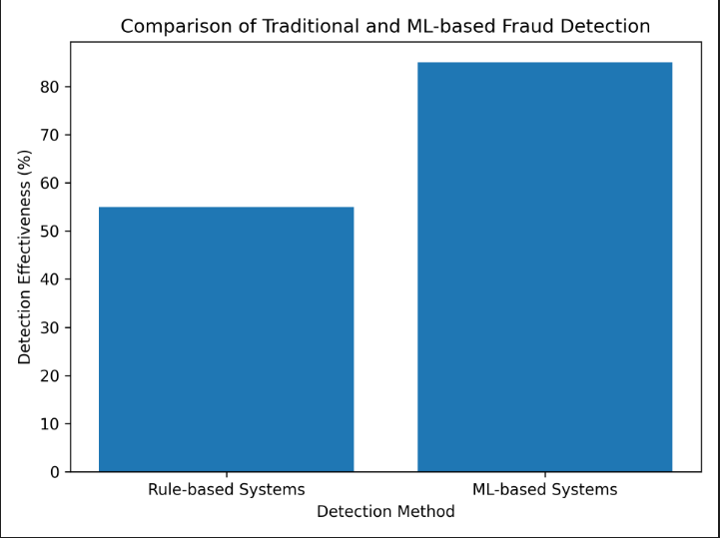
Figure 1.4 — Comparison of Traditional and Intelligent Fraud Detection Methods
Source: compiled by the author.
Approach | Advantages | Disadvantages
Rule-based systems | Simplicity of implementation, high interpretability | Low adaptability, high false positive rate
Logistic Regression | Fast training, interpretability | Limited ability to capture complex dependencies
Random Forest | High accuracy, robustness to overfitting | Reduced interpretability
Gradient Boosting | High effectiveness on imbalanced data | High computational complexity
Ensemble Models + XAI | High accuracy and decision interpretability | Complexity of configuration and implementation

Conclusions of Chapter 1
The central problem the project addresses has been set out in this chapter. Digital payments have expanded, and the fraud that goes with them has expanded along with them — fraud that is more automated, more adaptive, and harder to detect than what the industry was dealing with a decade ago.
The principal fraud categories — Card-Not-Present fraud, account takeover, phishing-based attacks, and merchant fraud — were examined in turn. The argument was developed that payment fraud is fundamentally a cybersecurity problem with financial consequences, not a purely financial problem.
Examining rule-based detection closely made one thing clear: the weaknesses — limited adaptability, too many false alarms, an inability to catch novel fraud types — are not bugs that can be patched out. They are properties built into the approach itself. Out of the realistic alternatives reviewed, ensemble machine learning paired with explainable AI emerged as the best match for the requirements: reasonable accuracy, resilience as fraud evolves, and decisions that can be explained afterwards.
These conclusions translate directly into the design decisions covered in the next chapter.

Reference
- https://ieeexplore.ieee.org/document/7410515 Dal Pozzolo A., Caelen O., Johnson R., Bontempi G. “Calibrating Probability with Undersampling for Unbalanced Classification.” IEEE Symposium on Computational Intelligence, 2015.
- https://www.sciencedirect.com/science/article/pii/S0957417415012083 Bahnsen A., Aouada D., Stojanovic A., Ottersten B. “Feature Engineering Strategies for Credit Card Fraud Detection.” Expert Systems with Applications, 2015.
- https://proceedings.neurips.cc/paper/2017/file/8a20a8621978632d76c43dfd28b67767-Paper.pdf Lundberg S., Lee S. “A Unified Approach to Interpreting Model Predictions.” NeurIPS, 2017.

CHAPTER 2

DESIGN OF THE REAL-TIME FRAUD DETECTION SYSTEM

2.1 System Architecture and General Design Concept
Building a fraud detection system that holds up in a real payment environment is more demanding than it may first appear. Three constraints have to be met at the same time: enough speed not to delay processing, enough accuracy to catch real fraud without burying analysts in false alarms, and enough transparency to allow any specific decision to be reviewed and challenged afterwards. The architecture described in this chapter was developed with all three constraints visible from the start.
The architecture of the proposed fraud detection system consists of the following main components:
- Data Collection Layer – responsible for receiving transaction data in real time.
- Data Preprocessing Module – performs normalization, feature scaling, and handling of missing or inconsistent values.
- Feature Engineering Module – extracts relevant behavioral and transactional features.
- Machine Learning Module – applies supervised learning models to classify transactions as legitimate or fraudulent.
- Ensemble Decision Layer – combines predictions from multiple models to improve detection performance.
- Explainability Module (XAI) – provides interpretation of model decisions using SHAP-based techniques.
- Decision Output Layer – generates final risk scores and alerts.
Latency was treated as a primary concern, not a secondary one. Authorization of a payment finishes within a matter of seconds, and the fraud check has to fit comfortably inside that interval. Anything slower leaves no chance to stop a fraudulent transaction before approval.
The subsections below address each of these elements in turn — how the algorithms were chosen, how the ensemble aggregation works in practice, and how the explainability layer was put together.

2.2 Selection of Machine Learning Algorithms
Algorithm selection is not a trivial decision when fraud constitutes less than 0.2% of the dataset. Standard classifiers are typically tuned for overall accuracy, which in this setting means they can comfortably hit 99.8% by labeling every transaction as legitimate — obviously useless for the actual task at hand. The algorithms chosen here had to handle two things in parallel: the severe class imbalance, and the messy non-linear patterns that separate fraud from ordinary spending.
Three algorithms made it into the final design. Logistic Regression was kept mainly as a baseline — fast, interpretable, and useful as a reference point against which more sophisticated models can be measured. Random Forest secured its place by handling mixed feature types well, resisting overfitting, and running reliably on high-dimensional data without much tuning. Gradient Boosting was added on the strength of its track record with imbalanced classification problems, where it typically outperforms simpler methods by a noticeable margin.
So why use three algorithms rather than simply keeping the strongest one? Because their learning mechanisms differ at a fundamental level. Logistic Regression produces a linear decision boundary. Random Forest builds an ensemble of decision trees. Gradient Boosting performs sequential error correction. Each model picks up different signals in the data, with the result that their mistakes tend to occur on different transactions. Averaging their predictions causes those errors to partly cancel each other out — producing a classifier more reliable than any of the three would be in isolation.
Table 2.1 provides a side-by-side summary of the three algorithms across the dimensions most relevant to this kind of application.

Table 2.1 – Comparative characteristics of selected machine learning algorithms
Algorithm | Advantages | Limitations
Logistic Regression | Simple and interpretable | Limited ability to detect complex patterns
Random Forest | High accuracy and robustness | Reduced interpretability
Gradient Boosting | Effective for non-linear relationships | High computational complexity
The comparison makes one thing clear: no single algorithm wins on every dimension. That observation by itself is enough to justify the ensemble approach.

2.3 Ensemble Decision-Making Approach
The value of an ensemble lies in precisely the disagreement between its components. When three models look at the same data through different lenses, their mistakes naturally land on different examples. Averaging the outputs generally means that any individual model's misjudgment ends up outvoted by the other two. The importance of this property is greater in fraud detection than in many other settings. A false negative means fraud not caught, and a real financial loss. A false positive means a legitimate payment blocked, and a customer who is now frustrated.
In operational terms, each incoming transaction is scored independently by all three models. Each model returns a probability between zero and one, and the ensemble layer averages those values into a single composite risk score. Transactions whose score is above the configured threshold are flagged for review.
The ensemble prediction can be represented as follows:
$FinalScore=\frac{P_{1}+P_{2}+P_{3}}{3}$FinalScore=3P1​+P2​+P3​​
where:
- $P_{1}$P1​ – prediction probability generated by the first model,
- $P_{2}$P2​ – prediction probability generated by the second model,
- $P_{3}$P3​ – prediction probability generated by the third model.
The improvement is not just statistical noise reduction. It reflects something concrete about how the models actually behave. Gradient Boosting might be the one to lock onto unusual transaction timing. Random Forest might be the one to spot an inconsistency between merchant category and geography. Logistic Regression might be the one to flag a strange relationship between transaction amount and account history. Each contributes its own angle, and combining them produces a fuller picture than any of the three would individually.
Extensibility was a deliberate feature of the aggregation layer. Adding a fourth or fifth model later on means simply plugging it into the averaging step — no architectural redesign required.

2.4 Explainable Artificial Intelligence (XAI) Integration
A well-known tension arises when machine learning is applied in regulated industries: the most accurate models also tend to be the least transparent. In payment security, this creates real difficulties. Analysts need to know why a transaction was flagged before deciding how to handle it. Regulators reviewing the system need visibility into how decisions are actually being made. Customers whose legitimate payments have been blocked deserve a proper explanation, not an apology. Without an explainability mechanism, even a highly accurate model is only half useful.
That gap is closed by the system's explainability layer. Rather than a bare probability number, the analyst receives a structured breakdown of which features pushed the prediction and by how much each contributed. Instead of a single line stating "92% likely fraud", the analyst can see that the transaction amount was roughly three times the account's typical level, or that the merchant category had no precedent in that account's history.
SHAP (SHapley Additive exPlanations) was chosen because it is model-agnostic and rests on a solid theoretical base in cooperative game theory. For each flagged transaction, SHAP produces a contribution score for every input feature — quantifying how strongly that feature pushed the prediction toward fraud or away from it. The output takes the form of a ranked list of the factors driving the decision. Exactly the kind of output an analyst can work with during an investigation.
The integration of explainability mechanisms provides several important advantages:
- improved transparency of machine learning decisions;
- enhanced trust in automated fraud detection systems;
- support for security analysts during incident investigation;
- compliance with regulatory requirements related to AI interpretability.
A second function of SHAP, beyond looking at individual transactions, is system-level monitoring. Reviewing contribution patterns across many predictions lets analysts check whether feature weights still align with domain intuition. If the model suddenly starts leaning heavily on a feature that ought to be largely irrelevant, the implication is that something has gone wrong — either with the training data, or with how the fraud landscape has shifted underneath the model.

Conclusions on Chapter 2
The architecture and the reasoning behind the design choices have been documented in this chapter. The ensemble approach was adopted because no single algorithm can satisfy all the requirements of this problem, and combining models that learn in different ways produces results superior to anything the individual models achieve on their own.
Each of the three algorithms — Logistic Regression, Random Forest, and Gradient Boosting — brings something the other two lack. The ensemble that results from combining them is steadier than any individual model and generalizes better.
SHAP-based explainability was part of the design from the start, not retrofitted later. In a regulated financial environment, the ability to explain automated decisions is essentially a baseline requirement — something both the operations team and the regulators reviewing the system expect.
The actual implementation of the architecture, and how it performed during testing, is the subject of the next chapter.

CHAPTER 3

IMPLEMENTATION AND EXPERIMENTAL EVALUATION

3.1 Dataset Description and Preprocessing
Validation on real data was essential. A model that looks impressive on paper but breaks down when run against actual transactions has little practical value. For this reason, a publicly available anonymized credit card dataset was selected. The dataset contains real transaction records, each labeled as either legitimate or fraudulent — a labeling structure that supports both supervised classifier training and evaluation against actual ground truth.
The dataset has one particular characteristic that complicates everything: fraud is uncommon. Fewer than 0.2% of all transactions are fraudulent. As a result, a model that simply predicts "legitimate" for every input would still report above 99% accuracy while catching no fraud whatsoever. Handling this imbalance correctly was one of the main implementation challenges. Plain accuracy provides no useful signal in this setting, which is why the evaluation relies on recall, precision, and false negative rate instead.
Before training the models, the dataset is preprocessed to ensure compatibility with the machine learning pipeline. The preprocessing stage includes:
- separation of input features and target labels;
- verification of missing or inconsistent values;
- normalization and feature scaling where required;
- train-test splitting with stratification to preserve the fraud ratio.
The preprocessing pipeline was set up so that both model types — the supervised classifier and the anomaly detector — work from a single consistent feature representation. That consistency is what makes it possible to combine their outputs in a meaningful way at the ensemble stage.

3.2 Model Training and System Implementation
The detection system is built from two distinct model types, each addressing a different slice of the problem. On the supervised side, Random Forest is trained on labeled data and learns the patterns associated with confirmed fraud cases. Its strength is recognizing fraud that resembles what it has already seen before. On the unsupervised side, Isolation Forest follows a completely different route — it uses no labels at all. Instead, it builds a profile of what normal transaction behavior looks like and raises a flag whenever an observation deviates far enough from that profile. This makes it particularly valuable against novel fraud patterns the supervised model would never have been trained on.
Taken together, the two models cover ground that neither could cover individually. Random Forest captures fraud resembling past fraud. Isolation Forest captures transactions that just look wrong, regardless of whether they match anything in historical records. Running both in parallel and combining their outputs through the ensemble layer produces a detector measurably more robust than either model would be on its own.
The implementation is organized into separate modules to improve maintainability and reproducibility:
- data loading module;
- preprocessing module;
- model training module;
- model loading module;
- detection module;
- security logging module;
- explainability module.
Modularity was a conscious design decision. Each component of the pipeline — preprocessing, training, inference, explainability, logging — can be tested independently and updated without affecting the rest of the system. If a better anomaly detection algorithm becomes available later on, swapping it in is a self-contained change rather than a full system rebuild.
At runtime, each transaction first passes through the preprocessing stage and is then scored simultaneously by both models. The two model outputs are averaged by the ensemble layer to produce a single risk score. If that score clears the configured threshold, the transaction gets flagged, and a structured record is written to the security log — including the SHAP feature contributions that explain the underlying decision.

3.3 Experimental Setup and Evaluation Metrics
Evaluating a fraud detection system is not as simple as reading an overall accuracy figure. Fraud occurs rarely enough that accuracy on its own carries almost no information — a model that never predicts fraud would still come in above 99%. The evaluation here therefore uses metrics that actually reflect what matters in practice: how much real fraud is being identified, how many false alarms the system is producing, and how often genuine fraud is slipping through unnoticed.
The following metrics are considered:
- Accuracy – the overall share of correctly classified transactions (a baseline sanity check);
- Precision – of all transactions flagged as fraud, how many really were fraudulent (false alarm rate);
- Recall – of all actual fraud cases, how many did the system catch (miss rate);
- F1-score – a balanced measure that combines precision and recall into a single score;
- False Negative Rate – the share of real fraud that was not detected, the most costly metric to get wrong.
The metric carrying the most weight in this evaluation is recall — the share of actual fraud cases the system correctly identifies. Each missed fraud event represents a preventable financial loss. The false negative rate, which is essentially the inverse of recall, captures that cost directly. Precision matters as well: too many false positives consume analyst time and inconvenience legitimate customers. The F1-score balances precision and recall.
The experimental workflow consists of the following steps:
- loading and preprocessing the dataset;
- splitting the data into training and test subsets;
- training the Random Forest and Isolation Forest models;
- running inference on test transactions;
- combining model outputs through the ensemble decision layer;
- generating classification metrics and logging suspicious events.
The framework allows the system to be evaluated on two levels simultaneously — as a classifier assessed against standard machine learning benchmarks, and as a security tool assessed against the practical criteria that determine whether it would actually be useful in a real payment environment.

3.4 Explainability and Security Analysis
Hitting the right numerical targets is necessary but not sufficient. A system that identifies 95% of fraud yet provides no explanation for why any specific transaction was flagged delivers only half of what is actually needed. The SHAP explainability layer closes that gap by attaching a feature-level explanation to every prediction the system produces.
For each flagged transaction, SHAP produces a ranked breakdown showing which features pushed the prediction toward fraud. An analyst examining a particular case might find, for example, that the transaction amount was well above the account's typical level, that the merchant category had never appeared in that account's history before, and that the transaction came through at an unusual hour. A structured explanation of this kind gives the analyst something concrete to investigate — not just a number to act on without context.
Combining supervised and unsupervised models gives the system a coverage profile that neither would deliver alone. The supervised model handles fraud fitting historical patterns. The anomaly detector picks up transactions that simply look wrong, even if they do not match any known fraud type. This layered design makes the system noticeably more resilient against the kind of novel attack patterns that consistently slip past traditional detection methods.
At the same time, several limitations remain:
- the system depends on the quality of the input data;
- highly imbalanced datasets may still affect model stability;
- model performance may change when fraud patterns evolve over time;
- explainability improves transparency but does not eliminate classification errors.
The limitations identified above are real. They are also problems that are reasonably well understood and currently subject to active research. Improved imbalance handling, online learning so the model continues updating itself, more sophisticated explainability methods — any of these would be a reasonable basis for follow-up work. Within its current scope, the system nevertheless demonstrates that combining ensemble learning with explainable AI is a technically sound approach to real-time fraud detection.

Conclusions on Chapter 3
This chapter has gone through the full implementation of the system — from dataset selection and preprocessing all the way through to model training, ensemble construction, and experimental evaluation. Using a real transaction dataset with its actual class imbalance left in place means the evaluation reflects the conditions the system would face in deployment, not a sanitized version of the problem.
Within a modular architecture, the pipeline brings together Random Forest and Isolation Forest, with an ensemble layer combining their outputs into decisions more reliable than what either model would produce individually.
The primary evaluation criteria were recall and false negative rate, chosen to reflect the asymmetric cost between missing fraud and triggering a false alarm. SHAP explainability was built into the system from the start rather than added as an afterthought, meaning every detection decision arrives with an accompanying explanation.
The experimental results support the project's central claims. Real-time operation is achievable, performance on heavily imbalanced data is meaningful rather than nominal, and the decisions produced are ones an analyst can understand and act on. Because the design is modular, individual components can be upgraded or replaced as better methods become available, without anyone needing to rebuild the system from scratch.

