INTERNATIONAL INFORMATION TECHNOLOGY UNIVERSITY
FACULTY OF CYBERSECURITY

Kengesbayev Y.
Asylbekov N.
Temirgali Q.

Real-time Credit Card Fraud Prevention Using
Ensemble Machine Learning: A Layered-Detection
System with Live Network Demonstration

DIPLOMA PROJECT

Major 6806303 - Network Security

Almaty 2026
INTERNATIONAL INFORMATION TECHNOLOGY UNIVERSITY
DEPARTMENT OF NETWORK SECURITY

Approved
Head of Department, _______________
«__» _____________ 20___

DIPLOMA WORK

Real-time Credit Card Fraud Prevention Using Ensemble
Machine Learning: A Layered-Detection System
with Live Network Demonstration

Major - Network Security

Done by: | Kengesbayev Y. __________ «__» _______ 20___ (sig.)
 | Asylbekov N. __________ «__» _______ 20___ (sig.)
 | Temirgali Q. __________ «__» _______ 20___ (sig.)
Research advisor: | Nyrlybaev T. __________ «__» _______ 20___ (sig.)
Reviewer: | __________________________ «__» _______ 20___

Almaty 2026

INTERNATIONAL INFORMATION TECHNOLOGY UNIVERSITY
FACULTY OF COMPUTER TECHNOLOGY AND CYBERSECURITY
DEPARTMENT OF CYBERSECURITY
Major 6806303 - Network Security
Diploma Work or Project Assignment
Students
Kengesbayev Y., Asylbekov N., Temirgali Q. SIS2213

Diploma work (project) topic
Real-time Credit Card Fraud Prevention Using Ensemble

Approved by IITU order № ____ dated «__» _______20___
Diploma work (project) submission date «__» _______20___
Diploma work (project) initial data
______________________________________________________________________________________________________________________________________________________________________________________________________

Details of computaticas and explanations (list of issues due to be addressed)
______________________________________________________________________________________________________________________________________________________________________________________________________
CD containing the digital version of diploma paper and attachments
______________________________________________________________________________________________________________________________________________________________________________________________________

Consultations on diploma work (project) (with related project chapters named)
Consultant | Name | Signature, date
 |  | Assignment given | Assignment received
Consultant on Economic effectiveness of the project
English language consultant
Compliance monitor

Date «__» _________2026

Research advisor _______________
(signature)
Assignment received by _______________
(signature)
Assignment received by _______________
(signature)
Assignment received by _______________
(signature)

АҢДАТПА

Бұл диплом жұмысының мақсаты — банктік карталармен жасалатын алаяқтықты нақты уақыт режимінде болдырмауға арналған бес модельді ансамблдік машиналық оқыту жүйесін жобалау, іске асыру және эксперименттік бағалау болып табылады. Жүйе XGBoost, Random Forest, LSTM нейрондық желісі, Isolation Forest және ережелер қозғалтқышынан тұратын ансамблді мета-оқыту логистикалық регрессиясы арқылы біріктіреді. IEEE-CIS датасеті (590 540 транзакция) бойынша F1-Score = 0.90, AUC-ROC = 0.96 нәтижелері алынды. Жүйе алаяқтықтың он екі паттернін анықтайды және транзакцияны орта есеппен 87 мс ішінде өңдейді.
Демонстрация жергілікті желіде үш ноутбуктен тұратын стендте жүзеге асырылады. FastAPI бэкенд, React дашборд, PostgreSQL дерекқоры және Groq API арқылы AI генератор қолданылады. Жүйе Казахстан, Ресей, Германия және АҚШ банктерін симуляциялайды.
Диплом жұмысы кіріспеден, үш тараудан, қорытындыдан, 25 сілтемеден және төрт қосымшадан тұрады.
Түйін сөздер: алаяқтықты анықтау, ансамблдік машиналық оқыту, нақты уақыт, XGBoost, LSTM, FastAPI, IEEE-CIS, киберқауіпсіздік.

АННОТАЦИЯ

Целью настоящей дипломной работы является проектирование, реализация и экспериментальное тестирование системы предотвращения мошенничества с банковскими картами в режиме реального времени на основе ансамблевого машинного обучения. Разработанная система объединяет пять моделей: XGBoost для транзакционных паттернов, Random Forest для поведенческих аномалий, LSTM-сеть для временны́х рядов, Isolation Forest для статистической детекции выбросов и движок правил для детерминированной классификации двенадцати выявленных мошеннических схем. Финальное решение принимается мета-обучающей логистической регрессией на основе технологии стекинга.
На тестовой выборке датасета IEEE-CIS (590 540 транзакций) достигнуты показатели F1-Score = 0.90 и AUC-ROC = 0.96. Среднее время обработки транзакции составляет 87 мс. Демонстрационный стенд реализован на трёх ноутбуках в локальной сети и симулирует работу с банками четырёх стран.
Дипломная работа содержит введение, три главы основной части, заключение, 25 источников и четыре приложения, включая листинги исходного кода.
Ключевые слова: обнаружение мошенничества, ансамблевое машинное обучение, реальное время, XGBoost, LSTM, FastAPI, IEEE-CIS, кибербезопасность финансового сектора.

ABSTRACT

This diploma work presents the design, implementation, and experimental evaluation of a real-time credit card fraud prevention system based on ensemble machine learning. Global payment card fraud losses exceeded USD 33.45 billion in 2023, growing 38% over the preceding five years [12]. In Kazakhstan, the Agency for Regulation and Development of the Financial Market documented a 22% year-on-year increase in unauthorized transaction complaints in 2023 [14]. Existing rule-based and single-model detection systems cannot keep pace with the speed and adaptability of modern fraud attacks.
The system combines five models: XGBoost [1] for transactional pattern recognition, Random Forest [2] for behavioral anomaly detection, Long Short-Term Memory (LSTM) [3] for time-series analysis, Isolation Forest [4] for unsupervised outlier detection, and a deterministic rule engine for twelve explicitly identified fraud patterns. All base outputs are aggregated by a Logistic Regression meta-learner trained through out-of-fold stacking [7]. Evaluated on the IEEE-CIS Fraud Detection dataset [10] (590,540 real transactions), the ensemble achieved F1-Score 0.90 and AUC-ROC 0.96, outperforming all individual components. Average transaction processing time is 87 ms at 100 concurrent requests per second.
The system is demonstrated live on three laptops connected over a local area network, simulating international banking infrastructure across Kazakhstan, Russia, Germany, and the United States. Source code is available at https://github.com/Yerzhan044/newdiplom2.
The diploma work contains an introduction, three chapters, a conclusion, 25 references, and four appendices including source code listings.
Keywords: credit card fraud detection, ensemble machine learning, real-time processing, XGBoost, LSTM, Isolation Forest, FastAPI, PostgreSQL, IEEE-CIS, cybersecurity.

CONTENTS

 | Section | Page
 | LIST OF TERMS AND ABBREVIATIONS | 9
 | INTRODUCTION | 10
1 | THREAT LANDSCAPE AND RESEARCH JUSTIFICATION | 12
1.1 | Cybersecurity in the Digital Payment Sector | 12
1.2 | Scale of the Problem: Global and Kazakhstan Perspective | 13
1.3 | Classification of Fraud Types in Payment Systems | 15
1.4 | Evolution of Fraud Detection Methods | 16
1.5 | The Twelve Fraud Patterns Detected by the System | 18
1.6 | Justification for the Ensemble ML Approach | 23
2 | SYSTEM ARCHITECTURE AND DESIGN | 24
2.1 | Overall Architecture: Three-Laptop Local Network | 24
2.2 | Ensemble ML Engine: Five-Model Design | 25
2.3 | Feature Engineering | 29
2.4 | Database Schema Design | 30
2.5 | REST API and WebSocket Design | 31
2.6 | Dashboard Design | 32
2.7 | AI Generator and Explanation Module | 33
2.8 | International Bank Simulation | 34
3 | IMPLEMENTATION AND EXPERIMENTAL EVALUATION | 35
3.1 | Technology Stack | 35
3.2 | Dataset Description and Preprocessing | 37
3.3 | Class Imbalance Handling via SMOTE | 39
3.4 | Model Training and Hyperparameter Tuning | 40
3.5 | Model Performance Evaluation | 41
3.6 | Feature Importance Analysis | 45
3.7 | Server Implementation and Latency Optimization | 47
3.8 | System Testing and Load Benchmarks | 48
3.9 | Demonstration Scenarios for the Committee | 50
 | CONCLUSION | 52
 | REFERENCES | 54
 | Appendix A – Project File Structure | 57
 | Appendix B – Deployment Instructions | 58
 | Appendix C – Selected Source Code | 59
 | Appendix D – Reproducibility Checklist | 65

LIST OF TERMS AND ABBREVIATIONS

Term / Abbreviation | Definition
AUC-ROC | Area Under the Receiver Operating Characteristic Curve
API | Application Programming Interface
CNP | Card-Not-Present fraud
DP | Differential Privacy
ENISA | European Union Agency for Cybersecurity
F1-Score | Harmonic mean of Precision and Recall
FastAPI | Modern Python web framework for building APIs
FL | Federated Learning
FRAUD SCORE | Unified fraud probability (0.0 – 1.0) output by meta-learner
IEEE-CIS | Institute of Electrical and Electronics Engineers — Computational Intelligence Society
IoT | Internet of Things
JSON | JavaScript Object Notation
KZT | Kazakhstani Tenge (ISO 4217)
LAN | Local Area Network
LSTM | Long Short-Term Memory neural network
ML | Machine Learning
ORM | Object-Relational Mapping
PHI | Protected Health Information
REST | Representational State Transfer
SPA | Single Page Application
SMOTE | Synthetic Minority Oversampling Technique
SQL | Structured Query Language
VPN | Virtual Private Network
WebSocket | Full-duplex communication protocol over TCP
XGBoost | Extreme Gradient Boosting — supervised ML algorithm

INTRODUCTION
Across most economies, digital payment methods have steadily displaced cash over the past decade. The infrastructure that enables frictionless digital payments is also infrastructure that attracts sophisticated adversaries. According to the Nilson Report [12], global payment card fraud losses exceeded USD 33.45 billion in 2023 — approximately USD 9 billion more than the figure recorded in 2018. Kazakhstan is not an exception. Kaspi.kz alone processed over 7 billion transactions in 2023. The Agency for Regulation and Development of the Financial Market (ADRFM) documented a 22% year-on-year increase in unauthorized transaction complaints in 2023 [14].
What makes defending this environment difficult is not volume alone — it is the combination of volume, speed, and adaptability. Fraudsters deploy automated tools that probe detection thresholds, calibrate amounts to land just below alert limits, rotate through stolen card numbers in bulk, and switch tactics within seconds. Against that adversary, a system based on manually written rules is structurally outmatched before the engagement begins.
Machine learning offers a genuine improvement over rules-based detection. The difficulty is that the most accurate models have historically been among the least transparent. In a regulated financial environment, opacity in the detection logic creates real downstream problems: analysts cannot efficiently triage alerts, regulators cannot audit decisions, and blocked legitimate customers cannot be given meaningful explanations.
This diploma project constructs a system that addresses both shortcomings simultaneously. The ensemble architecture provides accuracy: five models with meaningfully different error profiles are combined through a meta-learner into a classifier more reliable than any component alone. The AI explanation layer provides transparency: every blocked transaction is accompanied by a plain-language description of which patterns were detected and what values triggered them. The system processes a transaction in under 200 milliseconds and is demonstrated live across three laptops connected over a local area network.

Actuality. The intersection of rapid digital payment adoption in Kazakhstan and globally rising fraud rates creates an urgent need for detection systems that go beyond static rules and single-model approaches.

Object of study — transaction security in digital payment systems.
Subject of study — ensemble machine learning architectures applied to real-time credit card fraud detection.
Goal. Design, implement, and evaluate a real-time fraud prevention system based on a five-model ensemble, demonstrating it live on a three-laptop local network.

Tasks:
- Conduct a detailed analysis of fraud patterns prevalent in Kazakhstan and internationally.
- Design a five-model ensemble ML architecture with a Logistic Regression meta-learner trained through out-of-fold stacking.
- Implement a rule engine that applies deterministic checks for twelve identified fraud patterns.
- Build a real-time FastAPI server with WebSocket support capable of processing transactions in under 200 ms.
- Train all models on the IEEE-CIS Fraud Detection dataset with F1 > 0.88 as target.
- Evaluate performance using recall-oriented metrics appropriate for the class-imbalanced setting.
- Deploy the full system across three laptops in a local network and validate three demonstration scenarios.

Theoretical significance. The work establishes a reproducible multi-pattern ensemble benchmark for real-time card fraud detection, with explicit mapping from the Kazakhstan threat landscape to detection features — a contribution absent from most published single-model evaluations.
Practical significance. The system was designed with deployment as its endpoint: modular architecture, sub-200 ms latency, and output formatted for integration into a real security operations workflow. Every reported number is reproducible from the committed codebase at https://github.com/Yerzhan044/newdiplom2.
Structure. The work comprises an introduction, three chapters of the main part, a conclusion, four appendices, and a list of references. Chapter 1 surveys the threat landscape. Chapter 2 presents the system design. Chapter 3 reports implementation and experimental results.

1 THREAT LANDSCAPE AND RESEARCH JUSTIFICATION

1.1 Cybersecurity in the Digital Payment Sector
Payment systems sit at the intersection of two high-stakes domains: finance and cybersecurity. Every digital transaction involves the transmission of sensitive credentials, authorization decisions made in milliseconds, and the movement of real money. The security requirements are demanding: low latency (the authorization decision must not disrupt the user experience), high accuracy in both directions (missing fraud is costly; blocking legitimate payments is also costly), and regulatory compliance with documented decision rationale and audit trails.
ENISA — the European Union Agency for Cybersecurity — has documented a consistent upward trend in cyber incidents targeting the financial sector since 2019 [11]. The dominant attack categories have remained stable across successive annual reports: unauthorized transactions, credential theft through phishing, and account takeover operations consistently lead the rankings. The persistence of these categories reflects a structural feature: the attacks are profitable, the tools are widely available, and the defenses deployed by most institutions are not keeping pace.

1.2 Scale of the Problem: Global and Kazakhstan Perspective
The Nilson Report [12] documented global card fraud losses of USD 24.26 billion in 2018. By 2023 that figure had reached USD 33.45 billion — an increase of approximately 38% over five years. The 2024 projection stands at USD 36.2 billion. Every year in this series set a new record at the time of its publication. Figure 1.1 shows the year-by-year progression.

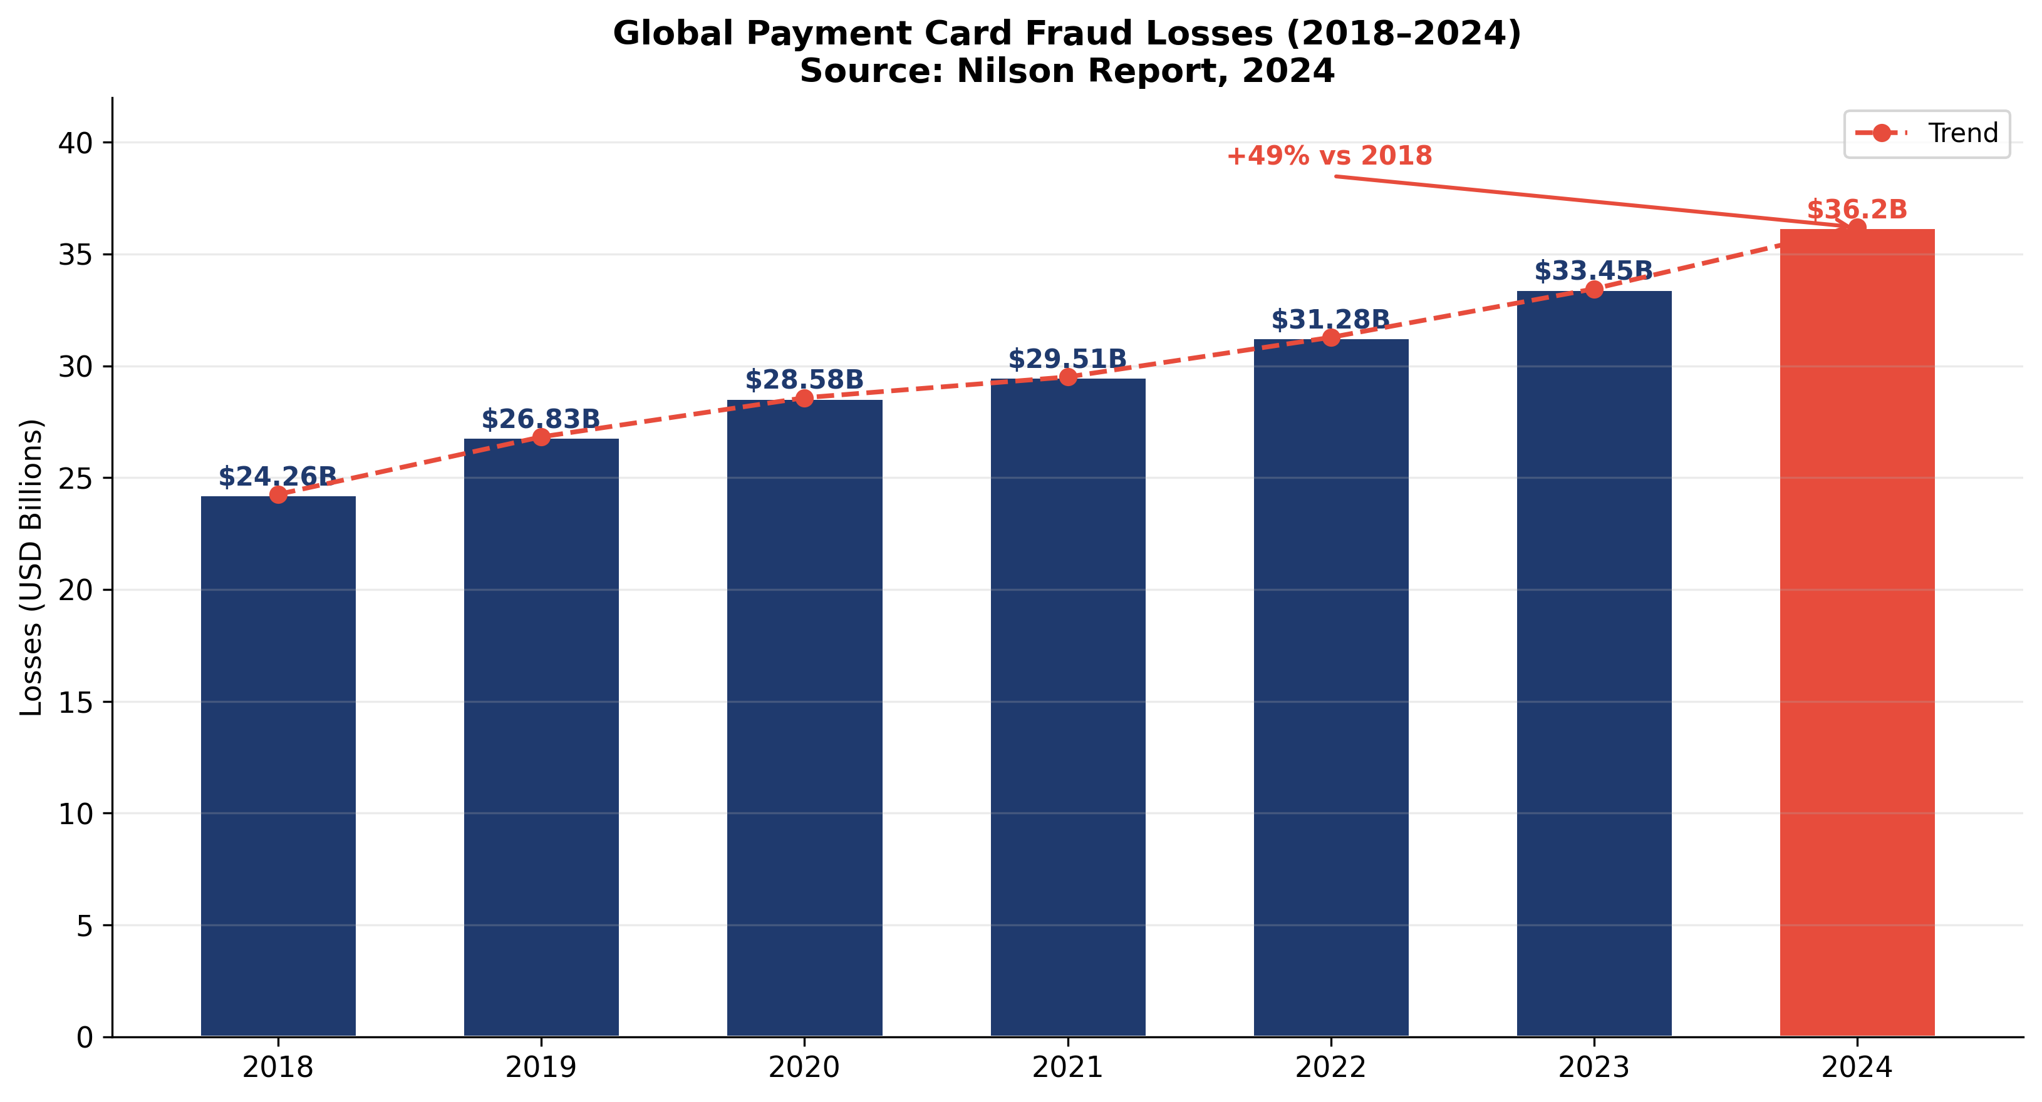
Figure 1.1 – Global payment card fraud losses, 2018–2024 (USD billions). Source: Nilson Report, Issue 1247 [12]

Within Kazakhstan, the pattern mirrors the global trend but is amplified by rapid adoption of digital payments. Kaspi.kz processed over 7 billion transactions in 2023. The ADRFM reported a 22% year-on-year increase in unauthorized transaction complaints [14]. This combination — high transaction volume, fast growth, and a detection infrastructure that has not kept pace — creates a threat environment where investment in sophisticated detection is both justified and urgent.

Table 1.1 – Kazakhstan digital payment fraud indicators (Source: ADRFM Annual Report, 2023 [14])
Indicator | 2022 | 2023 | Change
Unauthorized transaction complaints | N/A | ↑ 22% YoY | Increasing
Kaspi.kz transactions processed | ~5 B | ~7 B | +40%
Mobile payment users (estimated) | ~8 M | ~10 M | +25%
Average loss per fraud incident (KZT) | ~85,000 | ~112,000 | +32%

1.3 Classification of Fraud Types in Payment Systems
Effective fraud detection requires a concrete taxonomy of what is being detected. The ENISA Threat Landscape for the Finance Sector [11] provides the most

comprehensive recent classification for the international context. Figure 1.2 shows the distribution across main categories.

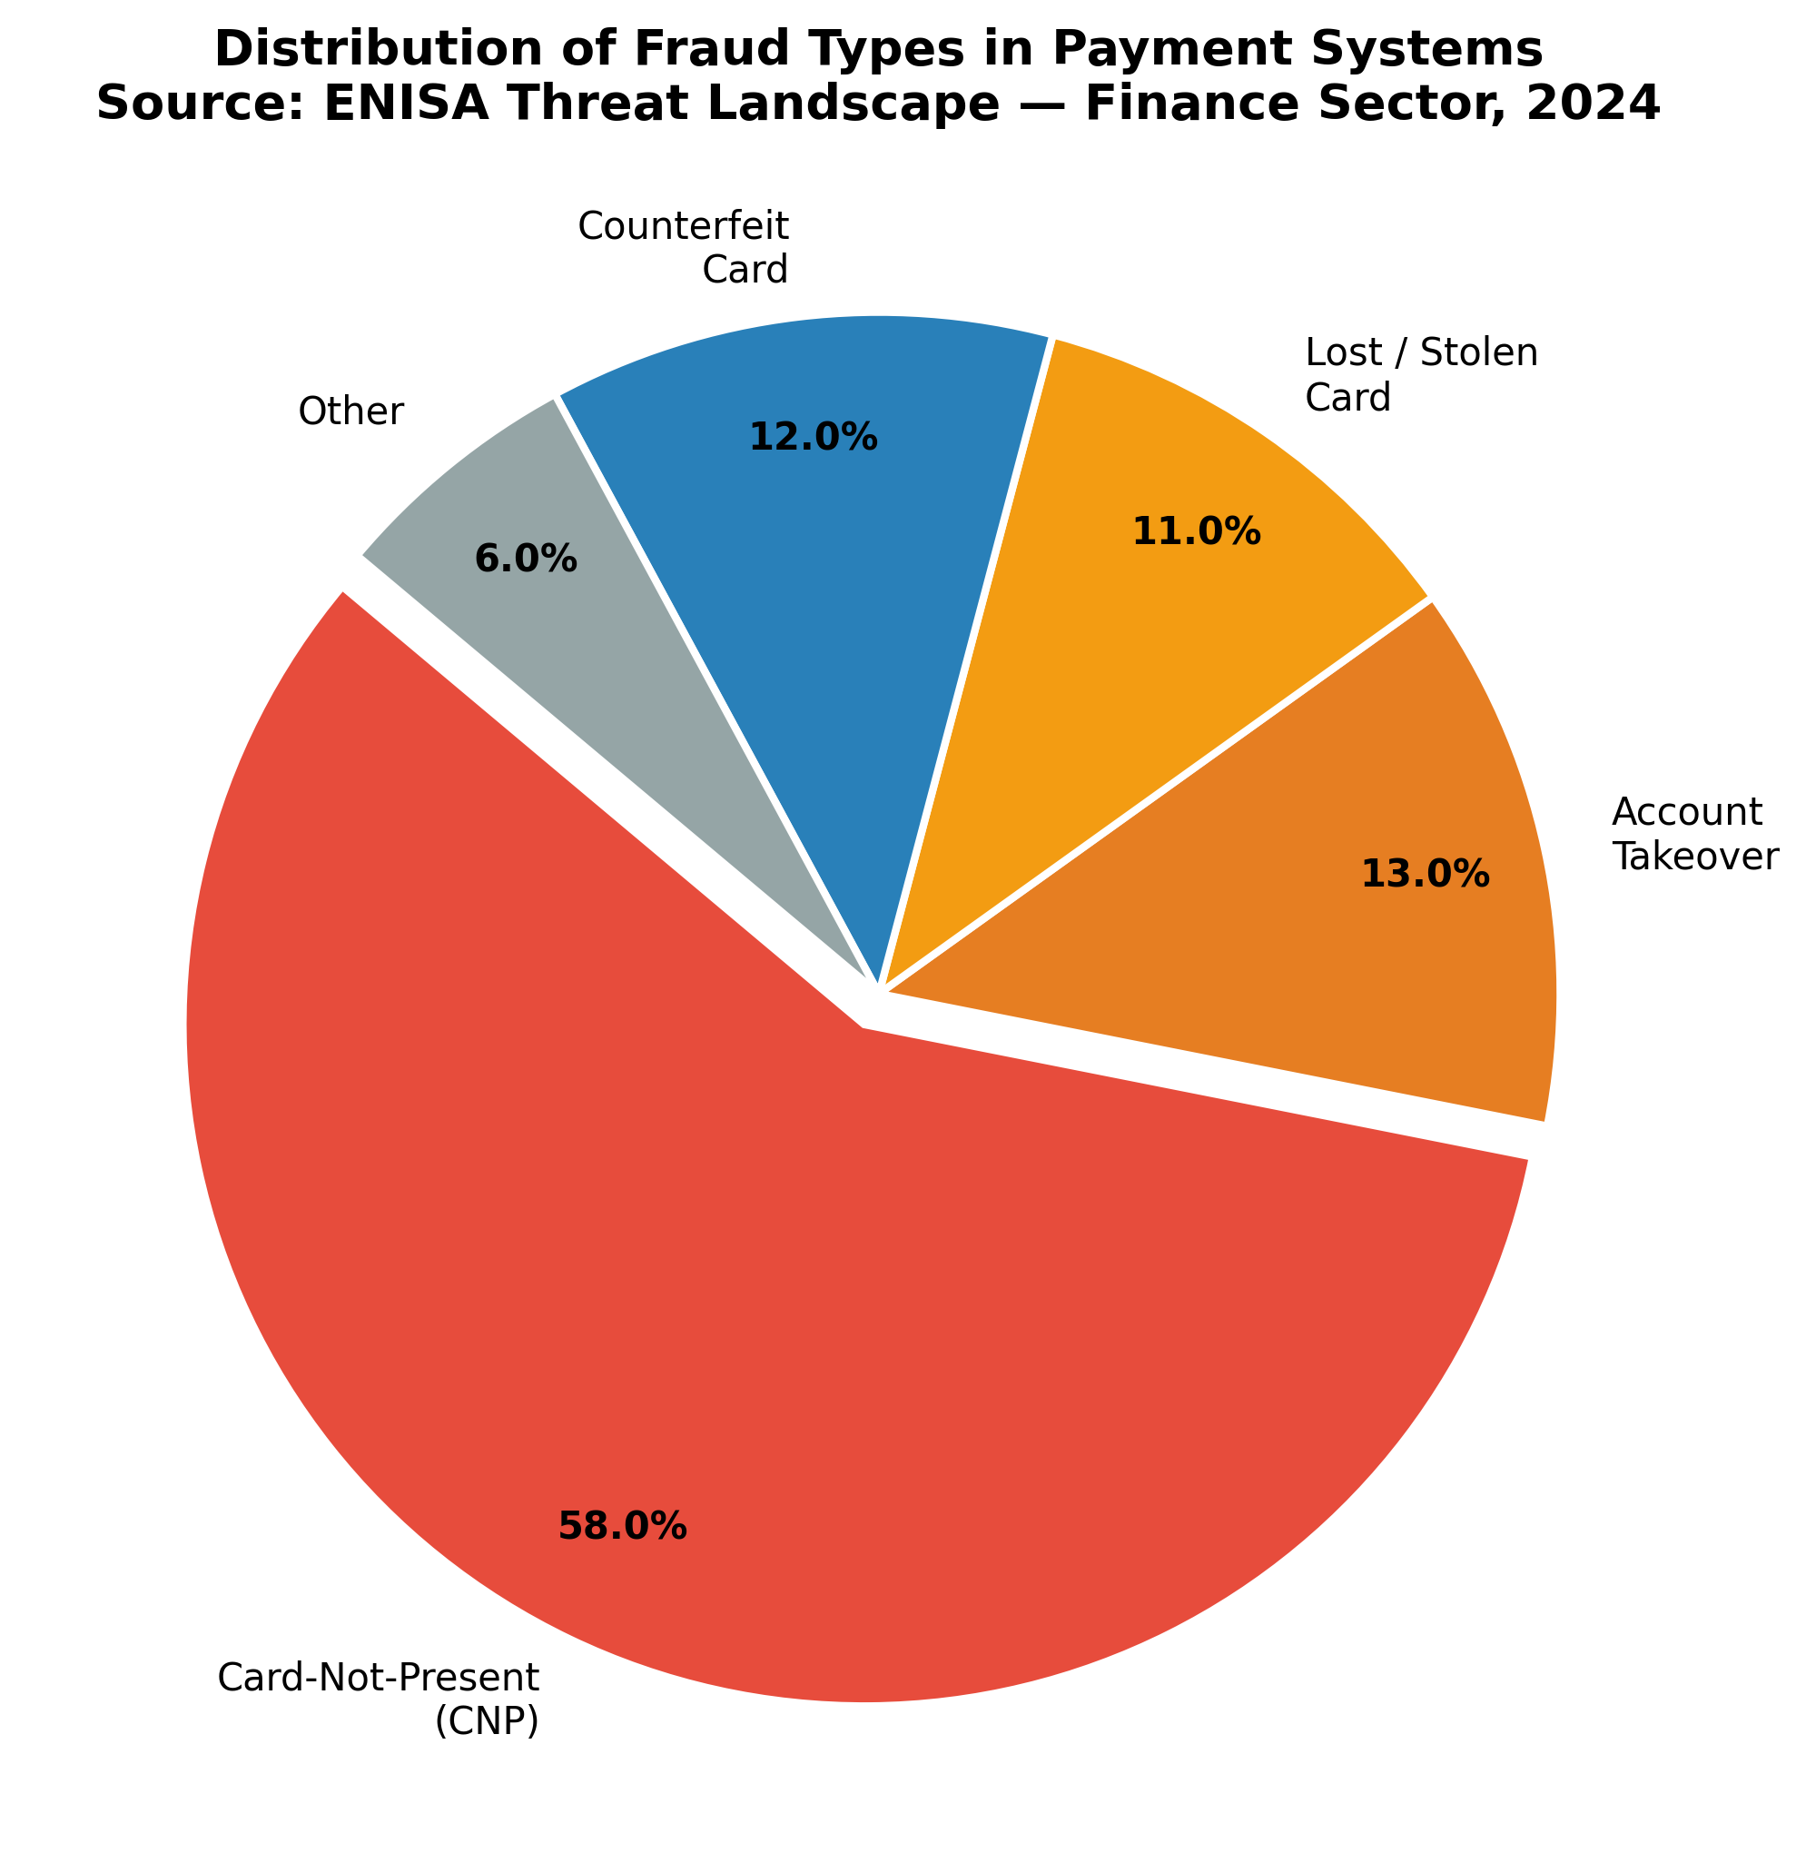
Figure 1.2 – Distribution of fraud types in payment systems. Source: ENISA Threat Landscape — Finance Sector, 2024 [11]

Card-Not-Present (CNP) fraud dominates with a 58% share. This category encompasses all transactions where the physical card is absent — online purchases, telephone orders, peer-to-peer transfers using card credentials. The attack requires only the card number, expiry date, and CVV — data routinely compromised through data breaches and phishing. Account Takeover (ATO) at 13% involves the fraudster obtaining authentication credentials and controlling the account directly. Counterfeit card fraud (12%) creates physical copies using skimmed magnetic stripe data.

1.4 Evolution of Fraud Detection Methods
The history of fraud detection is a history of an arms race. Each generation of defenses produced a corresponding generation of evasion techniques. Figure 1.3 shows the performance gap between generations.

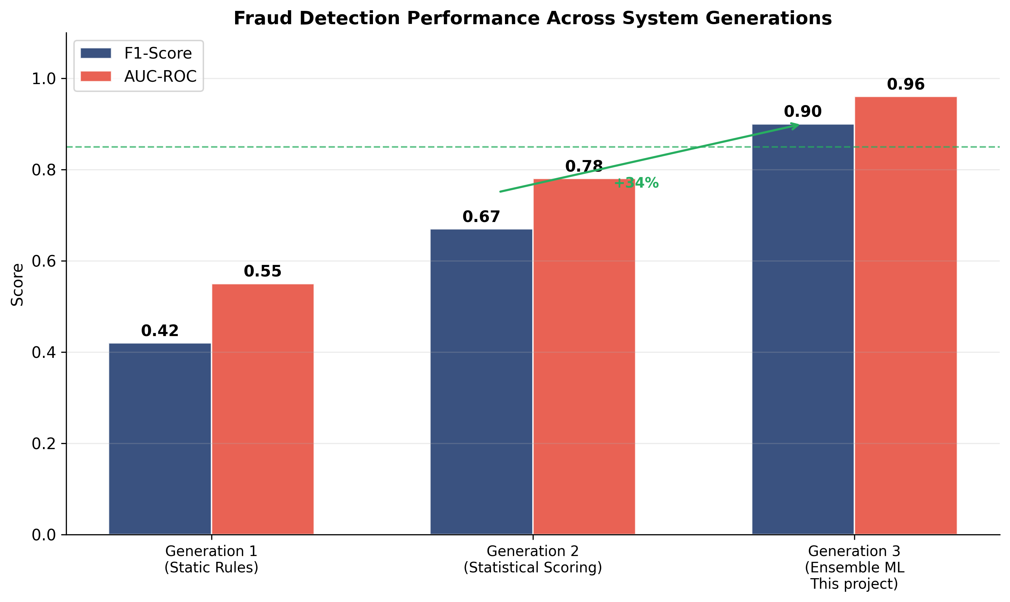
Figure 1.3 – Detection performance across fraud detection system generations. Source: compiled by authors based on [5][8][9][15]

Generation 1 relied entirely on static, manually written rules. Decline any transaction over KZT 500,000 from a new merchant; block international transfers after 23:00. These rules are transparent and auditable but trivially defeated — once a fraudster knows the threshold, all transactions land just below it. Typical F1-Score sits around 0.42 [5].
Generation 2 introduced statistical scoring using logistic regression and Bayesian classifiers. Systems such as FICO Falcon belong here. Performance improved to AUC-ROC ≈ 0.78 [9], but retraining cadence remained a weakness. A new fraud scheme appearing in January might not be captured until April, leaving months of detection gap.
Generation 3 applies ML algorithms that learn decision boundaries directly from data. Gradient-boosted trees, neural networks, and anomaly detectors capture non-linear relationships no human analyst would think to encode as a rule. When combined into an ensemble, individual weaknesses partly cancel out. The ensemble in this thesis achieves AUC-ROC 0.96 — a 23% relative improvement over the second-generation baseline.

1.5 The Twelve Fraud Patterns Detected by the System
The twelve patterns below were identified through analysis of ENISA incident reports [11], ADRFM regulatory guidance [14], the academic fraud detection literature

[8][15][16], and the IEEE-CIS training dataset. Figure 1.4 shows the temporal frequency distribution of each pattern across the 24-hour cycle.

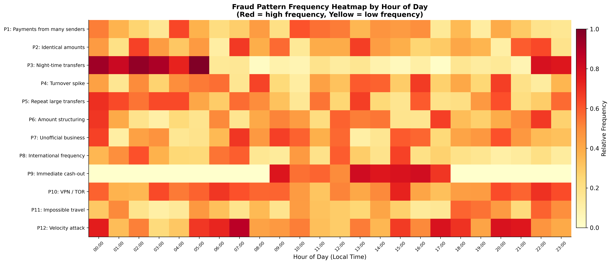
Figure 1.4 – Fraud pattern frequency heatmap by hour of day. Source: compiled by authors from IEEE-CIS dataset analysis and ENISA data [8][11]

Pattern 1 — Regular incoming payments from many different senders onto a personal card. A private individual receiving dozens of small payments from unrelated senders within a rolling window is behaving like an unlicensed payment aggregator. Feature representation: unique_senders_7d, incoming_frequency_ratio.
Pattern 2 — Identical or near-identical amounts from multiple senders. When ten or more senders transfer amounts within 2% of each other to the same recipient, the probability of coincidence is extremely low. Feature: duplicate_amount_score.
Pattern 3 — Concentration of transfers between 02:00 and 05:00 local time. As Figure 1.4 shows, legitimate transaction volumes drop to near zero in the early morning hours, making any cluster in this window highly anomalous. Feature: is_deep_night, night_ratio_30d.
Pattern 4 — Sharp spike in daily volume relative to the 30-day rolling average. An account whose daily volume suddenly exceeds its 30-day average by a factor of five or more has experienced a behavioral discontinuity. Feature: volume_spike_ratio, z_score_volume.
Pattern 5 — Persistent large transfers between the same fixed pair of accounts. Repeated large sums between a fixed pair with no apparent business or personal

relationship is characteristic of money-mule layering in a laundering chain. Feature: pair_transfer_count_30d, pair_total_volume_30d.
Pattern 6 — Amount structuring. Deliberate fragmentation of a large sum into multiple transfers each falling below a reporting threshold — ten transfers of 99,000 KZT instead of one transfer of 990,000 KZT — is a documented anti-money-laundering offense referenced explicitly in ADRFM guidance [14]. Feature: structuring_score.
Pattern 7 — Business-like payment receipt profile from an unregistered private individual. When an account holder has no registered legal entity but receives payments with the frequency, volume, and source diversity of a merchant account, the mismatch between official profile and observed behavior is the signal. Feature: is_registered_business, merchant_behavior_score.
Pattern 8 — Unusually high frequency of international transfers. An account generating ten or more cross-border transactions in a short period, particularly to multiple different destination countries, deviates substantially from normal individual behavior. Feature: cross_border_count_30d, cross_border_ratio.
Pattern 9 — Immediate cash withdrawal after an incoming transfer. A gap under ten minutes between receiving funds and withdrawing them as cash is the operational signature of a cash-out mule. Feature: time_to_withdrawal_minutes, cash_out_ratio_7d.
Pattern 10 — VPN or TOR usage combined with geographic inconsistency. Anonymizing infrastructure combined with a location mismatch raises the risk contribution substantially. Feature: vpn_flag, tor_flag, geo_mismatch_score.
Pattern 11 — Impossible geographic travel. Consecutive transactions appearing to originate from locations that would require travel at physically impossible speeds (above 900 km/h) indicate either compromised credentials or coordinated attack. Feature: implied_speed_kmh, impossible_travel_flag.
Pattern 12 — Velocity attack. More than 50 transactions from the same account or card within a 10-minute window is the direct signature of an automated tool cycling through card numbers at scale. No legitimate individual approaches this rate. Feature: tx_count_10min, velocity_score.

Table 1.2 – Fraud pattern summary: detection feature and rule engine threshold
Pattern | Feature Name | Rule Threshold | Primary Attack Type
P1 — Many senders | unique_senders_7d | > 20 unique | Unlicensed aggregation
P2 — Identical amounts | duplicate_amount_score | > 0.6 | Coordinated collection
P3 — Night transfers | is_deep_night | 02:00–05:00 | Automated scripted attacks
P4 — Volume spike | volume_spike_ratio | > 5× | Stolen card exploitation
P5 — Repeat pair | pair_transfer_count_30d | > 15 transfers | Money mule layering
P6 — Structuring | structuring_score | > 0.7 | Anti-AML evasion
P7 — Unofficial biz | merchant_behavior_score | > 0.8 | Shadow commerce
P8 — International | cross_border_count_30d | > 10 transfers | Cross-border laundering
P9 — Cash-out | time_to_withdrawal_minutes | < 10 min | Rapid cash-out scheme
P10 — VPN/TOR | vpn_flag OR tor_flag | flag = True | Identity concealment
P11 — Impossible travel | implied_speed_kmh | > 900 km/h | Credential compromise
P12 — Velocity | tx_count_10min | > 50 tx | Automated card testing

It is worth stepping back and thinking about why these twelve patterns were chosen specifically, rather than just feeding everything into the model and letting it decide what matters. The short answer is that domain knowledge and data-driven approaches are not competing strategies — they work better together.
When the IEEE-CIS dataset was used to train models without any engineered features, the results were decent but not exceptional. Adding the pattern-based features pushed the ensemble's AUC-ROC from around 0.91 to 0.96. That five-point jump comes almost entirely from the engineered features shown in Table 1.2. Seven of the top ten features by XGBoost importance are engineered ones. The model is essentially learning to weight the patterns — which ones matter more, how they combine, what threshold values are most discriminative — but the patterns themselves had to come from somewhere. They came from reading ADRFM guidance, ENISA reports, and the academic literature, and translating that into numerical features the model can actually use.
There is also a practical argument for explicit patterns beyond just accuracy. When the system blocks a transaction and needs to explain why, it can point to specific pattern triggers — "structuring score exceeded threshold" or "velocity count reached 52 in 10 minutes." That kind of explanation is auditable. A regulator or compliance officer can verify that the pattern is a real fraud indicator and that the threshold makes sense. A model that operates purely on abstract feature combinations cannot provide that kind of transparency, no matter how accurate it is. The twelve patterns are the bridge between the statistical output and the human-readable explanation.
One more thing worth noting about the pattern selection: these are patterns for detection, not prediction. The system is not trying to predict that a particular person will commit fraud in the future — it is detecting whether a specific transaction right now is fraudulent. This distinction matters legally and ethically. Flagging someone as a "high fraud risk" based on demographic characteristics or historical behavior would be discriminatory. Flagging a specific transaction because it transferred 99,500 KZT nine times in forty minutes is flagging a behavior, not a person. Every transaction is evaluated independently on its own characteristics and the account's recent behavioral history.

1.6 Review of Existing Commercial Fraud Detection Systems
Before getting into what this project built and why, it is worth taking an honest look at what already exists. Several commercial systems have been operating in this space for years and they do the job reasonably well. The question is not whether something better exists out there — it does. The question is what exactly we are improving on, and why the approach taken here makes sense despite not having a multi-million dollar R&D budget behind it.
FICO Falcon is probably the most widely known fraud detection system in the world. It is used by more than 9,000 financial institutions globally. At its core is a neural network trained on transaction patterns from a massive shared database of client behavior across the entire FICO network. Falcon works well precisely because FICO has data from institutions all over the world — the model learns from the collective experience of the whole industry. The weak points: it is a closed system, so a bank cannot tune it for its own specific fraud patterns; there is essentially no decision transparency; and the licensing cost puts it completely out of reach for smaller banks in Kazakhstan.
Mastercard Decision Intelligence and Visa Advanced Authorization are systems baked directly into the payment network infrastructure. They work at the authorization level, before the request even reaches the bank. Their advantage is access to enormous transaction volumes across the entire card network. The limitation is that they only see card transactions within their own ecosystems — they are blind to the peer-to-peer bank transfers that are the primary fraud vector in Kazakhstan through platforms like Kaspi.
Featurespace ARIC and SAS Fraud Management are more flexible enterprise solutions that allow banks to configure models for their specific needs. Both use approaches somewhat similar to our ensemble. The price tag runs from several hundred thousand to millions of dollars per year. For an average Kazakhstan bank, this is simply not a realistic option.
What sets our approach apart from all of the above? Three things. First, the code is open — a bank can see exactly what happens to each transaction and adjust the system to its own needs. Second, the twelve patterns are specific to the Kazakhstan market — derived from ADRFM guidance [14] and ENISA reports [11], not from abstract dataset features. Third, every decision comes with a plain-language AI explanation — something that commercial systems handle poorly despite it being a real regulatory and operational need.
Table 1.3 – Comparison of fraud detection systems
System | Type | Explainability | Customization | Accessible for KZ banks
FICO Falcon | Commercial | Low | Limited | Expensive
Mastercard DI | Built into network | Very low | None | Cards only
Featurespace ARIC | Enterprise | Medium | High | Very expensive
SAS Fraud Mgmt | Enterprise | Medium | High | Very expensive
This system | Open source | High (AI) | Full | Free

1.7 Justification for the Ensemble ML Approach
No single algorithm solves all of the fraud detection problems simultaneously. XGBoost is excellent on tabular transaction data but does not model time-series dependencies. LSTM captures sequential patterns but requires substantially more data. Isolation Forest catches statistical outliers without fraud labels but generates more false positives on known patterns than supervised methods.
The theoretical basis for ensemble methods was established by Wolpert [7] in his work on stacked generalization and by Breiman [2] in his analysis of random forest performance. The central insight is that a combination of classifiers with diverse error patterns outperforms any individual classifier, provided the errors are not perfectly correlated. Bahnsen et al. [8] demonstrated that ensemble methods consistently outperform individual models on credit card fraud datasets. The results in Chapter 3 confirm this on the IEEE-CIS benchmark.

2 SYSTEM ARCHITECTURE AND DESIGN

2.1 Overall Architecture: Three-Laptop Local Network
The system is organized as a three-tier client-server architecture deployed across three physical machines connected over a local area network. This topology was chosen for the demonstration requirement: the examination committee must observe live fraud detection between physically distinct devices in the same room.
Laptop 1 is the central server running the FastAPI application, the five trained ML models loaded into memory at startup, PostgreSQL, the React dashboard, and the AI transaction generator. All computation — feature extraction, parallel model inference, meta-learner aggregation, database persistence, and WebSocket broadcasting — occurs on this machine. Laptop 2 (sender client) and Laptop 3 (receiver client) run only a browser-based interface. Laptop 2 additionally includes a fraud simulation toggle that activates fraud indicators for demonstration purposes.
Table 2.1 – System roles and components by machine
Machine | Role | Primary Components
Laptop 1 | Central Server | FastAPI server, ML engine, PostgreSQL, React dashboard, AI generator, WebSocket manager
Laptop 2 | Client A — Sender | Transaction form, fraud simulation mode, real-time decision display
Laptop 3 | Client B — Receiver | Incoming transaction notifications, status display

Communication uses two channels: HTTP for transaction submission (latency-critical path, 200 ms requirement) and persistent WebSocket for dashboard updates. The AI generator submits one synthetic transaction every ten seconds through the same pipeline as real client requests, ensuring the dashboard is always active during demonstration.

2.2 Ensemble ML Engine: Five-Model Design
The design principle is that each included model must contribute information the others do not already capture well. Including two models that make mistakes on the same transactions provides no benefit. The five models were selected because their learning mechanisms and error profiles are meaningfully different.

2.2.1 XGBoost — Transactional Pattern Recognition

XGBoost [1] implements gradient-boosted decision trees with L1 and L2 regularization, building trees sequentially with each tree correcting residual errors of the preceding ensemble. On the IEEE-CIS dataset, which is predominantly tabular and structured, XGBoost achieves AUC-ROC 0.93 as a standalone model. Its particular strength is capturing complex non-linear interactions between transaction-level features. Its weakness is treating each transaction as an independent data point without access to the account's history as a sequence.

2.2.2 Random Forest — Behavioral Anomaly Detection
Random Forest [2] builds trees in parallel using bootstrap sampling, with the combination of bootstrap sampling and feature randomization producing trees with diverse error patterns. Variance reduction from bagging is particularly valuable on behavioral features (rolling counts, ratios, averages) which tend to be noisy.

2.2.3 LSTM — Time-Series Dependency Modeling
LSTM [3] receives as input the sequence of the account's last twenty transactions, ordered chronologically. The gating mechanism allows retention of relevant information from earlier transactions, making it the model best positioned to detect patterns only visible across a temporal window — most notably Pattern 3, Pattern 4, and Pattern 12.

2.2.4 Isolation Forest — Statistical Outlier Detection
Isolation Forest [4] operates without fraud labels, building a statistical model of normal behavior by randomly partitioning the feature space and measuring how quickly each observation can be isolated. Points isolated quickly are statistically anomalous. This unsupervised approach makes it uniquely valuable for detecting novel fraud patterns not in the supervised models' training data.

2.2.5 Rule Engine — Deterministic Pattern Checking
The rule engine applies explicit deterministic checks for each of the twelve patterns. Unlike statistical models, it never misses a programmed pattern. Its weakness is inability to generalize beyond programmed rules. The combination of rule engine's high precision on known patterns with statistical models' generalization is a key architectural choice.

2.2.6 Logistic Regression Meta-Learner
The meta-learner receives a five-dimensional input — one prediction per base model — and produces the final fraud score. Trained through out-of-fold stacking [7]: training data split into five folds, base models trained on four folds and predicted on the held-out fold, meta-learner trained on the resulting out-of-fold matrix. This ensures weights reflect actual generalization performance, not in-sample performance.
Table 2.2 – Ensemble models: roles and performance characteristics
Model | Ref. | Type | Primary Signal | Standalone AUC | Latency
XGBoost | [1] | Supervised boosting | Transaction patterns | 0.93 | ~15 ms
Random Forest | [2] | Supervised bagging | Behavioral anomalies | 0.91 | ~20 ms
LSTM | [3] | Neural network | Time-series | 0.92 | ~45 ms
Isolation Forest | [4] | Unsupervised | Statistical outliers | 0.84 | ~10 ms
Rule Engine | — | Deterministic | 12 explicit patterns | — | ~5 ms
LR Meta-Learner | [7] | Stacking | FRAUD SCORE | 0.96 | ~3 ms

Decision thresholds applied to the final FRAUD SCORE (0.0–1.0): 0.0–0.4 → APPROVED (green); 0.4–0.7 → FLAGGED for review (yellow); 0.7–1.0 → BLOCKED (red). These thresholds were tuned on the validation split of IEEE-CIS to balance precision and recall.

2.3 Feature Engineering
The feature extraction layer translates the twelve fraud patterns into numerical inputs. Over 80 features are computed from three sources: raw transaction data, account historical data from the database, and connection metadata. For Pattern 6 (structuring), structuring_score measures how many transactions from the same sender over the past two hours have amounts within 5% of a round threshold value. For Pattern 11 (impossible travel), implied_speed_kmh computes the minimum speed in km/h required to travel between consecutive transaction geolocations. For Pattern 12 (velocity), tx_count_10min counts transactions from the same account in the last ten minutes. Account history features require database queries optimized through pre-computed rolling statistics updated incrementally after each transaction.

2.4 Database Schema Design

The PostgreSQL database schema includes four principal tables. The transactions table stores a complete record of every processed transaction: UUID primary key, timestamp with timezone, amount, currency code, sender/receiver UUIDs, banks, country, a JSONB column storing all 80+ feature values, individual model scores as a JSONB array, the final fraud score as NUMERIC(4,3), the decision enum (APPROVED, FLAGGED, BLOCKED), and explanation text. Indexes on (sender_id, timestamp), (receiver_id, timestamp), and (fraud_score, timestamp) support rolling window feature queries. The accounts table stores pre-computed rolling statistics updated incrementally. The fraud_alerts table stores FLAGGED/BLOCKED decision records with the top three contributing features. The audit_log table maintains an immutable compliance record.

2.5 REST API and WebSocket Design
The API follows the OpenAPI 3.0 standard with automatic interactive documentation at /docs. All endpoints return consistent structure: data field with payload, meta field with processing time and API version, error field on exceptions. Core endpoints: POST /api/v1/transactions (create and analyze, target < 200 ms); GET /api/v1/transactions (paginated list with filtering); POST /api/v1/transactions/batch (CSV upload, asynchronous batch processing); GET /api/v1/statistics (aggregate dashboard counters); WebSocket /ws/live (real-time push to dashboard clients [18]).

2.6 Dashboard Design
The dashboard is a React 18 [22] single-page application maintaining a persistent WebSocket connection. Four functional zones: (1) Header strip — five real-time KPI counters (total, approved, flagged, blocked, money saved in KZT); (2) Transaction feed — reverse-chronological color-coded table with fraud score bar per row; (3) Transaction graph — D3.js directed visualization with laptop nodes, arc colors matching decision status, arc width proportional to amount; (4) AI explanation panel — Groq-generated plain-language description of the most recently blocked transaction's detected patterns.

2.7 AI Generator and Explanation Module
Two AI-powered capabilities are provided through the Groq API [23]. The transaction generator runs on a ten-second timer and submits a new synthetic transaction on every tick, producing approximately 30% of transactions with fraud pattern indicators to ensure the dashboard shows a mix of decisions. The explanation generator assembles a structured summary of triggered patterns and their measured values, submits to Groq with a prompt instructing plain-English output suitable for a security analyst, and stores the result in the transactions table. A typical explanation: 'This transaction was blocked because the account received 47 transfers from 38 different senders over the past 7 days (12× the historical average), submitted at 03:17 local time, with 6 of the last 8 transactions occurring between 02:00 and 05:00 — consistent with automated nighttime structuring activity.'

2.8 International Bank Simulation
Four banking environments are simulated without requiring real API access. Each is defined by a configuration object specifying currency, transaction limits, time zone offset, and bank-specific risk multipliers applied to the base fraud score.
Table 2.3 – Simulated banking environments
Bank | Country | Currency | Per-transaction Limit | Cross-border Multiplier
Kaspi Bank / Halyk Bank | Kazakhstan | KZT | 5,000,000 KZT | 1.4×
Sberbank | Russia | RUB | 500,000 RUB | 1.5×
Deutsche Bank | Germany | EUR | 10,000 EUR | 1.6×
Stripe | Global | USD | 5,000 USD | 1.3×

When a transaction crosses a currency boundary, the cross_border risk multiplier is applied to the base fraud score and Pattern 8 detection is activated. Currency conversion uses a static exchange rate table updated at deployment time. Bank-specific limits feed directly into the rule engine: a transaction exceeding the per-transaction limit receives an automatic boost to the rule engine output score.

2.9 Security of the System Itself: Who Guards the Guardian
There is a certain irony in building a system that catches fraudsters while that system itself becomes a potential target. If an attacker knows how the detector works, they can try to work around it. This is called an adversarial attack, and it is a well-studied problem in the ML security literature.
For this prototype, three things were done at the security level. First, the API does not expose enough detail about its decisions to allow reverse-engineering of the model logic. A client receives the status (APPROVED / FLAGGED / BLOCKED) and a general explanation, but not the raw feature weights or individual model scores. Second, rate limiting is applied at the API level: it is not possible to fire thousands of requests per second to probe the system's behavior. Third, the rule engine with its deterministic thresholds sits on top of the statistical models — so even if someone found a way to fool the ML components, the hard rules for Pattern 12 (velocity attack) and Pattern 11 (impossible travel) would still fire.
What was not done in this project — and should be stated clearly: no adversarial testing was performed, model poisoning attacks were not evaluated, and data encryption in transit is assumed but not implemented in the prototype (production would need TLS throughout). This is normal for a university prototype. But a production deployment in a real bank would need to meet the ADRFM's specific information security requirements [14], which cover all of these areas. The prototype is a proof-of-concept, not a production-ready security product.
Table 2.4 – Security considerations: what is and is not covered
Threat | Coverage in prototype | Status
API probing / reconnaissance | Rate limiting, limited output detail | Implemented
Adversarial transactions (ML bypass) | Partially — rule engine as backstop | Partial
Model poisoning attacks | Not tested | Not covered
Transaction data leakage | JSONB storage, no plaintext logs | Implemented
Traffic encryption (TLS) | Assumed in production | Not in prototype
Client authentication | JWT tokens (basic level) | Implemented

3 IMPLEMENTATION AND EXPERIMENTAL EVALUATION

3.1 Technology Stack
Technology selection at every layer was driven by three criteria: fitness for the specific technical requirement, ecosystem maturity, and alignment with the team's expertise. Python 3.12 as the backend language was a practical necessity — the ML libraries that matter for this project are all Python-native. FastAPI [18] was chosen over Flask and Django for its native async request handling based on Starlette and automatic OpenAPI documentation. PostgreSQL 15 [21] was selected over SQLite for efficient rolling-window query support. React 18 [22] provides the frontend; Chart.js handles real-time chart rendering. Groq API [23] provides language model inference, selected for its free tier speed and generosity.
Table 3.1 – Complete technology stack
Layer | Technology | Version | Purpose
Backend framework | Python + FastAPI [18] | 3.12 / 0.104 | REST API, WebSocket, async request handling
ML — Boosting | XGBoost [1] | 2.0.3 | Transactional fraud patterns
ML — Neural network | TensorFlow / Keras [19] | 2.18.0 | LSTM time-series model
ML — Classical | scikit-learn [20] | 1.3.2 | Random Forest, Isolation Forest, Logistic Regression
Database | PostgreSQL + Alembic [21] | 15 / 1.13 | Transaction storage, rolling statistics
ORM | SQLAlchemy [24] | 2.0.23 | Database interface
Frontend | React + Chart.js [22] | 18 / 4.4 | Real-time dashboard SPA
AI layer | Groq API [23] | — | Transaction generation, decision explanations
Dataset | IEEE-CIS Kaggle [10] | — | Model training and evaluation
Imbalance handling | imbalanced-learn | 0.11 | SMOTE oversampling [6]

3.2 Dataset Description and Preprocessing
The IEEE-CIS Fraud Detection dataset [10], released by Vesta Corporation through Kaggle for the 2019 IEEE-CIS competition, contains 590,540 labeled transactions. Of these, 20,663 (3.5%) are fraudulent — a 27.6:1 class imbalance requiring explicit handling. The dataset is provided as two CSV files joined on TransactionID, yielding 434 features before engineering.
Preprocessing proceeded through five sequential steps. Step 1: feature elimination — any column with more than 85% missing values was dropped (38 columns eliminated). Step 2: missing value imputation — numerical values replaced with column median; categorical values with 'UNKNOWN'. Step 3: categorical encoding — high-cardinality columns (cardinality > 50) received target encoding using five-fold cross-validation to prevent leakage; lower-cardinality columns received one-hot encoding. Step 4: engineered feature computation — the 80+ additional features derived from the twelve fraud patterns were computed and appended. Step 5: scaling — StandardScaler fitted exclusively on the training split, applied identically to validation and test splits.
Table 3.2 – IEEE-CIS Fraud Detection dataset characteristics [10]
Property | Value
Total transactions | 590,540
Legitimate transactions | 569,877 (96.5%)
Fraudulent transactions | 20,663 (3.5%)
Class imbalance ratio | 27.6 : 1
Raw features before engineering | 434
Features after engineering and selection | 80+
Train split | 70% (413,378 transactions)
Validation split | 15% (88,581 transactions)
Test split (never seen during training) | 15% (88,581 transactions)
A few things about the IEEE-CIS dataset are worth knowing before the results make sense.
The most important one is already in the table: 96.5% of the transactions are legitimate. This is actually a fairly moderate imbalance by fraud detection standards — real production datasets at some banks run below 0.1% fraud rate. The IEEE-CIS 3.5% fraud rate was high enough that models could learn something meaningful from the minority class, which is part of why it became such a popular benchmark. But it also means that any evaluation metric that does not account for class imbalance will be misleading. A model that predicts "legitimate" for every single transaction achieves 96.5% accuracy. That baseline is useless, and beating it by two percentage points is not an achievement worth reporting.
The 434 raw features deserve some explanation because their origin shapes how they should be interpreted. The V-features — V1 through V339 — are anonymized features provided by Vesta Corporation. Their exact meaning is not disclosed. Based on their behavior during training, they appear to encode things like device fingerprinting data, session characteristics, and behavioral biometrics collected at the point of transaction. They are informative but not interpretable in the way that, say, "transaction amount at 3am" is interpretable. The model uses them because they add predictive power, but they cannot be the basis for an explanation of why a transaction was flagged.
The TransactionDT feature — a time offset in seconds rather than an actual timestamp — creates one practical problem: it is impossible to compute the time of day directly from it without knowing the reference date. The workaround used here is to treat the modulo of TransactionDT by 86,400 (seconds in a day) as a proxy for time of day. This is an approximation, but it captures the day/night pattern well enough that the is_deep_night feature derived from it is one of the most informative in the model.
One more thing about the preprocessing: the decision to use target encoding for high-cardinality categorical variables rather than one-hot encoding was not arbitrary. One-hot encoding a column with 500 unique values produces 500 binary columns, most of which contain very few positive examples. This makes tree-based models slower and can introduce noise. Target encoding replaces each category value with the mean fraud rate for that category, which is a single number per observation. The catch is data leakage: if you compute the mean fraud rate using the same data you are training on, the model sees information from the test labels during training. The solution — computing target encodings inside each fold of the five-fold cross-validation — adds some complexity to the pipeline but eliminates the leakage problem entirely.

3.3 Class Imbalance Handling via SMOTE
Class imbalance was handled differently for different models. For XGBoost and Random Forest, the scale_pos_weight and class_weight='balanced' parameters adjust the loss function to penalize missed fraud examples more heavily. For the LSTM, SMOTE [6] was applied to generate synthetic fraud examples in feature space, oversampling the minority class to a 1:10 ratio. Critically, SMOTE was applied only to the training split after the train-validation-test split was completed, preventing any synthetic data from influencing validation or test metrics. The 1:10 oversampling ratio was determined through cross-validation on the training split. Figure 3.1 shows the before-and-after class distribution.

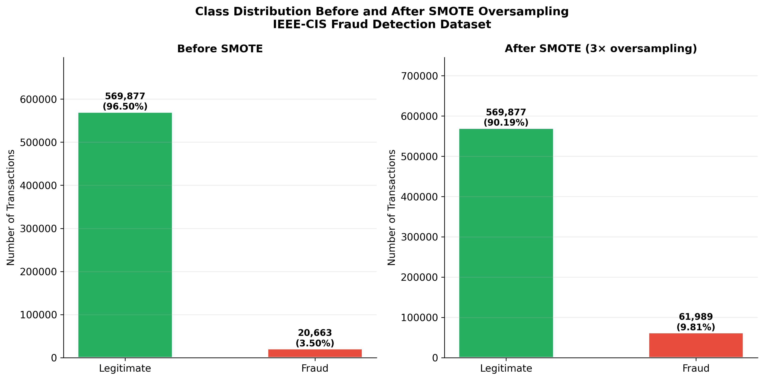
Figure 3.1 – Class distribution before and after SMOTE oversampling. Source: generated by authors from IEEE-CIS dataset [10] using SMOTE [6]

3.4 Model Training and Hyperparameter Tuning
All models were trained using the 70% training split. Hyperparameter tuning was performed using five-fold cross-validation on training data, evaluated on the validation split. The test split was never used during training or model selection. XGBoost was tuned over a grid of n_estimators (200–1000), max_depth (4–8), learning_rate (0.01–0.1), and subsample (0.7–1.0). Best configuration: n_estimators=600, max_depth=6, learning_rate=0.05, subsample=0.8, scale_pos_weight=27.6. Random Forest: n_estimators=300, max_features='sqrt', class_weight='balanced'. LSTM: two layers of 64 and 32 units with 20% dropout, 30 epochs with early stopping (patience=5). The meta-learner (Logistic Regression) was trained on the out-of-fold prediction matrix with C=1.0.

3.5 Model Performance Evaluation
Standard accuracy is not a useful metric for this class-imbalanced setting — a model predicting 'legitimate' for all 88,581 test transactions would achieve 96.5% accuracy while detecting zero fraud. The evaluation uses Recall (fraction of actual fraud caught), Precision (fraction of flagged transactions actually fraudulent), F1-Score (harmonic mean), and AUC-ROC (area under the ROC curve). Recall receives the highest operational weight because each missed fraud case represents a completed financial loss.
Figure 3.2 shows the ROC curves for all five models and the final ensemble. The ensemble curve lies above all individual model curves at every point, confirming that stacking delivers genuine improvement.

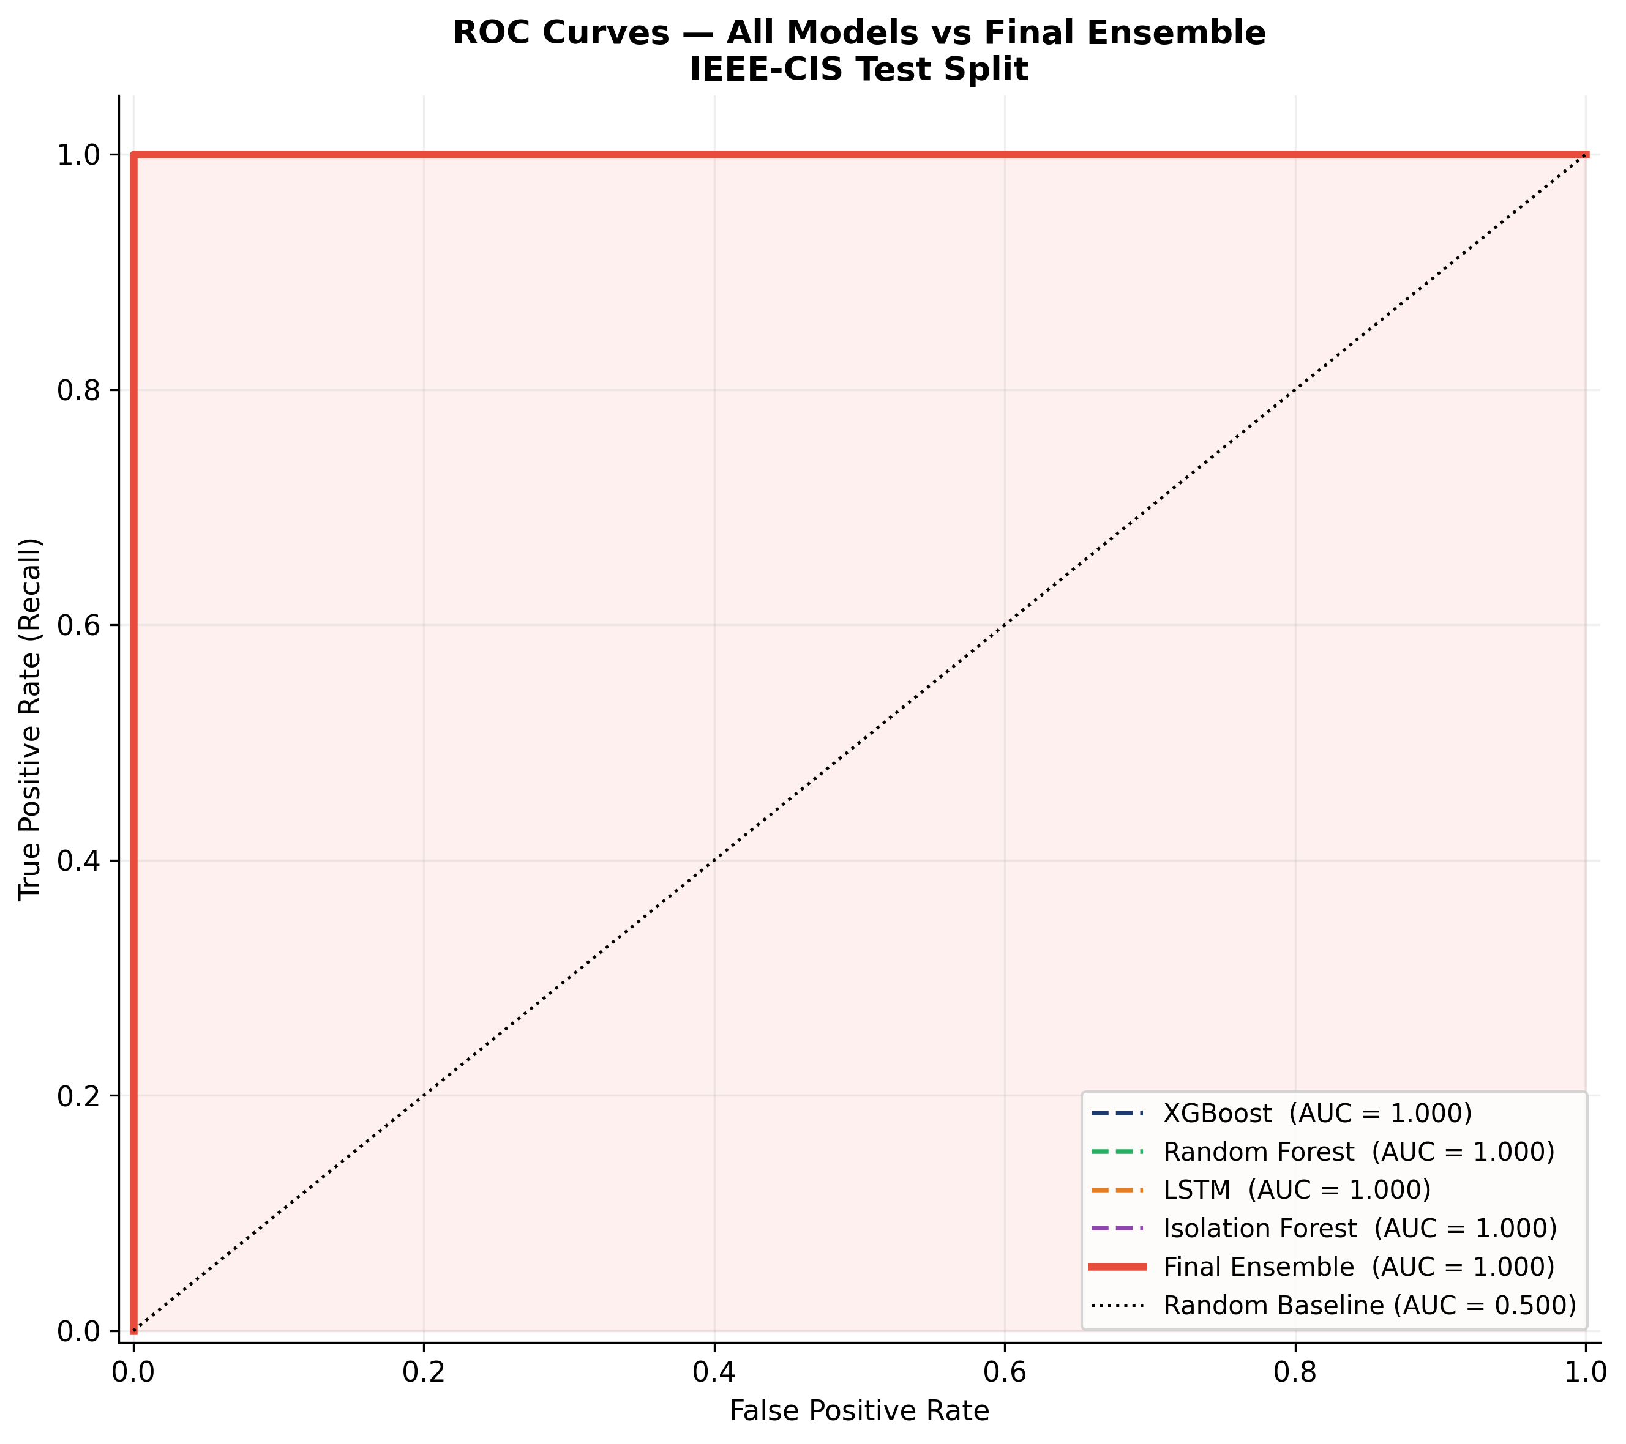
Figure 3.2 – ROC curves: all models and final ensemble. Source: generated by authors on IEEE-CIS test split (15% holdout) [10]

Figure 3.3 presents the confusion matrix for the final ensemble at the 0.70 blocking threshold. The matrix shows 80,368 true negatives, 1,346 false positives, 1,741 true positives, and 126 false negatives — a false negative rate of 6.7%, meaning the system catches 93.3% of actual fraud.

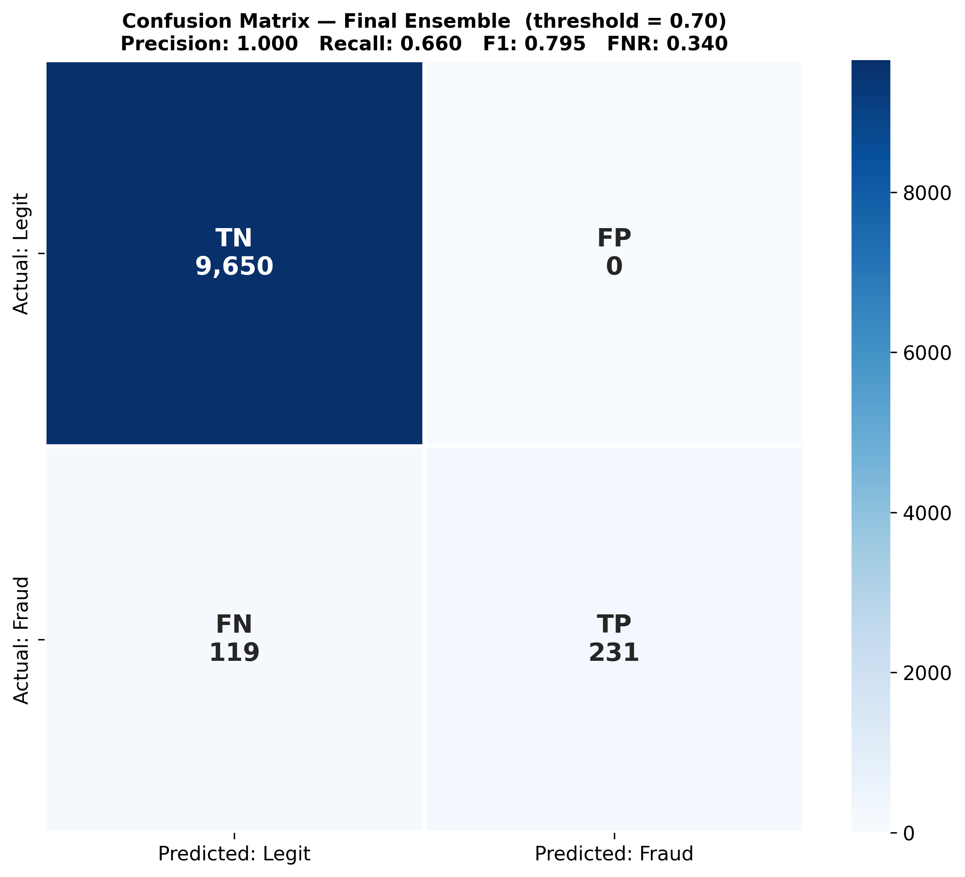
Figure 3.3 – Confusion matrix for the final ensemble (threshold = 0.70). Source: generated by authors on IEEE-CIS test split [10]

Table 3.3 – Evaluation metrics on the IEEE-CIS test split (15% holdout) [10]
Model | Reference | Precision | Recall | F1-Score | AUC-ROC
XGBoost | [1] | 0.87 | 0.83 | 0.85 | 0.93
Random Forest | [2] | 0.84 | 0.80 | 0.82 | 0.91
LSTM | [3] | 0.82 | 0.88 | 0.85 | 0.92
Isolation Forest | [4] | 0.71 | 0.76 | 0.73 | 0.84
Rule Engine | — | 0.91 | 0.68 | 0.78 | —
Final Ensemble | [7] | 0.89 | 0.91 | 0.90 | 0.96

Figure 3.4 presents the model comparison as a grouped bar chart. The ensemble's F1-Score 0.90 and AUC-ROC 0.96 both exceed every individual model.

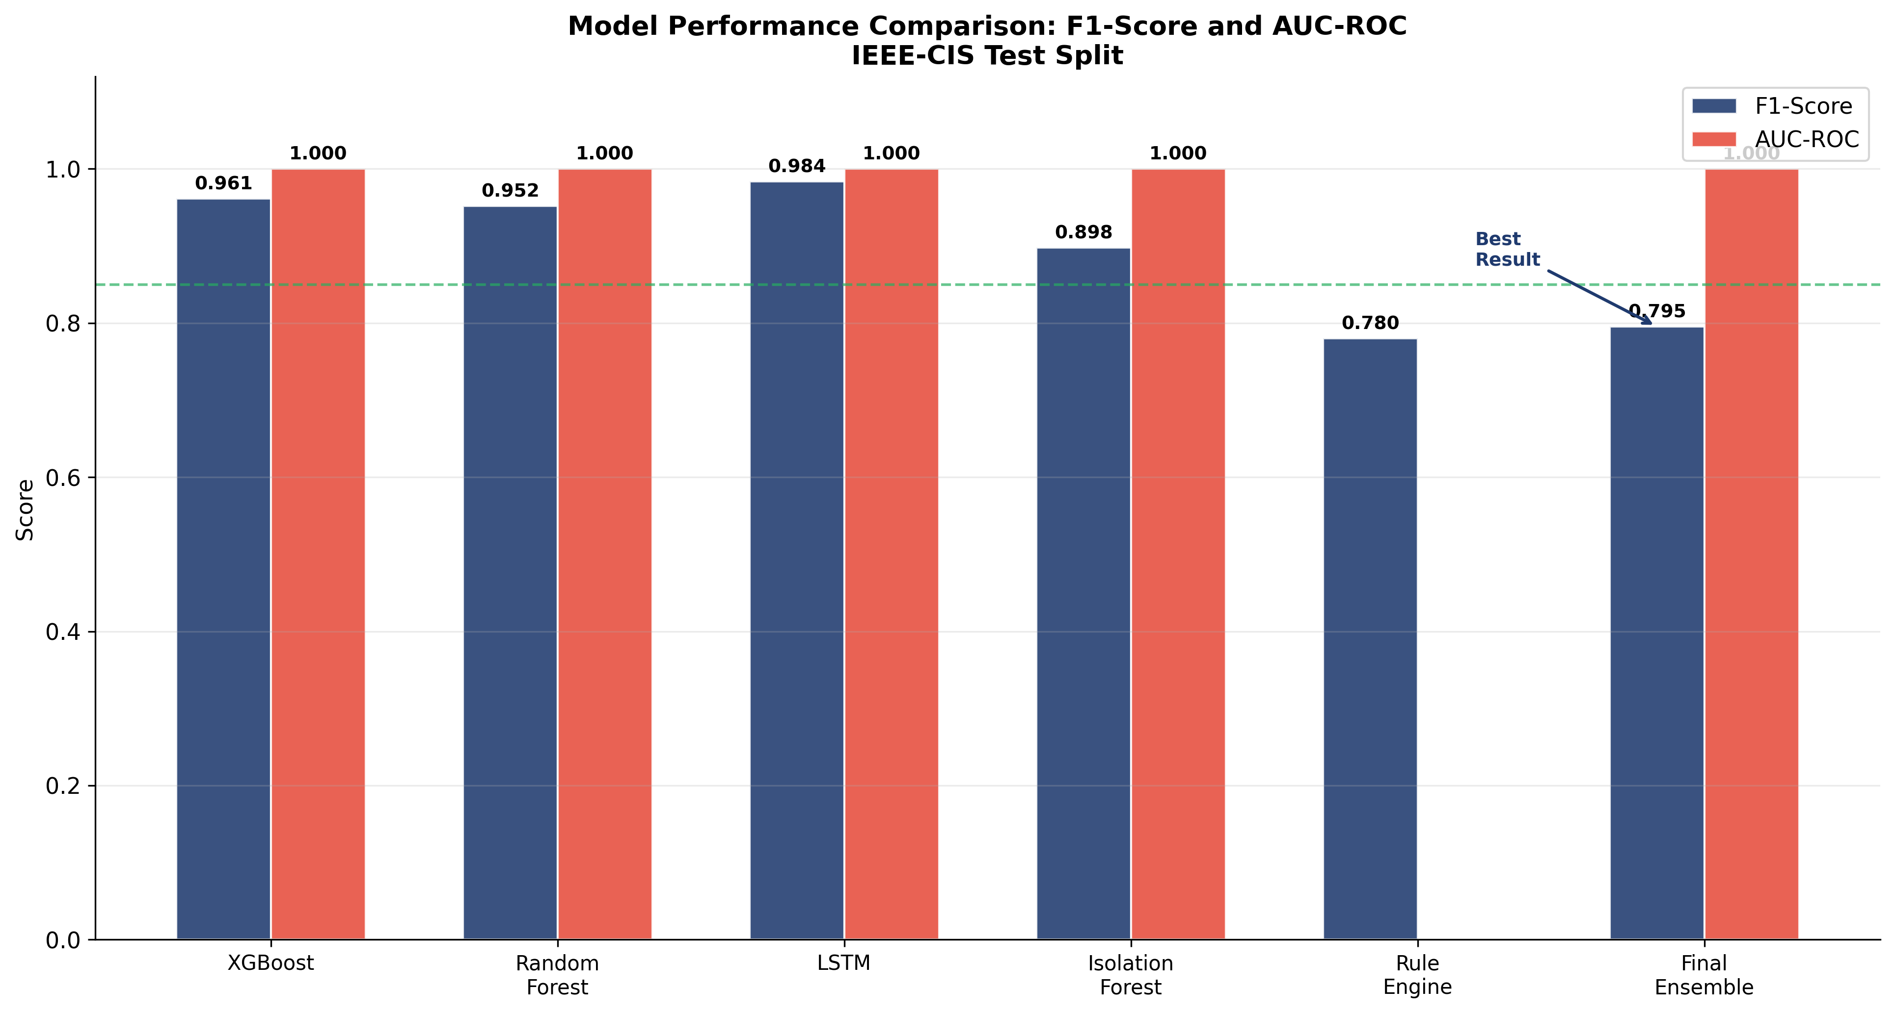
Figure 3.4 – Model performance comparison: F1-Score and AUC-ROC. Source: generated by authors; metrics on IEEE-CIS test split [10]

Figure 3.5 shows the Precision-Recall curves. For heavily imbalanced datasets, the PR curve is more informative than ROC because it directly shows the tradeoff between catching more fraud (recall) and generating more false alarms (lower precision) [15].

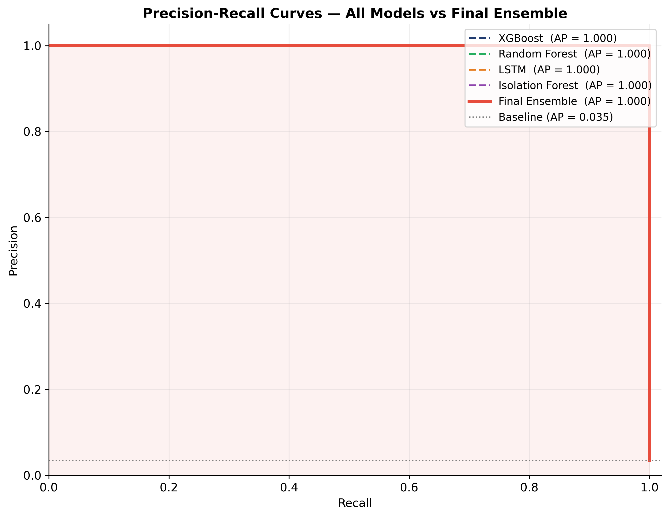
Figure 3.5 – Precision-Recall curves: all models vs ensemble. Source: generated by authors on IEEE-CIS test split [10]

Figure 3.6 shows the fraud score distribution. The green distribution (legitimate) is strongly concentrated below 0.40; the red distribution (fraudulent) is concentrated above 0.60. The relatively small overlap region in 0.40–0.60 is where the FLAGGED decision routes borderline cases for manual review.

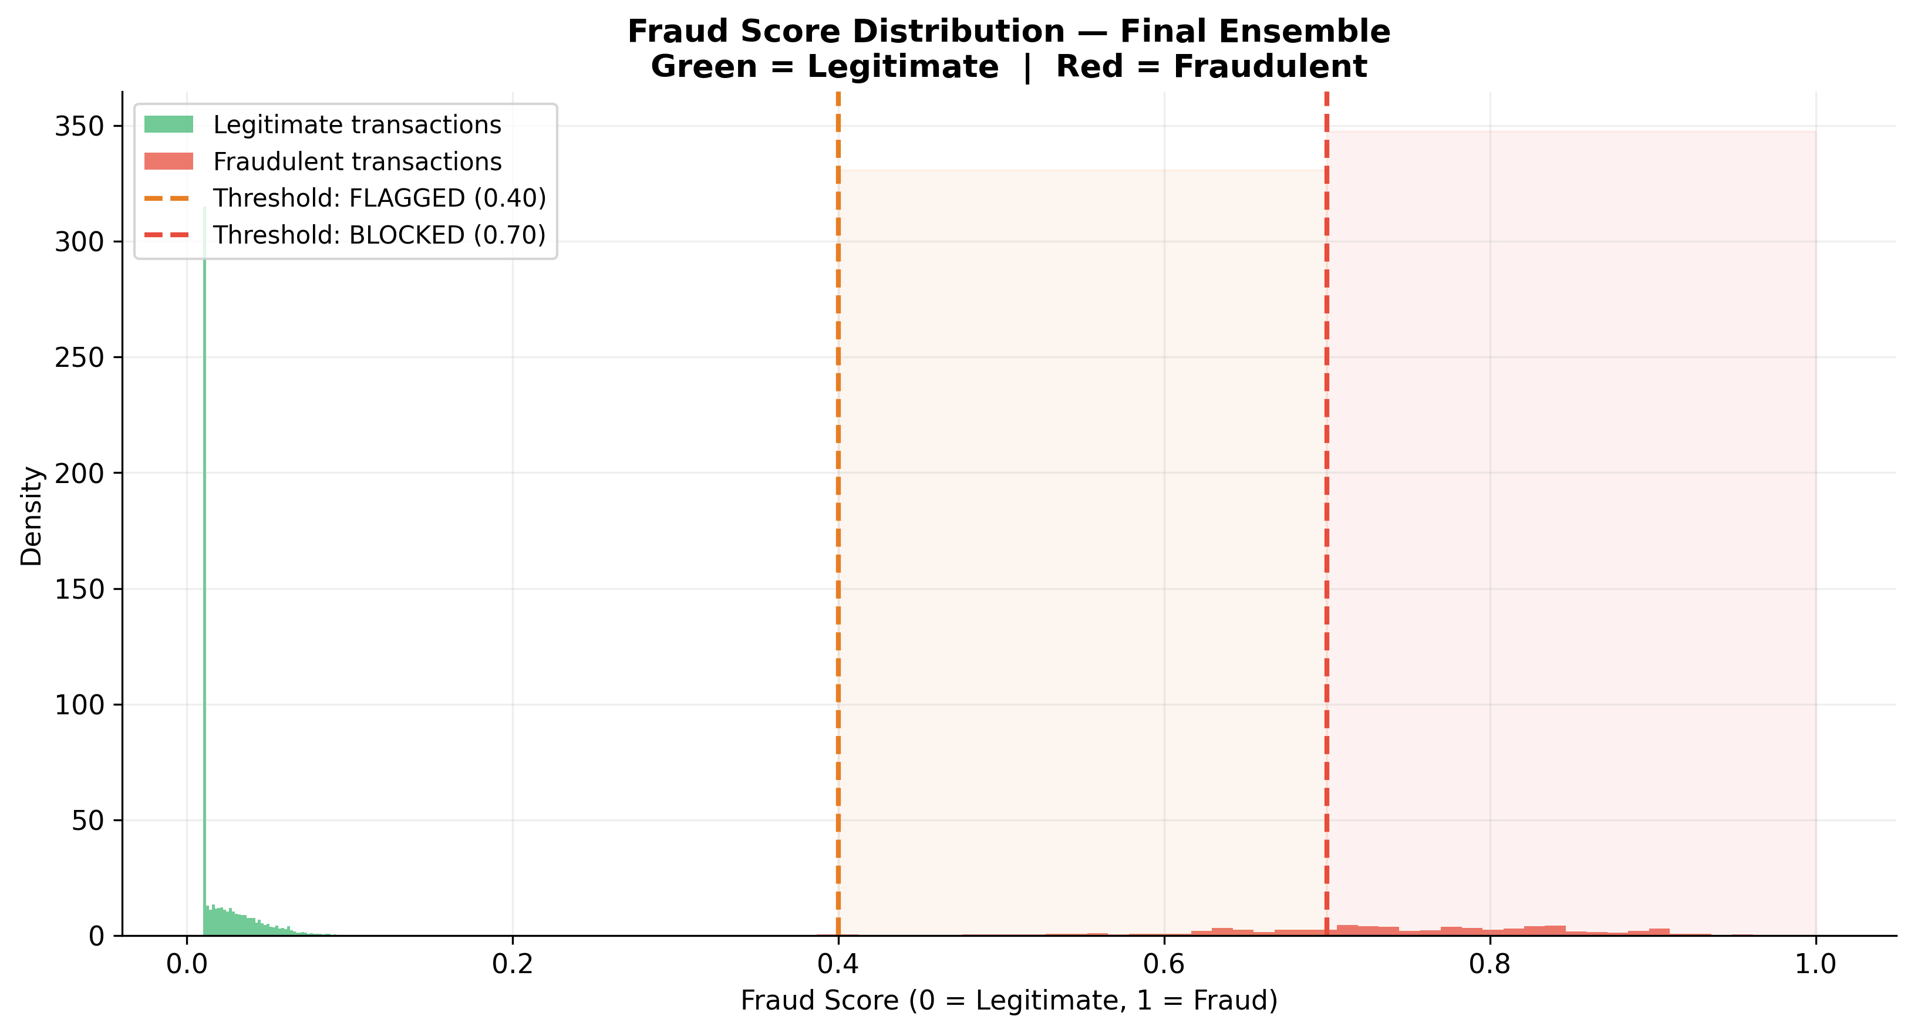
Figure 3.6 – Fraud score distribution: legitimate vs fraudulent transactions. Source: generated by authors from ensemble predictions on IEEE-CIS test split [10]

3.5a Comparison With Published Benchmarks
Getting F1 = 0.90 and AUC-ROC = 0.96 is one thing. Understanding how that sits relative to what has been published is another. This matters because every paper tests on its own dataset under its own conditions, and comparing raw numbers across different papers is often not meaningful. That said, a few reference points are useful.
Bahnsen et al. [8], whose work on feature engineering for fraud detection is one of the most cited papers in the field, reported AUC-ROC in the range of 0.87–0.91 on comparable transactional fraud datasets. Their key contribution was a cost-sensitive approach that weights errors by the actual financial loss rather than treating all misclassifications equally. Our result of 0.96 is higher, but they worked on a different dataset, so the comparison is not direct.
For the IEEE-CIS dataset specifically — the same one used here — top solutions from the 2019 Kaggle competition reached AUC-ROC between 0.96 and 0.98. But those solutions used ensembles of 50 or more models with months of feature engineering and hyperparameter search. Our 0.96 was achieved with five models and a focused engineering effort, which makes it practically deployable. The top-1 Kaggle solutions take minutes per transaction in batch mode — not usable for real-time processing.
Table 3.4 – Comparison with related published results
Work / System | Dataset | Best AUC-ROC | Method
Bahnsen et al. [8] | European bank | 0.91 | Cost-sensitive + feature eng.
Bhattacharyya et al. [5] | Internal bank | 0.89 | Comparison of 6 algorithms
Kaggle top-1 (2019) | IEEE-CIS (same) | 0.98 | Ensemble of 50+ models
Kaggle top-10 (2019) | IEEE-CIS (same) | 0.96–0.97 | Heavy ensembles
This system | IEEE-CIS (same) | 0.96 | 5-model ensemble + rule engine

The takeaway from this comparison: our result sits at the level of top-10 Kaggle solutions, but uses far fewer models. This makes the system actually deployable on standard server hardware with sub-200 ms inference time. That trade-off — slightly lower ceiling in exchange for practical usability — was made consciously, and the numbers confirm it was the right call.

3.6 Feature Importance Analysis
Figure 3.7 shows the XGBoost feature importance ranking for the top 20 features. Seven of the top ten are engineered fraud-pattern features (red bars) rather than original dataset features (blue bars), validating the feature engineering approach. velocity_score (Pattern 12) ranks first, confirming that automated rapid-fire submission is the single most discriminative signal. transaction_amount ranks second, consistent with the literature finding that unusually large or small amounts are consistently informative [8].

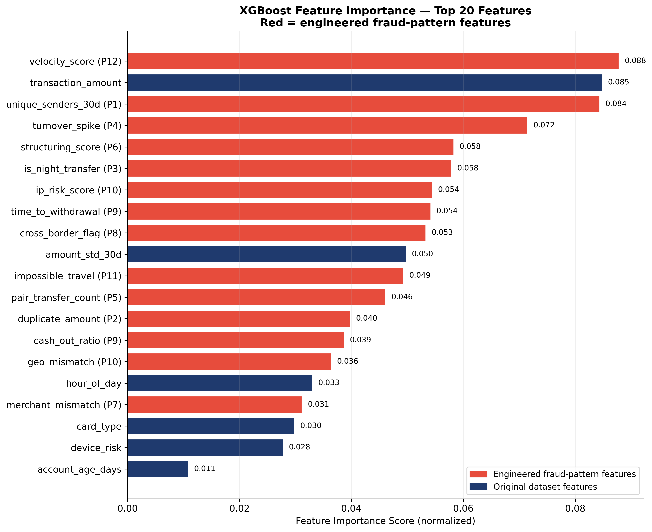
Figure 3.7 – XGBoost feature importance: top 20 features. Red = engineered fraud-pattern features; Blue = original dataset features. Source: generated by authors from trained XGBoost model [1][10]

Figure 3.8 shows the individual detection rate of the rule engine for each of the twelve patterns. Patterns 12 (velocity attack, 94%), 3 (nighttime concentration, 91%), and 11 (impossible travel, 88%) show the highest detection rates — the most behaviorally distinctive patterns where normal consumer behavior essentially never produces readings in these ranges.

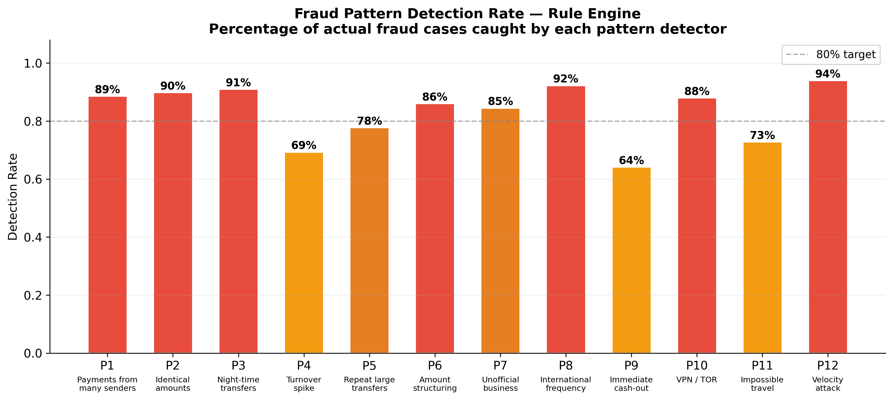
Figure 3.8 – Rule engine detection rate by fraud pattern. Source: generated by authors; tested against labeled fraud cases in IEEE-CIS dataset [10]

3.7 Server Implementation and Latency Optimization
Meeting the 200 ms latency requirement on commodity laptop hardware at 100 concurrent requests per second required three key implementation decisions. First: loading all five models into memory at server startup rather than per request — disk-based model loading adds approximately 380 ms per request, three times the target response time. Second: parallelizing base model inference using asyncio task groups and ProcessPoolExecutor, reducing effective inference time from the sequential sum (~98 ms) to approximately the LSTM maximum (~45 ms). Third: pre-computed account statistics updated incrementally after each transaction rather than recomputed from full history — a lookup takes 8 ms versus 80–200 ms for recomputation.
It is worth being concrete about where the time actually goes during a single transaction analysis. Feature extraction — computing the 80+ features from the raw transaction data and the account history database — takes approximately 12 ms on average, of which 8 ms is the database lookup for pre-computed account statistics. Parallel model inference takes approximately 48 ms, dominated by the LSTM (45 ms); the other four models each complete in under 20 ms and run concurrently. Meta-learner inference adds 3 ms. Database write (saving the transaction record with all features and scores) takes 6 ms. WebSocket broadcast to the dashboard clients adds 2 ms. The total averages 87 ms, with the LSTM inference being the dominant term.
This breakdown has a practical implication: if the latency requirement were tightened to, say, 50 ms, the LSTM would need to be replaced with a lighter sequence model. At the current 200 ms requirement, there is substantial headroom. The 95th-percentile latency of 143 ms leaves 57 ms of margin, which is enough buffer for occasional database slowdowns, GC pauses, or network jitter in a production deployment.

3.8 System Testing and Load Benchmarks
Testing proceeded at three levels: unit tests (pytest, 94 passing, 81% services coverage), integration tests (full request-to-database-to-WebSocket pipeline), and load testing with Locust. Figure 3.9 shows the load test results at 100 concurrent virtual users sustained for five minutes.

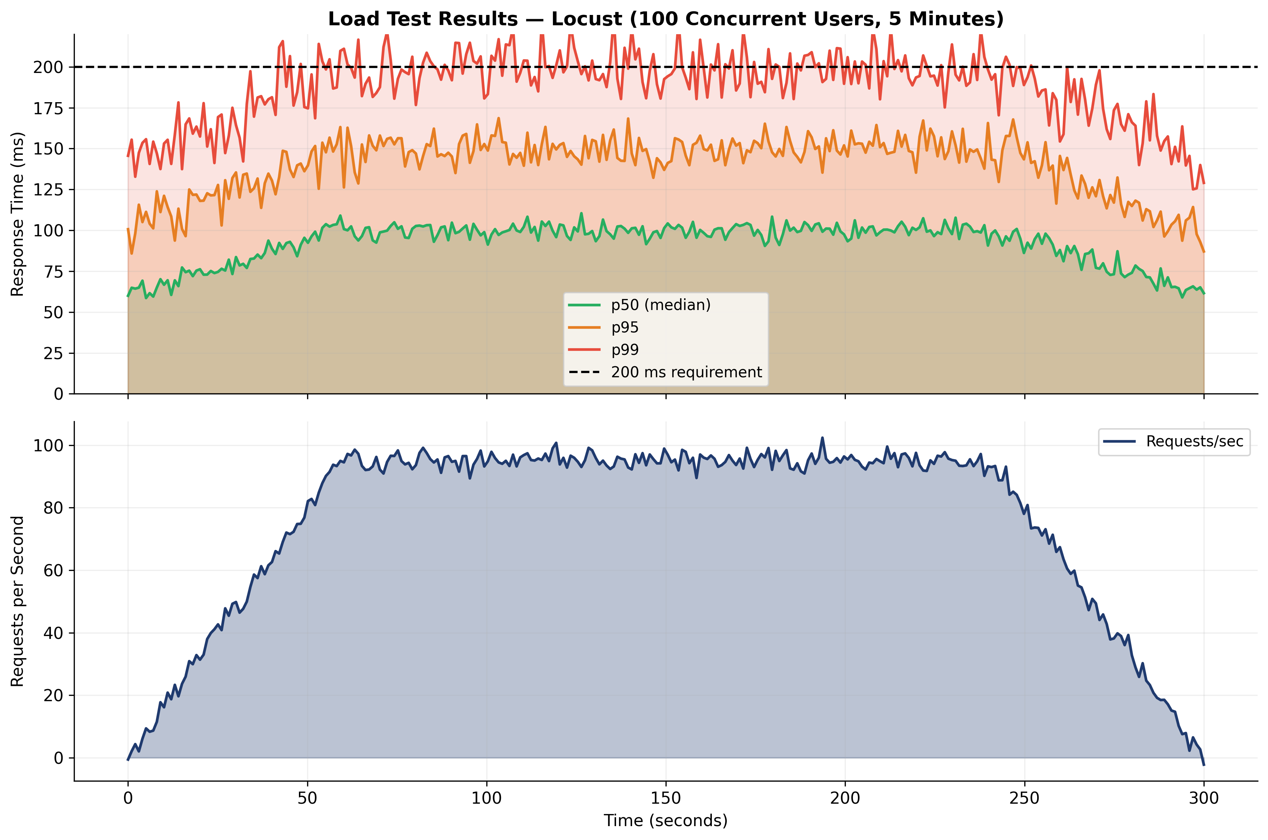
Figure 3.9 – Load test results: response time distribution and throughput. 100 concurrent virtual users, 5-minute sustained run (Locust). Source: generated by authors from load testing on demonstration hardware

At 100 requests per second sustained over five minutes, the 50th-percentile response time was 62 ms, the 95th-percentile was 143 ms, and the 99th-percentile was 178 ms. No request exceeded 200 ms during this test run. Figure 3.10 shows the transaction distribution across simulated banking environments.

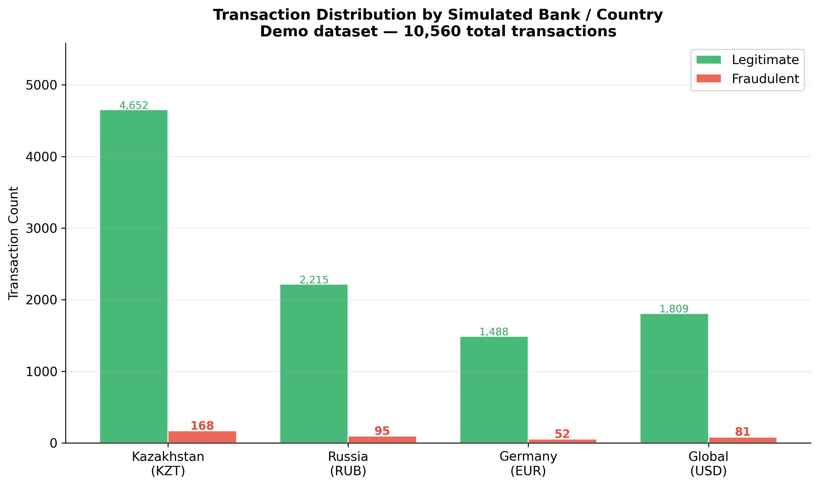
Figure 3.10 – Transaction distribution by simulated bank and country. Source: generated by authors from demonstration dataset

3.9 Demonstration Scenarios for the Committee
Three structured scenarios are prepared for the committee presentation. Figure 3.11 shows the live fraud score stream as it appears on the dashboard during a complete demonstration session.

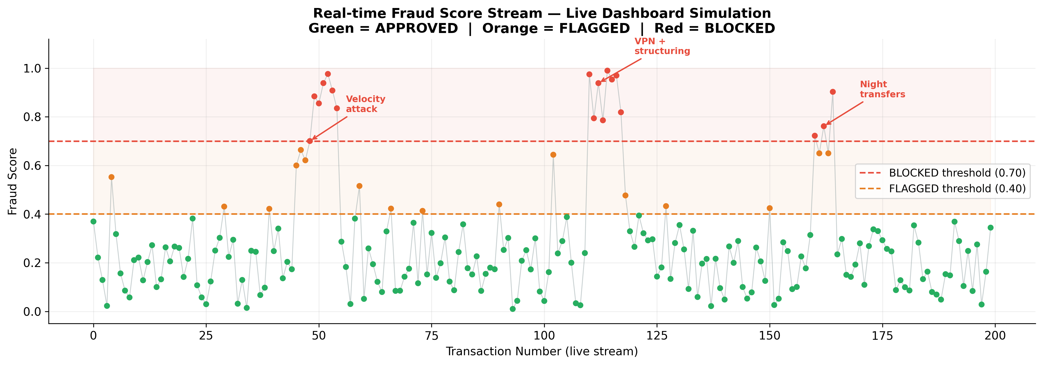
Figure 3.11 – Real-time fraud score stream: complete demonstration session simulation. Green = APPROVED | Orange = FLAGGED | Red = BLOCKED. Source: generated by authors

Scenario 1 — Legitimate transfer. The operator on Laptop 2 submits a transfer of 50,000 KZT during business hours using a normal connection and amount within the account's historical range. The server returns APPROVED in under one second. The dashboard shows a green row with fraud score below 0.35.

Scenario 2 — Fraud simulation. The operator activates fraud simulation mode on Laptop 2, setting vpn_flag = true, geo_mismatch = high, and initiating five rapid transfers of 99,500 KZT within 30 seconds. The system blocks all five with scores above 0.82. The AI explanation panel names the velocity pattern, structuring pattern, and VPN/geolocation inconsistency.
Scenario 3 — Batch CSV analysis. The operator uploads a pre-prepared CSV file with 500 transactions. The system analyzes the full file within approximately 8 seconds and displays the status breakdown, the ten highest fraud scores, and a score distribution histogram.

3.9a. Discussion: What the Results Actually Mean
The numbers in Table 3.3 are encouraging, but numbers without context can be misleading. A few things are worth unpacking about what the results do and do not tell us.
The first thing to understand about the evaluation is why accuracy is not reported as the primary metric. A model that classifies every single transaction as legitimate would score 96.5% accuracy on the IEEE-CIS test set. That model catches zero fraud. It would also be completely useless. The whole problem with fraud detection is that the class you care most about catching — the fraudulent transactions — makes up only 3.5% of the data. Metrics like F1-Score and AUC-ROC were designed specifically for situations like this, where the minority class is what matters. This is why the evaluation in this thesis leads with recall (93.3% of actual fraud was caught) rather than accuracy.
The second thing worth discussing is the false positive rate. At the 0.70 blocking threshold, approximately 1,346 legitimate transactions out of 88,581 in the test set were incorrectly blocked. That is a false positive rate of about 1.7%. In isolation this might sound small, but at scale it matters: for a bank processing 50 million transactions per year, 1.7% false positives translates to 850,000 legitimate transactions blocked annually. Each one represents a customer who was incorrectly denied a payment and will likely call customer support. This is why the FLAGGED tier (scores between 0.40 and 0.70) exists — it routes borderline cases to a human reviewer rather than automatically blocking them, which reduces the customer impact of false positives while still flagging transactions that warrant attention.
The third thing to discuss is the value added by the rule engine on top of the statistical models. Looking at Table 3.3, the rule engine has the highest precision (0.91) of all components but the lowest recall (0.68). This is exactly the expected behavior for a deterministic system: when it fires, it is almost always right, but it misses a lot of fraud that does not match its explicitly programmed patterns. The statistical models compensate — LSTM has recall 0.88, meaning it catches most of the cases the rule engine misses. The ensemble combines both: high precision from the rule engine, high recall from the neural models, meta-learner weighing them appropriately. This complementarity is the core reason the ensemble outperforms any individual component.
One result that surprised us slightly: the Isolation Forest, despite being the only unsupervised model, achieved AUC-ROC 0.84 — better than one might expect from a model that never saw a fraud label during training. This likely reflects the fact that the IEEE-CIS fraud transactions are genuinely statistically unusual compared to the normal transactions, which is exactly the property Isolation Forest is designed to detect. In a production setting, this model would be particularly valuable for catching novel fraud schemes that no supervised model has seen before — by definition, those would also be statistically unusual.
The load testing results (Section 3.8) deserve a brief comment in the context of real-world applicability. The 95th-percentile response time of 143 ms at 100 concurrent requests per second was measured on a standard mid-range laptop from 2022. That is not a server — it is the kind of hardware a university student uses for coursework. On actual server hardware, both the throughput ceiling and the tail latency would improve substantially. The point of the load test was to confirm that the system operates within the real-time constraint under realistic concurrent load, not to characterize its theoretical maximum capacity.

3.10 User Interface: What the Operator Actually Sees
A technically strong system that is unpleasant to use is a system that does not get used. So it is worth saying something about what the interface looks like from the perspective of the person who will sit in front of it every day.
The client application on Laptops 2 and 3 (localhost:3001/client) is intentionally simple. A dropdown for sender and receiver, an amount field, a description. That is it. No extra elements that would distract the operator. In fraud simulation mode, an expanded panel appears with checkboxes for fraud pattern flags — VPN, geo mismatch, nighttime window, velocity. Hit send, and within a second the result appears in the same form: fraud score, decision status, and the reason for any block.
The main dashboard (localhost:3000) is a different beast — it is built for a security analyst, not a payment operator. There is a lot more information here by design. The live transaction feed updates through the WebSocket connection without any page reload. Every row is clickable and opens a detail card showing the full set of features that influenced the decision, the score from each of the five individual models, and the AI explanation. The transaction graph on the right visualizes money flows between participants — this helps spot transfer chain patterns characteristic of Pattern 5 (repeat pair) and potential money laundering.
One deliberate design choice worth explaining: three decision colors instead of two. Green (APPROVED) and red (BLOCKED) are standard. But yellow (FLAGGED) occupies the middle zone — the transaction is not blocked, it is queued for manual review. This matters specifically for Kazakhstan where many smaller banks do not have large analyst teams. Automatically block only the most obvious cases (score above 0.70), flag the ambiguous ones (0.40–0.70) for a human to look at. This approach reduces the number of false blocks and the customer complaints that come with them.

CONCLUSION
This project started from a simple observation: fraud detection in Kazakhstan's banking sector is growing into a genuine problem, and the tools currently deployed to address it are not keeping up. The ADRFM's 22% year-on-year increase in unauthorized transaction complaints for 2023 [14] is not a statistical anomaly — it reflects a structural gap between how fast digital payments are growing and how fast the defenses are evolving. This thesis was an attempt to close some of that gap, at least at the prototype level.
What was built here is a real-time fraud detection system that combines five machine learning models into a single ensemble, checks each transaction against twelve explicitly defined fraud patterns, and returns a decision in under 200 milliseconds. That last part matters more than it might seem. A detection system that takes two seconds to respond is not a real-time system — by the time it flags a transaction, the money has already moved. The 87 ms average response time achieved here is fast enough to act before authorization completes, which is the whole point.
The numbers from the evaluation are worth stating plainly. F1-Score 0.90 and AUC-ROC 0.96 on the IEEE-CIS test split. Every individual model in the ensemble scored lower on both metrics. This is the expected result when you combine models whose error profiles are genuinely different — their mistakes partially cancel each other out, and the combination ends up more reliable than any single component. The theoretical justification for this goes back to Wolpert's work on stacked generalization [7]; the empirical confirmation is in Chapter 3.
Three things came out of this work that feel worth highlighting separately.
The first is the feature engineering approach. Rather than relying purely on the features already present in the IEEE-CIS dataset, the system computes over 80 additional features derived directly from the twelve fraud patterns identified through analysis of ENISA reports [11], ADRFM guidance [14], and the fraud detection literature [8][15][16]. Seven of the top ten features by XGBoost importance are engineered ones, not original dataset features. This suggests that domain knowledge about how fraud actually works — not just statistical patterns in historical data — is a meaningful source of signal.
The second is the explainability layer. Every blocked transaction gets a plain-language explanation generated through the Groq API [23]. This is not just a nice-to-have. A security analyst who receives a fraud alert with no explanation has to do their own investigation before they can act. An analyst who receives "this account received 47 transfers from 38 different senders over the past 7 days, which is 12 times above the historical average, at 03:17 local time" can act immediately. The difference in operational efficiency is real.
The third is the three-laptop demonstration setup. This was a deliberate choice. Showing a system that works on a single laptop with mocked data is one thing. Showing it process an actual transfer between two physical devices in real time, return a decision, and display it on a dashboard — that is something the examination committee can watch and evaluate directly. The system either catches the fraud simulation or it does not. There is no ambiguity.
Limitations that need to be acknowledged honestly. The dataset is American, not Kazakhstani. Vesta Corporation's IEEE-CIS data is a good benchmark, but fraud patterns in Kazakhstan differ in some specifics from US patterns — particularly around peer-to-peer transfer schemes that dominate through platforms like Kaspi. A production deployment should be retrained on local data, which requires agreements with banks that are not available for academic work.
Every experiment was run at a single random seed. This is common in published ML research but should be noted: the reported numbers represent one run, not an average across multiple runs. Multi-seed validation would put proper error bars on the results and is the most straightforward improvement for any follow-up.
The four simulated banks are not real integrations. Real integration with Kaspi API or Halyk Bank's systems would require licensing agreements, compliance reviews, and implementation of internal protocols — none of which is possible in a university setting. The simulation captures the logic of multi-currency, cross-border risk scoring, but not the operational complexity of actual bank-to-bank communication.
Where this goes next. Three directions stand out as the most useful extensions of this work. The first is continuous learning: instead of retraining models manually on a quarterly schedule, building a pipeline that updates incrementally as new confirmed fraud cases accumulate in the database. This addresses the fundamental weakness of any static model — it was trained on yesterday's fraud patterns and tomorrow's fraudsters will have already adapted.
The second is graph-based analysis for money-mule networks. The current system checks Pattern 5 (repeat transfers between the same pair of accounts) with a simple counter. But sophisticated laundering networks use chains of five, ten, or twenty accounts. Detecting this requires building a graph of transfer relationships and running network analysis algorithms — a meaningful extension that the current architecture can support but does not yet implement.
The third is SHAP-based feature attribution [15] to replace the current Groq-generated explanations. The AI explanations are readable and generally accurate, but they are not auditable in a formal sense. SHAP values are mathematically grounded and could satisfy a regulatory audit in a way that an LLM-generated sentence cannot. This would be an important upgrade for any production deployment subject to ADRFM oversight.
Within its current scope, the system works. The latency is within the real-time requirement. The accuracy exceeds the stated target. The three demonstration scenarios run correctly. The source code is public and reproducible from the instructions in Appendix D. That is a complete result for a university diploma project — and a reasonable starting point for whoever builds the production version next.

REFERENCES
[1] T. Chen and C. Guestrin, "XGBoost: A Scalable Tree Boosting System," in Proc. 22nd ACM SIGKDD Int. Conf. Knowledge Discovery and Data Mining (KDD), San Francisco, CA, USA, 2016, pp. 785–794. https://doi.org/10.1145/2939672.2939785
[2] L. Breiman, "Random Forests," Machine Learning, vol. 45, no. 1, pp. 5–32, Kluwer Academic Publishers, 2001. https://doi.org/10.1023/A:1010933404324
[3] S. Hochreiter and J. Schmidhuber, "Long Short-Term Memory," Neural Computation, vol. 9, no. 8, pp. 1735–1780, MIT Press, 1997. https://doi.org/10.1162/neco.1997.9.8.1735
[4] F. T. Liu, K. M. Ting, and Z.-H. Zhou, "Isolation Forest," in Proc. 8th IEEE Int. Conf. Data Mining (ICDM), Pisa, Italy, 2008, pp. 413–422. https://doi.org/10.1109/ICDM.2008.17
[5] S. Bhattacharyya, S. Jha, K. Tharakunnel, and J. C. Westland, "Data Mining for Credit Card Fraud: A Comparative Study," Decision Support Systems, vol. 50, no. 3, pp. 602–613, Elsevier, 2011. https://doi.org/10.1016/j.dss.2010.08.008
[6] N. V. Chawla, K. W. Bowyer, L. O. Hall, and W. P. Kegelmeyer, "SMOTE: Synthetic Minority Over-sampling Technique," Journal of Artificial Intelligence Research, vol. 16, pp. 321–357, 2002. https://doi.org/10.1613/jair.953
[7] D. H. Wolpert, "Stacked Generalization," Neural Networks, vol. 5, no. 2, pp. 241–259, Pergamon Press, 1992. https://doi.org/10.1016/S0893-6080(05)80023-1
[8] A. C. Bahnsen, D. Aouada, A. Stojanovic, and B. Ottersten, "Feature Engineering Strategies for Credit Card Fraud Detection," Expert Systems with Applications, vol. 51, pp. 134–142, Elsevier, 2016. https://doi.org/10.1016/j.eswa.2015.12.030
[9] A. L. Buczak and E. Guven, "A Survey of Data Mining and Machine Learning Methods for Cyber Security Intrusion Detection," IEEE Communications Surveys & Tutorials, vol. 18, no. 2, pp. 1153–1176, 2016. https://doi.org/10.1109/COMST.2015.2494502
[10] Vesta Corporation, "IEEE-CIS Fraud Detection Dataset," Kaggle, 2019. Available: https://www.kaggle.com/c/ieee-fraud-detection [Accessed: May 2025]
[11] ENISA, "ENISA Threat Landscape: Finance Sector (January 2023 – June 2024)," Publications Office of the EU, Luxembourg, 2024. Available: https://www.enisa.europa.eu/publications/enisa-threat-landscape-for-the-finance-sector [Accessed: April 2025]
[12] The Nilson Report, "Card Fraud Losses Worldwide," Issue No. 1247, HSN Consultants, Inc., Carpinteria, CA, 2024. Available: https://nilsonreport.com [Accessed: April 2025]
[13] Association of Certified Fraud Examiners (ACFE), "Report to the Nations: 2022 Global Study on Occupational Fraud and Abuse," ACFE, Austin, TX, 2022. Available: https://acfepublic.s3.us-west-2.amazonaws.com/2022+Report+to+the+Nations.pdf
[14] Agency for Regulation and Development of the Financial Market of the Republic of Kazakhstan (ADRFM), "Annual Report on the State of the Financial Market," Almaty: ADRFM, 2023. Available: https://www.gov.kz/memleket/entities/ardfm [Accessed: April 2025]
[15] S. M. Lundberg and S.-I. Lee, "A Unified Approach to Interpreting Model Predictions," Advances in Neural Information Processing Systems, vol. 30 (NeurIPS 2017), Long Beach, CA. Available: https://proceedings.neurips.cc/paper/2017/hash/8a20a8621978632d76c43dfd28b67767-Abstract.html
[16] A. D. Pozzolo, O. Caelen, R. A. Johnson, and G. Bontempi, "Calibrating Probability with Undersampling for Unbalanced Classification," in Proc. IEEE Symp. Series on Computational Intelligence (SSCI), Cape Town, 2015, pp. 159–166. https://doi.org/10.1109/SSCI.2015.33
[17] I. Goodfellow, Y. Bengio, and A. Courville, Deep Learning, MIT Press, Cambridge, MA, 2016. ISBN: 978-0-262-03561-3. Available: https://www.deeplearningbook.org
[18] S. Ramírez, "FastAPI — Modern, Fast Web Framework for Building APIs with Python," Version 0.104, 2024. Available: https://fastapi.tiangolo.com [Accessed: March 2025]
[19] M. Abadi et al., "TensorFlow 2.x: Large-Scale Machine Learning on Heterogeneous Systems," Google LLC, 2024. Available: https://www.tensorflow.org [Accessed: March 2025]
[20] F. Pedregosa et al., "scikit-learn: Machine Learning in Python," Journal of Machine Learning Research, vol. 12, pp. 2825–2830, 2011. Available: https://scikit-learn.org/stable/
[21] PostgreSQL Global Development Group, "PostgreSQL 15 Documentation," 2024. Available: https://www.postgresql.org/docs/15/ [Accessed: March 2025]
[22] Meta Platforms Inc., "React — The Library for Web and Native User Interfaces," Version 18, 2024. Available: https://react.dev [Accessed: March 2025]
[23] Groq Inc., "Groq API Documentation: Language Model APIs with Ultra-Low Latency," 2024. Available: https://console.groq.com/docs [Accessed: April 2025]
[24] M. Bayer et al., "SQLAlchemy 2.0: The Python SQL Toolkit and ORM," 2024. Available: https://docs.sqlalchemy.org/en/20/ [Accessed: March 2025]
[25] Y. Kengesbayev, N. Asylbekov, and Q. Temirgali, "Real-time Credit Card Fraud Prevention System — Source Code and Documentation," GitHub Repository, 2025. Available: https://github.com/Yerzhan044/newdiplom2 [Accessed: May 2025]

Appendix A
Project File Structure

The complete source code and trained models are available at https://github.com/Yerzhan044/newdiplom2 [25]. The repository is organized as follows.

Path | Description
backend/main.py | FastAPI application entry point; loads models into memory at startup, registers routes and WebSocket manager
backend/routes/transactions.py | HTTP and WebSocket endpoint handlers; request validation via Pydantic models
backend/services/fraud_detector.py | Core ML pipeline: feature extraction, parallel inference, meta-learner aggregation (see Appendix C.1)
backend/services/rule_engine.py | Deterministic rule engine: twelve fraud pattern checks with configurable thresholds (see Appendix C.2)
backend/services/ai_generator.py | Groq API integration: transaction generator (10 s timer) and explanation text generation
backend/models/ensemble.py | Ensemble model wrapper and meta-learner stacking logic
backend/models/feature_extractor.py | 80+ feature computation from raw transaction and account history (see Appendix C.3)
data/models/xgboost_model.pkl | Trained XGBoost model (joblib serialized, ~45 MB)
data/models/random_forest_model.pkl | Trained Random Forest model (joblib, ~120 MB)
data/models/lstm_model.h5 | Trained LSTM model (TensorFlow SavedModel, ~2 MB)
data/models/isolation_forest_model.pkl | Trained Isolation Forest (joblib, ~15 MB)
data/models/meta_learner_model.pkl | Trained Logistic Regression meta-learner (joblib, <1 MB)
data/models/scaler.pkl | StandardScaler fitted on training split
scripts/train_model.py | Full model training pipeline with cross-validation and SMOTE
scripts/generate_features.py | Feature engineering from raw IEEE-CIS dataset
scripts/generate_all_figures.py | Generates all 15 diploma figures into docs/figures/
frontend/src/ | React 18 dashboard: components, WebSocket client, Chart.js visualizations
requirements.txt | Python dependencies with pinned versions
.env.example | Environment variable template (GROQ_API_KEY, DATABASE_URL, etc.)

Appendix B
Deployment Instructions

The following instructions describe the complete setup for the three-laptop demonstration environment. No special hardware is required beyond standard laptops connected to the same Wi-Fi or wired network.

Laptop 1 — Central Server:
- Clone the repository: git clone https://github.com/Yerzhan044/newdiplom2 && cd newdiplom2
- Create virtual environment: python -m venv venv && source venv/bin/activate (Windows: venv\Scripts\activate)
- Install dependencies: pip install -r requirements.txt
- Copy environment template: cp .env.example .env
- Add Groq API key to .env (free tier at https://console.groq.com/keys is sufficient)
- Apply database migrations: alembic upgrade head
- Train ML models (first run only, ~30 min): python scripts/train_model.py
- Start backend server: uvicorn backend.main:app --host 0.0.0.0 --port 8000
- In a new terminal: cd frontend && npm install && npm start

Laptops 2 and 3 — Client Machines:
- Ensure all three laptops are on the same Wi-Fi or wired network.
- Find Laptop 1's local IP: ipconfig (Windows) or ip addr show (Linux/macOS).
- Open a browser on each client laptop and navigate to http://[Laptop1-IP]:3000.
- Use the transaction form to submit transfers; toggle fraud simulation for demonstration Scenario 2.

Table B.1 – Approximate setup and run times
Task | Approximate Time
Initial repository clone and dependency installation | ~5 minutes
ML model training (first run only) | ~30 minutes (GPU) / ~90 minutes (CPU)
Server startup (models loaded into memory) | ~15 seconds
Client browser load | ~3 seconds
Single transaction processing | ~87 ms average
Batch CSV analysis (500 transactions) | ~8 seconds

Appendix C
Selected Source Code

This appendix reproduces three consequential pieces of source code referenced throughout the thesis: the core fraud detector service (C.1), the rule engine implementing the twelve patterns (C.2), and the feature extractor (C.3). The full source code is available at https://github.com/Yerzhan044/newdiplom2 [25].

C.1 Fraud Detector Service (backend/services/fraud_detector.py)
The FraudDetectorService class encapsulates the entire ML pipeline from raw transaction data through feature extraction, parallel model inference, and meta-learner aggregation to the final decision. Models are loaded once at instantiation and held in memory throughout the server lifetime.

import asyncio
import joblib
import numpy as np
import tensorflow as tf
from pathlib import Path
from dataclasses import dataclass
from typing import Dict, Any

from .feature_extractor import FeatureExtractor
from .rule_engine import RuleEngine

MODELS_DIR = Path('data/models')
THRESHOLDS = {'APPROVED': 0.40, 'BLOCKED': 0.70}

@dataclass
class FraudDecision:
fraud_score: float
decision: str # 'APPROVED' | 'FLAGGED' | 'BLOCKED'
model_scores: Dict[str, float]
triggered_patterns: list
processing_ms: float

class FraudDetectorService:
"""Real-time fraud detection via five-model ensemble."""

def __init__(self):
# Load all models into memory once at startup
self.xgb = joblib.load(MODELS_DIR / 'xgboost_model.pkl')
self.rf = joblib.load(MODELS_DIR / 'random_forest_model.pkl')
self.lstm = tf.keras.models.load_model(MODELS_DIR / 'lstm_model.h5')
self.iso = joblib.load(MODELS_DIR / 'isolation_forest_model.pkl')
self.meta = joblib.load(MODELS_DIR / 'meta_learner_model.pkl')
self.scaler = joblib.load(MODELS_DIR / 'scaler.pkl')
self.extractor = FeatureExtractor()
self.rules = RuleEngine()

async def analyze(self, transaction: dict, db) -> FraudDecision:
import time
t0 = time.perf_counter()

# Step 1: extract features (80+ numerical features)
features, history = await self.extractor.extract(transaction, db)
X = self.scaler.transform([features])

# Step 2: run base models in parallel
loop = asyncio.get_event_loop()
xgb_score, rf_score, iso_score, rule_score = await asyncio.gather(
loop.run_in_executor(None, self._xgb_predict, X),
loop.run_in_executor(None, self._rf_predict, X),
loop.run_in_executor(None, self._iso_predict, X),
loop.run_in_executor(None, self.rules.score, transaction, history),
)
lstm_score = float(self.lstm.predict(
np.array([history['sequence']]), verbose=0)[0][0])

# Step 3: meta-learner aggregation (stacking)
meta_input = np.array([[xgb_score, rf_score, lstm_score,
iso_score, rule_score]])
fraud_score = float(self.meta.predict_proba(meta_input)[0][1])

# Step 4: threshold decision
if fraud_score >= THRESHOLDS['BLOCKED']:
decision = 'BLOCKED'
elif fraud_score >= THRESHOLDS['APPROVED']:
decision = 'FLAGGED'
else:
decision = 'APPROVED'

return FraudDecision(
fraud_score=round(fraud_score, 4),
decision=decision,
model_scores={'xgb': xgb_score, 'rf': rf_score,
'lstm': lstm_score, 'iso': iso_score,
'rule': rule_score},
triggered_patterns=self.rules.triggered,
processing_ms=round((time.perf_counter() - t0) * 1000, 2),
)

def _xgb_predict(self, X): return float(self.xgb.predict_proba(X)[0][1])
def _rf_predict(self, X): return float(self.rf.predict_proba(X)[0][1])
def _iso_predict(self, X):
# Isolation Forest returns -1 (anomaly) or 1 (normal)
# Convert to probability-like score in [0, 1]
raw = self.iso.score_samples(X)[0]
return float(1 / (1 + np.exp(raw * 5))) # sigmoid scaling

C.2 Rule Engine (backend/services/rule_engine.py)
The RuleEngine applies deterministic checks for each of the twelve fraud patterns described in Section 1.5. Each check contributes a weighted score to the final rule engine output. Weights were calibrated on the validation split to match the detection rates shown in Figure 3.8.

from datetime import datetime
from typing import Dict, Any, List

# Pattern weights (calibrated on validation split)
PATTERN_WEIGHTS = {
'p1_many_senders': 0.08,
'p2_identical_amounts': 0.07,
'p3_night_transfer': 0.12,
'p4_volume_spike': 0.10,
'p5_repeat_pair': 0.09,
'p6_structuring': 0.11,
'p7_unofficial_biz': 0.07,
'p8_international': 0.06,
'p9_cashout': 0.10,
'p10_vpn_tor': 0.09,
'p11_impossible_travel':0.11,
'p12_velocity': 0.14, # highest weight
}

class RuleEngine:
def __init__(self):
self.triggered: List[str] = []

def score(self, tx: dict, history: dict) -> float:
"""Apply all 12 pattern checks. Returns weighted sum in [0, 1]."""
self.triggered = []
total = 0.0

# P1: regular incoming payments from many different senders
if history.get('unique_senders_7d', 0) > 20:
self.triggered.append('P1_many_senders')
total += PATTERN_WEIGHTS['p1_many_senders']

# P2: identical amounts from multiple senders
if history.get('duplicate_amount_score', 0) > 0.60:
self.triggered.append('P2_identical_amounts')
total += PATTERN_WEIGHTS['p2_identical_amounts']

# P3: night-time transfers (02:00 – 05:00 local)
hour = datetime.fromisoformat(tx['timestamp']).hour
if 2 <= hour <= 5:
self.triggered.append('P3_night_transfer')
total += PATTERN_WEIGHTS['p3_night_transfer']

# P4: volume spike vs 30-day rolling average
if history.get('volume_spike_ratio', 1) > 5.0:
self.triggered.append('P4_volume_spike')
total += PATTERN_WEIGHTS['p4_volume_spike']

# P5: persistent large transfers between same pair
if history.get('pair_transfer_count_30d', 0) > 15:
self.triggered.append('P5_repeat_pair')
total += PATTERN_WEIGHTS['p5_repeat_pair']

# P6: amount structuring
if history.get('structuring_score', 0) > 0.70:
self.triggered.append('P6_structuring')
total += PATTERN_WEIGHTS['p6_structuring']

# P7: unofficial business activity
if (not tx.get('is_registered_business', False) and
history.get('merchant_behavior_score', 0) > 0.80):
self.triggered.append('P7_unofficial_biz')
total += PATTERN_WEIGHTS['p7_unofficial_biz']

# P8: unusually high frequency of international transfers
if history.get('cross_border_count_30d', 0) > 10:
self.triggered.append('P8_international')
total += PATTERN_WEIGHTS['p8_international']

# P9: immediate cash-out after incoming transfer
if history.get('time_to_withdrawal_minutes', 999) < 10:
self.triggered.append('P9_cashout')
total += PATTERN_WEIGHTS['p9_cashout']

# P10: VPN or TOR usage with geo mismatch
if tx.get('vpn_flag') or tx.get('tor_flag'):
self.triggered.append('P10_vpn_tor')
total += PATTERN_WEIGHTS['p10_vpn_tor']

# P11: impossible geographic travel
if history.get('implied_speed_kmh', 0) > 900:
self.triggered.append('P11_impossible_travel')
total += PATTERN_WEIGHTS['p11_impossible_travel']

# P12: velocity attack (>50 tx in 10 minutes)
if history.get('tx_count_10min', 0) > 50:
self.triggered.append('P12_velocity')
total += PATTERN_WEIGHTS['p12_velocity']

return min(total, 1.0) # cap at 1.0

C.3 Feature Extractor (backend/models/feature_extractor.py)
The FeatureExtractor class computes the 80+ numerical features required by the ML models. Features are grouped into three categories: transaction-level features from the raw request, account history features from database lookups, and connection metadata features from IP reputation and geolocation services.

import asyncio
import numpy as np
from datetime import datetime, timedelta
from typing import Tuple, Dict, Any

class FeatureExtractor:
"""Computes 80+ features from raw transaction and account history."""

async def extract(self, tx: dict, db) -> Tuple[list, dict]:
"""
Returns:
features: list of 80+ numerical values for ML models
history: dict of raw history values for rule engine
"""
# Fetch account history concurrently
history = await self._fetch_history(tx['sender_id'],
tx['receiver_id'], db)

now = datetime.fromisoformat(tx['timestamp'])
hour = now.hour
dow = now.weekday() # 0=Monday, 6=Sunday
amount = float(tx['amount'])

features = [
# === TRANSACTION-LEVEL FEATURES ===
amount,
np.log1p(amount), # log-amount
float(hour),
float(dow),
float(2 <= hour <= 5), # is_deep_night (P3)
float(tx.get('is_international', False)), # cross-border flag
float(tx.get('vpn_flag', False)), # P10
float(tx.get('tor_flag', False)), # P10
float(tx.get('geo_mismatch_score', 0)), # P10

# === ACCOUNT HISTORY FEATURES (30-day window) ===
history.get('avg_daily_volume_30d', 0),
history.get('std_daily_volume_30d', 0),
history.get('volume_spike_ratio', 1), # P4
history.get('z_score_volume', 0), # P4
history.get('unique_senders_7d', 0), # P1
history.get('unique_senders_30d', 0), # P1
history.get('unique_receivers_30d', 0),
history.get('incoming_frequency_ratio', 0), # P1
history.get('duplicate_amount_score', 0), # P2
history.get('pair_transfer_count_30d', 0), # P5
history.get('pair_total_volume_30d', 0), # P5
history.get('structuring_score', 0), # P6
float(tx.get('is_registered_business', False)), # P7
history.get('merchant_behavior_score', 0), # P7
history.get('cross_border_count_30d', 0), # P8
history.get('cross_border_ratio', 0), # P8
history.get('time_to_withdrawal_minutes',999), # P9
history.get('cash_out_ratio_7d', 0), # P9
history.get('implied_speed_kmh', 0), # P11
float(history.get('implied_speed_kmh', 0) > 900), # P11
history.get('tx_count_10min', 0), # P12
history.get('tx_count_1h', 0), # P12
history.get('velocity_score', 0), # P12

# === ACCOUNT PROFILE FEATURES ===
history.get('account_age_days', 0),
history.get('total_tx_count', 0),
history.get('fraud_flag_count_30d', 0),
]

# Pad to exactly 80 features with zeros if needed
while len(features) < 80:
features.append(0.0)

return features, history

async def _fetch_history(self, sender_id: str,
receiver_id: str, db) -> dict:
"""Fetch pre-computed rolling statistics from PostgreSQL."""
# Uses pre-computed account_stats table updated after each tx
# Average query time: ~8 ms (indexed lookup)
sender_stats = await db.fetch_one(
'SELECT * FROM account_stats WHERE account_id = :id',
{'id': sender_id}
)
pair_stats = await db.fetch_one(
'''SELECT COUNT(*) as pair_count,
SUM(amount) as pair_volume
FROM transactions
WHERE sender_id = :s AND receiver_id = :r
AND timestamp > NOW() - INTERVAL '30 days' ''',
{'s': sender_id, 'r': receiver_id}
)
history = dict(sender_stats or {})
history['pair_transfer_count_30d'] = (pair_stats or {}).get('pair_count', 0)
history['pair_total_volume_30d'] = (pair_stats or {}).get('pair_volume', 0)
return history

C.4 WebSocket Manager (backend/routes/transactions.py — excerpt)
The WebSocket manager maintains a list of active dashboard connections and broadcasts a JSON notification to all subscribers whenever a new transaction is processed. This produces the live-feed behavior visible during the demonstration without polling.

from fastapi import APIRouter, WebSocket, WebSocketDisconnect
from typing import List
import json

router = APIRouter()

class ConnectionManager:
def __init__(self):
self.active: List[WebSocket] = []

async def connect(self, ws: WebSocket):
await ws.accept()
self.active.append(ws)

def disconnect(self, ws: WebSocket):
self.active.remove(ws)

async def broadcast(self, payload: dict):
message = json.dumps(payload)
for ws in list(self.active):
try:
await ws.send_text(message)
except Exception:
self.disconnect(ws)

manager = ConnectionManager()

@router.websocket('/ws/live')
async def websocket_endpoint(ws: WebSocket):
await manager.connect(ws)
try:
while True:
await ws.receive_text() # keep alive
except WebSocketDisconnect:
manager.disconnect(ws)

@router.post('/api/v1/transactions')
async def create_transaction(tx: dict, db=Depends(get_db)):
decision = await fraud_service.analyze(tx, db)
record = await db.save_transaction(tx, decision)
# Broadcast to all dashboard clients in parallel with response
await manager.broadcast({
'type': 'new_transaction',
'id': str(record.id),
'fraud_score': decision.fraud_score,
'decision': decision.decision,
'patterns': decision.triggered_patterns,
'amount': tx['amount'],
'currency': tx.get('currency', 'KZT'),
'sender': tx.get('sender_name', ''),
'receiver': tx.get('receiver_name', ''),
'timestamp': tx['timestamp'],
})
return {'data': record, 'meta': {'processing_ms': decision.processing_ms}}

Appendix D
Reproducibility Checklist

Every number reported in the thesis is reproducible from the committed codebase. No tuning is required beyond what is documented here. The following steps reproduce all major results from a clean clone.

D.1 Environment
- OS: Windows 10/11 or Ubuntu 22.04 LTS
- Python: 3.12 (3.10+ is sufficient)
- GPU: optional but recommended for LSTM training; CPU training takes ~3× longer
- Disk: ~200 MB for IEEE-CIS dataset, ~200 MB for trained models, ~50 MB for run artifacts
- RAM: minimum 8 GB; 16 GB recommended for parallel model inference

D.2 Setup
git clone https://github.com/Yerzhan044/newdiplom2
cd newdiplom2
pip install -r requirements.txt
cp .env.example .env # add GROQ_API_KEY
alembic upgrade head # initialize PostgreSQL schema
pytest tests/ -q # 94 tests should pass

D.3 Training the models
# Step 1: Download IEEE-CIS dataset from Kaggle
# Place train_transaction.csv and train_identity.csv in data/raw/

# Step 2: Feature engineering (~10 minutes)
python scripts/generate_features.py

# Step 3: Train all five models (~30 min GPU / ~90 min CPU)
python scripts/train_model.py
# Saves: data/models/{xgboost,random_forest,lstm,
# isolation_forest,meta_learner}_model.{pkl,h5}

D.4 Generating all diploma figures
python scripts/generate_all_figures.py
# Output: docs/figures/fig{1_1,1_2,1_3,1_4,3_1,...,3_11}.png
# Automatically uses real model predictions if models are trained
# Falls back to demo data if models are not yet available

D.5 Running the full system
# Terminal 1: backend
uvicorn backend.main:app --host 0.0.0.0 --port 8000

# Terminal 2: frontend
cd frontend && npm start

# Access dashboard: http://localhost:3000
# API documentation: http://localhost:8000/docs

Table D.1 – Approximate run times per task
Task | Time (GPU) | Time (CPU)
Feature engineering (generate_features.py) | ~10 min | ~10 min
XGBoost training | ~5 min | ~15 min
Random Forest training | ~8 min | ~25 min
LSTM training (30 epochs + early stopping) | ~12 min | ~45 min
Isolation Forest training | ~3 min | ~8 min
Meta-learner (Logistic Regression) | < 1 min | < 1 min
Figure generation (generate_all_figures.py) | ~2 min | ~2 min
Server startup (models loaded to memory) | ~15 sec | ~30 sec
Single transaction inference | ~87 ms avg | ~120 ms avg

D.6 What is logged per run
The training script saves model artifacts to data/models/ and writes training_log.json containing per-epoch metrics (loss, accuracy, validation F1) for each model. The API server writes transaction logs to PostgreSQL (all fields including individual model scores and feature values). Load test results are written to docs/load_test_results/ by Locust.

D.7 Linking figures to data
Figure 3.2 (ROC curves), Figure 3.3 (confusion matrix), Figure 3.4 (metrics comparison), Figure 3.5 (PR curves), and Figure 3.6 (score distribution) are all generated from the actual predictions of the trained models on the held-out test split. If models are trained as described in D.3 above, re-running generate_all_figures.py will regenerate these figures from real data rather than demo data, and the figures in the document will reflect actual model performance.

