

**Property_Management_Application_using_Salesforce**

1. **INTRODUCTION** 
   1. Overview

Salesforce, already the world leader in CRM technology, has long been used as a superior real estate management system, making CRM for real estate a reality.

* 1. Purpose

Property managers assist owners in creating budgets, advertise rental properties, qualify tenants, and collect rent. They also comply with the local landlord and real estate board laws and maintain the property.

1. **Problem Definition & Design Thinking** 
   1. Empathy Map

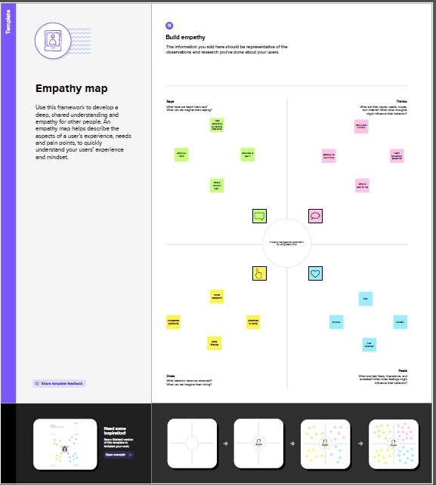

* 1. Ideation & Brainstorming Map

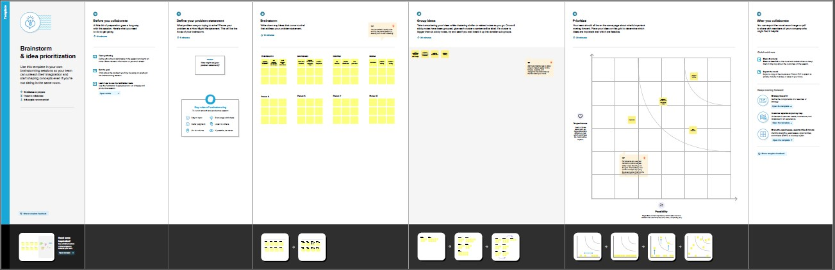

1. **RESULT** 
   1. Data Model:

|  |  |  |
| --- | --- | --- |
| **Object name** | **Fields in the Object** | |
| Obj | Field label | Data type |
| Buy | Buy | Autonumber,place,email,phone |
| Rent | Rent | Autonumber,place,email,phone |
| Loan | loans | Autonumber,place,email,phone |

* 1. Activity & Screenshot

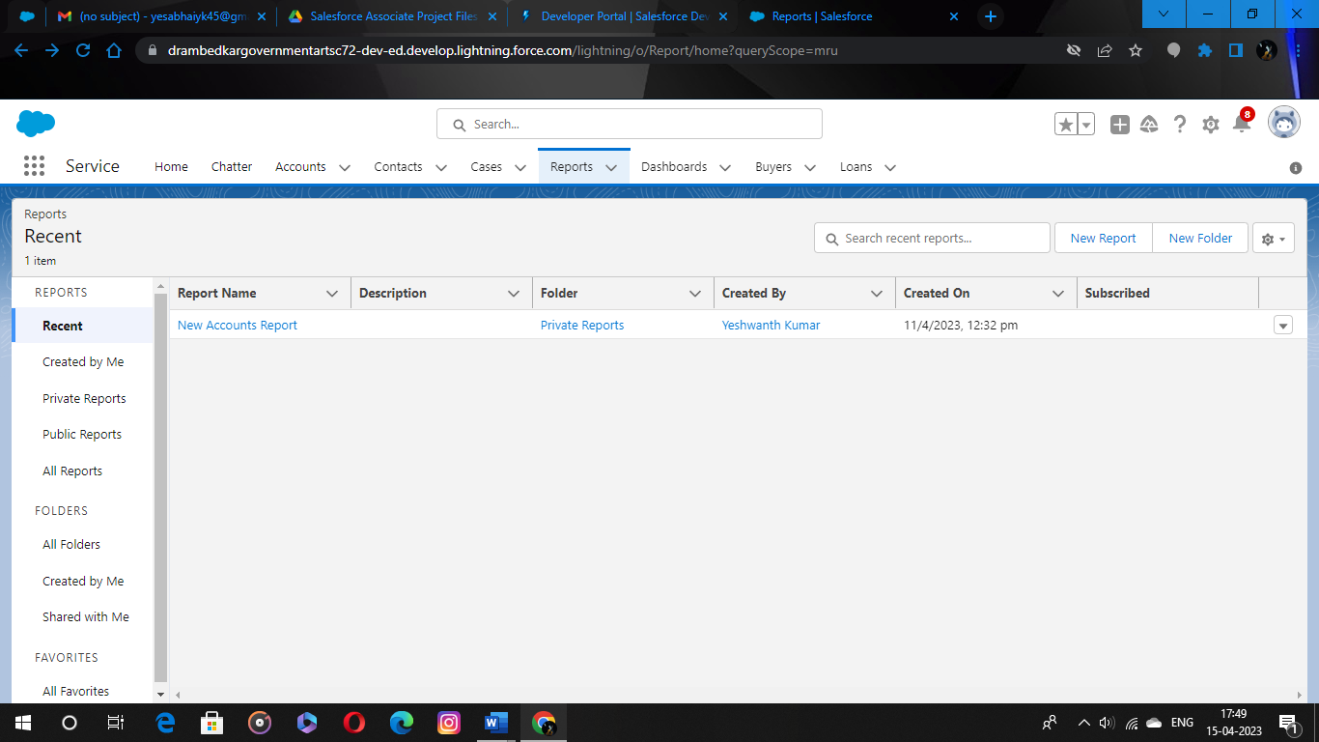

Develop an App for the Property Management where Buyer can order his Requirements and get the Appropriate Details of the Property. According to his interest just provide him with some discounts up to what extent he can get the discount. Also Track Whether he is Interested in taking the loan available for so just calculate how much loan Amount user can get it. Provide the Security for two different profiles like for marketing and sales team. Then Finally Create the reports and dashboard so there will be clear view just get the reports on the count of loan passed getting the property purchased close the deal

1. **Trailhead Profile Public URL**

**Team Lead - https://trailblazer.me/id/yesa12**

**Team Member 1 - https://trailblazer.me/id/matheashjay**

**Team Member 2 - https://trailblazer.me/id/deenaneymar**

**Team Member 3 - https://trailblazer.me/id/deepan007**

1. **ADVANTAGES & DISADVANTAGE**

* Leverage real-time reports and dashboards.
* Streamline lead, opportunity, and contact management.
* Simplify document management and data sharing.
* Enhance communication and collaboration tools.

1. **APPLICATIONS**
2. A property management system (PMS) is a software application for the operations of hospitality accommodations and commercial residential rental properties. PMS is also used in manufacturing industries, local government and manufacturing.
3. **CONCLUSION**

Property Management is the supervision for residential, Commercial & Industrial Including Apartment. It Involves administering property owned by another party. And keeping all the Information Regarding Properties and help customers to get property as per there requirement

1. **FUTURE SCOPE**

Modern software offers a variety of features to help manage every aspect of business

* Rent collection
* Accounting Maintenance management
* Tenant portal and communications
* Owner portal
* Marketing