Food Scanner App -Developer Guide
A web application for uploading or capturing food images, running object detection (via a custom-trained YOLO model running locally) with a self-made dataset with multiple food images, and visualizing detected food items with bounding boxes and interactive HTML labels. The app also features Gemini AI-powered suggestions for detected food items, making it a comprehensive and extensible platform for food recognition and recommendations.

Table of Contents
- Features
- Project Structure
- Setup & Installation
- Environment Variables & API Keys
- Usage
- How It Works
- Key Code Highlights
- Key Libraries Used
- Customization
- Troubleshooting

Features
- Upload or capture food images via webcam, drag-and-drop, or clipboard paste.
- Images are processed locally using your custom-trained YOLO model (no Hugging Face or external inference).
- Detected food items are shown with bounding boxes and interactive HTML labels, each with a colored dot and pointer.
- Gemini AI suggestions: For each meal/photo, Gemini AI suggestions (such as nutritional information, recipes, or related facts) are automatically generated and displayed in the output page.
- Responsive, user-friendly UI.

Project Structure
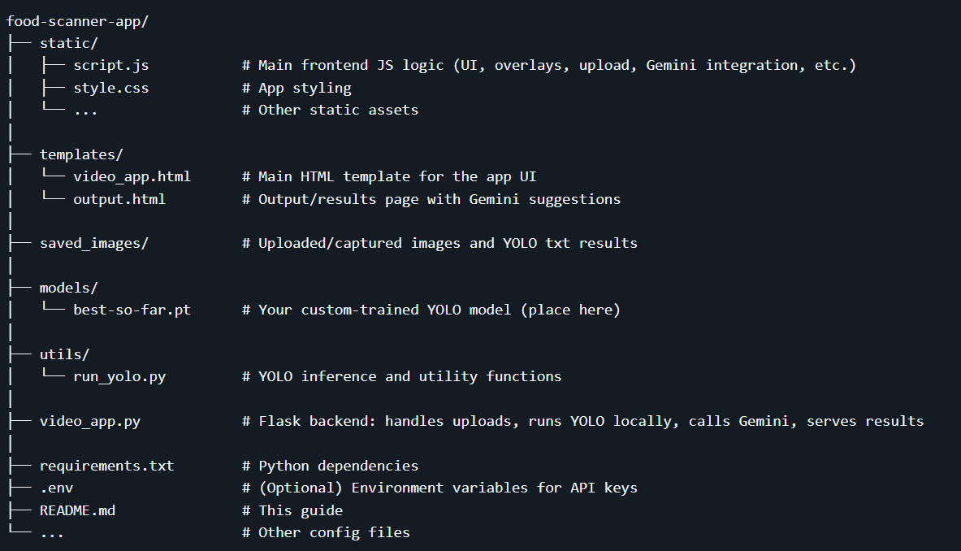

Setup & Installation

1. Fork & Clone the Repository
Fork repository from https://github.com/charan-the-dev/food-scanner
git clone https://github.com/yourusername/food-scanner.git
cd food-scanner

2. Install Python Dependencies
It’s recommended to use a virtual environment:
python -m venv .venv
.venv\Scripts\activate # On Windows
pip install -r requirements.txt

3. Place Your YOLO Model
Download custom-trained YOLO model file (e.g., food_recognition_model_v2.pt) from the drive
into the models/ directory.

Environment Variables & API Keys
To keep your API keys secure, use a .env file in your project root.
This file is not committed to version control.

Sample .env file
# .env
GEMINI_API_KEY=your_gemini_api_key_here
How to use: - Add your Gemini API key and endpoint as shown above. - In your video_app.py, load these variables using python-dotenv or os.environ:
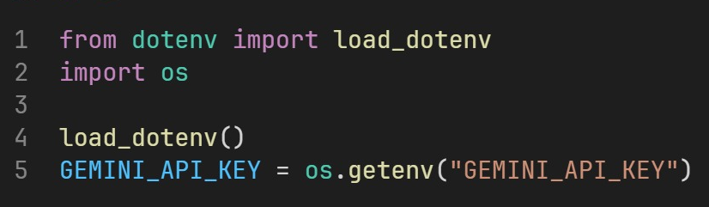

Usage
- Start the backend as above.
- Open your browser to http://localhost:5000.
- Upload an image via drag-and-drop, file picker, webcam capture, or clipboard paste.
- Wait for inference: The image is processed locally by your YOLO model, and results are displayed with bounding boxes and interactive labels.
- Review results: Each detected food item is labeled outside the image, with a colored dot and pointer line to the bounding box center.
- Gemini AI suggestions: For each meal/photo, Gemini AI suggestions are automatically generated and displayed in the output page, providing insights such as nutrition facts, recipes, or related information for the detected items.

How It Works
- Frontend (HTML/JS):
  - Handles image input (upload, webcam, paste).
  - Displays preview and sends image to backend.
  - Receives detection results and draws bounding boxes, colored dots, and HTML labels using <canvas>, <svg>, and absolutely positioned <div>s.
  - Gemini AI suggestions are displayed directly in the output page for the entire meal/photo, not per-item click.
- Backend (Flask/Python):
  - Receives image uploads.
  - Loads and runs the YOLO model locally using Ultralytics (from models/food_recognition_model_v2.pt(change in run_in_yolo.py)).
  - Parses detection results (bounding boxes, classes).
  - Calls Gemini AI API with the detected food items to generate suggestions for the meal/photo.
  - Renders the output page (output.html) with both detection results and Gemini suggestions.
- Visualization:
  - Each detected item is shown with:
    - A bounding box (canvas overlay).
    - A colored dot at the center (HTML element).
    - A pointer line from the dot to a label outside the image (SVG/canvas/HTML).
    - The label is styled and color-matched to the dot.
  - Gemini AI suggestions are shown in a dedicated section of the output page.

Key Code Highlights

1. Local YOLO Inference (utils/run_yolo.py)
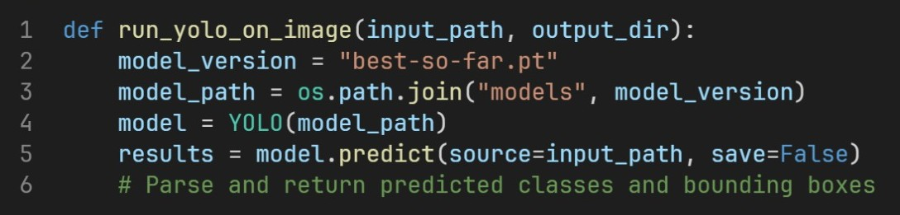

2. Gemini AI Suggestions Integration (video_app.py and output.html)
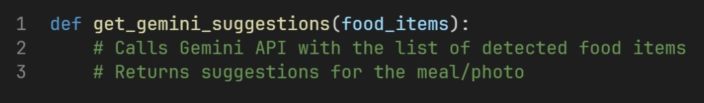
- Suggestions are rendered directly in output.html for the entire meal/photo.

3. Drawing Interactive Labels (static/script.js)
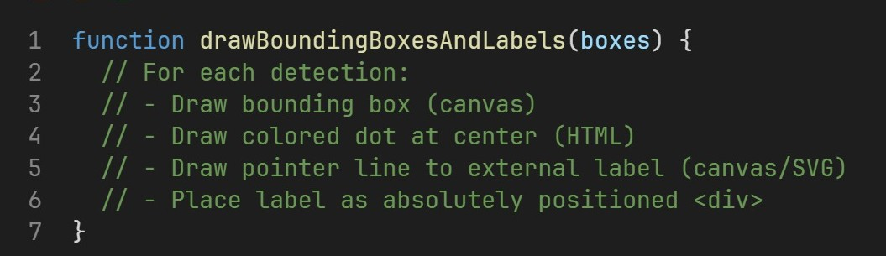

Key Libraries Used
Some of the most important libraries (see requirements.txt):
- Flask: Web framework for serving the app and handling requests.
- Ultralytics: For running YOLO model inference locally.
- google-generativeai: For using gemini vision model through API.
- opencv-python (cv2): For image processing and manipulation.
- python-dotenv: For loading environment variables from .env files.
- requests: For making HTTP requests (e.g., to Gemini API).
- Pillow: For image file handling.

Customization
- Change Model:
Replace the YOLO model file in the models/ directory with your own.
- Adjust Label Styles:
Edit the label and dot styles in static/script.js or style.css.
- Extend Gemini AI Suggestions:
Modify the backend/frontend to provide more detailed or different types of suggestions.

Troubleshooting
- Network Errors:
Ensure the backend is running and accessible at the correct address.
- No Detections:
Check your YOLO model and the parsing logic in run_yolo.py.
- Gemini AI Not Responding:
Verify your Gemini API credentials and endpoint configuration.
- UI Issues:
Make sure all static files are loaded and there are no JS errors in the browser console.

