COMP 2350

Lab Report:

More Database Lab Report

By Yeseol (Sol) Kim

Submitted to: Patrick Guichon

Introduction:

In this lab, there were 4 parts:

Screenshot #1:

First drawing show many to many relationships. One person may or may not get multiple skills also One skill may or may not is gotten multiple people. Many to many cases need middle table that connect two different tables. Second drawing is self-referential (unary) relationship follows all of the same rules as the relationships created between two tables. They can be one-to-one, one-to-many or many-to-many. The same unique constraints still apply and will dictate the type of relationship made.

Filename: 01_ERD_with_Many_to_Many_Relationship.png

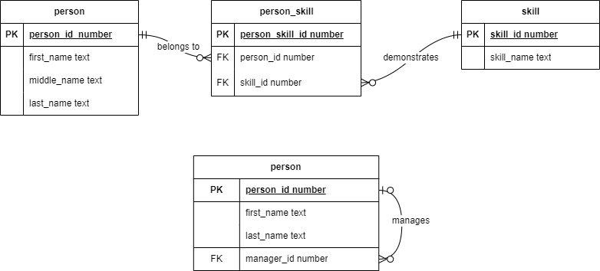

Screenshot #2:

Filename: 02_ERD_with_Many_to_Many_Relationship .vsdx



Screenshot #3:

In MySQL, we can make table and set up range of each column. For example, if you want to make in 0 to 100 grades.

ALTER TABLE grade //set up with this table

ADD CONSTRAINT check grade CHECK (grade >= 0 AND grade <= 100); //grade should between 0 to 100.

Then you can’t add data over 100.

Filename: 03_grade_constraint_failed.jpg

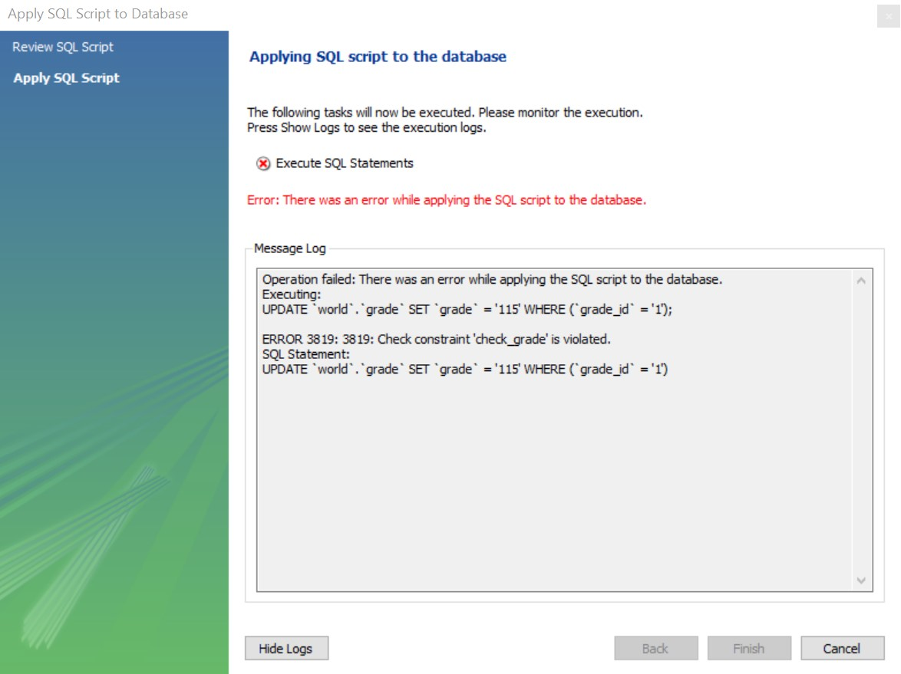

Screenshot #4:

Also connected with screenshot #3, It can set up time line too. Death date is supposed to after birth date. The command is below:

ADD CONSTRAINT CK_Valid_Dates CHECK (birth_date <= death_date);

Filename: 04_invalid_dates.jpg

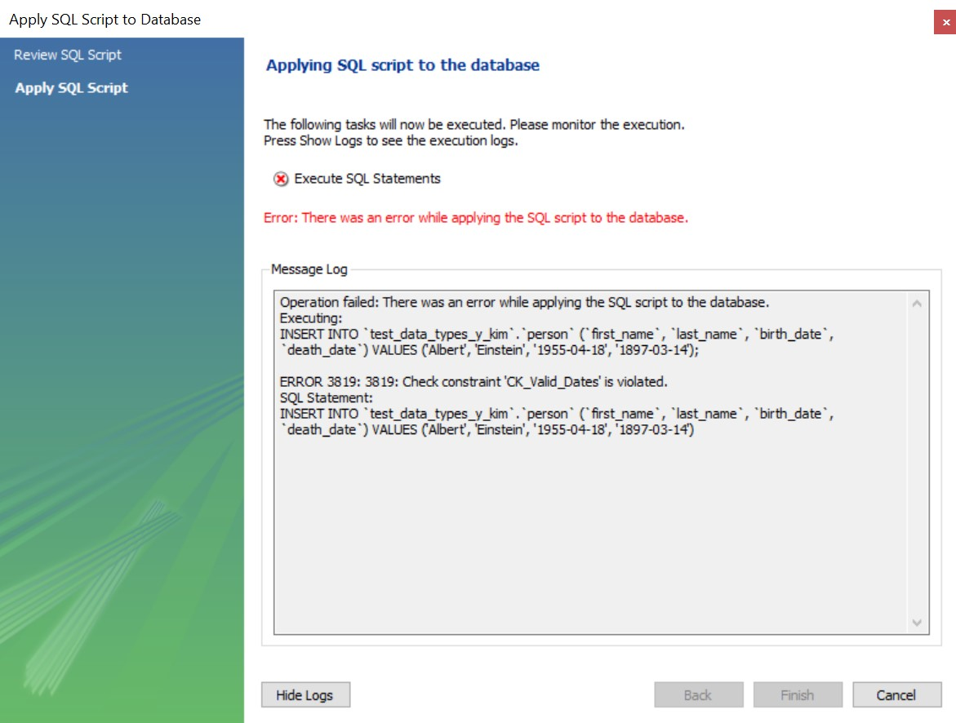

Screenshot #5:

I made another work branch at MySQL and made three tables “person, skill and person_skill”. Person and skill table are many to many relationships so they need middle table to connect together. When there is no data at person and skill tables, you can’t put any data in person_skill as well.

Filename: 05_data_in_wrong_order.jpg

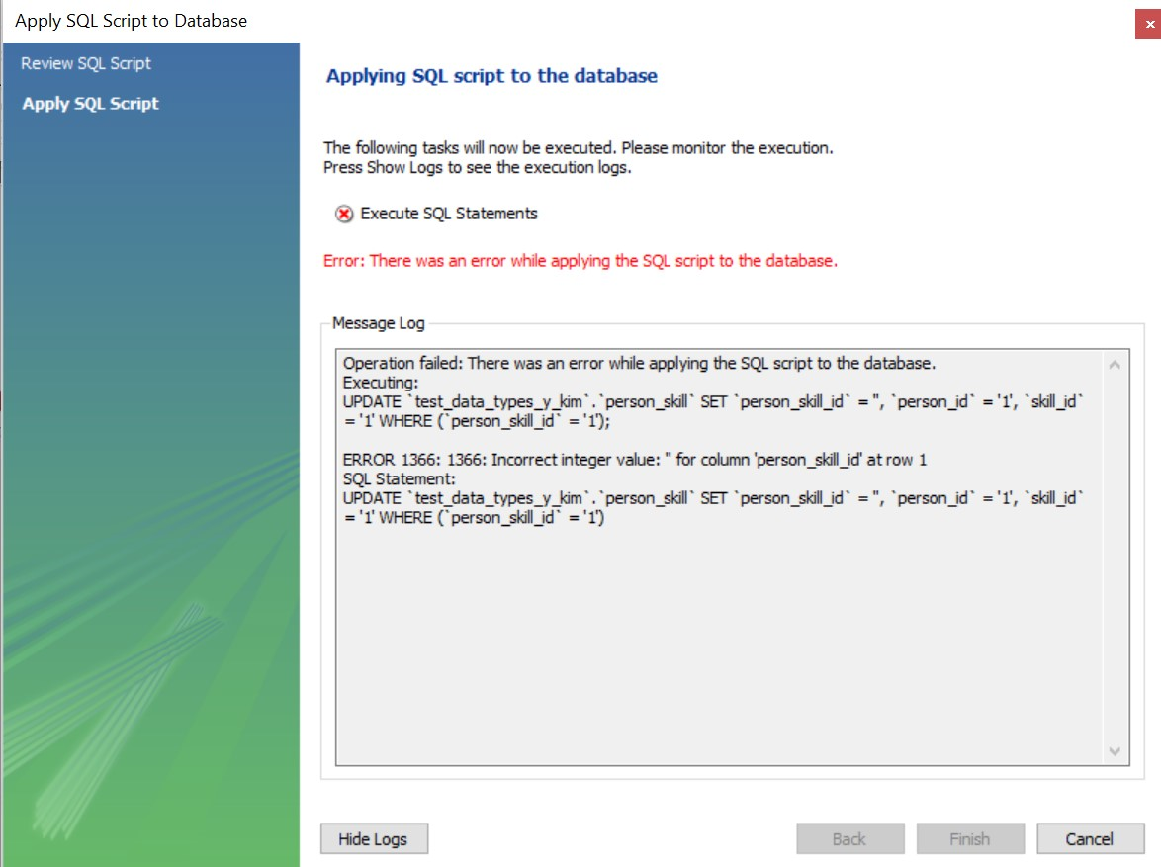

Screenshot #6:

This table represents individual persons with their full names stored in the columns first_name, middle_name, and last_name, all of which are of text data type. The person_id column, serving as the primary key, is of numerical data type, uniquely identifying each person in the table.

Filename: 06_person_data.jpg

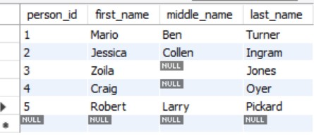

Screenshot #7:

The skill table captures various skills, ensuring uniqueness in each skill's name, denoted by the skill_name column. Each skill is uniquely identified by its corresponding skill_id, providing a distinct numerical identifier for each skill in the table.

Filename: 07_skill_data.jpg

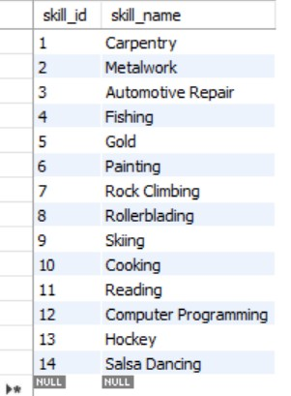

Screenshot #8:

Once the person and skill tables are populated, the person_skill table is established to capture relationships between individuals and their associated skills. The person_id and skill_id columns serve as both unique keys and foreign keys, ensuring referential integrity and facilitating the mapping of skills to specific individuals within the database.

Filename: 08_person_skill_data.jpg

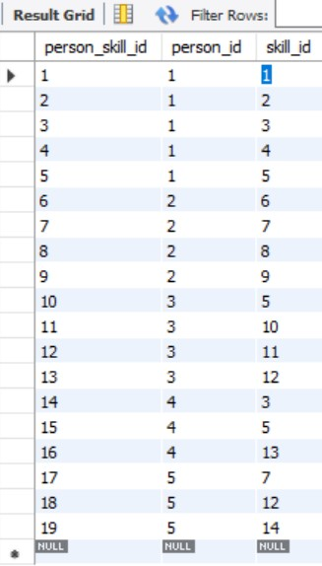

Screenshot #9:

The manager_id column has been added to the person table, utilizing the person_id as a foreign key. This enhancement enables the representation of managerial relationships, allowing individuals to be associated with their respective managers within the same person table. The manager_id column acts as a reference to another person_id within the same table, establishing hierarchical connections among individuals.

Filename: 09_person_manager_data.jpg

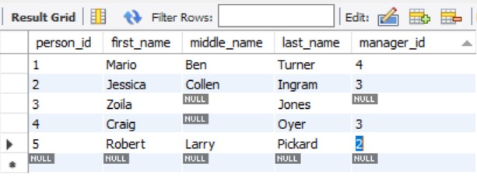

Screenshot #10:

Filename: 10_DB_MySQL_Version.jpg

Screenshot #11:

Filename: 11_Local_Version.jpg

Screenshot #12:

Filename: 12_Local_Site.jpg

Screenshot #13:

Filename: 13_Qoddi_Site.jpg