 SCOPE Student Services  
 Operation center 100 Lawrence Avenue, Smithtown, NY 11787

«LatterDate»  
«FullName»  
«Address»  
«City», «State» «ZipCode»  
  
Dear «FirstName»,  
  
This is the confirm the following change to the terms and conditions of your employment.  
  
 Position : «Position» District: «District»   
 Program : «Program»

EffectiveDate: «EffectiveDate»

Rate: «Rate»

Schedule : «Schedule»

Beginning «EffectiveDate» please use the enclosed time sheet. Please note all other terms and conditions of your employment remain the same.  
  
If you have any questions, please contact your District manager.  
  
  
Sincerely,  
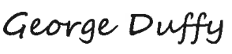  
**George Duffy**  
Executive Director  
SCOPE Education Services