Game Design Document

Fill up the following document

1. Write the title of your project.

UNICORN DASH

1. What is the goal of the game?

The goal of the game ***UNICORN*** ***DASH*** is the Unicorn from the game has to collect the diamonds to earn large amount of points and run as much as he can to achieve highest number in score board.

1. Write a brief story of your game.

the Unicorn dash game is something like the Trex runner game…that in the Trex game there is a trex as a PC and in my game there is a unicorn as a PC.In my game the unicorn has to run as much as he can to achieve highest number in score board and the unicorn has to collect the diamonds to earn large amount of points.In my game there are two achievements…points and score.when the unicorn is running there will come some flowers as obstacles.If the unicorn touches the flower the game will end.There are two types of diamonds in my game also.If unicorn collects White colour diamonds the score increases by 2 and if the unicorn collects black diamonds the score decreases by 1.There are two types of game ending…first is if the horse touches the flower or if the points are less than 0.In my game there will come sounds in between game for making the player excited..

PC=UNICORN NPC=FLOWERS,DIAMONDS

PLAYING DEVICE=LAPTOP MAKING IN=P5EDITOR

1. Which are the playing characters of this game?

* Playing characters are the ones who respond to the user based on the input from the user.
* Cars, monkeys, dinos, wizards, etc., are the playing characters in the game.

|  |  |  |
| --- | --- | --- |
| Number | Character Name | What can this character do? |
| 1 | UNICORN | RUNNING |
| 2 |  |  |
| 3 |  |  |
| 4 |  |  |
| 5 |  |  |
| 6 |  |  |
| 7 |  |  |
| 8 |  |  |

1. Which are the Non-Playing Characters of this game?

* Non-Playing characters are the ones that don't have an action or behavior when the user interacts with the game.
* Hurdles, stones, bananas, coins, etc., are non-playing characters in the game.

|  |  |  |
| --- | --- | --- |
| Number | Character Name | What can this character do? |
| 1 | FLOWERS | MAKE THE GAME TOUGH |
| 2 | BLACK DIAMONDS | DECREASES 2 POINTS |
| 3 | WHITE DIAMONDS | INCREASES 1 POINT |
| 4 |  |  |
| 5 |  |  |
| 6 |  |  |
| 7 |  |  |
| 8 |  |  |

Draw your imagination of this game. What does this game look like?

* Draw the game either on your computer or on paper.
* Add images of the game scenes to show each of the playing and non-playing characters at least once.

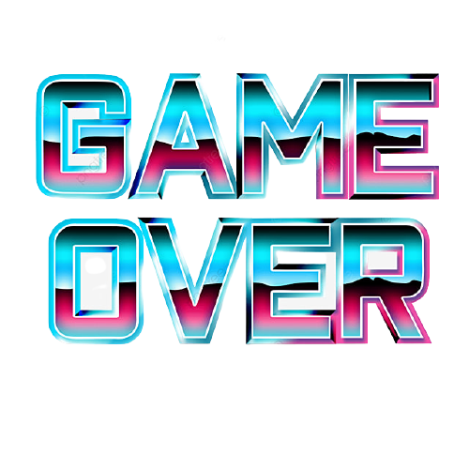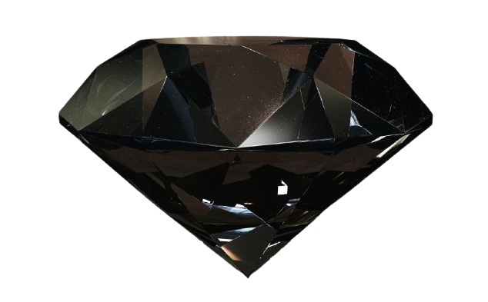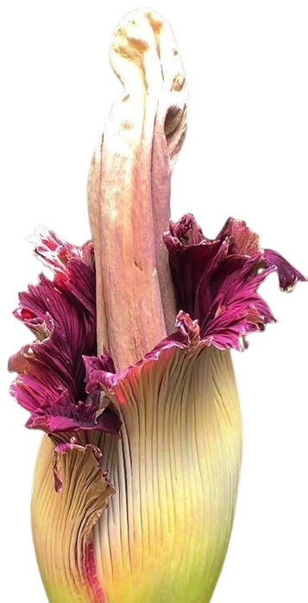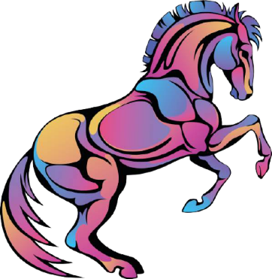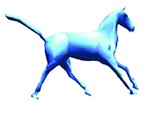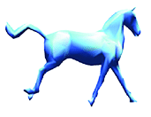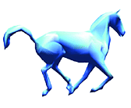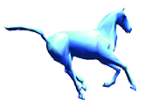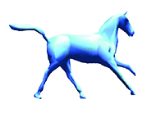

How do you plan to make your game engaging?

I will add a very beautiful background make add a very beautiful Unicorn…I will also add some beautiful flowers,black and White diamonds etc. for making the game more engaging.