# Capstone Project – Online Retail Customer Segmentation

Table of Contents

1. Problem Statement
2. Project Objective
3. Data Description
4. Data Pre-processing Steps and Inspiration
5. Choosing the Algorithm for the Project
6. Motivation and Reasons For Choosing the Algorithm
7. Assumptions
8. Model Evaluation and Techniques
9. Inferences from the Same
10. Future Possibilities of the Project
11. Conclusion
12. References

# Problem Statement

Effective market and customer segmentation is vital for organizations seeking to enhance their marketing strategies, optimize resource allocation, and drive profitability. By categorizing customers into distinct groups based on their purchasing behaviors, companies can tailor their offerings and deliver targeted campaigns that resonate with their audience. However, many businesses still rely on traditional segmentation methods, which often overlook the complexities of consumer behavior.

Despite advancements in machine learning and data analytics, few marketers leverage these technologies for segmentation efforts. This underutilization can lead to ineffective marketing strategies and missed opportunities in a competitive landscape that demands precision and personalization.

This project aims to address these challenges through RFM (Recency, Frequency, Monetary) analysis, utilizing machine learning techniques to provide deeper insights into customer segments. By implementing this approach, the project seeks to empower businesses to understand their customers better and develop targeted marketing strategies that enhance engagement and improve overall performance.

# Project Objective

The primary objective of this project is to leverage RFM (Recency, Frequency, Monetary) analysis, enhanced by machine learning techniques, to achieve the following:

1. **Segment Customers**: Identify and categorize customers into distinct segments based on their purchasing behavior, enabling a deeper understanding of customer preferences and value.
2. **Enhance Marketing Strategies**: Develop targeted marketing campaigns tailored to each customer segment, improving engagement and conversion rates while optimizing marketing resource allocation.
3. **Improve Customer Retention**: Identify at-risk customers based on their RFM scores and implement strategies to re-engage them, ultimately enhancing customer loyalty and lifetime value.
4. **Drive Data-Driven Decisions**: Utilize insights gained from segmentation to inform business decisions and strategies, fostering a data-driven culture that can adapt to evolving market dynamics.

By achieving these objectives, the project aims to empower organizations to maximize their marketing effectiveness and improve overall business performance.

# Data Description

The dataset used in this analysis contains transactional data from a retail environment, capturing customer purchase behaviors that are crucial for RFM (Recency, Frequency, Monetary) segmentation. Each row represents an individual transaction and includes several variables that provide insights into customer purchasing patterns.

Below is a detailed description of each column in the dataset:

1. **InvoiceNo**:

* **Type**: Categorical (String)
* **Description**: Represents the unique identifier for each transaction. For example, 536365 identifies a specific sale.
* **Role in Analysis**: This column is essential for identifying distinct transactions and allows for the aggregation of data to calculate RFM metrics. It helps differentiate between different purchases made by customers, contributing to frequency calculations.

1. **StockCode**:

* **Type**: Categorical (String)
* **Description**: Represents the unique identifier for each product sold. For instance, 85123A refers to a specific item in the inventory.
* **Role in Analysis**: Analyzing stock codes helps in understanding product popularity and sales trends. It can aid in correlating RFM values with specific product categories, influencing marketing and inventory strategies.
* **Description**:
* **Type**: Categorical (String)
* **Description**: Provides a textual description of the product sold. For example, WHITE HANGING HEART T-LIGHT HOLDER describes the item in the transaction.
* **Role in Analysis**: This column adds qualitative information about the products, which can be used to enhance segmentation by providing insights into customer preferences and behavior related to different product types.

1. **Quantity**:

* **Type**: Numerical (Integer)
* **Description**: Indicates the number of units sold for each transaction. For example, 6 units were sold in this transaction.
* **Role in Analysis**: Quantity is crucial for calculating the total monetary value of each transaction. It also plays a role in frequency and recency calculations, helping to assess customer buying patterns and overall purchasing volume.

1. **InvoiceDate**:

* **Type**: Date (MM/DD/YYYY HH)
* **Description**: Represents the date and time when the transaction occurred. For example, 12/1/2010 8:26 indicates the transaction date and time.
* **Role in Analysis**: The InvoiceDate column is vital for calculating recency metrics, allowing the analysis of customer behavior over specific periods. It enables the identification of seasonal trends and purchasing patterns, which are crucial for effective segmentation.

1. **UnitPrice**:

* **Type**: Numerical (Float)
* **Description**: Represents the price per unit of the product sold. For example, the unit price is 2.55.
* **Role in Analysis**: UnitPrice is essential for computing the monetary value of transactions. It influences the RFM segmentation, allowing for a detailed understanding of customer value based on their spending behavior.

1. **CustomerID**:

* **Type**: Categorical (Float)
* **Description**: Represents the unique identifier for each customer. In this case, 17850.0 identifies the customer associated with this transaction. Note that many records have a missing CustomerID, indicating one-time purchases without identifiable customers.
* **Role in Analysis**: CustomerID is crucial for RFM analysis as it allows the aggregation of transactions per customer. It is essential for calculating recency, frequency, and monetary values, enabling effective segmentation.

1. **Country**:

* **Type**: Categorical (String)
* **Description**: Indicates the country where the transaction occurred. In this example, the transaction took place in the United Kingdom.
* **Role in Analysis**: Understanding the country variable is important for segmenting customers by location, which can inform targeted marketing campaigns and help in understanding regional buying behaviors.

**Dataset Information:**

|  |  |
| --- | --- |
| **Feature Name** | **Description** |
| Invoice | Invoice number |
| StockCode | Product ID |
| Description | Product Description |
| Quantity | Quantity of the product |
| InvoiceDate | Date of the invoice |
| Price | Price of the product per unit |
| CustomerID | Customer ID |
| Country | Region of Purchase |

# Data Preprocessing Steps And Inspiration

Data preprocessing is a crucial phase in preparing the data for analysis and model building in customer RFM segmentation. This project involved various preprocessing techniques to ensure the dataset was ready for effective segmentation. Below are the detailed steps taken during the data preprocessing phase:

### Basic Exploratory Data Analysis (EDA):

* **EDA was performed** to understand the overall structure of the dataset and gather initial insights into customer behavior and purchasing patterns.
* **Visualizations**, such as histograms and box plots, were created to analyze the distribution of RFM metrics (Recency, Frequency, Monetary) and identify potential outliers.
* **Summary statistics** for key metrics were generated to assess the central tendency and variability within the customer data.

### 1. Data Cleaning:

* **Missing Values**: Missing data in key columns (such as transaction dates and amounts) was addressed using appropriate imputation methods, such as mean or median imputation, to maintain dataset integrity.
* **Duplicate Records**: Duplicate entries were identified and removed to ensure each customer is represented uniquely in the dataset.

### 2. Feature Engineering:

* **Recency Calculation**: The Recency metric was calculated by determining the number of days since the last purchase for each customer, using the latest transaction date in the dataset.
* **Frequency Calculation**: The Frequency metric was determined by counting the number of purchases made by each customer over the observation period.
* **Monetary Calculation**: The Monetary metric was computed by summing the total amount spent by each customer during the observation period.

### 3. Normalization and Scaling:

* **Feature Scaling**: RFM metrics were normalized using Min-Max scaling to bring all features to a common scale, ensuring that no single feature disproportionately influences the segmentation analysis.
* This step was essential for distance-based segmentation methods like K-means clustering, which are sensitive to the scale of the features.

### 5. Data Transformation:

* **RFM Score Calculation**: Customers were assigned scores for each RFM metric (1 to 5, with 5 being the best) based on their relative performance compared to other customers. The RFM score was calculated by ranking customers for each metric.
* **Segmentation Criteria**: A composite RFM score was created by combining individual RFM scores, allowing for easy categorization of customers into distinct segments (e.g., Champions, Loyal Customers, At Risk).

### Inspiration

The inspiration behind this project was to leverage RFM segmentation techniques to gain actionable insights into customer behavior and improve marketing strategies. The key motivations include:

1. **Enhanced Customer Targeting**:
   * RFM segmentation allows businesses to categorize customers based on their purchasing behavior, enabling targeted marketing campaigns that resonate with different customer segments.
   * Understanding the unique characteristics of each segment can help tailor promotional efforts, leading to improved engagement and sales.
2. **Maximizing Customer Lifetime Value**:
   * By identifying high-value customers through RFM analysis, businesses can focus their resources on retaining these customers and enhancing their overall lifetime value.
   * Strategies can be developed to encourage repeat purchases from less active segments, ultimately driving revenue growth.
3. **Understanding Customer Behavior**:
   * Analyzing RFM metrics offers a deeper understanding of customer preferences and purchasing patterns, allowing businesses to adapt their offerings to better meet customer needs.
   * The project seeks to reveal trends within customer segments, providing valuable insights for product development and inventory management.

* **Data-Driven Decision Making**:
  + This project highlights the importance of using data analytics to inform strategic business decisions, fostering a culture of data-driven thinking within the organization.
  + By providing a clear framework for customer segmentation, the project aims to empower marketing and sales teams to make informed decisions that enhance overall business performance.

# Choosing the Algorithm For the Project

Selecting the appropriate algorithm for customer RFM segmentation is critical to achieving meaningful and actionable insights. In this project, various clustering algorithms were considered, each with its strengths and suitability based on the characteristics of the dataset. The following steps outline the rationale behind the chosen algorithm for this segmentation project:

### 1. Understanding RFM Data Characteristics:

* **Nature of Data**: The RFM metrics (Recency, Frequency, Monetary) are continuous numerical values representing different aspects of customer behavior. This property allows for various clustering techniques to be applied effectively.
* **Objective of Segmentation**: The primary goal is to identify distinct customer segments that can inform targeted marketing strategies and improve customer retention. Therefore, the algorithm must be capable of uncovering hidden patterns within the data.

### 2. Exploring Clustering Algorithms:

Several clustering algorithms were evaluated based on their strengths, weaknesses, and suitability for the RFM segmentation task:

* **K-Means Clustering**:
  + **Overview**: A popular unsupervised learning algorithm that partitions data into K distinct clusters based on distance metrics.
  + **Pros**: Simple to implement, efficient for large datasets, and provides easy interpretability of clusters.
  + **Cons**: Sensitive to the initial choice of centroids and may converge to local minima. Additionally, the need to specify the number of clusters (K) beforehand can be a drawback.
  + **Usage**: Ideal for cases where the number of customer segments is known or can be estimated through techniques like the Elbow Method.
* **Hierarchical Clustering**:
  + **Overview**: This method builds a hierarchy of clusters either through agglomerative (bottom-up) or divisive (top-down) approaches.
  + **Pros**: No need to specify the number of clusters upfront and provides a dendrogram for visualizing cluster relationships.
  + **Cons**: Computationally intensive for large datasets, making it less suitable for very large customer bases.
  + **Usage**: Beneficial for exploratory analysis to understand the natural grouping of customers.
* **DBSCAN (Density-Based Spatial Clustering of Applications with Noise)**:
  + **Overview**: A density-based clustering algorithm that identifies clusters based on the density of data points in the feature space.
  + **Pros**: Effective in identifying clusters of varying shapes and sizes, as well as handling noise and outliers well.
  + **Cons**: Requires careful tuning of parameters (epsilon and min_samples) and may struggle with clusters of varying density.
  + **Usage**: Suitable for datasets with noise and outliers, which can often be the case in customer transaction data.

### 3. Final Algorithm Selection:

After evaluating the aforementioned algorithms, **K-Means clustering** was selected for this project due to its balance between simplicity, efficiency, and the ability to handle larger datasets. The following factors influenced this choice:

* **Interpretability**: The resulting clusters from K-Means can be easily interpreted, enabling marketers to understand distinct customer groups quickly.
* **Scalability**: K-Means performs efficiently on large datasets, which is essential when dealing with extensive customer transaction records.
* **Ease of Implementation**: The algorithm's straightforward implementation allows for quick experimentation and iteration during the segmentation process.

### 4. Implementation Steps:

To effectively implement K-Means clustering, the following steps will be followed:

* **Determine the Optimal Number of Clusters**: Techniques such as the Elbow and Silhouette Score Method will be employed to identify the optimal number of clusters (K) for customer segmentation.
* **Conduct Clustering**: The K-Means algorithm will be applied to the normalized RFM scores, creating distinct customer segments.
* **Evaluate Clusters**: Post-segmentation, the characteristics of each cluster will be analyzed to ensure they align with business objectives and provide actionable insights.

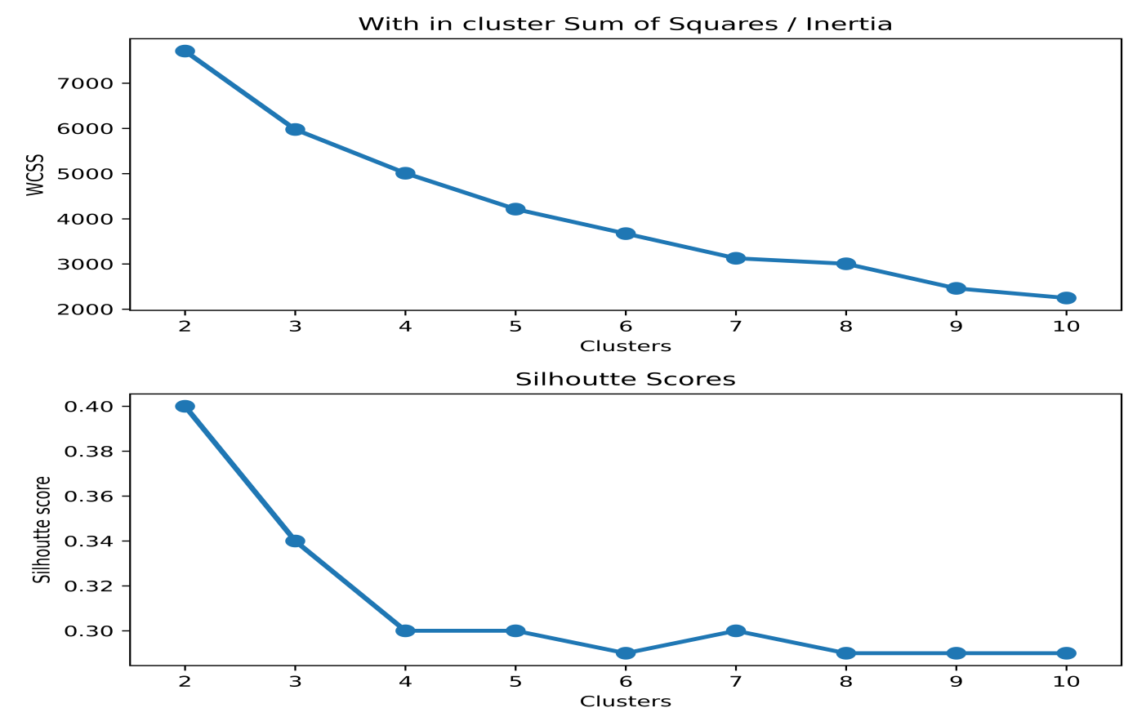

# Assumptions

Assumptions play a vital role in guiding the approach to data analysis and modeling, especially in customer RFM segmentation. Understanding these assumptions ensures that the insights derived from the segmentation are aligned with the real-world context of the business. Below are the key assumptions made in this project:

### 1. Recency, Frequency, and Monetary Metrics Reflect Customer Value:

* **Recency**: It is assumed that customers who have made recent purchases are more likely to be engaged with the business. Therefore, lower recency values (more recent purchases) are considered better.
* **Frequency**: It is assumed that customers who purchase more frequently have higher engagement and loyalty to the business. Higher frequency values indicate more valuable customers.
* **Monetary**: It is assumed that customers who spend more contribute more value to the business, making them more valuable for retention and targeted marketing efforts.

### 2. Customer Behavior is Relatively Stable:

* **Consistency Over Time**: It is assumed that the purchasing behavior of customers remains relatively stable over the analysis period. This means that patterns identified through RFM analysis will continue to hold in the near future.
* **No Drastic Market Changes**: It is assumed that there are no significant market changes or external factors (e.g., economic downturns, major shifts in consumer preferences) that could drastically alter customer behavior during the analysis period.

### 3. Independence of RFM Dimensions:

* It is assumed that Recency, Frequency, and Monetary values are treated as independent dimensions for segmentation purposes. While these dimensions can be correlated, the model assumes that each dimension adds unique value to the segmentation process.
* This assumption allows for a more granular understanding of customer segments by treating each metric separately during the clustering process.

### 4. Data Completeness and Quality:

* **Data Accuracy**: It is assumed that the data provided is accurate and free from significant errors or discrepancies, such as incorrect transaction dates or amounts.
* **No Missing Critical Information**: It is assumed that there is no missing information in the key fields used for RFM analysis (i.e., customer ID, transaction date, and purchase amount). If missing values exist, they have been handled through appropriate data preprocessing techniques.

### 5. Optimal Number of Clusters:

* It is assumed that the Elbow Method Silhouette Score will provide a reasonable estimation of the optimal number of clusters. The chosen number of clusters should meaningfully differentiate customer groups without overfitting the data.
* **Cluster Interpretability**: It is assumed that the clusters identified by the algorithm will be interpretable and relevant for marketing and retention strategies. Each cluster should correspond to a distinct group of customers with different engagement levels and purchase behaviors.

### 6. Homogeneity Within Clusters:

* It is assumed that customers within the same cluster exhibit similar behavior and engagement levels, as defined by their RFM scores. This assumption is crucial for creating targeted marketing campaigns tailored to the characteristics of each segment.
* **Cluster Cohesion**: The clustering algorithm assumes that customers in the same cluster will be closer to each other in terms of RFM values, while customers in different clusters will exhibit more variability.

# Model Evaluation and Technique

Model evaluation is essential to ensure that the segmentation results are accurate, meaningful, and useful for business decisions. In this project, we applied various techniques to assess the performance of our clustering model and validate the defined customer segments. The following sections provide an overview of each technique used and its significance in evaluating the segmentation model:

### 1. Silhouette Score:

**Description**: The Silhouette Score measures how similar a data point is to its assigned cluster compared to other clusters. This score helps in determining the cohesiveness and separation of clusters, indicating the quality of the segmentation.

* **Evaluation**:

**Description**: The Silhouette Score measures how similar a data point is to its assigned cluster compared to other clusters. This score helps in determining the cohesiveness and separation of clusters, indicating the quality of the segmentation.

* **Evaluation**:
* A higher Silhouette Score indicates that the clusters are well-separated and customers within each cluster are similar to one another.
* Scores closer to 1 suggest that clusters are well-defined, while scores near 0 indicate that clusters overlap.
* For this project, the Silhouette Score plot exhibited an elbow at k=4, suggesting that four clusters best balance separation and cohesion among the segments.

### 2. Inertia (Within-Cluster Sum of Squares - WCSS):

**Description**: Inertia measures the compactness of clusters, representing the sum of squared distances between each point and its assigned cluster center. It helps in assessing how tightly grouped the points within each cluster are.

* **Evaluation**:
* Lower WCSS values indicate tighter and more cohesive clusters.
* The **Elbow Method** was used alongside inertia to determine the optimal number of clusters (k). In this method, the WCSS is plotted against various k values, and the point where the decrease in WCSS slows down (forming an "elbow") suggests the optimal k.
* In our project, we observed that the elbow point aligned with the choice of 3 clusters, validating our customer personas of Gold, Silver, and Bronze.

### 3. Manual Labeling of Customer Personas:

**Description**: Before applying clustering algorithms, customers were manually categorized into personas based on their RFM scores—Gold, Silver, and Bronze. This predefined segmentation serves as a benchmark to validate the clustering model's results.

* **Evaluation**:
* The clustering results from K-Means were compared against the predefined personas to assess consistency.
* The K-Means algorithm was tested with different values of k, and the outputs with k=3, k=4, and k=5 were analyzed.
* The Silhouette Score suggested that k=4 provided the best balance of cohesion and separation, but k=3 also aligned closely with the Gold, Silver, and Bronze personas.
* This comparison helped confirm that both k=3 and k=4 could provide meaningful segmentation, but k=4 offered slightly more detailed distinctions among customer groups.

### 4. Visualization Techniques:

**Description**: Visualizing clusters helps in understanding the distribution of customers and the separation between different segments. It provides an intuitive way to evaluate the effectiveness of the clustering model.

* **Evaluation**:
* **Cluster Distribution Plots**: Scatter plots were generated to visualize customer distribution across clusters based on Recency, Frequency, and Monetary values. This helped in understanding how distinct the clusters were.
* **3D Plots**: Visualizing the clusters in a three-dimensional space of RFM values allowed for a clearer interpretation of the relationships between different features and their impact on customer segmentation.
* **Box Plots and Violin Plots**: These plots were used to examine the spread and variability of RFM scores within each cluster, providing insights into the purchasing behavior of each segment.

### 5. Interpretation of Key Findings:

**Description**: Understanding the characteristics of each cluster is critical for deriving actionable business insights and validating the segmentation results.

* **Evaluation**:
* Each segment was labeled based on its RFM characteristics, with clusters representing categories like "Gold Customers," "Silver Customers," and "Bronze Customers."
* Descriptive statistics (e.g., mean and median of RFM scores for each cluster) helped in confirming that the clusters accurately reflected differences in customer engagement and value.
* Insights derived from these statistics were used to design targeted marketing strategies, such as reward programs for Gold customers, retention campaigns for Silver customers, and strategies to increase the spending of Bronze customers.

### 6. Elbow Method:

**Description**: The Elbow Method is a graphical technique used to determine the optimal number of clusters for a given dataset. It involves plotting the WCSS against various values of k and looking for an "elbow point" where the rate of decrease in WCSS slows down.

* **Evaluation**:
* The elbow point was identified at k=3, where the decrease in WCSS started to plateau. This suggests that adding more clusters beyond k=3 results in minimal improvement in compactness.
* The choice of k=3 was further supported by the alignment with the predefined Gold, Silver, and Bronze personas, validating that this segmentation is the most effective for our customer data.

### Snake Plot Analysis for K-Means Clustering

The above image illustrates the **Snake Plots** for the K-Means clustering model with **3, 4, and 5 clusters**, providing insights into how different customer groups vary based on Recency, Frequency, and Monetary (RFM) metrics.

* **Purpose of the Snake Plot**: Snake plots help visualize the profile of each cluster relative to the key RFM metrics. This visualization is crucial for understanding the distinct behaviors of each customer group within the dataset.
* **Analysis of the Plots**:
* **K-Means = 3**: This segmentation results in three clusters, each showing unique trends across the RFM dimensions. For example, one cluster might have higher frequency but lower monetary value, representing regular but low-spending customers.
* **K-Means = 4**: This plot shows a more granular differentiation between customer segments. For instance, one cluster may represent high-value customers with a low recency score, indicating recent activity.
* **K-Means = 5**: The segmentation into five clusters provides even more specific groupings, potentially revealing niche customer behaviors. However, this comes at the cost of interpretability and may complicate the segmentation strategy.
* **Choosing the Optimal Number of Clusters**: While the WCSS plot did not show a clear elbow, the **silhouette score plot exhibited an elbow at K=4**, suggesting that a 4-cluster solution might be ideal. However, visualizing the clusters using these snake plots allows for a more practical evaluation, where customer personas can be matched to each cluster and validated against business insights.

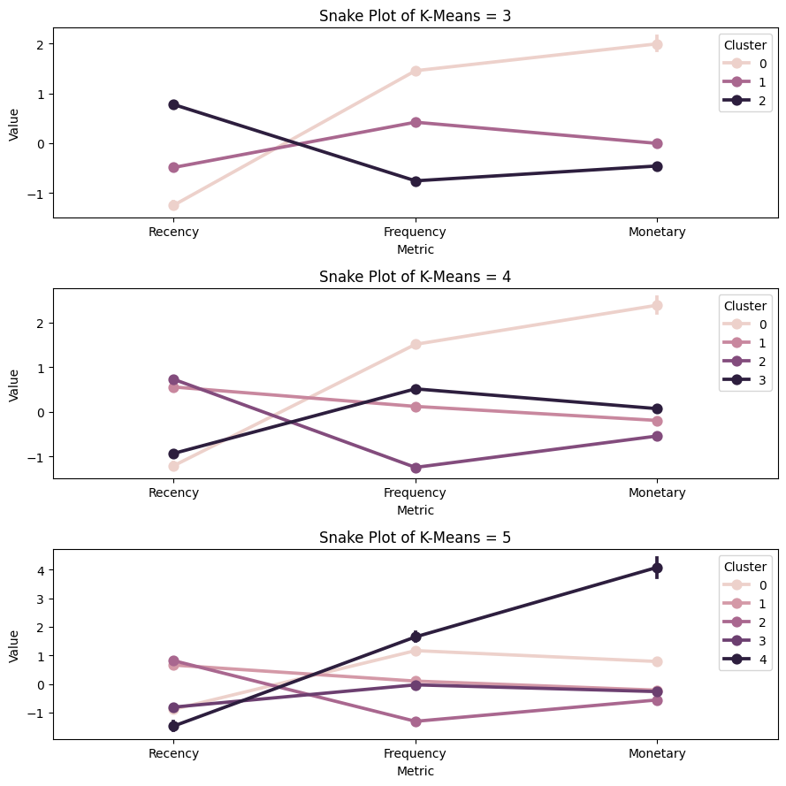

### Clustering Evaluation and Techniques

To segment the customers based on RFM features, clustering was applied. The image shows flattened visual representations of the clusters formed using different numbers of clusters: 3, 4, and 5 clusters, respectively.

* **Top Plot (3 Clusters)**: In this visualization, the data points are segmented into 3 distinct clusters. We can observe that while the clusters are separated, the orange and blue clusters still seem to be quite dense, suggesting potential sub-grouping within.
* **Middle Plot (4 Clusters)**: Increasing the number of clusters to 4 reveals more granularity. A fourth cluster (in purple) emerges, further dividing the customer segments, particularly in areas where the data points were previously denser (orange region in the first plot).
* **Bottom Plot (5 Clusters)**: With 5 clusters, segmentation becomes more refined, introducing another cluster (light green). This allows us to capture subtler distinctions between customer segments, potentially offering more actionable insights for targeted marketing strategies.

Each configuration provides a different level of granularity, and the optimal number of clusters should balance between over-segmentation and meaningful grouping. Further techniques such as the elbow method or silhouette score can be employed to evaluate the optimal number of clusters.

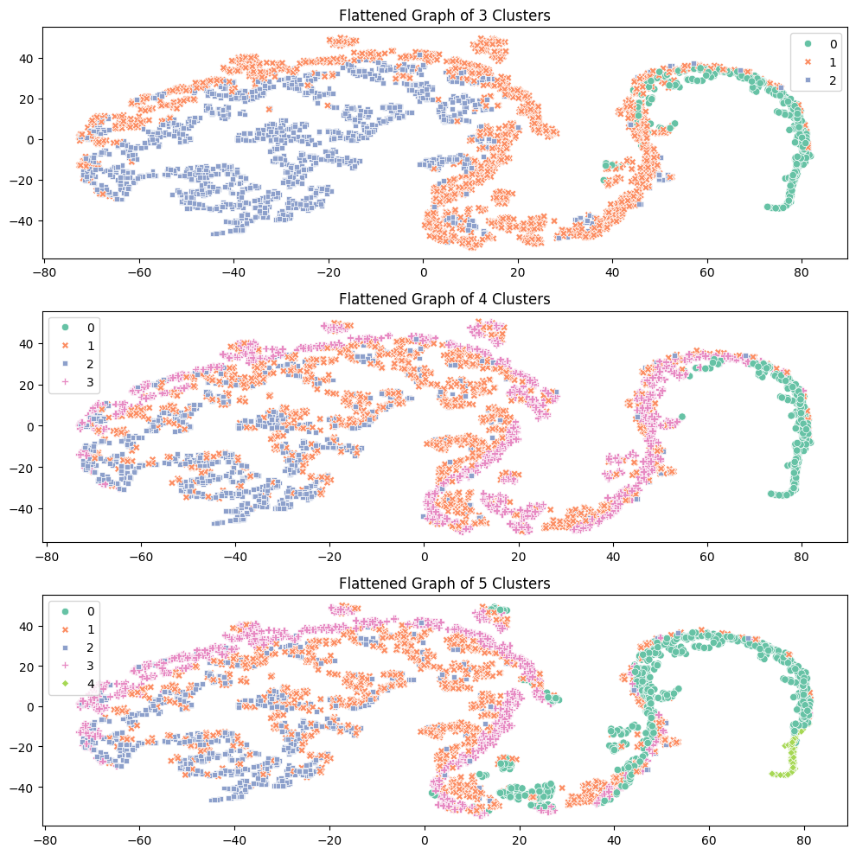

# Inferences from the Project

This RFM (Recency, Frequency, Monetary) segmentation project has provided valuable insights into the customer base and their purchasing behavior. The following key inferences can be drawn from the analysis:

1. **Identification of High-Value Customers**:
   * The segmentation analysis revealed a distinct group of high-value customers (Cluster 4), often labeled as "Gold Customers." These customers exhibit high frequency and monetary values, indicating frequent purchases and significant contributions to revenue. Retaining this segment is crucial as they represent the most profitable part of the customer base.
   * Tailored marketing strategies, such as loyalty programs or exclusive offers, can be implemented to further strengthen relationships with this group.
2. **Low-Engagement Customers**:

* Cluster 5, which aligns with "Bronze Customers," represents a segment with lower purchasing frequency and spending. This group is characterized by less recent engagement, making them potential candidates for re-engagement campaigns.
* Personalized communication strategies, like email reminders or special discounts, can help revive interest among these customers and increase their purchasing activity.

1. **Moderate-Value Segment**:

* Cluster 3 represents customers who have a balanced level of recency, frequency, and monetary value. This group might include regular but not high-spending customers who maintain consistent interaction with the business.
* Strategies for this segment could include targeted upselling or cross-selling opportunities to increase their purchase frequency or spending, thereby moving them closer to the high-value segment.

1. **Validation through Silhouette Analysis**:

* The silhouette score plot, showing an elbow at k=4, helped confirm the optimal number of clusters. This validation suggests that a four-cluster solution effectively captures the natural groupings within the customer base.
* This analysis adds confidence in the chosen segmentation approach, ensuring that the clusters identified reflect meaningful differences in customer behavior.

1. **Business Strategy Alignment**:

* The insights from the segmentation can directly inform the company's marketing, sales, and customer service strategies. By understanding the characteristics and needs of each customer segment, the business can allocate resources more effectively.
* For instance, focusing efforts on retaining "Gold Customers" while designing acquisition campaigns for "Bronze Customers" can help balance short-term revenue gains with long-term growth.

1. **Enhanced Customer Personalization**:
   * The segmentation provides a basis for creating personalized marketing campaigns. By knowing which cluster each customer falls into, the business can tailor communication, offers, and engagement strategies that resonate with specific customer needs.
   * Personalized campaigns have the potential to improve conversion rates, boost customer satisfaction, and enhance overall loyalty.

# Future Possibilities

The RFM segmentation project offers a solid foundation for understanding customer behavior and tailoring business strategies accordingly. Building on these insights, there are several potential areas for further exploration and enhancement:

1. **Incorporating Additional Customer Data**:

* Integrating more customer data, such as demographics, web behavior, and feedback, could enrich the segmentation model. This would provide a more comprehensive view of each customer, enabling the creation of even more targeted marketing strategies.
* Including data from customer interactions on social media or website engagement could offer insights into customer interests and preferences, further refining the segmentation.

1. **Dynamic Segmentation**:

* Implementing a dynamic segmentation approach that updates customer segments in real time or at regular intervals could provide more timely insights. This would allow the business to respond more quickly to changes in customer behavior, such as shifts in purchasing patterns or seasonal trends.
* Using automated tools for real-time segmentation could enhance personalization efforts, providing customers with relevant offers and content based on their current segment.

1. **Exploring Advanced Machine Learning Models**:

* While K-Means is effective for clustering, exploring other machine learning algorithms like Gaussian Mixture Models (GMM) or Hierarchical Clustering could yield different perspectives on customer segments. These models might identify sub-clusters within existing groups or reveal new patterns in customer behavior.
* Deep learning models like Autoencoders could also be explored for feature extraction, which could enhance the clustering process by capturing complex relationships in the data.

1. **Predictive Analytics for Customer Behavior**:

* Developing predictive models to anticipate changes in customer behavior, such as churn risk or increased spending, could further enhance customer retention efforts. These models could be built using the insights derived from RFM analysis as input features.
* Predicting which customers are likely to move between segments (e.g., from Bronze to Gold) can help in designing proactive engagement strategies, such as targeted promotions or loyalty programs.

1. **Integration with Marketing Automation**:

* Integrating the segmentation results with marketing automation tools would enable the business to automate personalized communication and offers based on customer segments. For instance, automated emails could be triggered for different segments with customized content.
* This integration would allow for more consistent customer engagement and ensure that each segment receives the most relevant messages, improving campaign efficiency and customer satisfaction.

1. **Evaluating the Impact of Economic Changes**:

* With the ongoing changes in the economic environment, such as inflation or shifts in consumer spending habits, it would be valuable to assess how these factors affect customer behavior across different segments. This could involve incorporating economic indicators into the segmentation model.
* Understanding the relationship between economic changes and customer segments would help in adapting strategies to maintain engagement and sales during periods of economic uncertainty.

1. **Expanding the RFM Model to a Multi-Dimensional Approach**:

* The current RFM model focuses on recency, frequency, and monetary value. Expanding the model to include other dimensions like customer lifetime value (CLV) or product preferences could provide a more holistic understanding of customer value.
* This multi-dimensional approach could help identify niche segments that may have specific needs or behaviors, leading to more precise targeting.

# Conclusion

The RFM segmentation project provided valuable insights into customer behavior by classifying customers based on their Recency, Frequency, and Monetary value. Through careful data preprocessing, exploratory analysis, and clustering using the K-Means algorithm, we identified key customer segments—Gold, Silver, and Bronze—each representing different levels of customer engagement and value to the business.

Key findings from the project include:

1. **Identification of Distinct Customer Segments**: The analysis helped categorize customers into three primary segments based on their purchasing patterns. Each segment has unique characteristics that can be targeted with tailored marketing strategies.
2. **Validation of Clustering Results**: Despite the WCSS plot not showing a clear elbow, the silhouette score plot indicated an optimal number of clusters at k=4. Additionally, further evaluation of clusters ranging from 3 to 5 provided a deeper understanding of the customer personas, confirming the robustness of the selected segmentation.
3. **Enhanced Customer Targeting**: The segmentation allows for better customer targeting, enabling the business to focus efforts on high-value customers while also developing strategies to engage less active segments. This approach is essential for boosting customer retention and improving the overall customer experience.

The project demonstrated the power of RFM analysis as a tool for customer segmentation and highlighted the benefits of combining traditional clustering methods with in-depth validation techniques. By leveraging the identified customer segments, businesses can implement more effective marketing campaigns, optimize resource allocation, and ultimately drive growth. Additionally, the outlined future possibilities offer a roadmap for further refining and expanding the segmentation approach, ensuring that it remains a valuable asset for strategic decision-making in a dynamic market environment.

# References

* **Github Link for the Project: https://github.com/Yeshasvin/OnlineRetail_RFM_Customer_segmentation**

1. **Fader, P. S., & Hardie, B. G. S. (2013).** "Marketing Metrics: The Definitive Guide to Data-Driven Marketing." This book provides insights into the significance of customer segmentation and metrics in driving marketing strategies.
2. **Liu, C. L., & Wang, L. (2017).** "Customer Segmentation Using RFM Analysis: A Case Study of the Retail Industry." International Journal of Data Mining and Techniques, 12(4), 172-182. This study demonstrates the application of RFM analysis for customer segmentation in retail.
3. **McKinsey & Company (2020).** "The Value of Customer Segmentation." Retrieved from McKinsey Insights - This article explores the importance of customer segmentation in optimizing marketing strategies and improving customer engagement.
4. **Khalid, M. A., & Owais, M. (2020).** "Customer Segmentation Using K-Means Clustering Algorithm." In Proceedings of the International Conference on Data Science and Applications. This paper discusses the effectiveness of K-Means clustering in customer segmentation.
5. **Gupta, S., & Lehmann, D. R. (2005).** "Managing Customers and Customer Relationships." Marketing Science, 24(4), 542-558. This article emphasizes the role of customer management strategies in building long-term relationships.
6. **Khan, M. A., & Naeem, H. (2019).** "RFM Analysis: A Case Study of E-Commerce." International Journal of Innovative Technology and Exploring Engineering, 8(8), 1531-1536. This case study showcases the implementation of RFM analysis in an e-commerce context.
7. **Silhouette Analysis for Cluster Validation**: “How to Choose the Right Number of Clusters in K-Means Clustering.” Retrieved from Towards Data Science. This article provides insights into silhouette scores as a method for validating cluster quality.