**A Machine learning deployed model to predict flight fare using Decision Tree cost functions improve test data accuracy**

**Project Members:**

Yeshraj Maganti-1144105

Subash Chandra Bose Kondru-1140025

Amarnath Pohanerkar-1140818

Sri Lakshmi Srinivas Gandham-1120106

**Contents**

1. Abstract 3
2. Literature Review 3
3. Basic Concepts in Machine Learning 4
   1. Introduction 4
   2. Predictive analysis Techniques 5
   3. Predictive analysis models 6
   4. Applications of predictive analysis 7
   5. Predictive Analytics 8
   6. Cross validation in machine learning 9
   7. One-Hot Encoding 10
   8. Ensemble Learning 12
4. Research on Predictive Analysis 14
5. Proposed System 15
   1. Data Pre-processing 17
   2. Feature Extraction 18
   3. Feature Selection 18
6. Methodology 21
   1. Dataset 22
   2. Data Cleaning 22
   3. Exploratory Data Analysis 23
   4. Handling Categorical Data 23
   5. Test Data 24
   6. Feature Selection 24
   7. Fitting model using Random Forest 26

7. Conclusion 29

8. Findings/Results 30

9. References 34

10. Appendix A Technology Information 36

**1.1 Abstract**

Flight transport system is playing vital role for every individual life when emergency takes place to travel from one place to another. The travelling of customers from source to destination at any time and they will come to know the chances of getting less prices of flight fare to plan their journey in a most economical where the charges are dynamic. So mainly the flight fare is the main challenging task to every customer will know about cost of the journey on priority basis. The machine learning model will suggest the best buy price of the flight ticket when to buy a ticket. The hyper parameters tuning will reduce the over-fitting of data and improves the accuracy on training data is with highest accuracy and on test data was improved as well on the prediction model. The data was collected from 16 routes among which 4 routes were used for analysis.

**1.2 Literature Review:** [1] The previous exploration work centre around the substances or properties which has a reliance to distinguish the expense of aircraft toll utilizing choice trees and the outcomes show just 82% of forecast. The fundamental choice tree model will perform expectation should address the overfitting and underfitting of data. [2]The Machine Learning calculations like Linear Regression is utilized to characterize the connections among reliant and the free factors (i.e. the scalar qualities and the exploratory information), Decision Tree, Random Forest, and Support Vector Machine are goes under administered realizing which is utilized to tackle relapse and characterization issues, K-Nearest Neighbours is accustomed to computing the Euclidean distance between the kth neighbours, Bagging Regression Tree is utilized to work on the dependability and precision of ML calculations and thus these are applied to work on the reliance of the elements are utilized to address a flight toll and the exactness results are improved to 88%. [3] Designing a specialist to distinguish the best buying strategy which is utilized to lessen the buy season of the client. Distinguishing the slacked set of highlights to display the impermanent connections dependent on separating new features.[4] Different variables which influence the flight cost make the privatization of forecast brings about building the models are prepared on highlights that are extricated sent in business flight administrations. The extraordinary days like celebrations and traveller seasons like winter will have full inhabitancy of the movement will be thought about through which the preparation of model can be done. [5] The AINN is utilized at foreseeing the charge costs and the Bagging Regression Tree model with 88% and Random Forest Model got precision consequences of 87%. The model expectations should be possible by utilizing the quantity of free flights and the necessary days that are preceding booking the flight. [6] The Prediction should be possible by utilizing choice trees and the arrangement exactness was worked on through hyperparameter tuning utilizing the weka device.

**1.3 Basic Concepts in Machine Learning**

**1.3.1 Introduction**

Prescient examination is the part of information investigation that is chiefly used to anticipate future occasions or results it is exclusively founded on information driven methodologies and procedures to arrive at resolutions or arrangements. The examination mostly utilizes logical strategies and prescient displaying to observe applicable examples in enormous informational collections thus these examples can be utilized to create different open doors in organizations by recognizing hazard and advantage focuses and so forth Prescient investigation is an expectant strategy for forward-looking arrangements and experiences to evaluate at any circumstance most of the cycles.

Prescient investigation consolidates the AI wording and calculations for model structure particularly to prepare the models so it is fundamentally critical to see how to pick these prescient methods for model structure and why we do prescient examination and I am certain the majority of us know about the huge expansion in the age of information surrounding us it has apparently become very clear since we are seeing parcel of information driven methodologies yet human has been putting away information since seemingly forever recording everything about been pervasive practice with the advanced age it has become to handle the information significantly more straightforward too however it has additionally opened a ton of chances for the a long time of long natural information to comprehend the connection between different parts of the information and may reason for it, in actuality, also assuming that we can utilize this information for you know different purposes we have like danger and misrepresentation location then there is market investigation functional developments functional upgrades crusading and so forth What's more one basic model is to utilize the climate information to concentrate on the examples and utilize prescient examination dependent on the bits of knowledge to foresee future occasions.

**1.3.2 Predictive analysis Techniques**

Some of the predictive analysis techniques are as follows

1) Regression

2) Classification

3) Clustering

4) Time series

5) Forecasting

The primary job of a relapse is a development of the proficient model to foresee the reliant traits from a lot of property factors relapse issue is the point at which the result variable is either genuine or a persistent variable that can be gauged or region or compensation and so on

1) Relapse is only a factual procedure that is utilized in applications like banking, money, and clinical to foresee what's to come. Relapse is in a general sense applied to a few kinds of information that contain different highlights. It is utilized to foresee the connection between a reliant variable and a gathering of free factors. The basic direct relapse is a relapse strategy where the autonomous variable has a relationship with the reliant variable it is predominantly a technique to perform investigation on the info factors or the informational collection which has a reliant variable and at least one free factors which are utilized to foresee the result design. The parallel variable will have just 2 results either 0 or 1 and the reliant variable are of type clear cut in nature. The reliant variable is additionally called the objective variable. The free factors will be treated as indicators. Strategic relapse is a unique rendition of direct relapse and it can just foresee the results which are of type all out factor which is utilized to anticipate the likelihood of the occasion utilizing the log work.

2) Grouping is only the most common way of sorting a bunch of information in different classes and the characterization should be possible on both organized (ie) the information all together and unstructured information(i.e) the information isn't all together. The interaction starts by anticipating the no of classes on determined informative items and classes are frequently examined as the objective name for classifications. The grouping prescient demonstrating task manages the reinforcement approximating and the planning capacity works out the result variable from the information factors to the discrete result factors. The principle objective of grouping is utilized to distinguish which class or classification kind of information is fitted into the model. A basic model, that coronary illness distinguishing proof can be ordered as the arrangement issue, and furthermore it is sorted as a double grouping issue. In the given dataset the various classes will be ordered as Heart infection and no-coronary illness. The classifier behaves like an identifier needs preparing the information to perceive precisely how the information factors are related with a specific class of infection or not illness and assuming the classifier is prepared accurately which can be utilized to distinguish whether or not the coronary illness is there for a specific patient since order is likewise the kind of directed learning even the objectives are additionally furnished with the information.

3) Grouping is mostly separating the main informative elements into homogenous classes or comparative information bunches. Bunched focuses from a similar gathering are like one another and the important items from various gatherings are as unique and gathering into various groups. The assortments of articles are gathered dependent on similitude. The LDA is utilized to bunch the groups of related information and spot the information of various kinds will be situated into various groups.

4) The time series model contains the grouping of information focuses caught utilizing time as the information boundary it utilizes the last year's information and the past information to foster mathematical measurements and foresee the information utilizing that measurement. It is a method for understanding a solitary measurement is creating over the long haul with an undeniable degree of exactness past straightforward midpoints.

5) Determining is only utilizing the recorded information to make forecasts or numeric expectations on new information dependent on the gaining from the past information

**1.3.3 Predictive analysis models**

A few models we can use for predictive analysis are

a) Direct relapse is to be utilized when the objective variable is persistent and the reliant variable and factors are ceaseless or a combination of constant and unmitigated and the connection between the autonomous variable and the reliant variable and (ie) when to know and when can utilize straight relapse. The Logistic relapse doesn't need a straight connection between the objective variable and the reliant variable the objective variable is the parallel expecting a worth of one or the other 1 or 0 or perhaps obvious or bogus.

b) The K means bunching model includes setting unlabelled informative items in independent gatherings dependent on likenesses and this calculation is utilized for the grouping model . Neural organizations help to comprehend the bunched information and arrange the information so these calculations are demonstrated freely after the human cerebrum and are intended to perceive designs.

c) A Decision tree is a guide of potential results of a progression of related decisions it permits a singular association to gauge potential activities against each other dependent on their expenses, probabilities, and advantages. As the name, it utilizes a tree-like model of choices and they can be utilized either to drive casual conversation or to delineate a calculation that predicts the most ideal decision numerical.

d) The Time series is significantly hostility investigation which is a procedure of anticipating the future that consistently relies upon patterns and irregularity and to show the information. A period series information contains a bunch of perceptions esteems that a variable requires some investment.

**1.3.4 Applications of predictive analysis**

A couple of utilizations of prescient examination are utilized in finance, Stock trade, Weather, Medical and Manufacturing

• Finance prescient investigation in money can help in recognizing the danger discovery for the danger location model to distinguish any fake exchanges for advances that you can identify utilizing the prescient examination

• Stock expectation too it can accumulate a great deal of information in time estimating forecast that can be considered for various stocks and there was a ton of cycle behind this yet far as the application goes stock forecast is a very decent application off prescient investigation in finance

• Climate forecast have state run administrations so legislatures are utilizing prescient investigation for crusading and for utilizing it for better recognition climate expectation that is catastrophe the executives there utilizing prescient examination

• Medical services expectation is utilized for foreseeing the effect of various strategies that are creating we can utilize the added substance examination in Healthcare for early recognition of illnesses, for example, malignant growth in heart components that could possibly be a piece of your life quite a long while later so it helps in anticipating that large number of sicknesses or known conditions at a beginning phase.

• Utilize prescient examination in assembling we can really recognize creation disappointments and stroll on it utilizing the expectation investigations than their helpless establishments utilizing prescient examination.

**1.3.5 Predictive Analytics**

Prescient examination is a classification of information investigation same to making expectations about future results dependent on chronicled information and examination procedures, for example, factual demonstrating and AI with the assistance of complex prescient investigation instruments and models. Any association can no utilization quick and current information to dependability figure patterns in conduct stock prerequisites, oversee delivering plans and arrange store designs to augment deals. Every now and again utilized prescient investigation to set up ticket costs reflecting past movements industry players can utilize the innovation to figure the quantity of visitors of some random night to amplify inhabitance and income. Prescient examination can likewise be utilized to identify and heart different kinds of criminal conduct before any genuine harm utilizing prescient investigation to concentrate on client conduct and activities, an association can recognize exercises that are strange, going from Mastercard misrepresentation to corporate spying to digital assaults. Models are the establishment of prescient examination. They are the layouts that permit clients to transform past and current information into noteworthy experiences. Some commonplace kinds of prescient models include:

*A client lifetime esteem model pinpoints clients who are not prone to put more in items and administrations.

*A client division model gatherings clients dependent on comparative qualities and buying conduct.

*A prescient support model estimate.

*Quality confirmation model spots and forestalls abandons in items and administrations.

Model clients approach a practically interminable scope of prescient demonstrating procedures. Numerous strategies are one of a kind to explicit items and administrations, nonexclusive methods choice tree, quite possibly the most famous technique, depend on a schematic, tree molded graphs that is utilized to decide obviously of activity or to show likelihood. The fanning techniques can likewise show each conceivable result of a specific choice and how one decision might prompt the following. Relapse methods are regularly utilized in financial contributing and other money arranged models to figure resource esteems and assist client with understanding the connections between factors, like products and stock costs. On the bleeding edge of prescient investigation strategies are neural organizations. Neural organizations are calculations intended to distinguish fundamental relationship inside an informational collection by impersonating the human brain works. While getting everything rolling in prescient examination isn't by and large a snap that basically any business can deal with as long as it is focused on the methodology and able to contribute the essential time and assets. Starting with the restricted scale pilot project in a basic business region in a superb method for covering fire up costs while limiting the time before monetarily compensates being coming in. 1 separate examination model is set in motion, it for the most part requires little upkeep.**1.3.6 Cross validation in machine learning**

The process of dividing the datasets into different categories or groups by adding label. It is a technique of categorizing the observation into different category. By taking the data analysing it and on the basis of some condition you finally divided into various categories. We classify it to perform productive analysis. Classification algorithm handled questions like this is this data belongs 'A' category or 'B' category this is the known data

In case of unknown datasets[11] the model will get under fitting and over fitting problems to overcome these problems the datasets will shuffled from the total observations and these observations are randomly selected together to form a set. The unknown sets sometimes will create under fitting and which has bias which is the model will not recognize the proper and needed patterns to train thus leads to under fit the model performance.

.The Over fitting of the data leads to model with poor performance once the data is passed through the model. The model performance will be increased by using the cross fold validation method. The fold cross validation method will randomly picked up the observations and apply permutation and combination among all the datasets which are having different sets of data. The Next phase is the compare phase once we apply all the cross fold validation techniques[11] to all the datasets identify the scores generated by it and which one is higher score then it leads to the less residuals and it perfectly used for training. Once the best dataset will be supplied as an input to the model it will give accurate results. The Next phase is the optimisation phase it will reduce the connections which are unnecessarily happen will drop the connections for better results when the model is getting training under the selected dataset.

The Cross-validation applications are used in Validation with overpowering applications to prevent a machine learning model from over fitting and under fitting there are several other applications of cross validation which are listed below:

* We can use it to compare the performances of a set of predictive modelling procedures.
* Cross validation excels in the field of medical research.
* It can be used in the meta-analysis since a lot of data analysts are already using cross validation.

**1.3.7 One-Hot Encoding**

One hot coded vectors precisely what is that when we are preparing a neural organization by means of are administered learning[9] we pass the named contribution to our model and it gives us an anticipated result.

• The model is behaves like a picture classifier, it acknowledges the named picture as a contribution to give the anticipated result.

• The understanding of naming isn't finished by the model. The marking, for example, feline or canine like English words and the result of the model isn't care for the words. So the forecasts should be possible by utilizing encoded which might be in whole number or a vector. The result of the model is as encoded design.

• Order of all out information can be encoded as whole number. So the all out names can be changed by utilizing One-hot encoding which is called as 0 or 1 and call it as vectors. The grouping is finished by utilizing vectors which demonstrates the arrangement of class classifications. So the model will order class classifications without any problem.

• The length of the classifications depends on class type. The dataset contain "bird", "plane" and "pony" pictures then the one hot encoding vectors with length of three and there are three classifications of the items. Allow us to refresh with one additional classifications onto the rundown of articles like "vehicle". So to group the pictures with the bird, plane, pony and vehicle and the vectors of length will be 4 classes of items.

• The names of the items in the dataset will change or encode[9] onto vectors and there are 4 classifications of classes are changed over onto one-hot encoding. Every single vector is having the connection which is equivalent to the quantity of out classifications which is referenced it as 0 or 1.

• The length of the categorisation of classes is 4.The grouping is finished by utilizing possibly it very well might be bird or plane or pony or vehicle. The file of every single article with the related vectors has a place with one of the four classifications of classes.

• From the dataset the name of class-1 that demonstrates a class name is bird and the mark of class-2 that shows a class name is plane and the name of class-3 which demonstrates a class name is horse and the name of class-4 which demonstrates a class name is vehicle. Assuming the class-2 picture is experienced, perform one-hot encoding with the file worth of class-2 is 1 and the leftover classes like class-1, class-3 and class-4 with the file esteems 0.The qualities that comparing to the classes are put in a record.

• The vector that is relate to the genuine classification will be filled by 1 assuming it go over the comparing classification of class from the accessible classes and later once will be shows with 0.The primary standard is every component which depends inside the vector is zero aside from the components that are has a place with the class of same.

• The vectors can be showing with the 0 or 1.The classes which are accessible is 4 and the class-1 is shown by utilizing 1000 once the 1 is demonstrating implies the class-1 is has a place with the real classification bird, the class-2 is demonstrated by utilizing 0100 once the 1 is showing implies the class-2 is has a place with the real classification plane. The class-3 is demonstrated by utilizing 0010 once the 1 is showing implies the class-3 is has a place with the genuine classification horse. The class-4 is shown by utilizing 0001 once the 1 is demonstrating implies the class-4 is has a place with the real classification vehicle.

**1.3.8 Ensemble Learning**

In the realm of measurements and AI group learning strategies endeavors to make the presentation of a prescient model better by working on their precision. Outfit learning is an interaction utilizing which various AI models are deliberately developed to take care of a specific issue. This issue can be of a characterization type or a relapse type. Troupe learning models have three fundamental parts are

1)Dataset:

The Data is confused and sent it to the AI model.The blending of information is alluded to as testing and perform line or section examining.

2)Group of base students: These are AI models that can either reliant or free to one another. Each base model gives it expectation in understanding to the information that is taken care of to demonstrate.

3)Grouping: Output of the multitude of base models is consolidated into the last model and the choice is made dependent on the greater part or by checking out their expectations weight.

The models like choice tree or svm and what is utilization of gathering learning. Group learning assists with further developing AI results by joining a few models. This methodology permits a forecast better prescient presentation contrasted with single model. That is the reason the troupe assumes a significant part in many AI. Outfit strategies are meta calculation that join a few AI methods into one prescient model to diminish varience or by working on the forecasts.

The Bias is happens when a calculation produces results that are efficiently biased because of wrong suspicions. The Bias mistake is helpful to evaluate how much on ana normal are the anticipated worth which is vary from the first values.The higher the predisposition prompts under execution and missing the valuable examples

The Varience ascertains the amount of the expectations are being mentioned on simialar observable fact which are vary from each other.The high varience prompts overfit.It won't perform viably on information under preparing.

There are three different types of techniques

1.Bagging:

It is likewise called bootstrap total. The bootstrap chooses a perception among the absolute n perceptions and the choice of the perception is simply arbitra

2.Stacking:

It is likewise called a democratic method. The forecasts from the few or numerous are consolidated. Producing at least two models are mutually consolidated on the equivalent dataset.

3. Boosting Technique

Outrageous lift is a limit and that implies is a major AI calculation with heaps of parts.

how XG support [8] does relapse with its interesting trees will construct incorporation, how does XG help does arrangement and the numerical subtleties, how are animosity and order are connected and why making exceptional trees.XG support however configuration to be with enormous confounded datasets. Utilizing this very basic preparing information on the X pivot have distinctive flight ticket cost and on the Y hub we have estimated value adequacy.

These two perceptions have somewhat huge positive qualities for total_stops adequacy and that implies that the cost was sensible. These two perceptions have somewhat huge negative qualities for total_stops adequacy and that implies that the cost isn't sensible to travel. The choice tree what begins with single leaf with kid leaf will investigate the root with left and right and the left youngster is having the leaf hub and later it will work out the quality score alongside the likeness score for the residuals this closeness score approaches the amount of the residuals squared over the quantity of receivables + Lambda

Lambda is a regularization boundary.

Presently Lambda = 0 currently plug residuals into the numerator and since there are 4 residuals in the leaf put a 4 in the denominator.

Since don't square the Residuals before add them together in the numerator 7.5 and negative 7.5 drop. Each out at the end of the day add this remaining to another leftover they counterbalance Each Other moreover 6.5 counteracts a large portion of negative 10.5 leaving negative 4 square in the numerator does the similitude score for the residuals in the root = 4 so this likeness = 4. [8] All of the residuals go to the leaf on the right it presently ascertain the closeness score for the leaf on the left by connecting the one lingering to the numerator and since only one remaining went to the leaf on the left the quantity of leftover equivalents 1.

Before set the Lambda equivalent to nothing and the closeness score for the leaf on the left is equivalent to value_cal. So we should put closeness is equivalent to value_cal under the leaves lastly work out the similitude score for the residuals that go to the leaf on the right. The amounts of residuals, squared into the numerator and since there are three residuals in the leaf on the right with in addition to 3 into denominator and very much like before we should allow Lambda to equivalent to nothing. Like prior, on the grounds that don't square the residuals prior to adding them together, 7.5 and - 7.5 leaving just a single remaining, 6.5, in the numerator. The similitude score for the residuals in the leaf on the right is equivalent to 14.08. So how about we put closeness is equivalent to 14.0 8 under the leaves. To work out the closeness scores for every hub. To see that when the residuals all together altogether different they offset one another and the score is moderately little. Conversely, when the residuals are comparable, or there is only one of them they don't counterbalance and the likenesses score generally huge. To evaluate how much better the leaves class their comparable residuals than the root we do this by working out the addition of dividing the residuals into two gatherings. Acquire is equivalent to the similitude score for the leaf on the left. Short the comparability score for the root.

**1.4 Research on Predictive Analysis**

The Research is being done on variation of AI into business is assuming an essential part and train the model by utilizing recorded information through which the forecast should be possible. The conveying of AI model will give the best outcomes to drive the business. Presently a days the forecast is done on each business to realize what will be the future status of the items whether trade. The preparation and testing of information is parted and the test information is utilized to approve the information. The model will prepare on test information. The Research is being done on variation of AI into business is assuming a crucial part and train the model by utilizing authentic information through which the expectation should be possible. The sending of AI model will give the best outcomes to drive the business. Presently a days the expectation is done on each business to realize what will be the future status of the items whether trade. The preparation and testing of information is parted and the test information is utilized to approve the information. The model will prepare on test information.

**2.1 Proposed System**

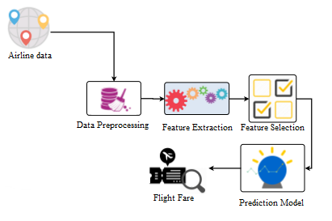

***Figure1: shows the proposed system***

**2.1.1 Airline Data**: The dataset with rows are 10683.

I) The Airline Feature has 12 distinct values

1. The JetAirways are 4746 entries

2. The IndiGo is with 2564 entries

3. The Air India is with 2192

4. The Multiple Carriers are with 1543 entries

5. The SpiceJet with 1026 entries

6. The others with 7 entries

II) The Date of Journey Feature has 44 distinct values

1. The date 18.05.2019 has 633 entries

2. The date 06.06.2019 has 630 entries

3. The date 09.05.2019 has 628 entires

4. The date 12.06.2019 has 628 entries

5. The date 21.05.2019 has 615 entries

6. The other dates with 10220 entries

III) The Source Feature has 5 distinct values with categorical values

1. The Delhi with 5682 entries

2. The Kolkata with 3581 entries

3. The Bangalore with 2735 entries

4. The Mumbai with 883 entries

5. The Chennai with 456 entries

IV) The Destination Feature is a categorical with 6 distinct values

1. Cochin with 5682 entries

2. Bangalore with 3581 entries

3. Delhi with 1582 entries

4. New Delhi with 1170 entries

5. Hyderabad with 883 entries

V) The Route Feature is a categorical with 132 distinct values

1. The DEL->BOM->COK with 3000 entries

2. The BLR->DEL with 1941 entries

3. The CCU->BOM->BLR with 1232 entries

4. The CCU->BLR with 896 entries

5. The BOM->HYD with 785 entries

6. The Other values of 127 different routes with 5499 entries

VI) The Dep_Time feature is categorical with 223 distinct values

1. The 18:52 with 288 values

2. The 17:00 with 275 values

3. The 10:00 with 265 values

4. The 07:05 with 240 entries

5. The 07:10 with 239 entries

6. The Different time values with 218 is 12047 entries

VII) The Arrival_Time feature is categorical with 1451 distinct values

1. The 19:00 with 536 values

2. The 21:00 with 466 values

3. The 19:15 with 434 values

4. The 16:10 with 185 entries

5. The 12:35 with 159 entries

6. The Different time values with 1446 is 11574 entries

VIII) The Duration feature is categorical with 374 distinct values

1. The 2h 50m is 672 entries

2. The 1h 30m is 493 entries

3. The 2h 45m is 432 entries

4. The 2h 55m is 418 entries

5. The 2h 35m is 399 entries

6. The different duration values with 369 is 10940 entries

IX) The Total_Stops feature is categorical with 5 distinct values

1. The nonstop with 4340 entries

2. The 1-stop with 7056 entries

3. The 2-stops with 1899 entries

4. The 3-stops with 56 entries

5. The 4-stops with 2 entries

X) The Additional_info feature is categorical with 10 distinct values

1. The No info is 10493 entries

2. The In-Flight meal not included is 2426 entries

3. The No check-in baggage included is 396 entries

4. The 1 Long layover is 20 entries

5. The Change airports is 8 entries

6. The different duration values with 5 is 11 entries

XI) The price feature is a real number which is the dependent variable

1. The Distinct values are 1870 entries.

2. There are missing values.

**2.1.2 Data Pre-processing**

The information highlights with high cardinality are Route is the characteristic which is high dimensional information with 132 unmistakable qualities. Dept_time is the component which is high dimensional information with 223 novel qualities. Arrival_time is the component with 1451 particular qualities and Duration has a high aspects with 374 unmistakable qualities. The Correlation is discover the connection between the reliant and free factors. The component Destination is profoundly corresponded with Airline and alongside three fields. The Airline include with profoundly corresponded with Destination and the cost is exceptionally associated with Airline. Date of Journey is exceptionally corresponded with Destination alongside two different elements. The Additional Feature is profoundly associated with Airline. The source is profoundly associated with objective highlights and Total_stops is connected with Destination and the Price has missing qualities with 20%.

**2.1.3 Feature Extraction**

The element designing is a significant perspective where every one of the straight out highlights are changing over into clear cut segment and there presence will be demonstrated as 1 and nonexistence will be shown as 0.Identify the number of special classes that are available in the information. Changing over the all out esteem into the straight out section and relegate the qualities 0 and 1 for each worth. The all out boundaries are less so the cardinality is less that is the reason we can apply one hot encoding and subsequently decrease the dimensionality decrease. Applying one hot encoding on train information of carrier list by utilizing a strategy called get fakers with set choice drop initially is valid. In the main record the Airline Indigo is available. So the one hot encoding results the aircraft that are to be available in the separate classifications here it is we have taken just 5 highlights.

**2.1.4 Feature Selection**

Unpredictable forest area is used to handle both gathering and backslide issues. From the start, the RF computation is used to organize feature importance and apply dimensionality decline. A short time later, the n-picked features are used with the unpredictable forest estimation and the F-measure not really set in stone for each decision tree as burdens to collect the assumption model. The assumption model is worked by using the WQRF Algorithm. The dataset which is requested into get ready and support datasets and picked of data subjectively. The overabundance data which is taken from plan and endorse is called test data. The dataset which is used for planning is set to rank the features using sporadic forest area estimation. Out of the picked importance incorporates the n-most features are picked that are delegated by loads using weighted RF Algorithm with arranged dataset is used to gather the assumption model. To gain the F measure for each and every tree, the endorsement set is used to discover the heaps. The n-most features are commitment to the figure model. The assumption model is surveyed by using 10-wrinkle cross endorsement to get affectability, precision, AUC and exactness.

**Model Prediction**

The Model creation is the significant part during the whole cycle. It will prepare the information which is only recognized the examples and those examples will be accumulated. The Layers of models are associated by different boundaries like actuation work, cost capacities and exactness boundaries. The over fitting and under fitting of information should be possible by forming the dataset utilizing cross approval procedures and if everything goes well the model will perform expectations precisely. The text based information can be taken and recognized the elements from the dataset and the information kind of the elements are might be unmitigated or whole number qualities. The information will be then changed over into ordinal and typical information. So the neural organizations assume a significant part in fostering the knowledge framework to make forecasts. The Training and testing should be possible by the choosing by choosing information haphazardly by the framework and train the model utilizing the preparation informational index. The disarray grid gives the data concerning whether or not the model is foreseeing appropriately. The approval dataset is likewise having a few highlights and these elements are tried with the preparation results whether or not it is turned out great. The Regression is has a place with the administered learning and it has past information to anticipate the future and in light of the examples the model will foresee the result. The relapse will have direct relapse, Multivariate versatile relapse, Locally weighted scatterplot smoothing, Support Vector relapse, Decision Tree utilizing CART, Random Forest Regression and KNN are the different relapse strategies to play out the expectation and conjecture the future dependent on the train information. The information will have patterns which are not distinguished by the people and it is a tedious and where every one of the highlights are totaled where every one of the intrigued designs are being associated and it has a few loads to be recognized it as an ideal result what the anticipating.

**2.2 Hyper Parameter Tuning**

The hyper boundary is utilized to decrease the blunders or residuals to the model preparing. The expense capacities and the enactment capacities are the significant capacity to get the model from under fit and overfit.If the model is anticipated off-base then it prompts the genuine condition in medical care and money area in like manner the patient isn't having illness.

**2.2.1 Cross Validation**

There are fundamentally two sorts of cross approval methods in AI.

The cross approval of comprehensive is only completely checking of dataset should be possible then just the division of dataset will be done and afterward gave it to the model for preparing. The P represents segment the dataset.

The comprehensive cross approval is a strategy principally includes testing the model in all possible savvy it is through by isolating the first informational collection into preparing nullification sets for a model we have leave P out cross approval and leave 1 out cross approval.

The other procedure is non-comprehensive strategy the haphazardly chosen information will be confused and make the segments into the band like 3-fold,4-overlap and 5-crease structures. The numerical blends will be done through the stages and mixes for the giving irregularity on the information. The parcels of information will be non-thorough like the information will be divided into the receptacles are of size 3 which is behaves like 3 cross overlay approval. Lets examine a little model we have k-overlap cross-approval holdout strategy. The cross approval is only haphazardly select the lines from 1 to 100 and these information esteems are set into parts named as Par1,Par2,Par3,Par4 and Par5.

|  |  |
| --- | --- |
| Par3 Par4 Par5 | Par1 Par3 Par5 |
| Par1 Par2 Par5 | Par1 Par4 Par5 |
| Par1 Par2 Par4 | Par2 Par3 Par5 |
| Par1 Par2 Par3 | Par2 Par4 Par5 |

***Table1:Partitions for dataset***

The Par1,Par2 and Par5 is treated as 3-crease cross approval where every one of the upsides of the dataset is set in these allotments. In AI, The k-overlap cross approval procedure is never sufficient information to prepare the model. By eliminating the some part of the information it represent a danger of over fitting the AI model or it may not perceive a predominant example assuming that insufficient information is accommodated the preparation stage. By diminishing the information it might likewise confront the danger of decreased exactness because of the blunder instigated by predisposition and to beat this issue we really want a technique that would make accessible of test information for preparing and furthermore hold some measure of information for testing too so k-overlap cross approval does precisely that.

Examine how precisely it functions so in this cross-approval strategy that is k-overlay cross approval

• The information is partitioned into k subsets and think about one subset from the information and made as the approval sit for the model.

• Save the k short one subset for preparing the model which shows the mistake assessment is arrived at the midpoint of for every one of the k preliminaries to get the compelling preparation of the model and every k subset will be in the approval sit once so it is likewise remembered for the k less one preparing set once too this fundamentally diminishes the blunder actuated by BIAS k-overlay cross approval.

• We should examine about the separated k overlap cross approval so in this method a slight changes made to the K-Val cross approval each progressions with the end goal that each crease will have a roughly approach level of tests of each target class as the entire set.

• In the event of expectation issues the mean responsive qualities around equivalent in the folds as a whole and sometimes there is an enormous lopsidedness in the responsive factors. We should attempt to comprehend this with a model so suppose we have a lodging value model show the costs of certain houses can be substantially more than different houses for in any grouping issue the examples might have more bad models than the positive guides to handle this error we follow the defined k crease cross approval procedure in AI so that is about delineated k overlay cross approval.

• The procedure that is hold out technique so this is the worked on cross approval strategy and in this technique we haphazardly appointed information focuses to 2 informational collections the size isn't important. For this situation and the fundamental thought behind this is to eliminate a section from your preparation set and use it to get forecasts from the model that is prepared on the remainder of the information. This technique experiences high difference since it takes simply a solitary rush to execute all of this and it might likewise give deluding results.

• The other procedure is leave p out cross approval. In this methodology p information focuses are avoided with regard to the preparation information. There are n-relevant informative items in the informational collection then m less P (m-p) information focuses are utilized for the preparation stage and the p information focuses are kept as the approval sit. This procedure is somewhat comprehensive in light of the fact that the above interaction is rehashed for every one of the potential blends in the first informational collection.

• To check the general viability of the model the mistake for every one of the path and it turns out to be computationally infeasible since the model requirements to prepare and approve for every one of the potential mixes and for an impressive huge P too. To leave one out cross approval this technique for cross-approval is like leave out however the main contrast is that for this situation p will be is equivalent to 1 and it really saves a great deal of time. The Advantage in spite of the fact that when the example information is too huge it can in any case take a ton of time yet it will in any case be faster then the leave one out cross approval strategy.

• The cross approval API too so we don't need to execute cross approval physically Scikit-learn library in python gives an example execution that will divide the information appropriately and there are cross approval hydrators that are utilized relying on the different cross approval systems for instance for k-overlay cross approval we have a k-overlap Scikit learn class likewise we have leave one clobber Scikit-learn end then, at that point, leave p outflank.

• Irregular pursuit of boundaries, utilizing 5 overlay cross approval,

search across 100 unique mixes of the given Flight charge dataset.

rf_random = RandomizedSearchCV(estimator = reg_rf, param_distributions = random_grid,scoring='neg_mean_squared_error', n_iter = 10, cv = 5, verbose=2, random_state=42, n_jobs = 1)

**3.1Methodology**

The Exploratory information investigation should be possible by changing over the information type into time stamp so athis segment is utilized in expectation. To deal with the absolute information when information isn't in any request then the One Hot Encoding strategy is performed and though the information is all together the name encoding procedure is utilized. The Regression is utilized to perform extraction of highlights from the information and the various sorts of relapses are accessible to get the various kinds of choice braid which is utilized to work on the precision of expectation and to control the over-fitting of the information. The element choice should be possible by utilizing SelectKBest in ExtraTreeRegressor. The fitting of the model should be possible by parting of information into train and test set to anticipate the flight charge concerning test information whenever required the scaling of information should be possible by RandomForest. The Random Forest is a kind of characterization calculation in AI and there are two sorts of uses like grouping and discovery. The hyper boundary tuning should be possible utilizing the technique called Randomized SearchCV is utilized to pass the expense capacity and Grid SearchCV is utilized to execute the fit and score of the model and dole out these boundaries to the word reference to fit the model.

**3.1.1 Dataset**

Since information is in type of dominate document we need to utilize panda's read_excel to stack the information. In the wake of stacking it is imperative to check the total data of information as it can sign a considerable lot of the secret data like invalid qualities in a segment or a column. Check whether or not any invalid qualities are there. assuming it is available then after should be possible, Imputing information utilizing Imputation strategy in sklearn, Filling NaN esteems with mean, middle and mode utilizing fillna() technique which depict information which can give factual examination. The dataset is accessible from kaggle and it comprises of string and decimal kind of information types. Aircraft is the kind of the organization, Date of Journey tells about the hour of movement, Source demonstrates about the beginning stage of movement. Objective shows about finishing point of the travel,Route demonstrates the path,Dept_Time tells about the voyaged flight arrived at time. Arrival_time tells about the voyaged flight left time, Duration demonstrates the absolute time traveled excursion, Total_stops shows the no of stops. Additional_Info shows the comments by the traveler, Price tells about the complete toll of the voyaged venture.of stops. Additional_Info indicates the remarks by the passenger, Price tells about the total fare of the travelled journey.

**3.1.2 Data Cleaning**

The Departure time in the information is given as just 24 hours of time yet the changing over Departure time to Datetime design gives the total data about the voyaged date and time. By extricating hour and minutes are being connected it with the Datetime organization and eliminate the characteristic Departure time .The trait length is having the Completing the upsides of term segment .Retrieving hour and minutes by changing hour and minutes over to minutes

**3.1.3 Exploratory Data Analysis**

To discover the count of the went departures from source to different objections are IndiGo, Air India, Jet Airways, SpiceJet, Multiple Carriers, Go Air, Vistara, AirAsia, Vistara Premium Economy, fly Airways Business, Multiple Carrier Premium economy, True Jet. Among the one Jet Airways have the biggest number of flights followed by Indigo and Air India. The section takeoff time is the point at which a flight leaves the air terminal and the date_of_journey we can remove esteems from Dep_Time.The segment appearance time when the flight is getting into the air terminal and the date_of_journey we can extricate values from Arrival_Time. Time taken to arrive at the trip to the objective is called Duration and it is the contrast between Departure time and Arrival_Time.All the term in the one rundown. Ascertain the length of the term is 2 if not add the 0 hour or 0 minutes. So the formation of two rundown which is term hours and span minutes to the train information. In train information the length is isolated into the term hours and minutes. The stripping and parting cycle can prompt the term section to be pre-handled. Along these lines, drop the section term from the train information and supplant the length hours and span minutes.

**3.1.4 Handling Categorical Data**

The Categorical information are of two sorts Nominal Data and Ordinal Data. One can track down numerous ways of taking care of absolute information. Some of them absolute information are, Nominal information is an information that are in no structure and can perform OneHotEncoder is utilized Ordinal information is an information that are all together and can perform Label Encoder is utilized. In ends of the week the expense will be more because of substantial traffic and in event periods like celebrations are special times of year where more individuals are voyaged. Some of the time the expense will be less during evenings because of this we can make the inferred highlights. The feline plot is the capacity which shows figure level interface for drawing clear cut plots which gives connection between one numeric and one downright element. This plot shows the Jet Airways business are significant expense and staying every one of the administrations are roughly same expense. As carrier information is ostensible information which is utilized to play out the OneHotEncoding. Apply this method to every one of the elements in the dataset who has Ordinal information and the Nominal information encoding. Course and Total Stops are identified with one another and think about just one element among Route and Total Stops. The component extra data has 80% of qualities are no_info. The absolute stops are an all out include like non-stop,1-stop,2-stops,3-stops and 4-stops. To perform one hot encoding check whether this one uses ostensible encoding or ordinal encoding. Thus, the total_stops are less the cost ought to be high from the dataset the BLR-DEL (Bangalore to New Delhi) for Indigo Airline the absolute stops are of type constant then the cost is Rs.3897 and the complete stops are of sort of type 1-stop the cost is Rs.13302.So,as per the dataset the no of stops is more the cost is high. The ordinal encoding is utilized for all out stops include, the higher worth will be doled out to the 4-pauses and least worth 0 to the relentless.

**3.1.5 Test Data**

It isn't great strategy to join train and test information to perform one-hot encoding method to the highlights. The pre-handling steps should be possible through train and test information independently in light of the fact that to keep away from over fitting issue which is called Data Leakage. The test dataset will contain every one of the highlights aside from the value include. The whole method is same as it resembles the train dataset pre-handling. Perform one-hot encoding to every one of the elements like appearance time to be in minutes and hours and the excursion day is splatted into the excursion day and journey_month. Later perform taking care of clear cut information and convert into ostensible encoding and ordinal encoding likewise the train dataset is converted.

**3.1.6 Feature Selection**

Include determination should be possible by heatmap, feature_importance and selectkbest. The hotness map is to play out the relationship between's the reliant and free factors. In case the connection is green it is decidedly corresponded and in the event that it us red which is contrarily associated. Assuming two free highlights are exceptionally connected and drop the autonomous component if both the free elements are doing likewise. Assuming the two free highlights are exceptionally corresponded are not drop from the dataset there is an issue of revile of dimensionality. To stay away from the scourge of dimensionality the relationship strategy is utilized. Tracks down relationship among's Independent and ward credits

• Duration_hours with total_stops 0.75

• Cost with the duration_hours 0.51

• Cost with total_stops 0.6

These highlights are exceptionally associated as seen from the result

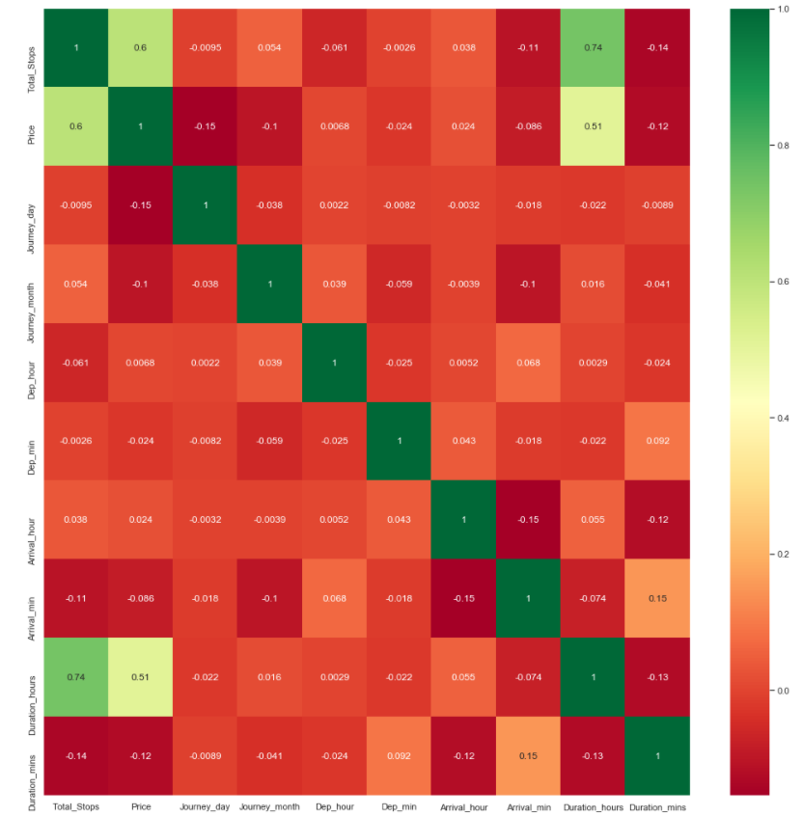

***Figure2: Correlation matrix between the features***

Feature_importance

The absolute stops are playing the main element among every one of the elements. The ExtraTreeRegressor is utilized to discover the feature_importance it checks which component are significant for the result variable (ie) the value which are profoundly corresponded and which have most extreme significance. This procedure is essentially used to lessen the elements not to expand the intricacy of the highlights.

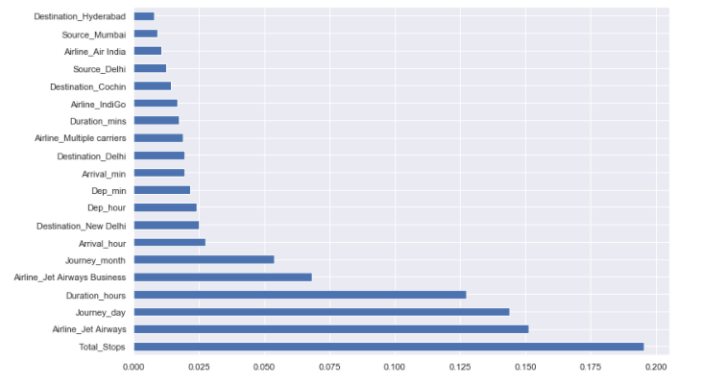

***Figure3: feature importance***

**3.1.7 Fitting model using Random Forest**

In ExtraTreeRegressor the fit() technique is having boundaries train and test (X,y) .It returns the choice is the item which is utilized to fit the train and test dataset. Subsequent to doing one-hot encoding effectively link every one of the highlights Split dataset into train and test set to forecast w.r.t X_test. If necessary do scaling of information Scaling isn't done in Random woods. Import model. Fit the information and Predict w.r.t X_test. In relapse really take a look at RSME Score. Hyper Parameter Tuning for better score. Since information is in type of dominate document can utilize pandas read_excel to stack the information. In the wake of stacking the total data of information as it can give sign a considerable lot of the secret data, for example, invalid qualities in a segment or a column and afterward Check whether or not any invalid qualities are there. in the event that it is available then after should be possible, Imputing information utilizing Imputation technique in sklearn and Filling NaN esteems with mean, middle and mode utilizing fillna() strategy or KNN Imputer Then I attempted to Describe information which can give factual investigation.

ExtraTreesRegressor (n_estimators_1=100,*,

Criterion_1='mse',

max_depth_1=None,

min_samples_split_1=2,

min_samples_leaf_1=1,

min_weight_fraction_leaf_1=0.0,

max_features_1='auto',

max_leaf_nodes_1=None,

min_impurity_decrease_1=0.0,

min_impurity_split_1=None,

bootstrap_1=False,

oob_score_1=False,

n_jobs_1=None,

random_state_1=None,

verbose_1=0,

warm_start_1=False,

ccp_alpha_1=0.0,

max_samples_1=None)

***Code Snippet1:Extra Tree Regressor***

An assessor which fits the choice trees from sub examples and utilizations the normal strategy to get the more precision and controlling the over fitting. As the name demonstrates the trees with gathering is called Extra Trees from RandomForest. ExtraTreeRegressor is a class which characterizes the quantity of trees where highlights are getting from the characterized hubs. The measure can be utilized to part the tree. The profundity of the tree manages the hubs to be parted until the kid hubs are having leaf hubs. The leaf hubs can be separated by utilizing min_samples_leaf _1 esteem, assuming that it has basically min no of hubs to be pruned. The leaf hub is required the amount of the relative multitude of all out loads of the hubs is 0.The hub parted should be possible by utilizing current hub, complete no of tests, the right hub and the left hub of the tree. The split indicates the level of the debasement is more prominent than or equivalent to the zero.

|  |  |  |
| --- | --- | --- |
| **Estimator** | **Cross Validation Score** | **Accuracy** |
| RandomForestRegressor | 90.04% | 97% |
| GradientBoostingRegressor() | 91.54% | 97% |
| XGBRegressor() | 91.54% | 99% |

***Table2: Comparison of Estimators***

estimator = RandomForestRegressor()

param_grid = {

"n_estimators" : [100,300,500],

"max_features" : ["auto", "sqrt", "log2"],

"min_samples_split" : [2,4,8],

"bootstrap": [True,False],

}

rfmodel = GridSearchCV(estimator, param_grid, n_jobs=-1, cv=5)

rfmodel.fit(x, y)

scores = cross_val_score (rfmodel, x, y, cv=5)

print("Cross validation score: {0:.2%} (+/- {1:.2%})".format(np.mean(scores), np.std(scores)*2))

***Code Snippet2:Random ForestRegressor***

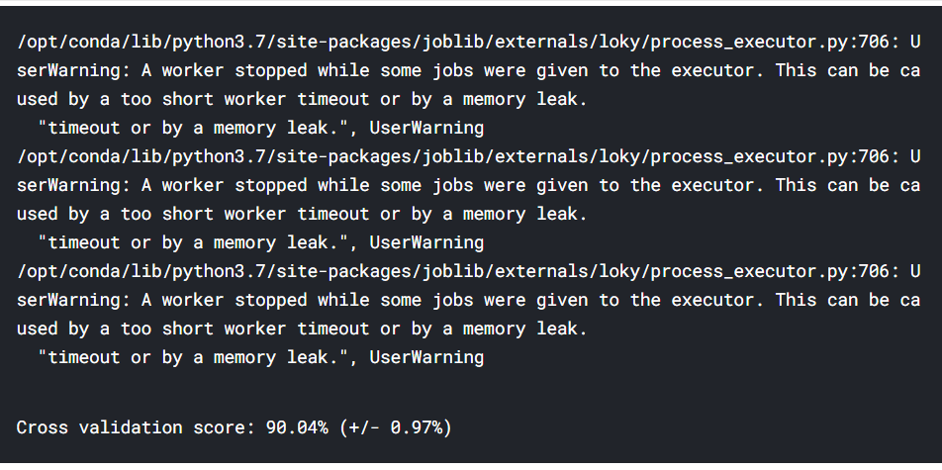

***Figure4: Validation score using Grid SearchCV***

#Gradient Boosting and XGBoost

gbm = GradientBoostingRegressor()

xgb = XGBRegressor()

best_gbm=GridSearchCV(gbm,param_grid={'learning_rate':[0.01,0.05 ,0.1],'max_depth':[3,5,7],'n_estimators':[500]},cv=5,n_jobs=-1)

best_xgb=GridSearchCV(xgb,param_grid={'learning_rate':[0.01, 0.05 ,0.1],'max_depth':[3,5,7],'n_estimators':[500]},cv=5,n_jobs=-1)

best_gbm.fit(x,y)

best_xgb.fit(x,y)

scores = cross_val_score(best_gbm.best_estimator_, x, y, cv=5)

print("GBM Cross validation score: {0:.2%} (+/- {1:.2%})".format(np.mean(scores), np.std(scores)*2))

scores = cross_val_score(best_xgb.best_estimator_, x, y, cv=5)

print("XGBoost Cross validation score: {0:.2%} (+/- {1:.2%})".format(np.mean(scores), np.std(scores)*2))

***CodeSnippet3:XGBoost***

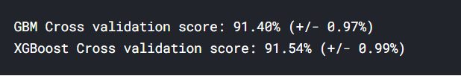

***Figure5: Validation using XGBoost***

**Limitations of cross validation**

The impediment with cross approval too so these are a couple of restrictions that are looked by cross approval:

• In an optimal circumstance, cross approval will deliver ideal outcomes. However, if there should be an occurrence of conflicting information, the outcomes might shift definitely. It is very unsure what sort of information will be experienced by the model.

• Prescient displaying regularly requires and development as far as information, this can essentially change the preparation and the approval sets radically.

• The outcomes might shift contingent on the highlights of the informational collection. Letters se we make a prescient model to identify an arrangement in an individual and prepared it with the particular arrangement of populace. It might shift with everyone causing irregularity and diminished effectiveness.

**4.1 Conclusion**

AI gives answers for parcel of issues while a few issues are unusual and some of them are unsurprising. The anticipated issues can be settled by utilizing relapse which incorporates choice trees. The choice trees are works with the condition which incorporates cross folds to further develop precision which is near the result.

**5.1Findings/Results**

The below table displays the airline data

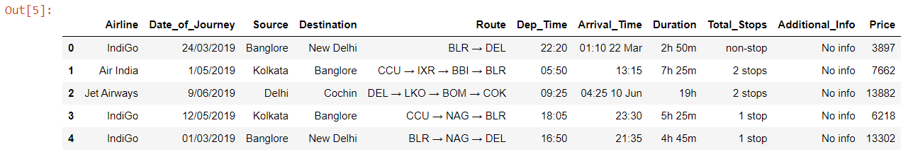

***Figure 6:Airline Data***

The below figure is a catplot which is applied on categorical attribute versus numerical attribute

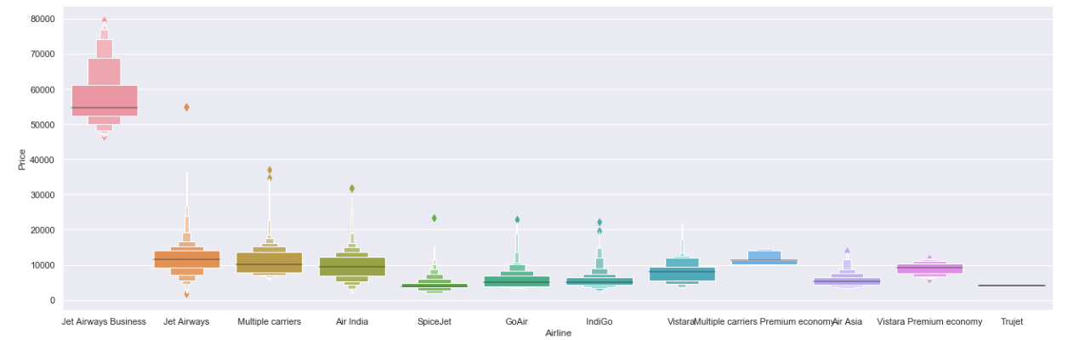

***Figure7: Outlier detection using catplot***

The Nominal data is the data which is not in order to avoid such we can perform one hot encoding

pd.get_dummies(Destination, drop_first = **True**)

pd.get_dummies(Source, drop_first= **True**)

pd.get_dummies(Airline, drop_first= **True**)

***Code Snippet4: One hot encoding***

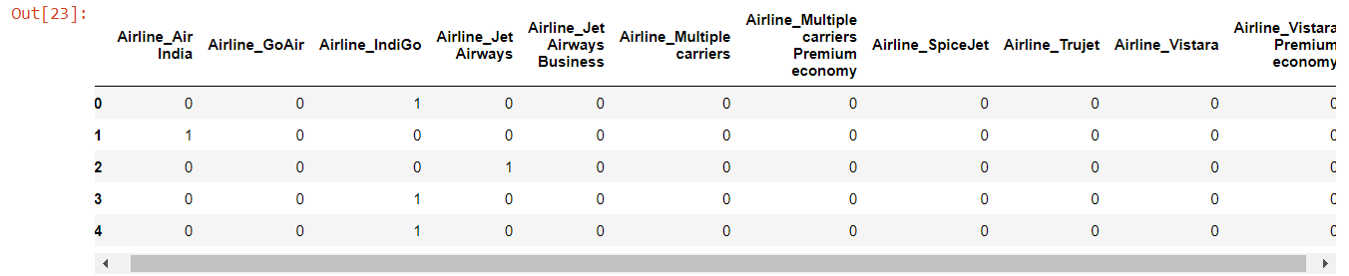

***Figure 8: One hot encoding***

Test data Info

---------------------------------------------------------------------------

<class 'pandas.core.frame.DataFrame'>

RangeIndex: 2671 entries, 0 to 2670

Data columns (total 10 columns):

# Column Non-Null Count Dtype

--- ------ -------------- -----

0 Airline 2671 non-null object

1 Date_of_Journey 2671 non-null object

2 Source 2671 non-null object

3 Destination 2671 non-null object

4 Route 2671 non-null object

5 Dep_Time 2671 non-null object

6 Arrival_Time 2671 non-null object

7 Duration 2671 non-null object

8 Total_Stops 2671 non-null object

9 Additional_Info 2671 non-null object

dtypes: object(10)

memory usage: 208.8+ KB

None

Null values :

---------------------------------------------------------------------------

Airline 0

Date_of_Journey 0

Source 0

Destination 0

Route 0

Dep_Time 0

Arrival_Time 0

Duration 0

Total_Stops 0

Additional_Info 0

dtype: int64

Airline

---------------------------------------------------------------------------

Jet Airways 897

IndiGo 511

Air India 440

Multiple carriers 347

SpiceJet 208

Vistara 129

Air Asia 86

GoAir 46

Multiple carriers Premium economy 3

Jet Airways Business 2

Vistara Premium economy 2

Name: Airline, dtype: int64

Source

---------------------------------------------------------------------------

Delhi 1145

Kolkata 710

Banglore 555

Mumbai 186

Chennai 75

Name: Source, dtype: int64

Destination

---------------------------------------------------------------------------

Cochin 1145

Banglore 710

Delhi 317

New Delhi 238

Hyderabad 186

Kolkata 75

Name: Destination, dtype: int64

Shape of test data : (2671, 28)

RandomizedSearchCV(cv=5,error_score=nan,estimator=RandomForestRegressor(bootstrap=True,ccp_alpha=0.0,criterion='mse',max_depth=None,max_features='auto',max_leaf_nodes=None,max_samples=None,min_impurity_decrease=0.0,min_impurity_split=None,min_samples_leaf=1,min_samples_split=2,min_weight_fraction_leaf=0.0,n_estimators=100,n_jobs=None,oob_score=False,iid='deprecated',n_iter=10,n_jobs=1,param_distributions={'max_depth':[5, 10, 15, 20, 25, 30],'max_features': ['auto', 'sqrt'],'min_samples_leaf': [1, 2, 5, 10],'min_samples_split': [2, 5, 10, 15,100], 'n_estimators': [100, 200, 300, 400, 500, 600, 700, 800,900,1000,1100,1200]},pre_dispatch='2*n_jobs', random_state=42,refit=True, return_train_score=False,scoring='neg_mean_squared_error',verbose=2)

***Output: RandomisedSearchCV***

Lingering blunder is the mistake which is essentially the distinction among real and anticipated worth. This blunder is utilized to work out the different measurements like mean outright mistake, mean square mistake, root mean square mistake. The mean normal blunder (MAE) is the amount of outright contrasts among real and anticipated qualities and it doesn't consider the heading that is positive or negative. In mean outright blunder to discover the contrasts between in the genuine and anticipated qualities. The informational index which contains 5 qualities with genuine and anticipated qualities. The mistake contrast and the outright blunder takes just anticipated worth is negative. Once to get every one of the positive upsides of all blunders add them and discover their mean. The mean square blunder (MSE) is consistently sure and esteem conclusion to 0 or a lower esteem is better. On the off chance that two MSE esteems that are thought about and to check which worth is more like zero. To utilize this large number of qualities for model expectation. Run a model the various boundaries autonomous factors the model with the lower MSE will be e the better worth. We should consider there are 5 qualities with genuine and anticipated and ascertain the mistake which is called distinction and it is utilized to work out the squared blunder. The RMSE is the root mean square blunder works out the square foundation of mean square mistake. The impact of every blunder on root mean square mistake is straightforwardly corresponding to the square mistake which is delicate to the exceptions and can misrepresent results assuming that there are anomalies in the informational index.

print('MAE:', metrics.mean_absolute_error(y_test, prediction))

print('MSE:', metrics.mean_squared_error(y_test, prediction))

print('RMSE:',np.sqrt(metrics.mean_squared_error(y_test, prediction)))

MAE: 1165.606162629916

MSE: 4062650.6911608884

RMSE: 2015.6018186042818

The R2 score is nothing but sum of square of residuals to the sum of square of totals. Consider there is an example the y contains the values of 1,2,3 and y predicted contains the values of 1,2,4. The error which is nothing but sum of squares of residuals is is 0 0 -1. Perform squares for the 0 0 -1 which gives the value as 1. The sum of squares of total is is having a y value 1,2,3 and calculate the mean value as 2. To calculate the deviations-1 0 1. To perform square we got a [1-2,2-2,3-2]

y_prediction = forest.predict(X_test)

metrics.r2_score(y_test, y_prediction)

0.8117443234361064

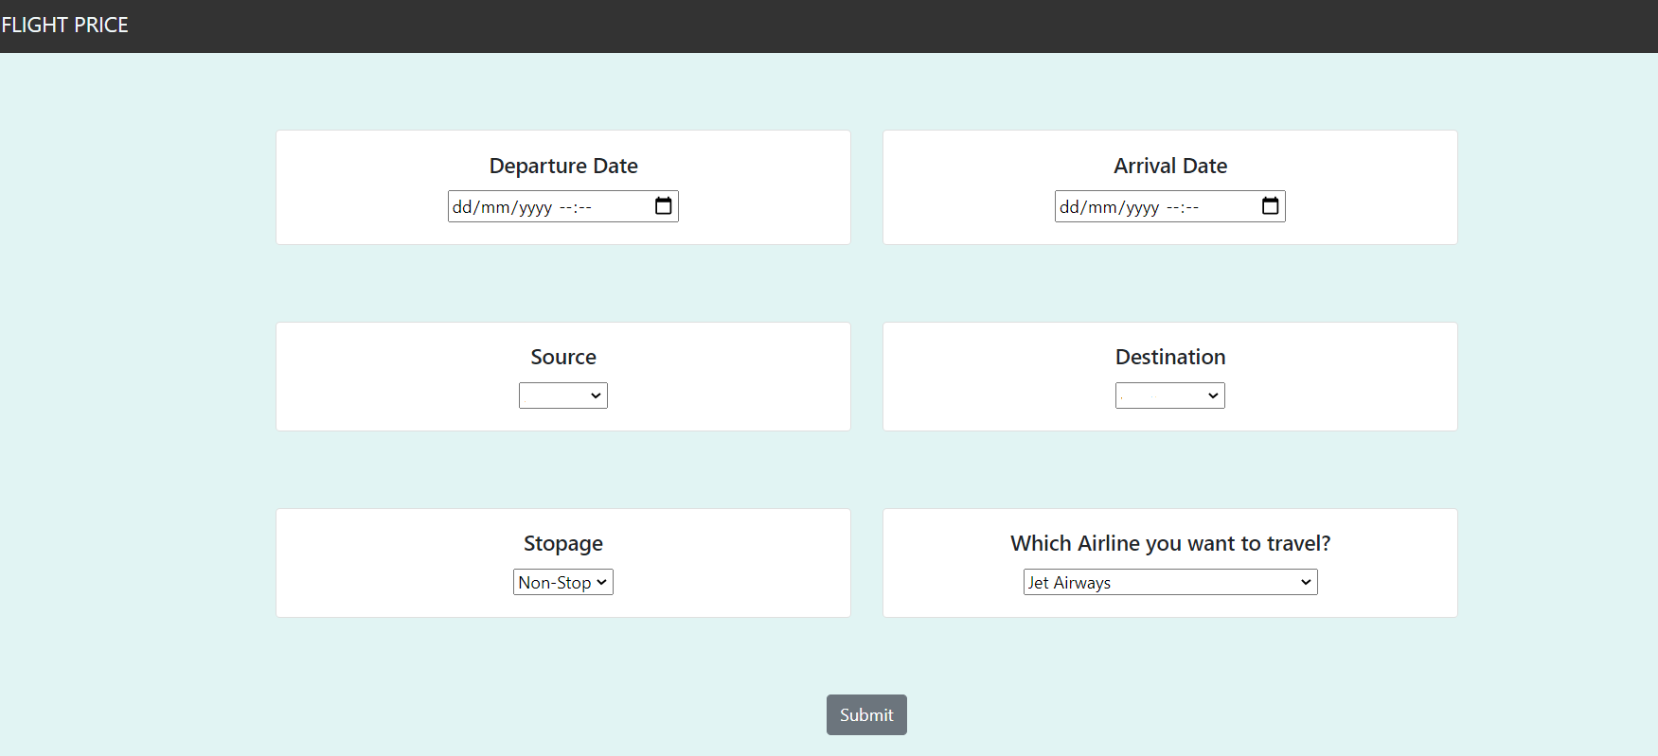

**6. References**

[1]Airline Prices Analysis and Prediction Using Decision Tree Regressor, May 2020,DOI:10.1007/978-981-15-5827-6_15In book: Data Science and Analytics (pp.170-186) by Rachana Jain, Preeti Nagrath

[2] INTERNATIONAL JOURNAL OF SCIENTIFIC & TECHNOLOGY RESEARCH VOLUME 8, ISSUE 12, DECEMBER 2019 ISSN 2277-86163297Predicting The Price Of A Flight Ticket With The Use Of Machine Learning Algorithms by Supriya Rajankar, Neha Sakharkar, Omprakash Rajankar

[3] Airfare Prices Prediction Using Machine Learning Techniques K. Tziridis, Th. Kalampokas,G.A. Papakostas HUMAIN-Lab Department of Computer and Informatics Engineering Eastern Macedonia and Thrace Institute of Technology Kavala, Greece email: { kenaaske, theokala, gpapak}@teiemt.gr K.I. Diamantaras Department of Information Technology TEI of Thessaloniki Sindos, Greece

[4] Predicting Airfare Prices - CS229http://cs229.stanford.edu › proj2012 › Papadakis-PDF by M Papadakis · Cited by 4

[5] <https://www.kaggle.com/nikhilmittal/flight-fare-prediction-mh/>

[6] Study of Machine Learning Algorithms for Special Disease Prediction using Principal of Component Analysis Prof. Dhomse Kanchan B. Assistant Professor of IT department MET’S BKC IOE, Nasik Nasik, India kdhomse@gmail.com, 2016 International Conference on Global Trends in Signal Processing, Information Computing and Communication

[7] P. Arumugam, V. Kadhirveni, R. Lakshmi Priya, Manimannan G,Prediction Cross Validation and Classification in the Presence COVID-19 of Indian States and Union Territories using Machine Learning Algorithms,Blue Eyes Intelligence Engineering and Sciences Publication, International Journal of Recent Technology and Engineering (IJRTE) ISSN: 2277-3878, Volume-10 Issue-1, May 2021.

[8]XGBoost: A Scalable Tree Boosting System,Tianqi Chen, University of Washington,tqchen@cs.washington.edu

Carlos Guestrin, Universityof Washington, guestrin @cs.washi ngton.edu ,KDD ’16, August 13-17, 2016, San Francisco, CA, USA.

[9] A Comparative Study of Categorical Variable Encoding,Techniques for Neural Network Classifiers

Kedar Potdar,Student, Taher S. Pardawala,Student, Chinmay D. Pai,Student, Computer Engineering. International Journal of Computer Applications (0975 – 8887),Volume 175 – No.4, October 2017.

[10] K. Potdar and R. Kinnerkar, “A Non-linear Autoregressive Neural Network Model for Forecasting Indian Index of Industrial Production”, Proceedings of the IEEE Tensymp 2017, Kochi, India

[11] Cross-validation: Daniel Berrar, Data Science Laboratory, Tokyo Institute of Technology,2-12-1-S3-70 Ookayama, Meguro-ku,Tokyo152-8550, Japan, Email: [daniel.berrar@ict.e.titech .ac. jp](mailto:daniel.berrar@ict.e.titech%20.ac.%20jp), Encyclopedia of Bioinformatics and Computational Biology, Volume 1, Elsevier, pp. 542–545.

[12] Random Search for Hyper-Parameter Optimization,James Bergstra JAMES.BERGSTRA@UMONTREAL.CA

Yoshua BengioYOSHUA.BENGIO@UMONTREAL.CA,Departe ment d ’Informatique et de recherche op ´ erationnelle ´

Universite de Montr ´ eal ´Montreal, QC, H3C 3J7, Canada