OdontoApp Test

Version: V.0.6.0

* 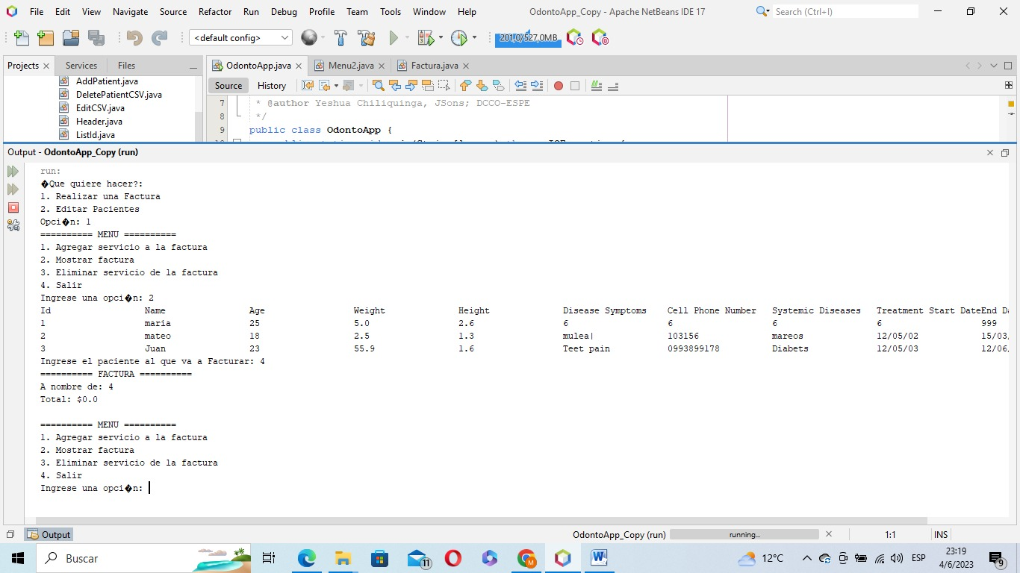When making the invoice, it allows the entry of a number instead of a name.
* 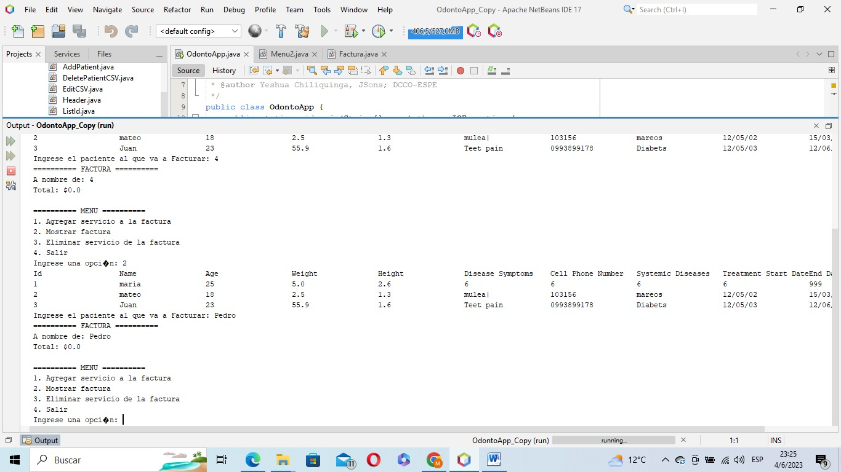The application does not validate if a person is registered at the time of making the invoice.
* The application does not present the services when we want to remove one of them from the bill.

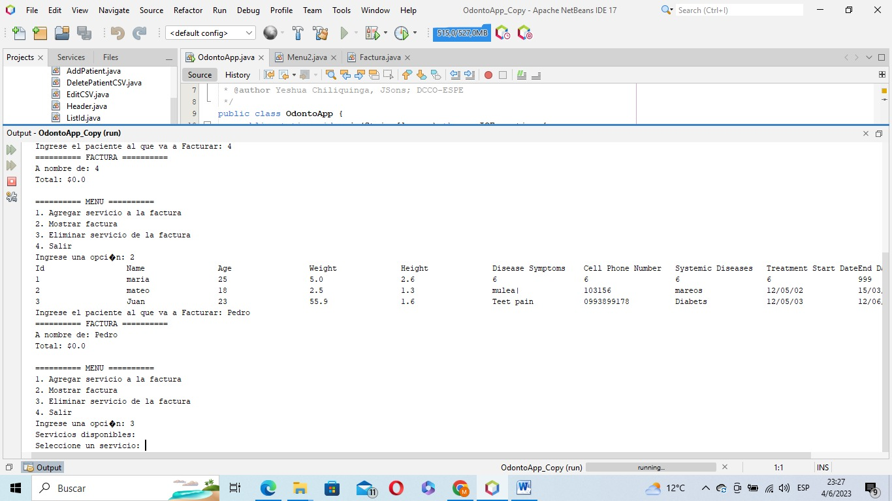

* 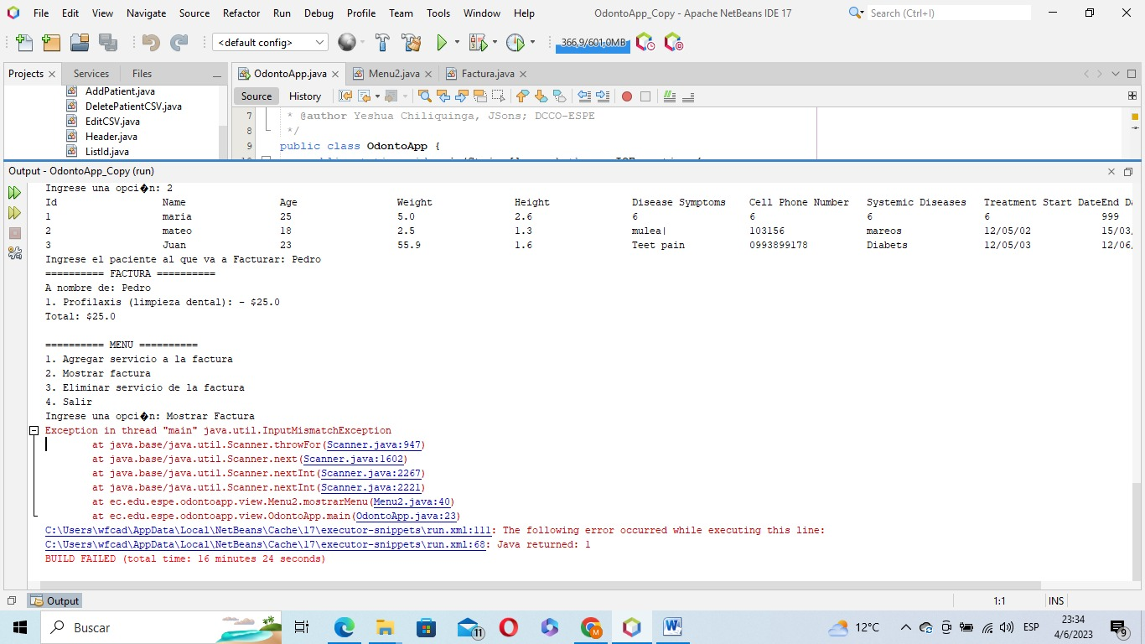Invoice menu has errors when entering letters instead of numbers.
* The program crashes when entering letters instead of numbers in the main menu.

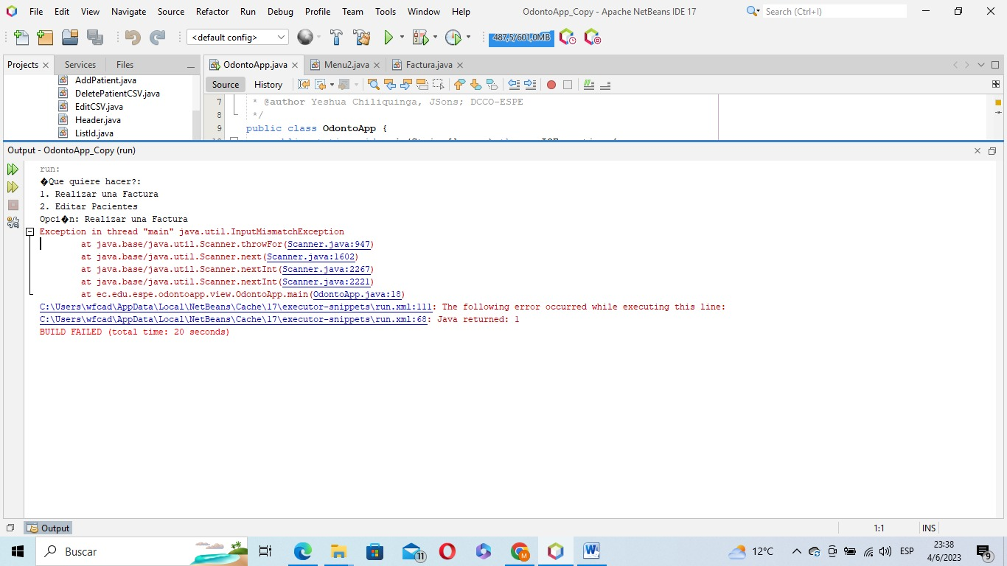

* The program does not ask to whom the service is added when we generate a bill first.

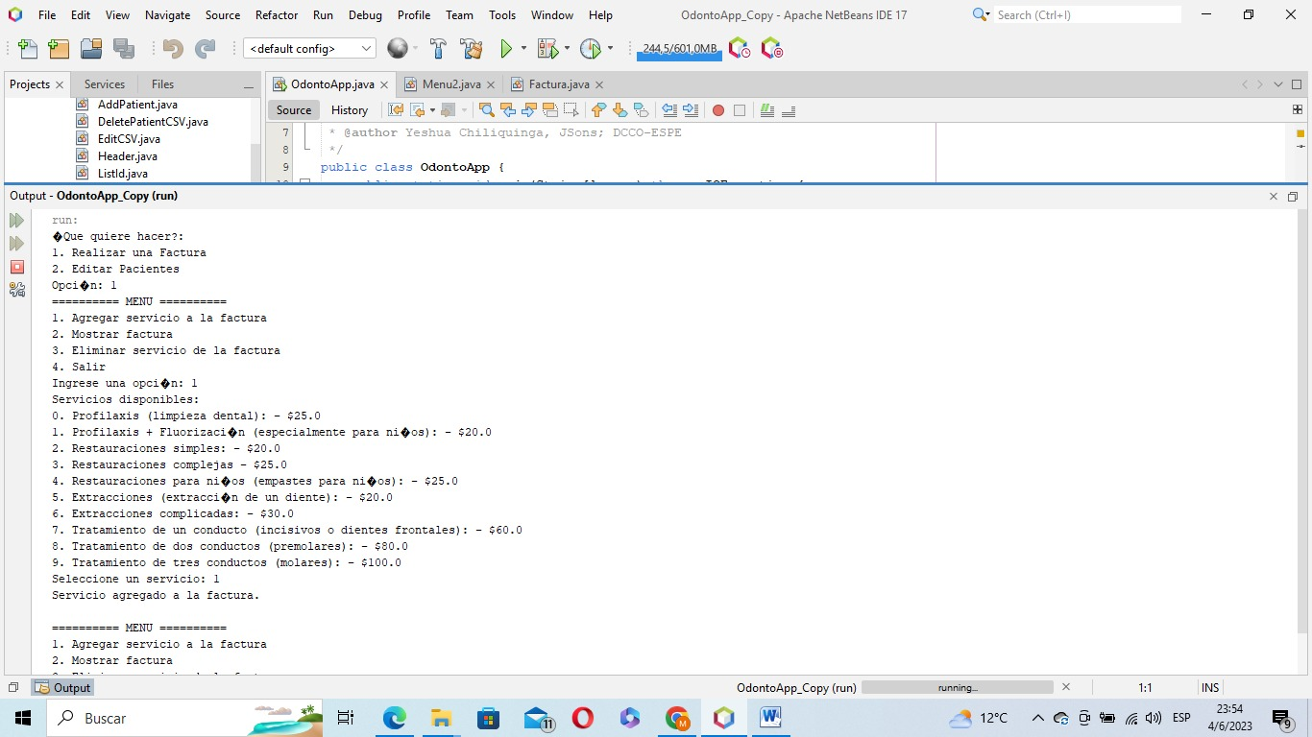

* 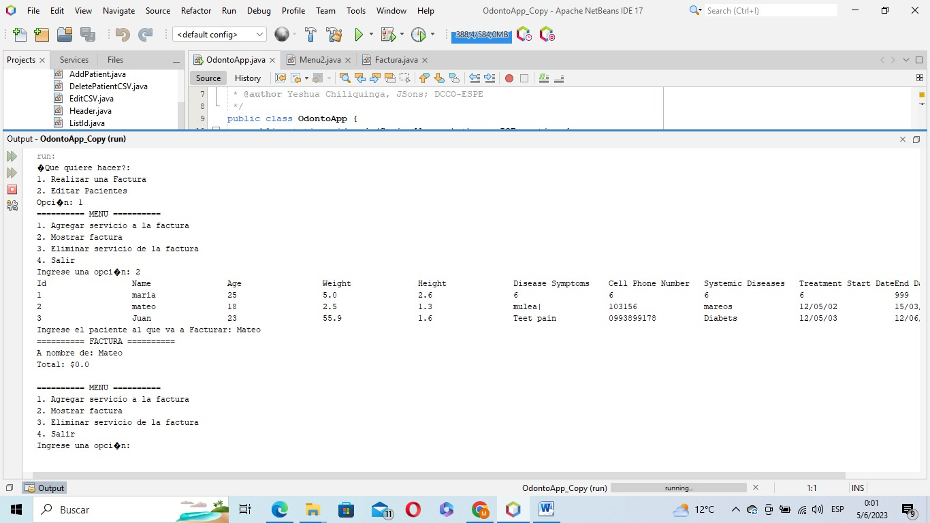The application does not generate invoices by id, but by name.
* The program crashes if I enter the name of the service instead of the number in the list of services.

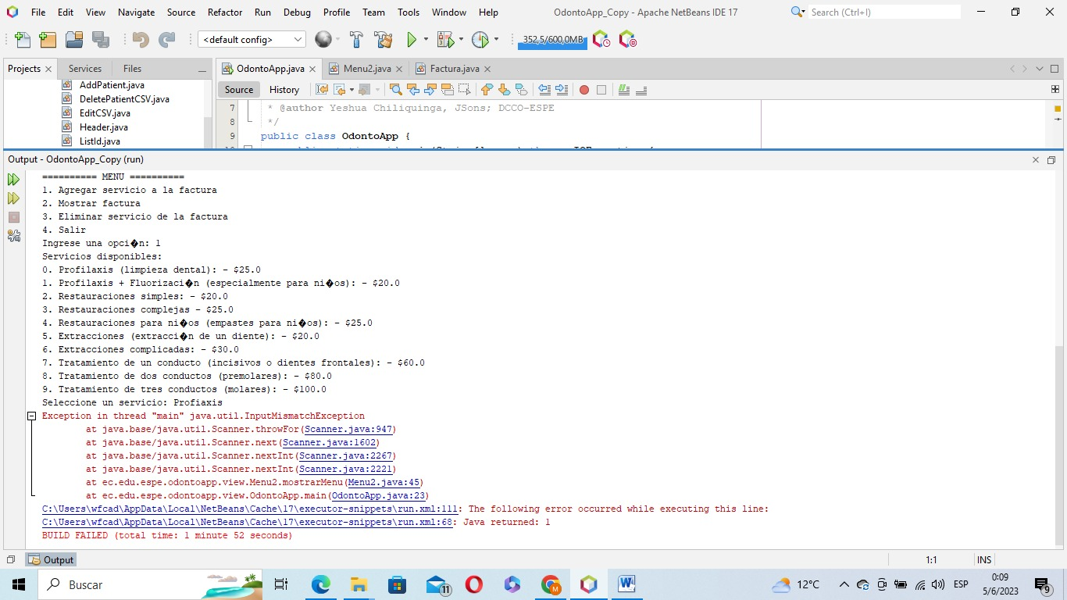

* 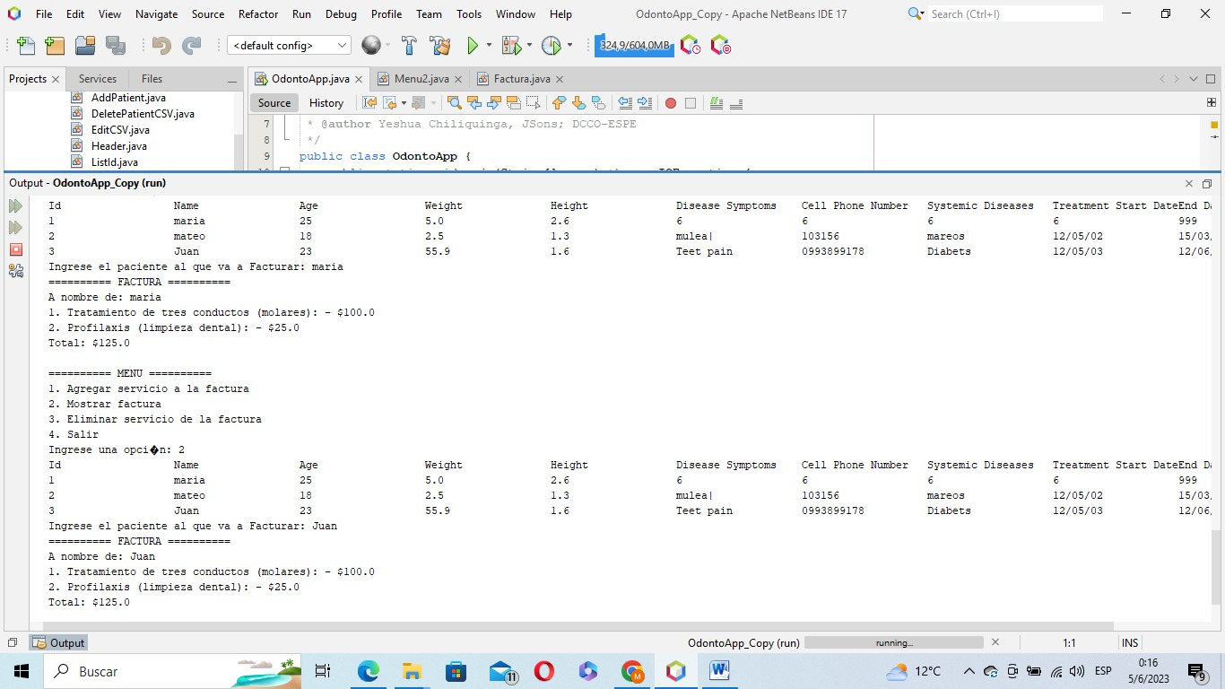Application aggregates the same bill for all patients.