OdontoApp Test

Version: V.0.2.0

public class ReadPatientsCSV {

* 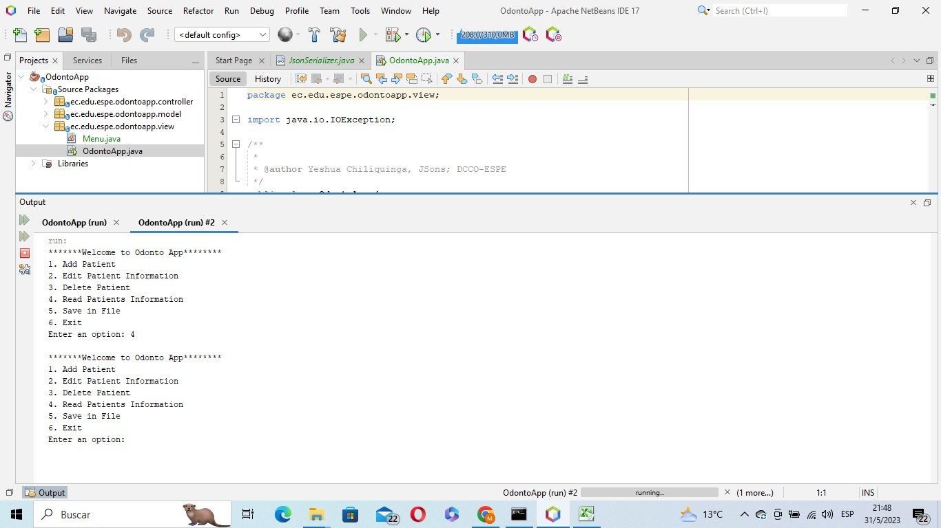The program doesn´t show an error message or any exception if I try the “Read data” option and I don´t have any data saved.

public class writePatientCSV {

* The program doesn´t present a message when it is saving files.

public class AddPatient {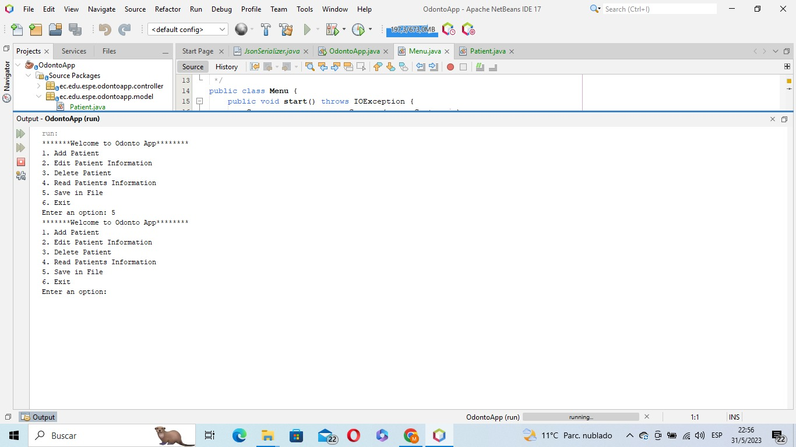

* The program doesn´t handle “ID”.

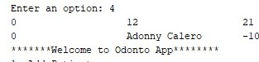

* The program doesn´t validate if a number is entered in the name field.

C:\Users\wfcad\Downloads\WhatsApp Image 2023-05-31 at 10.27.26 PM.jpeg

* The program doesn´t validate that the age is negative.

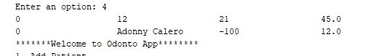

* The program receives incorrect date data.

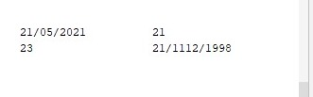

* In the cellphone number field the program allows the entry of letters.

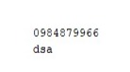

public class Menu {

* 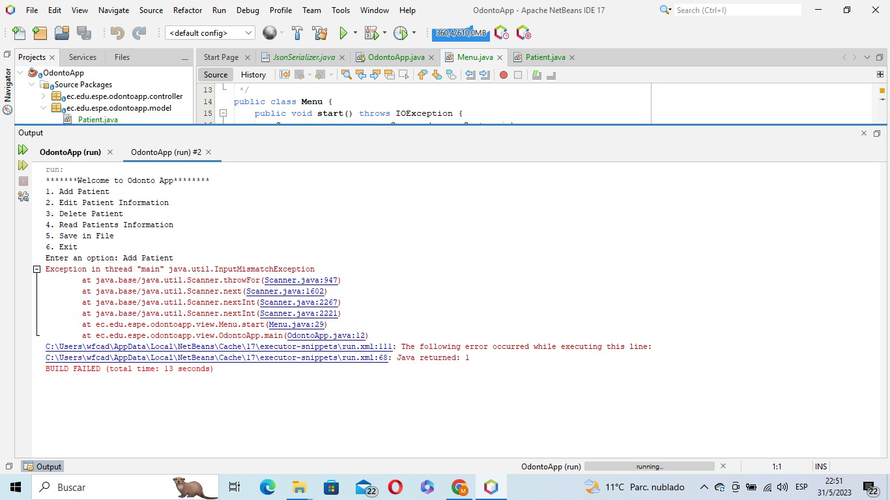If letters are entered in the menu options the program crashes.

public class EditCSV {

* 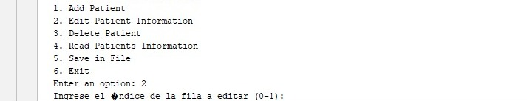In the option to edit patient information, it doesn´t display the current information that is saved.
* 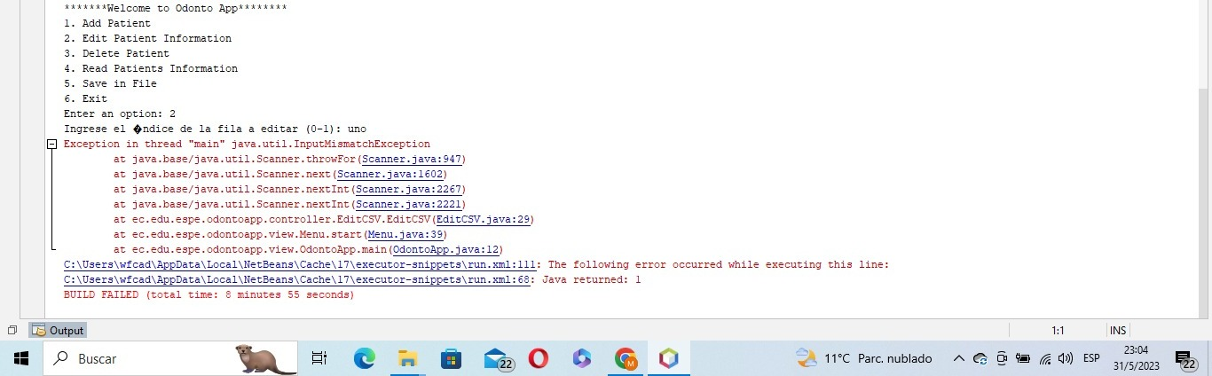The program crashes when we choose the “Edit patient information” option and we entered letters instead of numbers.

