OdontoApp Test

Version: V.0.4.0

* The program does not validate that numbers are entered in the name section.

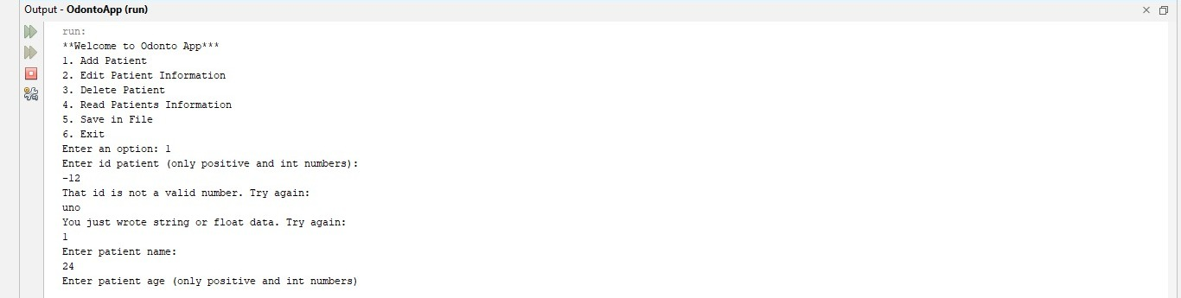

* The system allows you to enter a negative phone number.
* The program has an error when you chose the read the patient information option because first a message is printed that said that there is not registered any patient and then the patient data is printed.

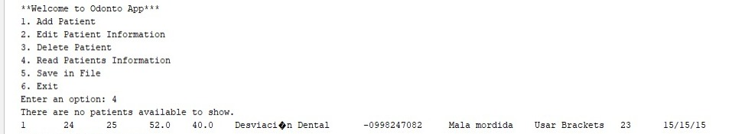

* The program receives erroneous date data.

C:\Users\wfcad\Downloads\WhatsApp Image 2023-06-01 at 12.56.43 AM.jpeg

* The program does not print a message when saving the data.

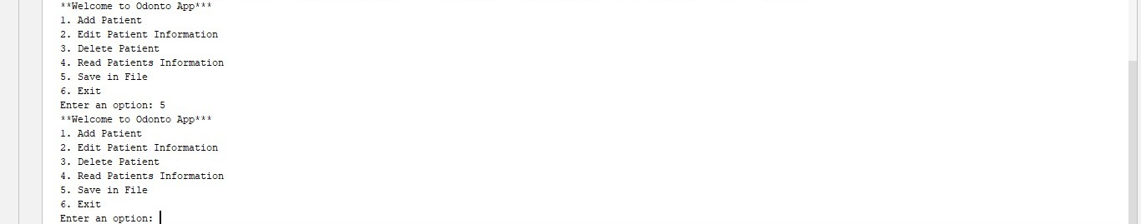

* The program doesn´t verify that the ID´s cannot be repeated.
* The program doesn´t generate the ID´s automatically.



* The program should improve its interface for user understanding.

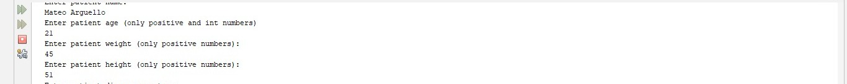

* When choosing the option to delete a patient, the program prints an erroneous message.

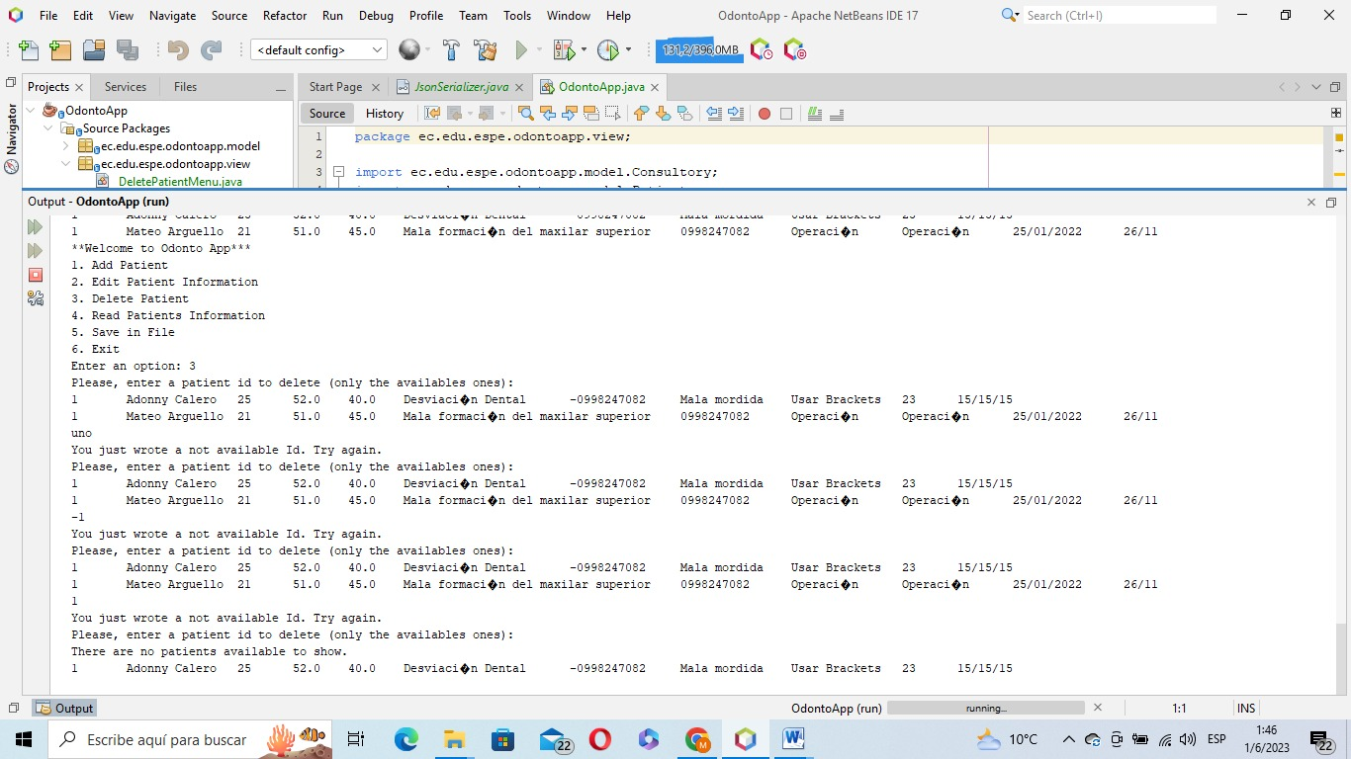

* In the option to delete the patient, the program remains in that option, that is, you cannot return to the main menu.

