**1. INTRODUCTION**

### Introduction

### This review paper deals with the sensible police investigation observation system exploitation completely different techniques. This method will increase the usage of mobile technology to produce an important security to trade, our homes and alternative management application. Web technology provides an honest manner for America to develop associate integrated computing network surroundings for the applying of various robotic systems.

### The idea of web based mostly robots is new technology and it doesn't have the restrictions of the vary of operation. At an equivalent time, the necessity to look at additional and additional folks, places, and connected with a need to tug out of things additional helpful info from the video knowledge, the unfold of exploitation embedded systems is motivating the new demands capabilities and capability.

### In such cases, we have a tendency to might use the planned robotic system whose operating supported Raspberry pi, which can enter those areas and supply America with the data within the kind of live videos of these locations. once somebody enters such extremely secured places, the camera mounted on the golem can continue capturing the videos from the environment to stay a record of the small print of the incident happened and this is often be} without delay accessible to the user and solely the attested users can see the recorded details.

### It can even realize the amount of persons situated with the assistance of the Infrared device. This review paper offers a peculiar approach towards closed-circuit television.

* 1. **Existing System :-**

Many systems are developed based mostly technologies like GSM and Zigbee. GSM electronic equipment that desires a lively SIM to send/receive SMS through microcontroller. Here the road controller 89C51 is connected to GSM electronic equipment through its UART port (Serial Ports).Sim card employed in the GSM module conjointly be is also compromised with bound risk and also the value of developing such system is sort of high. Security algorithmic rule adopted in GSM (e.g. A3, A5) is all not disclosed algorithms.

**Disadvantages:**

1. Sometimes due to the signal the message may not delivered.

2. Accuracy is low

3. Cost effective is also high compared to the other one

**1.3 Proposed system:-**

The planned system contains the digital camera, and raspberry pi, raspberry pi is that the heart of the project, raspberry pi at the side of the PCB containing motor driver IC and transformer electronic equipment. One will management the golem from remote finish say mobile or portable computer with the utilization of web and additionally we are able to get the live streaming of video from the golem for the aim of police work, this video is obtained on application of the remote device from wherever we have a tendency to square measure in operation the device additionally we have a tendency to square measure able to management the robotic movement. Camera is employed to capture the photographs, IR detector is employed to discover the thing if any object is detected it'll send the e-mail. DC motors square measure getting used for the movement of robotic wheels and stepper motor is employed for camera movement.

**Advantages:**

1. No need of man power
2. Easy to use
3. We can control remotely

**1.4 Embedded systems:-**

An embedded system may be a computing system designed to perform one or a number of dedicated functions usually with period computing constraints. It’s embedded as a part of an entire device usually as well as hardware and mechanical components. In contrast, an all-purpose pc, like a private pc (PC), is intended to be versatile and to fulfill a large vary of end-user wants. Embedded systems management several devices in common use these days. Embedded systems are controlled by one or a lot of main process cores that are usually either microcontrollers or digital signal processors (DSP). The key characteristic, however, is being dedicated to handle a selected task, which can need terribly powerful processors. As an example, traffic management systems could usefully be viewed as embedded, although they involve mainframe computers and dedicated regional and national networks between airports and measuring instrument sites. (Each measuring instrument most likely includes one or a lot of embedded systems of its own.)

Since the embedded system is devoted to specific tasks, style engineers will optimize it to cut back the scale and price of the merchandise and increase the irresponsibleness and performance. Some embedded systems are factory-made, cashing in on economies of scale.

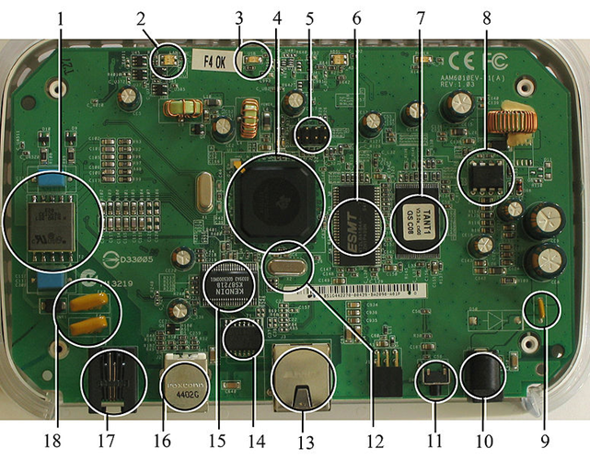

**Fig 1.4: A modern example of embedded system**

In general, "embedded system" isn't a strictly determinable term, as most systems have some part of extensibility or programmability. For instance, hand-held computers share some parts with embedded systems like the in operation systems and microprocessors that power them, however they permit totally different applications to be loaded and peripherals to be connected. Moreover, even systems that do not expose programmability as a primary feature typically got to support software package updates. On a time from "general purpose" to "embedded", massive application systems can have sub elements at the most points though the system as a full is "designed to perform one or many dedicated functions", and is therefore acceptable to decision "embedded". a contemporary example of embedded system is shown in fig: on1.4

**1.4.1 History:-**

In the earliest years of computers within the 1930–40s, computers were typically dedicated to one task, however were way large and dear for many varieties of tasks performed by embedded computers of nowadays. Over time but, the thought of programmable controllers evolved from ancient mechanical device sequencers, via solid state devices, to the utilization of technology. One in all the primary recognizably trendy embedded systems was the Apollo steerage laptop, developed by Charles Stark trader at the university Instrumentation Laboratory.

At the project's beginning, the {apollo|Apollo|Phoebus|Phoebus Apollo Greek deity} steerage laptop was thought-about the riskiest item within the Apollo project because it utilized the then recently developed monolithic integrated circuits to cut back the dimensions and weight. AN early factory-made embedded system was the Autonetics D-17 steerage laptop for the Minuteman missile, free in 1961. It absolutely was engineered from junction transistor logic and had a tough disk for main memory. Once the Minuteman II went into production in 1966, the D-17 was replaced with a brand new laptop that was the primary high-volume use of integrated circuits.

**1.4.2 Tools:-**

Embedded development makes up a small fraction of total programming. There's also a large number of embedded architectures, unlike the PC world where 1 instruction set rules, and the UNIX world where there's only 3 or 4 major ones. This means that the tools are more expensive. It also means that they're lowering featured, and less developed. On a major embedded project, at some point you will almost always find a compiler bug of some sort.

**1.4.3 Resources:-**

To save prices, embedded systems oft have the most cost effective processors which will do the task. This suggests your programs have to be compelled to be written as expeditiously as doable. once handling massive knowledge sets, problems like cache misses that ne'er matter in laptop programming will hurt you. Luckily, this would possibly not happen too often- use moderately economical algorithms to begin, and optimize only necessary. Of course, traditional profiles will not work well, thanks to constant reason debuggers do not work well.

**1.4.1 Real Time Issues:-**

Embedded systems of times management hardware, and should be ready to answer them in real time. Failure to try to thus might cause quality in measurements, or maybe injury hardware like motors. This is often created even harder by the shortage of resources accessible. The majority embedded systems got to be ready to order some tasks over others, and to be ready to place off/skip low priority tasks like UI in favor of high priority tasks like hardware management.

**1.4.2 Need for Embedded Systems:-**

The uses of embedded systems area unit just about limitless, as a result of a day new merchandise area unit introduced to the market that utilizes embedded computers in novel ways in which. In recent years, hardware like microprocessors, microcontrollers, and FPGA chips became less expensive. Therefore once implementing a replacement kind of management, it's wiser to only get the generic chip and write your own custom software package for it. Manufacturing a customized chip to handle a selected task or set of tasks prices way more time and cash. Several embedded computers even go together with in depth libraries, in order that "writing your own software" becomes a really trivial task so. From AN implementation viewpoint, there's a significant distinction between a pc and an embedded system.

**1.4.2(a) Debugging**

Debugging is that the method of finding and breakdown defects or issues inside a worm that stop corrects operation of pc code or a system.

* External rectifying victimization work or port output to trace operation victimization either a monitor in flash or employing a debug server just like the Remedy programmer that even works for heterogeneous multi core systems.
* An in-circuit copycat replaces the silicon chip with a simulated equivalent, providing full management over all aspects of the silicon chip.
* Interactive resident debugging, victimization the easy shell provided by the embedded OS (e.g. Forth and Basic)

**1.4.2(b) Reliability**

Embedded systems typically reside in machines that are expected to run endlessly for years while not errors and in some cases recover by them if miscalculation happens. Thus the package is sometimes developed and tested a lot of fastidiously than that for private computers, and unreliable mechanical moving elements like disk drives, switches or buttons are avoided.

**2. LITERATURE REVIEW**

**1. Survey on Design of an IoT based Warfare Car Robot using Sensor Network**

**Connectivity**

**Abstract:-**

Robots stay the main target of researchers and developers, and currently they're moving towards IoT based mostly devices and mobile robots to require advantage of the various sensing element allows facilities. A mechanism may be a machine capable of concluding a posh series of actions mechanically, particularly one programmable by a laptop. A mechanism is controlled by a person's and will be changed by its practicality at runtime by the operator. From past few decades, researchers area unit causative towards artificial intelligence. There’s without stopping of technology, creativity, and innovation. The project is meant to develop a mechanism mistreatment automaton application for remote operation hooked up to the wireless camera for watching purpose. Police work mistreatment the camera will facilitate the soldier team to create methods at run-time. This type of mechanism is useful for spying purpose in war fields. The automaton application loaded on mobile devices will connect with the protection system and simple to use user interface and mental image of the Warfield. The security system then acts on these commands and responds to the user. The camera and also the motion detector area unit hooked up to the system for remote police work mistreatment wireless protocol 802.11, ZigBee and Bluetooth protocols. This mechanism has the practicality of mines detection, object detection, GPS used for location and navigation and a gun to fireplace the enemy at the runtime.

**Conclusion:-**

Research groups are modifying the previously designed robots for new purposes and different aspects. We started our work from zero. However, our collaboration, hardworking, skills, and ambition gave us the power of doing best work. Our best understanding and combinesearches on parallel fields helped us to accomplish our work correctly. Now we can say that we can do more efficient work and can perform more difficult task easier. Our idea is mainly for army use. The army is doing researches on this type of ideas and doing their lab works to build a capable working robot. It will replace the humans and will save many lives in critical situations. We are very hopeful with our idea that it will bring a significant change in our technical field and our minds.

**2. Survey on Gesture Control Interface of a Robot-Car Using Raspberry-PI**

**Abstract:-**

The integration of additional and additional practicality into the human machine interface (HMI) of vehicles will increase the quality of device handling. So best use of various human sensory channels is an approach to change the interaction with in-car devices. Exploitation this idea, a car-robot is enforced whose navigation is done wirelessly with the assistance of a Raspberry Pi. Robots area unit presently enjoying an enormous role in our lives. There is a unit completely different sort of robots: wheeled robots, flying robots, manufactory building robots. The present thanks to management this robots area unit by exploitation a keyboard, joystick or pre-programmed commands. This project is getting ready to introduce a brand new approach to control a golem and it's by exploitation gestures. This project is to create an overseas management robot (car), which is controlled from distance exploitation solely gestures. The project has 2 elements an automobile and a sway station. The management station is laptop which has gesture recognition hardware in order that it will sight the commands and send them to the car. The management station is that the small laptop Raspberry Pi 3B. The information from the hand movements with the assistance of the measuring device area unit fed into the Encoder HT 12E through the Raspberry Pi. Then the values area unit transmitted with the assistance of Lone-Star State 434. Rx 434 receives the values within the receiver half, wherever it's decoded by a Decoder HT 12D and sent to the motor driver L293D. So motors area unit controlled with the information obtained from the motor drive**r.**

**Conclusion:-**

The main objective of the project was to create a robot-car that may run with the assistance of the hand gestures obtained from the measuring system MPU 6050 mistreatment wireless RF communication. A Raspberry Pi model 3B was used as a microcontroller. The automobile is showing correct movements for the pre-determined and tag completely different hand gestures. The info from the hand movements with the assistance of the measuring system are fed into the Encoder HT 12E through the Raspberry Pi. Then the values are transmitted with the assistance of American state 434. Rx 434 receives the values within the receiver half, wherever it's decoded by a Decoder HT 12D and sent to the motor driver L293D. Thus motors are controlled with the info obtained from the motor driver. The automobile solely moves once the measuring system is moved in a very specific direction as per the given calibrated values of the measuring system

**3. MOTIVATION**

Indeed, the relevant side of IoT isn't solely associated with the type of objects concerned, however to the type of knowledge retrieved. This is often the explanation why IoT is additionally referred to as web of everything. By interfacing directly with folks associated their expertise of a product (both associate object and an application), the accuracy of knowledge is granted. The IoT is developing as a lot of and a lot of enterprises have gotten concerned in sensible comes regarding business intelligence tools. Cisco, the most important networking company within the world, estimates the IoT ‘will contain fifty billion devices connected to the web by 2020’.

The purpose of the developing a project "Robocop: a video surveillance robot through iot using raspberry pi " is to computerized the surveillance of the secured places and borders of army which is user friendly simple, fast and cost effective. It detects the threats with the help of IR sensor. it consist of face detection to detect the threats it is having the database. it is done manually. The main function of the system is to surveillance of the places which it is allocated and gives us the alert meaningfully.

In this system we have gas sensor, smoke detector and face detection. The gas sensor is used to detect the harmful gases which can harm the humans when it detects the gases it gives us the alert

And smoke detector is used to detect the smokes. When the project is live we can stream the live video streaming.

IoT techniques support innovative businesses by permitting the chance to raised assess their customers’ feedback whereas exploitation their merchandise. The quality of information is definitely a bonus for fast the (re)positioning of a product on the market .IoT applications is employed in all sectors and altogether types of daily activities. Therefore, a corporation will begin developing its comes by that specialize in its own merchandise. That’s the rationale why Microsoft talks concerning “Internet of Your things”. Companies exploitation IoT solutions, cash in of industrial services given by good machines and optimized operations. Through AN increased analytics management, they improve conjointly their potency and productivity. Being AN evolving technology however conjointly AN incentive for innovation, IoT is attracting policy manufacturer’s attention on the creation of latest and specific policy and restrictive frameworks. Government’s area unit providing funding and benefits to IoT start-ups.IoT techniques area unit effecting large-scale amendment in however individuals live and work. AN example is given by the principal means that used nowadays to bring the IoT to consumers: the smartphone. Each reception or at work, at the workplace or within the warehouse, good devices and robots area unit up lifestyle and activities. The IoT can in all probability facilitate what the Organization for Economic Co-operation and Development (OCED) calls Next production revolution. In a stimulating paper, IoT technology represents the promise for ‘higher productivity, greener production, and new merchandise, services and business models that may facilitate meet international challenges. Despite several producing sectors have become more and more robotic, IoT devices don't seem to be commutation human labor. With the exception of the management and projected activities, the adoption of self-driving robots needs human coaching, maintenance and internal control. So, individuals can still be required within the production processes however they'll be helped by IoT solutions. The IoT provides the chance to attach, manage and management plenty of devices and objects that it had been attainable} to attach within the past and this can be possible because of the large choice of existing platforms and protocols. With the property provided to new assets, it's conjointly potential to gather knowledge that hasn’t been out there before. This helps enterprises to retrieve new data, to develop new options for his or her merchandise and to earn new revenues. The transport business is one in all the sectors fullest of interconnectivity. IoT solutions are embedded into machine-controlled and connected vehicles, therefore enhancing the potency of mobility.

**4. OBJECTIVES**

Preliminary investigation examines project feasibility; the chance the system is going to be helpful to the organization. The most objective of the practicability study is to check the Technical, Operational and Economical practicability for adding new modules and debugging previous running system. All systems area unit possible if they're given unlimited resources and infinite time. There are unit aspects within the practicability study portion of the preliminary investigation:

* Technical Feasibility
* Operation Feasibility
* Economic Feasibility
* Social Feasibility

**Technical Feasibility:**

This study is distributed to examine the technical practicableness, that's the technical necessities of the system. Any system developed should not have a high demand on the obtainable technical resources. This may cause high demands being placed on the shopper. The developed system should have a modest demand, as solely lowest or null changes for the implementing this technique.

**Operation Feasibility:**

**User-friendly**

Customer can use the forms for his or her numerous transactions i.e. for adding new routes, viewing the routes details. Additionally the client needs the reports to look at the varied transactions supported the constraints. These forms and reports are generated as easy to the consumer.

**Reliability**

The package wills pick-up current transactions on line. Concerning the recent transactions, User can enter them in to the system.

**Security**

The web server and info server ought to be protected against hacking, virus etc.

**Portability**

The application are going to be developed victimization normal open supply software system (Except Oracle) like Java, Felix domestics internet server, web individual Browser etc. these software system can work each on Windows and UNIX operating system o/s. therefore immovableness issues won't arise.

**Availability**

This software system is going to be obtainable invariably.

**Maintainability**

The system known as the wheels uses the 2-tier design. The first tier is that the user interface, that is claimed to be front-end and therefore the 2d tier is that the info, that uses My-Sql, that is that the back-end.

The front-end may be run on totally different systems (clients). The info is going to be running at the server. Users access these forms by victimization the user-ids and therefore the passwords.

**Economic Feasibility**

The computerized system takes care of the present existing system’s data flow and procedures completely and should generate all the reports of the manual system besides a host of other management reports.

It should be built as a web based application with separate web server and database server. This is required as the activities are spread throughout the organization customer wants a centralized database. Further some of the linked transactions take place in different locations.

Open source software like TOMCAT, JAVA, MySQL and Linux is used to minimize the cost for the Customer.

**Social Feasibility**

The facet of study is to envision the extent of acceptance of the system by the user. This includes the method of coaching the user to use the system with efficiency. The user should not feel vulnerable by the system, instead should settle for it as a necessity. The extent of acceptance by the users entirely depends on the strategies that area unit used to teach the user regarding the system and to form him conversant in it. His level of confidence should be raised in order that he's additionally able to build some constructive criticism that is welcome, as he's the ultimate user of the system.

**5. PROBLEM STATEMENT**

**5.1 Existing system**

Many systems are developed based mostly technologies like GSM and Zigbee. GSM electronic equipment that desires a lively SIM to send/receive SMS through microcontroller. Here the road controller 89C51 is connected to GSM electronic equipment through its UART port (Serial Ports).Sim card employed in the GSM module conjointly be is also compromised with bound risk and also the value of developing such system is sort of high. Security algorithmic rule adopted in GSM (e.g. A3, A5) is all not disclosed algorithms.

**Disadvantages:**

1. Sometimes due to the signal the message may not delivered.
2. Accuracy is low
3. Cost effective is also high compared to the other one.

**5.2 Proposed system**

The planned system contains the digital camera, and raspberry pi, raspberry pi is that the heart of the project, raspberry pi at the side of the PCB containing motor driver IC and transformer electronic equipment. One will management the golem from remote finish say mobile or portable computer with the utilization of web and additionally we are able to get the live streaming of video from the golem for the aim of police work, this video is obtained on application of the remote device from wherever we have a tendency to square measure in operation the device additionally we have a tendency to square measure able to management the robotic movement. Camera is employed to capture the photographs, IR detector is employed to discover the thing if any object is detected it'll send the e-mail. DC motors square measure getting used for the movement of robotic wheels and stepper motor is employed for camera movement.

**Advantages:**

1. No need of man power.
2. Easy to use.
3. We can control remotely.

**5.3 Requirements**

**5.3(a) Hardware requirements**

1. Raspberry pi
2. RPS
3. Camera
4. Motor driver & motors.
5. IR sensors.

**5.3(b) Software requirements**

1. Raspbian OS.
2. Python.

**5.4 Block Diagram**

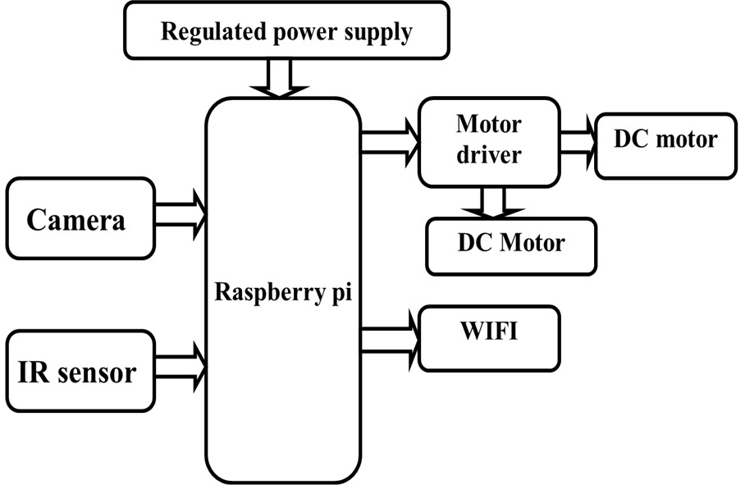

**Fig.no:-5.4 Block diagram**

**6. DESIGN METHODOLOGY**

**6.1 Power supply**

All digital circuits need regulated power offer. During this article we tend to are progressing to find out how to induce a regulated positive offer from the mains offer.

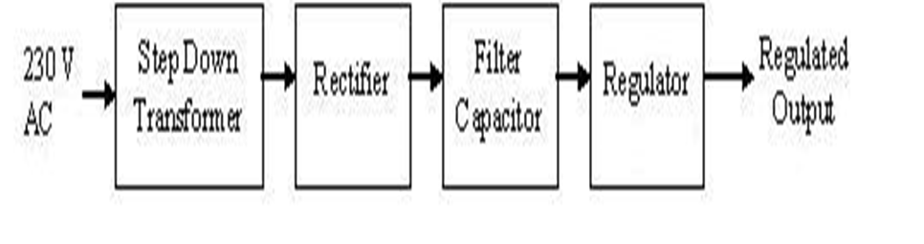

**Fig.no:- 6.1 power supply**

Figure 1 shows the basic block diagram of a fixed regulated power supply. Let us go through each block.

**6.1.1 Transformer**

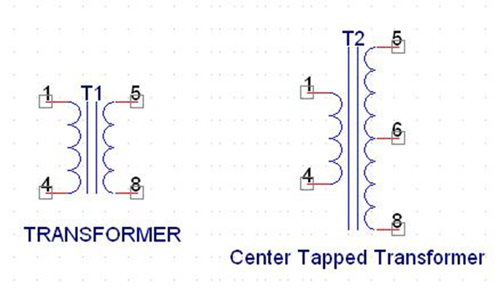

**Fig.no:-6.1.1 Transformer**

An electrical device consists of 2 coils additionally referred to as “WINDINGS” specifically PRIMARY & SECONDARY. They are connected along through inductively coupled electrical conductors additionally referred to as CORE. A dynamic current within the primary causes a amendment within the flux within the core & this successively induces associate degree alternating voltage within the secondary. If load is applied to the secondary then associate degree electrical energy can flow through the load. If we tend to think about a perfect condition then all the energy from the first circuit are going to be transferred to the secondary circuit through the flux.

**6.1.2 Rectifier**

An electrical device which converts an alternating current into a direct one by allowing a current to flow through it in one direction only.A rectifier is a device that converts an AC signal into DC signal. For rectification purpose we use a diode.

**6.1.3 Filter Capacitor**

Even though [*fr1] wave & full wave rectifier provide DC output, none of them provides a continuing output voltage. For this we tend to need to smoothen the wave received from the rectifier. This could be done by employing a electrical condenser at the output of the rectifier this electrical condenser is additionally referred to as “FILTER CAPACITOR” or “SMOOTHING CAPACITOR” or “RESERVOIR CAPACITOR”. Even once victimization this electrical condenser a little quantity of ripple can stay.

**6.1.4 Voltage Regulator**

A Voltage regulator is a device which converts varying input voltage into a constant regulated output voltage.

Voltage regulator can be of two types.

**6.1.4(a)Linear Voltage Regulator**

Linear voltage regulator is also called as Resistive Voltage regulator because they dissipate the excessive voltage resistively as heat.

**6.1.4(b) Switching Regulators**

They regulate the output voltage by change this ON/OFF terribly chop-chop. Since their output is either ON or OFF it dissipates terribly low power therefore achieving higher potency as compared to linear voltage regulators.

After filtering the rectifier output the signal is given to a transformer. the utmost input voltage that may be applied at the input is 35V.Normally there's a 2-3 Volts drop across the regulator therefore the input voltage ought to be a minimum of 2-3 Volts beyond the output voltage. If the input voltage gets below the Vmin of the regulator thanks to the ripple voltage or thanks to the other reason the transformer won't be able to manufacture the proper regulated voltage.

**6.4** [**Raspberry PI**](https://www.google.co.in/url?sa=t&rct=j&q=&esrc=s&source=web&cd=1&cad=rja&uact=8&sqi=2&ved=0CC0QFjAA&url=http%3A%2F%2Fwww.raspberrypi.org%2F&ei=Jz_4U5TdIZbo8AWz1oCoDQ&usg=AFQjCNEBMoebclm0Gk0LCZIStJbF04U1cQ&sig2=I8lZzlzrH5gkkrTh0Iam7Q)

There square measure presently four Raspberry Pi models. They’re the Model A, the Model B, the Model B+ and also the calculate Module. All models use identical central processing unit, the BCM2835, however alternative hardware options disagree. The Raspberry Pi may be a credit-card sized pc that plugs into your TV and a keyboard. It’s a capable very little pc which may be employed in physical science comes, and for several of the items that your desktop laptop will, like spreadsheets, word-processing and games. It conjointly plays high-definition video. we wish to ascertain it being employed by children everywhere the globe to be told however computers work, the way to manipulate the electronic world around them, and the way to program. The Raspberry Pi may be a low price, credit-card sized pc that plugs into a pc monitor or TV, and uses a regular keyboard and mouse..

**6.4.1 THE MODEL B+**

The Raspberry Pi Model B+ incorporates variety of enhancements and new options. Improved power consumption, enhanced property and larger IO area unit among the enhancements to the current Powerful, tiny and light-weight ARM based mostly laptop.

**Specifications**

Chip Broadcom : BCM2835 SoC

Core architecture : ARM11

CPU : 700 MHz Low Power ARM1176JZFS Applications Processor

GPU : Dual Core Video Core IV® Multimedia Co-Processor

Provides Open GL ES 2.0, hardware-accelerated OpenVG, and

1080p30 H.264 high-profile decodes.

Capable of 1Gpixel/s, 1.5Gtexel/s or 24GFLOPs with texture filtering

And DMA infrastructure.

Memory : 512MB SDRAM.

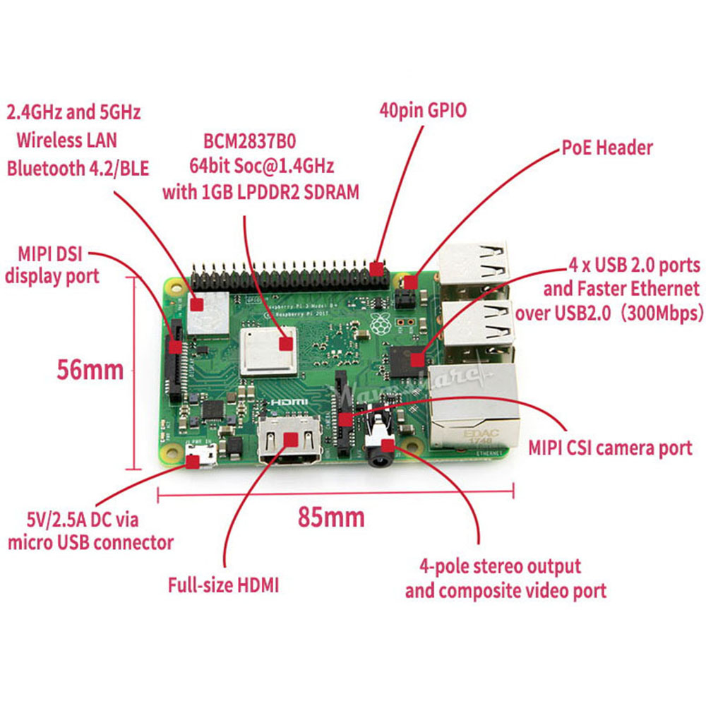

**Fig.no:- 6.4.1 schematic model of B+**

**6.5 APT**

The easiest way to manage installing, upgrading, and removing software is using APT (Advanced Packaging Tool) which comes from Debian. If a piece of software is packaged in Debian and works on the Raspberry Pi's ARM architecture, it should also be available in Raspbian.

To install or remove packages you need root user permissions, so your user needs to be in sudoers or you must be logged in as root. Read more about users and root.

To install new packages, or update existing ones, you will need an internet connection.

**Software Sources**

APT keeps a list of software sources on your Pi in a file at /etc/apt/sources. List. Before installing software, you should update your package list with apt-get update:

**sudo apt-get update**

**Installing a package with APT**

**sudo apt-get install tree**

Typing this command should inform the user how much disk space the package will take up and asks for confirmation of the package installation. Entering Y (or just hitting Enter, as yes is the default action) will allow the installation to occur. This can be bypassed by adding the -y flag to the command:

**sudo apt-get install tree -y**

**Using an Installed Package**

Tree is a command line tool which provides a visualization of the directory structure of the current directory, and all it contains.

* Typing tree runs the tree command. For example: tree

├── hello.py

├── Games

│ ├── asteroids.py

│ ├── pacman.py

│ ├── README.txt

│ └── tetris.py

**Uninstalling a Package with APT**

**Remove**

You can uninstall a package with apt-get remove:

**sudo apt-get remove tree**

The user is prompted to confirm the removal. Again, the -y flag will auto-confirm.

**Purge**

You can also choose to completely remove the package and its associated configuration files with apt-get purge:

**sudo apt-get purge tree**

**Upgrading Existing Software**

If software updates are available, you can get the updates with sudo apt-get update and install the updates with sudo apt-get upgrade, which will upgrade all of your packages. To upgrade a specific package, without upgrading all the other out-of-date packages at the same time, you can use sudo apt-get install some package

**Usage**

You will be shown raspi-config on first booting into Raspbian. To open the configuration tool after this, simply run the following from the command line:

**Sudoraspi-config**

**6.6 IR sensor**

Infrared (IR) light is electromagnetic radiation with longer wavelengths than those of visible light, extending from the nominal red edge of the visible spectrum at 700 nanometres (nm) to 1 mm. This range of wavelengths corresponds to a frequency range of approximately 430 THz down to 300 GHz,[1] and includes most of the thermal radiation emitted by objects near room temperature. Infrared light is emitted or absorbed by molecules when they change their rotational-vibrational movements. The existence of infrared radiation was first discovered in 1800 by astronomer William Herschel.

**6.7 D.C. Motor:**

A dc motor uses electrical energy to produce mechanical energy, very generally through the interaction of magnetic fields and current-containing conductors. The reverse process, producing electrical energy from mechanical energy, is carried out by an alternator, source or dynamo. Many types of electric motors can be run as sources, and vice versa. The input of a DC motor is current/voltage and its output is torque (speed).

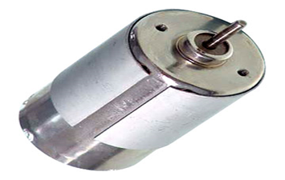

**Fig.no:- 6.25(a) DC Motor**

The DC motor has two basic parts: the rotating part that is called the armature and the stable part that includes coils of wire called the field coils. The stationary part is also called up the stator. Figure shows a depict of a distinctive DC motor, Figure shows a picture of a DC armature, and Figure shows a picture of a distinctive stator. From the picture you can see the armature is made of coils of wire wrapped around the core, and the core has a covered shaft that rotates on charges.

**6.8 Wi-Fi module**

Wifi, is a mechanism for wirelessly connecting electronic devices. A device enabled with Ethernet, such as a personal computer, video game console, smartphone, or digital audio player, can connect to the Internet via a wireless network access point. An access point (or hotspot) has a range of about 20 meters (65 ft) indoors and a greater range outdoors. Multiple overlapping access points can cover large areas.

A Ethernet enabled device such as a PC, video game console, mobile phone, MP3 player or PDA can connect to the Internet when within range of a wireless network connected to the Internet. The coverage of one or more interconnected access points — called a hotspot — can comprise an area as small as a single room with wireless-opaque walls or as large as many square miles covered by overlapping access points. "Ethernet" is a trademark of the Ethernet Alliance and the brand name for products using the IEEE 802.11 family of standards.

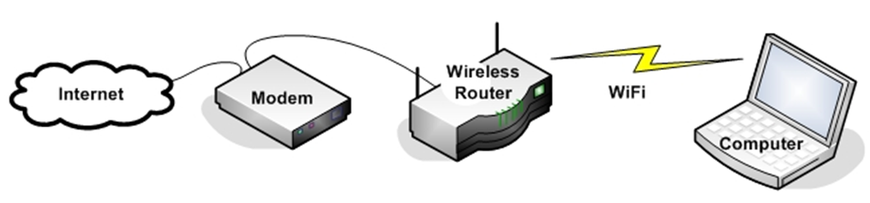

**Fig.no****:- 6.27**

**Implementation of our project**

**Sample code for webpage**

<html>

<head>

<script src="https://ajax.googleapis.com/ajax/libs/jquery/3.1.1/jquery.min.js"></script>

</head>

<body>

<imgsrc="http://192.168.43.199:8081" /><!--Enter the IP Address of your Raspberry Pi-->

<div style="float:right">

</div>

<div style=" height:400px; width:300px; float:right;">

<center>

<h1><span style="color:#5C5C5C;">Circuit</span><span style="color:#139442"> Digest</span></h1>

<h2>Surveillance Robot</h2><br><br>

<a href="#" id="up" style="font-size:30px;text-decoration:none;">&#x1F881;&#x1F881;<br>Forward</a><br><br></center>

<a href="#" id="left" style="font-size:30px;text-decoration:none;">&#x1F880;&#x1F880;Left</a>&nbsp;&nbsp;&nbsp;&nbsp;&nbsp;&nbsp;&nbsp;&nbsp;

<a href="#" id="right" style="font-size:30px; text-decoration:none;"> Right &#x1F882;&#x1F882;</a><br><br>

<center><a href="#" id="down" style="font-size:30px;text-decoration:none;"> Backward<br>&#x1F883;&#x1F883;</a></center>

</div><script>

$( document ).ready(function(){

$("#down").on("mousedown", function() {

$.get('/down_side');

}).on('mouseup', function() {

$.get('/stop');

});

$("#up").on("mousedown", function() {

$.get('/up_side');

}).on('mouseup', function() {

$.get('/stop');

});

$("#left").on("mousedown", function() {

$.get('/left_side');

}).on('mouseup', function() {

$.get('/stop');

});

$("#right").on("mousedown", function() {

$.get('/right_side');

}).on('mouseup', function() {

$.get('/stop');

});

});

</script>

</body>

</html>

**Sample code for functioning of the robot**

**from flask import Flask**

**from flask import render_template, request**

**importRPi.GPIO as GPIO**

**import time**

**app = Flask(_name_)**

**m11=18**

**m12=23**

**m21=24**

**m22=25**

**GPIO.setwarnings(False)**

**GPIO.setmode(GPIO.BCM)**

**GPIO.setup(m11, GPIO.OUT)**

**GPIO.setup(m12, GPIO.OUT)**

**GPIO.setup(m21, GPIO.OUT)**

**GPIO.setup(m22, GPIO.OUT)**

**GPIO.output(m11 , 0)**

**GPIO.output(m12 , 0)**

**GPIO.output(m21, 0)**

**GPIO.output(m22, 0)**

**print "done"**

**a=1**

**@app.route("/")**

**def index():**

**returnrender_template('robot.html')**

**@app.route('/left_side')**

**defleft_side():**

**data1="LEFT"**

**GPIO.output(m11 , 0)**

**GPIO.output(m12 , 0)**

**GPIO.output(m21 , 1)**

**GPIO.output(m22 , 0)**

**return 'true'**

**@app.route('/right_side')**

**defright_side():**

**data1="RIGHT"**

**GPIO.output(m11 , 1)**

**GPIO.output(m12 , 0)**

**GPIO.output(m21 , 0)**

**GPIO.output(m22 , 0)**

**return 'true'**

**@app.route('/up_side')**

**defup_side():**

**data1="FORWARD"**

**GPIO.output(m11 , 1)**

**GPIO.output(m12 , 0)**

**GPIO.output(m21 , 1)**

**GPIO.output(m22 , 0)**

**return 'true'**

**@app.route('/down_side')**

**defdown_side():**

**data1="BACK"**

**GPIO.output(m11 , 0)**

**GPIO.output(m12 , 1)**

**GPIO.output(m21 , 0)**

**GPIO.output(m22 , 1)**

**return 'true'**

**@app.route('/stop')**

**def stop():**

**data1="STOP"**

**GPIO.output(m11 , 0)**

**GPIO.output(m12 , 0)**

**GPIO.output(m21 , 0)**

**GPIO.output(m22 , 0)**

**return 'true'**

**if _name_ == "_main_":**

**print "Start"**

**app.run(host='0.0.0.0',port=5010)**

**7. EXPERIMENTAL STUDIES**

**7.1 Test cases**

|  |  |
| --- | --- |
| **Test Case 1** | |
| Test Case Name | Right |
| Description | This command is used to turn the robot towards right. |
| Output | As per the given command it turns right. |

|  |  |
| --- | --- |
| **Test Case 2** | |
| Test Case Name | Left |
| Description | This command is used to turn the robot towards left. |
| Output | As per the given command it turns left. |

|  |  |
| --- | --- |
| **Test Case 3** | |
| Test Case Name | Forward |
| Description | This command is used to move the robot to the forward. |
| Output | As per the given command it moves forward. |

|  |  |
| --- | --- |
| **Test Case 4** | |
| Test Case Name | Stop |
| Description | This command is used to stop the robot. |
| Output | As per the given command it stops. |

|  |  |
| --- | --- |
| **Test Case 5** | |
| Test Case Name | Gas |
| Description | This command is used to detect the harmful gases when the robot is in the movement and also when it stopped. |
| Output | As per the given command it detects the gas and gives us alerts. |

|  |  |
| --- | --- |
| **Test Case 6** | |
| Test Case Name | IR |
| Description | This command is used to detect the obstacles which are in the movement of the robot. |
| Output | As per the given command the robot halts when the obstacle is detected. |

**7.2 Working of our project**

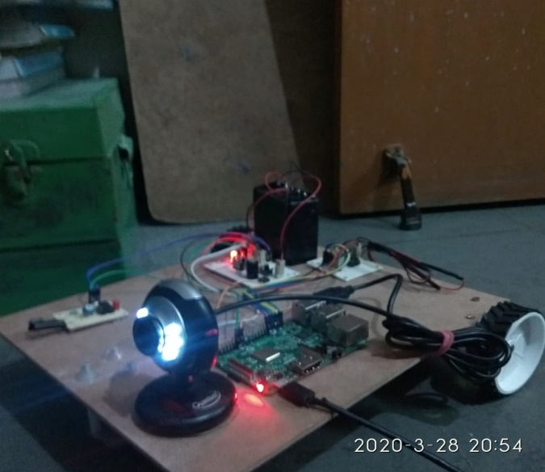

**Fig.no:-7.2(a)**

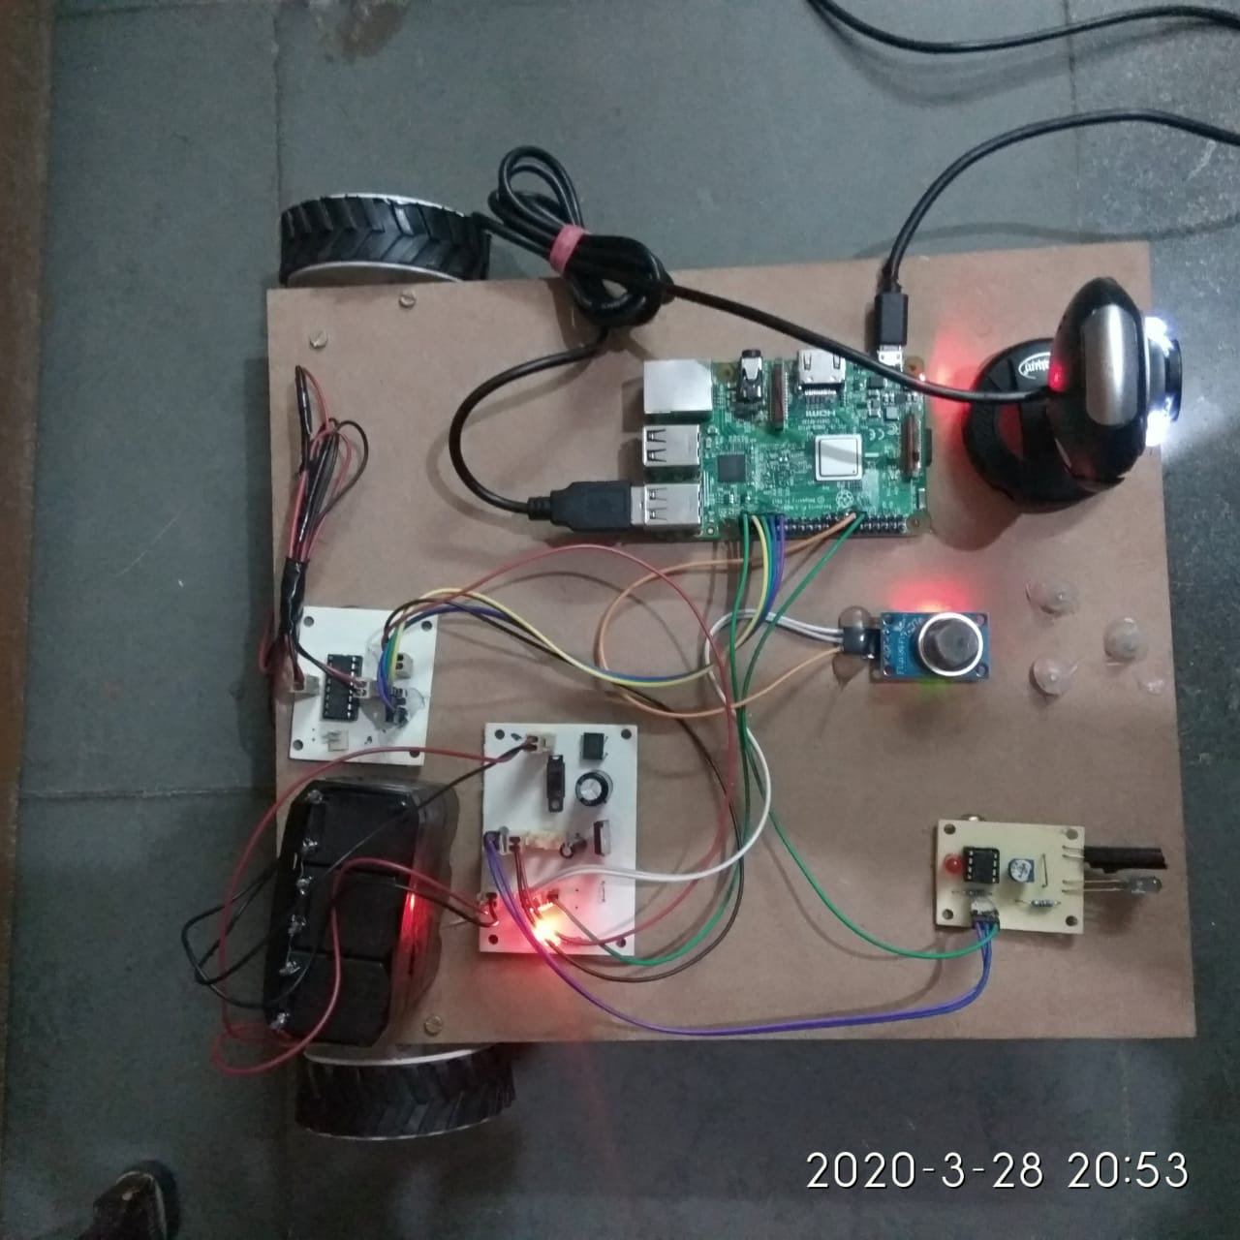

**Fig.no:-7.2(b)**

**7.3 Commands which are given to our project**

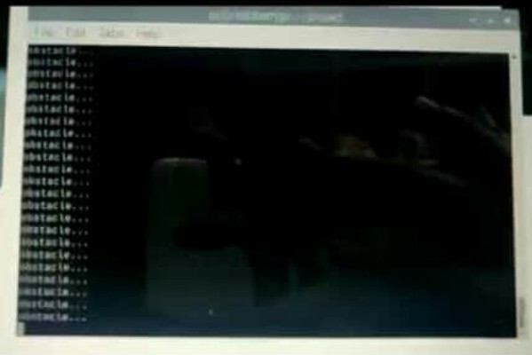

**Fig no:- 7.3(a) when the robot is in the movement when it interrupts with an obstacle it displays like as shown in the figure**

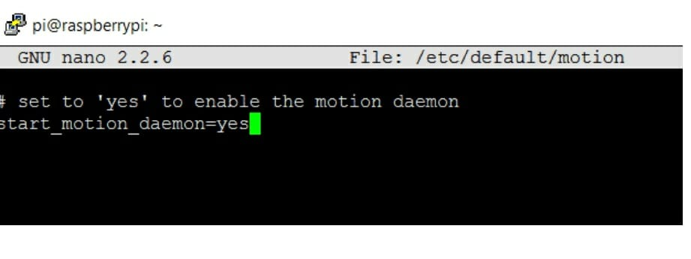

**Fig.no:- 7.3(b) to enable the motion commands of the robot**

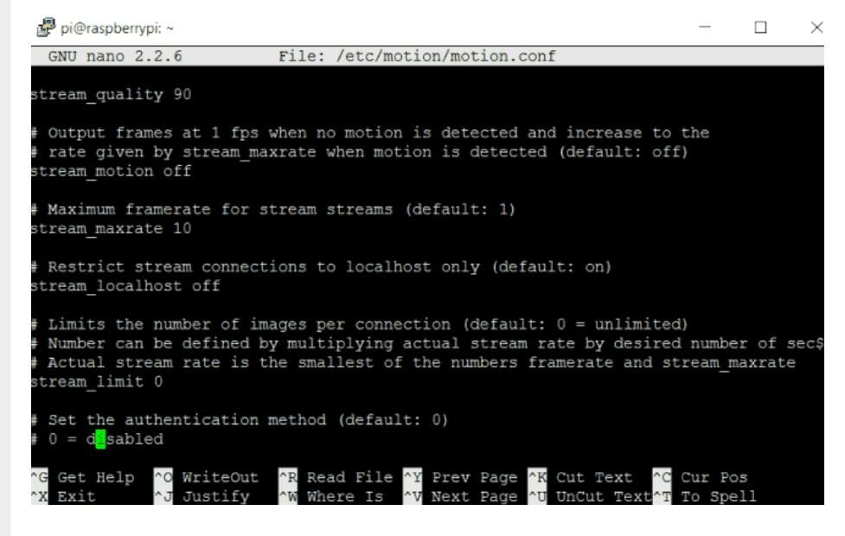

**Fig.no:- 7.3(c) to enable the USB camera for the live video streaming**

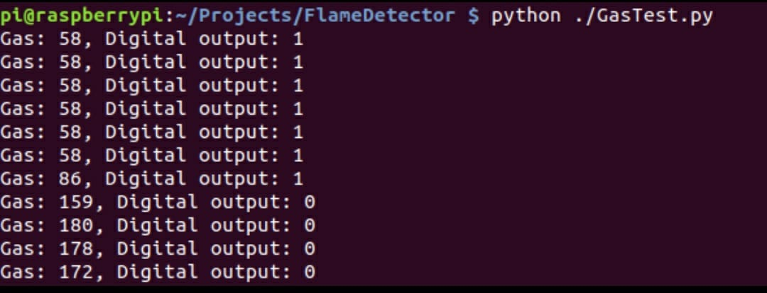

**Fig.no:- 7.3(d) when the robot detects the gas it displays as like in the figure**

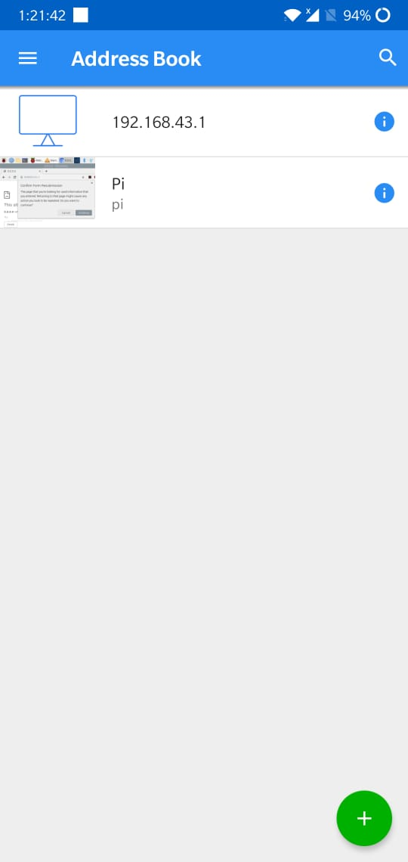

**Fig.no:- 7.3(e) IP address to integrate raspberry pi with PC/Mobile**

**RESULT**

The fig shows a pictorial representation of complete robot which is ready to a surveillance purpose in the border area. This robot will be the replacement instead of human soldier there is a surveillance robot. To implement this robot we use software as well as hardware tool. Instead of border area we also use this robot in which human beings are not reached. We also use this robot in medical purpose to monitor the movement of patient which are not be able to move from their bed and give its information to doctor and the their relative which are not near to the patient. The purpose of designing web page is to control robot.

## 8. CONCLUSION AND FUTURE WORK

## The vital and young growing field of robotics is becoming a vast research area with a variety of topics area of interest tends to range from medical technology to military assistance. This field is a developing area with significant amount of research in progress. Robocop is a smart surveillance robot that is just not strong enough to withstand brutal conditions but will also prove to be a great tool in present security conditions that constantly require surveillance with utmost precision and efficiency. The idea of technology is to provide risk free, durable and efficient way to assess an imminent threat without risking the human sacrifice and that is in the sector of military and spy agencies. It is a little contribution for the brave Soldiers who sacrifice their today for our better tomorrows. In future the aim is to take this project on a large scale by manufacturing these kinds of robots for the purpose of surveillance and monitoring as they can provide ease to military and spy agencies by capturing the environment and by doing operations in hazardous and remote environments.

This Project Work addressed the Program Outcomes (POs): PO1, PO2, PO3, PO4, PO5, PO6, PO7, PO8, PO9, PO10, PO11, PO12 and Program Specific Outcomes (PSOs): PSO1, POS2 & POS3. These Program Outcomes (POs) and Program Specific Outcomes (PSOs) are attained by demonstrating the working model of the project.

**8.1 FUTURE WORK**

**Open CV**

Open CV is computer vision library to perform the Face detection and recognition. Robot with the help Of camera get face recognisation and according to That manually we give the command to the robot Unfortunately the current binary version of Open CV Available to install in the Raspbian operating system through apt -get(version2.3.x) is too old to contain the face recognition algorithms used by this project. However you can download, compile, and install a later version of Open CV to access the face recognition algorithms.

**Laser Gun**

As we place robot instead of human solider it is necessary that the robot will be defense himself and protect our nation from the enemy. To make robot self defense we give the robot laser gun. The laser gun with the help of open cv and raspberry pi camera will detect the enemy and shoot according to mode of operation i.e. automatic and manual mode. It will be a good application of surveillance robot to protect the nation from enemy. To build a DIY motion tracking air soft (or nerf gun) turret with a raspberry pi 3. The air soft turret is autonomous so it moves and the gun when it detects motion. There is also an interactive mode so that you can control it manually from your keyboard. We used an air soft gun for this project, but you can

easily change modify this build to use a Nerf instead. This project is small, lightweight and

entirely battery operated. Motion Detection uses open CV and computer vision to track moving targets in front of the camera.

**9. REFERENCES**

[1] W. Budiharto, "1. W. Budiharto, “Intelligent Surveillance Robot with Obstacle Avoidance Capabilities Using Neural Network,”," Vols. Computational Intelligence and Neuroscience, Volume 2015, no. Article ID 745823, pp. 1, 2015.

[2] A. M. G. C. &. A. D. D. Paola, "“An Autonomous Mobile Robotic System for Surveillance of Indoor Environments"," International Journal of Advanced Robotic Systems, [National Research Council (CNR), Bari, Italy,, vol. Vol. 7, no. No. 1, pp. 19.

[3] A. R. K. S. &. M. B. C. R. Pooventhan K, "“Surveillance Robot Using Multi Sensor Network”," Vols. Vol. 3, Issue 2, pp. 113.

[4] A. Ray, "“Cooperative Robotics Using Wireless Communication,” “Cooperative Robotics Using Wireless Communication,”," A Thesis Submitted to the Graduate Faculty of Auburn University, Auburn,, December 16, 2005..

[5] G. V. &. R. Dhod, "“Defence Surveillance Robot Based On RF and DTMF Technology,”," International Journal of Advanced Research in Electrical, Electronics and Instrumentation Engineering, , Centre for Development of Advanced Co, Vols. Vol. 4, , no. Issue 6, pp. 5469.

[6] R. G. &. A. R. K. Borker, " “Wireless Controlled Surveillance Robot,”," International Journal of Advance Research in Computer Science and Management Studies, , P. V. P. I. T. Bavdhan, Pune –India., Vols. Volume 2,, no. Issue 2, pp. 436-437, February 2014.