Instructions for Creating an SQL Server Database and User

1. Open SQL Server Management Studio. Connect to the SQL Server using Window Authentication.

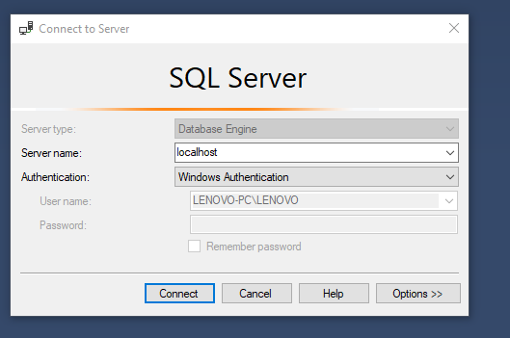

1. In the database tree, right click on the server and select properties. Select the Security page and select SQL Server and Windows Authentication mode.

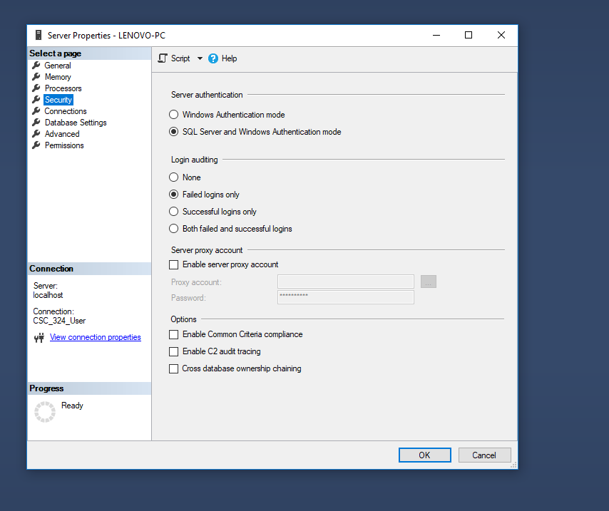

1. Logoff from your database server and restart the server. To restart the server, go to services and right click on SQL Server (MSSQLSERVER) and select stop and then start.

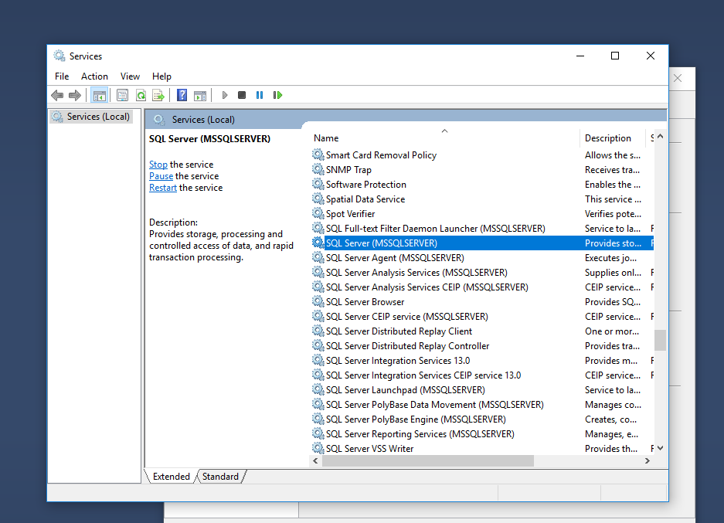

1. In the database tree, right click on Databases entry and select New Databases. Enter CSC_324 as the Database Name and click OK.
2. Right click on the name of CSC_324 database and select Properties.

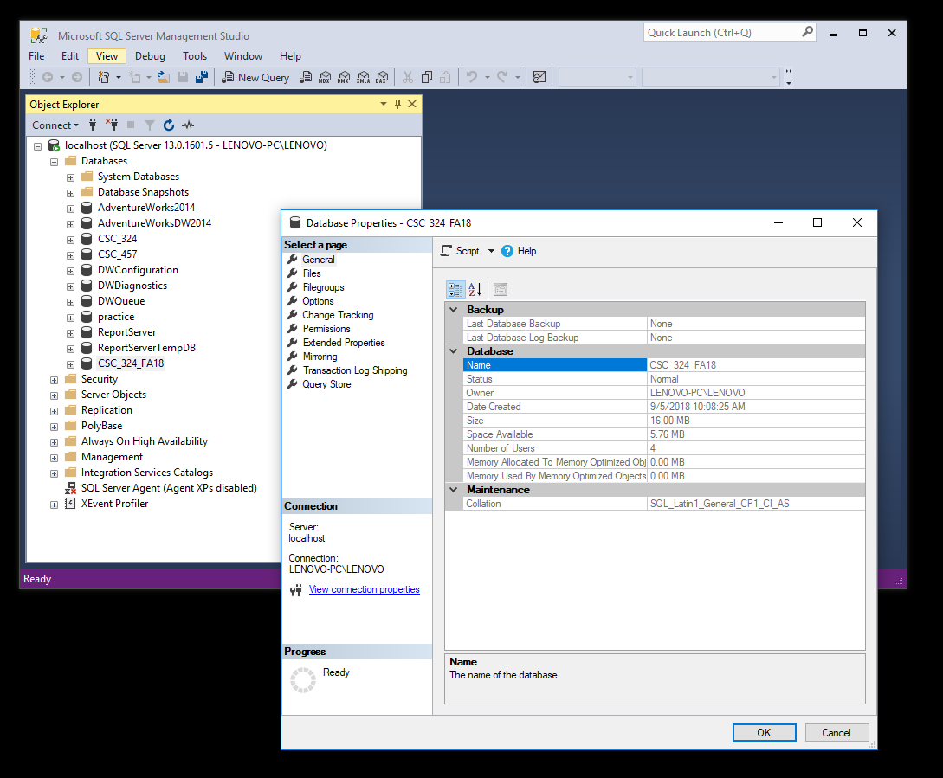

1. Select the Security page and then select SQL Server and Windows Authentication mode.
2. In the Login dialog box, enter a login name, chose SQL Server Authentication, and create a password.

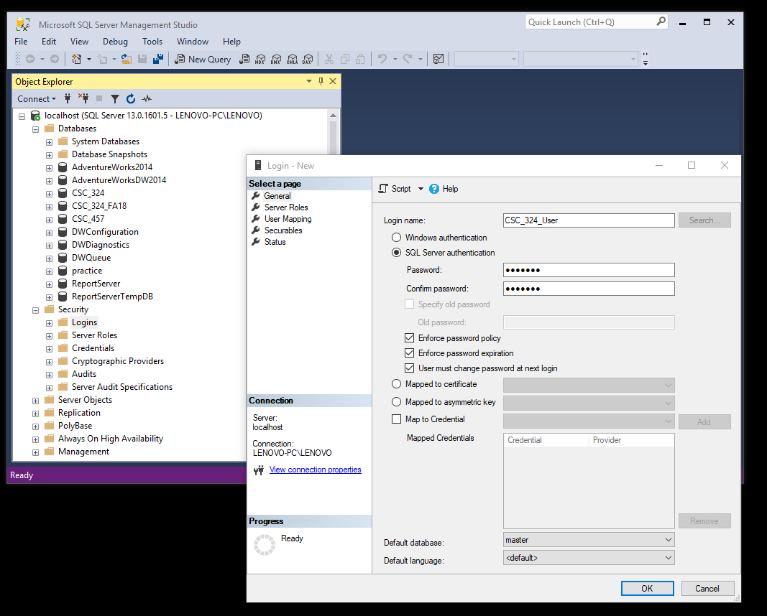

1. Click on the Server Roles entry and make sure public and sysadmin roles are selected.

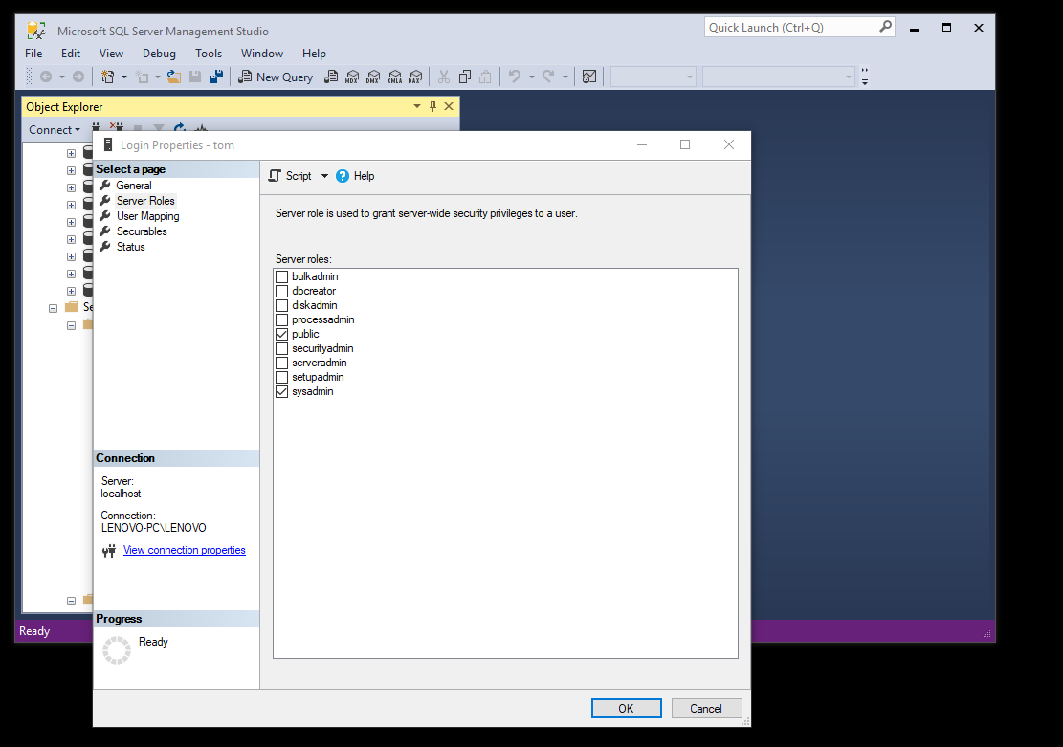

1. Click on User Mapping and make sure CSC_324 is selected.

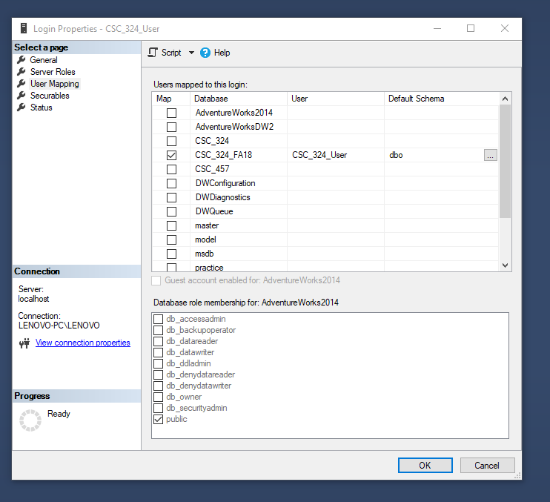

1. Disconnect from the database and reconnect as the CSC_324_User user. Make sure to login in using SQL Server Authentication.

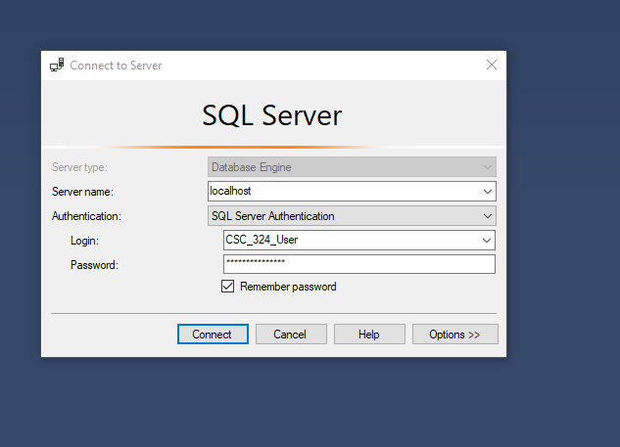

1. Make sure you have access to the CSC_324 database. Click on the CSC_324 icon and expand the Tables folder.