Project part 4

Yeshwanth nellikanti

J00626456

Report 1: Average Air Quality index for two consecutive years of a design.

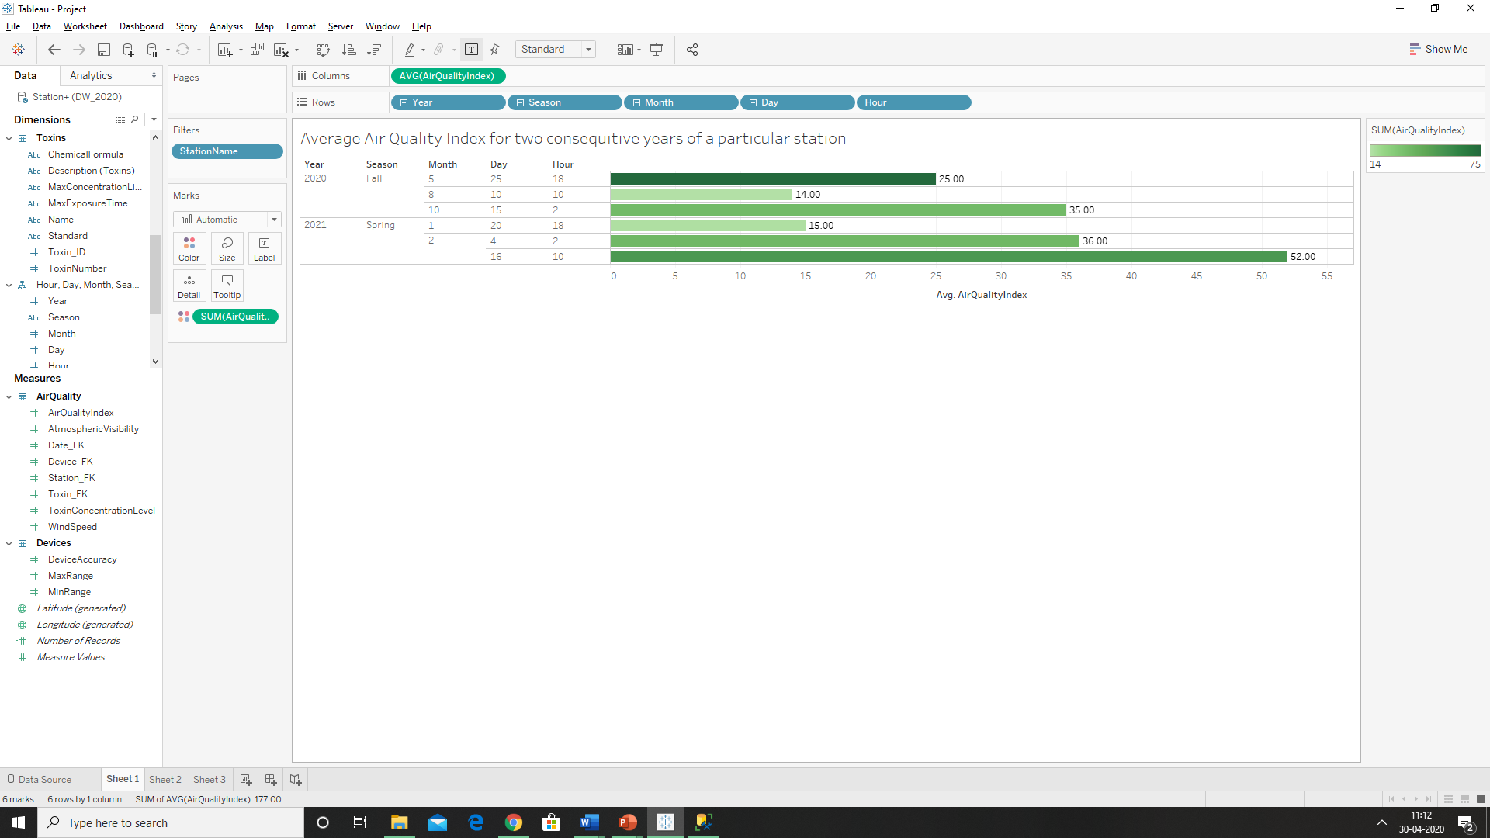

Report 2: Maximum of windspeed recorded at different stations in the morning and evening.

Maximun Wind speed: Region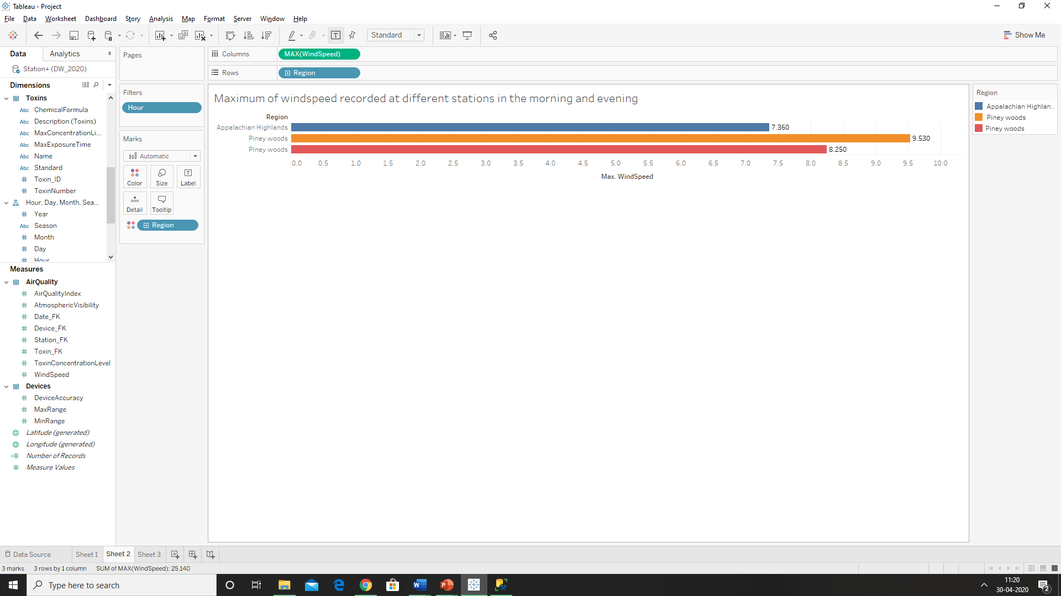

Maximun Wind speed: Region🡪County

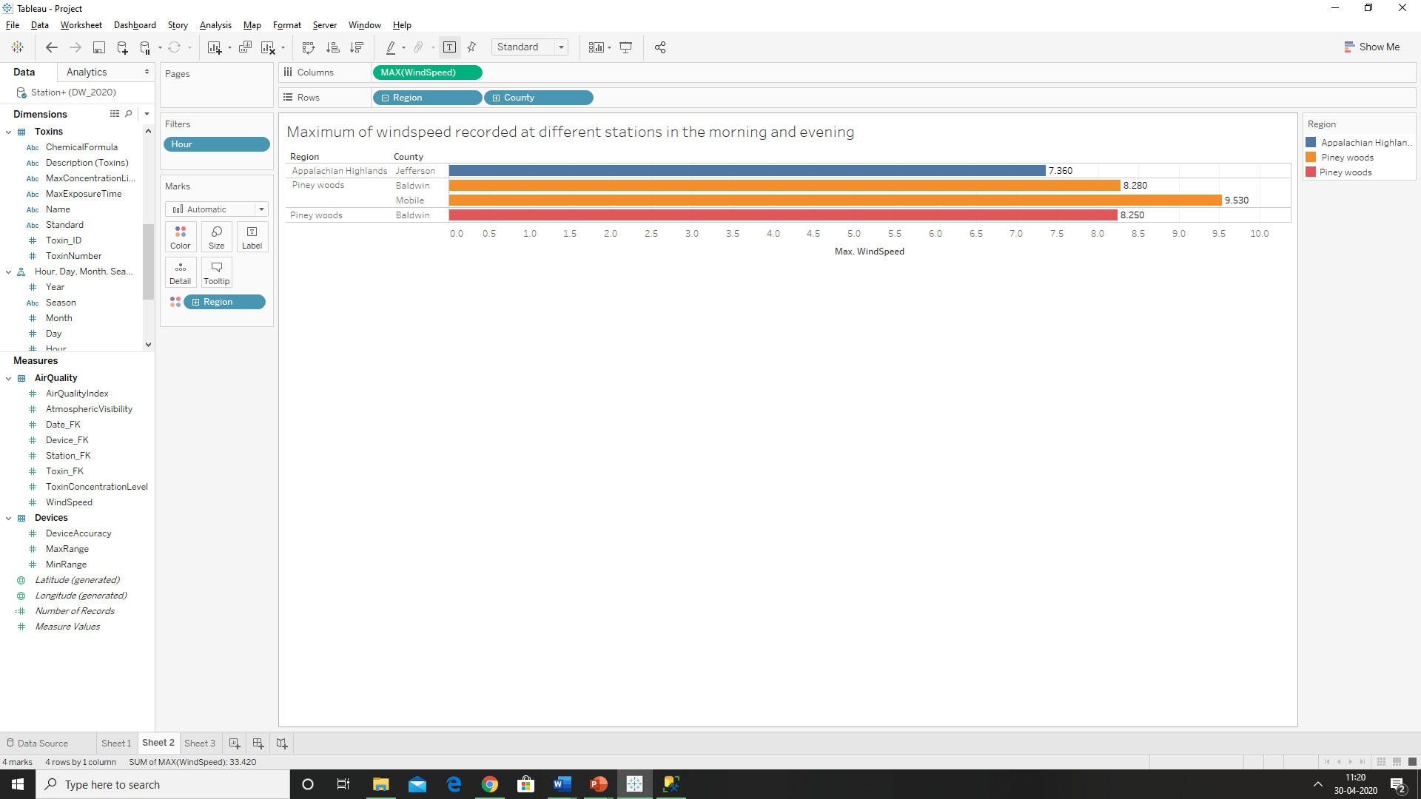

Maximun Wind speed: Region🡪County🡪City

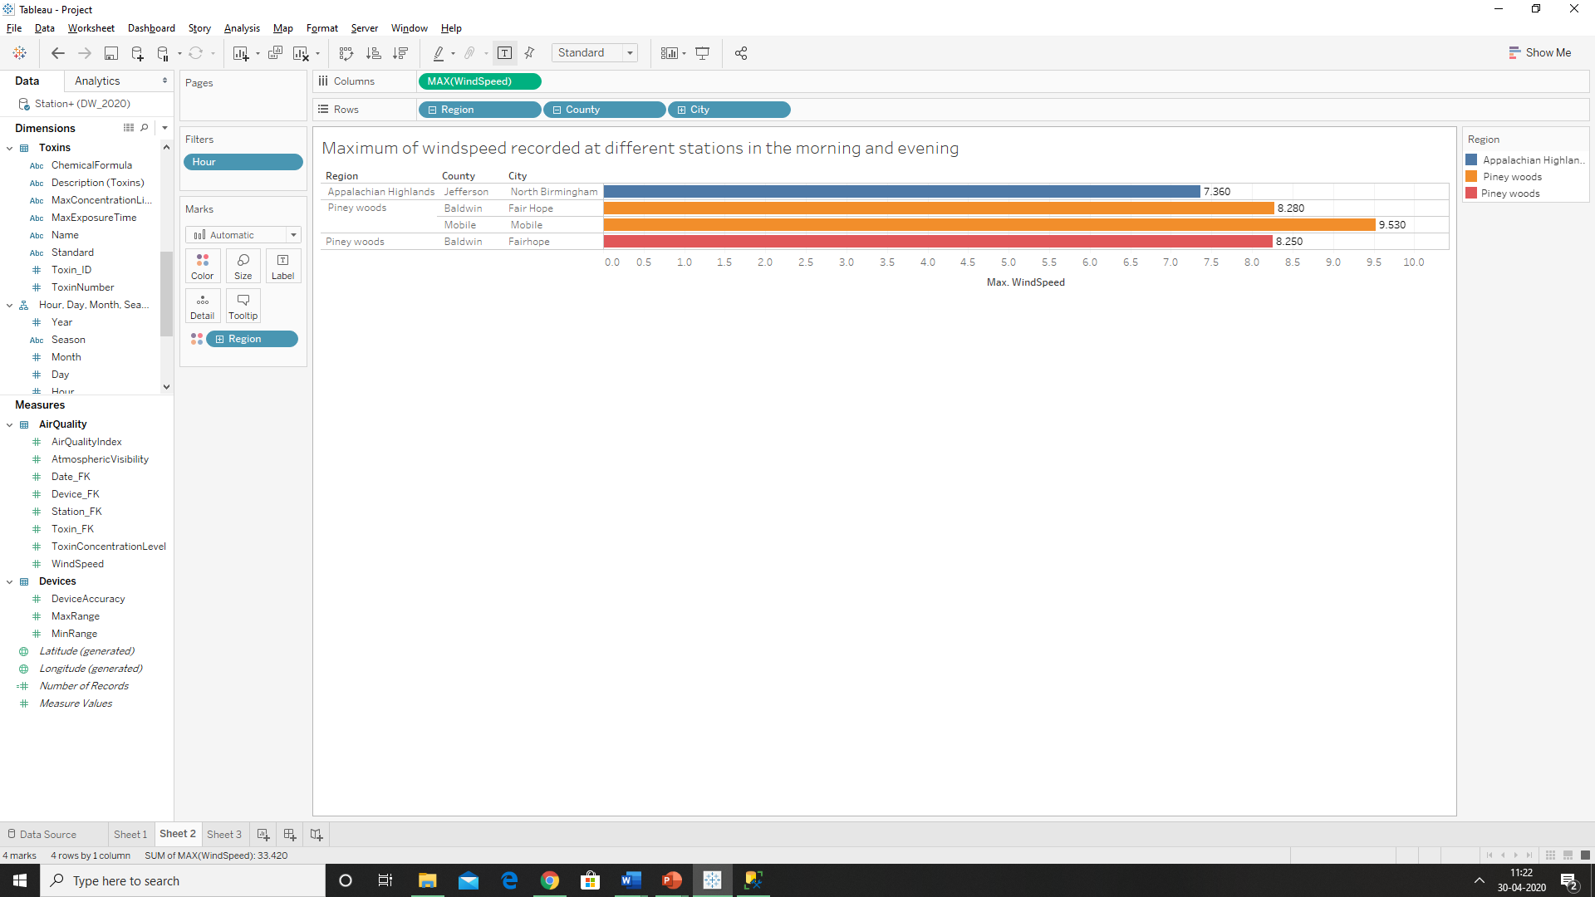

Maximun Wind speed: Region🡪County🡪Street

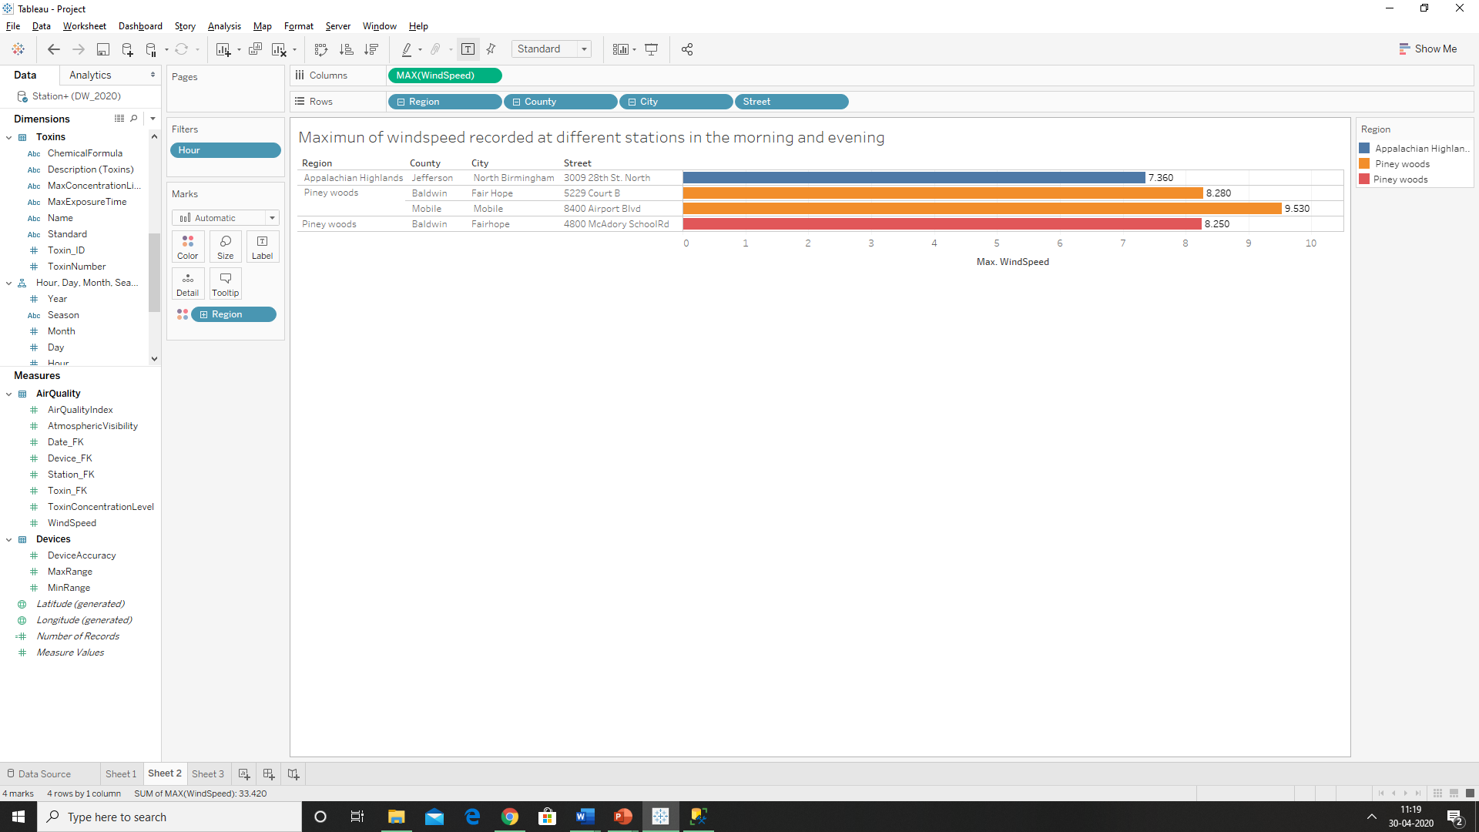

Report 3: Minimum concentration level recorded based on Station name, Chemical Formulae and Units.

