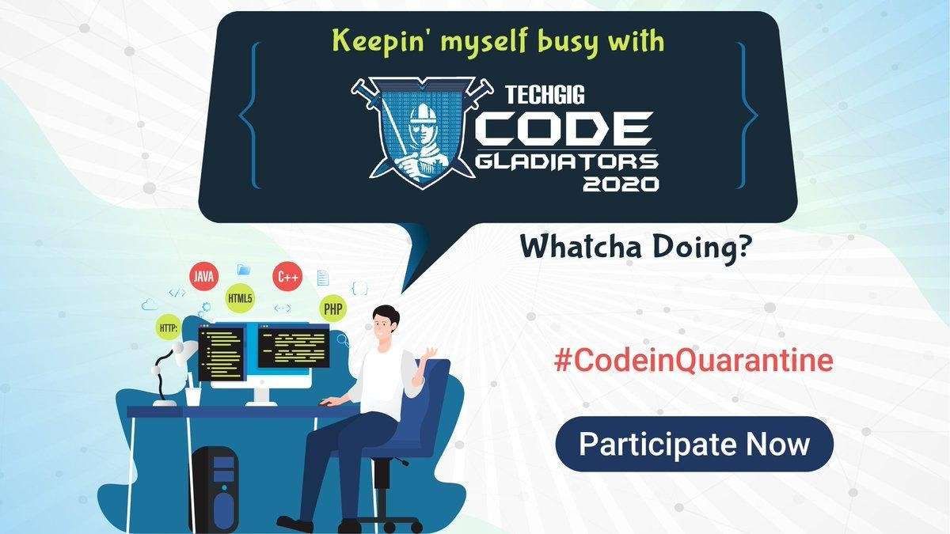



Team: YeshwanthsAI

*1.*

yeshuthecool@gmail.com

Yeshwanth Sai Melpati

*2.*

*3.*

7978055439





Covid track



*•*



We are building an Assistant is powered with Ibm watson and other ibm ai services to give ayurvedic remedies to users. User’s query or problem is noted and suggested treatment or recipes are given.



*• IBM watson*

*• IBM Annotator for clinical data*

*• IBM integrations*

*Source code:*

*https://drive.google.com/drive/folders/12aPuhlQDRLeD6_iGHyOELsDXt4_K1zI2?usp=sharing*

*Youtube:*

<https://www.youtube.com/watch?v=1DuTDIX_IUU>

*Associated attachment files:*

1. *Zipped folder*
2. *Presentation*