

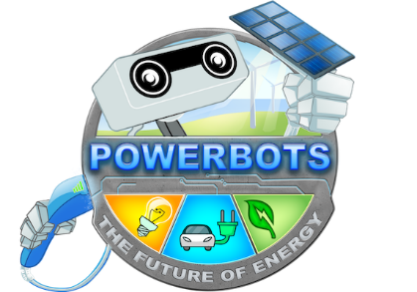

WRO2021 Elementary Open Category

**HYBRID: hybrid windmill that is capable of operating not only from the air but also from the water**

Performed by: Nogaev Timur, Issabek Ibrakhim

Almaty 2021

Content

Introduction 2

Solution 3

Code 7

Conclusion 9

# Introduction

Nowadays there is such a global problem as a lack of resources. People consume several million tons of fossil fuels a year. In this connection, the resources of our planet are being depleted. To solve this problem, humanity came up with new methods of energy generation - this is green energy, one of the main components of which is windmills. But unfortunately, they are not effective, when there is no wind, they are completely inactive. We can say that we wasted time, money, and materials.

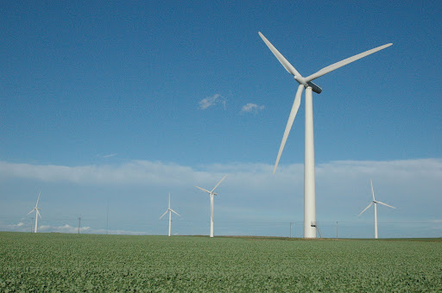

But we have a solution! Our Hybrid project! This hybrid windmill is capable of operating not only from the air but also from the water! But how?

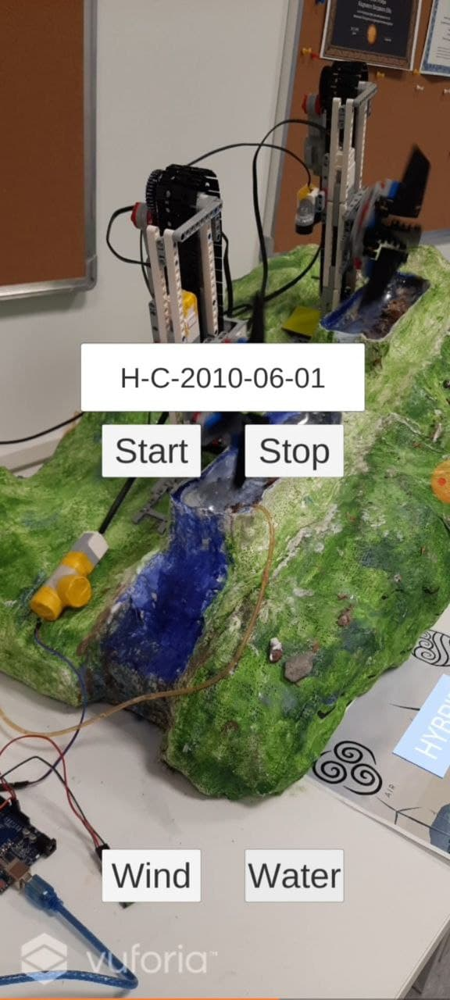

# Solution

Hybrid can work both from water and wind. All this is due to the fact that the mill can lower the wind turbine into the water using a perpendicular conveyor and rotate the blades perpendicular to the current, thereby increasing the effectivity. Thus, our mill can generate electricity not only from the air but also from water.

Nowadays, the mills themselves are completely inactive in the absence of wind, and even in windy places the absence of wind can last for hours, days, and even weeks. Therefore, we can say that the efficiency of our mill is much higher than the current windmills.

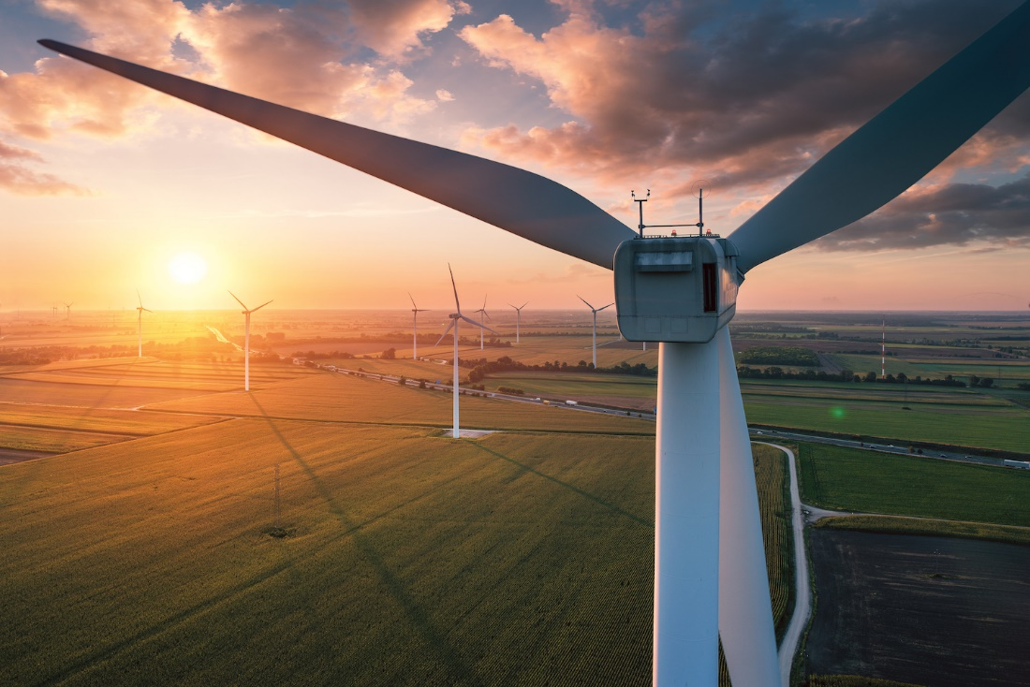

**When there is no wind current mills don’t work!**

So, we acquire new system in which when there is no wind our mill lover the wind turbine into water and hybrid starts to generate energy from it. The working mechanism of our mill is very simple. Our mill consists of a wind turbine, blades, a conveyor, and a platform on which everything is installed.

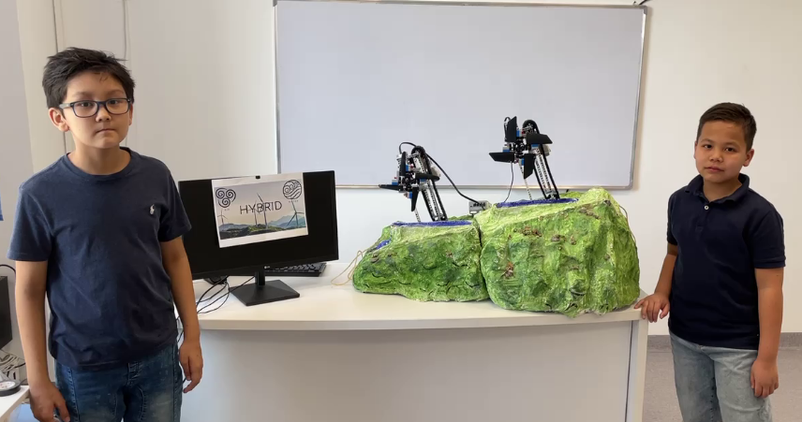

**Our mill has two modes:**

1. When the wind blows, our mill works in standard mode, generates energy from the wind.

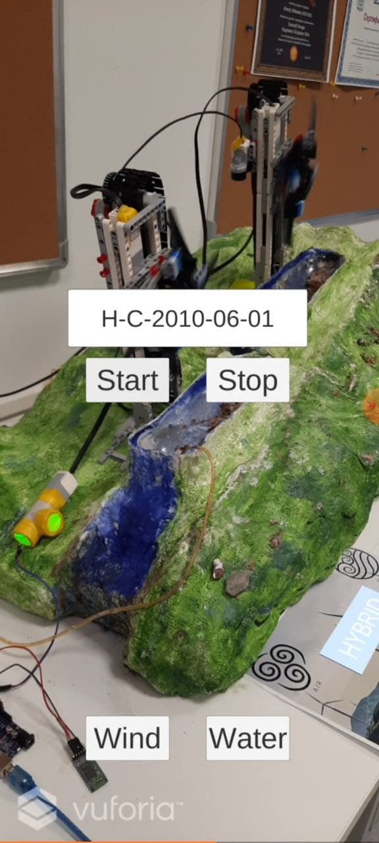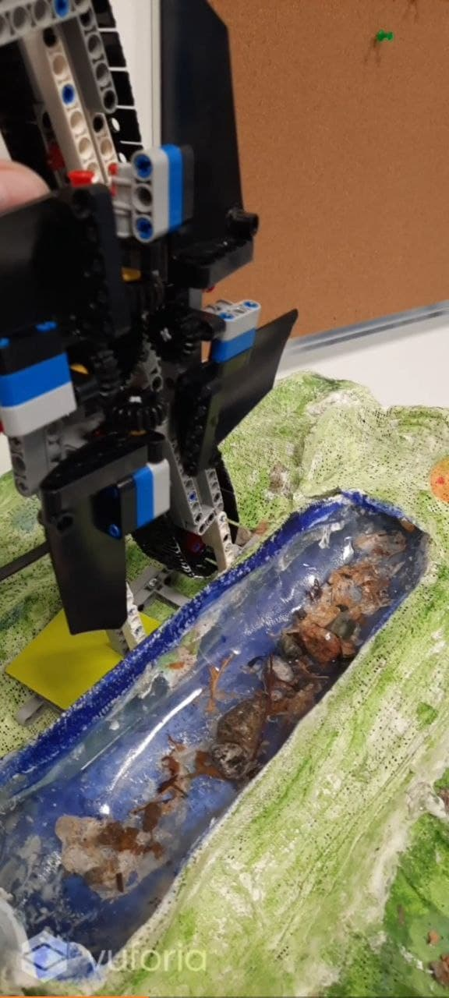

Blades of wind turbine are perpendicular to wind to maximize the output

1. When there is no wind, our mill turns the blades perpendicularly to increase the area with which the water interacts, then lowers the windmill into the water. So, the Hybrid began to generate energy from the flow of water.

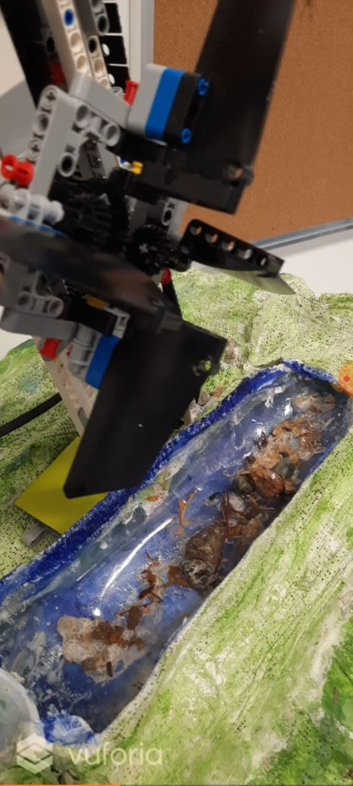

Blades of wind turbine are perpendicular to water to maximize the output

For demonstration we used the augmented reality method with mobile application. Here we used Vuforia engine to create an app with augmented reality. We created the mark on that image. So, the Vuforia engine placed the significance points on the image and we can freely use it to create events.

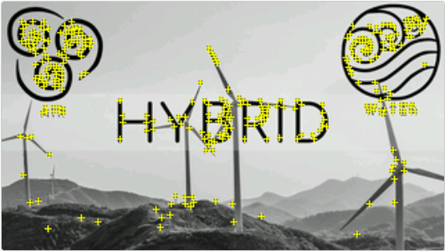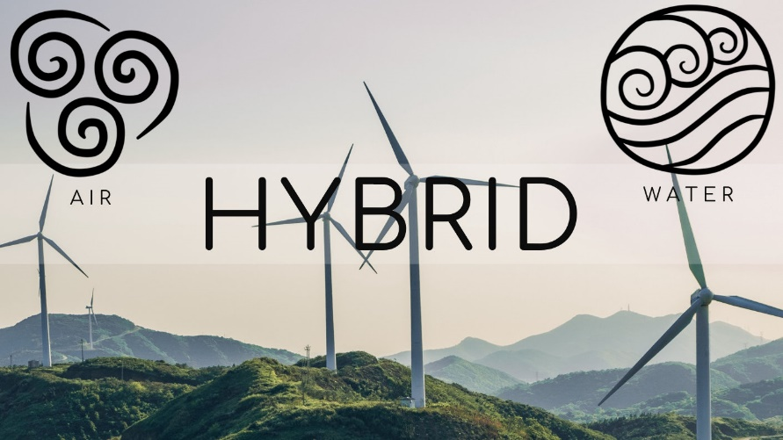

Also, to transmit the data from app we use Bluetooth modules and Arduino. After sending data to Arduino, we use LED to send the data to EV3, so that we can receive the data in real-time.

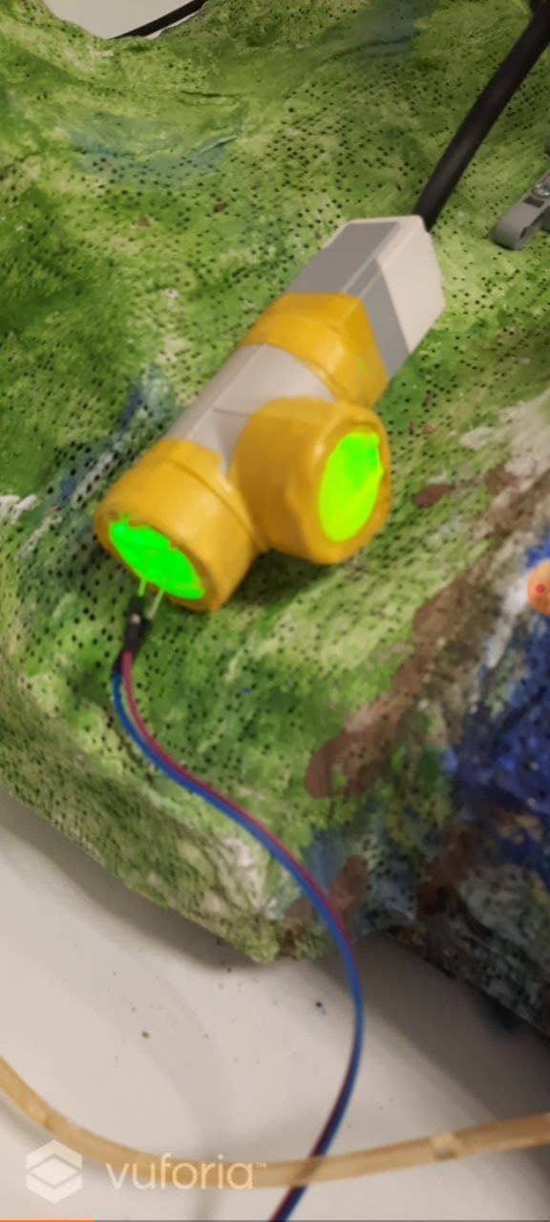

# Code

**EV3 loop code:**

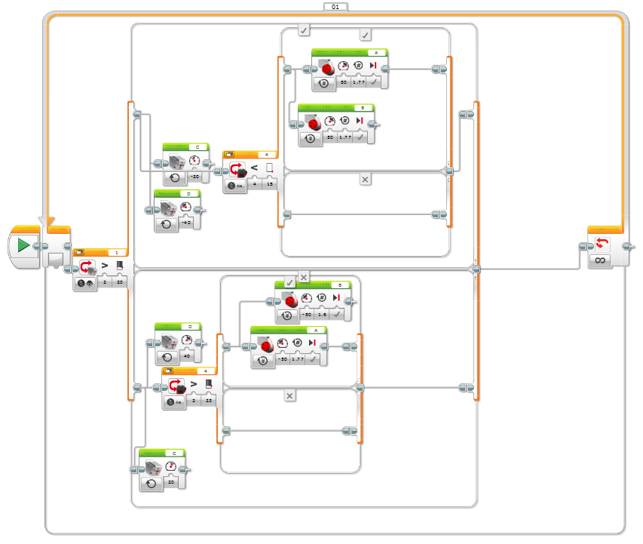

Here we have infinite loop in which we check what data we received from Arduino by LED, then we rotate the blades correspondingly. Also, we check the distance between turbine and Earth to find out the position of turbine. If it is on the top and we should work from wind, we don’t turn the AB motors on and vice versa with water mode.

**Arduino loop code:**

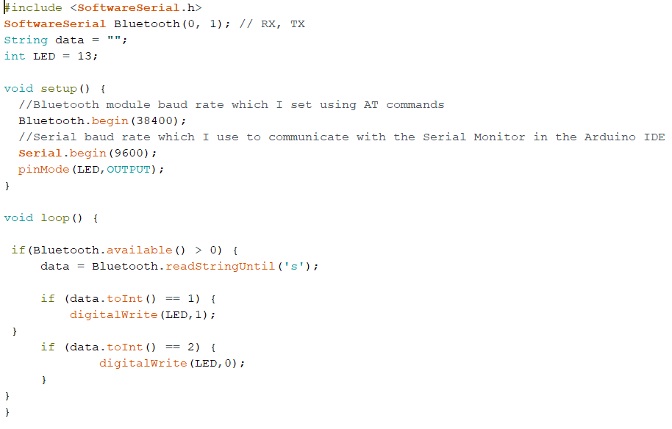

Here is the infinite loop in which we receive the data from Bluetooth. If 1 we turn the LED on, if 2 we turn the LED off.

# Conclusion

Hybrid is the latest development of our time, surpassing the current windmills in efficiency and saving time and money. Thank you for your attention, we are the Hybrid team!

