- Hardware Components Description


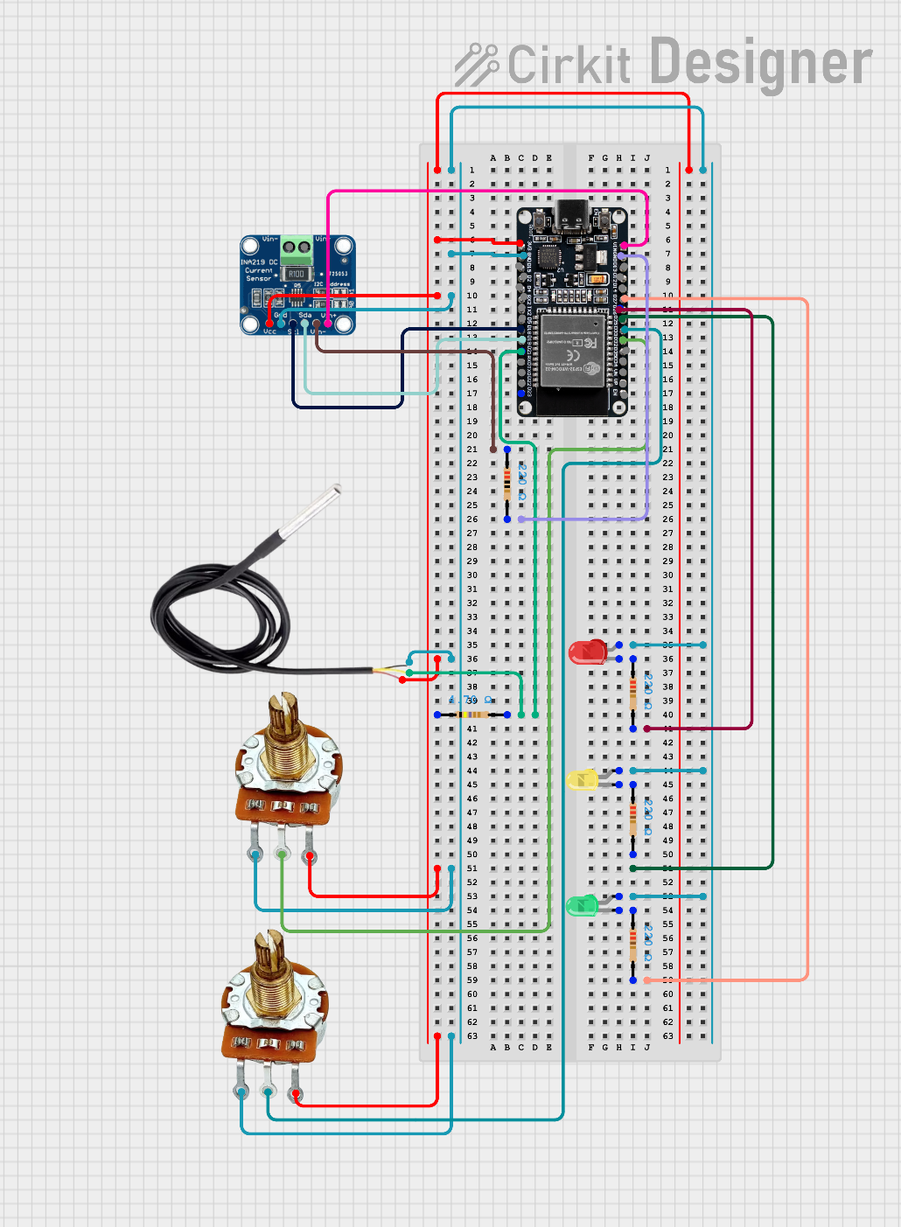

Component | Function | Description
ESP32 MCU | Main controller | Executes deterministic rules and embedded anomaly detection
INA219 | Voltage & current sensing | Measures battery voltage and current in real time
DS18B20 | Temperature sensing | Monitors battery temperature
Potentiometers | EPS emulation | Simulate solar input and electrical load
LEDs | Status indication | Display system state: NORMAL / WARNING / CRITICAL
Breadboard | Prototyping | Physical integration of components
PC (OBC Simulation) | Supervisory computer | Runs temporal analysis, diagnosis logic, and AI models
USB Serial Link | Communication interface | Transfers telemetry data between MCU and OBC

- How the System Works (Workflow)
- Sensors acquire EPS parameters such as voltage, current, and temperature.
- The MCU evaluates deterministic safety rules in real time.
- A lightweight embedded autoencoder detects local deviations from nominal behavior.
- Telemetry data and anomaly indicators are transmitted to the OBC via a USB serial link.
- The OBC performs temporal analysis and system-level diagnosis.
- The resulting system state is reported to the user (NORMAL / WARNING / CRITICAL).
- AI Capabilities
EPS Guardian integrates lightweight artificial intelligence models to support anomaly detection while preserving deterministic safety.
A compact autoencoder is embedded on the MCU to detect local deviations from nominal EPS behavior in real time.
A higher-level temporal model running on the OBC analyzes telemetry sequences to confirm persistent or correlated anomalies.
All AI components operate strictly in an advisory mode.
They do not trigger autonomous actions and cannot override deterministic safety rules.
- User Interaction
The EPS Guardian prototype does not require direct user control during operation.
System feedback is provided through:
- LED indicators:
  - Green: NORMAL operation
  - Yellow: WARNING state
  - Red: CRITICAL anomaly
- Serial telemetry logs transmitted to the PC-based OBC for monitoring and analysis.
No user commands or manual interventions are required while the system is running.

- Safety & Limitations
This prototype is designed for monitoring and demonstration purposes only.
- The system operates in a Pure Observer mode and does not perform autonomous corrective actions.
- Deterministic safety rules always have absolute priority over AI-based analysis.
- Part of the EPS behavior (battery, solar input, and load) is simulated or emulated to ensure safe and reproducible testing.
- The prototype is not flight-qualified and is not intended for in-orbit deployment.

- Conclusion
EPS Guardian demonstrates a safe and interpretable hybrid monitoring approach for CubeSat Electrical Power Systems. By combining real-time deterministic supervision with advisory AI-based temporal analysis, the prototype enables early anomaly detection while preserving system safety.

