Software Requirements Specification
Restaurant
Menu & Ordering System
Final Version
June 23, 2020

Yesra Balloul (1st category)
Fatema Karout(2nd category )

Table Of Contents

TABLE OF CONTENTS
TABLE OF CONTENTS v
LIST OF FIGURES vii
LIST OF TABLES ix
REVISION HISTORY xi
1 INTRODUCTION 1
1.1 Purpose 1
1.2 Scope 1
1.2.1 Overview 1
1.2.2 Benefits 2
1.3 Nomenclature 2
1.4 Structure 3
2 OVERALL DESCRIPTION 5
2.1 Product Perspective 5
2.1.1 System interfaces 5
2.1.2 User interfaces 5
2.1.3 Hardware interfaces 6
2.1.4 Software interfaces 6
2.1.5 Communications interfaces 6
2.1.6 Memory 6
2.1.7 Operations 7
2.1.8 Site adaptation requirements 7
2.2 User Characteristics 7
2.3 Constraints 8
2.4 Assumptions 8
2.5 Apportioning of Requirements 8
3 REQUIREMENTS 9
3.1 Functional Requirements 9
3.1.1 General 9
3.1.2 Customer 9
3.1.3 Waiter 10
3.1.4 Chef 11
Table Of Contents

3.1.5 Supervisor 11
3.2 Non-Functional Requirements 12

3.2.1 Safety ............................................................................................................................... 12
3.2.2 Security ............................................................................................................................ 12
3.2.3 Human engineering .......................................................................................................... 13
3.2.4 Performance requirements............................................................................................... 13
- UML ANALYSIS MODELS ................................................................................................................. 15
  - Use Cases ................................................................................................................................ 15
    - Actors ............................................................................................................................... 15
    - Use case diagram.............................................................................................................. 16
    - Use case descriptions ....................................................................................................... 17
  - Activity Diagrams .................................................................................................................... 23
  - Class Diagram .......................................................................................................................... 31
    - Class descriptions ............................................................................................................. 31
  - Statechart Diagrams ................................................................................................................ 34

• •

1 INTRODUCTION
The following section provides an overview of the derived Software Requirements Specification (SRS) for the subject Restaurant Menu and Ordering System (RMOS). To begin with, the purpose of the document is presented and its intended audience outlined. Subsequently, the scope of the project specified by the document is given with a particular focus on what the resultant software will do and the relevant benefits associated with it. The nomenclature used throughout the SRS is also offered. To conclude, a complete document overview is provided to facilitate increased reader comprehension and navigation.

1.1 Purpose
The purpose of this SRS is to outline both the functional and non-functional requirements of the subject RMOS. In addition to said requirements, the document also provides a detailed profile of the external interfaces, performance considerations and design constraints imposed on the subsequent implementation. It is the intention that the presented set of requirements possesses the following qualities; correctness, unambiguousness, completeness, consistency, verifiability, modifiability and traceability. Consequently, the document should act as a foundation for efficient and well-managed project completion and further serve as an accurate reference in the future. The primary audience of this SRS document will be the development team employed to implement the specified RMOS. It will not only provide an extensive capacity for project planning and progress assessment but it will further assist with developer/stakeholder interactions. The secondary document audience comprises the stakeholders of the project, that is, restaurateurs and associated staff. To this audience group, this SRS should convey and confirm the required functionality and represent a contractual agreement between the involved parties.

1.2 Scope
In current formal dining environments, some form of physical static menu is utilised to convey the available food and beverage choices to customers. Said menus are generally paper based and hence impose restrictions on the textual real estate available and the ability a restaurateur has to update them. This document specifies the requirements for a restaurant paper menu and ordering replacement strategy to alleviate the problems associated with the current archaic method. Three related concepts are encompassed by the general scope of the Restaurant Menu and Ordering System. The first pertains to the replacement of paper-based menus using an electronic format, the second relates to a complementary electronic strategy for the front of house handling of a customer’s order and the third surrounds the process of transferring said electronic orders to the kitchen for preparation. It should be noted that while the suggested strategy incorporates the use of various hardware components, the primary focus of the presented SRS relates to the constituent software elements.

1.2.1 Overview
The Restaurant Menu and Ordering System is a software package to facilitate ordering within a traditional restaurant. The customer is able to view the menu, place orders, call the waiter, and organise the final bill through the surface computer interface built into their table. Waiters are able to initialise a table for customers, control table functions remotely to assist customers, confirm orders, send orders to food preparation staff and finalise the customer’s bill – all through their wireless tablet PC. The food staff, with their touch-display interfaces to the system, are able to view orders sent to the kitchen by waiters. During preparation, they are able to let the waiter know the status of each item, and can send notifications when items are completed, again through the touchdisplay.

The system contains full accountability and logging systems, and supports supervisor actions to account for exceptional circumstances, such as a meal being refunded or walked out on.

Customers are presented with an attractive and easy-to-use surface computer GUI with a drag-anddrop ‘object’ metaphor in their menus. Waiters are able to perform all actions that the table system normally handles via their tablet PCs, so in the event of a customer being unable to operate the surface computer, the waiter can handle orders traditionally while using retaining the accountability and logging functions of the system, and retaining the same channel of communication with food staff.

1.2.2 Benefits
Greater flexibility in menus, an increase in restaurant productivity and capacity for extensive business auditing are the primary benefits associated with the RMOS. Menu updates can be rolled out at any time with no extra labour from printing and distributing new menus, allowing for more dynamic pricing and content changes. With the underlying software system taking responsibility for a customer’s order throughout its lifecycle, not only is accuracy ensured, but all actions are logged in a database for analysis and accountability of staff. This allows the company to audit and account staff time, materials and restaurant efficiency, as well as to review exceptional circumstances for future handling.

1.3 Nomenclature
This subsection presents definitions for the terms and acronyms used throughout this SRS as they relate to the subject RMOS.

Term | Description
Item | Single serving of food/beverage
Order | Comprises one or more items
Meal | Comprises one or more orders (associated with one customer)
Customer | Restaurant patron that orders/pays for a meal
Staff | General restaurant employee
Waiter | Staff member whose primary job is to take orders/serve meals to customers
Chef | Staff member whose primary job is to prepare items
Supervisor | Staff member whose primary job is to manage restaurant operations
Table | Comprises one or more seats at which customers sit and place orders from
Account | Comprises all the meals from a table
Payment | Comprises the total cost of zero or more meals and zero or more tips
Server | Backend computer that hosts the restaurant menu and ordering system
Surface Computer | Built into tables to provide customers with menu/ordering functionality
Tablet | Wireless mobile computer to provide staff with customer serving functionality
Display | Touch screen to provide a means for chefs to interact with the system
Register System | Point of sale terminal for handling bill payments
Bankcard | Customer debit/credit card
Menu | Surface computer representation of the available items and other options
Table 1.3.1 System Terminology
Acronym | Description
SRS | Software Requirement Specification
RMOS | Restaurant Menu and Ordering System
DBMS | Database Management System
LAN | Local Area Network
IP | Internet Protocol
TCP | Transmission Control Protocol
UDP | User Datagram Protocol
IEEE 802.11 | Wireless Local Area Network Standard
SSLv3 | Secure Sockets Layer Version 3
WPA2-PSK | Wi-Fi Protected Access 2 with Pre-Shared Key
Table 1.3.2 System Acronyms

1.4 Structure
The structure of this Software Requirements Specification is as follows. Section 2 presents an overall description of the subject RMOS. Attention is given to putting the resultant software product into perspective and further outlining end-user characteristics, system constraints and assumptions. Section 3 is devoted to the explicit specification of software requirements both functional and nonfunctional in nature. The functional requirements listed have been demarcated according to the categories of system users. For completeness, Section 4 extends upon Section 3 through the inclusion of UML analysis models and diagrams. To begin with, the identified RMOS use cases are given. In supplement, activity diagrams for each use case are presented along with an overall class diagram and relevant statechart diagrams.

Overall Description
2 OVERALL DESCRIPTION
The following section presents an overall description of the subject RMOS. In particular, the product has been put into perspective through a detailed assessment of the system, user, hardware, software and communication interfaces, memory considerations, operational modes and site adaptation requirements. Further, characteristics of the system’s end-users are discussed along with the identified system constraints and assumptions. To conclude the section, an apportioning of requirements has been outlined.

2.1 Product Perspective
The software described in this SRS is the software for a complete RMOS system. The system merges various hardware and software elements and further interfaces with external systems. Thus, while the software covers the majority of the system's functionality, it relies on a number of external interfaces for persistence and unhandled tasks, as well as physically interfacing with humans.

2.1.1 System interfaces
The RMOS interfaces with an existing payment system, including a cash register and softwareaccessible credit/EFTPOS system, in order to quickly and easily handle customer billing. The payment system should be operable such that it can return information to the RMOS system as to whether payment was successful or failed.

2.1.2 User interfaces
There are three separate user interfaces used by the RMOS software, each related to an interfaced physical hardware device (see Section 2.1.3). These three user interfaces are the Surface Computer UI, Tablet UI and Display UI.

Surface computer UI
The Surface Computer UI is the interface used by restaurant customers. This interface uses the surface computer paradigm - users interact with the system by dragging 'objects' around on the flatscreen touch-sensitive display. For the RMOS, users can manipulate objects such as items of food, dietary requirements, tips and menus on the surface of their table. Such objects can be moved into static objects such as meals and payments to perform various functions. In addition to this object manipulation paradigm, a limited system menu is necessary. Users will summon their restaurant menu, which is combined with a system/command menu, using an easy touch gesture, a double-tap on the touch surface, and dismiss it with a similar gesture or by tapping a close button GUI element. The GUI will take a small percentage of the table's screen, so the UI will be clear and uncluttered.

Tablet UI
The Tablet UI is designed to run on a small, wireless-enabled touch-screen tablet PC, to be used by waiters to accommodate customer needs. This UI will be designed for use with a stylus input into the touch-screen. Because the number of operations the UI needs to support is relatively limited, there will be no nested menu structure. The UI shall provide simple graphical interfaces, similar to a map, to allow the user to select tables/customers as the target of operations.
Overall Description

Display UI
The Display UI provides kitchen staff with simple functionality related to ordered items. The UI will display the list of items in large, easy-to-read text, sorted by time of submission with additional information (such as dietary requirements and the destination table) displayed in tabulated format. Input is provided by fingertips, as opposed to a stylus

2.1.3 Hardware interfaces
There are three external hardware devices used by the RMOS, each related to a user interface (see Section 2.1.2). These devices are the surface computers, the wireless tablets and the touch displays.
All three devices must be physically robust and immune to liquid damage and stains. The devices (with the possible exception of displays) must also have good industrial design aesthetics, as they are to be used in place of normal restaurant tables and notepads and will be in direct contact with customers. The devices behave as 'terminals' in the sense that they never have a full system image, do not store data and are not used for the core logic of the system. However, they should be fully capable computers that can use textual data from the server along with local UI/interpretation code to display UI elements and take input. All order and transaction records should be stored on the server, not these computers. The performance of dumb terminals over an area the size of a restaurant is likely to be unacceptable. In all three cases, the hardware device takes information from the RMOS and processes the information to display. It also provides user input information to the RMOS.

2.1.4 Software interfaces
The RMOS will interface with a Database Management System (DBMS) that stores the information necessary for the RMOS to operate. The DBMS must be able to provide, on request and with low latency, data concerning the restaurant's menu, employees (and their passwords) and available dietary requirements. Additionally, it should take and archive data provided to it by the RMOS. This data will include records of all orders and transactions (system states and state changes) executed by the RMOS. The DBMS must store all data such that it can be used for accounting, as well as accountability.

2.1.5 Communications interfaces
The RMOS will interface with a Local Area Network (LAN) to maintain communication with all its devices. It should use a reliable-type IP protocol such as TCP/IP or reliable-UDP/IP for maximum compatibility and stability. All devices it will interface with should contain standard Ethernet compatible, software accessible LAN cards to maintain communication between the server and the surface computers, tablets, displays and the external payment system. Devices that are wireless should also use Ethernet compatible cards, using the IEEE 802.11b/g standard and having support for WPA2-PSK encryption. The use of IEEE 802.11n transmission standard hardware is also acceptable if all other local hardware is conformant to the same standard.

2.1.6 Memory
The memory usage of the RMOS will obviously have to be constrained by the devices it is intended to run on. In particular, the wireless tablets, as mobile devices, may have limited memory - this should be taken into account when writing the tablet software. Memory constraints upon the server, Overall Description
surface computers and displays are not likely to be an issue as each will likely have at least a gigabyte of primary memory and hundreds of gigabytes or more of secondary memory.

2.1.7 Operations
The RMOS has only one mode of operation. However, because of the restaurant environment it is used in, it must be able to operate for long periods, without error. The server must be able to operate unattended indefinitely. It should not need physical interaction except for upgrades and failure of hardware elements. Backup and recovery should be handled by the DBMS and operating system, or external software running on a timed backup system. Interaction from the RMOS should not be required. Since stateful data should not be stored on any of the devices other than the server, keeping a system image on the server for each device may be a sufficient operational method to facilitate restoration should a device become corrupted.

2.1.8 Site adaptation requirements
Site configuration for the RMOS is expected to encompass the following steps:
- Install the server, surface computers and displays
- Acquire sufficient tablets for all staff that need to use them
- Network all devices, install operating systems, server software and DBMS
- Secure network, distribute initial passkeys
- Install RMOS software
- Configure server RMOS software

Some customisation of RMOS software elements may be required, including:
- Table layout maps
- GUI elements, especially for customer-facing UIs

2.2 User Characteristics
The end-users of the RMOS fall into three primary categories, unskilled, partly skilled and highly skilled.

Unskilled user
The users of the surface computers are walk-in customers and should therefore be assumed to have no relevant prior skills or education other than basic abilities to operate an automated system; no more complex than a parking meter or vending machine.

Partly skilled user
The users of the tablets and displays are waiters and chefs respectively and they should be able to use the system and further be able to train others with minimal training themselves. They must be able to explain all elements of the user interfaces except the server. Supervisors also fall into the same category, though they will have to learn other sections of the system (refunds etc); these should not be of notably greater complexity than the standard functions. This class of user would be expected to have a junior high-school certificate education or equivalent.
Overall Description

Highly skilled user
The initial installation and configuration of hardware and the constituent RMOS system components (especially the server) is guaranteed to require someone with notable computer experience, including extensive experience with network and operating systems to complete it. The software should not be needlessly complex, but it is still expected not to be entirely 'plug and play'. This class of user is expected to have a high-school certificate or equivalent, as well as extensive computer experience.

2.3 Constraints
The RMOS should be written in an object-oriented language with strong GUI links and a simple, accessible network API. The primary candidate tool chains are Java/Swing, C++/Qt and Python/Qt. The system must provide a capacity for parallel operation and system design should not introduce scalability issues with regard to the number of surface computers, tablets or displays connected at any one time. The end system should also allow for seamless recovery, without data loss, from individual device failure. There must be a strong audit chain with all system actions logged. While interfaces are covered in Section 2.1, it is worth noting that this system is likely to conform to what is available. With that in mind, the most adaptable and portable technologies should be used for the implementation. The system has criticality insofar as it is a live system. If the system is down, then customers must not notice, or notice that the system recovers quickly (seconds). The system must be reliable enough to run crash and glitch free more or less indefinitely, or facilitate error recovery strong enough such that glitches are never revealed to its end-users.

2.4 Assumptions
The SRS assumes that none of the constituent system components will be implemented as embedded applications. The implication is that the target hardware will provide a capacity for standalone program/application deployment and not require customised embedded firmware to be written. It is further assumed that tablet PCs of sufficient processing capability and battery life will be utilised. The surface computers employed by the system should facilitate being utilised/left on for extended periods (sufficient for daily use) and that they are programmable in the same fashion as x86 architecture computers. Finally, it is further assumed that the deployment environment is capable of supporting an IEEE 802.11 wireless network for system communication.

2.5 Apportioning of Requirements
This subsection pertains to both the functional and non-functional requirements omitted unintentionally from this SRS document.

3 REQUIREMENTS
The following section presents the complete set of functional and non-functional requirements identified for the subject RMOS. Functional requirements are listed first, according to their relationship to the overall system, customers, waiters, chefs and supervisors. The non-functional requirements that pertain to safety, security, the interface, human engineering, qualification, operation, maintenance and performance are subsequently presented. The functional requirements have been specified using a natural language description and as such, the reader is directed to Section 4 (UML Analysis Models) for further detail.

3.1 Functional Requirements
This subsection presents the identified functional requirements for the subject RMOS. Initially, general requirements that pertain to the whole system are given. Where possible, subsequent requirements have been demarcated based on their relevance to the users of the system, that is, customers, waiters, chefs and supervisors.

3.1.1 General
Table 3.1.1 presents the identified functional general requirements that directly relate to the entire subject RMOS.

Requirement | Description
G01 | A server shall host the RMOS and provide system data processing and storage capability.
G02 | A surface computer shall provide a customer with all customer system functionality.
G03 | A tablet shall provide a waiter/supervisor with all waiter/supervisor system functionality (according to access control).
G04 | A display shall provide a chef with all chef system functionality.
G05 | All system functionality shall be accessible through touch sensitive surface computers, tablets and displays via simple touch gestures.
G06 | A tablet shall be capable of interfacing with a register to facilitate the accurate processing of a payment.
Table 3.1.1 Functional General Requirements

3.1.2 Customer
Table 3.1.2 presents the identified functional customer requirements that directly relate to the customers of the subject RMOS.

Requirement | Description
C01 | A customer shall be able to engage their menu by double tapping the activated surface computer in their table.
C02 | A customer shall be able to dismiss their menu by double tapping its dismiss option.
C03 | A customer shall be able to create an empty pending order through their engaged menu.
C04 | A customer shall not be able to dismiss their engaged menu while there is a non-empty pending order associated with the engaged menu.
C05 | A customer shall be able to navigate through the available items in their engaged menu.
C06 | A customer shall be able to add an item to a pending order by dragging the item from the engaged menu onto the order.
C07 | A customer shall be able to remove an item from a pending order by dragging the item off the order.
C08 | A customer shall be able to add a special dietary requirement to an order by dragging the requirement from the engaged menu onto the order.
C09 | A customer shall be able to add a wildcard special dietary requirement to an order in the case that their requirement is not represented by the system.
C10 | A customer shall be able to place an order through their engaged menu if it is pending and not empty.
C11 | A customer shall be able to cancel an order through their engaged menu if it is pending and not yet placed.
C12 | A customer shall be able to call for waiter assistance through their engaged menu.
C13 | A customer shall be able to engage bill mode to finalise payment through their engaged menu.
C14 | A customer shall be able to disengage bill mode to cancel the billing process through their engaged menu.
C15 | When in billing mode, a surface computer shall display a representation of a cash payment for the whole table.
C16 | When in billing mode, a surface computer shall display a representation of a bankcard payment for each customer.
C17 | When in billing mode, a surface computer shall display a representation of every meal ordered that may each be dragged into a payment.
C18 | When in billing mode, a surface computer shall display a representation of tip denominations that may be dragged into a payment.
C19 | A customer shall be able to drag a meal into a bankcard payment or a cash payment.
C20 | A customer shall be able to drag a meal out of a bankcard payment or a cash payment.
C21 | A customer shall be able to drag a tip denomination into a bankcard payment or a cash payment.
C22 | A customer shall be able to drag a tip denomination out of a bankcard payment or a cash payment.
Table 3.1.2 Functional Customer Requirements

3.1.3 Waiter
Table 3.1.3 presents the identified functional waiter requirements that directly relate to the waiters (and supervisors) of the subject RMOS.

Requirement | Description
W01 | A waiter shall be able to log into a tablet using their assigned username and password.
W02 | A waiter shall be able to log out of a tablet.
W03 | A waiter shall be able to activate a surface computer and consequently open its associated account through a tablet.
W04 | A waiter shall be able to deactivate a surface computer and consequently close its associated account through a tablet.
W05 | A waiter who activates a surface computer shall be assigned to the table that contains it.
W06 | A waiter assigned to a table shall be alerted via their wireless tablet when:  - An order is placed from that table  - An item ordered by that table is rejected by the kitchen  - An item ordered by that table is ready to be served  - The table has requested waiter assistance
W07 | A tablet shall allow a waiter to accept an order placed by a customer through a surface computer.
W08 | A tablet shall allow a waiter to reject an order placed by a customer through a surface computer.
W09 | A tablet shall allow a waiter to indicate the delivery of an item to its customer.
W10 | A tablet shall allow a waiter to process a payment using cash.
W11 | A tablet shall allow a waiter to process a payment using a bankcard.
Table 3.1.3 Functional Waiter Requirements

3.1.4 Chef
Table 3.1.4 presents the identified functional chef requirements that directly relate to the chefs (and supervisors) of the subject RMOS.

Requirement | Description
K01 | A chef shall be able to accept a customer’s order item through a display.
K02 | A chef shall be able to reject a customer’s order item through a display.
K03 | A chef shall be able to indicate that a customer’s order item is ready to be served through a display.
Table 3.1.4 Functional Chef Requirements

3.1.5 Supervisor
Table 3.1.5 presents the identified functional supervisor requirements that directly relate to the supervisors of the subject RMOS.

Requirement | Description
S01 | A supervisor shall be able to do everything a waiter can.
S02 | A supervisor shall be able to do everything a chef can.
S03 | A supervisor shall be able to abort/purge a customer’s meal from the active system with no expectation of payment.
S04 | A supervisor shall be able to abort/purge a table's account/meals from the active system with no expectation of payment.
S05 | A supervisor shall be able to issue a refund for one or more items to a customer.
Table 3.1.5 Functional Supervisor Requirements

3.2 Non-Functional Requirements
This subsection presents the identified non-functional requirements for the subject RMOS. The subcategories of non-functional requirements given are safety, security, interface, human engineering, qualification, operational and maintenance.

3.2.1 Safety
Table 3.2.1 presents the identified non-functional safety requirements that directly relate to the entire subject RMOS.

Requirement | Description
F01 | The system shall log every state and state change of every surface computer, tablet and display to provision recovery from system failure.
F02 | The system shall be capable of restoring itself to its previous state in the event of failure (e.g. a system crash or power loss).
F03 | The system shall be able to display a menu at all times to facilitate manual order taking should the need arise.
F04 | The system shall utilise periodic 30-second keep-alive messages between tablets and the server to monitor tablet operational status.
F05 | The system shall flag tablets that fail to send timely keep-alive messages as non-operational and disassociate the assigned waiter from the tablet.
Table 3.2.1 Non-Functional Safety Requirements

3.2.2 Security
Table 3.2.2 presents the identified non-functional security requirements that directly relate to the entire subject RMOS.

Requirement | Description
Y01 | Wireless communication throughout the system will be encrypted using SSLv3 at the application layer and WPA2-PSK at the data link layer.
Y02 | The WPA2-PSK password used for wireless communication must have a bitstrength of at least 80 bits.
Y03 | The WPA2-PSK password used for wireless communication must be changed every three months.
Y04 | A waiter password used for tablet login must have a bit-strength of at least 64 bits.
Y05 | A waiter password used for tablet login must be changed every three months.
Y06 | A waiter shall only be able to log into one tablet at any given instance of time.
Y07 | A waiter that attempts to log into a second tablet while already logged into
 | another tablet shall be rejected and notified through both tablets.
Y08 | The system shall provide two levels of access:  - A supervisor level for unrestricted access to system functionality  - A waiter level for access to waiter functionality
Y09 | A surface computer shall not require a user to log in.
Y10 | A tablet shall require a user to log in using a username and password.
Y11 | A display shall not require a user to log in.
Table 3.2.2 Non-Functional Security Requirements

3.2.3 Human engineering
Table 3.2.3 presents the identified non-functional human engineering requirements that directly relate to the entire subject RMOS.

Requirement | Description
H01 | Any element of the system will take no longer than 10-seconds to restart.
H02 | A surface computer must not dismiss an engaged menu unless the customer requests it.
Table 3.2.3 Non-Functional Human Engineering Requirements

3.2.4 Performance requirements
Table 3.2.4 presents the identified non-functional performance requirements that directly relate to the entire subject RMOS.

Requirement | Description
P01 | The server shall be capable of supporting no less than 200 concurrent connections from any combination of surface computers, tablets and displays.
P02 | The server shall be capable of supporting an arbitrary number of surface computers, tablets and displays, that is, it shall provide no limit on how many devices are in the system.
P03 | The server shall be capable of supporting an arbitrary number of active meals/orders, that is, no meals/orders shall be lost under any circumstances.
P04 | The server shall be capable of supporting an arbitrary number of active customer payments, that is, no payments shall be lost under any circumstances.
Table 3.2.4 Non-Functional Performance Requirements

Uml Analysis Models
- UML ANALYSIS MODELS
4.1 Use Cases
This subsection extends upon the functional requirements given in Section 3.1 through the presentation of detailed use cases. To facilitate an unambiguous and clear view of how the endusers interact with the subject RMOS, the actors (end-users) involved in the use cases, a use case diagram and detailed use case descriptions are provided. The use cases that find representation are Log In, Log Out, Activate Table, Deactivate Table, Accept Order, Deliver Item, Process Bankcard Payment, Process Cash Payment, Abort Meal, Abort Account, Issue Refund, Place Order, Call Waiter, Pay Bill, Accept/Reject Item and Indicate Item Ready.

4.1.1 Actors
There are four actors in the RMOS, waiter, chef, supervisor and customer. While the waiter, chef and customer actors are base specialisations, the supervisor class inherits from both the waiter and chef actors as a generalisation.

4.1.2 Use case diagram
Figure 4.1.1 presents a use case diagram for the subject RMOS. The key interactions between the end-users of the system and the system itself are depicted.

Restaurant Menu
&
Ordering System
Supervisor
«inherits»
«inherits»
Waiter
Chef
Customer
Place Order
Indicate Item
Ready
Accept
/
Reject
Item
Issue Refund
Abort Account
Pay Bill
Abort Meal
Call Waiter
«includes»
«includes»
Log In
Log Out
Accept Order
Deactivate Table
Process Bankcard
Payment
Activate Table
Process Cash
Payment
Deliver Item

Figure 4.1.1 Restaurant Menu & Ordering System Use Case Diagram

4.1.3 Use case descriptions
Table 4.1.1 presents the Log In use case description to show the interaction between a waiter and a tablet when logging into the system.

Use Case | Log In
Primary Actor | Waiter
Goal In Context | Enable waiter access to the system through a tablet
Preconditions | The waiter has a valid username and password and is not already logged in
Trigger | The waiter requires access to the system to perform their job
Scenario | - The waiter selects ‘Log In’ from the tablet menu  - The tablet prompts the user for their username and password  - The user enters their username and password  - The tablet enables access to the system according to access control
Exceptions | The waiter enters an invalid username or password
Table 4.1.1 Log In Use Case Description
Table 4.1.2 presents the Log Out use case description to show the interaction between a waiter and a tablet when logging out of the system.

Use Case | Log Out
Primary Actor | Waiter
Goal In Context | Disable waiter access to the system through a tablet
Preconditions | The waiter is already logged in
Trigger | The waiter no longer requires access to the system to perform their job
Scenario | - The waiter selects ‘Log Out’ from the tablet menu  - The tablet disables access to the system
Exceptions
Table 4.1.2 Log Out Use Case Description
Table 4.1.3 presents the Activate Table use case description to show the interaction between a waiter and a tablet when activating a table for use by a customer.

Use Case | Activate Table
Primary Actor | Waiter
Goal In Context | Activate the surface computer in a table to enable customer functionality
Preconditions | The waiter is already logged in
Trigger | A new group of customers have been seated at the table
Scenario | - The waiter selects ‘Activate Table’ from the tablet menu  - The waiter selects a free deactivated table from those available  - The waiter selects the seats to be occupied by customers  - The surface computer in the table is activated and an account is created  - An empty order is automatically created for each customer at the table  - The waiter is assigned to take care of the table’s account
Exceptions | There are no free deactivated tables available
Table 4.1.3 Activate Table Use Case Description
4.1.4 presents the Deactivate Table use case description to show the interaction between a waiter and a tablet when deactivating a table once its customers leave.

Use Case | Deactivate Table
Primary Actor | Waiter
Goal In Context | Deactivate the surface computer in a table once its customers have left
Preconditions | The account (every meal) associated with the table has been finalised/paid
Trigger | A table of customers finalise their account and leave the restaurant
Scenario | - The waiter selects 'Deactivate Table' from the tablet menu  - The waiter selects the table to be deactivated  - The table is deactivated and its account details are archived  - The account is deleted from the active system
Exceptions
Table 4.1.4 Deactivate Table Use Case Description
Table 4.1.5 presents the Accept Order use case description to show the interaction between a waiter and a tablet when accepting a new order placed by a customer.

Use Case | Accept Order
Primary Actor | Waiter
Goal In Context | Accept an order that has been placed by a customer
Preconditions | A customer has placed an order
Trigger | The waiter chooses to serve the customer
Scenario | - The waiter selects 'Take Order' from the tablet menu  - The waiter selects a table with pending orders from those assigned to them  - The waiter selects a pending order from the selected table  - The waiter confirms the order and selects ‘Accept’ from the tablet menu  - The items in the order are sent to the kitchen for preparation  - The order is added to the customer’s meal (and the table’s account)
Exceptions | The waiter rejects the order by selecting 'Reject' from the tablet menu
Table 4.1.5 Accept Order Use Case Description
Table 4.1.6 presents the Deliver Item use case description to show the interaction between a waiter and a tablet when delivering an order item to a customer.

Use Case | Deliver Item
Primary Actor | Waiter
Goal In Context | Deliver a ready item to its customer
Preconditions | An item for a table assigned to the waiter is prepared and ready
Trigger | The system sends an alert to the waiter notifying them the item is ready
Scenario | - The waiter reads the alert, noting the item and its table/seat number  - The waiter delivers the item to the customer who ordered it  - The waiter marks the item as delivered through the tablet
Exceptions
Table 4.1.6 Deliver Item Use Case Description
4.1.7 presents the Process Bankcard Payment use case description to show the interaction between a waiter and a tablet when processing the bankcard payment of a customer bill.

Use Case | Process Bankcard Payment
Primary Actor | Waiter
Goal In Context | Charge a customer for their meals taking a bankcard payment
Preconditions | Meals have been assigned to the customer’s bankcard payment bill
Trigger | The waiter chooses to finalise a customer’s bill
Scenario | - The waiter selects 'Bill Table' from the tablet menu  - The waiter selects a table with outstanding bills from which the customer’s have asked to finalise their account  - The waiter selects a customer to process payment for, from a list of customers with meals assigned to their bankcard payment bill  - The waiter swipes the customer's bankcard through the tablet  - The system interfaces with the register system to process the payment  - The meals are marked as paid and disappear from the surface computer
Exceptions | The transaction is rejected by the register system
Table 4.1.7 Process Bankcard Payment Use Case Description
Table 4.1.8 presents the Process Cash Payment use case description to show the interaction between a waiter and a tablet when processing the cash payment of a customer bill.

Use Case | Process Cash Payment
Primary Actor | Waiter
Goal In Context | Charge a table of customers for their meals taking a collective cash payment
Preconditions | Meals have been assigned to the table’s cash payment bill
Trigger | The waiter chooses to finalise a customer’s bill
Scenario | - The waiter selects 'Bill Table' from the tablet menu  - The waiter selects a table with outstanding bills from which the customer’s have asked to finalise their account  - The waiter selects 'Cash Payment' from the tablet menu  - The waiter takes cash from customers and moves to the payment system  - The tablet automatically connects with the payment system when in proximity  - The waiter processes the payment using the payment system  - The meals are marked as paid and disappear from the surface computer  - The waiter returns to the customers with their change
Exceptions | Insufficient cash is provided by the customers
Table 4.1.8 Process Cash Payment Use Case Description
4.1.9 presents the Pay Bill use case description to show the interaction between a customer and a surface computer when paying for their meals.

Use Case | Pay Bill
Primary Actor | Customer
Goal In Context | A customer decides to pay for their meals when they are ready to leave
Preconditions | Every item ordered by the customer has been delivered or cancelled
Trigger | The customer asks to finalise their bill
Scenario | - The customer double-taps the table to bring up a menu  - The customer selects 'Ask For Bill' from the menu  - The surface computer enters billing mode and displays a representation of each customer's bankcard payment, a table cash payment and each customer's meal  - The customer drags/assigns their meals into the appropriate payment  - The customer drags/assigns any tip denominations into the appropriate payment  - The customer finalises the assignment process and an alert is sent to the waiter assigned to the table  - The waiter processes the payment  - The customer double-taps the dismiss menu option on the table to close the menu
Exceptions | The customer cancels billing mode
Table 4.1.9 Pay Bills Use Case Description
Table 4.1.10 presents the Place Order use case description to show the interaction between a customer and a surface computer when placing an order.

Use Case | Place Order
Primary Actor | Customer
Goal In Context | Place an order for menu items from the restaurant
Preconditions | The customer has been seated at an activated table
Trigger | The customer wants to order one or more menu items
Scenario | - The customer double-taps the table to bring up a menu  - The customer selects 'Order' from the menu  - The surface computer in the table displays an empty order and the available food/beverage/dietary requirement items  - The customer navigates through the available items and adds the ones they want by dragging them from the menu onto their order (menu items can be removes by dragging them out of the order)  - The customer selects 'Place Order' from the menu  - The waiter assigned to the table’s account is notified that the order has been placed  - The customer double-taps the dismiss menu option on the table to close the menu
Exceptions | The customer cancels the order by selecting 'Cancel' from the menu
Table 4.1.10 Place Order Use Case Description

Uml Analysis Models
4.1.11 presents the Call Waiter use case description to show the interaction between a customer and a surface computer when calling for waiter assistance.

Use Case | Call Waiter
Primary Actor | Customer
Goal In Context | Get assistance from the waiter assigned to the customer’s table
Preconditions | The customer has been seated at an activated table
Trigger | The customer decides they require waiter assistance
Scenario | - The customer double-taps the table to bring up a menu  - The customer selects 'Call Waiter' from the menu  - An alert is sent to the waiter assigned to the table
Exceptions
Table 4.1.11 Call Waiter Use Case Description
Table 4.1.12 presents the Abort Meal use case description to show the interaction between a supervisor and a tablet when aborting a customer’s meal.

Use Case | Abort Meal
Primary Actor | Supervisor
Goal In Context | Abort a customer’s meal with no expectation of payment
Preconditions | The meal exists and is associated with the customer
Trigger | Exceptional circumstances arise and the supervisor must abort the meal
Scenario | - The supervisor selects 'Abort Meal' from the tablet menu  - The supervisor selects a table from those that have active meals  - The supervisor selects an active meal from the selected table  1) The details of the meal, the abortion and the supervisor are archived  4) The active meal is deleted from the active system
Exceptions
Table 4.1.12 Abort Meal Use Case Description
Table 4.1.13 presents the Abort Account use case description to show the interaction between a supervisor and a tablet when aborting a table’s account.

Use Case | Abort Account
Primary Actor | Supervisor
Goal In Context | Abort a table’s account with no expectation of payment
Preconditions | The account exists and is associated with the table
Trigger | Exceptional circumstances arise and the supervisor must abort the account
Scenario | - The supervisor selects 'Abort Account' from the tablet menu  - The supervisor selects a table from those that have active accounts  - The details of the account, the abortion and the supervisor are archived  - The active account is deleted from the active system
Exceptions
Table 4.1.13 Abort Account Use Case Description
4.1.14 presents the Issue Refund use case description to show the interaction between a supervisor and a tablet when aborting a table’s account.

Use Case | Issue Refund
Primary Actor | Supervisor
Goal In Context | Refund a customer’s payment for a meal
Preconditions | The customer paid for a meal in the restaurant
Trigger | Exceptional circumstances arise and the supervisor must refund the payment
Scenario | - The supervisor confirms that refund should be given  - The supervisor selects 'Issue Refund' from the tablet menu  - The supervisor selects the meal from a list for the given date  - The supervisor selects ‘Confirm Refund’ from the tablet menu  - The details of the meal, the refund and the supervisor are archived  - The supervisor returns the cost of the meal to the customer
Exceptions
Table 4.1.14 Issue Refund Use Case Description
Table 4.1.15 presents the Accept/Reject Item use case description to show the interaction between a chef and a display when accepting or rejecting an item requested by a customer.

Use Case | Accept/Reject Item
Primary Actor | Chef
Goal In Context | Notify waiters if an item cannot be prepared
Preconditions | The item has not already been accepted or rejected
Trigger | Chef proceeds to action the pending items on a kitchen display
Scenario | - The chef checks if the pending item can be fulfilled and rejects or accepts it  - An accepted pending item is added to a list of items to prepare  - A rejected pending item is removed from the kitchen display and an alert is sent to the waiter assigned to the pending item’s account
Exceptions
Table 4.1.15 Accept/Reject Item Use Case Description
Table 4.1.16 presents the Indicate Item Ready use case description to show the interaction between a chef and a display when indicating that an accepted item is ready to be delivered to its customer.

Use Case | Indicate Item Ready
Primary Actor | Chef
Goal In Context | Alert the appropriate waiter that an item is ready to be delivered
Preconditions | The item has been accepted by a chef
Trigger | Item preparation completes
Scenario | - The chef selects the item from the list of items to prepare  - The chef selects 'Ready' from the display menu  - An alert is sent to the waiter assigned to the prepared item’s account
Exceptions
Table 4.1.16 Indicate Item Ready Use Case Description
4.2 Activity Diagrams
Figure 4.2.1 presents the Log In activity diagram to provide a graphical representation of a waiter logging into the system.
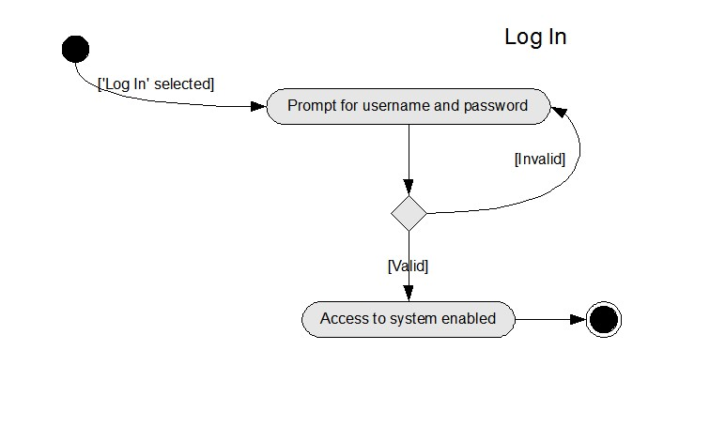

Figure
4.2
.
1

Log In Activity
Diagram

Figure 4.2.2 presents the Log Out activity diagram to provide a graphical representation of a waiter logging out of the system.
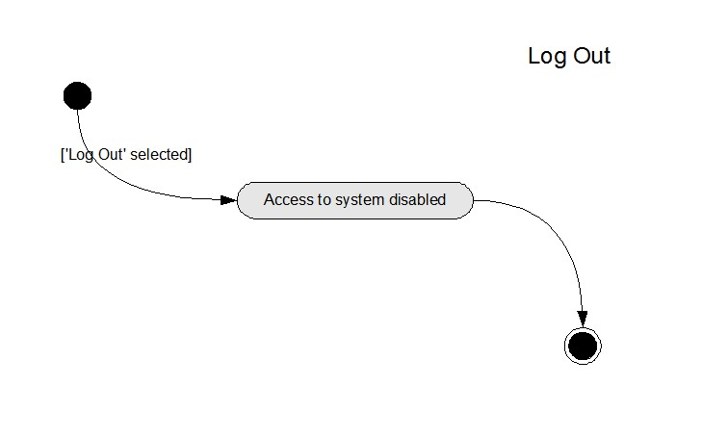

Figure 4.2.2 Log Out Activity Diagram
4.2.3 presents the Activate Table activity diagram to provide a graphical representation of a waiter activating the surface computer in a table.
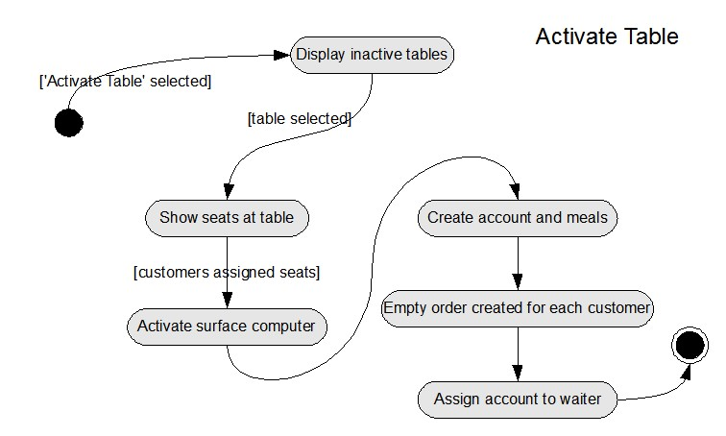

Figure
4.2
.
3

Activate Table Activity Diagram

Figure 4.2.4 presents the Deactivate Table activity diagram to provide a graphical representation of a waiter deactivating the surface computer in a table.
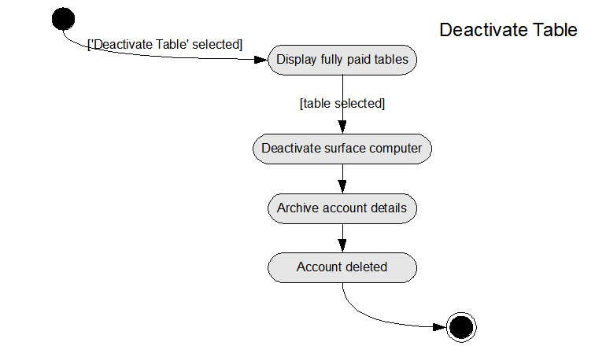

Figure 4.2.4 Deactivate Table Activity Diagram
4.2.5 presents the Accept Order activity diagram to provide a graphical representation of a waiter accepting a customer’s order.
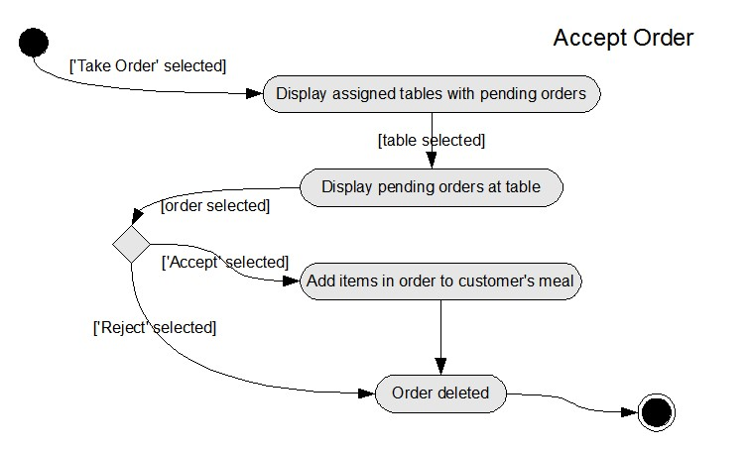

Figure
4.2
.
5

Accept Order Activity Diagram

Figure 4.2.6 presents the Deliver Item activity diagram to provide a graphical representation of a waiter delivering an item to a customer.
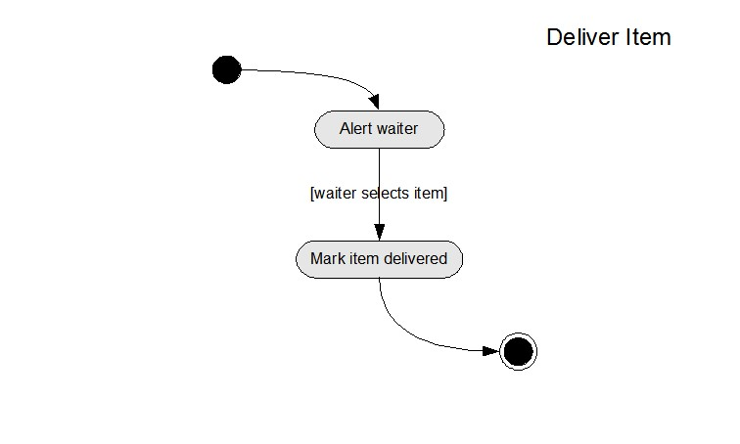

4.2.6 Deliver Item Activity Diagram
4.2.7 presents the Process Bankcard Payment activity diagram to provide a graphical representation of a waiter processing a bankcard payment.
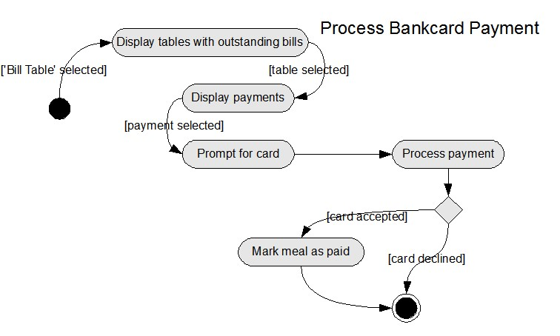

Figure 4.2.7 Process Bankcard Payment Activity Diagram
Figure 4.2.8 presents the Process Cash Payment activity diagram to provide a graphical representation of a waiter processing a cash payment.
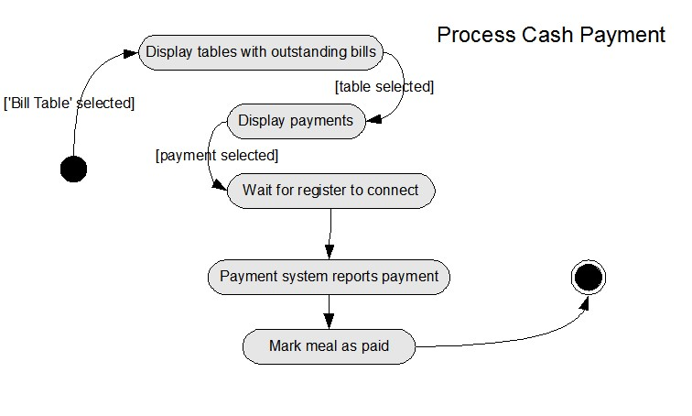

Figure 4.2.8 Process Cash Payment Activity Diagram

Uml Analysis Models
4.2.9 presents the Pay Bill activity diagram to provide a graphical representation of a customer paying for their meal.
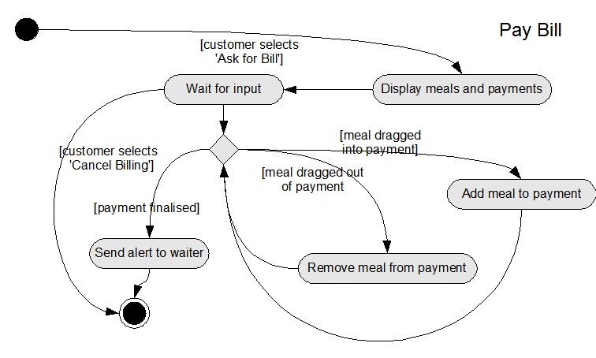

Figure
4.2
.
9

Pay Bill Activity Diagram

Figure 4.2.10 presents the Place Order activity diagram to provide a graphical representation of a customer placing an order.
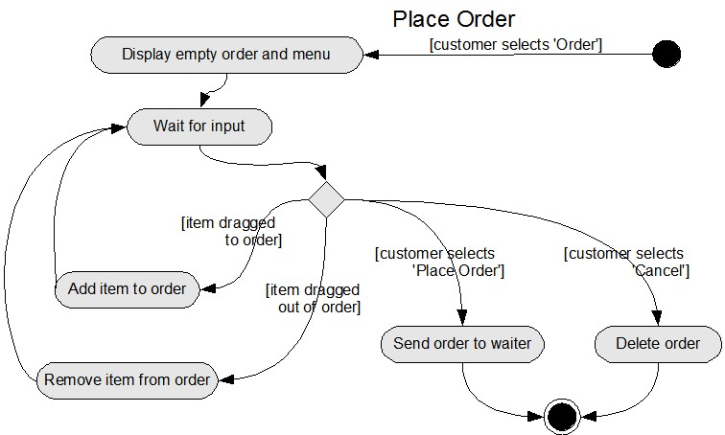

4.2.10 Place Order Activity Diagram
4.2.11 presents the Call Waiter activity diagram to provide a graphical representation of a customer calling for waiter assistance.
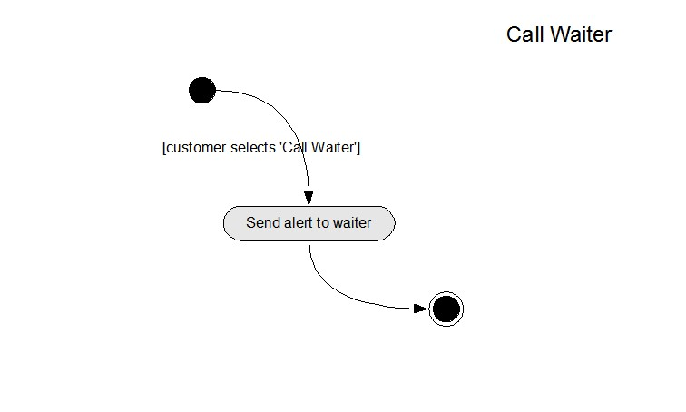

Figure
4.2
.
11

Call Waiter Activity Diagram

Figure 4.2.12 presents the Abort Meal activity diagram to provide a graphical representation of a supervisor aborting a customer’s meal.
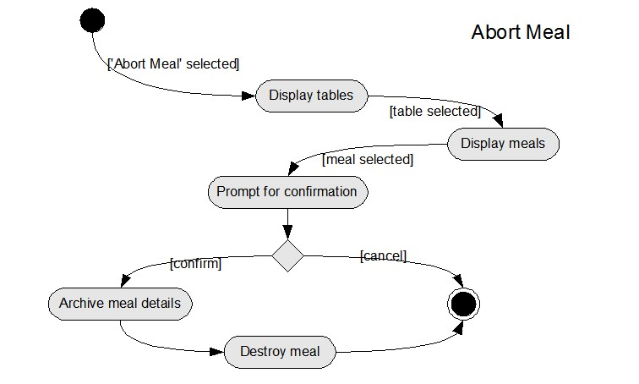

4.2.12 Abort Meal Activity Diagram
4.2.13 presents the Abort Account activity diagram to provide a graphical representation of a supervisor aborting a table’s account.
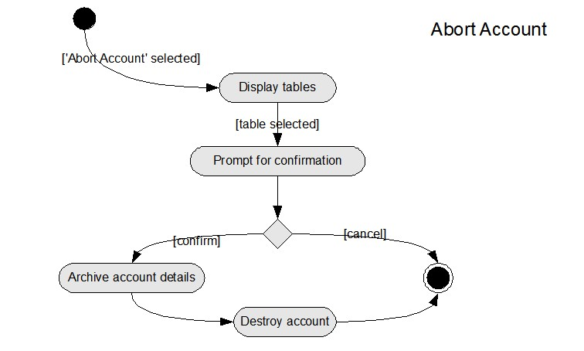

Figure
4.2
.
13

Abort Account Activity Diagram

Figure 4.2.14 presents the Issue Refund activity diagram to provide a graphical representation of a supervisor issuing a customer with a refund.
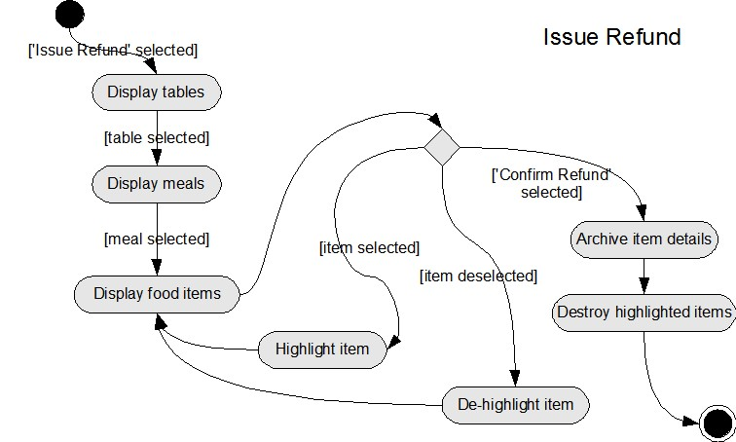

4.2.14 Issue Refund Activity Diagram
4.2.15 presents the Accept/Reject Item activity diagram to provide a graphical representation of a chef accepting or rejecting an item from a customer’s order.
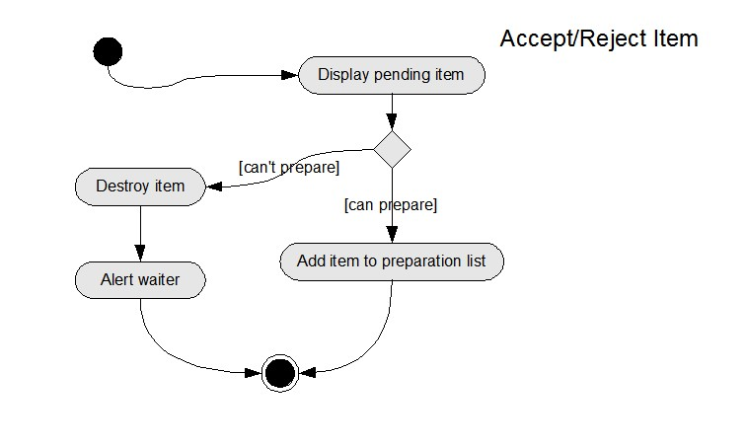

Figure
4.2
.
15

Acce
pt/Reject Item Activity Diagram

Figure 4.2.16 presents the Indicate Item Ready diagram to provide a graphical representation of a chef indicating that a customer’s item is ready for delivery.
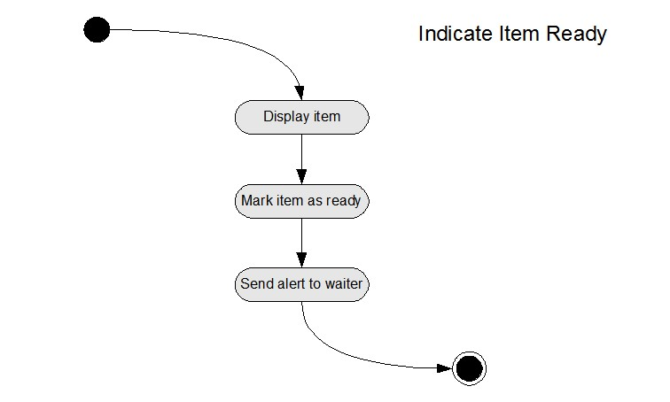

Figure 4.2.16 Indicate Item Ready Activity Diagram

4.3 Class Diagram
4.3.1 Class descriptions
The following subsection presents descriptions for the classes identified for the subject RMOS.
Item
This class represents an item of food or beverage from the restaurant’s menu. It exists as a part of either a single order or a single meal, but not both at the same time (an order gets decomposed into the constituent Items and they are added to a meal). An Item that is part of an order may contain a dietary requirement. An Item contains the menu item's name, price, description, status and an image or model to depict the Item on a surface computer or display.
DietaryRequirement
This class represents a customer’s dietary requirement (e.g. vegetarian, celiac). It exists as part of either a single Order or a single Item, but not both at the same time. A DietaryRequirement contains both the name and a description of the particular requirement it represents.

Order
This class represents a collection of Items and DietaryRequirements. It is part of a single Meal and maintains information about whether it has been placed or approved. An Order can be in either the placed, cancelled or the approved state. An Order will typically be deleted shortly after it has been approved and its Items added to the customer's Meal, tying the Items in the Order to an Account.

Meal
This class represents a collection of all items ordered by a single customer. It is part of a single Account and maintains the seat number related to the Meal. The total price of a Meal is also maintained.

Account
This class represents the associated Meals and Payments of a Table of customers. It consists of one or more Meals and one or more Payments. An account is related to one Table and is associated with one Tablet.

Table
This class represents a physical table at which a customer may be seated and its integrated surface computer. If the represented table is activated, an Account will be associated with the Table. It contains information about its current mode and its unique identification number. Further, it may be woken (activated), put to sleep (deactivated), placed in ordering mode or placed in billing mode.

Tablet
This class represents a wireless tablet used by staff; it essentially represents a waiter/supervisor logged into the tablet and consequently the system. The class contains information about who is logged into the Tablet. It may also be associated with any number of Alerts that can be sent to it by the system.

Alert
This class represents a message sent to a Tablet to alert the waiter/supervisor of an event related to one of the Tables they have been assigned. It maintains a category (e.g. 'item rejected', 'item ready') and a description. An Alert belongs to exactly one Tablet.

Payment
This class represents a payment to be made to the restaurant. It may contain any number of Meals and TipDenominations and is related to exactly one Account. A Payment maintains its total value and the seat number of the paying customer.

BankcardPayment
This class represents an extension of the Payment class for customer payments that are to be paid using a bankcard.

CashPayment
This class represents an extension of the Payment class for customer payments that are to be paid using cash.

TipDenomination
This class represents a tip denomination to be given to a waiter. A TipDenomination belongs to a single Payment and contains information about the denomination value.

Uml Analysis Models

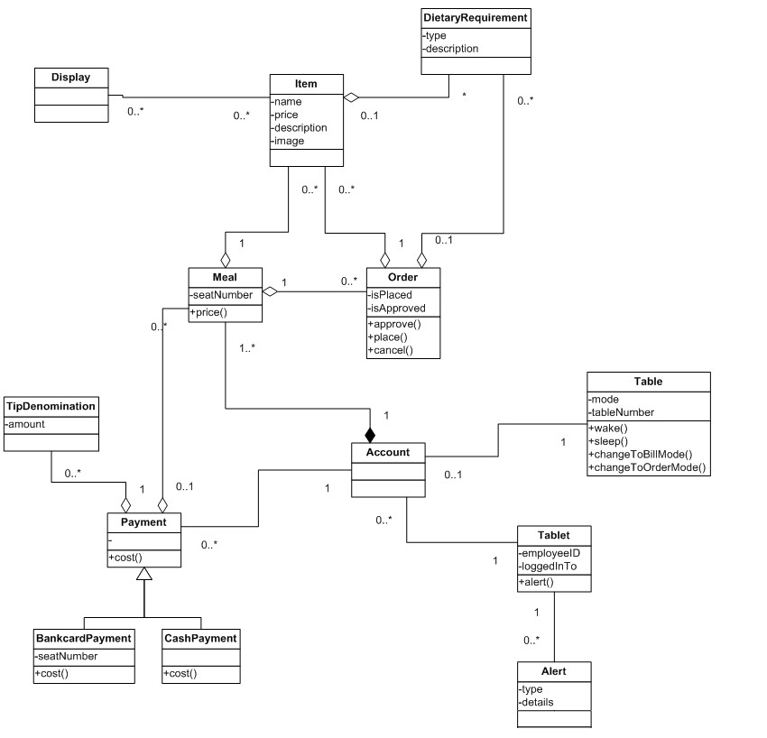

4.4 Statechart Diagrams
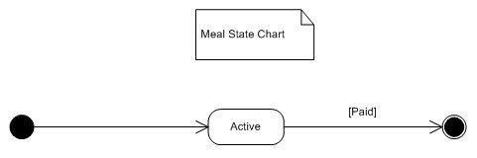
Figure 4.4.1 Meal Class Statechart Diagram

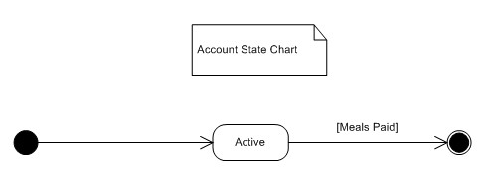
Figure 4.4.2 Account Class Statechart Diagram
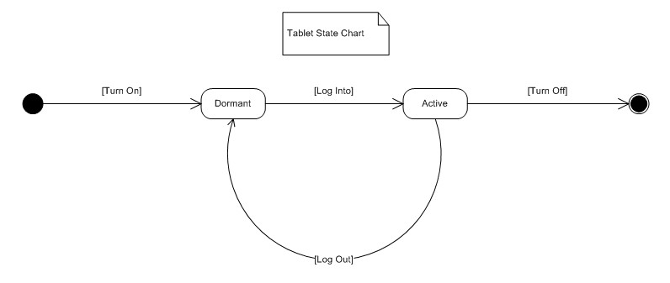
Figure 4.4.3 Tablet Class Statechart Diagram

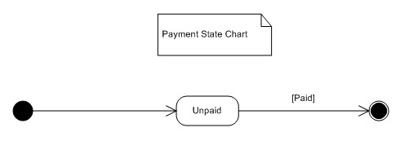
Figure 4.4.4 Payment Class Statechart Diagram

Uml Analysis Models
Unsent
Sent
Accepted
Delivered
[
Owner Sent
]

[
Acceptance
]

[
Delivered
]

[
Owner Paid
]

[
Rejection
]

Item State Chart

Figure 4.4.5 Item Class Statechart Diagram

Order State Chart
Pending
Approved
[
Approval
]

[
Items Transferred
]

Figure 4.4.6 Order Class Statechart Diagram

Table State Chart
Ordering
Billing
[
Bill Request
]

[
Bill Cancellation
]

Dormant
[
Activation
]

[
Payment Completion
]

Figure 4.4.7 Table Class Statechart Diagram

